Name: Ngala Dirane

Section: Data Profiling

Date: 13/10/2018

1. Alter the ***tbl_stg_Prospects*** table to include FirstName, LastName, Dept, City, State columns – (Project document)

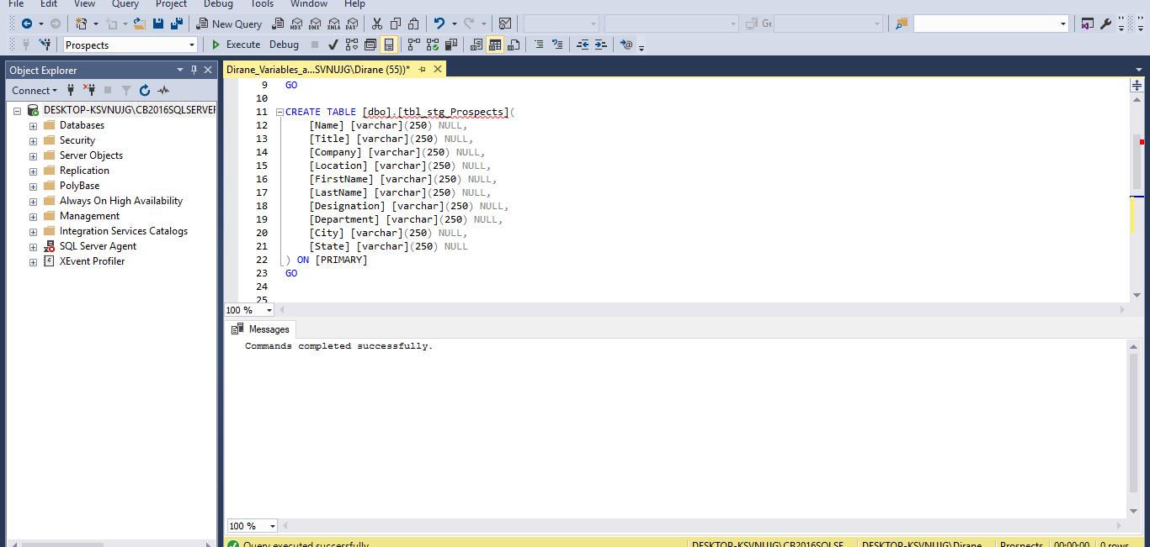

1. Modify ***Load_Prospects_Staging.dtsx*** to include the following
   1. 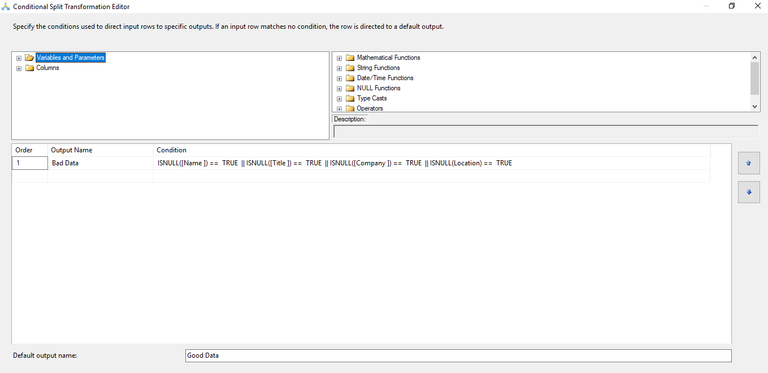split the excel columns to populate appropriate information in the newly added fields in ***tbl_stg_Prospects*** table.

Figure : Conditional Splitting

Figure : Derived Columns Transformation

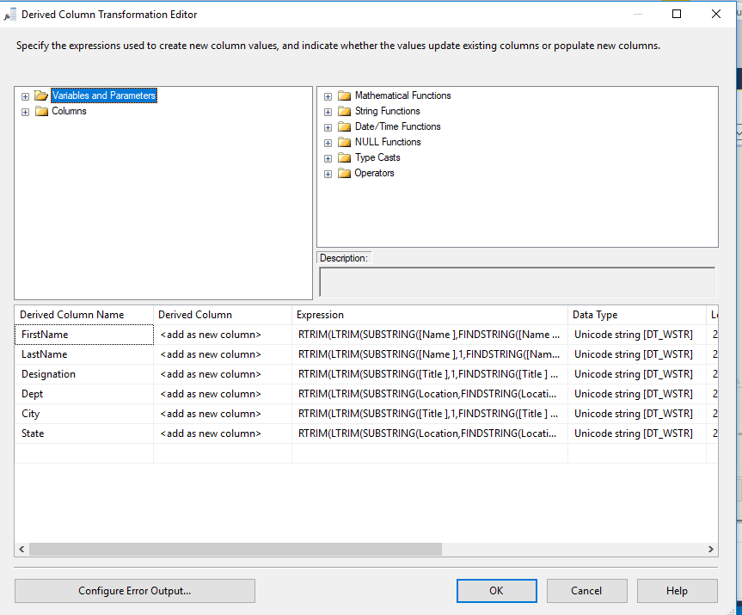

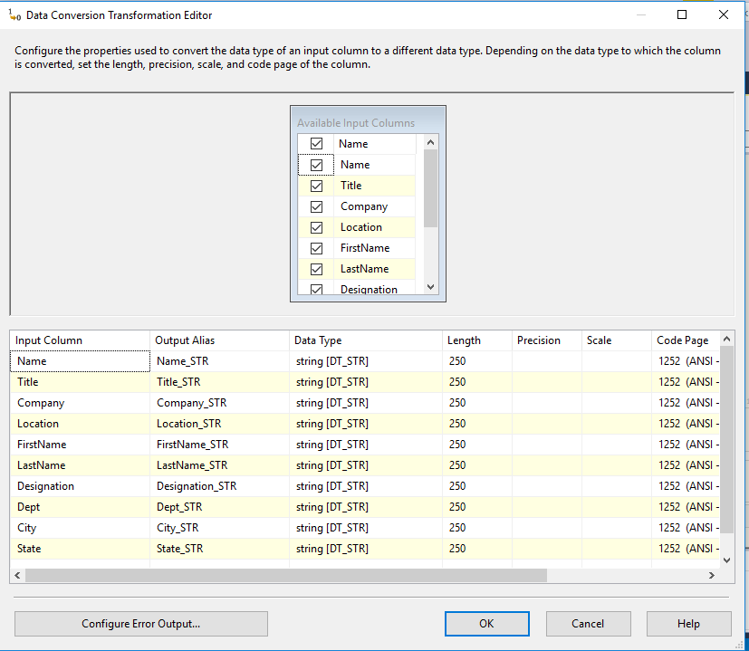

Figure : Data Conversion

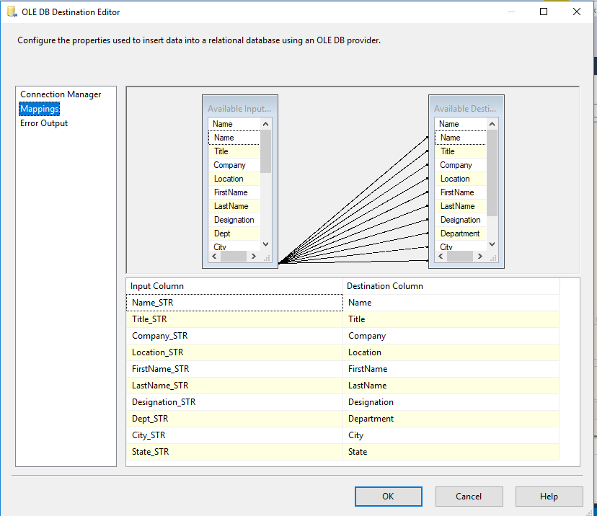

Figure : Mapping Splitted Fields

* 1. 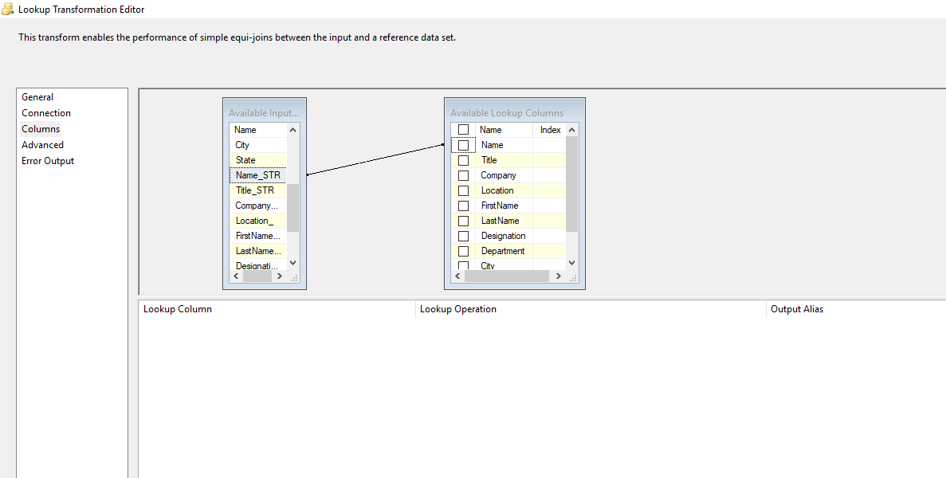filter out records that do not have any value (NULL) in any of the four excel columns

Figure : Mapping Filtered Data

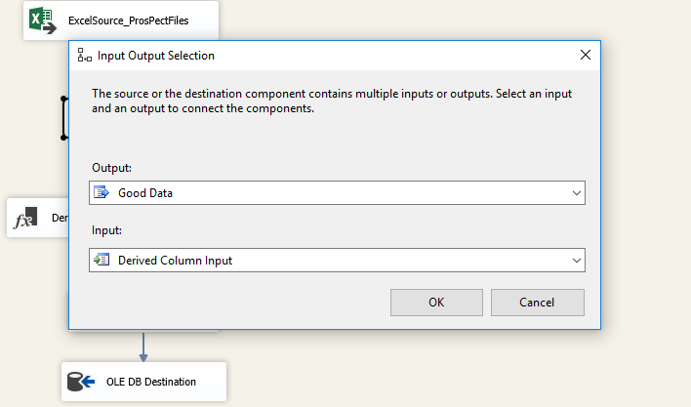

* 1. 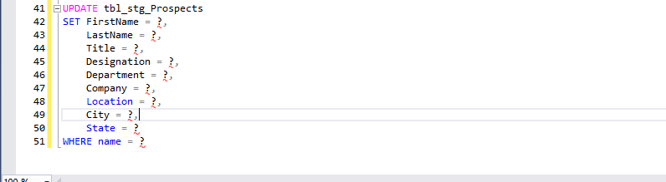check for matching name in ***tbl_stg_Prospects*** table and according insert or update the records in ***tbl_stg_Prospects*** table

Figure : Update Query

Figure : Code for file path and name

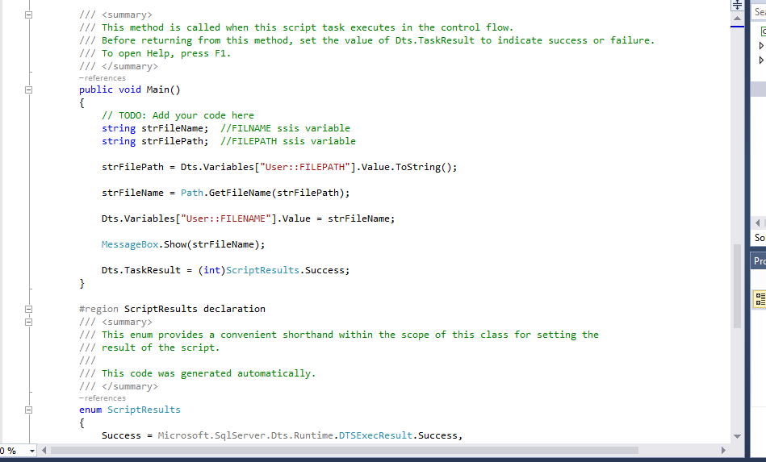

Figure : Matching Parameters

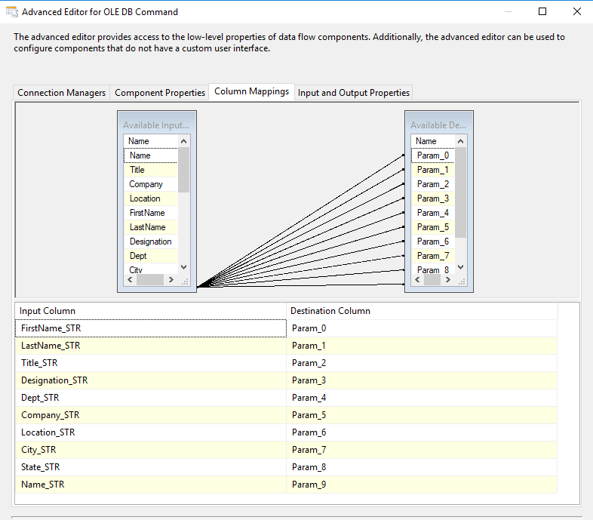

* 1. 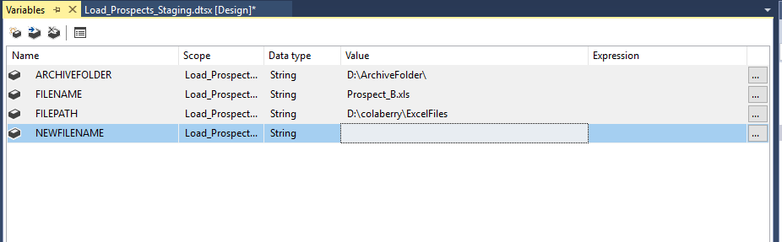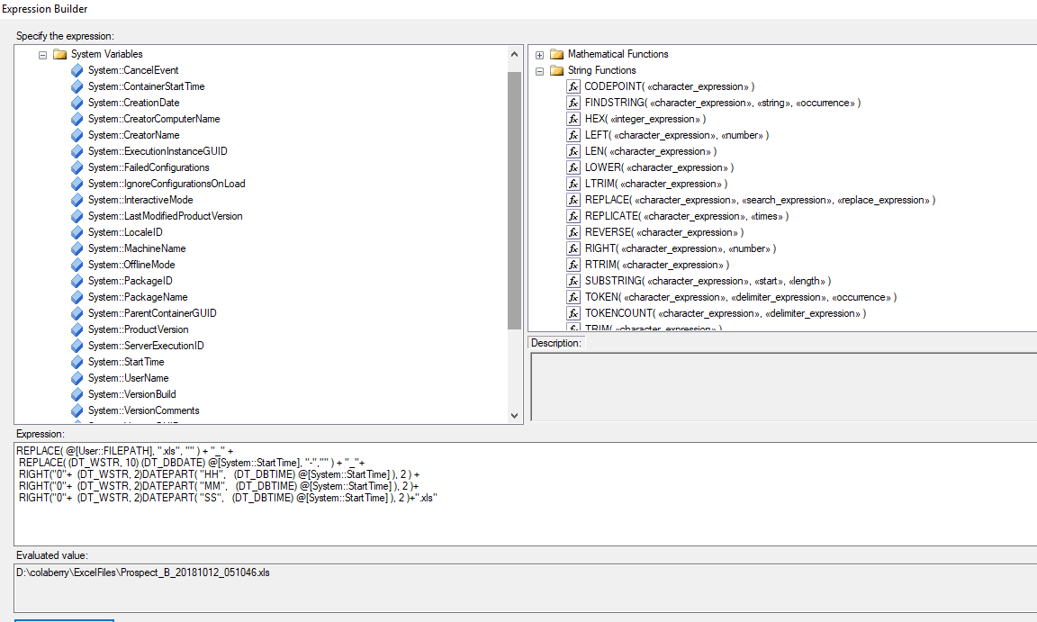Append datetime to the successfully loaded files and move it to ***Archive*** folder

Figure : Adding Variables

Figure : Configuring the new file Name

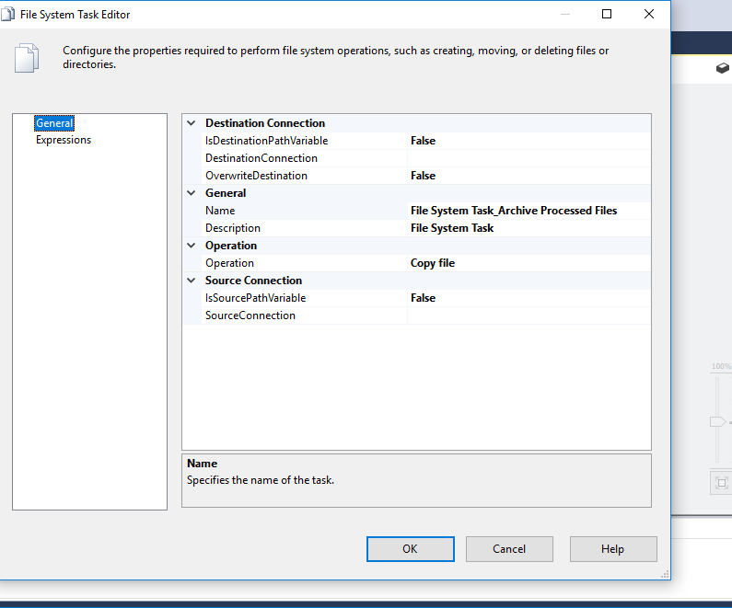Figure : File System Task

Figure : Final View

