Name: Ngala Dirane

Section: Extract, Transformation and Load Basics

Date: 06/10/2018

1. Create an SSIS package to load Employee.txt file in to ***LearningSSIS..tblEmployee***

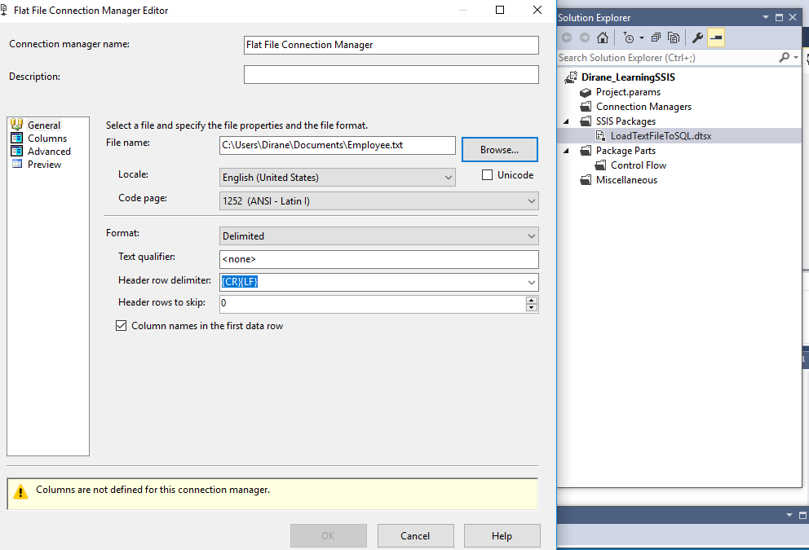

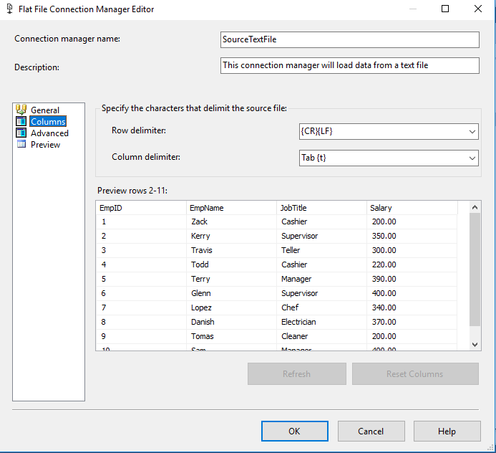

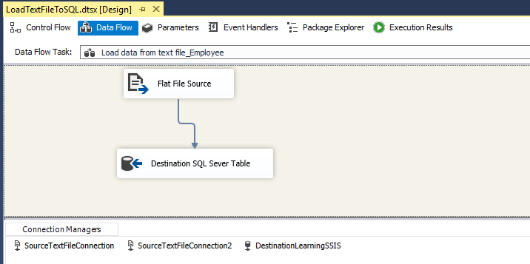

1. Create table ***tblEmp*** in ***LearningSIS2*** database with the same schema as ***LearningSSIS..tblEmployee*** table
2. (do not populate tblEmp)
3. Create a SSIS package to load the data from ***LearningSSIS..tblEmployee*** to ***LearningSSIS2..tblEmp***

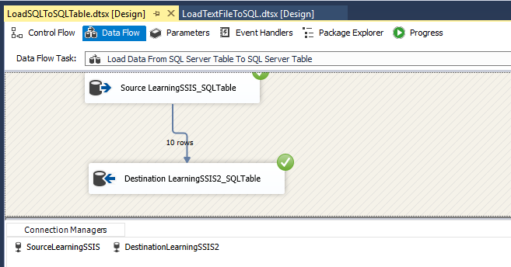

1. Create database ***Prospects***
2. Create table ***tbl_stg_Prospects*** in Prospects – (Refer to Project document)
3. Create a SSIS package ***Load_Prospects_Staging.dtsx*** to load the data from Prospect_B.xls to ***tbl_stg_Prospect***

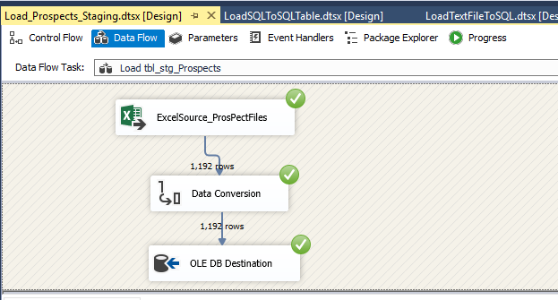

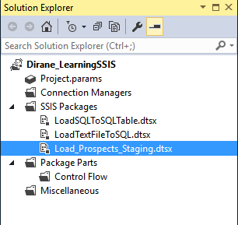

Find an article that explains the importance of ETL in an organization. Write a one paragraph summary on the article and post it to the Discussion Group. Take a screenshot of the posted article and attach it to the bottom of this hw.

