Name: Ngala Dirane Ngiri

Section: End of Class

Date: 28/10/2018

**Figure 1: Facebook review**

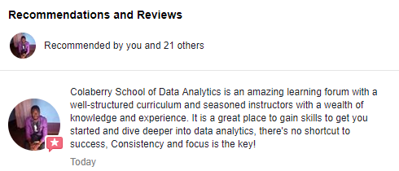

**Figure 2: LinkedIn Colaberry review**

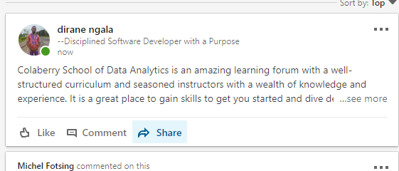

**Figure 3: Tweet to Colaberry**

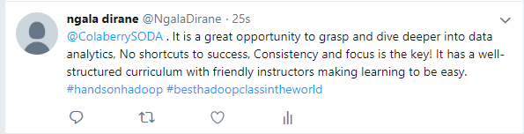

**Brief Testimonial about my experience.**

Thank you Colaberry School of Data analytics. It has been a great experience taking this course from day one up to this day. Lessons were well-structured and delivered by competent instructors, while the environment was absolutely friendly. During my study time, I developed a good relationship with classmates and learned from the experiences shared by instructors. Based on what I've learned from this program, I would recommend Colaberry School of data analytics to just anyone who is willing to focus and study hard to earn a happy living while working in this field.