1. Do the class room assignment 3 times. (Only show screen shots for one round)

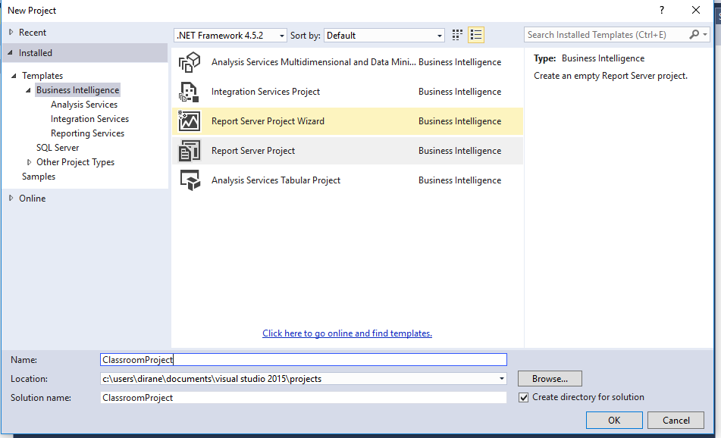

Figure : Creating new project

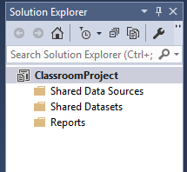

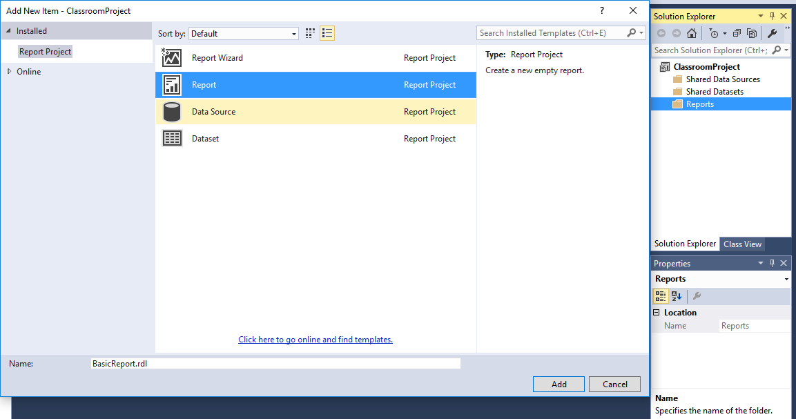Figure : Solution Explorer showing created project

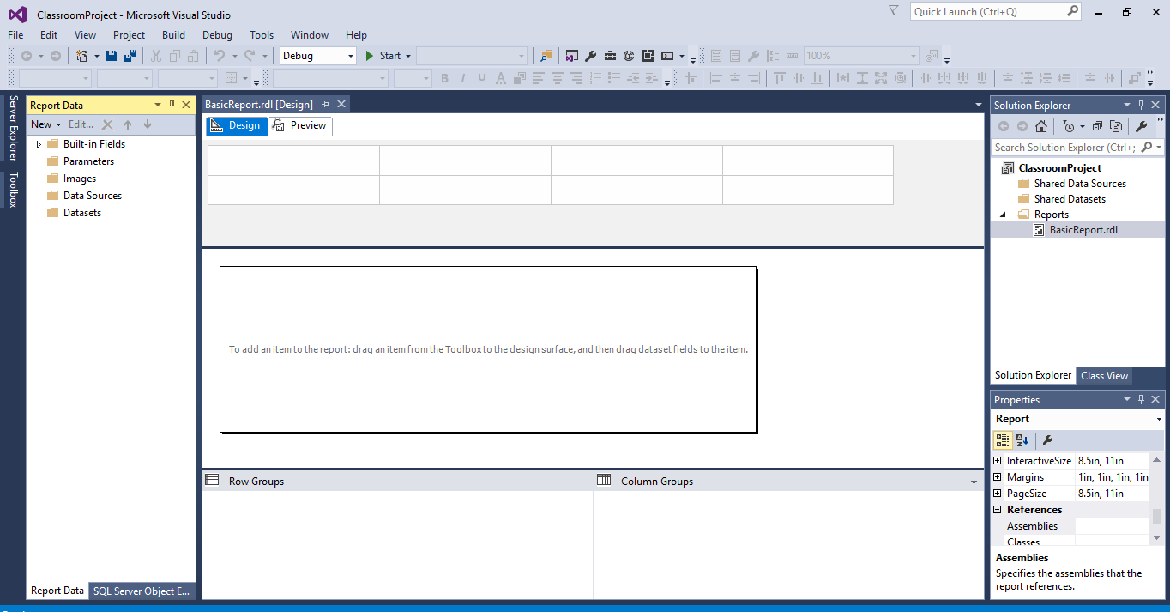

Figure : Report display

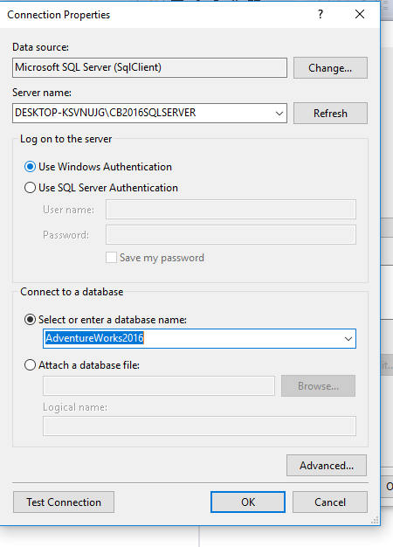

Figure : Embedded Connection

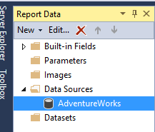

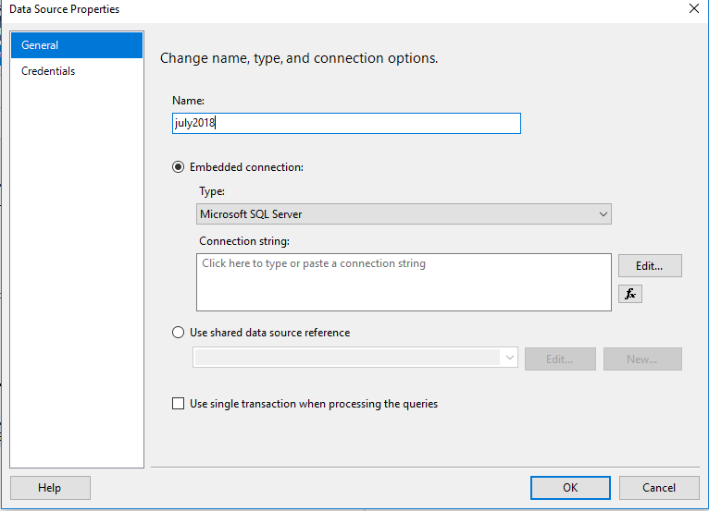

Figure : Creating data source

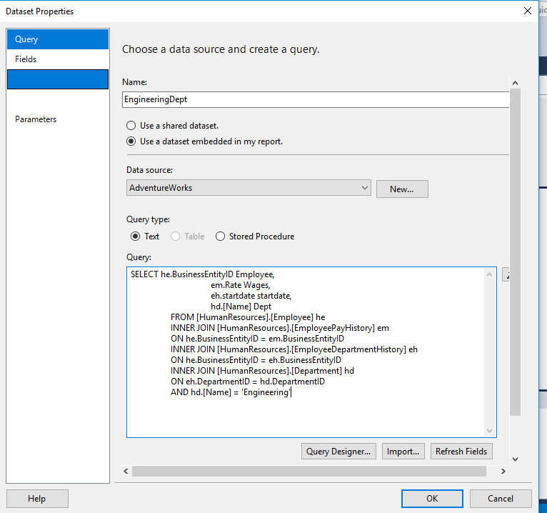

Figure : New data set

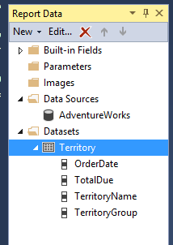

Figure : Territory Data sets

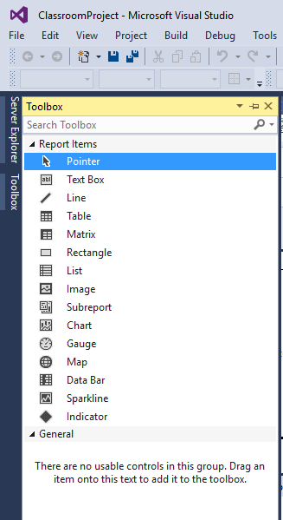

Figure : Tool bar

1. Create a DataSet using 4 tables in a join.



Figure : Creating datasets with four tables joined

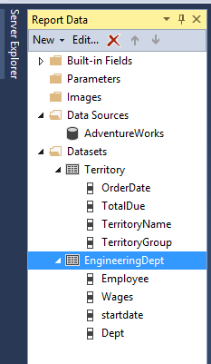

1. Create 5 different Objects using the dataset.

5. Take a screenshot of each individual report with an explanation of what the chart is showing below the chart.

6. Review your [SSRS Dashboard Project](http://www.novedeatraining.com/CentralStation/Event/EventEdit.aspx?EventID=1193)

Find an article that explains the importance of Reporting in an organization. Write a one paragraph summary on the article and post it to the Class Discussions. Take a screenshot and include it with this assignment.

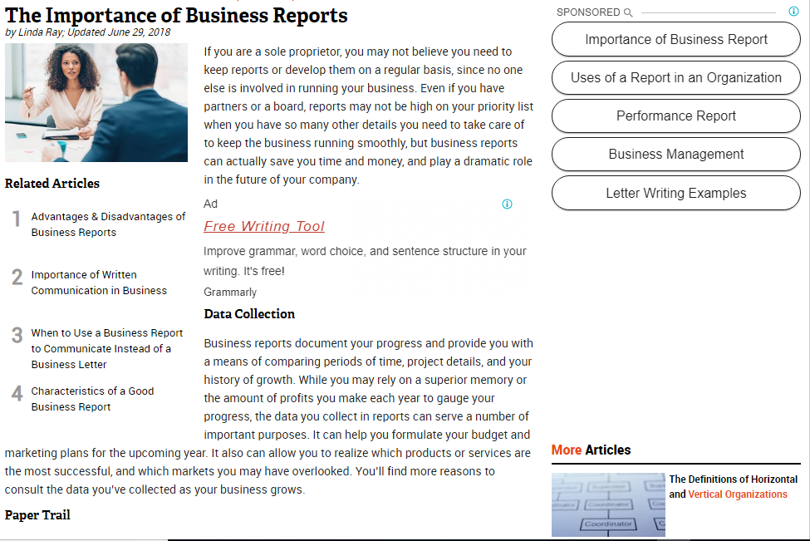

Figure : Importance of Reporting in an Organization