Name: Ngala Dirane

Section: Package Deployment and Storage

Date: 27/10/2018

1. Create a package Load_Prospect_Master.dtsx that will call all the three packages in the correct order

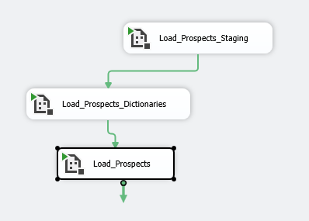

Figure : Create and run package successfully: Load_Prospects_Master

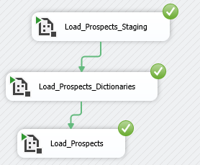

1. Configure package Load_Prostect_Staging.dtsx to read values from XML configuration file during execution.

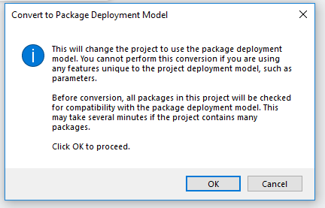

Figure : Package successfully converted to deploy mode

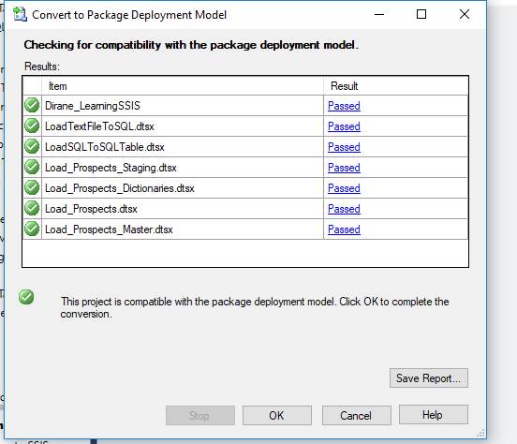

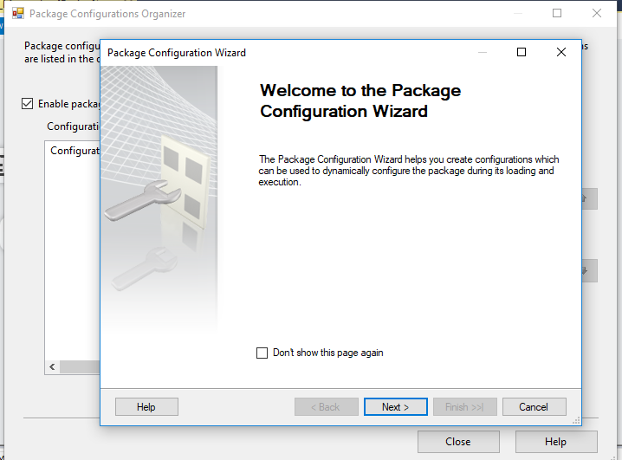

Figure : Content of XML Configuration file

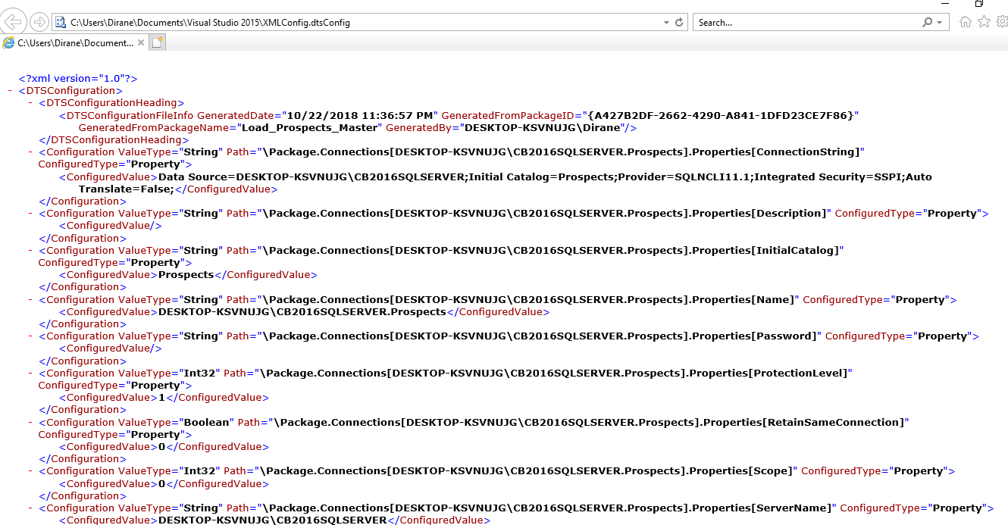

1. Configure package Load_Prospects_Dictionaries.dtsx and Load_Prospects.dtsx to read values from SQL Server during execution.

Figure : SQL Package Configuration

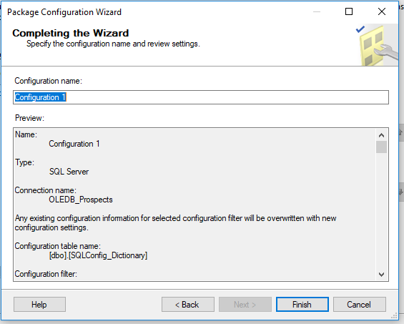

Figure : SQL Configuration file content

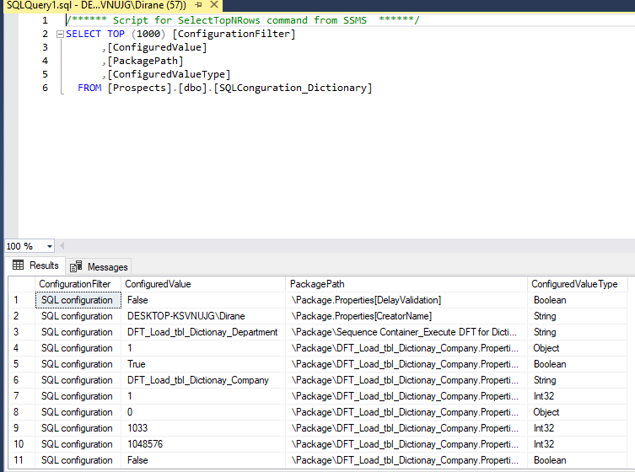

1. Create a SQL Server Agent job to schedule your package to run once daily

Figure : Creating Catalog

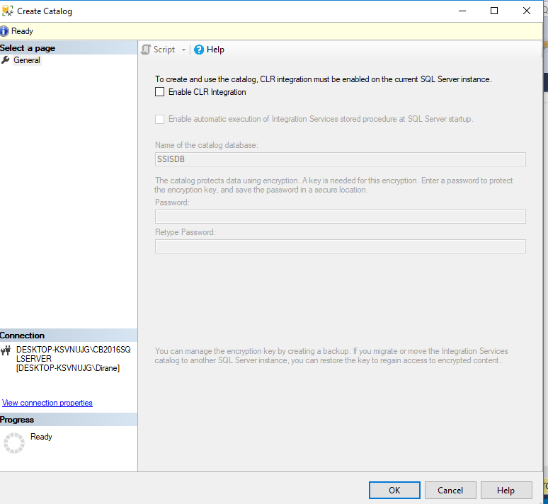

Figure : Creating Jobs

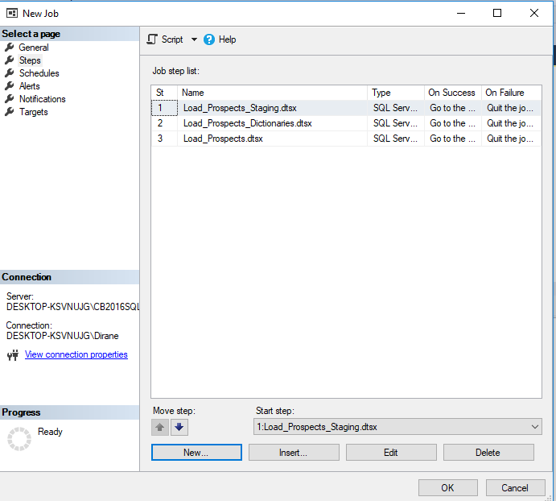

Figure : Job Scheduling

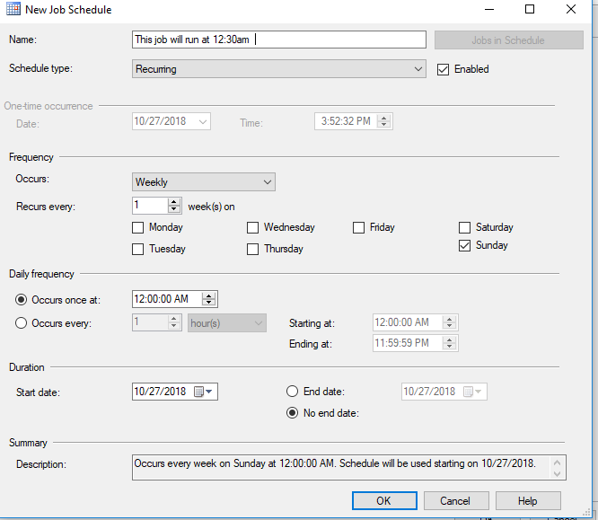

Figure : Running step by step Jobs

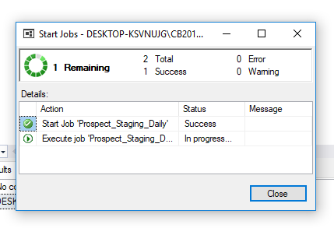

Figure : Package Deployment

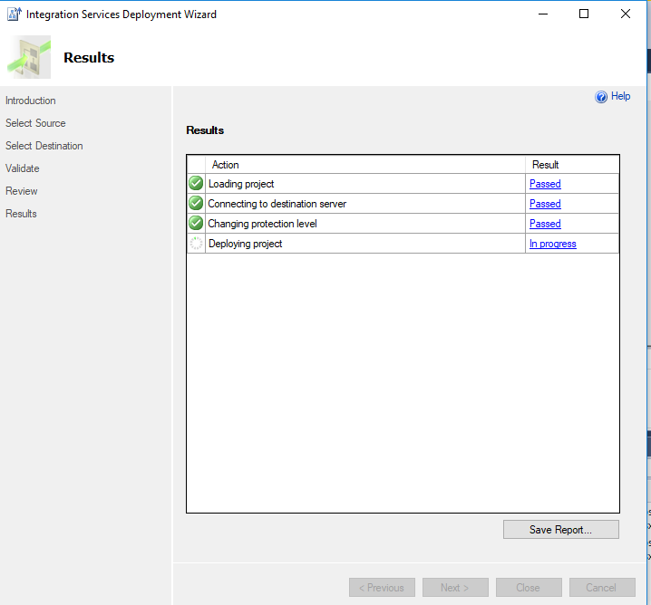

Figure : Package Deployed

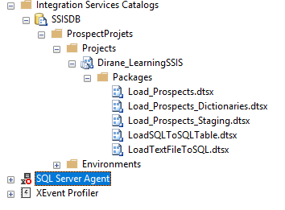

Figure : Successfully Deployed all packages

