Name: Ngala Dirane

Section: Package Design Considerations

Date: 20/10/2018

1. Configure database mail on your SQL instance.

Figure : Configuring the Database Mail account

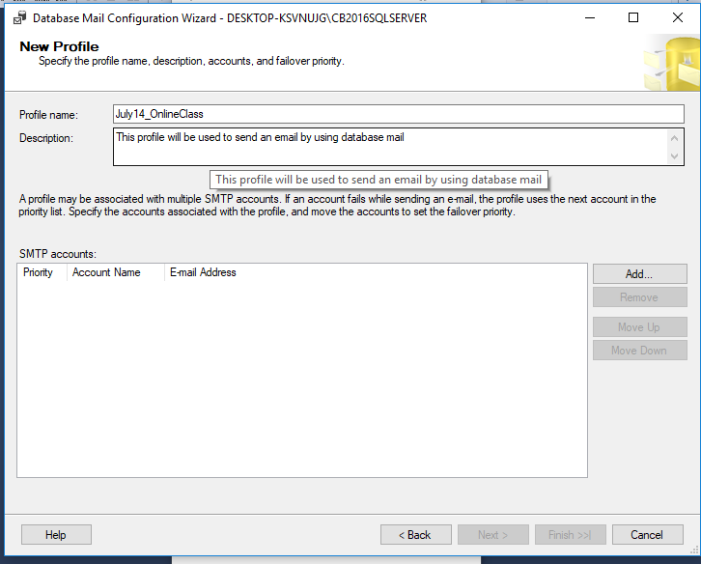

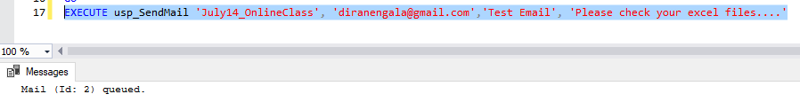

Figure : Stored Procedure to Send Email

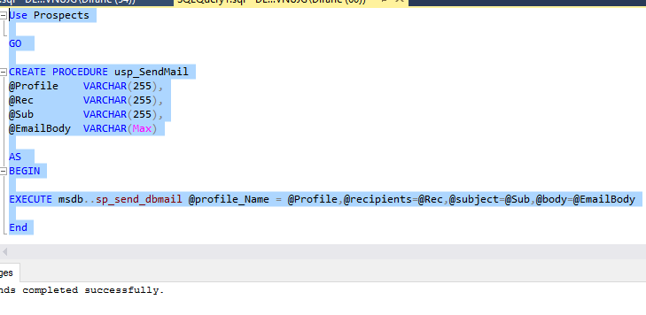

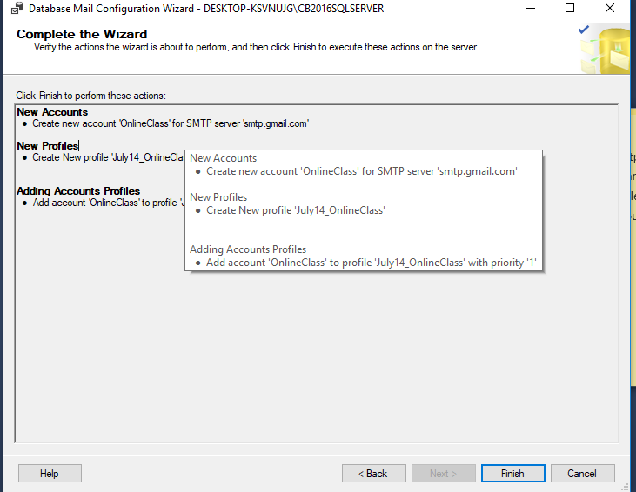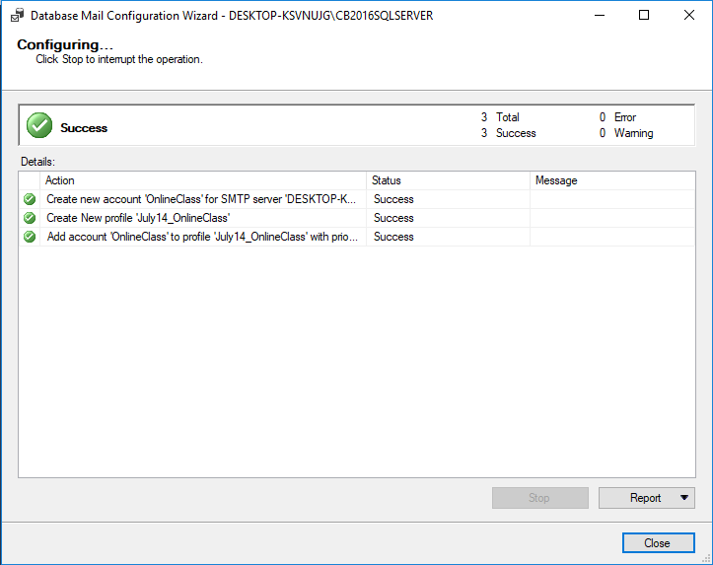

1. Modify ***Load_Prospects_Dictionaries.dtsx*** to include the following
   1. 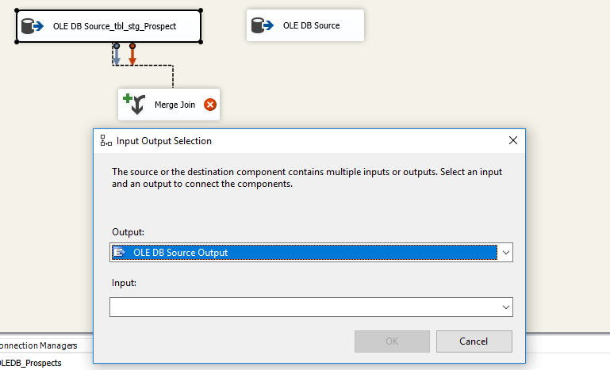Use Merge Join while loading Title and Department dictionaries instead of Lookup component.

Figure : Adding Merge Join

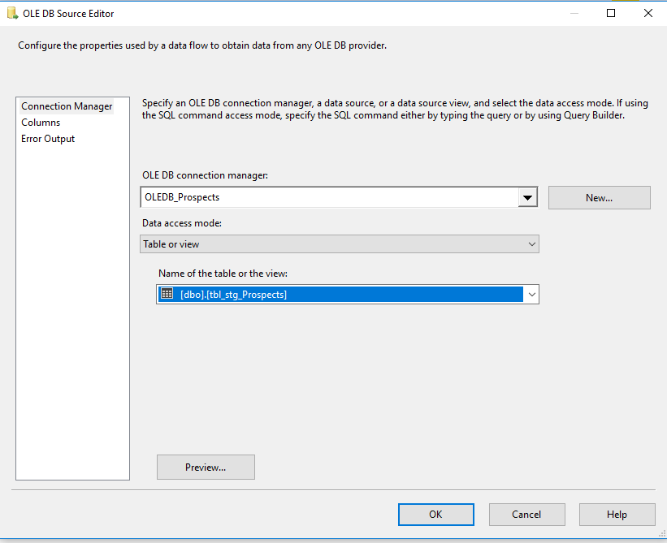

Figure : Configuring Source for Merged data

Figure : Using sort and setting sort key

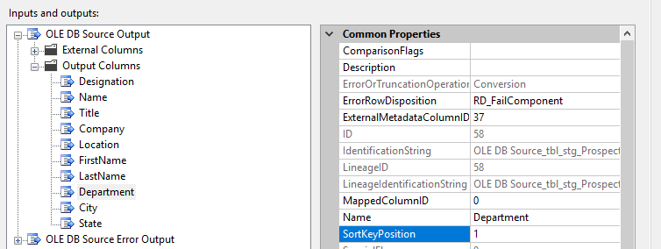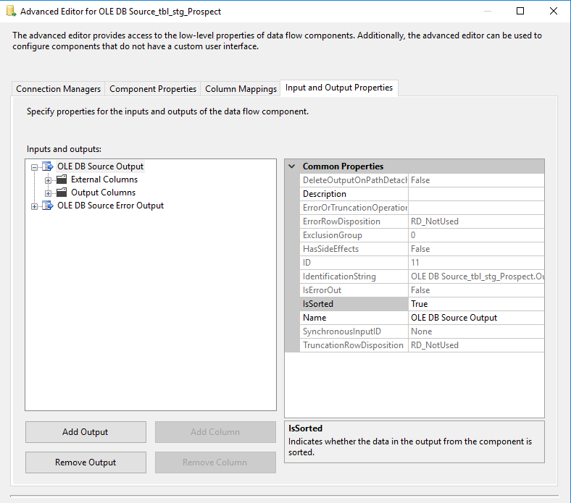

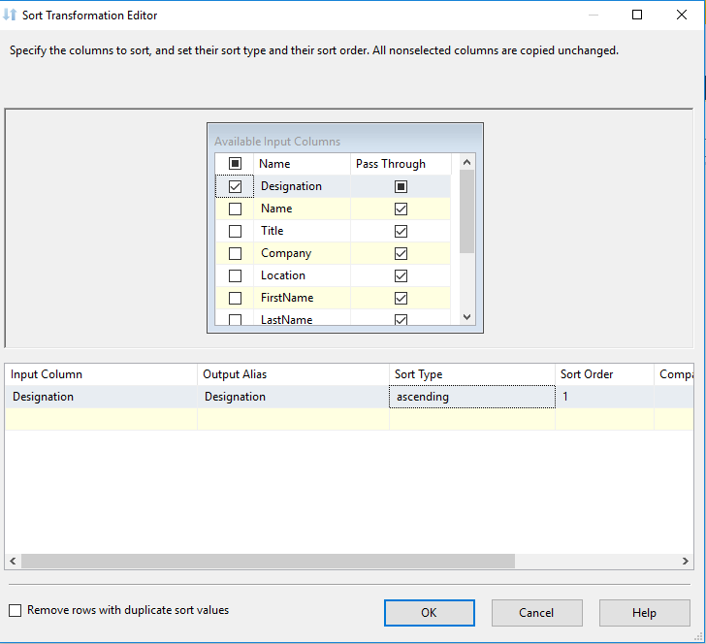

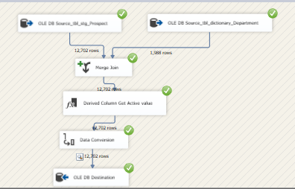

Figure : Package ran successful for dictionary_Department table

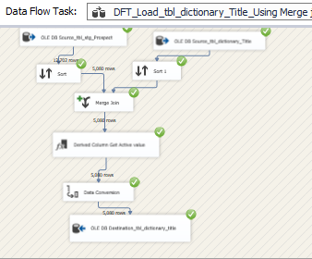

Figure : Package Ran successfully for dictionary Title table

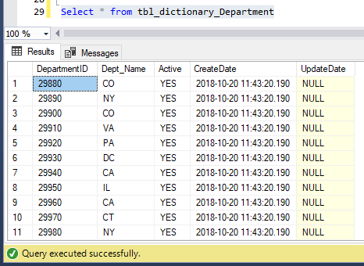

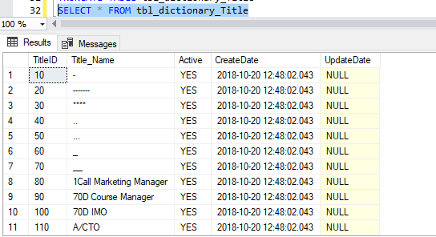

* 1. 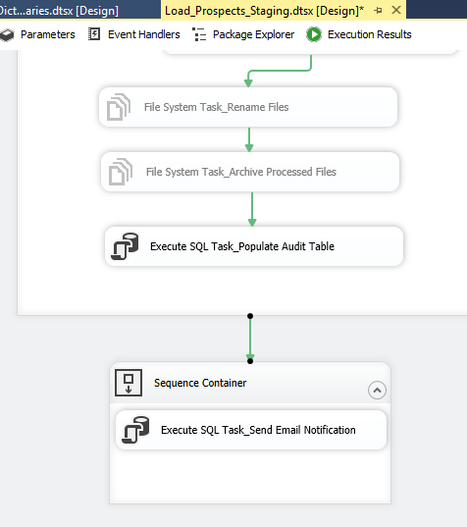Include related tasks on the control flow tab of all the packages in sequence containers

Figure : Adding Sequence Containers to Load Prospect Staging package

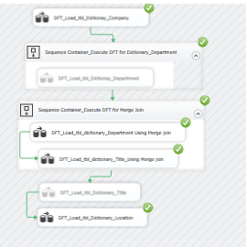

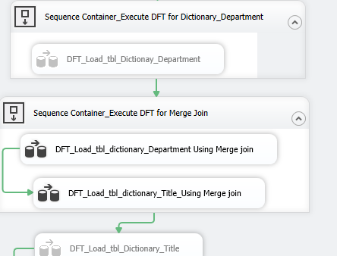

Figure : Showing Sequence Containers for the new Package

1. Create table ***tbl_Prospects*** - Refer to the project documentation for details

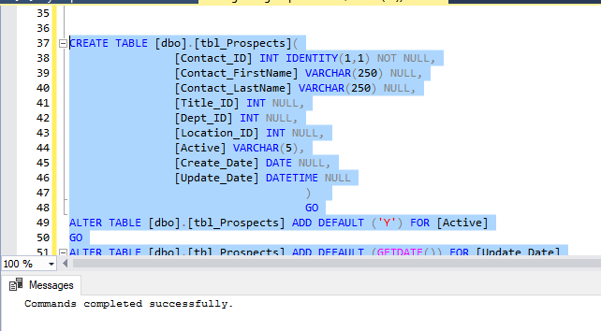

1. Create package ***Load_Prospects.dtsx*** to read from staging and dictionary tables and load the final ***tbl_Prospects*** table

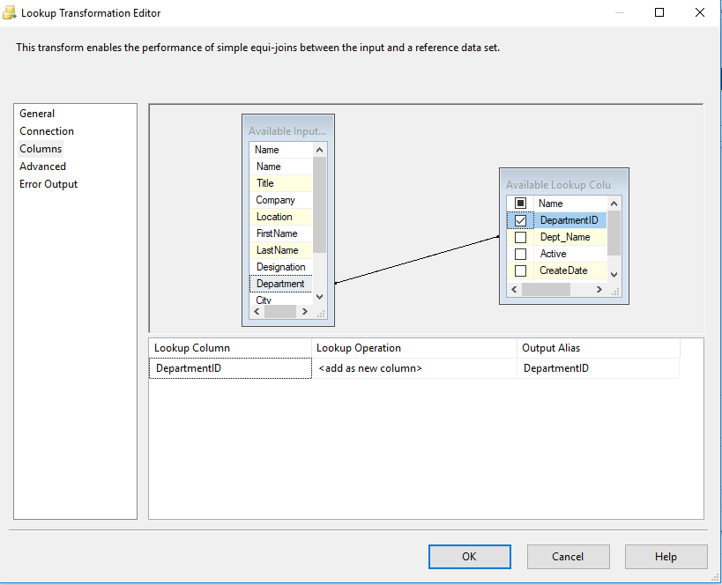

Figure : Configuring Lookup Transformations to load and transform data

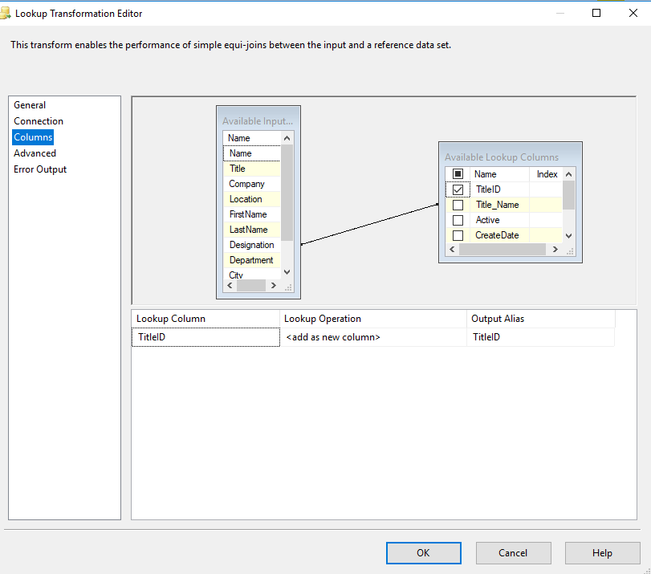

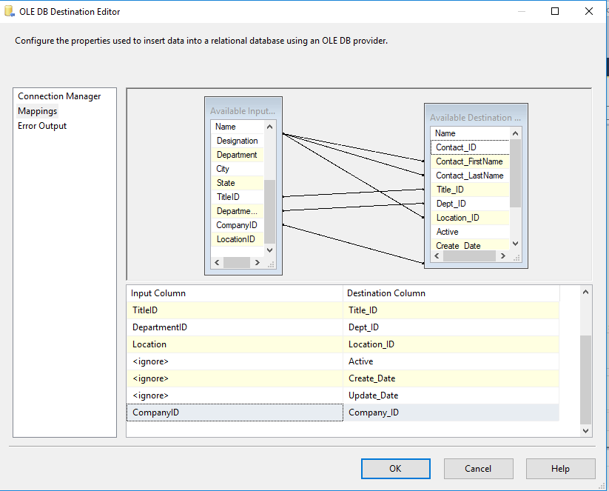

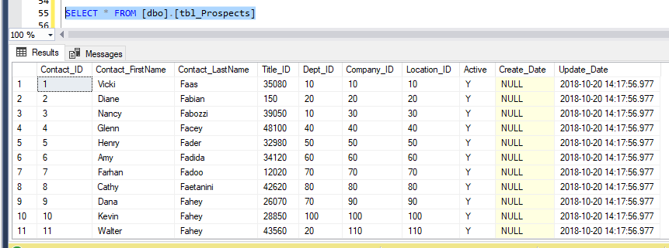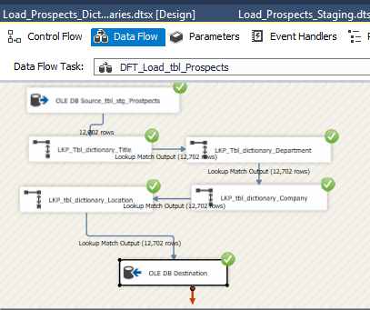

Figure : Result after Merge and Loading IDs from Title, Company, Location and Department Tables

Figure : Package run successfully after Configuring Lookups