Name: Ngala Dirane Ngiri

Lesson: Query Editor Features

Date: 23/07/2018

Question:

1. **CREATING TABLES** (RIGHT CLICK NEW TABLE)

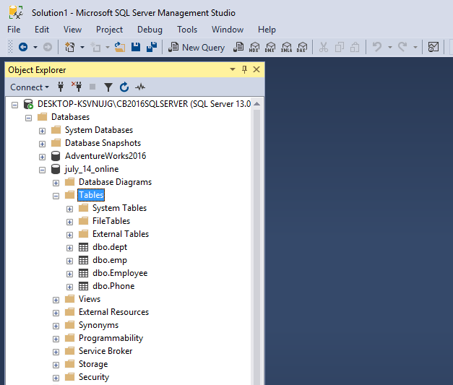

Figure 1: Employee and Phone Creation

1. If they already exist, delete and recreate **emp** (empid int,empname varchar(50),deptid int) & **dept** (deptid int,deptname varchar(50)) **TABLES**.

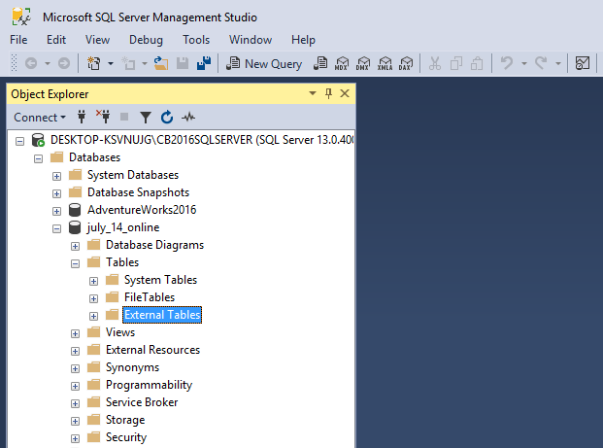

Figure 2: emp and dept deleted



Figure 3: Tables recreated

1. Populate the above tables using (Right Click table – Edit Top 200 Rows)

a. Put 10 rows in each table

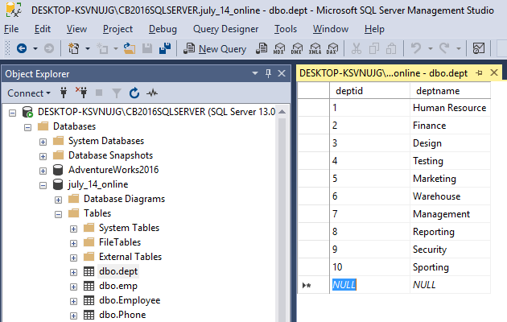

Figure 4: Dept Populated

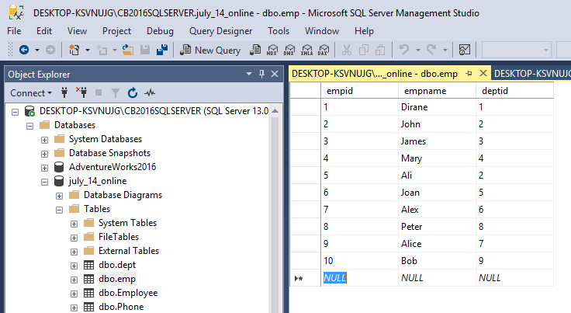

Figure 5: Emp Populated

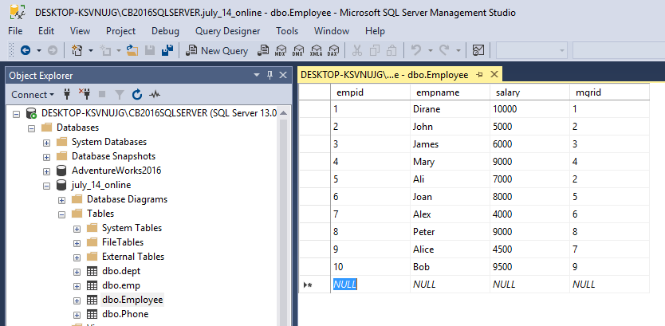

Figure 6: Employee Populated

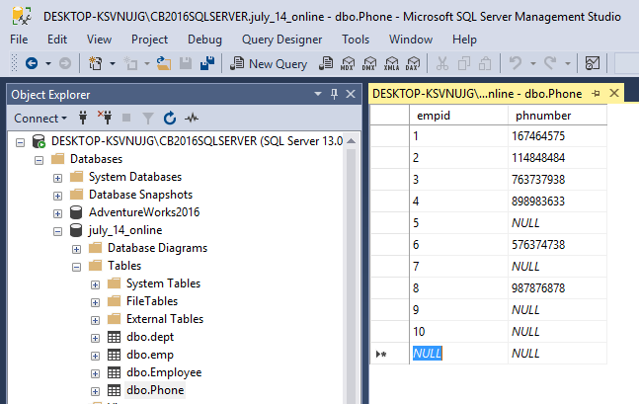

Figure 7: Phone Populated

1. **CREATING SELECT STATEMENTS** - *If the statements below don’t match your data, alter your data to be able to answer the questions.*
2. Retrieve all records from Employee table

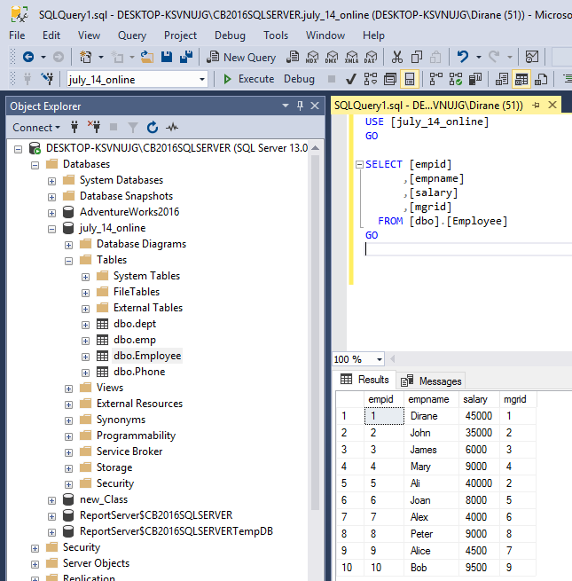

1. Retrieve all records from Emp table

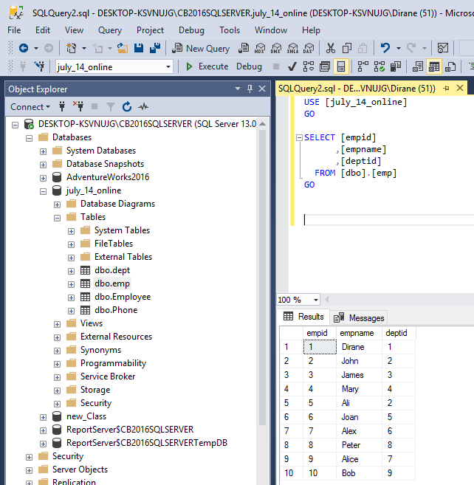

1. Retrieve all records from dept table

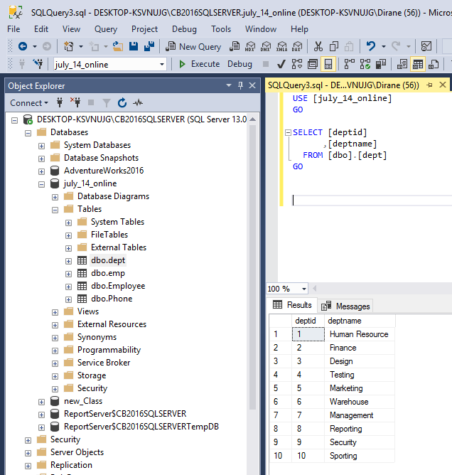

1. Retrieve all columns from the emp table where first name = Ali

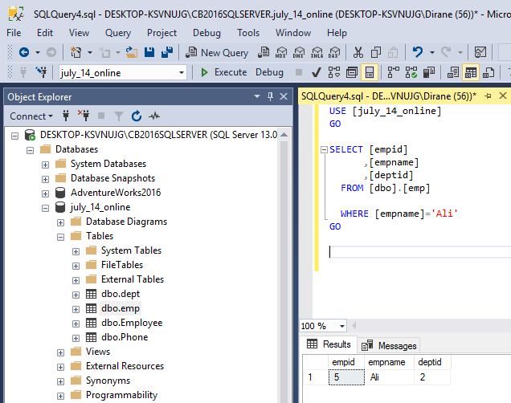

1. Retrieve empname and Salary from the Employee table where Salary is greater than $30,000

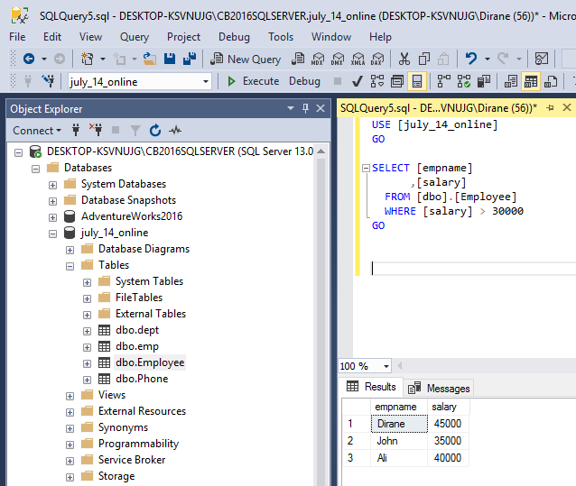

1. Find the deptname of deptid 1

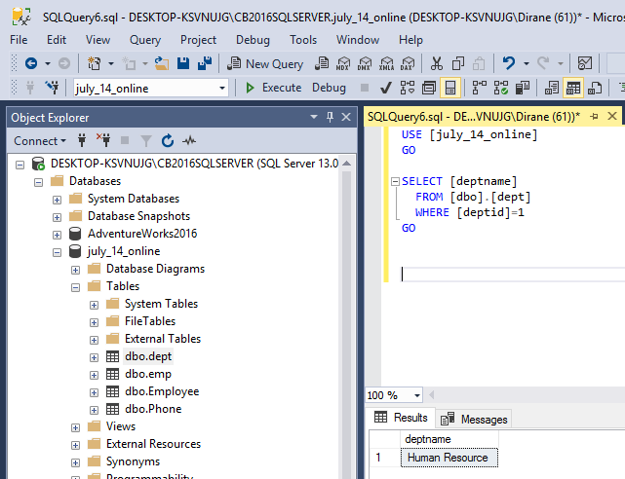

1. Select all empid’s from Employee table where mgrid = 5

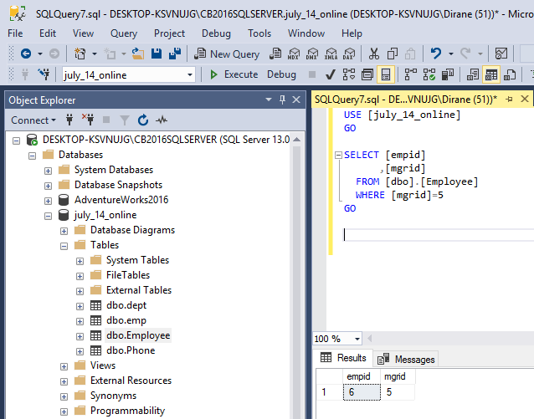

1. Select all empid’s from Phone table where employee does not have a phone number.

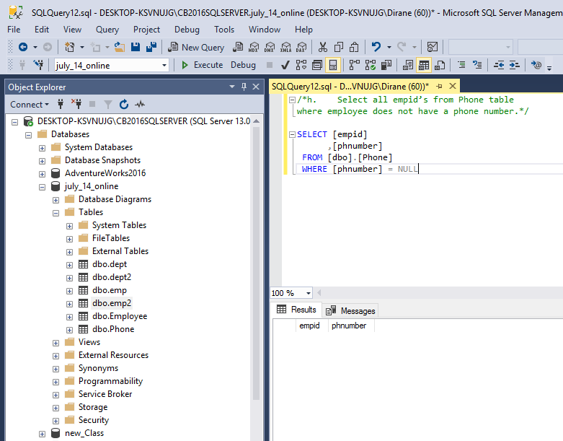

5. **CREATE TABLES USING SCRIPT** Create **emp2** (empid int,empname varchar(50),deptid int) & **dept2** (deptid int,deptname varchar(50)) TABLES using CREATE TABLE.

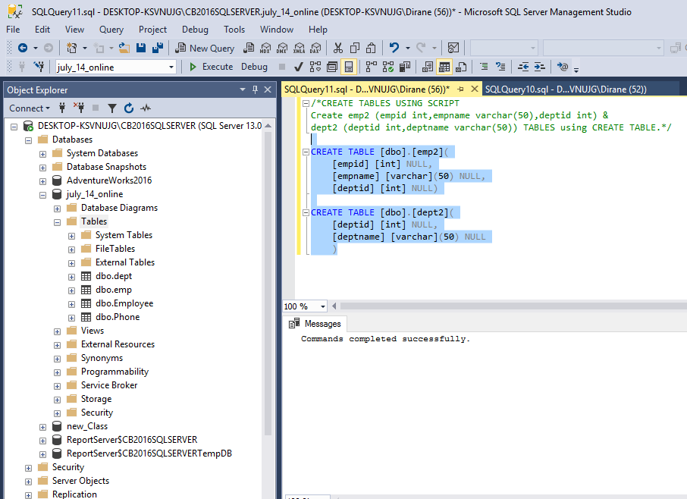

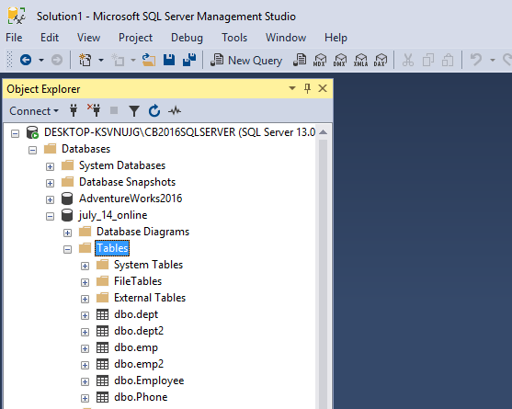

GROUP ASSIGNMENT:

1. Submit a screenshot of your created zoom account. Add to it the 2 meet times for your group

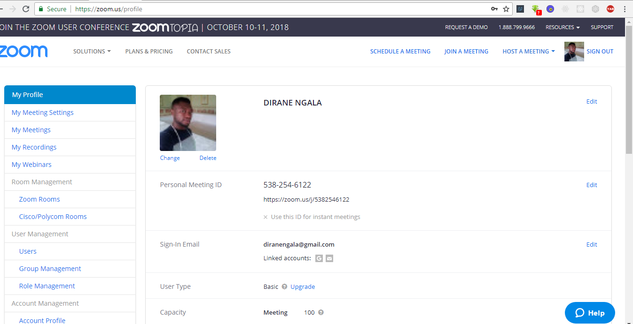

Group Members:

1. Dirane Ngala
2. Rajasekha Kolusu
3. Efe Kragha
4. Nardos Mengistu
5. Tare Kragha