Name: Ngala Dirane Ngiri

Lesson: Selecting and Grouping Data

Date: 28/07/2018

Question

1. Quiz Sum & Count

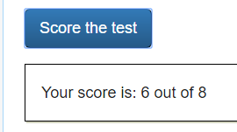

Find 5 interesting facts about BI and poste them to the Class Discussions. Take a screenshot of the Post and attach it to the Word Doc submitted in this assignment.

