Sales by Month Drilldown

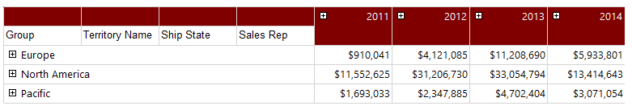

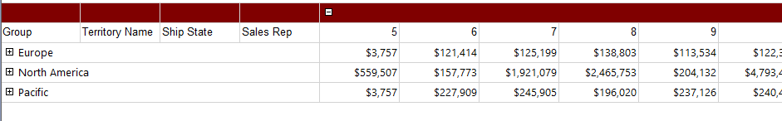

Sales by Territory Drilldown

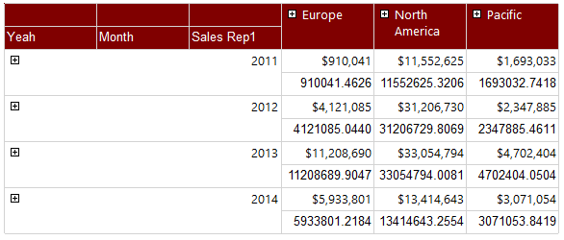

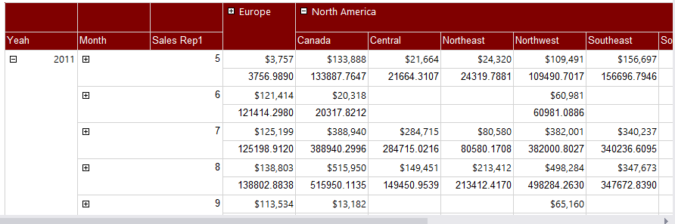

Sales by Rep

