Name: Ngala Dirane

Section: Variables and Expressions

Date: 09/10/2018

1. Modify ***Load_Prospects_Staging.dtsx*** to include the following
   * Truncate the ***tbl_stg_Prospects*** table before loading the Prospect_B.xls file.
   * 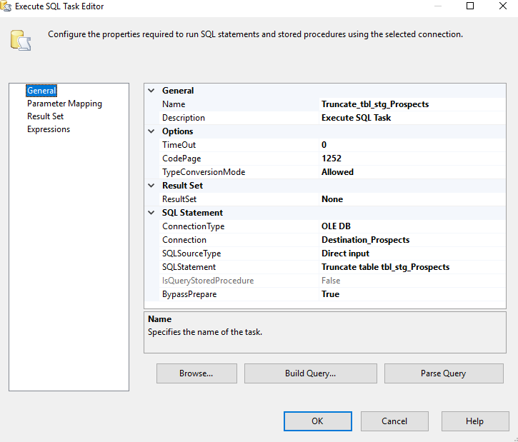Add functionality to load multiple Excel files

Figure : Execute SQL Task Editor

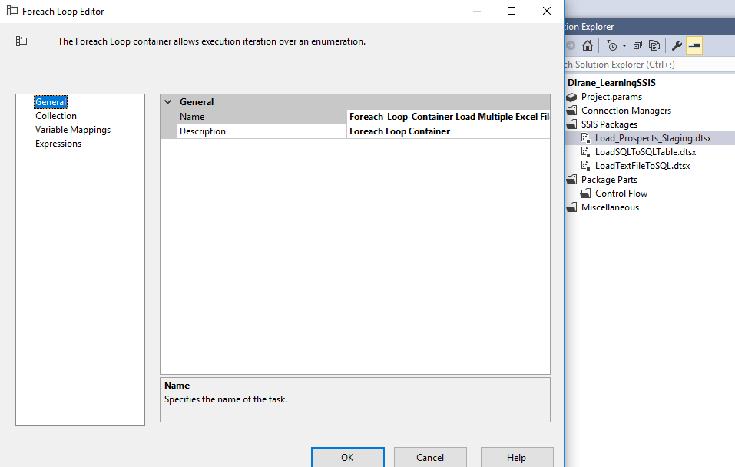

Figure : Configuring the For each loop to load multiple files

Figure : Bellow shows the connection of Execute SQL truncate to Location

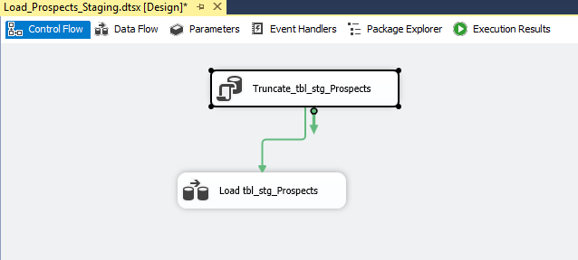

Figure : Truncate Statement

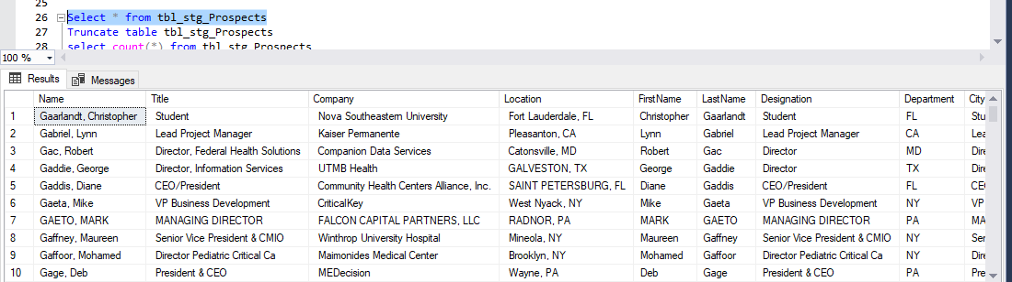

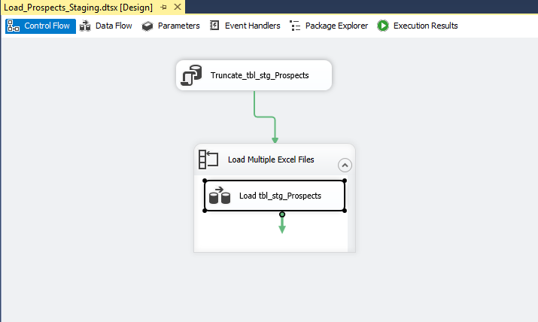

Figure : Loading Multiple files