Name: Ngala Dirane Ngiri

Lesson: Working with tables

Date: 25/07/2018

Question:  Quiz (BBC) - <http://sqlzoo.net/wiki/BBC_QUIZ>

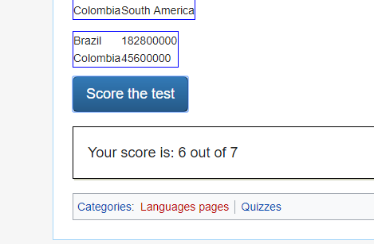

Question: Quiz(Nobel) - <http://sqlzoo.net/wiki/Nobel_Quiz>

