The screenshots bellow are arranged in the following order: there are a pair or screenshots, first is view of a report with its default parameters and the second is a view of the filtered report.

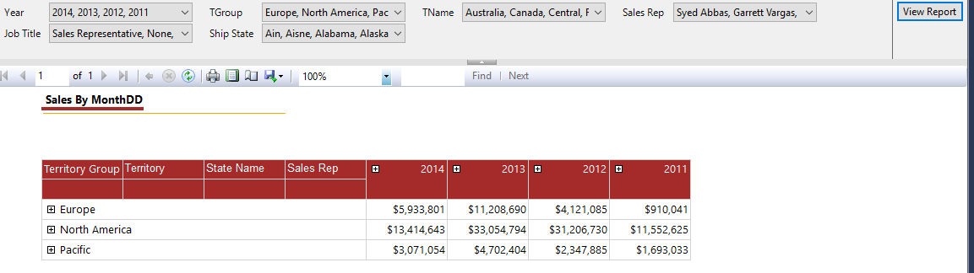

Figure :Sales By Month with default parameters

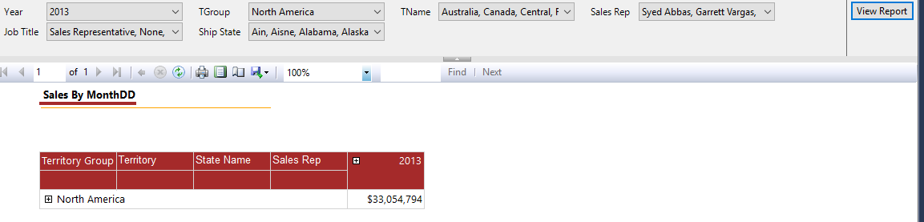

Figure Sales By Month Filtered

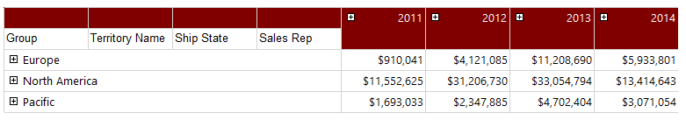

Figure : Sales By Rep with defualt Parameters

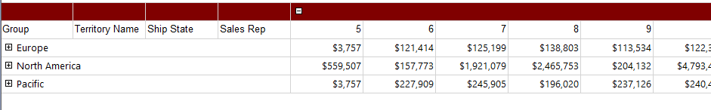

Figure :Sales By Rep filtered

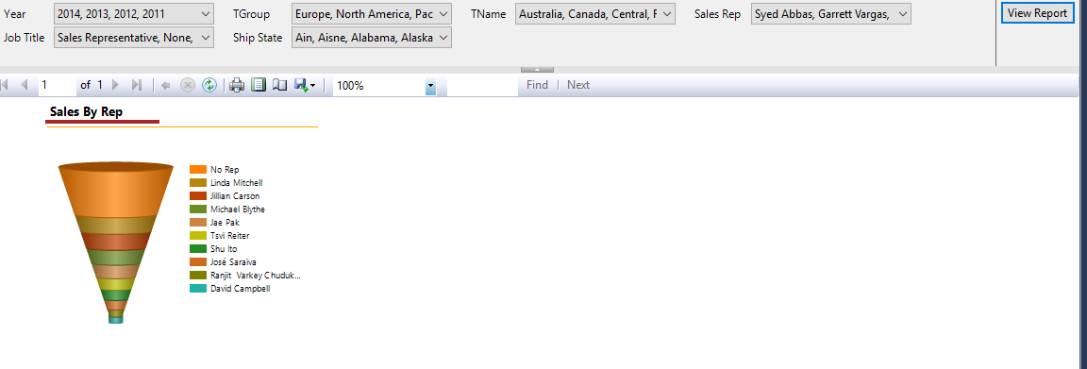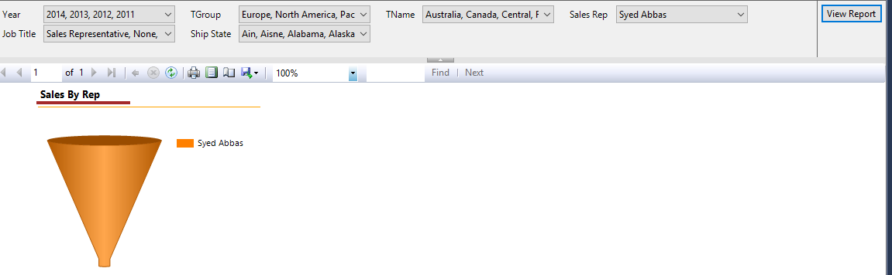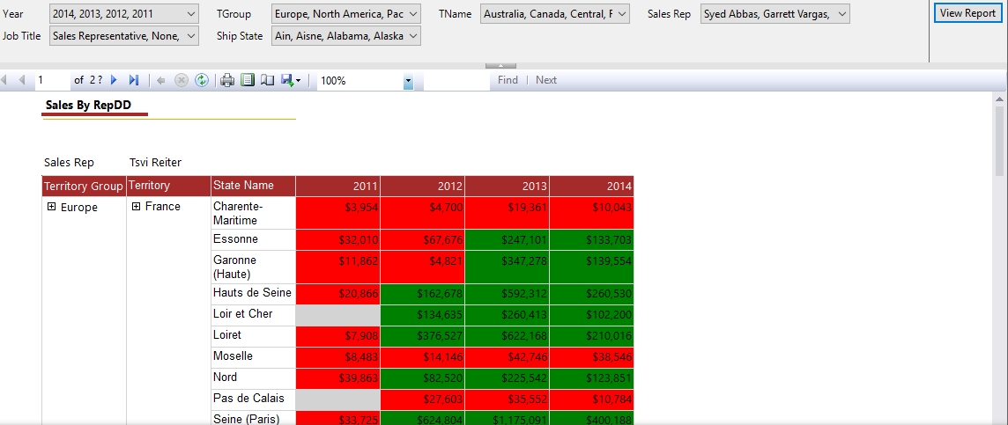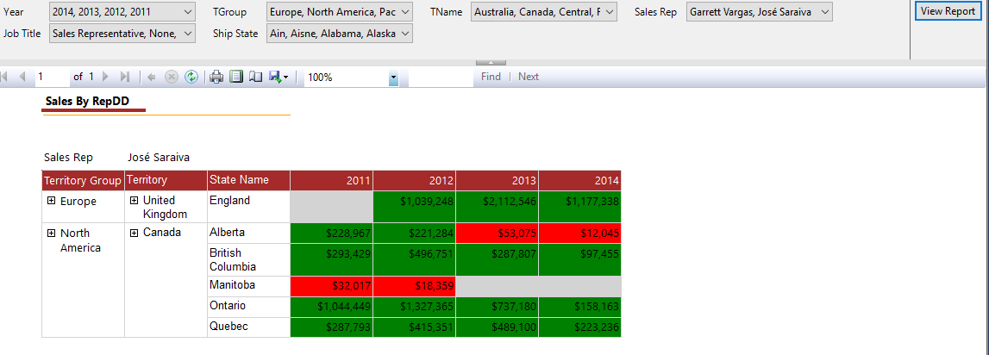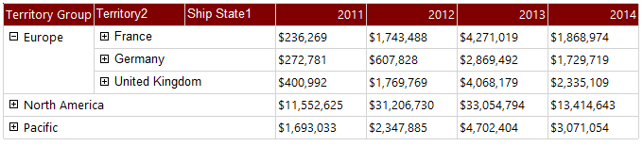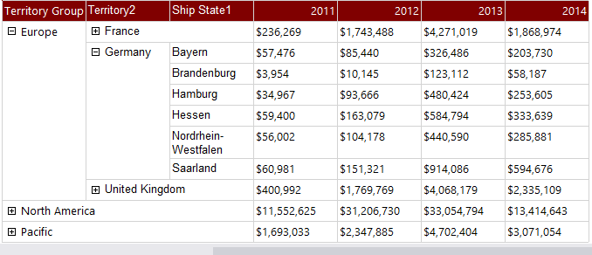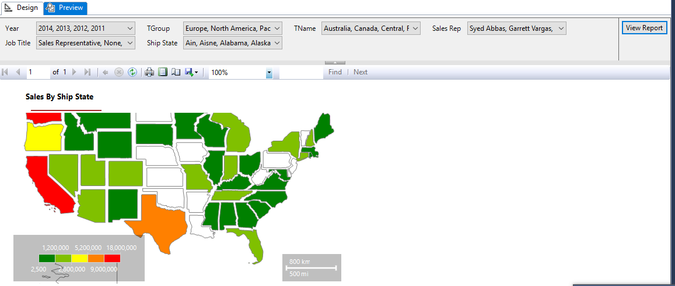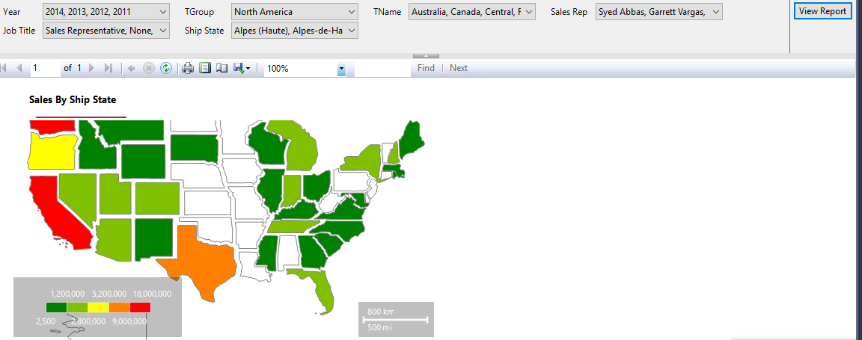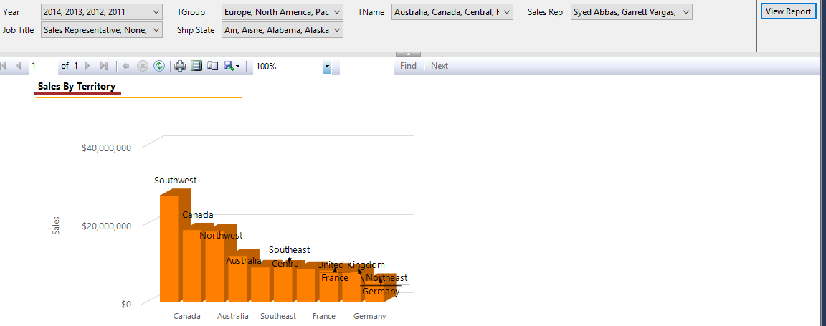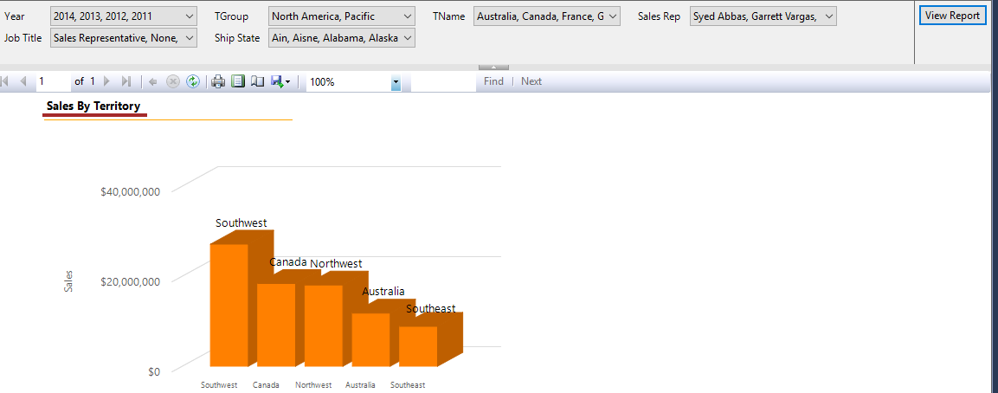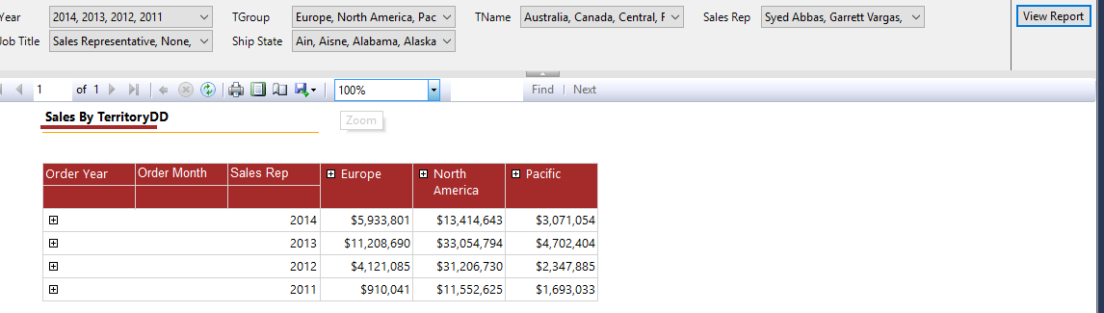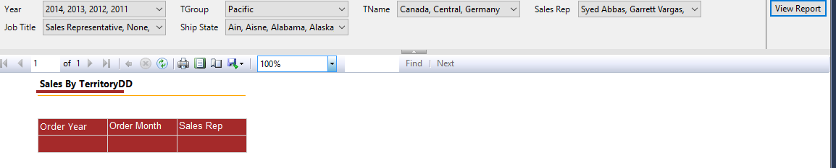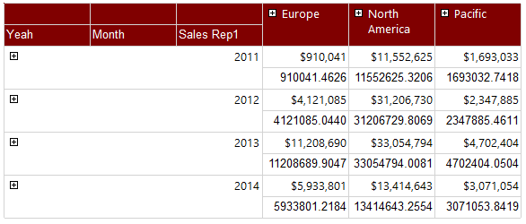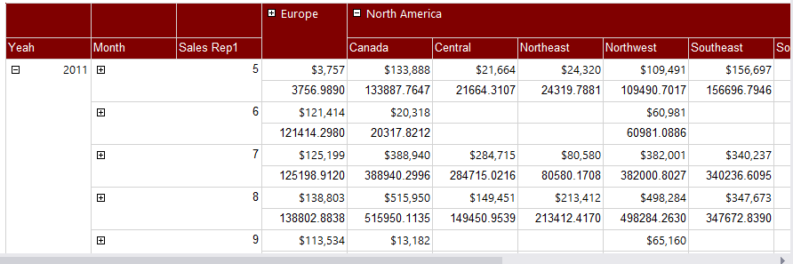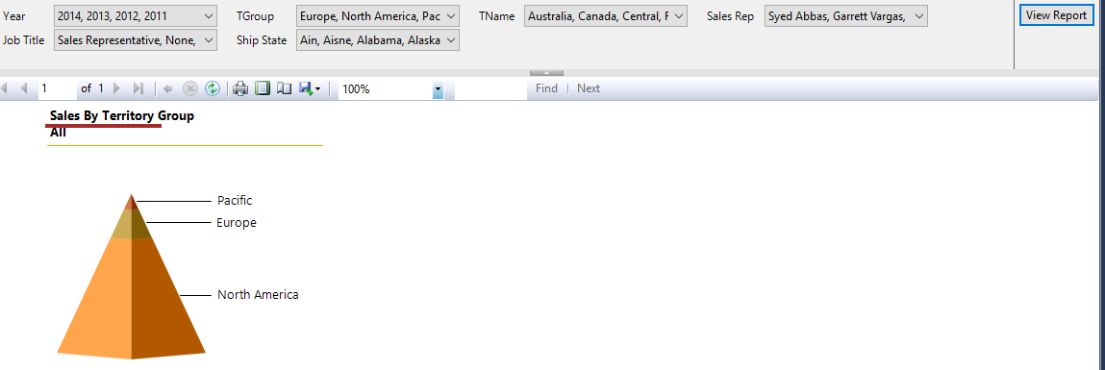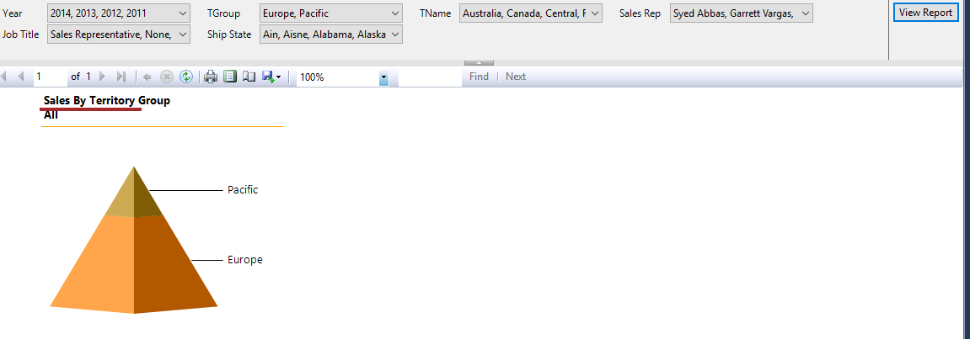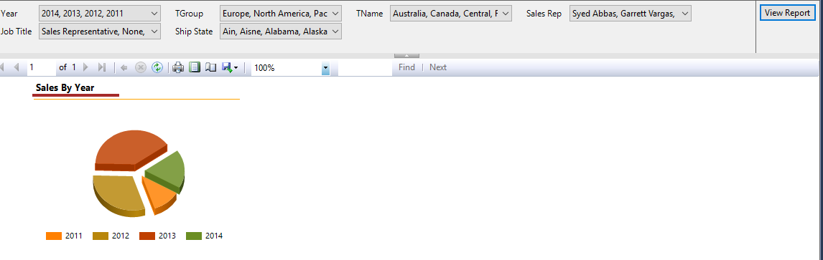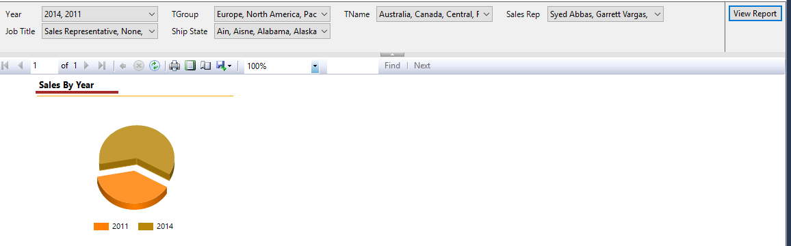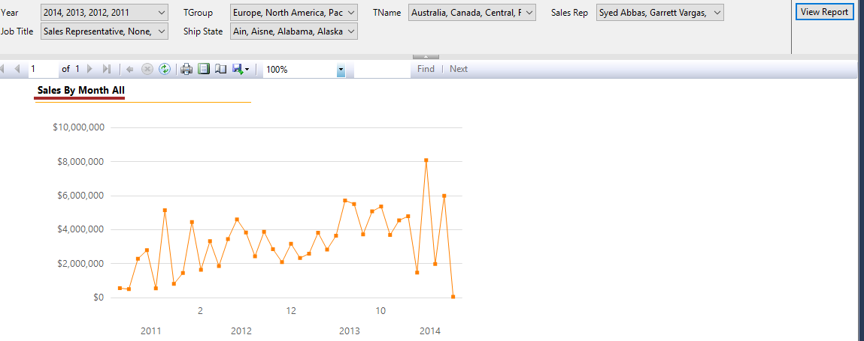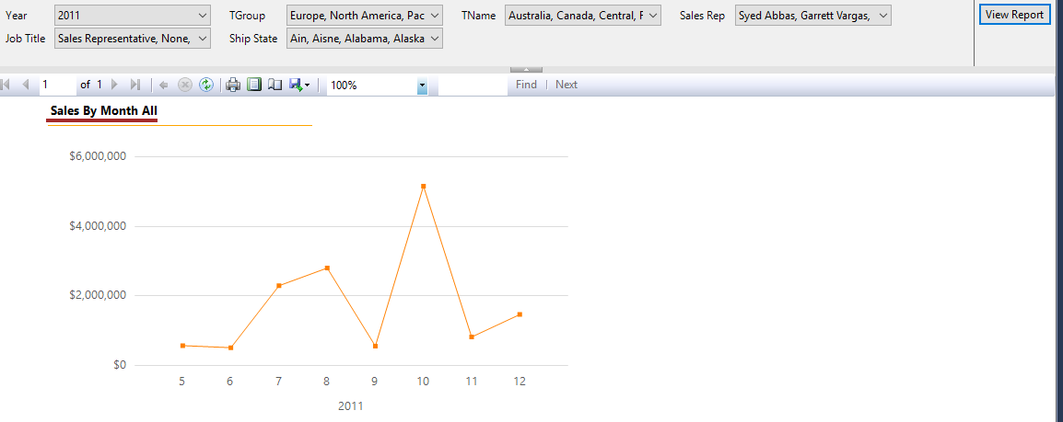

**Group Exercise:**

It’s time to switch leaders. The leaders will change another 3 times during the program so other people will have a chance to lead the call. Leaders are responsible for

1. Starting and running the calls
2. Getting an update from everyone on the team
3. Putting a plan in place for those behind to catch up

In a Word Doc, specify who will be the leader of your group for this quarter. Then take a screenshot of your whole team on a Zoom call. List out the name and last completed section for everyone on your team.

Meeting date: 23/09/2018

Ngala Dirane: Section 18

Kragha Tare: Section 18

Kragha Efe: Section 18

Rajas kulu: Section 22

Current group leader: Rajas Kulu

Next group leader: Ngala Dirane