VASAVI COLLEGE OF ENGINEERING

ELECTRONIC DEVICES

MINI PROJECT REPORT

5V/350mA REGULATED POWER SUPPLY (CHARGER)
ECE-B 2/4 SEM 3


SUBMITTED BY:
1602-21-735-072 Arun
1602-21-735-073 Chaitanya
1602-21-735-074 Dinesh
1602-21-735-075 Divya
1602-21-735-076 Harshitha
1602-21-735-077 Jashwanth

CONTENTS PG.NO

INTRODUCTION 3

STEPS FOLLOWED 4

CIRCUIT DIAGRAM 5

STEP WISE DETAILED EXPLANATION 6

APPLICATIONS 8

CONCLUSION 8

INTRODUCTION:

The main aim of this project is to make a DC regulated power supply of constant voltage 5V, 350 mA current from 230 v AC supply.

A regulated power supply is a device that maintains a constant output voltage regardless of changes in the input voltage or load current. In this project, we will be designing a 5V,350 mA regulated power supply using a full wave rectifier and a C section filter without an IC regulator.

The process of converting a.c. voltage into d.c. voltage is called as rectification. This is achieved with i) Step-down Transformer, ii) Rectifier, iii) Filter and iv) Voltage regulator circuits

Transformer – steps down 230V AC mains to low voltage AC. ✓
Rectifier – converts AC to DC, but the DC output is varying.
Regulator – eliminates ripple by setting DC output to a fixed voltage.

The circuit diagram for a 5V, 350mA regulated power supply using a zener diode would consist of the following components:

COMPONENTS:

- step down transformer 12V
- 1N4007 -4 No
- 2.2 mF capacitor -1 No
- 390 ohm resistor-1No
- 1K ohm resistor -1No
- PCB
- Power cord
- Zener diode 5V-1N47338

STEPS FOLLOWED:

- A transfoermer to step down the input voltage to a suitable level for the zener diode

- Rectification: Such a device is capable of converting a sinusoidal input waveform, whose average value is zero, into a unidirectional Waveform, with a nonzero average component. A rectifier is a device, which converts a.c. voltage (bi-directional) to pulsating d.c. voltage (Unidirectional)

3.Filter circuit:
The output of a rectifier contains dc component as well as ac component. Filters are used to minimize the undesirable ac i.e., ripple leaving only the dc component to appear at the output.

4.A resistor to limit the current flow to zener diode

5.A zener diode to regulate output voltage

6.A load resistor to represent the load on the power supply

Note: Before implementing the design with hardware components ,first testing must be done in MULTISIM in order to know the specificatons and required components of the design.

CIRCUIT DIAGRAM;

We have tested the circuit in MULTISIM,using low capacitance values and while placing the same on the PCB we have reduced the components,by placing the available components .we have replaced several capacitors in parallel with a a single capacitor.

We have soldered the components on PCB and added a plug cord to the model.

It is important to note that a Zener diode based regulator is not the most efficient way of creating a regulated power supply and are not suitable for high current application.

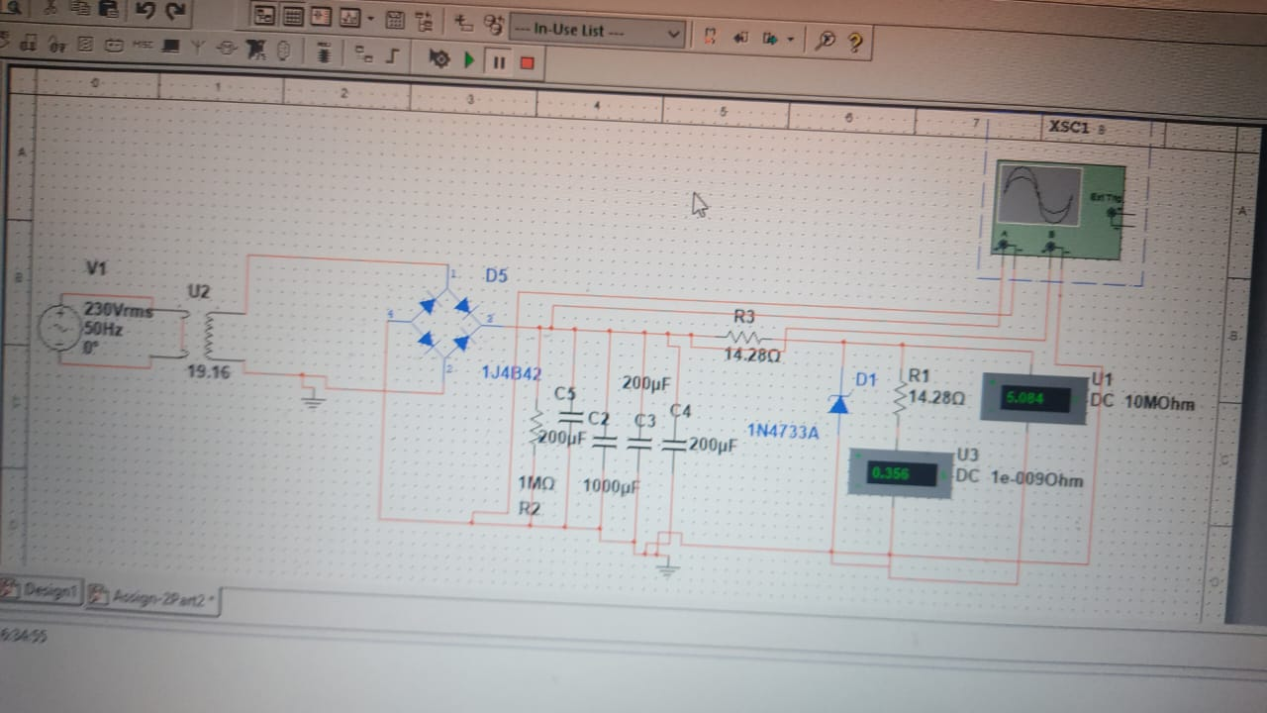

DETAILED EXPLAINATION:

Since, the required output voltage is 5V, we have used a 12V step down transfoermer(230V:12).

FULL WAVE BRIDGE RECTIFIER:
We have not used a full wave rectifier as it not a center tapped transformer.
This type of single phase rectifier uses four individual rectifying diodes connected in a closed loop "bridge" configuration to produce the desired output. The main advantage of this bridge circuit is that it does not require a special centre tapped transformer, thereby reducing its size and cost. The single secondary winding is connected to one side of the diode bridge network and the load to the other side as shown below.
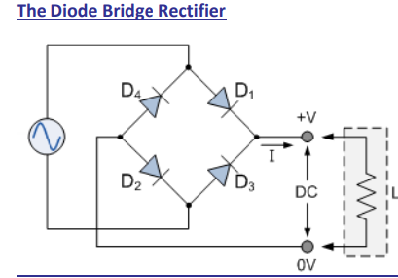
The four diodes labelled D1 to D4 are arranged in "series pairs" with only two diodes conducting current during each half cycle. During the positive half cycle of the supply, diodes D1 and D2 conduct in series while diodes D3 and D4 are reverse biased and the current flows through the load.

CAPACITOR FILTER:
This is the most simple form of the filter circuit and in this arrangement a high value capacitor C is placed directly across the output terminals. During the conduction period it gets charged and stores up energy to it during non-conduction period. Through this process, the time duration during which Ft is to be noted here that the capacitor C gets charged to the peak because there is no resistance (except the negligible forward resistance of diode) in the charging path. But the discharging time is quite large (roughly 100 times more than the charging time depending upon the value of RL) because it discharges through load resistance RL. The function of the capacitor filter may be viewed in terms of impedances. The large value capacitor C offers a low impedance shunt path to the ac components or ripples but offers high impedance to the dc component. Thus ripples get bypassed through capacitor C and only dc component flows through the load resistance RL Capacitor filter is very popular because of its low cost, small size, light weight and good characteristics.

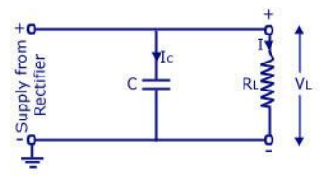

We have assumed the ripple factor to be 0.1
By substiuting the value of R and in the formula of ripple factor we get 2.2mF

VOLTAGE REGULATED CIRCUIT:

A voltage divider circuit is used to provide feedback to the control circuit for maintaining a constant voltage output. It is composed of two resistors connected in series. The voltage across the resistors is divided according to the ratio of their resistance values, and this divided voltage is used as a reference for the control circuit.
As we opted for 12V transformer which is equal to Vrms ,we obtain maximum voltage when it is converted to DC i.e, Vm=Vrms*sqrt(2), i.e 12*1.414=16.9V we got 17.9V
After the voltage drop across the Capacitive filter the remaining voltage will be in between 16.9V. As the 5v Zener diode should be in breakdown, remaining (6.5 to7) V must be dropped across the remaining part before the zener diode. So we have used a current limiting resistor of 390 ohm. So if we connect Load resistance of 1Kohms parallel to zener .

APPLICATIONS:

The main function of this is to supply a constant voltage to a circuit that should be functioned in a particular power supply limit.
Mobile phone chargers
Regulated power supplies in different appliances
Various oscillators & amplifiers

CONCLUSION:

The 5V, 350mA regulated power supply designed using a full wave bridge rectifier and a Capacitive filter without an IC regulator is a simple and cost-effective solution for providing a constant voltage output. The circuit is easy to build and can be used for a wide range of applications. The use of voltage divider circuit, safety features and proper selection of component values will help in achieving the desired voltage and current output.

