

NAME OF THE STUDENT: | Diraq Najir Girach
REGISTER NUMBER: | 23BCE1112
COURSE CODE: | BCSE309P
COURSE TITLE: | Cryptography and Network Security Lab
CLASS NUMBER: | CH2025260501999
SLOT: | L15+L16
COURSE HANDLING FACULTY: | Prof. Karthika V

Digital Signature Standard (DSS)

Implementation

Sender (client)
import java.io.*;
import java.net.*;
import java.math.BigInteger;
import java.security.MessageDigest;
import java.security.SecureRandom;
import java.util.*;

public class sender {
public static void main(String[] args) throws Exception {
SecureRandom random = new SecureRandom();

// 1. Generate DSS Parameters
BigInteger q = new BigInteger(160, 50, random); // 160-bit prime

BigInteger p, kMultiplier;
do {
kMultiplier = new BigInteger(512 - 160, random);
p = kMultiplier.multiply(q).add(BigInteger.ONE);
} while (!p.isProbablePrime(50)); // 512-bit prime

BigInteger h, g;
do {
h = new BigInteger(511, random);
g = h.modPow(p.subtract(BigInteger.ONE).divide(q), p);
} while (g.compareTo(BigInteger.ONE) <= 0); // Generator

// 2. Generate Keys
BigInteger x = new BigInteger(159, random); // Private key
BigInteger y = g.modPow(x, p); // Public key

// 3. Define the Message
System.out.println("enter message:");
Scanner in = new Scanner(System.in);
String message = in.nextLine();
System.out.println("select 1 to simulate authentic message, 0 for otherwise:");
int ch = in.nextInt();
if(ch == 0){
x = x.add(BigInteger.ONE);
}

System.out.println("--- Sender (Client) ---");
System.out.println("Message: " + message);

// 4. Call the explicit sign function
// Returns an array where index 0 is 'r' and index 1 is 's'
BigInteger[] signature = sign(message, p, q, g, x);
BigInteger r = signature[0];
BigInteger s = signature[1];

System.out.println("Generated Signature (r): " + r);
System.out.println("Generated Signature (s): " + s);

// 5. Connect to Receiver and transmit data
try (Socket socket = new Socket("localhost", 5000);
ObjectOutputStream out = new ObjectOutputStream(socket.getOutputStream())) {

out.writeObject(p);
out.writeObject(q);
out.writeObject(g);
out.writeObject(y);
out.writeObject(message);
out.writeObject(r);
out.writeObject(s);

System.out.println("\nPayload securely sent to the receiver.");
}
}

public static BigInteger[] sign(String message, BigInteger p, BigInteger q, BigInteger g, BigInteger x) throws Exception {
SecureRandom random = new SecureRandom();

// Hashing the message (SHA-256)
MessageDigest md = MessageDigest.getInstance("SHA-256");
BigInteger hash = new BigInteger(1, md.digest(message.getBytes()));

BigInteger k, r, s;
do {
// Random per-message key (0 < k < q)
k = new BigInteger(159, random);

// r = (g^k mod p) mod q
r = g.modPow(k, p).mod(q);

// s = (k^-1 * (H(m) + x*r)) mod q
BigInteger kInv = k.modInverse(q);
s = kInv.multiply(hash.add(x.multiply(r))).mod(q);

// Ensure neither r nor s are zero (extremely rare, but required by DSS standard)
} while (r.equals(BigInteger.ZERO) || s.equals(BigInteger.ZERO));

return new BigInteger[]{r, s};
}
}

receiver (server)
import java.io.*;
import java.net.*;
import java.math.BigInteger;
import java.security.MessageDigest;

public class receiver {
public static void main(String[] args) throws Exception {
System.out.println("--- Receiver (Server) ---");
System.out.println("Waiting for connection on port 5000...");

// Start server socket
try (ServerSocket serverSocket = new ServerSocket(5000);
Socket socket = serverSocket.accept();
ObjectInputStream in = new ObjectInputStream(socket.getInputStream())) {

System.out.println("Sender connected!\n");

// 1. Receive DSS parameters, public key, message, and signature
BigInteger p = (BigInteger) in.readObject();
BigInteger q = (BigInteger) in.readObject();
BigInteger g = (BigInteger) in.readObject();
BigInteger y = (BigInteger) in.readObject();
String message = (String) in.readObject();
BigInteger r = (BigInteger) in.readObject();
BigInteger s = (BigInteger) in.readObject();

System.out.println("Received Message: " + message);
System.out.println("Received Signature (r): " + r);
System.out.println("Received Signature (s): " + s);

// 2. Verify Signature
boolean isValid = verify(p, q, g, y, message, r, s);

if (isValid) {
System.out.println("\nSUCCESS: Digital Signature Verified. The message is authentic.");
} else {
System.out.println("\nFAILURE: Digital Signature is INVALID.");
}
}
}

// Standard DSS Verification Logic
public static boolean verify(BigInteger p, BigInteger q, BigInteger g, BigInteger y,
String message, BigInteger r, BigInteger s) throws Exception {
// Step A: Checking bounds 0 < r < q and 0 < s < q
if (r.compareTo(BigInteger.ZERO) <= 0 || r.compareTo(q) >= 0 ||
s.compareTo(BigInteger.ZERO) <= 0 || s.compareTo(q) >= 0) {
return false;
}

// Step B: Hashing the message (SHA-256)
MessageDigest md = MessageDigest.getInstance("SHA-256");
BigInteger hash = new BigInteger(1, md.digest(message.getBytes()));

// Step C: w = s^-1 mod q
BigInteger w = s.modInverse(q);

// Step D: u1 = (H(m) * w) mod q
BigInteger u1 = hash.multiply(w).mod(q);

// Step E: u2 = (r * w) mod q
BigInteger u2 = r.multiply(w).mod(q);

// Step F: v = ((g^u1 * y^u2) mod p) mod q
BigInteger v1 = g.modPow(u1, p);
BigInteger v2 = y.modPow(u2, p);
BigInteger v = v1.multiply(v2).mod(p).mod(q);

// Step G: Signature is valid if v == r
return v.equals(r);
}
}

Output

Valid case
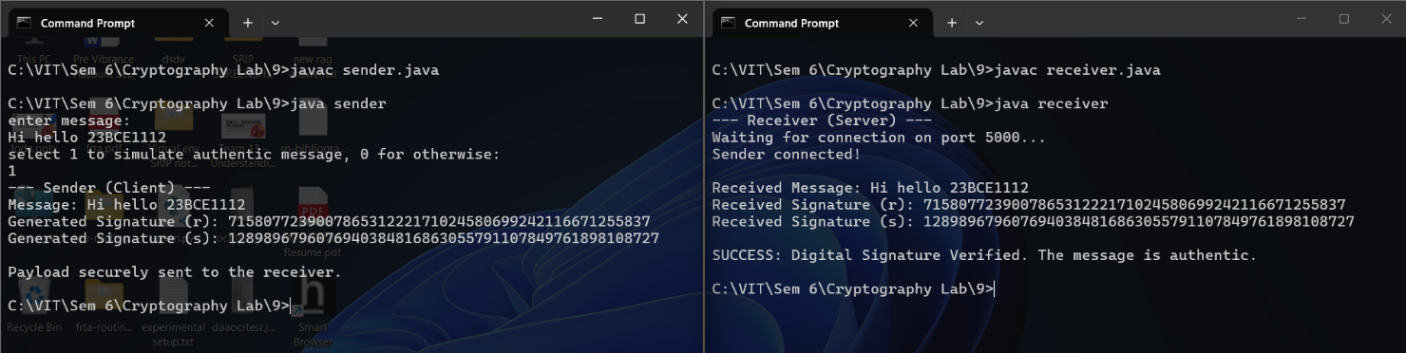

Invalid case
