Nasa

Planet: Next World

Classified

Basic Information



Nextworld: The Next Frontier

**Wormhole:** (One-way) worm hole leads from the Sol System to the NextSystem.

**Bianary Star System (NextStar A and NextStar B)**

**NextStar A:** Principal member of the binary system. Slightly larger and more luminous than Sol. Yellowish in colour. About 10 percent more massive than the Sun with a radius about 20 percent larger. Visual magnitude of +0.01

2 inner rocky planets and three outer gas giants orbit NextStar A.

**NextStar B:** companion star (secondary star) of the binary system. Slightly smaller and less luminous than the Sun. About 90 percent the mass of the Sun and 15 percent smaller in radius. Visual magnitude of 1.33

Five rocky planets and three gas giants orbit NextStar B

NextGiant: second of three gas giants and fourth planet orbiting NextStar A in the nextSystem. Slightly smaller and denser than Jupiter. 11 moons in total **Nextworld is the 5th moon.**

**NextWorld:**

Atmosphere (breathable, non-toxic). Earthlings would find it difficult to breath without a mask though.

Slightly less gravity than the earth (10% less)

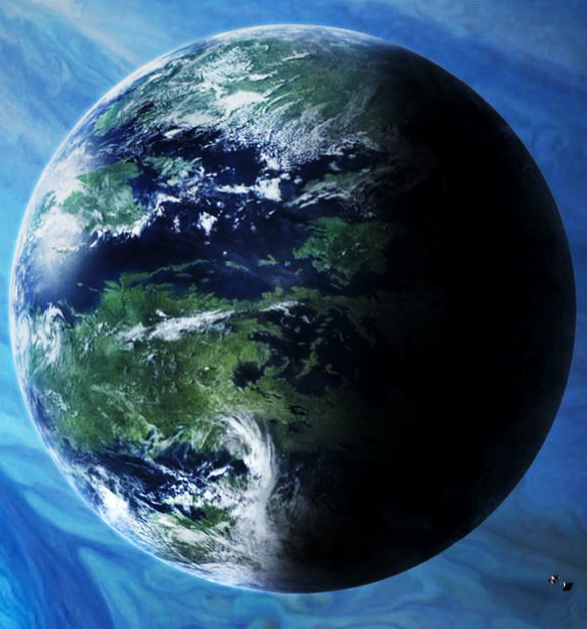Temperatures are warmer than that of earth

Every 10 years there is a 4-year cooling (temperatures drop by up to 50 percent)

Polar Ice caps grow, and snowfall becomes common in many reasons

Has all the same Terrain features as earth.

Additional terrain features include the Floating mountains (region that contains rocks and mountains that seem to defy gravity)

The living Forest contain many forms of “sentient” plant life. Including various forms of carnivorous plants.

Many species of Flora and Fauna are bio-luminescent

Rains slightly more than on earth.

There are many different forms of life that inhabit the planet

**Basic Planet Information**

Is the 5th of the 11 moons surrounding the gas giant (NextGiant). Has an atmosphere which supports life and is non-toxic. However, any visitor from Earth would find the atmosphere difficult to breath without a mask.

**Known Species**

Pollosos: vaguely humanoid creatures that have feathers but can’t fly.

Xololo: 4 paws creature that doesn’t have fur its one of the tallest creatures of the planet. Its bigger than an elephant

Axol: Creature that live on the water. Its an amphibian has wings and can fly to another big source of water.

**Orbit information**

One year there normally lasts 158.528 earth days. The planet has an average orbital speed of 29.78 kilometres per second, the radius of the planet is of 589800 km.

**Temperature**

The temperature that normally have the planet can be very nice, 10 months of the year they normally have an average temperature of 20 celsius. But the last 2 months of the year can be very harsh. One of does two months have an average temperature 60 Celsius, the latter month is very cold as they have an average temperature of -65C.

|  |  |  |  |
| --- | --- | --- | --- |
| **Surface temp.** | **Min** | **Mean** | **Max** |
| **Kelvin** | 194K | 294.1K | 603.2K |
| **Celsius** | -79.2C | 20.9C | 65.9C |
| **Fahrenheit** | --110.56F | 69.62F | 150.62F |