controller_j.add_region_multi(qc=singularity_joint, \
qbound=0.10, qrbound=0.40, \
mask=np.array([1, 1, 1, 1, 1, 1, 1]), \
kq=40, kr=10, \
inner=True, scale=np.ones((7, 1)))

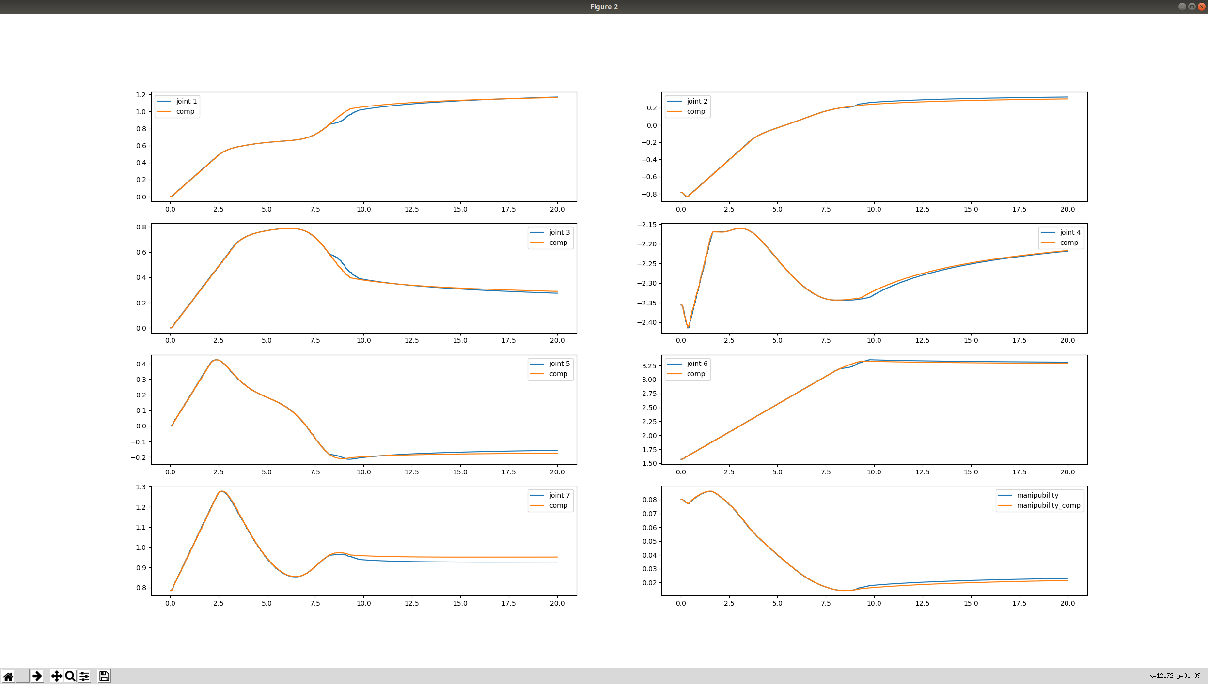
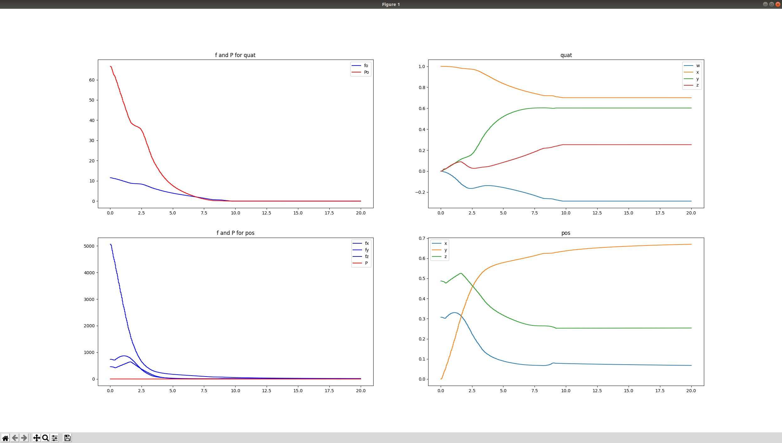

controller_j.add_region_multi(qc=singularity_joint, \
qbound=0.05, qrbound=0.40, \
mask=np.array([1, 1, 1, 1, 1, 1, 1]), \
kq=400, kr=100, \
inner=True, scale=np.ones((7, 1)))

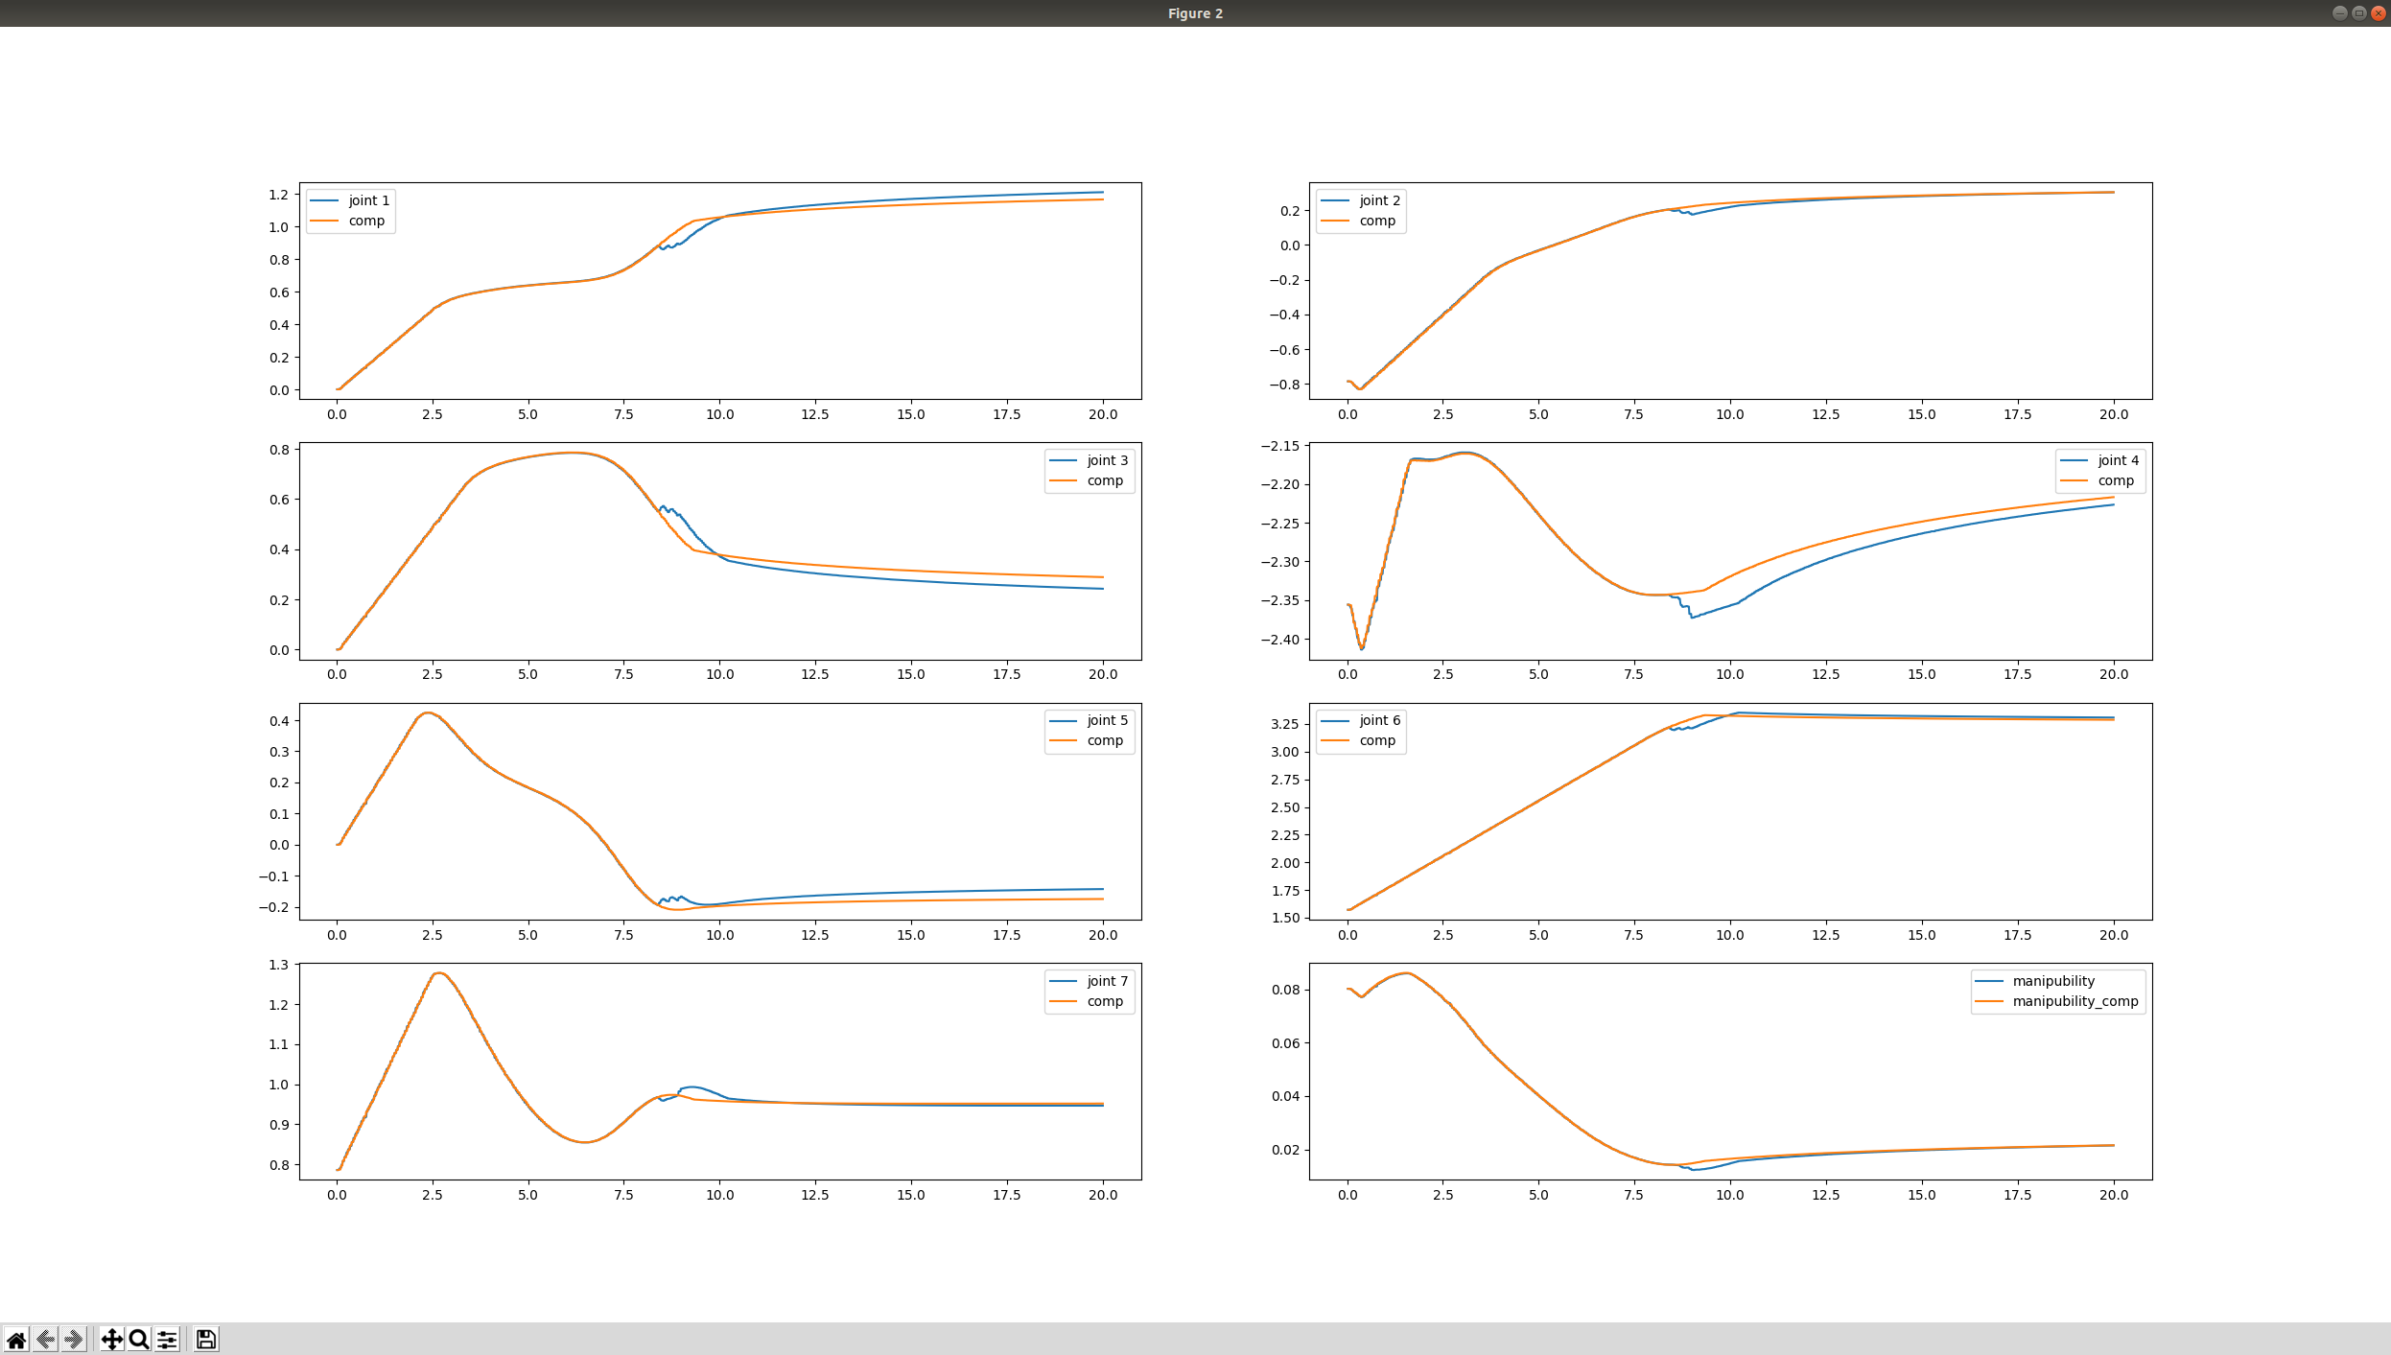
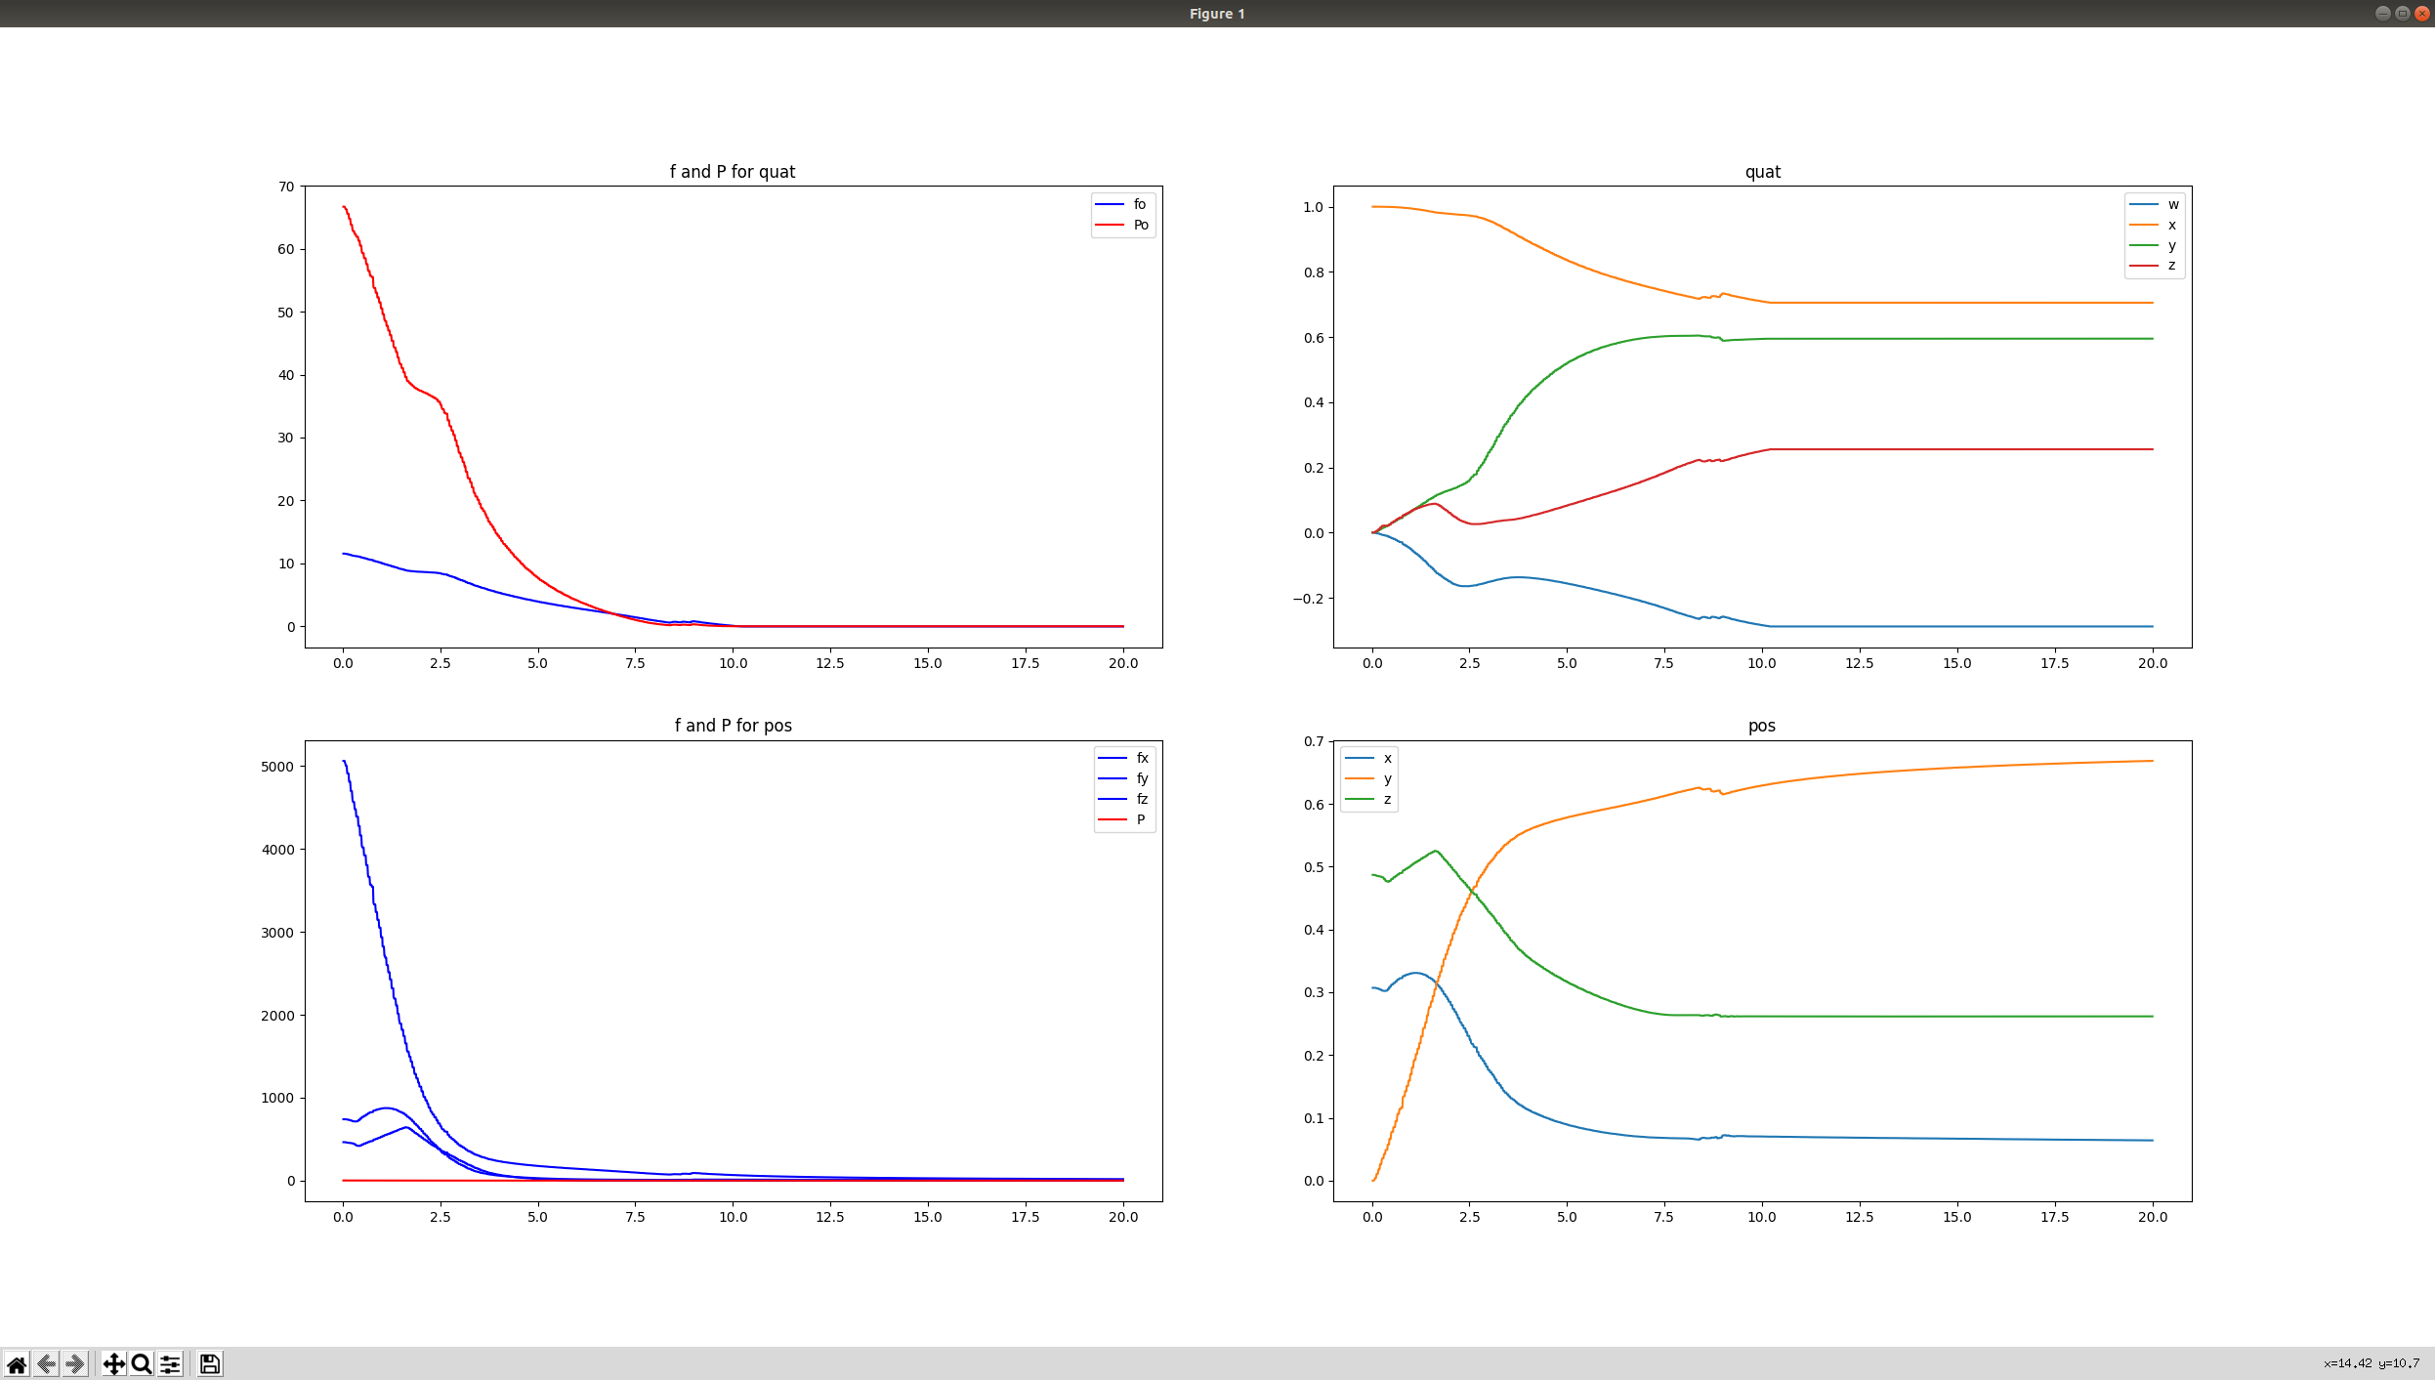

controller_j.add_region_multi(qc=singularity_joint, \
qbound=0.1, qrbound=0.40, \
mask=np.array([1, 1, 1, 1, 1, 1, 1]), \
kq=10000, kr=1000, \
inner=True, scale=np.ones((7, 1)))
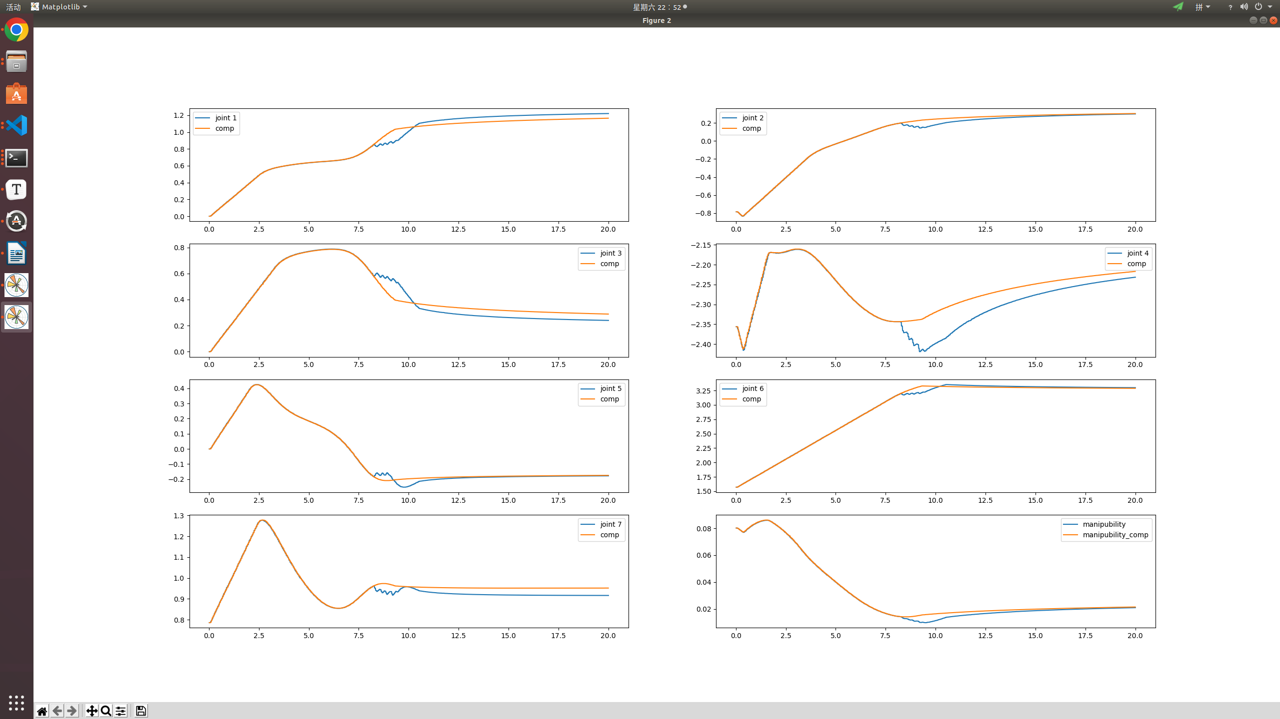

controller_j.add_region_multi(qc=singularity_joint, \
qbound=0.05, qrbound=0.20, \
mask=np.array([1, 1, 1, 1, 1, 1, 1]), \
kq=40, kr=10, \
inner=True, scale=np.ones((7, 1)))
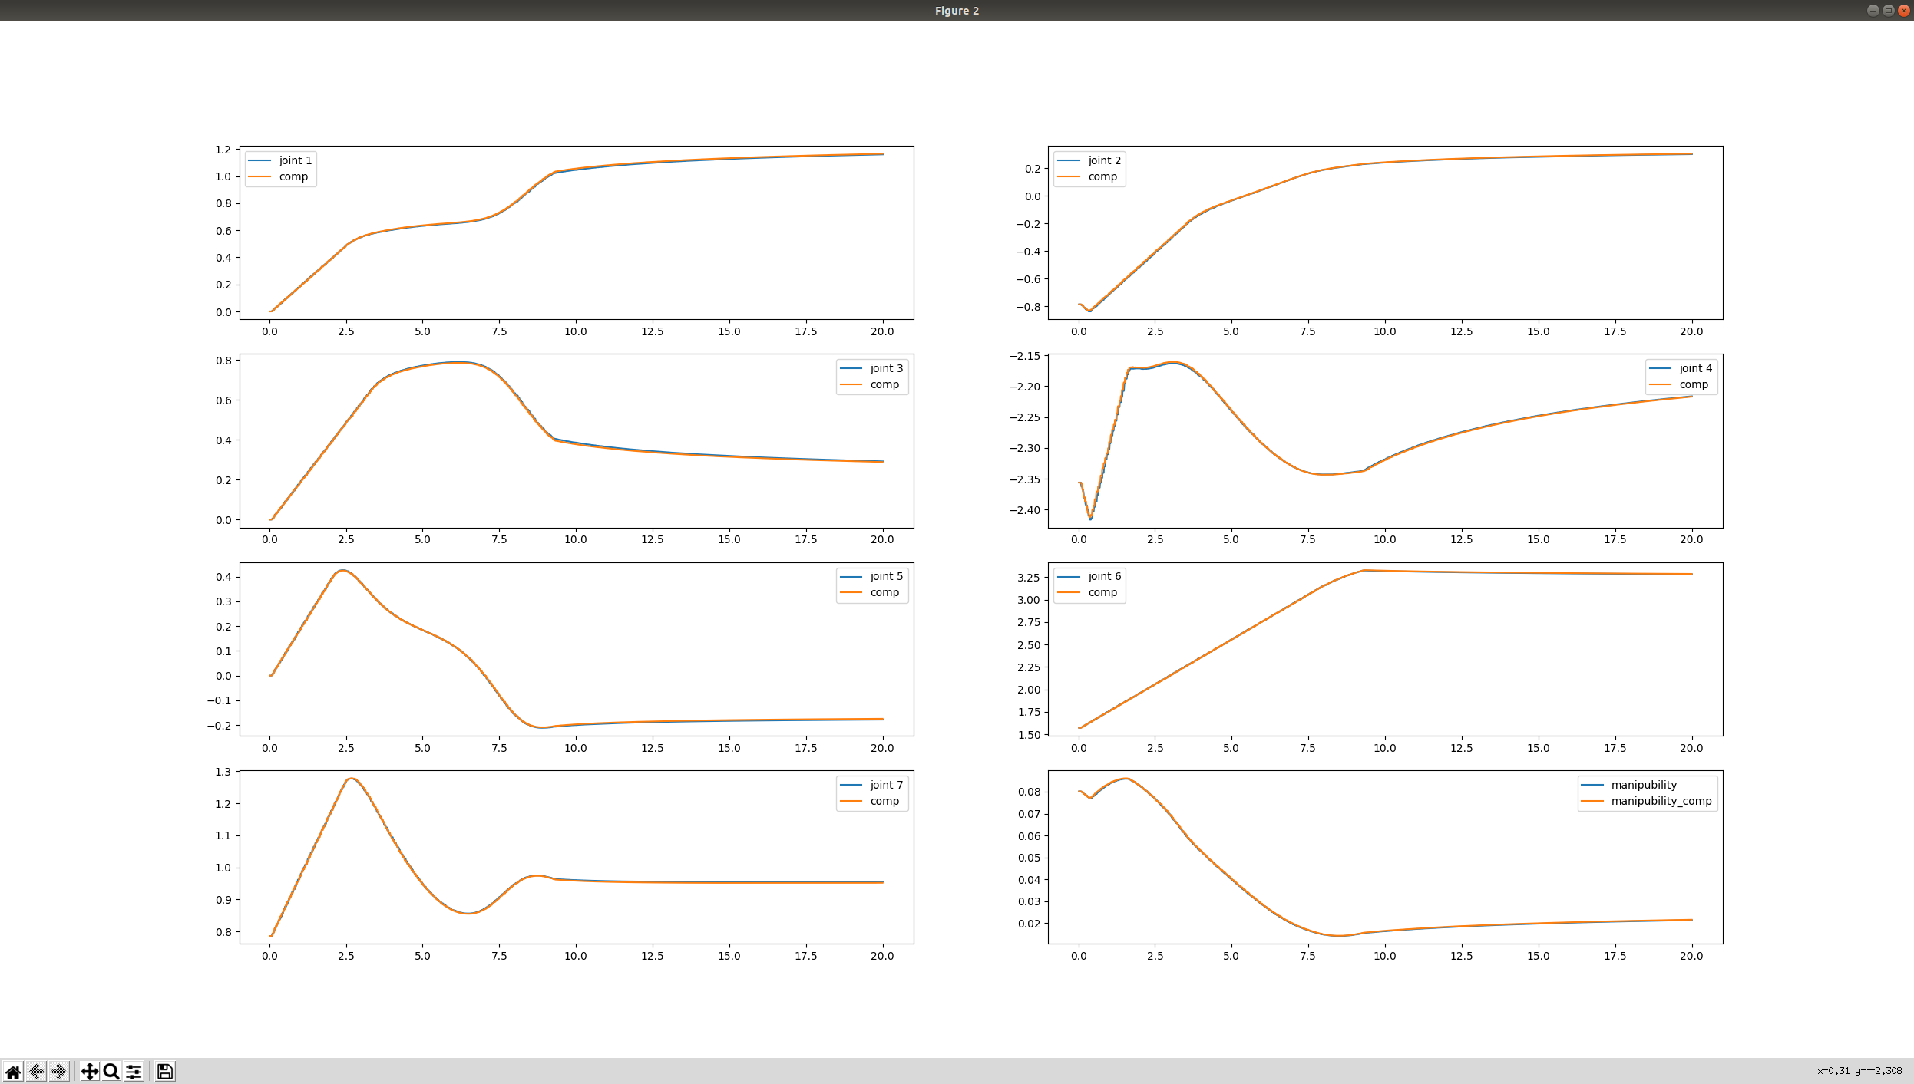

controller_j.add_region_multi(qc=singularity_joint, \
qbound=0.05, qrbound=0.70, \
mask=np.array([1, 1, 1, 1, 1, 1, 1]), \
kq=400, kr=10, \
inner=True, scale=np.ones((7, 1)))

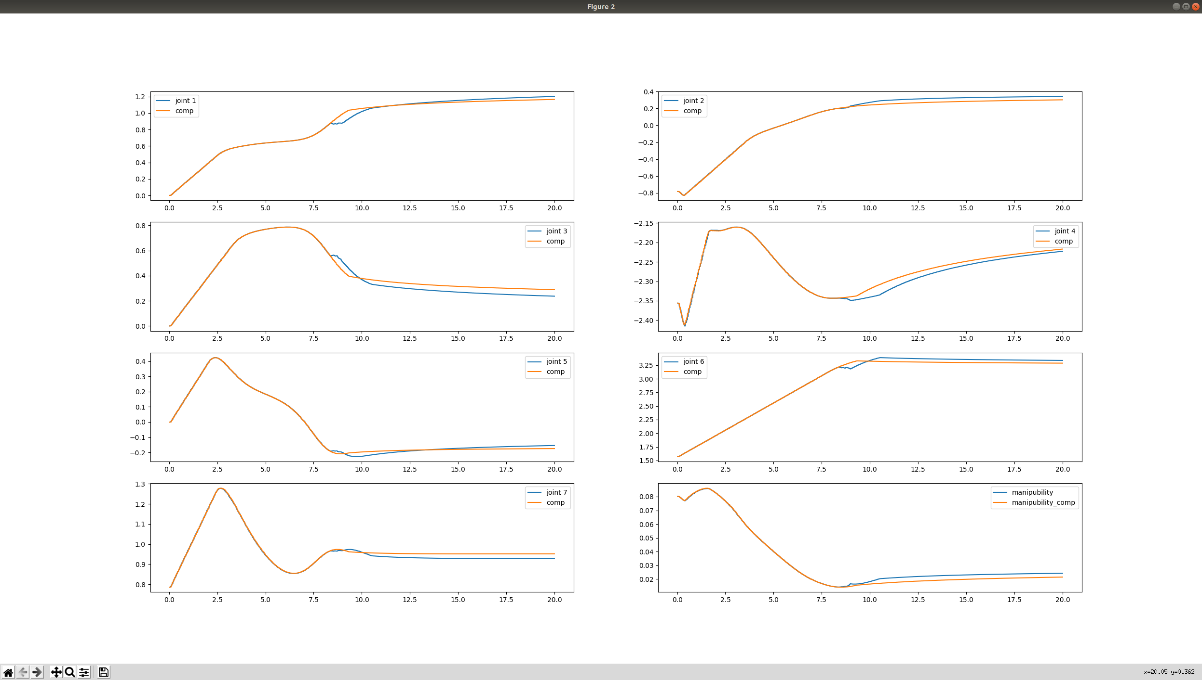
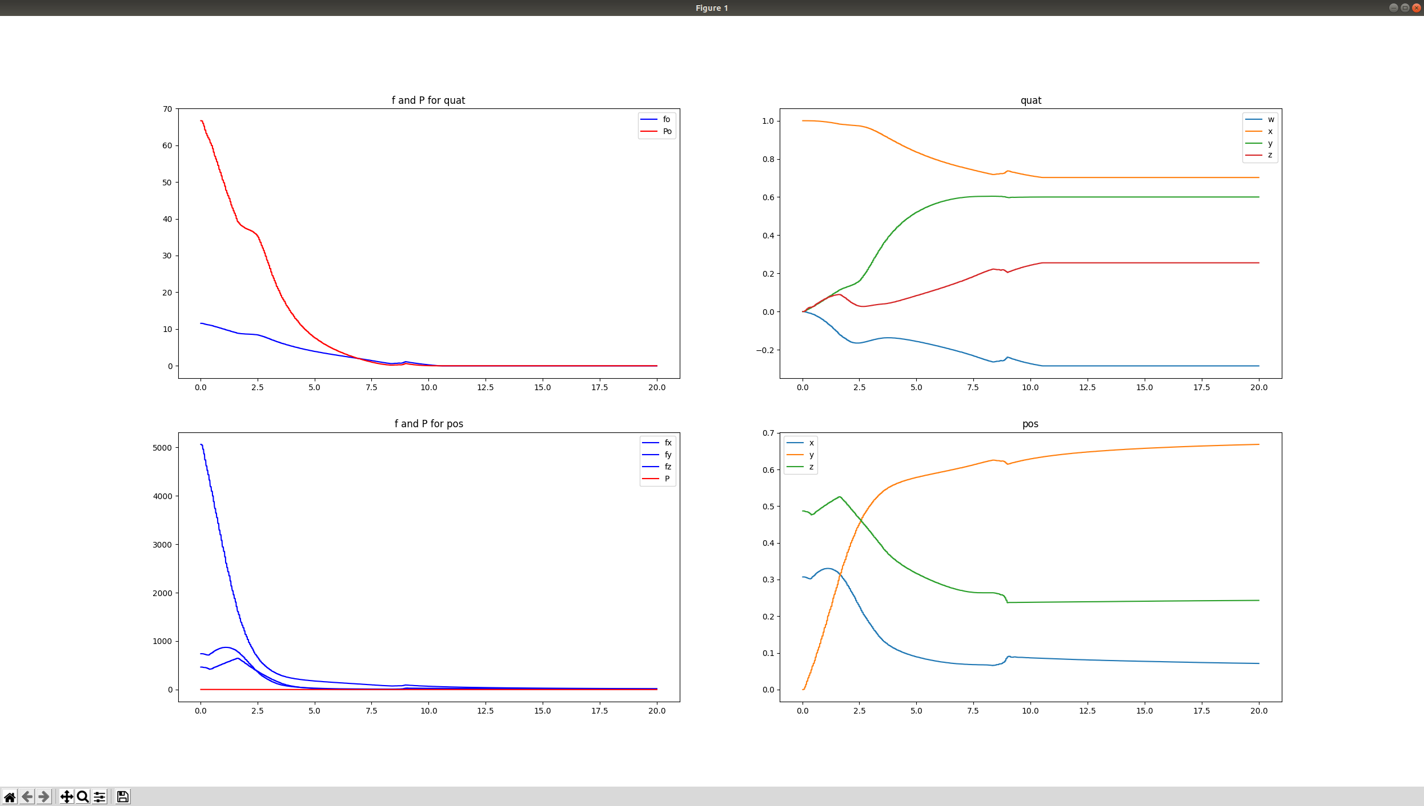
controller_j.add_region_multi(qc=singularity_joint, \
qbound=0.5, qrbound=0.70, \
mask=np.array([1, 1, 1, 1, 1, 1, 1]), \
kq=400, kr=10, \
inner=True, scale=np.ones((7, 1)))

震荡太厉害了
