Summary

Senior Dev in Web , C++ , Python, Front End Web Design and Web Backend,Jr. Dev in Java, React Native, ReactJs, Python Matlab, OpenCv, Android Studio, Flutter

Skill Highlights

|  |  |
| --- | --- |
| * Project management * Strong decision maker * Offensive Security * Game Development * Web Development * Defensive Security | * Creative design * Innovative * Service-focused * Programming * Hacking * Software Reverse Engineering |

Experience

**Full Stack Developer** - 2017/06/17/ to Current

**Employed**, General Santos City

* Chief Technology Executive(**CTO**)- **Paytrixx**

2019-12-29 – 2020-04-07,

Develop project concepts and maintain optimal workflow.

Senior developer to manage large, complex design projects for stable

* Security Engineer(**EH**)

– **Boxtypd Technologies** 2020-02-13- 2020-06-07,

Hacking Developed App Within The Company Through Finding Vulnerability and Exploiting The Flaws To Stabilize and Strengthen Security and Software Reverse Engineering By Making my Own Programmed Tools For Penetration Testing.

* **Philippine Ambassador (Volunteer)–** Parrot Security Operating System 2017-06-17-2020-01-03
* Freelance Bug Bounty Hunter at Hackerone, Bugcrowd, and Secuna

Education

Junior High School Completion: - 2019

**NDDU-IBED Lagao G.S.C**

Senior High School Grade 12- Currently (2020-2021)

**STI of General Santos City**

**Certifications**

Penetration Testing and Ethical Hacking(2017),

Malware Reverse Engineering(2017),

Post Exploitation Hacking(2017),

CompTIA Network+(2017),

Advanced Penetration Testing(2017),Cisco CCNA(2017),

Web Application Penetration Testing(2017),

Computer Hacking Forsenics(2017),

CompTIA Linux+(2017),CISA(2017),

PCI/DSS CompTIA Security+ (2017),

Developing Ethical Hacking Tools With Python(2019)

**Rolando H. Ferrer Jr.**

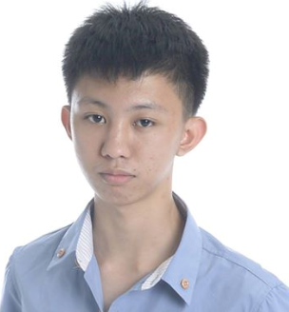

Contact

**Address:**

**Tiongson St. Lagao G.S.C South Cotabato**

**ZIP: 9500**

**Phone:**

+63 09517903414

+63 9557667573

**Email:**

**hadessallfeur@gmail.com**

Languages

Filipino

English