TICVAI PLATFORM
Hosting and Cost
Four options, what they cost, and what we recommend

Submitted to
Miracle Star Trading L.L.C.
Dubai, United Arab Emirates
Submitted by
Softlabs Group
Softlabs Technologies And Development Pvt. Ltd.
Mumbai, India
24 August 2026 — Design Package — Version 1.0

CONFIDENTIAL

How TICVAI will be hosted, and what it costs
A summary for commercial and product. 31 August 2026.
There is a technical companion to this document. Everything here is in it, with the workings.

The problem in one paragraph
A museum and a stadium are the same software and completely different machines.
Qossai put it well on 31 July: a water park might see two thousand visitors in a day — about five people a minute, all day, nothing dramatic. A stadium the size of Real Madrid’s sells sixty thousand seats in a couple of hours, and everybody arrives at once.
Build for the museum and the stadium falls over. Build for the stadium and the museum is paying for machinery it will never switch on.
This document is how we serve both without doing either of those things.

The three sizes of venue
 | Example | Guests a day | What the day looks like
Small | Museum, water park | 2,000 | Steady from open to close
Medium | Theme park, concert night | 18,500 | Quiet, then a rush before the gates
Large | Stadium, arena | 60,000 | Everything in a two-hour window
These are the client’s own numbers. 18,500 is from the brief for Saturday’s concert; 1,200 is the corporate gala in the Grand Hall.

The four ways we can host it
Two of these are the everyday choice. One is for a big sale. One is an upgrade.

1 · Private — a customer has their own setup
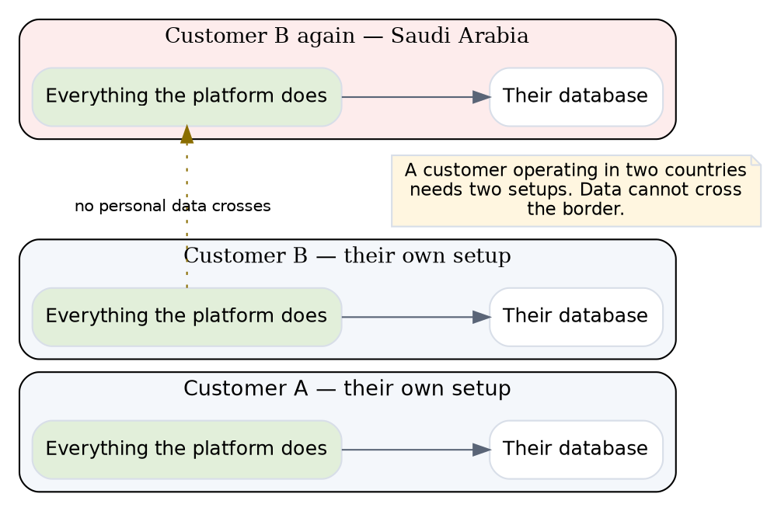
Private setup
Everything the platform does, running only for them, with their own database.
A customer operating in two countries needs two. Data cannot cross the border, and the two are linked only by a reference that carries no personal information.

2 · Shared — customers share one setup per country
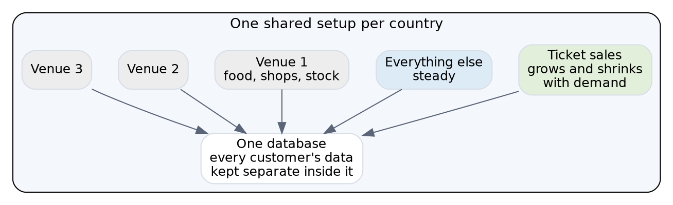
Shared setup
This is the default and it is what we recommend.
The ticket-selling part grows and shrinks with demand. Everything else stays a steady size, because no rush of ticket buyers makes a kitchen cook faster.
Each venue’s food, shop and stock systems run at that venue, so a venue keeps working when the internet does not.
One database, with every customer’s data kept separate inside it.

3 · Big sale — rented for the sale, then switched off
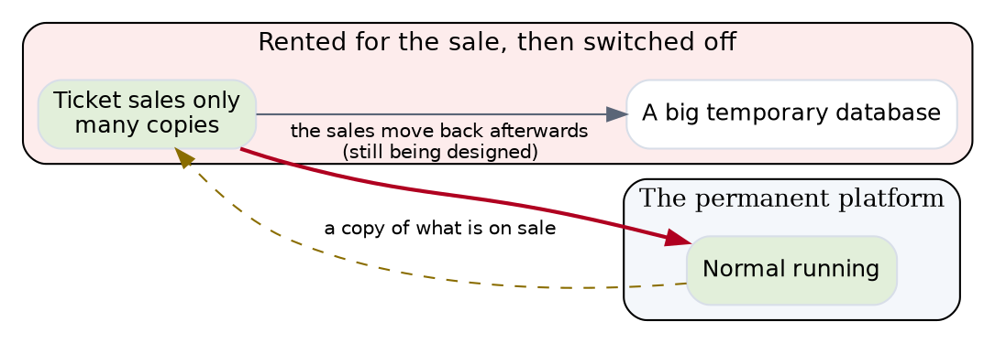
Big sale
Only the parts that sell tickets. Six of the sixteen parts of the platform have nothing to do with buying a ticket and are not switched on.
Afterwards the sales move back into the main platform. That is the part still being designed and it is the honest gap in this plan.

4 · Shared plus venue equipment — an upgrade to option 2
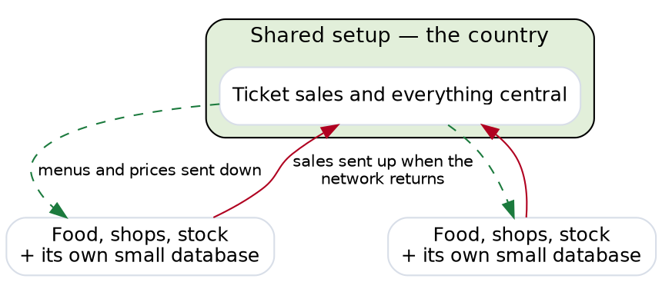
Venue equipment
A small amount of equipment at each venue with its own database.
The only reason to take this is a venue that must keep trading through an outage at the country level — not just a broken internet connection at the venue, which option 2 already handles.
It costs roughly 1.8 times option 2, and almost all of the difference is six hundred small databases to look after.

What each option costs, and how it is billed
Three of these run all the time and are billed monthly. One runs for hours.
Option | Billed as | Amazon | Google
1 · Private | per month, always on | $948 / month | $779
2 · Shared | per month, always on | $3,485 / month | $2,874
3 · Big sale | per hour, while it runs | $11.76 / hour | $9.76
4 · Shared + venue equipment | per month, always on | $3,965 / month | $3,237

What a big sale actually costs
It is rented by the hour and returned.
 | Amazon
A two-hour sale window | $24
A cautious six-hour window | $71
A full day, if somebody forgets to switch it off | $282
A whole month, if somebody really forgets | $8,587
A sixty-thousand-seat stadium selling out costs about twenty-four dollars in machinery.
The risk is not the cost, it is forgetting. Left running for a month it costs more than the platform it was protecting, so switching it off has to be automatic rather than somebody’s job.

With two hundred customers, three venues each
Option | Monthly cost | What that is
1 · Private, one each | $189,600 | 200 separate setups, 200 databases
2 · Shared | $96,910 | one setup per country, one database
4 · Shared + venue equipment | $177,283 | one setup plus 600 small ones
3 · Big sale | $24 per event | rented and returned
Private hosting for everyone costs roughly twice what shared does, and delivers isolation that a customer serving one guest per second is not asking for.

What each option is good and bad at

1 · Private
Good — Nobody else can affect them. If something breaks, it breaks for one customer. Their data is on its own machine, which is the easiest answer to give a compliance officer. Restoring their data to last Tuesday affects only them.
Bad — Costs about the same for a museum as for a theme park, because the machinery is sized for the software rather than the traffic. Two hundred customers means two hundred sets of everything to update, back up and watch. A customer in two countries needs two.
Use it when a contract requires it, or a customer is alone in a country, or they are big enough to fill it.

2 · Shared
Good — Cheapest by a wide margin. One thing to update instead of two hundred. The ticket-selling part borrows capacity from quiet customers when a busy one needs it, which is why a sudden rush is absorbed rather than felt.
Bad — If it goes down, it goes down for everyone in that country. Data is kept properly separate so nobody can see anyone else’s, but availability is shared even though privacy is not.
And one thing worth knowing before it is promised: restoring one customer’s data to last Tuesday would restore everybody’s. That is a real limitation and it has not been raised with anyone.
Use it as the default.

3 · Big sale
Good — Twenty-four dollars. It protects the exact failure Qossai described in Bahrain. It runs only the ticket-selling parts, so there is less to go wrong.
Bad — It has to be planned in advance, which suits an announced concert and not a surprise. The sales taken during it have to be moved back into the main platform afterwards, and that mechanism is still being designed.
Use it for an announced on-sale where a large number of people will arrive at one moment.

4 · Shared plus venue equipment
Good — A venue keeps trading through a countrywide outage, not just a broken connection at the venue.
Bad — 1.8 times the cost of option 2, and six hundred small databases to look after. The protection is against a rare failure — option 2 already keeps a venue trading when its own internet fails.
Use it when a venue’s contract requires trading through an outage they do not control.

What one venue costs
A venue’s share of option 2, per month.
Venue size | Their share
Small — museum, water park | about $310 / month
Medium — theme park | about $780 / month
Large — stadium, normal day | about $1,900 / month
Large — stadium, on a sell-out | + $24 for the sale
A museum on its own private setup costs $948 a month — more than three times its share of a shared one, for a venue serving about one guest per second.
And that is the decision that moves the most money. Across two hundred customers it is $97,000 a month against $190,000.
Same software. Same performance. Twice the cost.

What happens when something breaks
Three honest answers.
On a private setup, a failure affects one customer. Nobody else notices.
On a shared setup, a failure affects everybody sharing it. Their data is kept properly separate — one customer can never see another’s — but if the shared system goes down, it goes down for all of them.
This is the real trade and it belongs in a customer’s contract rather than buried in a technical document. A customer paying for shared hosting should know they are sharing.

The thing we are most careful about
Qossai told us what happens when this goes wrong. A ticketing platform his team installed for a theatre in Bahrain went down when roughly thirty thousand people tried to buy at the same moment. It took days to fix and cost them the client.
That exact shape is what the sell-out configuration exists for. When a big sale is coming, we stand up dedicated machinery for it, run the sale, and take it down afterwards.
Two things about it are worth knowing:
It only runs the parts that sell tickets. Not the restaurant system, not the stock system, not reporting — six of the sixteen parts of the platform have nothing to do with buying a ticket and are not switched on.
Afterwards, the sales have to be moved into the main system. That is the part still being designed, and it is the honest gap in this plan.

Amazon or Google
We priced both.
Google comes out 15–18% cheaper, mostly on database pricing.
That is not a reason to pick it. What matters more: which one satisfies Dubai’s compliance review, which has the better managed database, and which relationship we would rather have at 3 a.m. during an incident. Fifteen percent does not settle any of those.
And that decision is still open — it is waiting on guidance from the Dubai Electronic Security Center.

The AI feature, and who pays for it
The AI Concierge costs the customer, not us. They bring their own account with an AI provider, and we cap how much it can spend so a runaway conversation cannot empty their budget.
What we pay for is the search index behind it — roughly $1,150 a month across every customer, shared.
We spend a lot of effort not calling the AI at all. The same forty questions get asked thousands of times a day at a kiosk, so we remember the answers. A remembered answer is instant and free; a new one costs the customer money and takes a second.
One caution. The search index we plan to use has not yet been confirmed as acceptable under UAE compliance rules. It is the cheapest part of the whole system and the only part whose legal position is unsettled, which is worth resolving before it is in production.

What we recommend
Share by default. One shared setup per country, with every customer’s data properly separated inside it.
Offer private hosting as a paid upgrade to customers who ask for it, and be clear it is one setup per country — a customer operating in both the UAE and Saudi Arabia needs two, because the data cannot cross the border.
Stand up dedicated machinery for big sales and take it down after.

What we still need decided
Two things are holding this up, and both have been open since 24 August.
How the database is organised. There is a disagreement between what was recommended to the client and what the design says. Nobody can finalise costs until it is settled, and the difference is significant.
Amazon or Google. Waiting on the Dubai compliance guidance.
And one thing nobody has asked for yet: how much data loss and how much downtime the client considers acceptable. Every plan in this document assumes an answer to that and none of them states it.

