TICVAI PLATFORM
Deployment Architecture
Technical — four configurations, costed and configured

Submitted to
Miracle Star Trading L.L.C.
Dubai, United Arab Emirates
Submitted by
Softlabs Group
Softlabs Technologies And Development Pvt. Ltd.
Mumbai, India
24 August 2026 — Design Package — Version 1.0

CONFIDENTIAL

Deployment architecture — four configurations, costed on AWS and GCP
31 August 2026. CF-162.
A commercial summary of this document exists at docs/active/deployment-summary-commercial.md — same conclusions, no vCPU counts.
Runnable in deploy/. All four use the same images, the same schema and the same limits — only placement changes.

Part 1 · What a cell is
A cell is a deployment and a legal boundary at once (ADR-0001). control.cell carries region_id, country_code and tenant_id, because a cell sits in one region and holds one tenant or many.
CellKind already exists — shared · dedicated · onPremise · controlPlane (ADR-0017) — and tenantId is documented as “null on a shared cell, which holds many; nullable since the ADR-0014 amendment, it was required when a cell meant one tenant.”
So three of the four configurations below already have a name in the package. The fourth, a cell per venue, does not — and that is where the interesting question sits.

The rule the whole document rests on
A service is shared and horizontally scaled when its load is a function of requests. It is scoped when its load is a function of how many of something exist. It sits at the region when the law does.
Derived from the contracts rather than assumed: every one of the 1,025 operations declares the scope it resolves at, and the distribution is
venue 682 (67%) · tenant 247 (24%) · region 48 (5%) · workstation 45 (4%)

Part 2 · Real venues, and what they actually cost in requests
The client gave the bracket on 31 July. Qossai contrasted two extremes: a stadium such as Real Madrid’s, roughly 60,000 seats, selling out within a few hours of tickets going live — against a water park or museum seeing a maximum of around 2,000 visitors a day, roughly five people a minute.
Dinesh summarised it back as an auto-scaling requirement and Qossai confirmed it. The numbers below are that conversation turned into arithmetic.

What a guest costs
From the flows already walked: F58, a ticket sold at a till and added to, is 21 operations. F59, a seat picked and held, is 7. F61, a gate opening and admitting a group, is 12.
A buying guest costs about 22 requests — discovery, selection, checkout. A visiting guest costs about 14 — admission and in-venue spend.

The three tiers
Tier | Example | Guests/day | Buy % | Requests/day | Steady RPS | Peak RPS | Window
Small | Museum, water park | 2,000 | 30% | 41,200 | 1.0 | ~2 | steady across 12h
Medium | Theme park, concert day | 18,500 | 55% | 482,850 | 11.2 | ~124 | peak 3h before gates
Large | Stadium sell-out | 60,000 | 95% | 2,094,000 | 48.5 | ~1,045 | 2h sale window
18,500 is the client’s own figure — “TICVAI knows that 18,500 guests are attending Saturday’s concert, 2,100 are VIP ticket holders.” 1,200 is a corporate gala in the Grand Hall. Neither is invented.

🔴 Two things this changes
The brief’s ceiling of 250,000 requests a day is below one medium venue. A theme park on a concert day is 482,850, and a stadium sell-out is 2.09 million. The daily-volume axis in the original brief was sized for a small venue and read as a platform ceiling.
And the peak depends entirely on how compressed the sale is. 60,000 seats over a two-hour window is 1,045 RPS at a six-times burst. Compressed into twenty minutes — which is what “sold out in minutes” means — it is 6,270 RPS, above the 5,000 target and matching the Bahrain shape exactly.
So the 5,000 RPS figure is not a safety margin. It is roughly one stadium selling out fast, and a second concurrent sale exceeds it.

The steady state still sizes nothing
Even at the large tier, steady state is 48.5 RPS. Every tier spends most of its day between 1 and 50 requests per second, and the entire sizing question is the window.

Part 3 · The number that sizes everything
250,000 requests a day is 2.9 per second. Five thousand per second is 1,700 times that.
At 5k RPS the entire daily volume arrives in fifty seconds.
Every scale in the brief — 10k through 250k — sits between 0.1 and 2.9 RPS at steady state. Daily volume sizes nothing here. The burst does, and the burst is not a bigger version of the day.
A 5k RPS spike is a queue of people buying one thing. It touches eleven operations across two services and 17 tables of 380. Marketing, Reporting, Inventory, F&B, Retail and Maintenance see no part of it.

Part 4 · (a) Independent tenant — dedicated
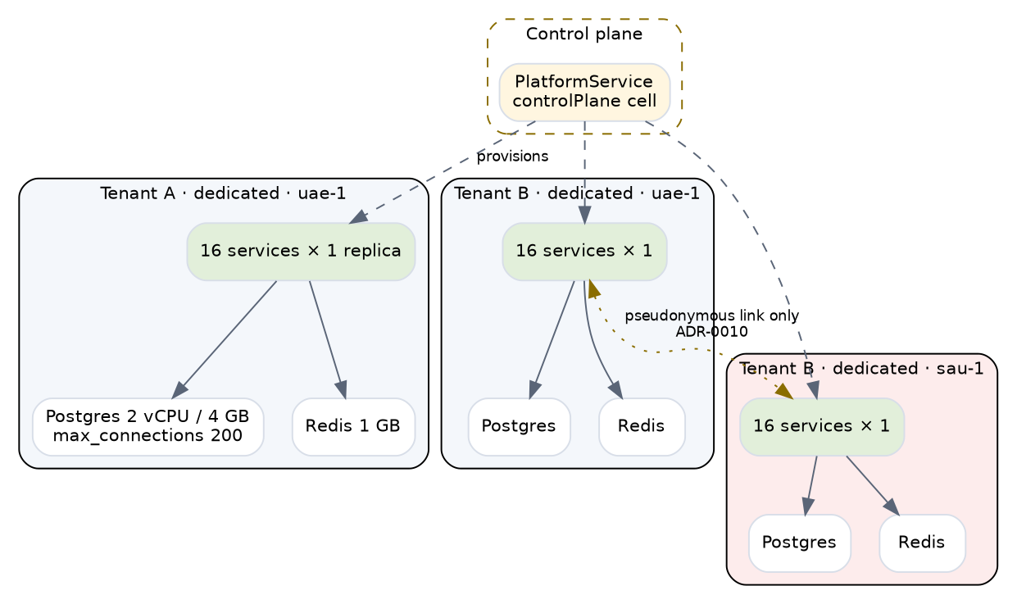
Independent tenant
One tenant, one database, one of everything. 18 containers.
Right for | A tenant who requires isolation contractually · one alone in a jurisdiction · one large enough that its own load justifies the stack
Wrong for | Everybody else
Blast radius | One tenant
Autoscale | None. At 2.9 RPS there is nothing to scale on

🔴 One correction to the client’s request
A tenant-level cell forces a choice: either a tenant may never operate in two jurisdictions, or the cell spans them and UAE data residency breaks.
Offer it as dedicated per tenant per region. A tenant in UAE and Saudi gets two cells, linked only by a pseudonymous guest reference (ADR-0010). That is how the request survives ADR-0001, and it is the only way it does.

Part 5 · (b) Shared platform — the default
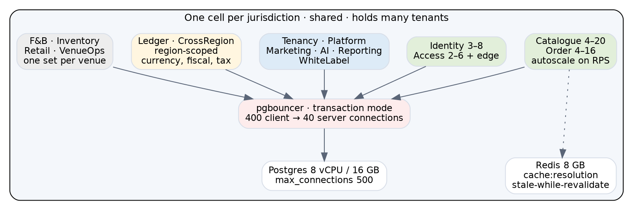
Shared platform
One cell per jurisdiction, holding many tenants. 39 containers before venues.
Shared and autoscaled on RPS — Catalogue 4–20, Order 4–16, Identity 3–8, Access 2–6.
At the venue, same cell — F&B, Inventory, Retail, VenueOps. 123 of their operations work offline, and a kitchen runs at the speed of a kitchen: no spike makes food faster.
At the region — Ledger and CrossRegion. Currency, fiscal year and tax are region properties (ADR-0018).

pgbouncer is not optional
20 Catalogue replicas at 20 connections each is 400 against a primary that will not want them. Transaction pooling is what makes horizontal scaling of the shared tier possible at all — without it the tier stops scaling around six replicas and the bottleneck looks like the database when it is the pool.

The trade, stated rather than assumed
Blast radius is the cell — every tenant in it. scope_path partitioning is correctness, not isolation: a bug reaches one tenant’s rows; an outage reaches all of them.
That belongs in a tenant contract, not in an architecture document nobody reads.

Part 6 · (c) Flash sale — ephemeral
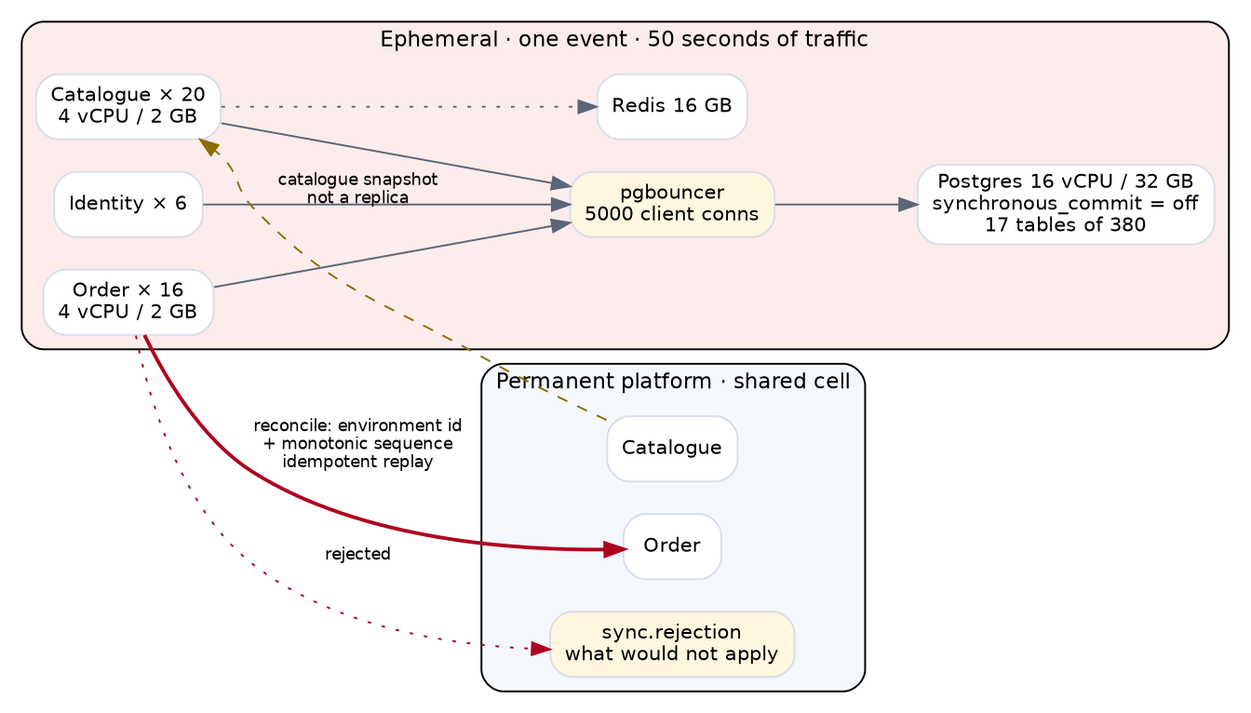
Flash sale
Three services, 17 tables, 45 containers, and gone afterwards.
Catalogue 20, Order 16, Identity 6. Postgres 16 vCPU / 32 GB. pgbouncer at 5,000 client connections.

Two things that are decisions, not settings
synchronous_commit = off. A crash loses the last few milliseconds of commits. For a sale lasting fifty seconds that reconciles afterwards, throughput is worth more than the durability window — but copied from a tuning guide it is a data-loss bug waiting for an incident review.
The catalogue is a snapshot, not a replica. If the permanent platform changes a price during the sale, reconciliation has to decide which one the guest paid. That is unanswered.

🔴 acquireInventoryHold is where this fails
Every buyer wants the same rows. The lease path serialises on contention, and no amount of horizontal scaling helps a contended row — twenty replicas queue behind one lock.
Load-test this before anything else. It is a property of the contention model and cannot be estimated from a per-instance figure.

The reconciliation route, designed
The shape already exists one layer down. syncOrders reconciles a till’s offline journal: a device id, a monotonic sequence, idempotent replay, and sync.rejection for what will not apply — kept, because a till that loses a rejected sale silently is worse than one that reports it.
Same three properties, one layer up: an environment id in place of a device id, a sequence that orders the replay, and a rejection table somebody works afterwards.

Part 7 · (d′) Shared burst tier, venue-local offline tier
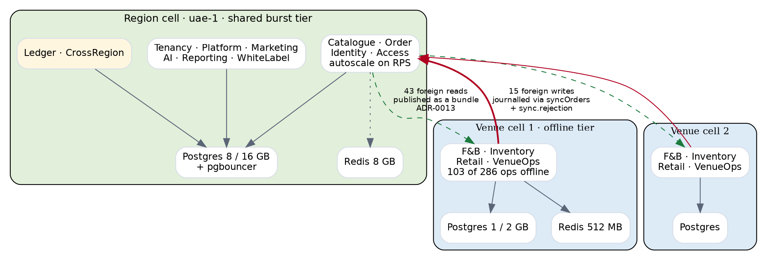
Venue-local offline
The inverse of putting the horizontal-scaling services at the venue.

🔴 Why the inverse
Those four — Catalogue, Order, Identity, Access — carry the burst. Per venue, each absorbs its own venue’s spike: a flash sale means that venue needs twenty Catalogue replicas while 599 cells sit idle. The problem has moved, not gone, and the pooling that would have absorbed it is gone with it.
Offline is the reason to be at the venue, not scaling. 103 of the venue tier’s 286 operations work offline. A venue with no network still cooks, still counts stock, still sells merchandise.

The design constraint, and how it resolves
The venue tier owns 80 tables and reads 100 — ten foreign schemas, 43 reads and 15 writes across the boundary.
Foreign reads are cached, not fetched. 12 into platform, 8 into identity, 6 into catalogue — the org tree, who a principal is, what a menu item is. All slow-changing, all already published to a till as a bundle (ADR-0013). The same mechanism serves a venue cell.
Foreign writes are journalled, not written. 5 into orders, 4 into marketing, 4 into catalogue, through syncOrders and sync.rejection. The mechanism exists and F33 walks it.

Part 8 · Cost — AWS and GCP
Rates are on-demand, Middle East region, and indicative. AWS Fargate + RDS PostgreSQL + ElastiCache; GCP Cloud Run + Cloud SQL + Memorystore. CF-64 supplies the contracted ones and will move these materially — committed-use and savings plans typically take 25–40% off both.

Billing unit, before the numbers
🔴 Three of the four run continuously and one does not. Quoting a monthly figure for the flash sale is the mistake that makes it look like the most expensive option when it is the cheapest.
Config | Billed as | AWS | GCP
(a) dedicated tenant | month, always on | $948 / mo | $779
(b) shared platform | month, always on | $3,485 / mo | $2,874
(c) flash sale | hour, while it runs | $11.76 / hr | $9.76 / hr
(d′) burst + venue-local | month, always on | $3,965 / mo | $3,237
A sixty-thousand-seat sell-out at a two-hour window is $24 of infrastructure.
Flash-sale duration | AWS
2-hour sale window | $24
6-hour cautious window | $71
Left up for a day | $282
Left up for a month | $8,587
The risk is not the cost, it is forgetting to tear it down. Teardown must be automatic — tied to the sale window in the catalogue rather than to somebody’s calendar.

One deployment, per month
Application, database and session cache only. The AI tier is costed separately below because it is shared across every configuration and sized by tenant count rather than by topology.
Config | Containers | App vCPU | DB vCPU | Redis GB | AWS | GCP
(a) dedicated tenant | 18 | 16 | 2 | 1 | $948 | $779
(b) shared platform | 39 | 57 | 8 | 8 | $3,485 | $2,874
(c) flash sale | 45 | 157 | 16 | 16 | $8,587 | $7,125
(d′) burst + venue-local | 44 | 59 | 11 | 9.5 | $3,965 | $3,237

🔴 The AI tier, which the table above leaves out
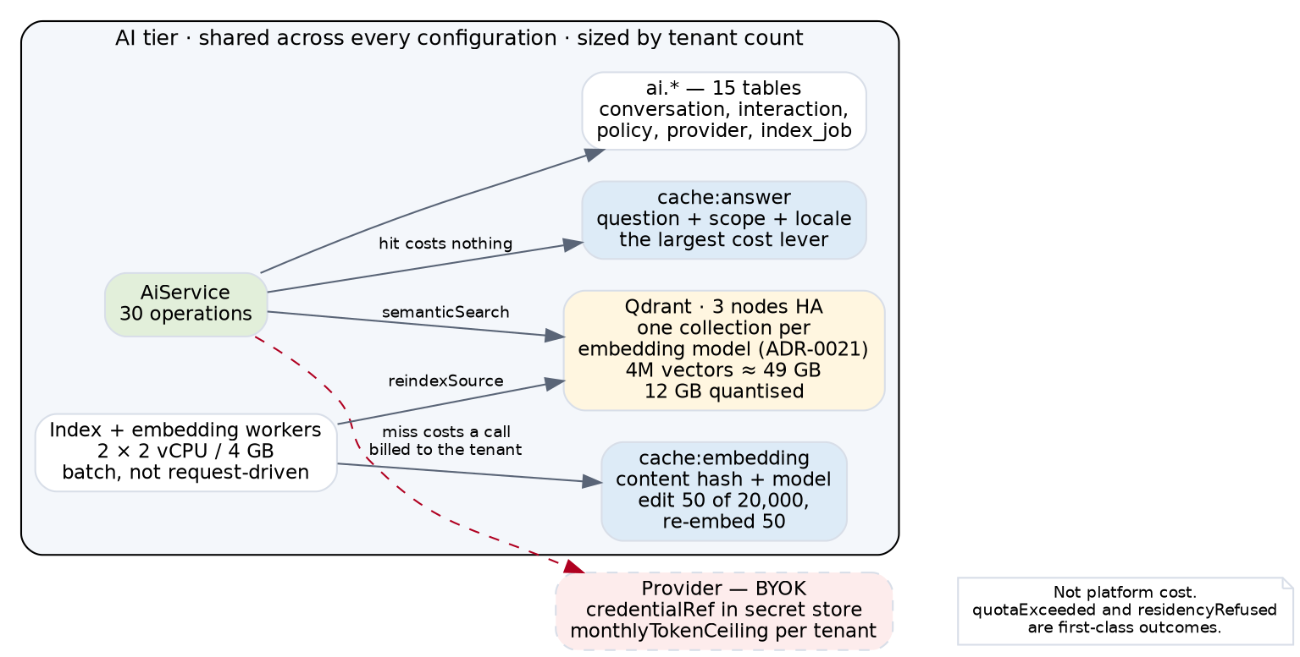
AI tier
Qdrant is a fourth store and the four configurations cost three. Nine operations use it — semanticSearch, sendAiMessage, ingestKnowledgeDocument, reindexSource and five more — and ADR-0021 puts one collection per embedding model, shared across tenants using that model.
Sizing, at 200 tenants averaging 20,000 chunks each:
4 million vectors × 1,536 dimensions × float32 = 24.6 GB raw. With the HNSW index and payload roughly 49 GB; scalar-quantised to int8, about 12 GB. Quantisation is the difference between one node and three, and it costs recall — a decision, not a default.
Component | AWS / month | GCP / month
Qdrant self-hosted, 3 nodes HA (4 vCPU / 16 GB each) | $694 | $596
Qdrant self-hosted, 1 node | $231 | $199
AI cache tier — cache:answer + cache:embedding, 8 GB | $274 | $286
Index and embedding workers, 2 × 2 vCPU / 4 GB batch | $180 | $152
AI tier total, HA | $1,148 | $1,034
Neither provider offers managed Qdrant. Both mean self-hosting on the compute tier or buying Qdrant Cloud, and the 12 August minute made this conditional: Qdrant was proposed over Postgres native vectors subject to confirming UAE compliance. That confirmation has not happened, and if it fails the vectors move into Postgres and this table changes shape entirely.

LLM tokens are not platform cost
BYOK, and the contract already says so. setAiProvider takes a credentialRef that lives in the secret store, monthlyTokenCeiling caps consumption per tenant, and AiProviderError has quotaExceeded and residencyRefused as first-class outcomes.
So the token spend is the tenant’s. What the platform pays for is the vector store, the caches and the workers — the table above.
cache:answer is the largest lever and the package already says why: forty questions repeat thousands of times a day at a kiosk. A cache hit costs nothing and a miss costs a provider call, so the hit ratio is worth measuring before the node count is.

At 200 tenants averaging three venues
Config | AWS / month | GCP / month | Shape
(a) dedicated per tenant × 200 | $189,600 | $155,800 | 3,600 containers, 200 databases
(b) one cell + 600 venue service sets | $96,910 | $82,502 | 815 containers, 1 database
(d′) one cell + 600 venue cells | $177,283 | $141,720 | 1,412 containers, 601 databases
(c) is $12 an hour on AWS and $10 on GCP. Run for one event it costs less than lunch; left running a month it costs more than the platform it is protecting.

What the numbers say
(a) is twice (b) and delivers isolation nobody at 2.9 RPS is asking for.
(d′) is 1.8× (b), and every dollar of the difference is 600 small databases. That is the price of a venue trading through a regional outage, and it is a conversation about what a venue is paying for rather than an architecture decision.
GCP is 15–18% cheaper across all four, driven mostly by Cloud SQL vCPU pricing against RDS. That is not a reason to choose it. DESC compliance, the managed Postgres feature set and the support relationship all matter more than 17%, and CF-64 is where they get weighed.

Part 9 · Optimisations, and what they do to the numbers
Four ADRs landed on 31 August — ADR-0031 contention, ADR-0032 pooling and shedding, ADR-0033 outbox and dead letters, ADR-0034 AI retrieval and cost. Each changes a figure above.

The request path
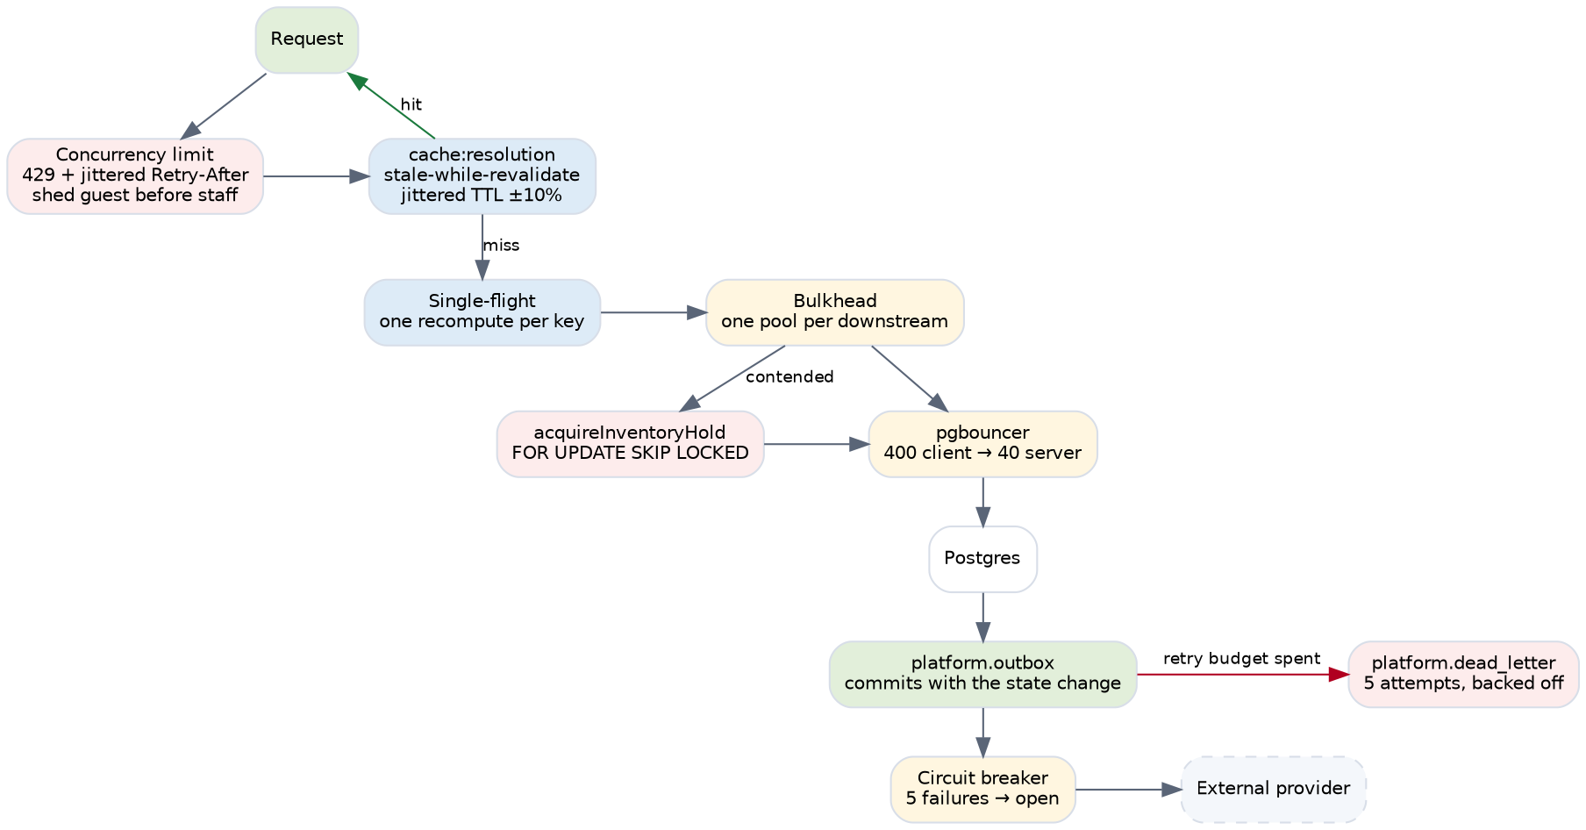
Backend optimisations
pgbouncer is the one that changes the shape. In transaction mode, 400 client connections share 40 server ones. Without it the shared tier stops scaling around six replicas and the ceiling in config (b) is not the database — it is the pool that does not exist.
Cost: two containers, about $70 a month on either provider. It is the cheapest line in this document and it decides whether the most expensive one works.
Backpressure changes what an overload looks like, not what it costs. A 429 with a jittered Retry-After is free; a service queueing until it dies is not. Shedding guests before staff is a commercial decision — x-ticvai-audience already says which is which, but the ordering should be checked with Qossai rather than assumed.
Stale-while-revalidate on cache:resolution removes a stampede that would otherwise be sized for. Permission resolution reads five tables on every authorised call; at 5,000 RPS a synchronised expiry is a database outage that looks like a traffic spike. Without it, config (b) needs a larger Postgres for a load that only exists at cache boundaries.
FOR UPDATE SKIP LOCKED on the lease path is what makes config (c) possible at all. Optimistic retry at 5,000 RPS is a retry storm; SKIP LOCKED turns contention into throughput where the caller does not care which seat they get.

The AI path
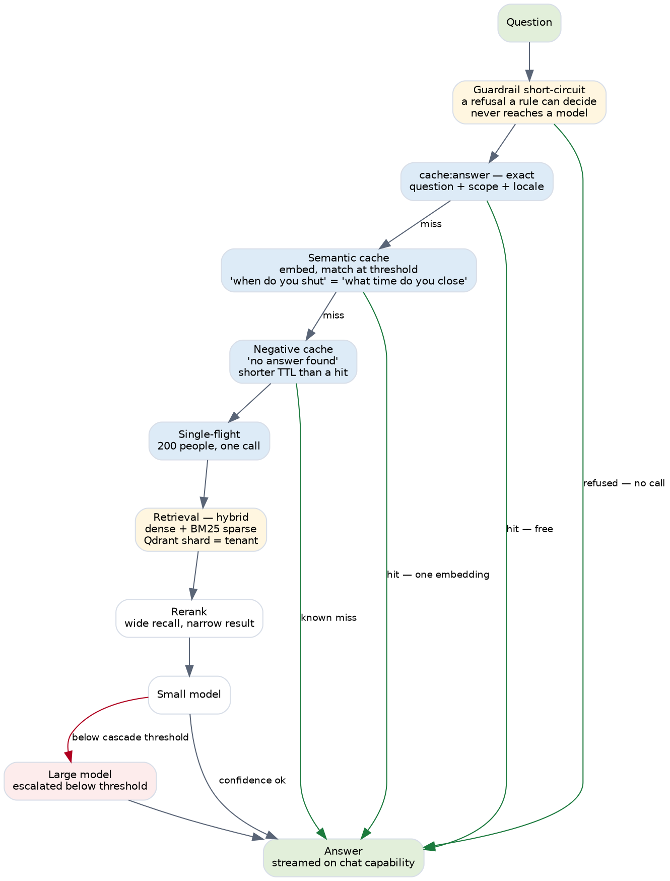
AI optimisations
Every green edge is a provider call that never happens, and provider calls are the tenant’s bill rather than the platform’s — which makes this the commercial argument, not the infrastructure one.
The semantic cache is the largest single lever. cache:answer is exact-match on question, scope and locale; what time do you close and when do you shut are two misses and two completions. An embedding costs a fraction of a completion, so the trade is favourable even when it misses.
Quantisation is the largest infrastructure lever, and it moves the Qdrant line directly:
 | Vectors | AWS / month | GCP / month
No quantisation, 3 nodes HA | 49 GB | $694 | $596
Scalar int8, 3 nodes | 12 GB | $347 | $298
Scalar int8, 1 node | 12 GB | $116 | $100
It costs recall, and ADR-0034 makes it a declared decision rather than a default for exactly that reason — a tenant whose search quality drops after an infrastructure change should be able to find the line that did it.
Model cascade and batch embedding do not appear in the table at all, because they reduce token spend and tokens are BYOK. They are worth more than everything else here and none of it is our bill.

What the four ADRs add to the platform’s own cost
Component | Per cell, AWS | Per cell, GCP
pgbouncer, pair | $70 | $63
Outbox relay | $90 | $76
Total added to config (b) | $160 | $139
4.6% of the (b) bill, and it buys the difference between a tier that scales to twenty replicas and one that stops at six.
🔴 Three failure tables now exist and nobody has a screen for them. sync.rejection, platform.dead_letter, ai.index_failure. A dead-letter table nobody reads converts a visible outage into an invisible backlog — the dashboard is a gap in the screen layer, not the infrastructure one.

Part 10 · Which configuration a venue gets
Mapped to the tiers in Part 2, not to the abstract scales in the brief.
Venue | Guests/day | Configuration | Catalogue | Order | Postgres | AWS / month
Small — museum, water park | 2,000 | (b) shared cell | 2–4 | 2–4 | shared 8/16 | ~$310
Medium — theme park | 18,500 | (b) shared cell | 4–12 | 4–10 | shared 8/16 | ~$780
Large — stadium, routine day | 60,000 | (b) + dedicated replicas | 8–20 | 6–16 | shared 8/32 | ~$1,900
Large — stadium, sell-out | 60,000 in 2h | (c) for the window | 20 | 16 | dedicated 16/32 | +$12/hour
Per-venue figures are that venue’s share of a shared cell, not a stack of its own — which is the point of config (b) and the reason the small tier is $310 rather than the $948 a dedicated cell costs.

🔴 A small venue cannot justify its own cell
$948 a month for a museum doing one request per second. At dedicated placement the infrastructure costs more than a member of staff, and that is the conversation to have before promising isolation to a tenant who does not need it.

The large tier is two different problems
A routine Saturday at 60,000 guests is 48.5 RPS steady and fits inside a shared cell with more replicas.
A sell-out is a different event entirely — 1,045 RPS over two hours, 6,270 if it compresses into twenty minutes. That is config (c), it runs for the window, and it costs twelve dollars.
The mistake to avoid is provisioning the routine day for the sell-out. A stadium is at 48 RPS for 363 days and 6,000 RPS for two, and paying for the second shape all year is how the (a) numbers happen by accident.

Part 11 · What each configuration trades
 | (a) dedicated | (b) shared | (c) flash sale | (d′) venue-local
Blast radius | one tenant | the whole cell | the sale only | cell, plus one venue
Isolation | machine-level | scope_path partition | n/a — one event | machine per venue
PITR granularity | per tenant | per cell — all tenants | none | per cell
Scales with | nothing | requests | requests | venue count
Cost driver | tenant count | request volume | duration | venue count
Fails when | tenant outgrows it | pooler saturates | lease contention | 600 databases to migrate
Operational units | 200 stacks | 1 | ephemeral | 1 + 600

The single strongest argument for each
(a) — point-in-time recovery is per tenant. Restoring one customer to last Tuesday touches nobody else.
(b) — one thing to upgrade. A schema migration is one migration, not two hundred, and the burst tier pools capacity across every quiet tenant.
(c) — $24, and it isolates the exact failure that cost a client relationship in Bahrain.
(d′) — a venue trades through a regional outage, not merely through its own broken connection, which (b) already survives.

And the strongest argument against each
(a) — the machinery is sized for the software, not the traffic. A museum at 1 RPS costs what a theme park costs.
(b) — 🔴 PITR restores every tenant in the cell. Recovering one customer means recovering all of them. This is not in any cost table and nobody has been told.
(c) — the reconciliation route back is undesigned, and teardown is a discipline rather than a mechanism until it is automated.
(d′) — 1.8× config (b) for protection against a rarer failure than the one (b) already handles.

Part 12 · Recommendation
Default to (b). One cell per jurisdiction, shared burst tier, venue services per venue but not per-venue cells. 815 containers and one database at 200 tenants.
Offer (a) as dedicated, per tenant per region.
Offer (d′) as an upgrade to (b), not an alternative. The only reason to take it is a venue that must trade through a regional outage.
Keep (c) ephemeral and separate.
Add the AI tier once, not per configuration. It is shared, sized by tenant count, and at $1,148 a month on AWS it is 1.2% of the (b) bill at 200 tenants — but it is the only component whose compliance is unconfirmed, and that matters more than its cost.

Part 13 · Implementation notes
The detail a commercial summary cannot carry.

Postgres configuration, per configuration
Setting | (a) dedicated | (b) shared | (c) flash sale
max_connections | 200 | 500 behind pgbouncer | 800 behind pgbouncer
shared_buffers | 1 GB | 4 GB | 8 GB
synchronous_commit | on | on | off — a decision, see Part 6
effective_cache_size | 3 GB | 12 GB | 24 GB
random_page_cost | 1.1 | 1.1 | 1.1
Replicas | none | 2 | 1, read-only for catalogue
random_page_cost = 1.1 on all three because every one runs on SSD. The default of 4.0 is tuned for spinning disks and makes the planner avoid index scans it should be choosing.

Connection arithmetic, which is where (b) actually fails
Twelve shared services, each scaling to twenty replicas, each holding twenty connections is 4,800. Postgres will refuse at 500.
pgbouncer in transaction mode collapses that: a connection is held for the duration of a statement rather than a session, so 4,800 client connections share roughly 40 server ones at realistic concurrency.
What transaction mode forbids and every service must respect:
- No prepared statements across transactions
- No SET outside a transaction — including SET search_path
- No advisory lock held between statements — ADR-0031’s singleton lock is taken and released inside one transaction for exactly this reason
- No LISTEN/NOTIFY
A service that breaks one of these fails intermittently under load and works perfectly in development, which is the worst failure shape there is.

Autoscaling triggers
On requests per second, not CPU.
CPU lags a burst by the time it takes to fill a queue. A fifty-second flash sale is over before a CPU-triggered scale-out has served anything, and by the time CPU registers the load the latency damage is already done.
Catalogue scale out at 400 RPS/replica cooldown 60s min 4 max 20
Order scale out at 250 RPS/replica cooldown 60s min 4 max 16
Identity scale out at 600 RPS/replica cooldown 90s min 3 max 8
Access scale out at 800 RPS/replica cooldown 120s min 2 max 6
Per-replica thresholds are hypotheses. tools/bench.py establishes the real ones, and the Order figure is the one most likely to be wrong because it is bounded by lease contention rather than by CPU.
Scale in is slower than scale out, deliberately: 5 minutes against 60 seconds. A sale that pauses for ninety seconds should not lose its capacity.

Health, readiness and the difference
Readiness fails when the pool is exhausted or the database is unreachable. The instance stops receiving traffic and is not killed.
Liveness fails only on a deadlocked process. An instance that is merely overloaded must not be restarted — restarting it moves its load onto its equally overloaded neighbours, which is how a brownout becomes an outage.
/_health already reports poolSize, poolIdle and coldStartMs in the generated skeletons.

Cold start
A pool that fills lazily makes the first request the slow one and the container look healthy. The skeletons fill the pool at startup and time it, which is why coldStartMs is a field.
Budget: under 5 seconds to ready. Above that, autoscaling cannot respond inside a burst and the minimum replica count has to absorb it instead — which means paying for idle capacity to cover a slow start.

Backup and restore, which nothing in the package states
🔴 There is no RPO or RTO anywhere in 34 ADRs. These are the shapes each configuration can support, not targets anybody has agreed:
 | (a) dedicated | (b) shared | (c) flash sale
Continuous archiving | per tenant | per cell | none — ephemeral
Point-in-time recovery | to the tenant | to the cell, all tenants | not applicable
Restore blast radius | one tenant | every tenant in the cell | n/a
Point-in-time recovery on a shared cell restores every tenant in it. Recovering one tenant to last Tuesday means recovering all of them, and that is a property nobody has been told about.
It is the strongest technical argument for dedicated placement and it is not in the cost table, because it does not show up until the day it matters.

Part 14 · What would falsify this
Every figure above is a container count and a limit, not a measurement. tools/bench.py runs the same workload against all four.
Decides (b) at scale: the replica count at which pgbouncer becomes the bottleneck instead of Postgres.
Decides (d′): whether a venue-local Postgres at 1 vCPU / 2 GB sustains F&B and Inventory during service. If it does not, the venue tier needs more and the 1.8× becomes worse.
Decides (c): lease contention throughput on one hot performance.
python3 tools/bench.py --pattern hot-venue --rps 5000 --seconds 600
hot-venue sends 90% of load to one venue — the Bahrain distribution, and the pattern that separates the four most sharply.

Part 15 · Still blocking
CF-161 — one database per cell or one per service. Every connection number here assumes shared-schema, and per-service databases turn (d′)’s 601 databases into several thousand. ADR-0028 still reads Accepted while contradicting a client-facing recommendation.
CF-64 — AWS or Azure, pending DESC. This document prices AWS and GCP because those were asked for; Azure is not costed and should be if it is still a candidate. CF-64 also carries RPO and RTO, which are stated nowhere in the package.

