TICVAI PLATFORM
Architecture Note
Hierarchy, Data Segregation and Services

Submitted to
Miracle Star Trading L.L.C.
Dubai, United Arab Emirates
Submitted by
Softlabs Group
Softlabs Technologies And Development Pvt. Ltd.
Mumbai, India
24 August 2026 — Design Package — Version 1.0

CONFIDENTIAL

Contents
- 1. Overview
- 2. The hierarchy
- 3. Data segregation
- 4. Sixteen services
- 5. Consequences
- 6. Merges considered
- 7. Limitations
- 8. Accompanying material

TICVAI — Hierarchy, Data Segregation and Services
Architecture note · 24 August 2026 · Softlabs

1. Overview
Three questions, answered against a package of 1,014 operations, 379 tables and 477 screens.
Where does configuration live? Eight scope levels, each earning its place by owning something nothing above or below can own.
How is the data divided? 26 schemas in one Postgres per cell — not one database per tenant, and not one shared table with a tenant column.
What ships together? Sixteen services, and the data boundary decides where they split.
The three answers are not independent. Service boundaries follow schema boundaries; schema boundaries follow the scope model. Getting the order wrong means drawing service boundaries and then discovering the tables disagree — which is exactly what happened once during this work, and section 4 says so.

2. The hierarchy
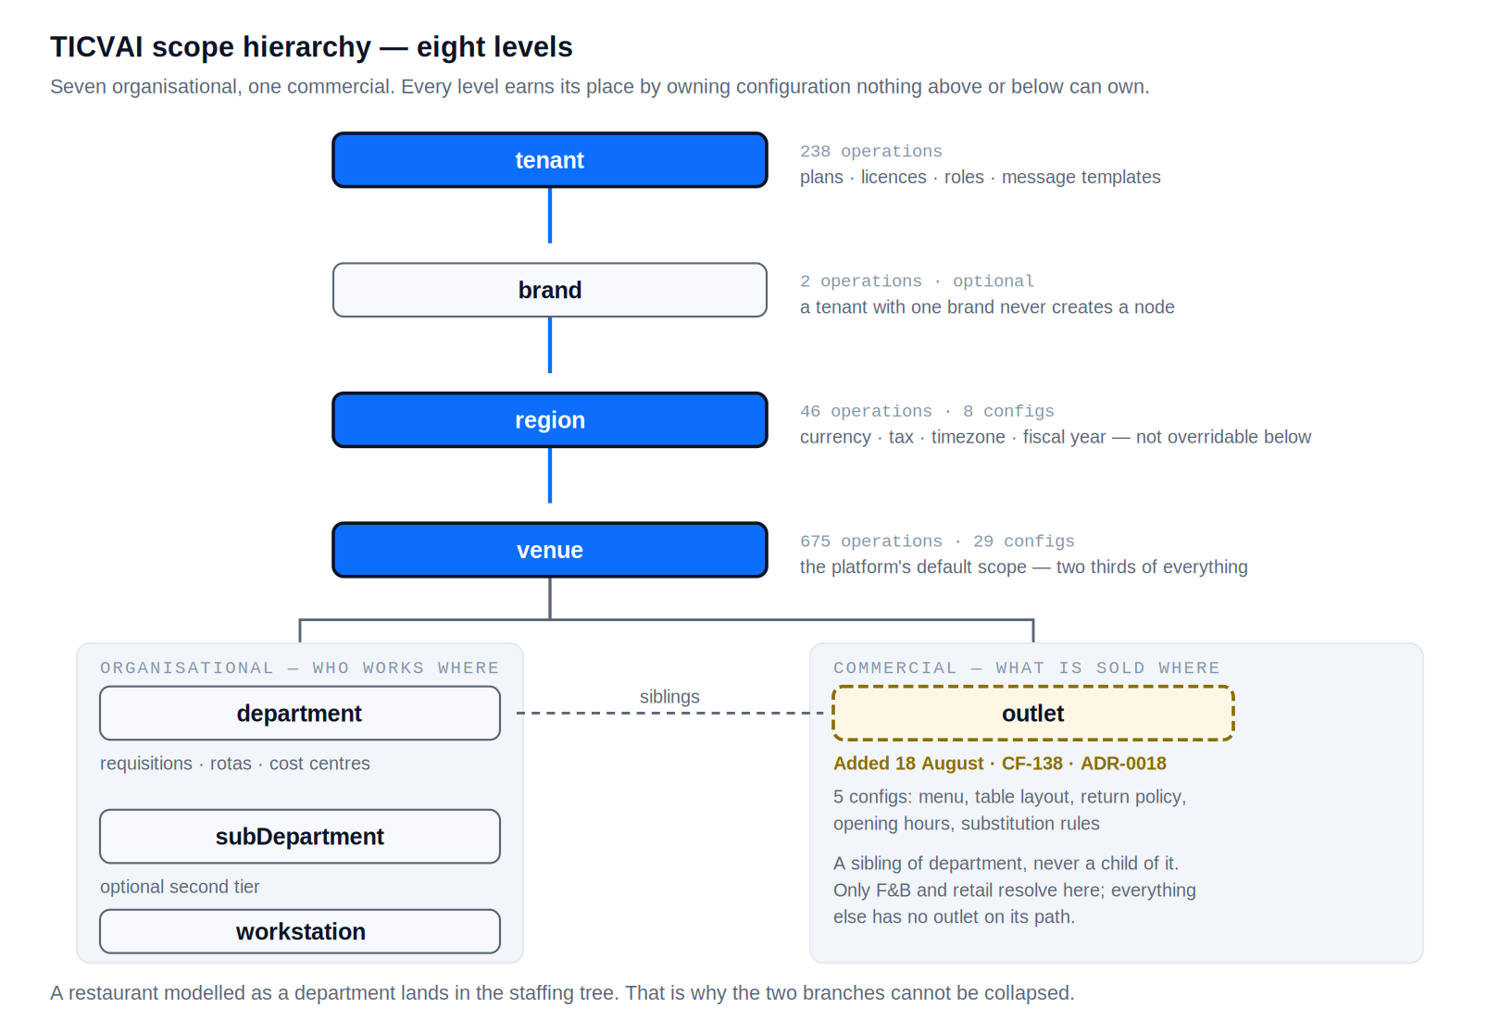
The eight scope levels and what resolves at each

2.1 Why a hierarchy at all
A venue operator does not have one set of settings. A tenant with four brands across two countries and eleven venues has settings belonging at four different heights. Flattening them produces one of two failures: every venue configures everything from scratch, or one change at the top breaks a venue that needed to differ.
platform.scope_node is the answer, and it is reached by 289 of 379 tables — the tenancy spine. A node has a level, a parent_id and a materialised path; configuration resolves by walking that path upward until something answers.
ADR-0011 made the hierarchy binding. Seven levels were confirmed with the client; outlet was added on 18 August as an eighth.

2.2 Why each level exists
Level | Operations | Owns | Why here
tenant | 238 | Plans, licences, roles, templates | Bought here. A role defined at venue would be defined eleven times
brand | 2 | Brand identity | Optional and free when unused — a tenant with one brand never creates a node
region | 46 | Currency, decimal scale, timezone, fiscal year | Not overridable below. One venue on a different decimal scale is a ledger that cannot consolidate
venue | 675 | Almost everything operational | Two thirds of all operations. The platform’s default
department | — | Requisitions, rotas, cost centres | The staffing and budget tree
subDepartment | — | A second tier | Optional
workstation | 45 | Config profile, offline policy, deposit box | A till is a scope, not just a device
outlet | — (5 configs) | Menu, tables, return policy, hours | A sibling of department — see below

2.3 Why outlet is a sibling and not a child
This is the decision worth defending.
A restaurant inside a venue has a menu, hours, a table layout, a return policy and stock. On the face of it that is a department.
Modelling it as one puts the restaurant in the staffing tree. Departments carry requisitions, rotas and cost centres — and a venue whose restaurant is run by a concession would be describing staff it does not employ.
A department answers who works where; an outlet answers what is sold where. The same physical restaurant can be one department and two outlets — a kitchen and a bar.
Only five configurations resolve at outlet, and everything else has no outlet on its path. That is what made an eighth level cheap enough to add after the hierarchy was already binding.
Raised as CF-138, decided in ADR-0018.

3. Data segregation
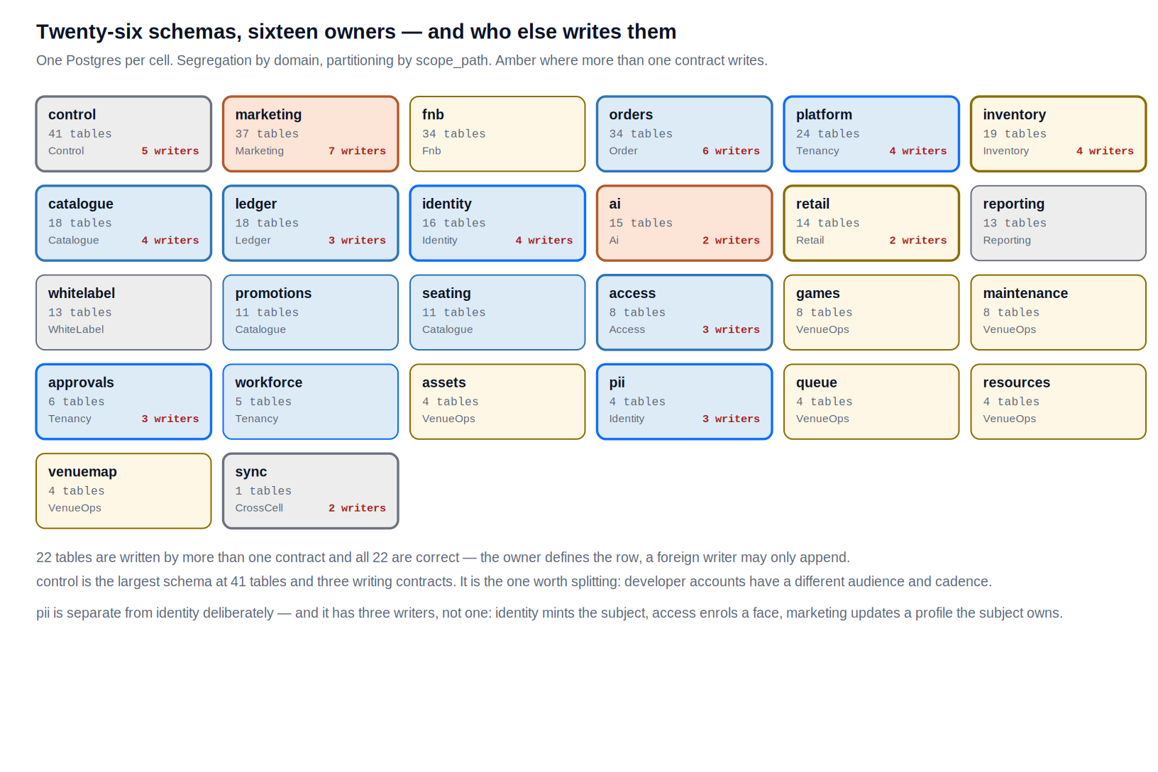
Twenty-six schemas and who owns them

3.1 The shape
26 schemas in one Postgres per cell. One cell per jurisdiction (ADR-0001); within a cell, segregation by domain rather than by tenant.
Not one database per tenant (ADR-0005). A venue operator with eleven venues is one tenant, and four hundred tenants would be four hundred databases to migrate, back up and monitor. Tenancy is a partition key, not a deployment boundary.
Not one shared schema either. 379 tables in one namespace is a namespace nobody can reason about, and it makes the service boundary impossible to enforce.

3.2 Every schema
Schema | Tables | Owner | Stores | Written by
access | 8 | Access | postgres | access, catalogue, orders
ai | 15 | Ai | postgres, postgres-analytical | ai, reporting
approvals | 6 | Tenancy | postgres | approvals, subscription, workforce
assets | 4 | VenueOps | postgres | assets
catalogue | 18 | Catalogue | postgres | catalogue, fnb, inventory, orders
control | 41 | Control | postgres | marketing-crm, platform-ops, public-api, subscription, white-label
fnb | 34 | Fnb | postgres | fnb
games | 8 | VenueOps | postgres | games
identity | 16 | Identity | postgres, redis | identity, orders, public-api, tenancy
inventory | 19 | Inventory | derived, postgres | fnb, inventory, maintenance, retail
ledger | 18 | Ledger | postgres | finance, orders, shift
maintenance | 8 | VenueOps | postgres | maintenance
marketing | 37 | Marketing | postgres | access, fnb, identity, marketing-crm, orders, public-api, workforce
orders | 34 | Order | postgres | fnb, identity, marketing-crm, orders, resources, shift
pii | 4 | Identity | postgres | access, identity, marketing-crm
platform | 24 | Tenancy | postgres | cross-cell, identity, inventory, tenancy
promotions | 11 | Catalogue | postgres | promotions
queue | 4 | VenueOps | postgres | queue
reporting | 13 | Reporting | derived, postgres | reporting
resources | 4 | VenueOps | postgres | resources
retail | 14 | Retail | postgres | orders, retail
seating | 11 | Catalogue | postgres | seating
sync | 1 | CrossCell | postgres | access, games
venuemap | 4 | VenueOps | postgres | venue-map
whitelabel | 13 | WhiteLabel | postgres | white-label
workforce | 5 | Tenancy | postgres | workforce

3.3 The five that need stating
pii is separate from identity. A principal is who may act; a subject is who they are (ADR-0023). Three writers, narrowly scoped — identity mints the subject, access enrols a face, marketing updates a profile the subject owns. That narrowness is what makes a subject-access export and a deletion request answerable.
ledger is append-only. Never updated, never deleted — a different discipline from everything around it, and one that should not share a schema with tables that mutate.
platform holds the spine. scope_node, reached by 289 tables.
inventory.stock_level is derived and never stored. Four operations wrote it directly and were found on 20 August. A stored level and a movement ledger that disagree is a stock count nobody can reconcile — check-package now refuses any write to a derived table.
ai is written by one contract only (ADR-0020). That boundary caught four wrongly-placed writes in a single week.

3.4 Cross-schema writes
22 tables are written by more than one contract, and all 22 are correct.
The rule: the owner defines the row; a foreign writer may only append to it. A till closing posts to ledger.entry because settling a shift is a ledger act. orders writes access.entitlement because a sale issues a ticket.

4. Sixteen services
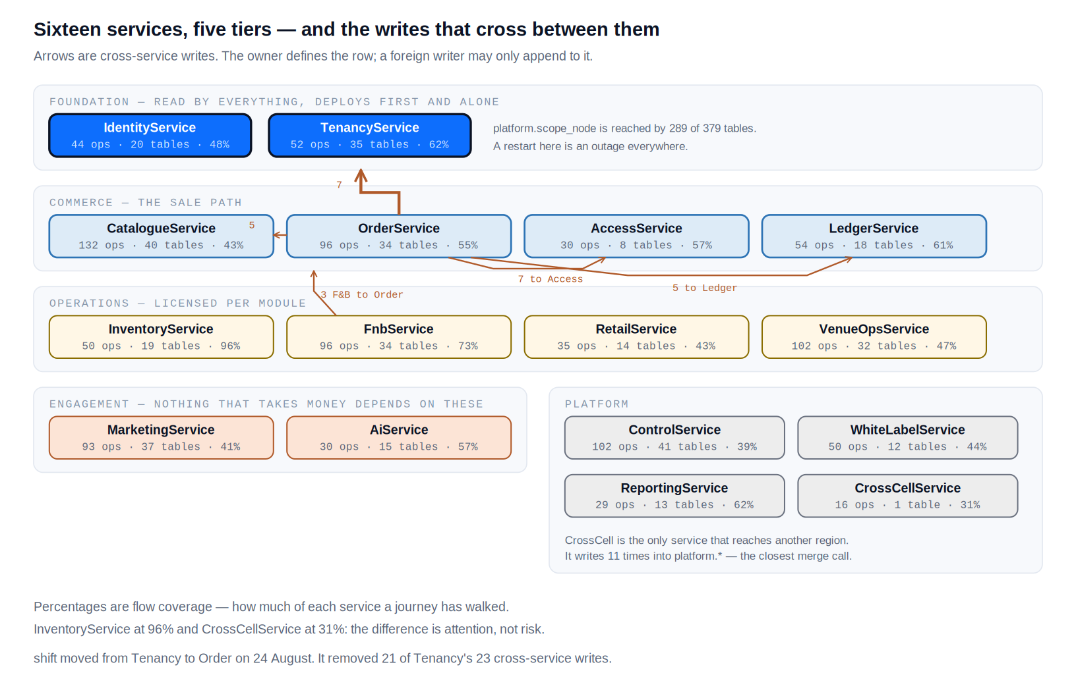
The service map and the writes that cross between services

4.1 How the number was reached
The lineage named a service on every operation and named 31. Three were the same service spelled two ways — OrderService/OrdersService, LedgerService/FinanceService, MarketingService/MarketingCrmService. That is how one contract becomes two repositories.
That left 28, one per contract, which is a mapping rather than a decision.

4.2 The correction worth reading
shift was folded into TenancyService and moved to OrderService the same day.
The reasoning was that a shift owns no tables of its own. That is true, and the conclusion was wrong. A service with no data belongs where its data is — and a shift’s data is entirely in orders: orders.shift, orders.deposit_box, orders.cash_movement, orders.cash_count_line.
A shift is venue-scoped, which is what made it look like a tenancy concern. But venue scope is the platform’s default rather than a service boundary — 675 of 1,014 operations are venue-scoped.
Scope answers whose configuration is this. Schema answers whose data is this. The first was allowed to decide the second, and the coupling made it visible: all 43 of Tenancy’s cross-service touches into orders were the shift contract. Moving it took Tenancy’s cross-service writes from 23 to 2.

4.3 The sixteen
Service | Tier | Ops | Tables | Screens | Journeys | Flows % | Schemas owned
Tenancy | Fnd | 52 | 35 | 71 | 18 | 62% | platform, workforce, approvals
Identity | Fnd | 44 | 20 | 36 | 13 | 48% | identity, pii
Catalogue | Com | 132 | 40 | 73 | 30 | 43% | catalogue, promotions, seating
Order | Com | 96 | 34 | 101 | 37 | 55% | orders
Ledger | Com | 54 | 18 | 20 | 6 | 61% | ledger
Access | Com | 30 | 8 | 29 | 13 | 57% | access
VenueOps | Ops | 102 | 32 | 53 | 15 | 47% | queue, maintenance, resources, venuemap, assets, games
Fnb | Ops | 96 | 34 | 57 | 17 | 73% | fnb
Inventory | Ops | 50 | 19 | 28 | 12 | 96% | inventory
Retail | Ops | 35 | 14 | 19 | 10 | 43% | retail
Marketing | Eng | 96 | 37 | 40 | 18 | 41% | marketing
Ai | Eng | 30 | 15 | 21 | 10 | 57% | ai, qdrant
Control | Plat | 102 | 41 | 42 | 10 | 39% | control
White label | Plat | 50 | 13 | 25 | 6 | 44% | whitelabel
Reporting | Plat | 29 | 13 | 31 | 10 | 62% | reporting
CrossCell | Plat | 16 | 1 | 4 | 1 | 31% | sync
Flows % is flow coverage — how much of each service a journey has traced end to end. Not tests, not build. Every flow written in this project has found a defect, so a service under 40% is unwalked rather than under-documented: its defects are still in it.

4.4 The eight worth defending
The other eight are what they look like — a domain with its own schema, its own scaling profile and its own licence. These eight are not.
Tenancy — platform.scope_node is reached by 289 of 379 tables — the tenancy spine. Workforce and approvals are folded in because each is small, both read scope_node constantly and write it rarely, and splitting them means three services doing the same joins.
shift was folded in here on 24 August and moved to OrderService the same day. The reasoning was that a shift owns no tables of its own — which is true — and the conclusion was wrong. A service with no data belongs where its data is, and a shift’s data is entirely in orders: orders.shift, orders.deposit_box, orders.cash_movement, orders.cash_count_line.
The coupling made it visible. All 43 of Tenancy’s cross-service touches into orders were the shift contract — 19 writes and 24 reads, the heaviest coupling in the platform, created to solve a cosmetic problem.
Scale. Read-heavy and highly cacheable. Config changes are rare. If it is down. Same as identity — nothing runs without a scope.
Order — The transactional core. 96 operations, 34 tables, and the highest write rate in the platform. Separate because its scaling profile is unlike anything else — a Saturday evening is ten times a Tuesday morning.
shift belongs here and not in Tenancy. A shift is venue-scoped, which is what made it look like a tenancy concern — but venue scope is the platform’s default rather than a service boundary: 675 of 1,014 operations are venue-scoped.
What decides the service is who owns the tables. A shift holds cash, orders.deposit_box reconciles against payments, and orders.cash_movement posts to ledger.entry at close. A till’s takings and a till’s drawer are the same money counted twice — separating them makes every settlement a distributed join.
Scale. Write-heavy, spiky, latency-critical. The one that autoscales. If it is down. Down means no sales. Highest availability target in the platform.
Ai — Separate at any size, and not because of size. ADR-0020 makes it a hard boundary: only this service writes AI tables, and it is read-only against the transactional core. That boundary caught four wrongly-placed writes in one week — it survives because it is enforced, and enforcing it across a shared deployment is harder than across a network.
Scale. Latency-tolerant, cost-sensitive, token-metered. Different hardware from everything else. If it is down. Down degrades suggestions and the concierge. Nothing that takes money depends on it.
Marketing — 93 operations and 37 tables — the biggest thing in the package, and probably two services eventually. CRM and campaigns have different write patterns: a guest profile is read constantly and written rarely; a campaign send is a burst of millions of rows nobody reads again.
Kept as one for now because splitting a service before it has a load profile is guessing.
Scale. Bursty on send, read-heavy otherwise. The one to watch for a split. If it is down. Down stops campaigns and guest lookup. Neither stops trading.
Control — Three contracts, one schema, 41 tables. Subscription, platform operations and the public API all write control.* — they are one bounded context that was split into three contracts for API-surface reasons, not for data reasons.
Splitting them would give three services writing one schema, which is the arrangement every distributed-data guide warns about.
Scale. Low volume, high consequence. Tenant provisioning and licensing. If it is down. Down blocks provisioning and the developer API. Trading is unaffected.
CrossCell — The only service that reaches another region (ADR-0010, ADR-0014). Separate because it is the one place where data crosses a jurisdiction, and a boundary that matters legally should be a boundary that exists physically.
It moves a pseudonymous guest link rather than a guest, which is the whole design.
Scale. Low volume, high scrutiny. If it is down. Down blocks cross-region entitlements. Each region continues alone.
Ledger — Money, and it is append-only. 54 operations over 18 tables that are never updated and never deleted — a different discipline from everything around it, and one that should not share a deploy with anything that does mutate.
Scale. Write-heavy, batch-tolerant, not latency-critical. Recognition and revaluation are jobs. If it is down. Correctness over availability. A ledger that is briefly unavailable is recoverable; one that is briefly wrong is not.
Access — The gate. Validating an entitlement is a sub-300ms decision made forty times a minute per lane, and it must work when the network does not.
Scale. Read-heavy, extreme latency sensitivity, edge-cached. frozenDays is held rather than replayed precisely because the gate cannot afford the arithmetic. If it is down. Down means the gates stop. Runs at the edge with a local decision cache.

5. Consequences
Deploy order is the tier order. Foundation first and alone — twelve contracts read Identity, and 289 tables anchor on platform.scope_node.
Four services can be down without stopping a sale: Marketing, AI, Reporting, CrossCell. A deliberate property that should be tested rather than assumed.
Order autoscales and nothing else needs to. A Saturday evening is ten times a Tuesday morning.
Ledger is correctness over availability — the only service where that trade runs the other way.

6. Merges considered
CrossCell into Tenancy is the closest call. 16 operations, one table, and 11 of its writes go into platform.*. Kept separate because it is the only service reaching another jurisdiction, and putting that code inside the service everything depends on widens the blast radius of a mistake.
Ledger into Order — kept separate. Append-only versus mutable is a different discipline.
Retail into Inventory — kept separate. Licensed separately; a venue running ticketing with no shop should not deploy retail.
control is worth splitting rather than merging. 41 tables and three writing contracts — the largest schema in the package. Developer accounts have a different audience and cadence, and P14 is the only platform that touches them.

7. Limitations
Build is 0%. 379 tables specified, none written. The first month of production traffic will move at least one boundary — most likely Marketing, which is 93 operations with two clearly different write patterns.
The cloud provider is undecided (CF-64). Everything above is provider-neutral; nothing below it can be.
Flow coverage is 53% across 93 flows, up from 21% on the same day. Coverage is uneven and the spread is the useful number: InventoryService at 96%, CrossCellService at 31%.

8. Accompanying material
Artefact | What it holds
TICVAI_Services_and_Data_Segregation.xlsx | Five sheets: services with coverage, schema segregation, cross-service writes, deploy order, hierarchy
docs/adr/0028-service-decomposition.md | The decision, its alternatives, its provenance
docs/adr/0011-hierarchy-is-binding.md | The seven organisational levels
docs/adr/0018-configuration-scope.md | Resolution rules and the outlet decision
handoff/service-sections.json | Sixteen viewer sections with operations, tables, screens, flows, coverage
docs/active/flow-coverage-plan.md | The three passes and where the ceiling is

