**The global hydrodynamic model  
CaMa-Flood (version 4.0)**

**Dai YAMAZAKI**

Institute of Industrial Science, The University of Tokyo

yamadai@rainbow.iis.u-tokyo.ac.jp

with Support of CaMa-Flood development team:

X. Zhou (U-Tokyo), E. Dutra (ECMWF)

January, 2021

**NOTE:**

This manual only contains the description on the default model configurations. Some options developed by external contributor are not included in the current manual version. We are now working on improving the document management strategus for CaMa-Flood project.

Please contact the developer (Dai Yamazaki) for the acquisition of the CaMa-Flood package. Do not redistribute the package to someone else without a notice to the developer. This is because the developer wants to keep the list of users for making a notice of the updates and bugs of the CaMa-Flood package.

Table of Contents

1. Introduction 3

1.1 Model Overview 3

1.2 Recent Change History 4

2. CaMa-Flood Package & Instruction 5

2.1 Contents of the Package 5

2.2 Quick Instruction for global simulation 5

2.3 Runoff forcing setting 8

2.4 Channel parameter calibration 9

2.5 Channel Bifurcation Scheme 10

2.6 Downscaling 10

2.7 Regionalization 11

2.8 River network map at different resolutions 12

3. Main Program Source Codes 13

3.1 Code Tree 13

3.2 Codes for hydrodynamic calculations 14

4. River Network Map 18

4.1 Global 15-arcmin river network map (glb_15min/) 18

4.2 Rectangular-grid simulation 23

4.3 Channel Cross-section Parameters 23

5. Input Runoff Forcing 25

6. Output Files 26

7. Shell Script to execute simulations 28

7.1 test1-glb_15min.sh 28

7.3 test2-conus_06min_netcdf.sh 29

7.3 test3-jpn_fcast.sh 29

8. Simulation Settings 31

8.1 Restart Mode 31

8.2 Simulation Time 31

8.3 Runoff Interpolation 31

8.4 Routing Scheme 32

8.5 Adaptive and Constant Time Step Schemes 32

8.6 Usage of netCDF 32

References 33

Version History 35

# 1. Introduction

## 1.1 Model Overview

This document is the user’s manual for the global river model, CaMa-Flood (Catchment-based Macro-scale Floodplain model).

The CaMa-Flood is designed to simulate the hydrodynamics in continental-scale rivers. The entire river networks of the world are discretized to the hydrological units named unit-catchments for achieving efficient flow computation at the global scale. The water level and flooded area are diagnosed from the water storage at each unit-catchment using the sub-grid topographic parameters of the river channel and floodplains. By adapting “gird-vector hybrid river network map” which corresponds one irregular-shaped unit-catchment to one rectangular grid-box, both realistic parameterization of sub-grid topography and easy data handling are achieved. The river discharge and flow velocity are calculated with the local inertial equation [Bates et al., 2010] along the river network map which prescribes the upstream-downstream relationship of unit-catchments. The time evolution of the water storage, the only one prognostic variable, is solved by the water balance equation which considers inflow from the upstream cells, outflow to the downstream cell and input from runoff forcing at each unit-catchment. Bifurcation of river channels can be also represented by analyzing high-resolution topography. The detailed description of the CaMa-Flood model is found in the description papers [Yamazaki et al., 2011; 2013; 2014a]

The major advantage of the CaMa-Flood simulations is the explicit representation of flood stage (water level and flooded area) in addition to river discharge. In addition to traditional model validation with gauged river discharge, it is possible to make a direct comparison between model simulations and satellite observations. Observations of water surface elevation by satellite altimeters and/or flooded area by SAR and microwave imagers are very useful to enhance the calibration/validation of the global river model [e.g. Yamazaki et al., 2012a]. Explicit representation of flooded area is helpful for flood damage assessment by overlaying it with socio-economic datasets [e.g. Hirabayashi et al., 2013]. The assimilation of observed flood stage into the CaMa-Flood simulation is a potential research topic, for optimizing model parameters and extending the forecast skill for near future flooding.

Another advantage of the CaMa-Flood model is its high computational efficiency of the global river simulations. The complexity of the floodplain inundation processes is reasonably approximated to a diagnostic scheme at the scale of a unit-catchment by introducing the sub-grid topographic parameters. The cost of the prognostic computation of river discharge and water storage is optimized by implementing the local inertial equation [Bates et al., 2010] and the adaptive time step scheme [Hunter et al., 2005]. The high computational efficiency of the CaMa-Flood model is beneficial for computational demanding experiments such as ensemble/long-term experiments [Pappenberger et al., 2012; Hirabayashi et al., 2013] and dynamic coupling between river routine and other hydrological schemes [Cohen et al., 2013].

In the latest version (v4.0), the baseline topography is updated from “SRTM/HydroSHEDS” to “MERIT DEM/MERIT Hydro” (Yamazaki et al. 2017; Yamazaki et al. 2019). As most of the errors (bias + noise) in elevation data were removed and latest water body layers are were integrated, the uncertainty in water level and flood extent simulations were largely reduced. Also, river channel width is objectively parameterized using satellite measurement (Yamazaki et al. 2015, Yamazaki et al. 2014). Due to the extensive work on these topography data development, CaMa-Flood simulation is now ready for the integration of satellite surface water measurement for calibration and validation (while channel bathymetry estimation is a remaining challenge).

## 1.2 Recent Change History

**Major update [v4.0].**

- v4.0 is the public release version (converted from v3.96). No major change in data and code from the early adapter version v3.96.

- Map data: Bug in floodplain profile (fldhgt, flddif) are fixed. (v3.96)

- Latest topography datasets (MERIT Hydro) was integrated, and FLOW upscaling algorithm was updated compared to v3.6.

- Source code structure is significantly modified for more flexible model coupling.

# 2. CaMa-Flood Package & Instruction

## 2.1 Contents of the Package

The package of the CaMa-Flood model contains the main programs of global river simulations, some sets of river network map and its sub-grid topography parameters, a sample dataset of input runoff forcing, and some tools used for analysis.

Please extend the **CaMa-Flood_$(version)_$(date).tar.gz** package on your computer. The you will find the following directories under the main directory **$(CaMa-Flood)/** .

**Table 2.1: List of directories in the CaMa-Flood package**



## 2.2 Quick Instruction for global simulation

The quick instruction to execute a test run with the CaMa-Flood model is described in this section. The test run is global hydrodynamic simulation at the 15-arcmin resolution (**map/glb_15min/**) for the period from 2000 to 2001 with the sample input runoff forcing (**inp/test-1deg/**). The local inertial equation is used for the calculation of river discharge and flow velocity, and the adaptive time step scheme is activated in order to optimize the time step. Bifurcation channels scheme is turned on in the default setting.

CaMa-Flood highly relies on public libraries, so please make sure the necessary libraries are installed when trying compiling CaMa-Flood. The installation of CaMa-Flood will provide useful information once it finds the missing libraries. Please contact your administrator for help when you meet problem for the libraries.

1. Please edit the Mkinclude file, **$(CaMa-Flood)/adm/Mkinclude** according to the computer environment. If you do not use netCDF, comment out the lines #**DCDF=-DUseCDF**. Mkinclude can be a linkage to other files, please choose the right one according to your computer system (MacOS or Linux).

- MPI is not supported in v3.9 and later

1. The shell script to automatically compile all the source codes is prepared. Go to **$(CaMa-Flood)/gosh/** directory, and execute the command:

**%./compile.sh**

or **% ./compile.sh yes**

Then, the source codes in **src/ and map/src/** directories are compiled by the command **% make all**. When you put the argument “**yes**”, the command **% make clean** is executed before compiling which makes sure all your updates in the source codes are activated.

1. Go to the map directory (**map/glb_15min/**). Prepare river topography parameters.

(notice: If you are doing a regional simulation, you first go to the 2.7 regionalization, finish the procedures there and then go back to this step.)

- Copy the code and script to prepare river parameters by: **% cp -r ../src/src_param** or **% cp -r $(CaMa-Flood)/map/src/src_param .** Then, enter the **src_param** folder and execute the script (Edit the shell script for your simulation setting if needed):

**% ./s01-channel_params.sh**

The script folder contains the codes [1] to calculate “annual average discharge” (calc_outclm.F90); [2] to calculate river channel width and channel depth assuming hydro-geometry power-low equations (calc_rivwth.F90); [3] to combine the satellite-based river width parameter width that from the power low equation (set_gwdlr.F90); [4] to set the bifurcation channel parameters (set_bifparam.F90).

Note that all the dataset in the CaMa-Flood archive is prepared in “little endian” byte order. If the default byte order of your computer environment is “big endian”, you have to convert the endian of the sample dataset. (Endian conversion subroutines are prepared in CaMa-Flood source code, but this is for expert use).

1. Go to the shell script directory (**gosh/**). Edit the executable script **test1-glb_15min.sh** (hereafter: **“go script”**) for your computer environment and experiments settings. You can modify, for example, experiment name, number of OpenMP threads, usage of the adaptive time step scheme, the interpolation with the input matrix, and the list of output files.

CaMa-Flood can be run in parallel. Please specify your requirement for server sources (e.g., the core name, the number of nodes you will use, etc) if you want to run the model in parallel at higher speed. And please use specific location for the CaMa-Flood directory (**${BASE}**) in this case. Otherwise, the relative location is applicable.

After editing the executable go script, type the command to run the simulation.

**% ./test1-glb_15min.sh**

Or submit a job task to the server (for cluster environment)

**% qsub test1-glb_15min.sh**

1. The simulation results are outputted to the running directory specified in the script, **$(CaMa-Flood)/out/${EXP}/** in the default setting. The progress of the simulation is written to the log file, **run_YYYY.log**. The sample run costs around 60 mins with one single CPU for one year.
2. The output file is in the “plain binary” format, which consists of the sequence (nx*ny) of 4 byte real data without any header. The data array is from 180W to 180E (1440 grid cells) and from 90N to 90S (720 grid cells). The output can also be written into netCDF (see section 8.6).

## 2.3 Runoff forcing setting

CaMa-Flood requires daily runoff forcing in plain binary format or netCDF format.

Runoff forcing data can be prepared in “plain binary format” (or Fortran direct access, GrADS binary, ArcGIS EHdr), and should be named as **${PREFIX)yyyymmdd${SUFFIX}**. The sample runoff data prepared in **inp/test_1deg/Roff/** directory. The runoff file is named Roff____yyyymmdd.one by setting **PREFIX=”Roff____”** and **SUFFIX=”.one”**. Default runoff data is prepared in the unit [mm/day], and converted in CaMa-Flood to [m3/s] by setting the unit conversion ratio **DROFUNIT=86400000** (from [mm/day] to [m/s]). Also, set the input forcing frequency **IFRQ_INP=24** (daily). The area for each grid is given from a file (ctmare.bin in unit [m2]). If runoff data is prepared in other unit, the ${DROFUNIT} should be modified accordingly with the converting ratio to m/s.

NetCDF runoff input can be used by setting **LINPCDF=.TRUE.**, NetCDF runoff directory **CROFDIR**, NetCDF runoff file **CROFCDF**, NetCDF runoff variable name **CROFVAR**, NetCDF data start date **SYEARIN**, **SMONIN**, **SDAYIN** need to be specified. In general, if the netCDF runoff is prepared for one year within one separated file, SYEARIN, SMONIN, SDAYIN are the default settings.

If prepared runoff forcing is different from the default grid coordinate system (i.e. global domain in Cartesian grid coordinate at 1-degree spatial resolution), a new input matrix should be generated. Please go to **map/$(your map)/src_param** directory, edit **s02-generate_inpmat.sh** if the runoff forcing is at linear Cartesian grid coordinate, (including domain ranges, spatial resolution, latitudes sequence). By executing **./s02-generate_inpmat.sh**, a new dimension file “**diminfo.txt**’ and a new input matrix “**inpmat.bin**” are generated. Please specify these files in the main executable shell scripts (**test1-glb_15min.sh**) (${CDIMINFO} & ${CINPMAP}). In the default setting, **s02-generate_inpmat.sh** generates input matrix for sample 15min netCDF runoff forcing (inp/test_15min_nc).

If runoff forcing is prepared at other grid coordinates (e.g. non-Cartesian grid coordinates), Please edit **generate_inpmat.F90**. There is a part which relates the (lon,lat) of each sub-grid high-resolution pixel to the (ixin, iyin) of input runoff forcing. Please edit these lines according to the grid coordination of your runoff forcing.

If runoff forcing is not at daily timestep, remember to change the ${IFRQ_INP} and ${DT} in s01-channel_params.sh to corresponding values. For example, IFRQ_INP=3, DT should be 10800.

If you prepare your own runoff inputs, we suggest you prepare the binary runoff in daily (one file for each day), and netCDF runoff for one year (all days in one year in one single nctCDF file). These are default settings in the codes. Otherwise, you need to modify the source code to properly read your own runoff inputs.

## 2.4 Channel parameter calibration

The channel parameter (width: rivwth.bin, depth: rivhgt.bin, roughness: rivman.bin) can be modified by script “**s01-channel_params.sh”** and code “calc_rivwth.F90 / set_gwdlr.F90”.

The channel width W and depth H are estimated by the equations below:

(2.1)

(2.2)

where is averaged discharge (outclm.bin calculated by calc_outclm.F90). The parameters for width () and depth () can be modified in the script **s01-channel_params.sh.** The Manning’s Roughness coefficient is set to constant (0.03) as default.

Instead of river width parameter estimated by the power-low equation (**rivwth.bin**), satellite-based river width (MERIT Hydro width) can be given by the set_gwdlr.F90. The original satellite-based width data is width.bin, and the code “set_gwdlr.F90” generates the new parameter (**rivwth_gwdlr.bin**) by combining the satellite and power-low width values (in order to handle uncertainty in satellite width product.

## 2.5 Channel Bifurcation Scheme

Chanel bifurcation scheme is activated by setting **LPTHOUT=.TRUE.** in the go script. While bifurcation channel network is pre-processed by analysing the high-resolution topography (bifori.txt), bifurcation channel depth should be added by executing set_bifparam.F90. Also, how many bifurcation layers to be considered should be specified in the script **s01-channel_params.sh.**

## 2.6 Downscaling

Simulated floodplain depth can be downscaled from the simulation resolution (15-arcmin or 6-arcmin) onto the original high-resolution DEM (up to 3-arcsec). The sample code for downscaling is prepared in **etc/downscale_flddph/** directory. The sample script s01-downscale.sh is prepared, which is designed to downscale the simulation result of **test1-glb_15min.sh**.

Please compile the codes in src/ directory by **%make all**. Then, specify the project name (TAG), the target domain, target time period, downscale resolution (RES=1min in default), and map and output directory in s01-downscale.sh. And then execute % ./s01-downscale.sh. The downscaled depth data is stored in flood_$(TAG) directory. Also the figures can be generated by the Python script in fig_$TAG directory.

The default downscaling resolution is 1min and the 1min map has been included in the map directory. But if you want to downscale the map to 3sec or 15sec, remember to link (or copy) the high resolution DEM information from original dataset ${cmf_v400_data} to your map folder ${CaMa-Flood}/map/glb_15min/

% ln -s ${cmf_v400_data}/map/glb_15min/3sec .

or % ln -s ${cmf_v400_data}/map/glb_15min/15sec .

and then modify the ${RES} in s01_downscale.sh as for your purpose. For those internal users, the ${cmf_v400_data} is “/home/yamadai/work/CaMa_v400/cmf_v400_data/”. The soft linkage will save space if you have multiple CaMa-Flood runs.

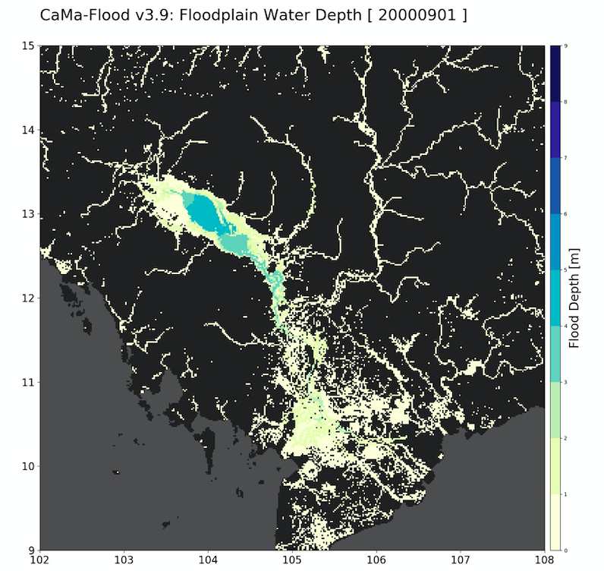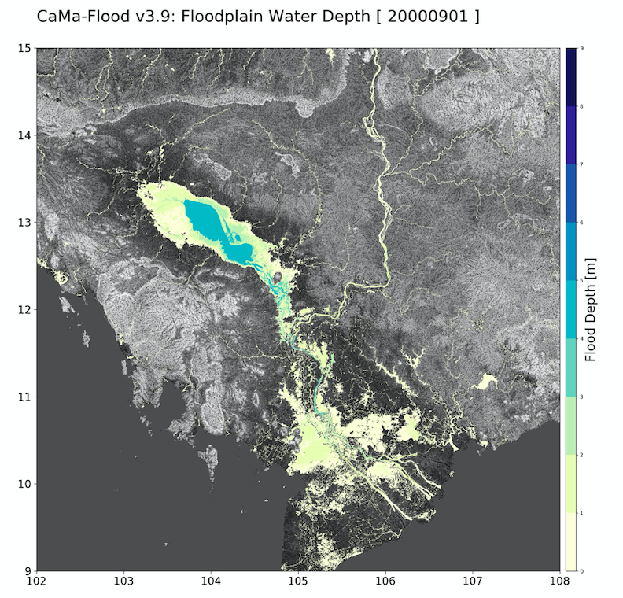

**Figure 2.1 Example of downscaled floodplain depth (left:1min, right: 3sec). There is a background elevation map for 3sec map.**

## 2.7 Regionalization

For regional simulations, tools to extract regional maps from the global maps are prepared. Please create a new map directory and enter “**mkdir map/reg_15min/**”. Copy the script/code for regionalization by **% cp -r map/src/src_region map/reg_15min/src_region**, and go to **map/reg_15min/src_region** directory. Execute all .F90 modules by %make. Edit the script s01-regional_map.sh to specify the original global map directory and domain of regional maps. Because the original global map is large in size, you can use soft links to original global map %ln -s /home/yamadai/work/cmf_v400_data/map/glb_15min/ .

Execute ./**s01-regional_map.sh** which includes **cut_domain.F90** (extract regional maps), **cut_bifway.F90** (extract bifurcation channel), **set_map.F90** (calculate associate info from river network maps), **combine_hires.F90** (extract sub-grid high-resolution info),and **generate_inpmat.F90** (generate input matrix for regional simulations for **inp/test-1deg/** default sample forcing). Scripts **s02-wrte_ctl_map.sh** and **s03-wrte_ctl_hires.sh** to generate CTL file for GrADS are also executed within **s01-regional_map.sh**.

Other procedures (e.g. generate channel cross-section parameters, use GWD-LR river width, set bifurcation channels) are the same as the global river network map. (go back to step 3) Please copy **map/src/src_param to reg_15min/**, and execute the scripts for river topography parameter settings.

In case your long-term runoff file is in different resolution of the runoff used for generating the river parameters. Go to src_param folder, edit s02-generate_inpmat.sh first, change the size and domain range of the runoff data (according to the runoff inputs), specify the dimension information ${DIMINFO} and ${INPMAT}. Execute % ./s02-generate_inpmat.sh to have the right dimension information of the runoff input.

Then, regional simulations can be executed by just changing map descriptions in the executable go scripts. Change the ${CDIMINFO} and ${CINPMAT} accordingly in the go script to properly read your own runoff. Sample shell scripts (**region_15min**) are prepared in **gosh/** directory.

A sample regionalized map for CONUS region (**conus_06min**) is included in the package, which is based on the global map **glb_06min** (available on the webpage)

## 2.8 River network map at different resolutions

The river network map at different resolutions (1min, 3min, 6min) is prepared. The higher resolution map is mainly developed for regional simulations. These can be downloaded from the CaMa-Flood v4 webpage.

# 3. Main Program Source Codes

The programs of the CaMa-Flood global river model are written in Fortran90. The programming structure follows the basic coding guidelines of Fortran90 as much as possible (this was achieved under the collaboration with Dr. Emanuel Dutra in ECMWF). The program includes the parallelization by OpenMP. The netCDF input/output is also supported. The netCDF schemes sometimes cause troubles when compiling the codes, so these schemes can be excluded from the program by preprocessing of the codes.

The program building is supported by the “make” function, and compiling rules are written in the “**Makefile**” in **src/** directories. The original files with the suffix (*.F90) are automatically pre-processed following the setting in **$(CaMa-Flood)/adm/Mkinclude,** and the main executable program (**MAIN_cmf**) is built.

## 3.1 Code Tree

The code trees of the CaMa-Flood program are shown in Table 3.1.

The main program consists of the main executable (**MAIN_cmf.F90**), driver for controlling model initialization/finalization (**cmf_drv_control_mod.F90**), driver for advance time steps (**cmf_drv_advance_mod.F90**), controller for various modules (**cmf_ctrl_*_mod.F90**). The main hydrodynamic calculations are written in the calculation codes (**cmf_calc_*_mod.F90**), which are called by the driver or controllers. Model variables are listed in the shared variable modules (**yos_cmf_*.F90**). Small functions/subroutines are listed in **cmf_utils_mod.F90.**

**Table 3.1: The code tree of main programs (src/ directory)**

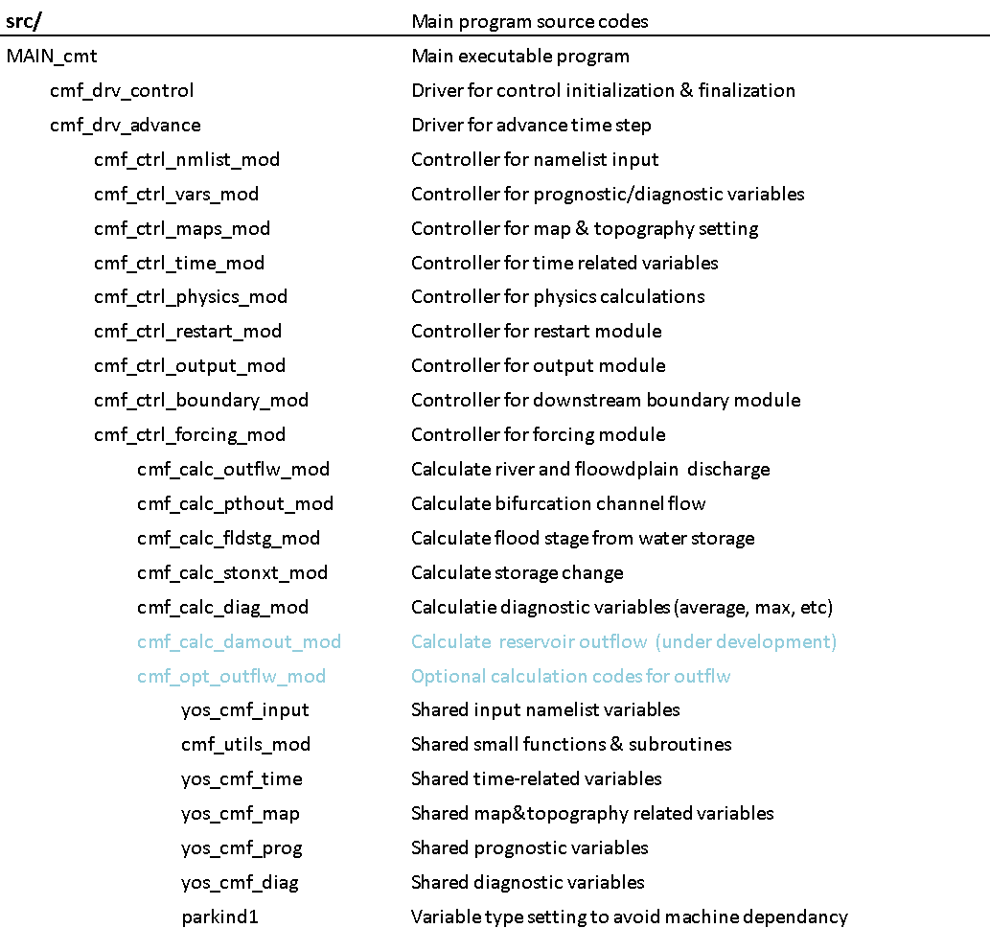

## 3.2 Codes for hydrodynamic calculations

The main scheme of hydrodynamic calculation is controlled by **cmf_ctrl_physics_mod.F90**. The flow of the hydrodynamic calculation is as follows:

### (1) Estimate optimum time step (CALC_ADPSTP in cmf_ctrl_physics_mod.F90)

When the adaptive time step scheme is activated ( LADPSTP=.true. ), the default time step DT specified in the go shell script is divided into smaller time step satisfying the CFL condition within **cmf_ctrl_physics_mod.F90**. The adaptive time step is decided at the start of **cmf_ctrl_physics_mod.F90**, and the same is repeated during the default time step .

### (2) Diagnose flood stage (cmf_calc_fldstg_mod.F90).

In **cmf_calc_fldstg_mod.F90**, the flood stage is diagnosed from the water storage at each grid cell. River channel water storage, , floodplain water storage, , river water depth,, floodplain water depth, , and flooded area, , are diagnosed from the total water storage of a grid point, , by solving either of simultaneous equations (3.1) or (3.2). Either of the simultaneous equations (3.1) or (3.2) is chosen by comparing the total water storage, , and the flood initiation storage, . The flood initiation storage is given as, , where is channel depth, is channel width, and is channel length. For the case that the total water storage, , is less or equal to the flood initiation storage, , the simultaneous equations (3.1) are applied:

(3.1)

For the case that the total water storage, , is greater than the flood initiation storage, , the simultaneous equations (3.2) are applied:

(3.2)

The equation in (3.2) means that the water surface elevations of the river channel and the floodplain are same. This equation is based on the assumption that water mass is instantaneously exchanged between the channel and the floodplain to balance the water surface elevations of the two reservoirs. The function , which is the inverse function of the floodplain elevation profile , describes flooded area, , as a function of floodplain water depth, (see Figure 4.2c).

### (3) Calculate river discharge (cmf_calc_outflw_mod.F90)

In **cmf_calc_outflw_mod.F90**, the river discharge (low water channel) and floodplain discharge (high water channel) from each cell toward its downstream cell indicated by the river network map is calculated. The river discharge is calculated with the local inertial equation [Bates et al., 2010].

The local inertial equation is derived by neglecting the second term of the St. Venant momentum equation (3.3):

(3.3)

where is the river discharge (m3s-1), is the flow cross section area (m2), is the flow depth (m), is the bed elevation (m), is the hydraulic radius (m), is acceleration due to gravity (ms-2], is the Manning’s friction coefficient (m-1/3s-1). and are the flow distance and time, respectively. The first, second, third, and fourth terms represent the local acceleration, advection, water slope, and friction slope, respectively. The explicit form of the he local inertial equation (3.4) is used in the CaMa-Flood model:

(3.4)

where is the water surface slope, is the discharge at the previous time step, and is the river discharge between the time and . The hydraulic radius is approximated by flow depth . The Manning’s coefficient is set to =0.03 in default, and given by the topography map rivman.bin.

The negative river discharge, which may occur in the calculation by the local inertial equation and the diffusive wave equation, represents the backward water flow from the downstream grid cell towards the current grid cell.

The flow limiter is introduced in order to prevent the situation that the total outflow from a grid exceeds the total water storage of the grid. The amount of the water leaving each grid cell is calculated, and the modification rate is applied on the river discharge calculated by the local inertial equation when the total outflow is larger than the total storage of the grid.

Floodplain discharge (i.e. high water channel) is calculated in the default setting. Floodplain discharge is also calculated by the local inertial equation (Eq. 3.4). The flow area A is calculated by dividing floodplain storage by channel length. The flow depth h is given by the floodplain depth. The manning’s coefficient for floodplain flow is set to =0.10 in the default setting. Floodplain discharge calculation is turned off by specifying **LFLDOUT=.FALSE.** in go script.

### (4) Calculate bifurcation channel flow (cmf_calc_pthout_mod.F90)

Bifurcation channel discharge is calculated when bifurcation flow scheme is activated in the shell script (**LPTHOUT=.TRUE.**). Bifurcation channel discharge is also calculated by the local inertial equation (Eq. 3.4). The flow area A and flow depth h is calculated for aggregated bifurcation channels with same bifurcation channel elevations. The manning’s coefficient for floodplain flow is set to =0.03 for river bifurcation and =0.10 for overland bifurcation.

Discharge in each bifurcation channel is saved as **pthflwYYYY.pth** (dimension, npthout*npthlev), while net bifurcation flow at each grid is saved as **pthoutYYYY.bin** (dimension: nx*ny)

Bifurcation flow is optional. It can be used for global simulations after version 3.9 and later, and it is activated in the test scripts.

### (5) Calculate storage change (cmf_calc_stonxt_mod.F90)

The storage change at each grid cell from the time to is calculated by the mass conservation equation (3.5):

(3.5)

where and represent the water storage of grid i at the time and , represents the river (+ floodplain + bifurcation channel) discharge outflow from grid at time , represents the river (+ floodplain + bifurcation channel) discharge inflow from the upstream grid , is the unit-catchment area of grid , represents the input runoff to the grid .

# 4. River Network Map

The river network map and its associated sub-grid topographic parameters required for the CaMa-Flood simulations are stored in the **$(CaMa-Flood)/map/** directory. These maps are generated from the fine-resolution global flow direction maps (MERIT Hydro [Yamazaki et al, 2019]; with hydrologically adjusted elevation (MERIT DEM [Yamazaki et al. 2017; Yamazaki et al. 2012] and river width data [Yamazaki et al. 2014]) by the upscaling algorithm FLOW [Yamazaki et al., 2009].

The dataset in the **map/** directory is prepared in the “plain binary” format, which consists of the sequence (nx*ny) of data without any header. The default data array is from 180W to 180E and from 90N to 90S in case of global gridded maps. The byte order of the data is “little endian”. The description files (**\*.ctl**) to visualize the data on GrADS are included along with the map datasets.

## 4.1 Global 15-arcmin river network map (glb_15min/)

The three sets of a river network map and topographic parameters are prepared in the CaMa-Flood v4.0 package. The **glb_15min/** directory contains the grid-vector-hybrid river network map at the 15-arcmin resolution. The river network map is upscaled from the 3” MERIT Hydro. Each 15min grid box corresponds to one unit-catchment (Figure 4.1), so that the grid-vector-hybrid river network map is easy to handle in the analysis and visualization procedure, though the computational efficiency is about half of the vector-based river network map.

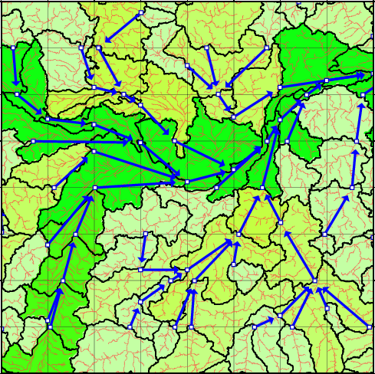

**Figure 4.1: Discretization of unit-catchments in the river network map. The outlet pixel of each unit-catchment is marked with a blue circle.**

The information of the dimension of the river network map is written in the **params.txt**. The size of the river network map (east-west grid number, **nx**; north-south grid number, **ny**), number of floodplain layers (**nfpl**), size of the grid box (**gsize**), and the domain boundary (**west**, **east**, **south**, **north**) are listed.

The river network map (**nextxy.bin**) prescribes the downstream cell of each grid cell. The records 1 and 2 denote the downstream grid point ix (**nextx**) and iy (**nexty**), respectively. The cell number in nextxy.bin is in the Fortran system (i.e. Top-left cell is [1,1] and bottom right cell is [nx,ny]). The river mouth is represented as -9, inland termination is -10, and ocean (undefined) is -9999. The river network map is prepared as “relative downstream format” (downxy.bin), in which the relative location of the downstream grid is stored. If the considering cell is [ix,jy] and its downstream is [jx,jy], and in case (jx=ix+dx, jy=iy+dy); the nextxy.bin represents the downstream by (jx,jy), while downxy.bin represents the downstream by (dx,dy).

A set of topographic parameters (Figure 4.2a) consists of the unit-catchment area [m2] (**ctmare**), base elevation [m] (**elevtn**), channel length [m] (**rivlen**), channel depth [m] (**rivhgt**), channel width [m] (**rivwth**), downstream distance [m] (**nxtdst**), and floodplain elevation profile [m] (**fldhgt**). The floodplain elevation profile is the CDF function (Figure 4.2b) of the height above the nearest river channel within each unit-catchment (Figure 4.2c), which is used to calculate the flooded area [m2] from the flood depth [m]. 10 values from each 10th percentile of the CDF function are stored in **fldhgt.bin**. For example, the record 3 of the **fldhgt.bin** represents the flood depth [m] of the unit-catchment when 30% of its area is flooded.

Channel width and depth parameters (**rivwth.bin**, **rivhgt.bin**) are calculated using empirical equations (see **map/src_param/s01-channel_params.sh**). The satellite-based river width from MERIT Hydro width [Yamazaki et al. 2019; Yamazaki et al., 2014b] is also prepared (**width.bin**). The recommended channel width data for calculation is the integrated channel width (**rivwth_gwdlr.bin**, calculated by **set_gwdlr.F90**)

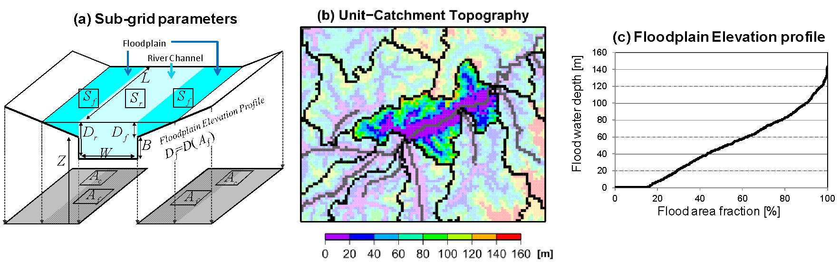

**Figure 4.2: (a) Schematic illustration of the sub-grid parameters for the river channel and floodplains. (b) Unit-catchment topography. The height above the nearest river channel is shown by the background color. (c) Floodplain elevation profile.**

The input matrix (lookup table) for interpolating gridded runoff forcing to irregular unit-catchments is also prepared (**inpmat-test_1deg.bin**). Each unit-catchment receives input water mass from the input grid boxes which overlap the unit-catchment. The input water mass into the grid cell i is calculated by Equation (4.1):

(4.1)

where is the input water mass into the grid cell [m3s-1], is the overlapped area between the unit-catchment of the grid cell and the runoff grid box [m2], is the runoff forcing of the runoff grid box [ms-1]. is the maximum number of the overlapped runoff grid boxes for one unit-catchment (**inpnum**) which determines the size of the input matrix (**nxin*nyin*inpnum**), and it is written in the dimension file (**diminfo.txt**). Records 1 and 2 of the input matrix represents the (**ixin, iyin**) location of the corresponding runoff grid box, and the record 3 represents the overlapped area [m2] (**inpa**).

A file to specify dimensions of simulation (domain, resolution, number of CaMa-Flood grids and input grids, input matrix filename) is prepared (e.g. **diminfo_test-1deg.txt**, for simulation with sample 1 degree runoff input inp/test-1deg/).

**Table 4.1: The river network map and topographic parameters**

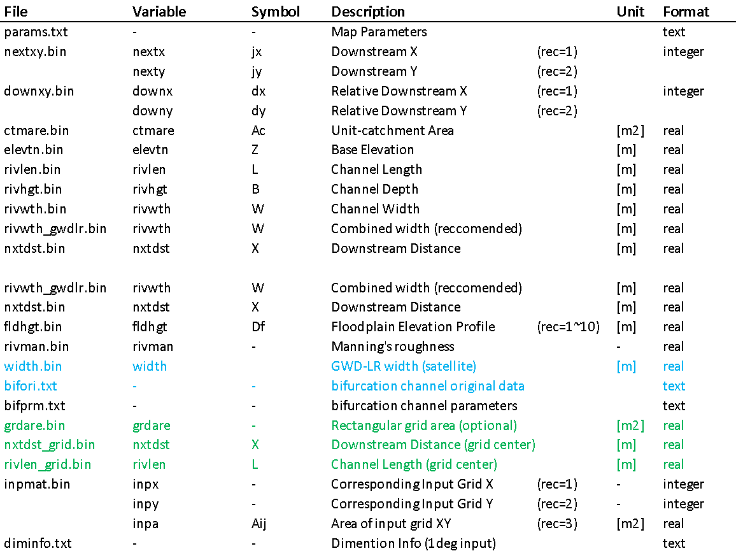

**Table 4.2: The river network map and topographic parameters**

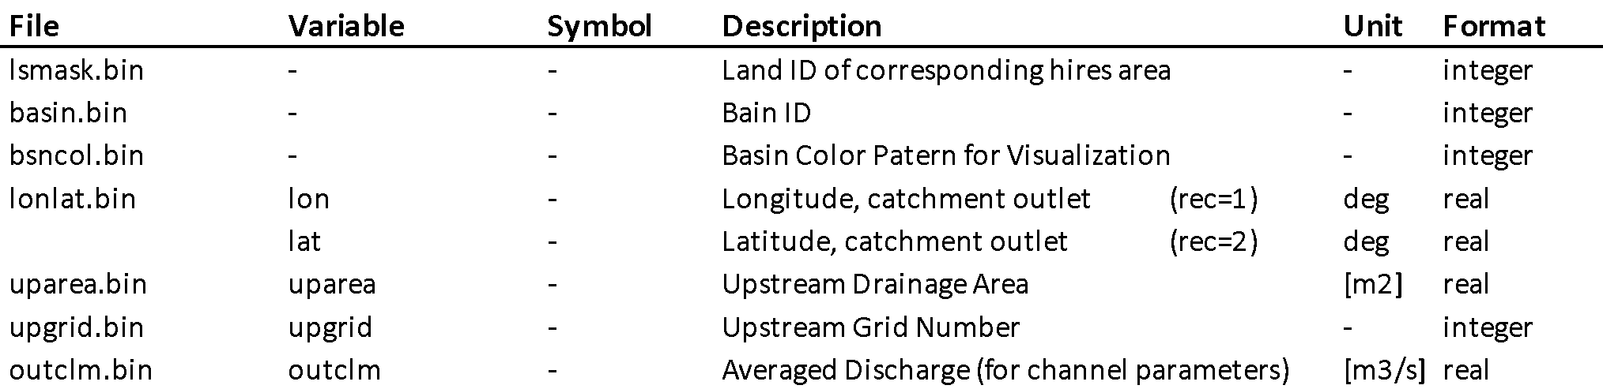

Some high-resolution data required for generating input matrix and floodplain depth downscaling are prepared as (1min/, 15sec/, 3sec/) in **map/glb_15min/** directory. The high-resolution data is divided into tiles **$(TILE).$(VAR).bin** and the domain of each tile is listed in “**location.txt**” file.

**$(TILE).flwdir.bin** and **$(TILE).downxy.bin** describe the downstream direction in D8 format and downstreamXY format, respectively. **$(TILE).catmxy.bin** represents the CaMa-Flood catchment (iXX,iYY) of each hires pixel (ix,iy), **$(TILE).catmzz.bin** represents the corresponding floodplain layer of each pixel. **$(TILE).flddif.bin** represents the height above the river channel of each pixel [m], which is used for downscaling. **$(TILE).visual.bin** can be used for high-resolution catchment boundary visualization, where sea=0, land(undefined)=1, land(defined in CaMa)=2, grid-box=3, catchment-boundary=5, channel=10, outlet-pixel=20, and river-mouth=25. The other files are explained in Table 4.3.

**Table 4.3: The high-resolution maps**

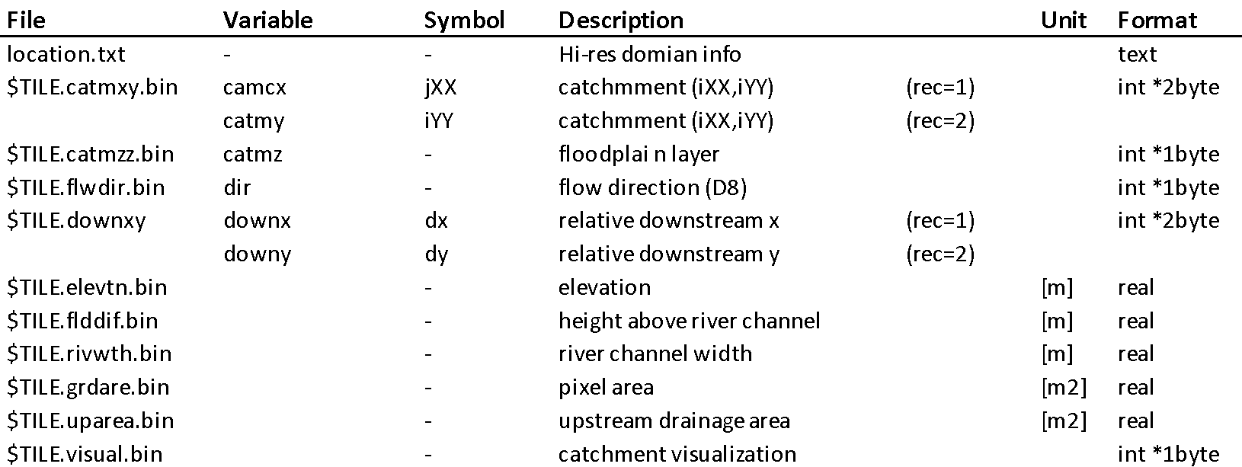

## 4.2 Rectangular-grid simulation

Instead of using irregular unit-catchments, the CaMa-Flood model can stably execute hydrodynamic simulations with traditional rectangular grid boxes as its computational elements, by specifying “grdare.bin, rivlen_grid.bin, nxtdst_grid.bin” in the go shell script. The irregular unit-catchment area is replaced with the area of the rectangular grid box, while the upstream-downstream relationship is given by the same river network map of the grid-vector-hybrid approach. The channel length and downstream distance are also replaced with the distance between the centers of the grid box and its downstream grid box. The topographic parameters for the fully-grid-based approach are prepared in the same directory of the grid-vector-hybrid approach. Rectangular-grid simulation contains some bugs in v390-395 have been fixed.

## 4.3 Channel Cross-section Parameters

The channel cross-section parameters (channel length and channel depth) are estimated by an empirical function of river discharge climatology, while the other topographic parameters are explicitly derived from the fine-resolution flow direction map and DEM.

Firstly, the climatology of daily river discharge is calculated by the **calc_outclm.F90** program in **$(CaMa-Flood)/map/src_param/** directory. The climatology of daily river discharge is written to the output file **outclm.bin**. The record 1 is the annual average discharge (m3/s), , while the record 2 represents the 30-day moving average of upstream runoff (used before v3.9.4). The annual maximum of 30-day moving average of upstream runoff, , is introduced because it is assumed that the size of a channel cross-section is determined by flood peak discharge rather than the annual average discharge.

Second, the channel cross-section parameters (channel width (m), ; Channel depth (m), ) are calculated by the program **calc_rivwth.F90** in the **$(CaMa-Flood)/map/** directory. The channel width **rivwth.bin** and channel depth **rivhgt.bin** are generated. These two parameters were derived by the following empirical equations:

(4.2)

(4.3)

where is the channel width (m), is the channel depth (m), and is the annual average discharge [m3 s-1].

The default parameters of ,,, , , , , have been predefined in ***s01-channel_params.sh.*** However, note that the uncertainty in these cross-section parameters is still very high, so extensive calibration is recommended when you set up a new simulation. The coefficients of Equation (4.2) and (4.3) can be changed in the shell script ***s01-channel_params.sh***. For generating cross-section parameters, go to the map file directory (e.g. **map/global_15min/**) and execute **% ./s01-channel_params.sh**.

In addition to the power-low estimation, satellite-based river width data are prepared in “width.bin”. The combined width parameter (integration of power-low and satellite) can be generated by the code set_gwdlr.F90. The combined width parameter is recommended in CaMa-Flood simulations.

# 5. Input Runoff Forcing

A set of sample input runoff forcing is prepared at **$(CaMa-Flood)/inp/test-1deg/** directory. The sample input data is prepared for the years 2000 and 2001, from the output of Ensemble Land State Estimator (ELSE) [Kim et al., 2010]. The sample runoff is calculated using the land surface model MATSIRO forced by the climate forcing from the JRA-25 reanalysis with precipitation correction using GPCC. The sample runoff data is at 1 degree resolution, and prepared in the “plain binary” format. The data array is from 180W to 180E and from 90N to 90S. Note that the byte order of the sample data is “little endian”, so that endian conversion may be required according to the computer environment.

The naming convention of the input runoff forcing is **$(prefix)YYYYMMDD$(suffix)**. In case of the sample data, the prefix is “**Roff____**” and the suffix is “**.one**”. This setting can be changed in a shell script in **$(CaMa-Flood)/gosh/** directory.

The default unit of runoff input is [mm/day] and it’s converted to [m3/s] in simulation. another unit [water mass / unit area / unit time] can be used by changing the following parameters in gosh script. **DROFUNIT**: runoff unit conversion ratio (set to 86400000 in default for conversion from [mm/day] to [m/s]). **IFRQ_INP**: input forcing update frequency (hour).

If you want the runoff input forcing for the full period other than the sample data period (2000-2001), please contact the CaMa-Flood developer. You can also replace the sample input data with another runoff dataset. Runoff input files in netCDF format can also be used. Sample netCDF runoff at 15min is prepared in **inp/test_15min_nc/** directory.

In case the grid coordinate system of the runoff forcing is different from the sample dataset, you have to re-calculate the input matrix **inpmat-$(resolution).bin** for the runoff interpolation scheme. The input matrix can be generated by editing and executing the shell script **map/src/src_param/s02-generate_inpmat.sh**. The default value in **map/s03-generate_inpmat.sh** can be used to generate the input matrix for the sample 15min netCDF runoff. Remember change the $CDIMINFO $CINPMAT in the gosh file if the output file names are changed.

# 6. Output Files

The CaMa-Flood can output variables listed in Table 6.1. These output files are in plain binary format at the same grid coordinate system as the river network map. The output is daily in a default setting. Undefined value (for ocean grids) is set to 1.e20.

**Table 6.1 List of output variables**

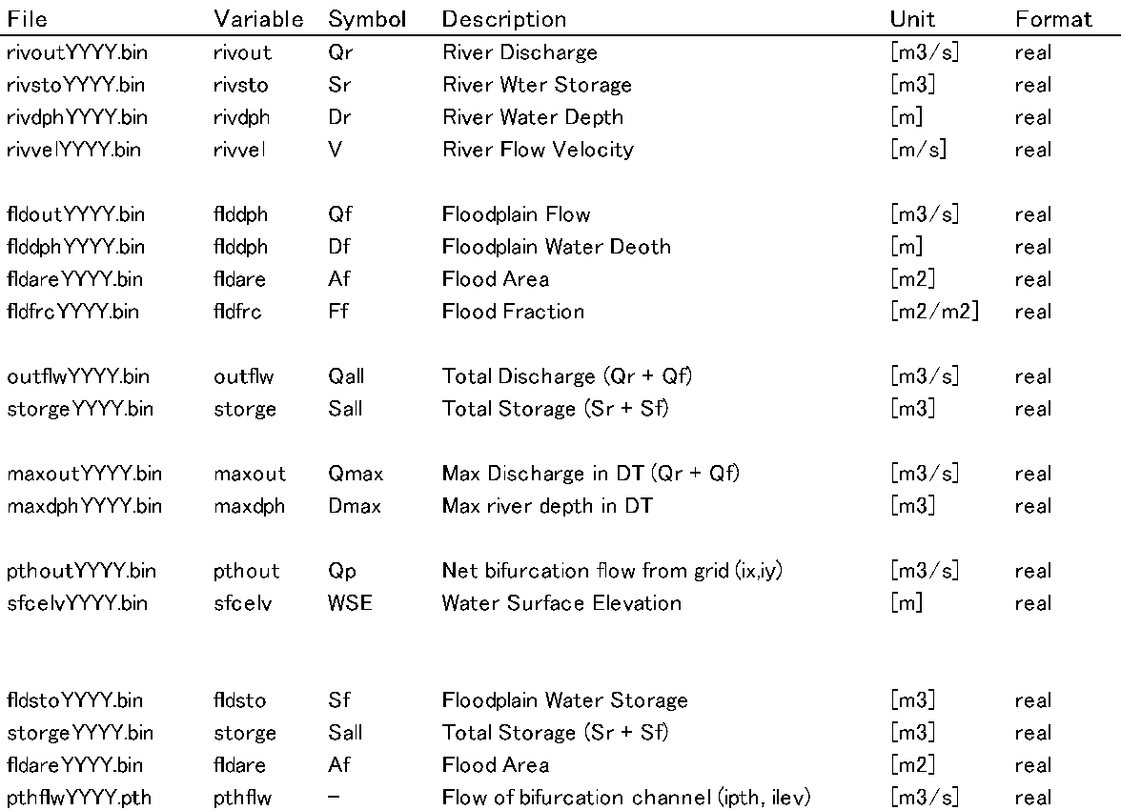

Flood fraction represents the fraction of the flooded area to the unit-catchment area of each grid cell. The water surface elevation is calculated as , where is base elevation, is channel depth. Flood Fraction is the fraction of flooded area to the unit-catchment area of each grid cell. Note that flooded area and flood fraction is calculated based on **the irregular shaped unit-catchment**, so that they are not suitable for a rigorous comparison against gridded dataset. If you want to have flooded area or flood fraction for the regular gridded box, please do the downscaling first (section 2.6) and the aggregate the high-resolution flooded pixels to the grid box at the ideal spatial resolution. The river discharge and flow velocity are outputted as daily average, while the other variables are outputted as the instantaneous value at GMT 00:00 of each day. The max discharge and max river depth represent “maximum value within ”, which is needed for some applications. In the latest version, the output can be written in netCDF if ${LOUTCDF}=.TRUE. in the go script.

In the sample executable shell script, the output files are written in the result directory **$(CaMa-Flood)/out/$(experiment)**.

# 7. Shell Script to execute simulations

## 7.1 test1-glb_15min.sh

Executable shell scripts to run a CaMa-Flood simulation are prepared in the shell script directory **$(CaMa-Flood)/gosh/**. The sample executable shell script is **test1-glb_15min.sh**. In the executable shell script, the simulation settings are written in the input namelist “**input_cmf.nam**”, and then the simulation is executed in the running directory specified in the shell script.

The setting of the sample executable shell script (**test1-glb_15min.sh**) is as follows.

- BASE Directory: **BASE=”$(CaMa-Flood)/”** or **BASE=`pwd`/../**

- Experiment name: **EXP=“test1-glb_15min”**

- The simulation is executed in the running directory **RDIR=“${BASE}/out/$EXP”**. The OpenMP parallelization with 4 CPUs.

- Floodplain flow is activated (**LFLDOUT=.TRUE.**), bifurcation channel scheme is activated (**LPTHOUT=.TRUE.**). Storage only restart is deactivated (**LSTOONLY=.FALSE.**)

- River discharge is calculated by the local inertial equation (the local inertial equation for small slope areas; the diffusive wave equation for steep areas). Adaptive time step is activated (**LADPSTP=.TRUE.**).

- Simulation time is set from 1990 to 1991 **(YSTA, YEND**). The simulation starts from the zero storage condition (**SPINUP=0**) and spin-up period is set to 1 years (**NSP=1**).

- The river network map and topography parameters in the map directory **FMAP=”$(CaMa-Flood)/map/glb_15min/”** are used. Channel width parameter is from GWD-LR (**CRIVWTH=${FMAP}/rivwth_glwlr.bin**), channel depth parameter is from empirical equation (**CRIVHGT=${FMAP}/rivhgt.bin**).

- Input runoff forcing is interpolated by using the input matrix (LINTERP=.TRUE. ; **CINPMAT=${FMAP}/inpmat-test_1deg.bin**). Runoff input forcing in the runoff directory **CRUNOFFDIR="${BASE}/inp/test_1deg/runoff/"** is used.

- The output is written in the running directory **COUTDIR="./"** . Output variable can be specified by listing them in **COUTVARS**. For example, total river discharge (outflw), river water depth (rivdph) and flooded area (fldare), flooded fraction (fldfrc), water surface elevation (sfcelv), total water storage (storge). The bifurcation channel flow output is automatically set to NONE in the simulation when bifurcation channel scheme is deactivated.

## 7.3 test2-conus_06min_netcdf.sh

Another given example is regional simulation for CONUS (Continental United States) with runoff inputs in netcdf format. Different settings from the global test script are listed as follows:

- Option to use netcdf runoff input: **LINPCDF=”.TRUE.”**.

- Input runoff: the sample runoff is prepared in **CROFDIR="${BASE}/inp/test_15min_nc/"**. The file name of the runoff starts with **CROFPRE=”e2o_ecmwf_wrr2_glob15_day_Runoff_”** and the variable name for runoff is given as **CVNROF=”Runoff”**.

- The river network map and topography parameters in the map directory **FMAP=”$(CaMa-Flood)/map/conus_06min.** This map only covers the CONUS region.

- The runoff matrix should be prepared since only part of the global data is used. The detailed steps are described in section 2.7 Regionalization. The new runoff matrix can be specified with **CDIMINFO** and **CINPMAT**.

- Option to write output in netcdf: **LOUTCDF=”.TRUE.”**.

- Select the netcdf as the form for restart file **CRESTSTO=”${CVNREST}${CYR}010100.nc”**.

## 7.3 test3-jpn_fcast.sh

This example script is for forecasting which should be limited in a smaller region with much finer spatial resolution and shorter computation time step. The sample region is the Japan region with simulation at 1min spatial resolution. The specific settings are listed as follows:

- Higher temporal resolution of the runoff input: **DT=3600** and **IFRQ_INP=”1”** since the input is hourly.

- More frequent restarting: **IFRQ_RST=”3”** as the restarting repeats every 3 hours.

- The sample hourly runoff is **CROFDIR="${BASE}/inp/test_jpn_1hr/"**

- The 1min map for Japan **FMAP=”$(CaMa-Flood)/map/tej_01min”**

- The runoff matrix are specified with **CDIMINFO** and **CINPMAT.**

- The forecasting leading time can be modified in setting the **EDAY** and **EHOUR**. The given sample is for 39 hour forecasting, **EDAY=$(($SDAY+1))** and **EHOUR=$(($SHOUR+15)).**

# 8. Simulation Settings

The simulation options available in the CaMa-Flood model are explained in this section. The switches (or variables) to control the simulation setting are stored in “**yos_cmf_input.F90**”, and they can be changed by editing the input namelist “**input_cmf.nam**”.

## 8.1 Restart Mode

The CaMa-Flood can be run from the zero-storage condition or from the initial condition given by a restart file. For the simulation from the zero-storage condition, set **IRESTART=0** (default). Spin-up period can be specified by setting **NSP=$(spin-up years)**.

For the simulation from the restart file, set **IRSTRT=1**, and specify the restart file directory (**CRESTDIR**) and the restart file name (**CRESTSTO**). The restart files are outputted at the end of each year as defaults (**IFRQ_RST=0**), but hourly/daily/monthly restart file can be saved by changing **IFRQ_RST**.

For discharge calculation by local inertial equation, discharge and flood stage of the previous time step is required for a strict restart. When restart only from water storage is preferred, please change the setting in gosh script to **LSTOONLY=.TRUE.**

## 8.2 Simulation Time

Simulation time can be specified at specific dates by editing **SYEAR, SMON, SDAY, SHOUR** and **EYEAR, EMON, EDAY, EHOUR**.

## 8.3 Runoff Interpolation

Runoff forcing can be inputted to unit-catchment by the “nearest point interpolation” or the “runoff interpolation scheme with mass conservation”. The nearest point interpolation is activated by setting **LINTERP=.FALSE.** . The nearest point interpolation is valid only when either of the grid-vector-hybrid map or the fully-grid-based map is used. The runoff interpolation scheme with mass conservation is activated by setting **LINTERP=.TRUE.** and by specifying the input matrix name (**CINPMAT**).

## 8.4 Routing Scheme

Floodplain flow routing can be activated by setting **LFLDOUT=.TRUE.** .

Bifurcation channel scheme can be activated by setting **LPTHOUT=.TRUE.** . Bifurcation channel parameters must be generated in the map directory by **map/s01-channel_params.sh**.

The kinematic wave routing can be used by setting **LKINE=.TRUE.** .

The floodplain inundation scheme can be deactivated by setting **LFPLAIN=.FALSE.** . Note that the run without floodplain inundation is not stable with the diffusive wave equation, so the no floodplain option must be used with the kinematic wave equation (**LKINE=.TRUE.**).

## 8.5 Adaptive and Constant Time Step Schemes

The adaptive time step scheme is activated by setting **LADPSTP=.TRUE**. and set the time step **DT=86400** (1 day). The time step can be smaller than 1day. For example, when hourly output is needed, use **DT=3600**. Then the adaptive time step routine automatically selects the maximum acceptable time step at the initiation of the daily calculation loop in **cmf_ctrl_physics_mod.F90**. Note that the adaptive time step scheme is valid only when the local inertial equation is used (**LKINE=.FALSE.**).

In order to use the constant time step scheme, deactivate the adaptive time step (**LADPSTP=.FALSE.**) and manually set the time step **DT=$(timestep_in_sec)**.

## 8.6 Usage of netCDF

The netCDF I/O commands are supported in the CaMa-Flood model. Please activate the flag **DCDF=-DUseCDF** in **$(CaMa-Flood)/adm/Mkinclude**. The netCDF I/O is activated by the following flags in the namelist: for river network maps (**LMAPCDF**); for restart data (**LRESTCDF**), and output data (**LOUTCDF**). Note that netCDF river network map is mainly used in ECMWF, and not included in the sample package.

# References

Bates, P. D., M. S. Horrit, and T. J. Fewtrell (2010), A simple inertial formulation of the shallow water equations for efficient two-dimensional flood inundation modeling, J. Hydrol., 387, 33-45, doi:10.1016/j.jhydrol.2010.03.027.

Cohen, S., Kettner, A.J., and Syvitski, J.P.M., 2013. WBMsed: a distributed global-scale riverine sediment flux model - model description and validation. Computers and Geosciences, 53, 80-93, doi: 10.1016/j.cageo.2011.08.011.

Farr, T. G., et al. (2007), The Shuttle Radar Topography Mission. Rev. Geophys. 45, RG2004, doi:10.1029/2005RG000183.

Hirabayashi, Y., R. Mahendran, S. Koirala, L. Konoshima, D. Yamazaki, S. Watanabe, H. Kim, S. Kanae (2013) Global flood risk under climate change, Nature Climate Change, 3, 816-821, doi:10.1038/nclimate1911.

Hunter, N. M., M. S. Horritt, P. D. Bates, W. D. Wilson, and M. G. F. Werner, (2005) An adaptive time step solution for raster-based storage cell modeling of floodplain inundation, Advances in Water Resources, 28, 975–991.

Lehner, B., K. Verdin, and A. Jarvis (2008), New global hydrography derived from spaceborne elevation data, EOS Trans. AGU, 89(10), doi:10.1029/2008EO100001.

Masutomi, Y., Y. Inui, K. Takahashi, and U. Matsuoka (2009), Development of highly accurate global polygonal drainage basin data, Hydrol. Processes, 23, 572-584, doi:10.1002/hyp.7186.

Pappenberger, F., E. Dutra, F. Wetterhall, and H. L. Cloke (2012) Deriving global flood hazard maps of fluvial floods through a physical model cascade, Hydrol. Earth Syst. Sci., 16, 4143-4156, doi:10.5194/hess-16-4143-2012.

Yamazaki, D., T. Oki., and S. Kanae (2009), Deriving a global river network map and its sub-grid topographic characteristics from a fine-resolution flow direction map, Hydrol. Earth Syst. Sci., 13, 2241–2251.

Yamazaki, D., S. Kanae, H. Kim, and T. Oki (2011), A physically-based description of floodplain inundation dynamics in a global river routing model. Water Resour. Res. 47, W04501, doi:10.1029/2010WR009726.

Yamazaki, D., H. Lee, D. E. Alsdorf, E. Dutra, H. Kim, S. Kanae, and T. Oki (2012a), Analysis of the water leveldynamics simulated by a global river model: A case study in the Amazon River, Water Resour. Res., 48, W09508,doi:10.1029/2012WR011869.

Yamazaki, D., C. Baugh, P. D. Bates, S. Kanae, D. E. Alsdorf, and T. Oki (2012b), Adjustment of a spaceborne DEM for use in floodplain hydrodynamic modeling. J. Hydrol., 436-437, 81-91, doi:10.1016/j.jhydrol.2012.02.045.

Yamazaki, D., G. A. M. de Almeida, and P. D. Bates (2013), Improving computational efficiency in global river models by implementing the local inertial flow equation and a vector-based river network map, Water Resources Research, published online.

Yamazaki, D., T. Sato, S. Kanae, Y. Hirabayashi, and P. D. Bates (2014a), Regional ﬂ ood dynamics in a bifurcating mega delta simulated in a global river model, Geophys. Res. Lett., 41, doi:10.1002/2014GL059744.

Yamazaki, D., F. O ’ Loughlin, M. A. Trigg, Z. F. Miller, T. M. Pavelsky, and P. D. Bates (2014b), Development of the global width database for large rivers, Water Resour. Res., 50, doi:10.1002/2013WR014664.

Yamazaki, D., M.A. Trigg, D. Ikeshima (2015), Development of a global ~90 m water body map using multi-temporal Landsat images, Remote Sens. Env. 171, doi: 10.1016/j.rse.2015.10.014

Yamazaki, D., D. Ikeshima, R. Tawatari, T. Yamaguchi, F. O'Loughlin, J.C. Neal, C.C. Sampson, S. Kanae and P.D. Bates (2017), A high accuracy map of global terrain elevations, Geophysical Research Letters, 44, doi: 10.1002/2017GL072874

# Version History

**CaMa-Flood Ver 1**

The first version developed in U-Tokyo as a part of the master thesis of the developer. This version was used for the simulations in [Yamazaki et al., 2011, WRR].

**CaMa-Flood Ver 2**

The program was improved under the collaboration with ECMWF. Many schemes for improving the computational efficiency have been implemented to the model, including the 2D-map to 1D-vector conversion and parallelization using OpenMP and MPI. This version was used for the simulations in [Yamazaki et al., 2012a, WRR].

**CaMa-Flood Ver 3**

The routing scheme was finally stabilized in this version by implementing the local inertial equation developed in U-Bristol.

* Ver 3.0: Implementation of “the local inertial equation” and “the adaptive time step scheme”
* Ver 3.1: New river network maps in which the elevations of river mouth are corrected to 0 m.
* Ver 3.2: Implementation of “the vector-based river network map”, and “the runoff interpolation considering mass conservation”. Many additional changes are included along with these new schemes.
* Ver 3.3.0: ~~The hybrid routing which uses both of the local inertial equation and the diffusive wave equation. The error of discharge calculation in high slope areas was fixed.~~ (problem solved in v3.3.1)
* Ver 3.3.1: The stabilized local inertial equation (instead of the hybrid routing). This version is used for the simulation in [Yamazaki et al , 2013]
* Ver 3.4.0: Floodplain flow is implemented. Minor changes in model structure (e.g. diagnostic variable, subroutine names at the control level.)
* Ver 3.4.4: Regionalization, Downscaling, Input matrix generation.
* Ver 3.4.5: Bug fix in elevation map.
* Ver 3.5: Test Version for Bifurcation Flow (not distributed)
* Ver 3.6.0: Test Version for Global Bifurcation and GDW-LR
* Ver 3.6.1 Distributed Version: Global Bifurcation Flow, GWD-LR, etc.
* Ver 3.6.2 Bug fix.
* Ver 3.9.4 Latest topography datasets (MERIT Hydro) was integrated, and FLOW upscaling algorithm was updated. Changes in filenames and code structures.
* Ver 3.9.5 Bug fix.
* Ver 3.9.6a Bug fix.
* Ver 3.9.6b Bug fix in restarting process.
* Ver 4.0: official release of the new version. (contents are virtually same as v3.96b, with some minor corrections)