**Control: ds24 in PBS / 2mM TX – old stock TX-Ethanol**

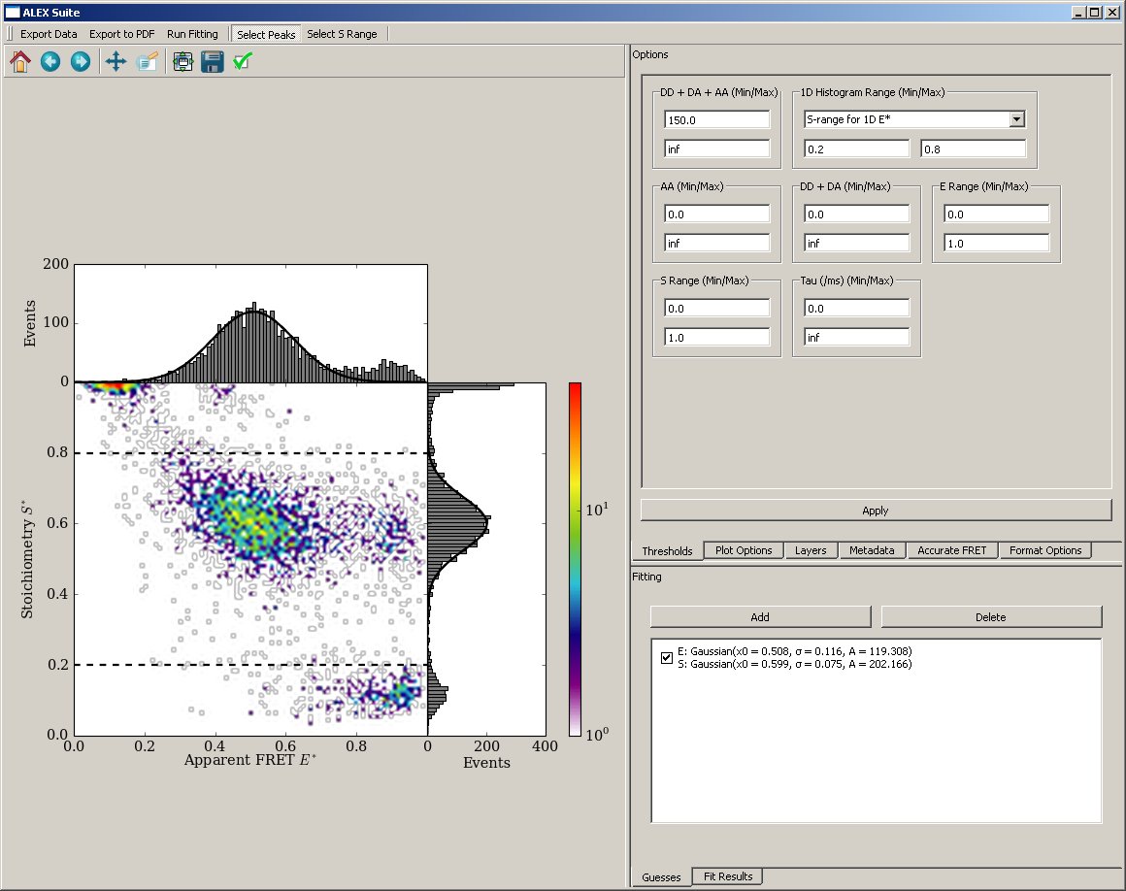 **0.508 (0.116) / 0.599 (0.075)**

**Control: ds24 in PBS / 2mM TX – new stock TX-Ethanol**

|  |  |
| --- | --- |
| **15.01. – 0.478 / 0.614** | **14.01. – 0.493 (0.083) / 0.606 (0.068)** |
|  |  |

**Control: ds24 in PBS / 2mM TX – new stock TX-Ethanol – after alignment**