Automated identification and separation of quartz CW-OSL signal components with R

Dirk Mittelstraß1,*, Christoph Schmidt2, Jan Beyer3, Johannes Heitmann3, Arno Straessner1

1Institut für Kern- und Teilchenphysik, Technische Universität Dresden, 01062 Dresden, Germany

2Institute of Earth Surface Dynamics, University of Lausanne, 1015 Lausanne, Switzerland

3Department of Applied Physics, TU Bergakademie Freiberg, 09599 Freiberg, Germany

*Correspondence to*: Dirk Mittelstraß ([dirk.mittelstrass@luminescence.de](mailto:dirk.mittelstrass@luminescence.de))

**Abstract.** The accuracy of quartz OSL dating results relies strongly on the dominance of the thermally stable and easy-to-bleach ‘fast’ signal component. If this component does not dominate the initial OSL signal in a given data set, systematic errors are likely. These originate in the signal contribution of insufficiently bleached or thermally unstable traps. To solve this issue, a new approach for mathematical component separation is presented. First, we identify the number of signal components and their decay constants. We do this by creating one global OSL decay curve from all records of a given data set and apply a multi-component exponential decay fitting method. Second, we deploy the found decay constants in an algebraic decomposition algorithm and divide every single OSL record into its signal components. We test the accuracy, precision and robustness of the proposed procedures by comprehensive simulations and evaluate the results by statistical methods. The simulations demonstrate the mathematical reliability of the method in the majority of scenarios. The usefulness of the method as reliable and rapid data analysis tool in quartz OSL dating is demonstrated though the re-evaluation of some previously obtained standard SAR data sets. The new approach is freely available as **R** package ‘OSLdecomposition’.

# 1 Introduction

The optically stimulated luminescence (OSL) signal of natural quartz minerals is routinely used to date Quaternary sediments and archaeological materials (Aitken, 1998; Preusser et al., 2009; Roberts et al., 2015). Under the assumption of first-order kinetic processes of charge redistribution upon illumination, it was suggested that the bulk OSL signal of quartz is composed of several individual components (Bailey et al., 1997; Huntley et al., 1985; Smith and Rhodes, 1994). Each signal component decays exponentially under continuous wave stimulation (CW-OSL) and in dependence to the speed of decay, the components are termed 'fast', 'medium' and 'slow' (Bailey et al., 1997; Smith and Rhodes, 1994). For quartz OSL signals, multiple slow decaying components are known, which are enumerated 'slow1', 'slow2' etc. (Bailey, 2002; Jain et al., 2003; Singarayer and Bailey, 2003). In addition, an ‘ultrafast’ component was found in some quartz samples (Goble and Rittenour, 2006; Jain et al., 2003, 2008).

Due to its fast optical resetting and its thermal stability, the 'fast' component commonly represents the target signal for dating and dosimetry purposes (see review by Wintle and Murray, 2006). The significant presence of other than the 'fast' component in the initial portion of the CW-OSL curve entails inaccuracies in the determined equivalent dose (*D*e). First, the comparatively low thermal stability of the 'ultrafast', 'medium' and one or more of the 'slow' components may lead to dose underestimation due to drainage of trapped charge over the dating period (Choi et al., 2003; Goble and Rittenour, 2006; Klasen et al., 2015; Li and Li, 2006; Solongo et al., 2006; Steffen et al., 2009). Second, the lower bleaching rate of 'non-fast' signals could result in overestimated doses, especially in environments where light exposure of quartz grains during transport is temporally limited (e.g., colluvial deposition) or spectrally restricted (e.g., lack of UV during transport under water) (Aitken, 1998; Bailey et al., 1997; Fuchs and Lang, 2009; Singarayer and Bailey, 2004).

More reliable and accurate dating results for quartz samples are achieved if the 'fast' component is isolated from the bulk OSL signal. Various approaches to do so were proposed in the past two decades, from which a common one is the application of the LM-OSL technique (Bulur, 1996; Bulur et al., 2000). Here, individual OSL components occur in a peak-like shape, achieved by linearly increasing the optical stimulation power over the measurement period (in analogue to thermoluminescence measurements). Assuming first-order kinetics, the maximum of a peak is directly related with the decay rate (i.e., photo-ionisation cross-section) of the component (Bulur, 2000). Thus, LM-OSL measurements allow to identify the OSL components and by simply looking at the diagrams. This ‘looking-at’ approach can also be performed at CW-OSL measurements which offer better signal-to-noise ratio (SNR), shorter measurement periods and higher stochastic signal variability (Pagonis et al., 2020). This is enabled by the mathematical transformation of CW-OSL into 'pseudo'-LM-OSL curves (Bos and Wallinga, 2012; Bulur, 2000; Kitis et al., 2011). But, the ‘looking-at’ analysis of LM-OSL and pseudo-LM-OSL measurements is time-consuming and requires sufficient user experience and is therefore not applicable for routine dating.

For separating the OSL components accurately and efficiently in routine dating, a procedure is required which does not rely on user interaction. To be applicable for standard measurement protocols, such a procedure needs to work with PMT-measured CW-OSL curves. However, as an ill-posed problem (Istratov and Vyvenko, 1999), the decomposition of multi-exponential decay functions, like CW-OSL curves, is not straightforward. Deterministic fitting algorithms are prone to find local minima instead of global ones. It may also occur that they stop before achieving results due to diverging parameters, which might happen if the SNR is not sufficiently high or the start parameters are chosen badly. These problems become more severe with an increasing number of OSL components.

Bluszcz and Adamiec (2006) presented a sophisticated strategy: They fitted experimental data in multiple cycles with an increasing number of components. The fitting quality after each cycle is compared with the outcome from the previous cycle by a statistical criterion (F-test). If this test cannot detect a significant improvement in fitting quality by adding an additional component, the previous fitting cycle with one component less is defined as sufficient. The starting parameter issue, still relevant for each fitting cycle, is solved by applying a parameter-evolution-based algorithm which finds global minimum fittings from multiple random sets of starting parameters. Peng et al. (2014) substituted the F-test with the Bayesian Information Criterion and studied through a large number of simulations the accuracy in finding the correct number of OSL components and their decay constants. They found that despite accurate overall results, the algorithm becomes inaccurate for dim signals and short measurement times.

This means, despite the progress made by Bluszcz and Adamiec (2006) and Peng et al. (2014), bright sample material or high doses are needed to provide a sufficient signal-to-noise ratio in all single CW-OSL curves. Sufficient signal-to-noise ratios are also needed for experimental methods of stimulating the 'fast' component discretely (Bailey, 2010; Jain et al., 2005; Singarayer and Bailey, 2004) and graphical component dose evaluation via *D*e(*t*)-plots (Bailey, 2000, 2003; Huntley et al., 1985; Tsukamoto et al., 2003)

As a consequence, more noise-insensitive and mathematically robust methods to isolate the 'fast' component were developed. The simplest and probably most common method is the ‘early light background subtraction’ (Ballarini et al., 2007; Cunningham and Wallinga, 2010). Here the signal interval is chosen to contain 50 % of the medium component signal and the subsequent background interval is chosen to contain the other 50 % of the medium component signal. Thus, the medium component is removed from the initial bulk signal. In the ‘Fast ratio’ approach, (Durcan and Duller, 2011) assume a 3-component CW-OSL model and approximate those data points in a bulk decay curve when particular components are dominant. They then solve a relation equation to estimate the fast component contribution to the initial signal. More noise-insensitive and providing a full separation of the fast and medium components is the method proposed by (Shen and Lang, 2016). They also assume a 3-component model, smooth the CW-OSL curve, define three intervals of component dominance and estimate the fast and medium component signal intensity by solving two relation equations. Although all these methods are mathematically robust and somewhat noise-insensitive, their accuracy relies on the exact knowledge of the OSL component decay rates. These are either taken from literature or obtained by separate LM-OSL measurements or CW-OSL fittings. However, the actual decay constants may differ from sample to sample and from OSL reader to OSL reader. The reliability of the calculated natural dose therefore depends on the agreement of the assumed set of OSL components with the actual OSL components of the sample, which is a hard to detect source of potential systematic errors. Furthermore, none of these approaches accounts the occurrence of multiple slow components.

Specific goals of this paper are:

* To …

To solve the discussed issues, an approach is needed, which combines the flexibility and objectivity of fitting procedures with the robustness and noise-insensitivity of relation equations. We achieve this by dividing the component-specific dose determination process into multiple major steps. For each step the in our knowledge most reliable method was chosen and tested and optimized for accuracy, precision and robustness by numerous simulations. Entirely novel in the field of luminescence dating is the component intensity calculation method applied in step 2. All steps are realized as **R** functions and bundled in the new **R** package OSLdecomposition. This new package is designed to be user-friendly and to enhance the usual workflow of data analyses performed with the **R** package Luminescence (Kreutzer et al., 2012).

The paper is organized as follows:

## 2 Mathematical approach

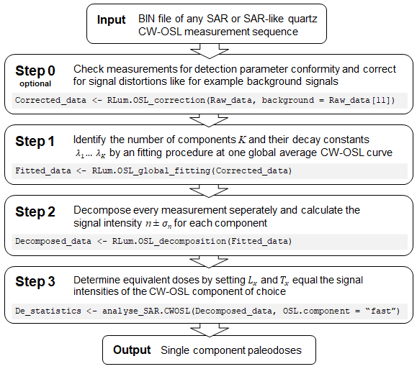

Figure : General workflow example of a signal component-wise quartz CW-OSL dose calculation approach. Grey highlighted: Associated R commands from package ‘OSLdecomposition’ (Step 0 – 2) and ‘Luminescence’ (Step 3)

We divide the component-specific dose calculation process into multiple steps as outlined in figure 1: Step 0 ensures the data set meets some basic requirements; Step 1 identifies the OSL component occurring in the data set by calculating one reference CW-OSL curve and applying the Bluszcz and Adamiec (2006) fitting procedure on it; Step 2 separates the components in each CW-OSL curve by an algebraic decomposition algorithm; Step 3 calculates component-wise equivalent doses by using the standard SAR protocol analysis methods. Each step stands for its own, connected to the next step only by the handed over data set, extended by some results. Thus, the methods used in each step can be improved and replaced without affecting the methods in the other steps.

## 2.1 Underlying assumptions

The mathematical approach is based upon a set of assumptions which will be considered as true for any CW-OSL data set. The first and fundamental assumption is that any CW-OSL signal $I\left(t\right)$ of quartz can be described as sum of exponential decays of first order:

|  |  |
| --- | --- |
| $$I\left(t\right)= \sum_{k=1}^{K}{n_{k}λ_{k}{\text{e}}^{-λ_{k}t}}$$ | (1) |

Every summand models one OSL signal component. We assume the number of components $K$ and the decay parameters $λ_{k}$ as constant throughout all measurements in a given data set while the component intensities $n_{k}$ have individual values for each single CW-OSL measurement. We further assume that the luminescence signal is measured in discrete and fixed time intervals, usually called ‘channels’, which is the default, and often the only available, detection mode for all commercially available OSL reader, as far as the authors know. Then, the signal of each channel is described by the integration of equation (1) over that channels time interval:

|  |  |
| --- | --- |
| $$I_{i}=\int_{\left(i-1\right)∆t}^{i∆t}{I\left(t\right)}= \sum_{k=1}^{K}{n_{k}\left({\text{e}}^{-λ_{k}\left(i-1\right)∆t}-{\text{e}}^{-λ_{k}i∆t}\right)} i=1, 2, 3,…,N$$ | (2) |

Here $∆t$ is the channel width, $i$ is the channel index and $N$ is the number of channels of the particular CW-OSL measurement. All methods further outlined in this paper, assume the correctness of equation (2) and the regression and decomposition algorithms used in Step 1 and Step 2 use equation (2) as curve model.

Equation (2) demands the data set to meet the following further requirements:

1. Identical stimulation and detection settings for all measurements
2. Corrected or negligible signal background
3. Corrected or negligible detector non-linearity

It is the task of step 0 in figure 1 is to check requirement 1 and eventually correct the data set to meet requirement 2 and 3.

## 2.2 Step 1 - Signal component identification

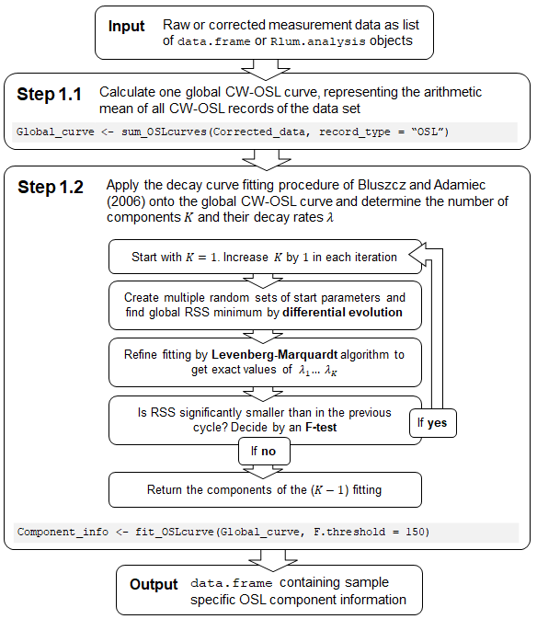

Figure : Workflow of the global CW-OSL signal component identification for a given data set. Step 1.2 is identical to the multi-exponential fitting approach of Bluszcz & Adamiec (2006). Grey highlighted: Associated R commands from package ‘OSLdecomposition’

One major goal during the development of the presented methods was to provide CW-OSL signal decomposition even for measurements with weak signals. Fitting equation (1) or (2) with all parameter unknown to low-SNR curves has a high likelihood of failure or false results, depending on the used algorithm and the accuracy of the start parameters. Therefore, an approach to increase SNR prior fitting is necessary.

### 2.2.1 Global average curve

In step 1.1, outlined in figure 2, the R function sum_OSLcurves() returns a sufficient-SNR curve by calculating one arithmetic mean CW-OSL curve from all CW-OSL curves of a data set. The data point values ${ \overline{I}}_{i}$ and their standard deviations ${\overline{σ}}_{i}$ of this reference CW-OSL curve are then given by:

|  |  |  |  |
| --- | --- | --- | --- |
| $${ \overline{I}}_{i}=\frac{1}{M}\sum_{m=1}^{M}{I_{i,m}}$$ | $${\overline{σ}}_{i}=\frac{1}{M}\sqrt{\sum_{m=1}^{M}{σ_{i,m}^{2}}}$$ | $$i=1, 2, 3,…,N$$ | (3) |

Here, $M$ is the number of all CW-OSL curves in the data set and $m$ is the index of each particular one. The signal values ${\overline{I}}_{i}$ have the same order of magnitude as their corresponding signal values ${ I}_{i.m}$ in the majority of CW-OSL curves of the data set. But because of the square root, the signal errors ${\overline{σ}}_{i}$ will be one or two magnitudes of order smaller than the single CW-OSL curve error values $σ_{i.m}^{ }$ depending on the number CW-OSL curves and their homogeneity regarding error values. This allows us to fit (2) onto the reference CW-OSL curve with high accuracy and precision even if the single curves provide only low-SNR signals.

It has to be noted, that using a reference CW-OSL curve to determine the decay constants is mathematically allowed because we assumed $λ_{1}… λ_{K}$ as global constants. Thus the values of the term ( ${\text{e}}^{-λ_{k}(i-1)∆t}-{\text{e}}^{-λ_{k}i∆t})$ in equation (2) remain static throughout the data set and just vary with the indices $i$ and $k$. The only parameters varying from CW-OSL curve to CW-OSL curve are the component intensities $n_{1}… n_{K}$. Fitting the reference CW-OSL curve gives back the arithmetic mean of the component intensities.

### 2.2.2 Multi-component exponential decay fitting

In step 1.2, fit_OSLcurve() applies the multi-component exponential decay fitting procedure developed by Bluszcz and Adamiec (2006) at the reference CW-OSL curve and returns the CW-OSL component parameters. For the further data analysis in step 2, just the number of OSL components $K$ and their decay constants $λ_{k}$ are of relevance. We will give in this publication just a brief description of the Bluszcz and Adamiec (2006) procedure. A throughout description can be found there or in Mittelstraß (2019) which includes also a closer look at the dependencies of $χ^{2}$.

In the procedure, equation (2) is fitted at the reference CW-OSL curve in cycles with increasing number of components $K$. The starting problem issue is solved by HELA (‘hybrid evolutionary-linear algorithm’), a specialized version of the differential evolution algorithm developed by Storn and Price (1997). HELA searches for residual minima from various random starting points inside a wide parameter space. By refining these starting points in multiple iterations, the global minimum can be found with very high certainty. To improve precision and to estimate the uncertainty of the resulting values, a Levenberg-Marquardt nonlinear regression is applied afterwards.

As minimisation value serves $χ^{2}$…

|  |  |
| --- | --- |
| $$χ^{2}=\sum_{i=1}^{N}{\frac{{\left(I_{i}-I_{i}^{*}\right)}^{2}}{\frac{I_{i}^{*}}{M}+\frac{∆tσ_{\text{detection}}^{2}}{M}}}$$ | (4) |

|  |  |
| --- | --- |
|  | (5) |

<<

*Why no error values in Step 1?*

Equation 4 allows us to calculate parameter errors without using computing time intense Monte Carlo simulations, see Bevington & Robinson (1997) or Mittelstraß (2019) for details. We decided deliberately to not provide these error values as function output. They describe just the uncertainty of a parameter in regard of the minimisation process, but not the uncertainty in regard of the true model. Simulations show, that underfitted models lead to smaller error values than in the correctly fitted models. …

## 2.3 Step 2 - Signal curve decomposition

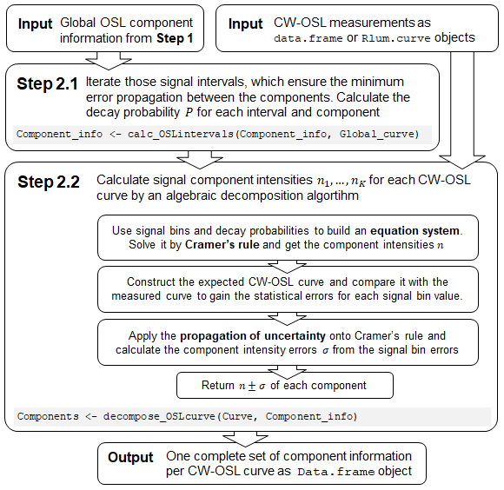

Figure : Workflow of the CW-OSL curve decomposition procedure. Grey highlighted: Associated R commands from package ‘OSLdecomposition’

# 3 Validation by simulation

## 3.1 Step 1 accuracy and reliability

- rework simulations without backgrounds and larger parameter space:

**Table 1:** Input parameters for step 1 simulations. The decay rates are calculated from the (Durcan and Duller, 2011) values assumed a stimulation wavelength is 480 nm and a stimulation intensity of 40 mW/cm². Rounding errors are less than 5 % for all decay rates.

|  |  |  |
| --- | --- | --- |
|  | **Parameter** | **Input variants** |
| **OSL components** | Fast $\left(λ=2.5 {\text{s}}^{-1}\right)$ | *n* = 0, 1000, 3000, 10000 |
| Medium $\left(λ=0.4 {\text{s}}^{-1}\right)$ | *n* = 0, 1000, 3000, 10000 |
| Slow1 $\left(λ=0.1 {\text{s}}^{-1}\right)$ | *n* = 0, 3000, 10000, 30000 |
| Slow2 $\left(λ=0.03 {\text{s}}^{-1}\right)$ | *n* = 10000, 30000, 100000 |
| **Detection conditions** | Channel width | $$Δt=0.1, 0.2, 0.5 \text{s}$$ |
| Number of channels | $$N=100, 200, 400$$ |
| Combined OSL curves | $$M=100, 200, 400$$ |

* Of particular interest is the F-value needed to separate correct fitting from over- and under-fittings:  
  *Rework diagram, draw legend into it. Try to use Excel!*
* 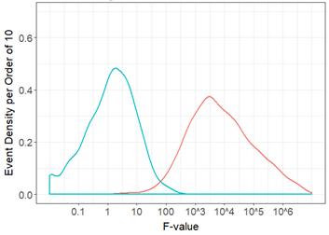

## 3.2 Step 2 accuracy and reliability

## 3.3 Implications of uncorrected background signals

So far we ignored the effects of uncorrected background signals or the

# 4 R package OSLdecomposition

## 4.1 List of basic functions

## 4.2 Interaction with the Luminescence package

## 4.2 Workflow

# 5 Example data analysis

# 6 Discussion and Conclusion

# Author contribution

# Competing interests

The authors declare that they have no conflict of interest.

# Acknowledgments

We are thankful to Margret C. Fuchs for her helpful comments and for providing the data sets BK8, Batagai and Oy7. We are thankful to Sebastian Kreutzer for providing the data set BT594 and for his help with R. We are thankful to Richard Bernstein on the fruitful discussions about the underlying math. This research did not receive any specific grant from funding agencies in the public, commercial, or not-for-profit sectors.

# References

Aitken, M. J.: An introduction to optical dating: the dating of Quaternary sediments by the use of photon-stimulated luminescence, Oxford University Press, Oxford ; New York., 1998.

Bailey, R.: Simulations of Variability in the Luminescence Characteristics of Natural Quartz and its Implications for Estimates of Absorbed Dose, Radiation Protection Dosimetry, 100(1), 33–38, doi:10.1093/oxfordjournals.rpd.a005881, 2002.

Bailey, R. M.: The interpretation of quartz optically stimulated luminescence equivalent dose versus time plots, Radiation Measurements, 32(2), 129–140, doi:10.1016/S1350-4487(99)00256-5, 2000.

Bailey, R. M.: Paper II: The interpretation of measurement-time-dependent single-aliquot equivalent-dose estimates using predictions from a simple empirical model, Radiation Measurements, 37(6), 685–691, doi:10.1016/S1350-4487(03)00079-9, 2003.

Bailey, R. M.: Direct measurement of the fast component of quartz optically stimulated luminescence and implications for the accuracy of optical dating, Quaternary Geochronology, 5(5), 559–568, doi:10.1016/j.quageo.2009.10.003, 2010.

Bailey, R. M., Smith, B. W. and Rhodes, E. J.: Partial bleaching and the decay form characteristics of quartz OSL, Radiation Measurements, 27(2), 123–136, doi:10.1016/S1350-4487(96)00157-6, 1997.

Ballarini, M., Wallinga, J., Wintle, A. G. and Bos, A. J. J.: A modified SAR protocol for optical dating of individual grains from young quartz samples, Radiation Measurements, 42(3), 360–369, doi:10.1016/j.radmeas.2006.12.016, 2007.

Bluszcz, A. and Adamiec, G.: Application of differential evolution to fitting OSL decay curves, Radiation Measurements, 41(7–8), 886–891, doi:10.1016/j.radmeas.2006.05.016, 2006.

Bos, A. J. J. and Wallinga, J.: How to visualize quartz OSL signal components, Radiation Measurements, 47(9), 752–758, doi:10.1016/j.radmeas.2012.01.013, 2012.

Bulur, E.: An alternative technique for optically stimulated luminescence (OSL) experiment, Radiation Measurements, 26(5), 701–709, doi:10.1016/S1350-4487(97)82884-3, 1996.

Bulur, E.: A simple transformation for converting CW-OSL curves to LM-OSL curves, Radiation Measurements, 32(2), 141–145, doi:10.1016/S1350-4487(99)00247-4, 2000.

Bulur, E., Bøtter-Jensen, L. and Murray, A. S.: Optically stimulated luminescence from quartz measured using the linear modulation technique, Radiation Measurements, 32(5–6), 407–411, doi:10.1016/S1350-4487(00)00115-3, 2000.

Choi, J. H., Murray, A. S., Cheong, C. S., Hong, D. G. and Chang, H. W.: The resolution of stratigraphic inconsistency in the luminescence ages of marine terrace sediments from Korea, Quaternary Science Reviews, 22(10–13), 1201–1206, doi:10.1016/S0277-3791(03)00022-2, 2003.

Cunningham, A. C. and Wallinga, J.: Selection of integration time intervals for quartz OSL decay curves, Quaternary Geochronology, 5(6), 657–666, doi:10.1016/j.quageo.2010.08.004, 2010.

Durcan, J. A. and Duller, G. A. T.: The fast ratio: A rapid measure for testing the dominance of the fast component in the initial OSL signal from quartz, Radiation Measurements, 46(10), 1065–1072, doi:10.1016/j.radmeas.2011.07.016, 2011.

Fuchs, M. and Lang, A.: Luminescence dating of hillslope deposits—A review, Geomorphology, 109(1–2), 17–26, doi:10.1016/j.geomorph.2008.08.025, 2009.

Goble, R. J. and Rittenour, T. M.: A Linear Modulation OSL Study of the Unstable Ultrafast Component in Samples from Glacial Lake Hitchcock, Massachusetts, USA, Ancient TL, 24(2) [online] Available from: https://www.researchgate.net/publication/268359162_A_Linear_Modulation_OSL_Study_of_the_Unstable_Ultrafast_Component_in_Samples_from_Glacial_Lake_Hitchcock_Massachusetts_USA, 2006.

Huntley, D. J., Godfrey-Smith, D. I. and Thewalt, M. L. W.: Optical dating of sediments, Nature, 313(5998), 105–107, doi:10.1038/313105a0, 1985.

Istratov, A. A. and Vyvenko, O. F.: Exponential analysis in physical phenomena, Review of Scientific Instruments, 70(2), 1233–1257, doi:10.1063/1.1149581, 1999.

Jain, M., Murray, A. S. and Bøtter-Jensen, L.: Characterisation of blue-light stimulated luminescence components in different quartz samples: implications for dose measurement, Radiation Measurements, 37, 441–449, 2003.

Jain, M., Murray, A. S., Bøtter-Jensen, L. and Wintle, A. G.: A single-aliquot regenerative-dose method based on IR (1.49eV) bleaching of the fast OSL component in quartz, Radiation Measurements, 39(3), 309–318, doi:10.1016/j.radmeas.2004.05.004, 2005.

Jain, M., Choi, J. H. and Thomas, P. J.: The ultrafast OSL component in quartz: Origins and implications, Radiation Measurements, 43(2), 709–714, doi:10.1016/j.radmeas.2008.01.005, 2008.

Kitis, G., Polymeris, G., Kiyak, N. and Pagonis, V.: Preliminary results towards the equivalence of transformed continuous-wave Optically Stimulated Luminescence (CW-OSL) and linearly-modulated (LM-OSL) signals in quartz, Geochronometria, 38(3), 209–216, doi:10.2478/s13386-011-0031-8, 2011.

Klasen, N., Fischer, P., Lehmkuhl, F. and Hilgers, A.: Luminescence dating of loess deposits from the Remagen-Schwalbenberg site, Western Germany, Geochronometria, 42(1), doi:10.1515/geochr-2015-0008, 2015.

Kreutzer, S., Schmidt, C., Fuchs, M. C., Dietze, M., Fischer, M. and Fuchs, M.: Introducing an R package for luminescence dating analysis, Ancient TL, 30, 1–8, 2012.

Li, B. and Li, S.-H.: Comparison of De estimates using the fast component and the medium component of quartz OSL, Radiation Measurements, 41(2), 125–136, doi:10.1016/j.radmeas.2005.06.037, 2006.

Mittelstraß, D.: Decomposition of weak optically stimulated luminescence signals and its application in retrospective dosimetry at quartz, Master thesis, TU Dresden, Dresden., 2019.

Pagonis, V., Kreutzer, S., Duncan, A. R., Rajovic, E., Laag, C. and Schmidt, C.: On the stochastic uncertainties of thermally and optically stimulated luminescence signals: A Monte Carlo approach, Journal of Luminescence, 219, 116945, doi:10.1016/j.jlumin.2019.116945, 2020.

Peng, J., Dong, Z., Han, F., Han, Y. and Dai, X.: Estimating the number of components in an OSL decay curve using the Bayesian Information Criterion, Geochronometria, 41(4), 334–341, doi:10.2478/s13386-013-0166-x, 2014.

Preusser, F., Chithambo, M. L., Götte, T., Martini, M., Ramseyer, K., Sendezera, E. J., Susino, G. J. and Wintle, A. G.: Quartz as a natural luminescence dosimeter, Earth-Science Reviews, 97(1–4), 184–214, doi:10.1016/j.earscirev.2009.09.006, 2009.

Roberts, R. G., Jacobs, Z., Li, B., Jankowski, N. R., Cunningham, A. C. and Rosenfeld, A. B.: Optical dating in archaeology: thirty years in retrospect and grand challenges for the future, Journal of Archaeological Science, 56, 41–60, doi:10.1016/j.jas.2015.02.028, 2015.

Shen, Z. and Lang, A.: Quartz fast component opticallystimulated luminescence: Towards routine extraction for dating applications, Radiation Measurements, 89, 27–34, doi:10.1016/j.radmeas.2016.01.034, 2016.

Singarayer, J. S. and Bailey, R. M.: Further investigations of the quartz optically stimulated luminescence components using linear modulation, Radiation Measurements, 37(4), 451–458, doi:10.1016/S1350-4487(03)00062-3, 2003.

Singarayer, J. S. and Bailey, R. M.: Component-resolved bleaching spectra of quartz optically stimulated luminescence: preliminary results and implications for dating, Radiation Measurements, 38(1), 111–118, doi:10.1016/S1350-4487(03)00250-6, 2004.

Smith, B. W. and Rhodes, E. J.: Charge movements in quartz and their relevance to optical dating, Radiation Measurements, 23(2), 329–333, doi:10.1016/1350-4487(94)90060-4, 1994.

Solongo, S., Wagner, G. A. and Galbaatar, T.: The estimation of using the fast and medium components in fired quartz from archaeological site Karakorum, Mongolia, Radiation Measurements, 41(7–8), 1001–1008, doi:10.1016/j.radmeas.2006.05.023, 2006.

Steffen, D., Preusser, F. and Schlunegger, F.: OSL quartz age underestimation due to unstable signal components, Quaternary Geochronology, 4(5), 353–362, doi:10.1016/j.quageo.2009.05.015, 2009.

Storn, R. and Price, K.: Differential Evolution – A Simple and Efficient Heuristic for global Optimization over Continuous Spaces, Journal of Global Optimization, 11(4), 341–359, doi:10.1023/A:1008202821328, 1997.

Tsukamoto, S., Rink, W. J. and Watanuki, T.: OSL of tephric loess and volcanic quartz in Japan and an alternative procedure for estimating De from a fast OSL component, Radiation Measurements, 37(4), 459–465, doi:10.1016/S1350-4487(03)00054-4, 2003.

Wintle, A. G. and Murray, A. S.: A review of quartz optically stimulated luminescence characteristics and their relevance in single-aliquot regeneration dating protocols, Radiation Measurements, 41, 369–391, 2006.



Figure : The logo of Copernicus Publications.