OSL decomposition report *(alpha version)*

Table of Contents

Settings 2

Step 1 – Evaluation of component number and decay constants 3

Step 2 – Single curve decomposition 7

Step 3 – Component-wise dose calculation 8

Summary 11

**Preface** This report was automatically generated using the Rmarkdown[1] script EvaluateDataSet.Rmd and the **R** package OSLdecomposition written and maintained by Dirk Mittelstraß ([dirk.mittelstrass@luminescence.de](mailto:dirk.mittelstrass@luminescence.de)). The dose calculation deploys also functions of the R packages numOSL by Jun Peng *et al.*[2] and Luminescence by Sebastian Kreutzer *et al.*[3]

This report and the containing results can be used, shared and published by the data set maintainer at will. If the results are published, however, it is demanded to state the main R package OSLdecomposition including it version number (0.10.16.3). It is also recommended to add this report to the supplement of your publication.

Continuous

## 

Basic idea

The method is based on the assumption, that every OSL curve can be described as sum of exponential decays:

|  |  |
| --- | --- |
| $$I\left(t\right)= \sum_{k=1}^{K}{n_{k}λ_{k}{\text{e}}^{-λ_{k}t}}$$ | (4.1) |

Here, I(t) represents the luminescence signal, K the number signal components, n the integrated signal intensities (or just ‘signal values’) of each signal component and lambda_k their decay constants.

We also assume, that the set of decay constants is the same for all OSL curves in a given data set. So we can apply the following approach:

1. Determine the component number K and the decay parameters lambda … lambda_K globally by multi-exponential decay fitting at one representative superposition OSL curve
2. Determine the signal values n_1 … n_K for each OSL curve by a decomposition algorithm
3. Determine the natural dose signal component-wise by building separate signal-dose growth curves for each set of n_k values

A full description of the method and the algorithms involved, as well as some performance tests, can be found in the master thesis of D. Mittelstraß[1]

## Settings

|  |  |
| --- | --- |
| **Script conditions** |  |
|  |  |
| Script version | 2019-10-16 |
| Script executed at | 2019-10-16 22:01:00 |
| R version | 3.6.1 |
| Used packages | OSLdecomposition 0.10.16.3 |
|  | Luminescence 0.9.5 |
|  | numOSL 2.6 |
| **Data set conditions** |  |
| Evaluated record types | OSL |
| Data set entries (aliquots) | 24 |
| Indicies of dismissed entries | none |
| Indicies of background measurements | none |
| Dose information containing entries | 20 |
| OSL records per entry | 14 |
| Channel number | N = 250 |
| Channel width | d*t* = 0.2 |

|  |  |
| --- | --- |
| **Sample conditions** |  |
|  |  |
| Sample type | coarse grain quartz |
| Expected age | ~ 200 ka |
| Environmental dose rate | 1.57 Gy ka-1 |
| Expected dose | ~ 315 Gy |
| Laboratory dose rate | 0.0825 Gy s-1 |
| Assumed stimulation intensity (@ 470 nm) | 35 mW cm-2 |
| **Algorithm parameters** |  |
| Cut measurements if exceeding | 40 s |
| Maximum allowed components | 5 |
| Threshold *F*-value | 50 |
| Decomposition algorithm | det+nls |

## 

Data pre-treatment

Prior data evaluation, the records will be corrected for signal background, over-length, etc., depending on the script presets and the provided data. The following corrections were performed for this data set, applying the function prepare_XXX():

The OSL measurement duration of 50 s exceed the preset cut time of 40 s. The records are cutted therefore.

## Step 1 – Evaluation of component number and decay constants

For calculating the decay parameters, one representative OSL curve is needed. This is provided by combining all records to one **global mean curve**. Each data point of the global curve represents the arithmetic mean of all data point values of the same channel in all OSL curves. This increases the signal-to-noise ratio by about one to two orders of magnitude, but still maintains the decay parameter information, assumed the decay constants are equal in each record.

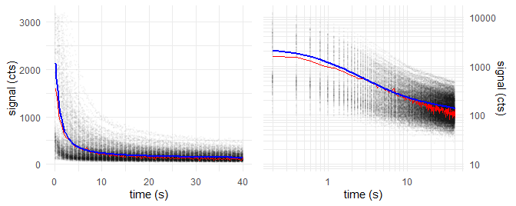**Figure 2:** *Altered global mean curve*

We take the global mean curve and perform a multiple cycles of **multi-exponential nonlinear regression**. In each cycle, the number of components *K* increases by one. With the increasing number of components, decreases the residual square sum between the fitted model curve and the measured data and the fit gets better.

The underlying algorithm was proposed and described by Blues & Adamiec and realized in R by the function numOSL::decomp() by Peng et al.. Their function is used in fit_OSLcurve(), which created the following series of fittings, displayed with plot_OSLcurve():

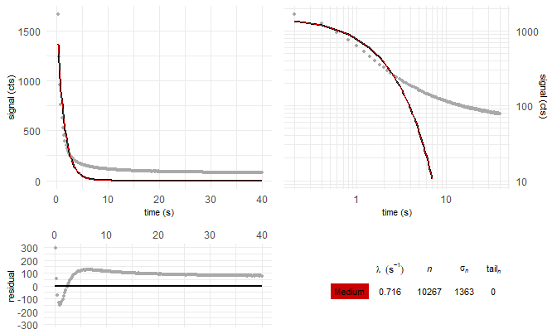

Fitting the global mean curve with K = 1 components: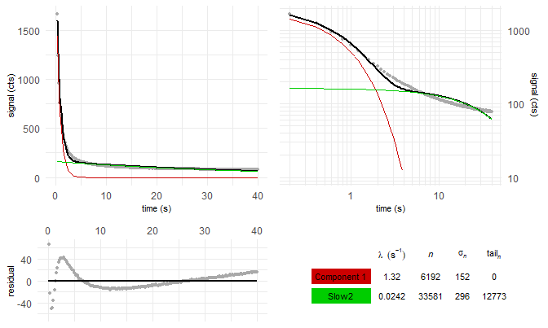

Fitting the global mean curve with K = 2 components: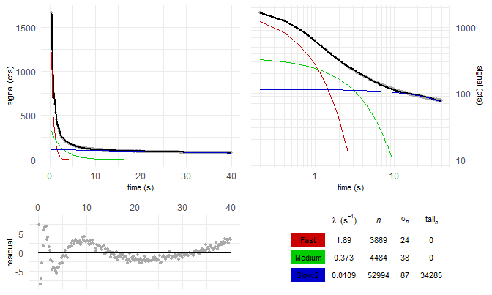

Fitting the global mean curve with K = 3 components: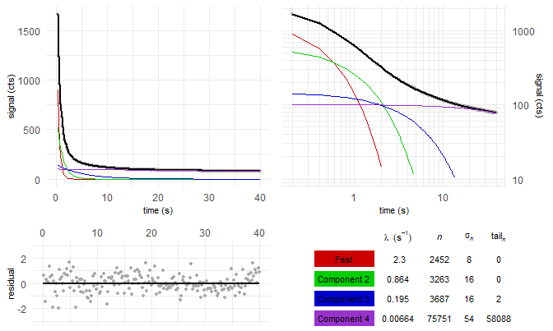

Fitting the global mean curve with K = 4 components: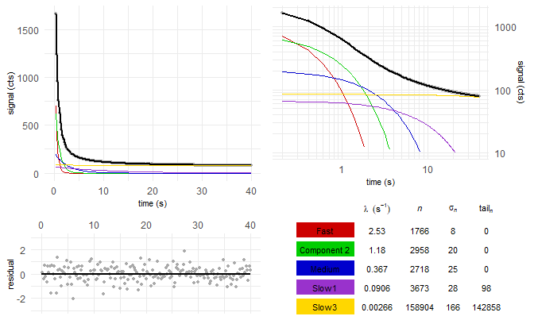

Fitting the global mean curve with K = 5 components:

Table 1: Decay constants and fit quality parameters for multi-exponentional decay fitting with K components

|  |  |  |  |  |  |  |  |
| --- | --- | --- | --- | --- | --- | --- | --- |
| K | $λ_{1}$ $(s^{-1})$ | $λ_{2}$ $(s^{-1})$ | $λ_{3}$ $(s^{-1})$ | $λ_{4}$ $(s^{-1})$ | $λ_{5}$ $(s^{-1})$ | $$χ^{2}$$ | F-value |
| 1 | 0.244 |  |  |  |  | 4.61e+06 |  |
| 2 | 0.723 | 0.0239 |  |  |  | 8.23e+04 | 5.39e+03 |
| 3 | 1.24 | 0.31 | 0.0124 |  |  | 1.5e+03 | 5.24e+03 |
| 4 | 1.59 | 0.578 | 0.172 | 0.00844 |  | 240 | 502 |
| 5 | 1.73 | 0.765 | 0.319 | 0.0939 | 0.00565 | 225 | 6.14 |

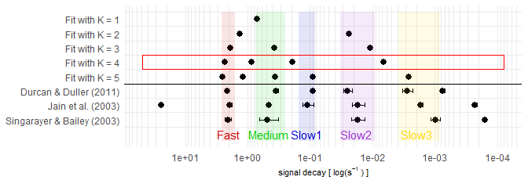

Figure 2: BlaBla

## Step 2 – Single curve decomposition

In Step 2, each of the 1234 OSL curves is decomposed into its 4 signal components.

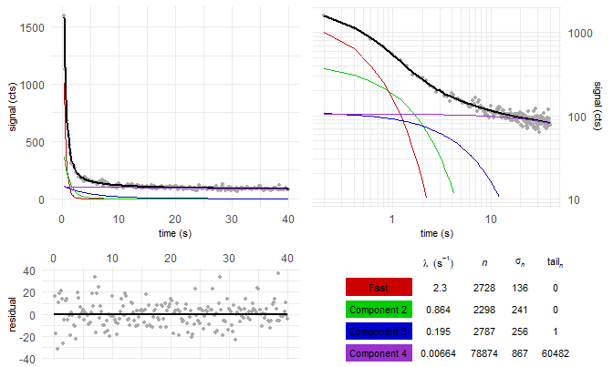

Figure 3: first OSL curve (natural dose) of example aliquot in the data set

L/T table of aliquot 1:

Table 2: …

|  |  |  |  |  |  |  |  |
| --- | --- | --- | --- | --- | --- | --- | --- |
| *i* (reg. cycle) | dose (Gy) | $L_{i}$/ $T_{i}$ | $$σ_{L_{i}/T_{i}}$$ | $$L_{i}$$ | _{L_i}$ | $$T_{i}$$ | _{T_i}$ |
| 0 | natural | 35.58 | 48.11 | 2728 | 136 | 77 | 104 |
| 1 | 49.5 | 7.62 | 4.97 | 1049 | 102 | 138 | 89 |
| 2 | 99 | 9.64 | 4.19 | 1618 | 105 | 168 | 72 |
| 3 | 198 | 12.20 | 5.84 | 2599 | 187 | 213 | 101 |
| 4 | 346.5 | 14.15 | 6.73 | 2937 | 229 | 208 | 97 |
| 5 | 0 | 0.00 | 0.35 | -159 | 65 | 259 | 100 |
| 6 | 99 | 24.86 | 41.64 | 1706 | 170 | 69 | 115 |

## Step 3 – Component-wise dose calculation

From the above L/T table, we create a signal dose curve or “growth curve”:

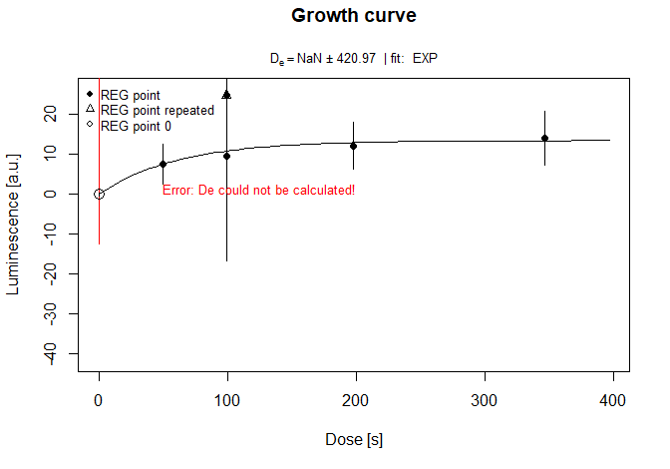

Figure 4: Growth curve

We try the exponential growth curve fitting for all components. How often is this successfull?

|  |  |  |  |  |  |  |
| --- | --- | --- | --- | --- | --- | --- |
| LB | EB | K = 1 | K = 2 | K = 3 | K = 4 | K = 5 |
| 20 | 19 | 20 | 20 | 18 | 16 | 14 |
|  |  |  | - | 19 | 20 | 17 |
|  |  |  |  | - | 18 | 20 |

What about the median doses?

|  |  |  |  |  |  |  |
| --- | --- | --- | --- | --- | --- | --- |
| LB | EB | K = 1 | K = 2 | K = 3 | K = 4 | K = 5 |
| 147.26 | 171.1 | 153.14 | 137.35 | 176.05 | 167.88 | 215.8 |
|  |  |  | - | 101.34 | 132.22 | 132.21 |
|  |  |  |  | - | 125.5 | 97.31 |

Plotted dose distribution

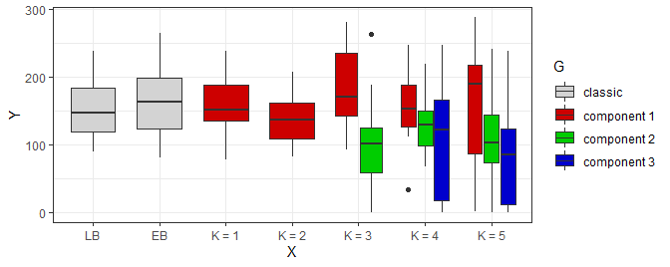

How many aliquot were not rejected?

|  |  |  |  |  |  |  |
| --- | --- | --- | --- | --- | --- | --- |
| LB | EB | K = 1 | K = 2 | K = 3 | K = 4 | K = 5 |
| 15 (20) | 10 (19) | 9 (20) | 13 (20) | 8 (18) | 5 (16) | 1 (14) |
|  |  |  | - | 3 (19) | 4 (20) | 2 (17) |
|  |  |  |  | - | 1 (18) | 1 (20) |

Recycling ratio test:

|  |  |  |  |  |  |  |
| --- | --- | --- | --- | --- | --- | --- |
| LB | EB | K = 1 | K = 2 | K = 3 | K = 4 | K = 5 |
| 1.03 +- 0.07 | 1.19 +- 0.37 | 1 +- 0.04 | 1.05 +- 0.08 | 1.07 +- 0.12 | 1.19 +- 0.55 | 1.97 +- 4.61 |
|  |  |  | - | 1 +- 0.78 | 0.96 +- 0.35 | 1 +- 0.63 |
|  |  |  |  | - | 1.39 +- 1.95 | 0.99 +- 1.08 |

Recuperation test:

|  |  |  |  |  |  |  |
| --- | --- | --- | --- | --- | --- | --- |
| LB | EB | K = 1 | K = 2 | K = 3 | K = 4 | K = 5 |
| 0.01 +- 0.01 | 0 +- 0 | 0.06 +- 0.03 | 0 +- 0 | 0.01 +- 0.01 | 0 +- 0 | 0.01 +- 0.01 |
|  |  |  | - | 0 +- 0.01 | 0.07 +- 0.11 | 0.17 +- 0.72 |
|  |  |  |  | - | 0.03 +- 0.1 | 0.11 +- 0.31 |

Let us apply the rejection criteria.

What about the median doses now?

|  |  |  |  |  |  |  |
| --- | --- | --- | --- | --- | --- | --- |
| LB | EB | K = 1 | K = 2 | K = 3 | K = 4 | K = 5 |
| 147.69 (15) | 197.63 (10) | 209.87 (9) | 140.43 (13) | 229.79 (8) | 154.01 (5) | 210.63 (1) |
|  |  |  | - | 85.61 (3) | 158.21 (4) | 123.43 (2) |
|  |  |  |  | - | 164.89 (1) | 83.32 (1) |

Plotted dose distribution

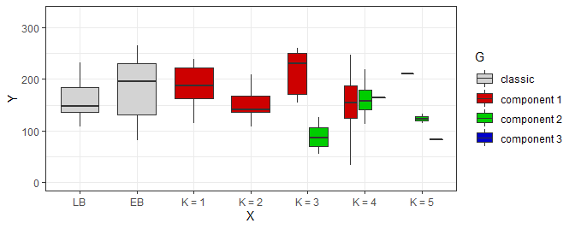

Central age model after Galbraith et al. (1999):

Error : [calc_CentralDose()] ‘data’ should have at least two columns and two rows! Error : [calc_CentralDose()] ‘data’ should have at least two columns and two rows! Error : [calc_CentralDose()] ‘data’ should have at least two columns and two rows!

|  |  |  |  |  |  |  |
| --- | --- | --- | --- | --- | --- | --- |
| LB | EB | K = 1 | K = 2 | K = 3 | K = 4 | K = 5 |
| 96.98 +- 5.41 (15) | 113.22 +- 17.09 (10) | 128.5 +- 21.25 (9) | 94.73 +- 3.62 (13) | 121.58 +- 11.6 (8) | 104.17 +- 20.98 (5) | - (1) |
|  |  |  | - | 60.26 +- 12.39 (3) | 112.64 +- 21.83 (4) | 80.73 +- 34.1 (2) |
|  |  |  |  | - | - (1) | - (1) |

Minimum age model after Galbraith et al. (1999) and Wallinga & Cunningham (2012):

|  |  |  |  |  |  |  |
| --- | --- | --- | --- | --- | --- | --- |
| LB | EB | K = 1 | K = 2 | K = 3 | K = 4 | K = 5 |
| 97 +- 10.16 (15) | 76.78 +- 21.01 (10) | 128 +- 30.41 (9) | 94.75 +- 10.14 (13) | 126.38 +- 20.96 (8) | 104.08 +- 31.4 (5) | 133.75 +- 69.18 (1) |
|  |  |  | - | 58.3 +- 21.66 (3) | 109.02 +- 33.96 (4) | 80.52 +- 47.19 (2) |
|  |  |  |  | - | - (1) | 52.91 +- 70.11 (1) |

1. Y. Xie, J. J. Allaire, and G. Grolemund, R Markdown: the definitive guide. Boca Raton: Taylor & Francis, CRC Press, 2018.
2. J. Peng, Z. Dong, F. Han, H. Long, and X. Liu, ‘R package numOSL: numeric routines for optically stimulated luminescence dating’, Ancient TL, vol. 31, 2013.
3. S. Kreutzer, C. Schmidt, M. C. Fuchs, M. Dietze, and M. Fuchs, ‘Introducing an R package for luminescence dating analysis’, Ancient TL, vol. 30, 2012.