OSL decomposition report *(alpha version)*

Table of Contents

Basic idea 2

Script & data parameter 3

Data pre-treatment 4

Step 1 – Evaluation of component number and decay constants 5

Step 2 – Single curve decomposition 10

Step 3 – Component-wise dose calculation 13

Summary 16

|  |  |
| --- | --- |
|  |  |
| Data set | BT1713_SAR_classic.bin |
| Script executed at | 2019-10-21 19:21:52 |

**Preface**  
This report was automatically generated using the Rmarkdown[1] script EvaluateDataSet.Rmd in the **R** package OSLdecomposition written and maintained by Dirk Mittelstraß ([dirk.mittelstrass@luminescence.de](mailto:dirk.mittelstrass@luminescence.de)). The dose calculation deploys also functions of the R packages numOSL by Jun Peng *et al.*[2] and Luminescence by Sebastian Kreutzer *et al.*[3]

This report and the containing results can be used, shared and published by the data set maintainer at will. If the results are published, however, it is demanded to state the main **R** package OSLdecomposition including its version number (0.10.21.3). It is also recommended to add this report to the supplement of your publication.

## Basic idea

The method is based on the assumption, that every OSL curve can be described as sum of signal components[4]. It is further assumed, that each signal component can be described by an exponential decay following first order kinetics. The shape of every CW-OSL curve can then be modelled by:

$$I(t)=\sum_{i=1}^{K}{n_{i}}λ_{i}exp(-λ_{i}t)$$

Here, *I(t)* represents the luminescence signal during continuous stimulation, *K* the number signal components, *ni* the integrated signal intensities (or just ‘signal values’) of each signal component and $λ_{i}$ their decay constants. We also assume, that the set of decay constants is the same for all OSL curves in a given data set. So we can apply the following data analysis approach:

1. Determine the component number *K* and the decay parameters $λ_{i}$, …, $λ_{K}$ globally by multi-exponential decay fitting at one representative superposition OSL curve
2. Determine the signal values *n1*, …, *nK*for each OSL curve by a decomposition algorithm
3. Determine the natural dose signal component-wise by building separate signal-dose growth curves for each set of *ni* values

A full description of the method and the algorithms involved, as well as some performance tests, can be found in the master thesis of D. Mittelstraß[5].

## Script & data parameter

|  |  |
| --- | --- |
| **Script conditions** |  |
| Script version | 2019-10-21 |
| R version | 3.6.1 |
| Packages performing calculations | OSLdecomposition 0.10.21.3 |
|  | Luminescence 0.9.5 |
|  | numOSL 2.6 |
| **Data set conditions** |  |
| Evaluated record types | OSL |
| Data set entries (aliquots) | 10 |
| Indicies of dismissed aliquots | none |
| Indicies of background measurements | none |
| Analyzed aliquots | 10 |
| OSL records per entry | 14 |
| Channel number | *N* = 999 |
| Channel width | $Δt$ = 0.0998999 s |
| Measurement time | *tend* = 99.8000031 |

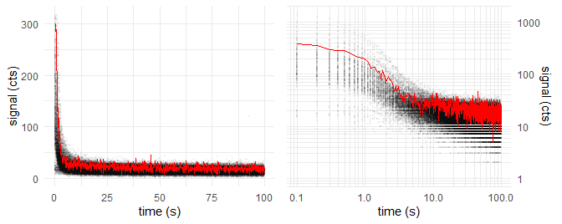

*Figure 1: Raw data points of all OSL curves (grey opaque) and natural dose OSL curve of first aliquot (red)*

|  |  |
| --- | --- |
| **Sample conditions** |  |
| Sample type | coarse grain quartz |
| Expected age | ~ 10 ka |
| Environmental dose rate | 1 Gy ka-1 |
| Expected dose | ~ 10 Gy |
| Laboratory dose rate | 0.055 Gy s-1 |
| Stimulation wavelength | 530 nm |
| Assumed stimulation intensity | 50 mW cm-2 |
| **Algorithm settings** |  |
| Cut measurements if exceeding | *tmax* = 200 s |
| Maximum allowed components | *Kmax* = 5 |
| Threshold *F*-value | *Fthreshold* = 50 |
| Decomposition algorithm | det+nls |

## Data pre-treatment

Prior data evaluation, the records will be corrected for signal background, measurement over-length, etc., depending on the script settings and the provided data. The following corrections were performed by applying the function prepare_OSLdata():

## Step 1 – Evaluation of component number and decay constants

For calculating the decay parameters, one representative OSL curve is needed. This is provided by combining all records to one **global mean curve**. Each data point of the global curve represents the arithmetic mean of all data point values of the same channel in all OSL curves. This increases the signal-to-noise ratio by about one to two orders of magnitude, but still maintains the decay parameter information.

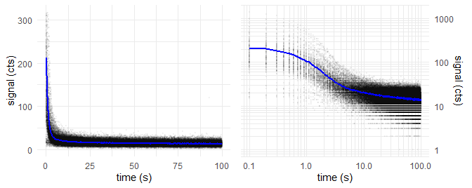

*Figure 2: Global mean OSL curve (blue)and data points of all OSL records (grey opaque)*

We take the global mean curve and perform a multiple cycles of **multi-exponential nonlinear regression**. In each cycle, the number of components *K* increases by one. With increasing number of components, decreases the signal deviation (residual curve) between the fitted model curve and the measured data and the fit gets better.

The underlying algorithm was proposed and described by Bluszcz & Adamiec [6] and realized in **R** by the function numOSL::decomp() by Peng *et al.*. Their function is used in fit_OSLcurve(), which calculated the following series of fittings, displayed with plot_OSLcurve():

The subsequent diagrams are structured the following way: * *Upper left:* Global mean curve (grey), fit model curve (black) and component signals  
* *Upper right:* Same as log-log diagram  
* *Lower left:* Residual curve between fit and global mean curve  
* *Lower right:* Result table with estimated type of component names (colored)

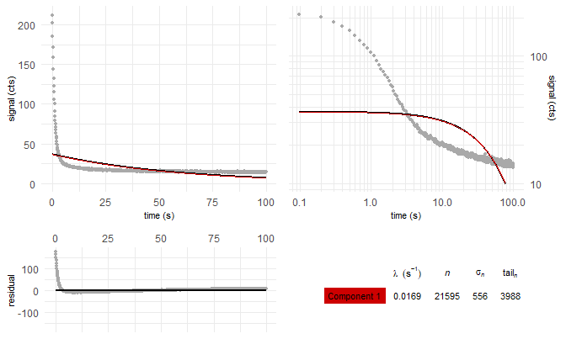

*Figure 3: Global mean curve fit with K = 1 components*

———

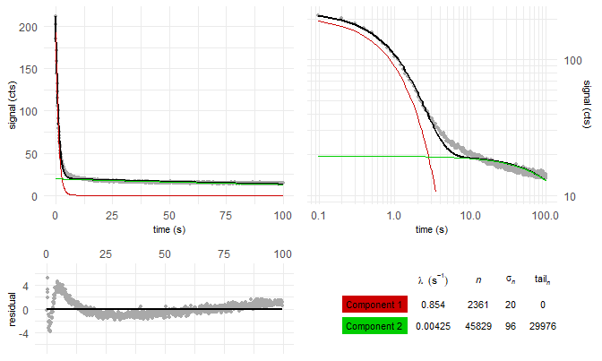

*Figure 4: Global mean curve fit with K = 2 components*

———

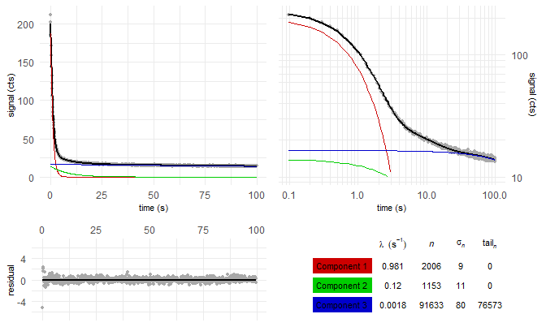

*Figure 5: Global mean curve fit with K = 3 components*

———

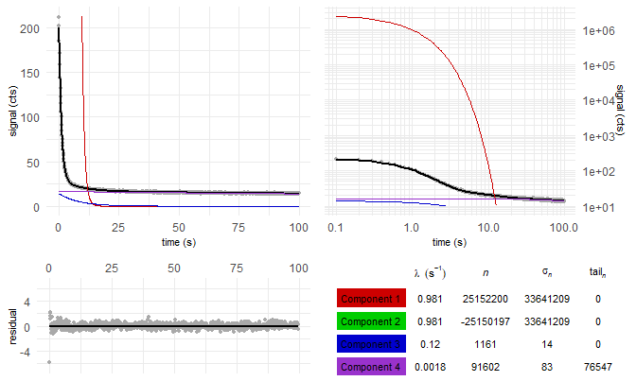

*Figure 6: Global mean curve fit with K = 4 components*

———

But which of these fittings gives back a sufficient model of the global mean curve, without over-fitting it? We solve this by comparing the residual square sum (*RSS*) of each fitting with the *RSS* value of the previous fitting. This is called *F*-test and was already proposed by Bluszcz & Adamiec:

$$F_{K}=\frac{(RSS_{K-1}-RSS_{K})/2}{RSS_{K}(N-2K)}$$

If *FK* falls below the preset threshold value of *Fthreshold* = 50, the new fitting model with *K* components is apparently not significantly better than the *K* - 1 model.

Table 1: Decay constants and fit quality parameters for multi-exponentional decay fitting with K components

|  |  |  |  |  |  |  |  |
| --- | --- | --- | --- | --- | --- | --- | --- |
| K | $λ_{1}$ $(s^{-1})$ | $λ_{2}$ $(s^{-1})$ | $λ_{3}$ $(s^{-1})$ | $λ_{4}$ $(s^{-1})$ | $λ_{5}$ $(s^{-1})$ | RSS | $$F_{K}$$ |
| 1 | 0.0169 |  |  |  |  | 2.05e+05 |  |
| 2 | 0.854 | 0.00425 |  |  |  | 1.36e+03 | 7.43e+04 |
| 3 | 0.981 | 0.12 | 0.0018 |  |  | 191 | 3.04e+03 |
| 4 | 0.981 | 0.981 | 0.12 | 0.0018 |  | 191 | -2.64e-09 |

The fitting with *K* = 3 components is found to be the best suiting model to describe the given sample. Signal components with not-first-order kinetics, however, can lead to over-fitting. It is recommended to take the results of the *K* = 2 fitting model also into consideration.

If the stimulation light wavelength is about 470 nm and the stimulation light intensity is 50 mW cm-2 as presetted, the photoionisation cross-sections of the components can be calculated. These can be compared with the quartz LM-OSL findings, given in literature[7][8][9]

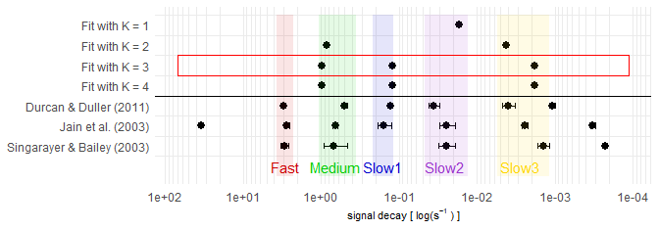

*Figure 7: Comparison of decay constants between fitting cases and comparison with reference values. Red square: Best fit

———

## Step 2 – Single curve decomposition

In Step 2, we decompose each OSL curve into its signal components. We set the decay constants found in Step 1 as fixed values for all OSL curves of the data set. This allows us to apply very robust and noise-insensitve signal decomposition methods. In case, the decomposition method “det+nls” is chosen, the following workflow is applied:

1. Divide the measurement time into *K* intervals. These intervals are calculated and optimized globally by calc_OSLintervals().
2. Integrate the signal curve of each OSL record over these intervals. From the integration values and the fitting model found in Step 1, build one equation system with *K* equations for each OSL record.
3. Solve the equation system by an analytic determinant based method, called ‘Cramer’s rule’, and get the area under the component curve or ‘intensity’ *nk* for each signal component
4. To enhance stability and precision of the method, refine the set of *nk* values in a quasi-linear regression using base::nls(). If this refining-fit fails, go on with the Cramer’s rule achieved values.
5. Calculate the standard deviation of the integration values from step 2 by the residuals between fit-model OSL curve and real data points
6. Apply the propagation of uncertainty method onto Cramer’s rule and calculate the uncertainty $σ_{k}$ for each component intensity value *nk*

All steps, beside the first step, are realized in decompose_OSLcurve(). The table in figure 8 displays the particular outcome of this method for the *K* = 3 model applied at the first OSL curve of the first aliquot as example. The parameter *tailn* gives back the area under the component which is not displayed in the OSL diagram. If the measurement was not cutted in the data-pretreatment and an appropriate background correction was performaed, *tailn* equals the not-released signal of the component.

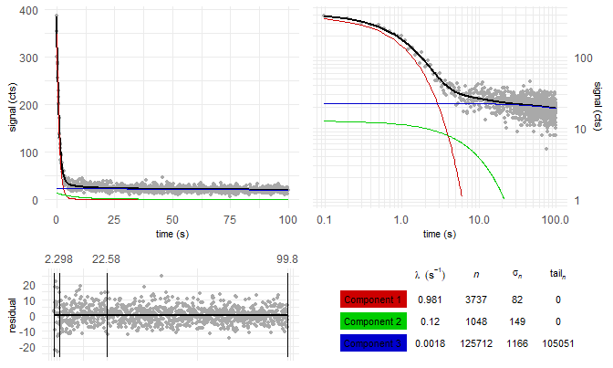

*Figure 8: 3-component decomposition results of the first OSL record in the data set. The vertical lines in the residual diagram show the integration intervals.

———

We assume the data set is measured in accordance to the SAR protocol[10]. Then every OSL measurement is followed by the regeneration of a fixed test-dose and the measurement of the OSL signal related to this test-dose. The testdose-related OSL signal is indicated by the variable *Ti*, the natural and regenerated dose OSL signal is indicated by the variable *Li*. The normalized OSL signal is therefore given by $L_{i}/T_{i}$.

A L/T table provides a structure for the signal values and dose regeneration points we need to build dose-signal curves in Step 3 and to test for signal behaviour criteria. One L/T table per signal component and aliquot is built. To avoid some potential issues in Step 3, we apply the following conditions when assigning the signal values to the table:  
* If the measurement time was not cutted: Substract the value of *tailn* from the *nk* value of the subsequent OSL measurement. This enables correctly built L/T tables for slow decaying components.  
* If the measurement time was cutted: Do not build L/T tables of a component, when more than 1% of the components signal would be transferred into *tailn*. So the component can not be further evaluated and misleading conclusions are avoided. * Set negative $L_{i}/T_{i}$ values to $L_{i}/T_{i}=0$ to avoid calculation issues although negative values are mathematically and physically possible (due to photo-transfer).

Table 2: L/T table of fastest decaying component of first aliquot for the K = 3 case

|  |  |  |  |  |  |  |  |
| --- | --- | --- | --- | --- | --- | --- | --- |
| *i* (reg. cycle) | dose (Gy) | $$L_{i}/T_{i}$$ | $$σ_{L_{i}/T_{i}}$$ | $$L_{i}$$ | $$σ_{L_{i}}$$ | $$T_{i}$$ | $$σ_{T_{i}}$$ |
| 0 | natural | 3.06 | 0.18 | 3737 | 82 | 1220 | 67 |
| 1 | 5.5 | 0.91 | 0.05 | 1308 | 55 | 1431 | 49 |
| 2 | 11 | 1.68 | 0.06 | 2818 | 63 | 1674 | 47 |
| 3 | 22 | 2.78 | 0.12 | 5170 | 129 | 1859 | 69 |
| 4 | 33 | 4.01 | 0.17 | 8439 | 164 | 2106 | 80 |
| 5 | 0 | 0.00 | 0.02 | 11 | 40 | 2412 | 78 |
| 6 | 5.5 | 0.88 | 0.04 | 2279 | 65 | 2586 | 73 |

## Step 3 – Component-wise dose calculation

From the above L/T table, we create a signal dose curve or “growth curve”:

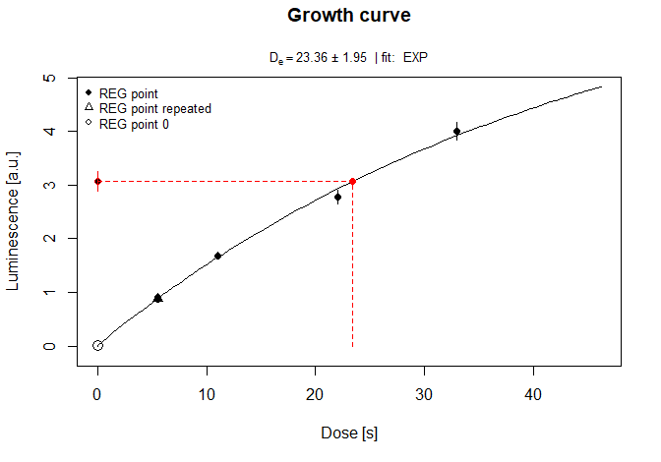

Figure 4: Growth curve

We try the exponential growth curve fitting for all components. How often is this successfull?

|  |  |  |  |  |  |
| --- | --- | --- | --- | --- | --- |
| late b. | early b. | K = 1 | K = 2 | K = 3 | K = 4 |
| 10 | 10 | 10 | 10 | 10 | 9 |
|  |  |  | 10 | 10 | 9 |
|  |  |  |  | 10 | 10 |
|  |  |  |  |  | 8 |

What about the median doses?

|  |  |  |  |  |  |
| --- | --- | --- | --- | --- | --- |
| late b. | early b. | K = 1 | K = 2 | K = 3 | K = 4 |
| 9.86 | 12.13 | 10.76 | 9.4 | 11.64 | 17.22 |
|  |  |  | 29.33 | 0.71 | 17.22 |
|  |  |  |  | 61.44 | 2.02 |
|  |  |  |  |  | 57.25 |

Plotted dose distribution

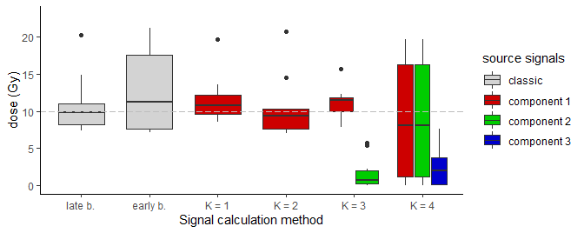

How many aliquot were not rejected?

|  |  |  |  |  |  |
| --- | --- | --- | --- | --- | --- |
| late b. | early b. | K = 1 | K = 2 | K = 3 | K = 4 |
| 6 (10) | 2 (10) | 0 (10) | 7 (10) | 6 (10) | 0 (9) |
|  |  |  | 0 (10) | 1 (10) | 0 (9) |
|  |  |  |  | 1 (10) | 0 (10) |
|  |  |  |  |  | 1 (8) |

Recycling ratio test:

|  |  |  |  |  |  |
| --- | --- | --- | --- | --- | --- |
| late b. | early b. | K = 1 | K = 2 | K = 3 | K = 4 |
| 0.94 +- 0.07 | 0.88 +- 0.43 | 1 +- 0.03 | 0.96 +- 0.09 | 0.95 +- 0.09 | 3.66 +- 6.52 |
|  |  |  | 1.02 +- 0.06 | 1.06 +- 0.1 | 3.66 +- 6.52 |
|  |  |  |  | 1.07 +- 0.21 | 0.83 +- 0.23 |
|  |  |  |  |  | 1.12 +- 0.21 |

Recuperation test:

|  |  |  |  |  |  |
| --- | --- | --- | --- | --- | --- |
| late b. | early b. | K = 1 | K = 2 | K = 3 | K = 4 |
| 0.03 +- 0.02 | 0.02 +- 0.04 | 0.52 +- 0.11 | 0.01 +- 0.01 | 0.01 +- 0.01 | 0.31 +- 0.48 |
|  |  |  | 0.26 +- 0.04 | 0.66 +- 0.6 | 0.31 +- 0.48 |
|  |  |  |  | 0.09 +- 0.03 | 0.77 +- 0.93 |
|  |  |  |  |  | 0.09 +- 0.03 |

Let us apply the rejection criteria.

What about the median doses now?

|  |  |  |  |  |  |
| --- | --- | --- | --- | --- | --- |
| late b. | early b. | K = 1 | K = 2 | K = 3 | K = 4 |
| 10.39 (6) | 23.06 (2) | - | 9.31 (7) | 11.64 (6) | - |
|  |  |  | - | 5.69 (1) | - |
|  |  |  |  | 444.66 (1) | - |
|  |  |  |  |  | 249.14 (1) |

Plotted dose distribution

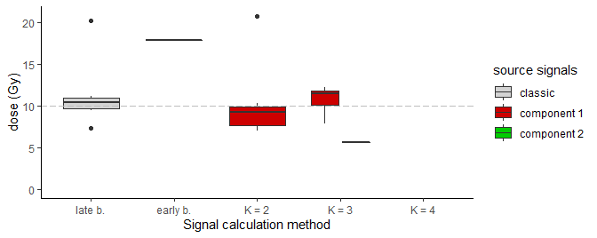

Central age model after Galbraith et al. (1999):

|  |  |  |  |  |  |
| --- | --- | --- | --- | --- | --- |
| late b. | early b. | K = 1 | K = 2 | K = 3 | K = 4 |
| 10.91 +- 1.39 (6) | 19.25 +- 3.07 (2) | - | 9.71 +- 1.26 (7) | 12.04 +- 1.69 (6) | - |
|  |  |  | - | - (1) | - |
|  |  |  |  | - (1) | - |
|  |  |  |  |  | - (1) |

Minimum age model after Galbraith et al. (1999) and Wallinga & Cunningham (2012):

|  |  |  |  |  |  |
| --- | --- | --- | --- | --- | --- |
| late b. | early b. | K = 1 | K = 2 | K = 3 | K = 4 |
| 9.53 +- 1.6 (6) | 20.16 +- 6.49 (2) | - | 8.49 +- 1.22 (7) | 10.27 +- 1.8 (6) | - |
|  |  |  | - | - (1) | - |
|  |  |  |  | 444.66 +- 245.81 (1) | - |
|  |  |  |  |  | 249.14 +- 111.13 (1) |

## Summary

Time difference of 10.75904 mins

1. Y. Xie, J. J. Allaire, and G. Grolemund, R Markdown: the definitive guide. Boca Raton: Taylor & Francis, CRC Press, 2018.
2. J. Peng, Z. Dong, F. Han, H. Long, and X. Liu, ‘R package numOSL: numeric routines for optically stimulated luminescence dating’, Ancient TL, vol. 31, 2013.
3. S. Kreutzer, C. Schmidt, M. C. Fuchs, M. Dietze, and M. Fuchs, ‘Introducing an R package for luminescence dating analysis’, Ancient TL, vol. 30, 2012.
4. R. M. Bailey, B. W. Smith, and E. J. Rhodes, ‘Partial bleaching and the decay form characteristics of quartz OSL’, Radiation Measurements, vol. 27, no. 2, pp. 123–136, Apr. 1997.
5. D. Mittelstraß, ‘Decomposition of weak optically stimulated luminescence signals and its application in retrospective dosimetry at quartz’, Master thesis, TU Dresden, Dresden, 2019.
6. A. Bluszcz and G. Adamiec, ‘Application of differential evolution to fitting OSL decay curves’, Radiation Measurements, vol. 41, no. 7–8, pp. 886–891, Aug. 2006.
7. J. A. Durcan and G. A. T. Duller, ‘The fast ratio: A rapid measure for testing the dominance of the fast component in the initial OSL signal from quartz’, Radiation Measurements, vol. 46, no. 10, pp. 1065–1072, Oct. 2011.
8. M. Jain, A. S. Murray, and L. Bøtter-Jensen, ‘Characterisation of blue-light stimulated luminescence components in different quartz samples: implications for dose measurement’, Radiation Measurements, vol. 37, pp. 441–449, 2003.
9. J. S. Singarayer and R. M. Bailey, ‘Further investigations of the quartz optically stimulated luminescence components using linear modulation’, Radiation Measurements, vol. 37, no. 4, pp. 451–458, Aug. 2003.
10. A. S. Murray and A. G. Wintle, ‘Luminescence dating of quartz using an improved single-aliquot regenerative-dose protocol’, Radiation Measurements, vol. 32, no. 1, pp. 57–73, Feb. 2000.