OSL decomposition report *(alpha version)*

Table of Contents

Basic idea 2

Script & data parameter 3

Data pre-treatment 4

Step 1 – Evaluation of component number and decay constants 5

Step 2 – Single curve decomposition 10

Step 3 – Component-wise dose calculation 11

Summary 14

|  |  |
| --- | --- |
|  |  |
| Data set | BK-8_1295-1280_63-40um_2mm_Qz1_ed.BIN |
| Script executed at | 2019-10-20 15:36:36 |

**Preface**  
This report was automatically generated using the Rmarkdown[1] script EvaluateDataSet.Rmd in the **R** package OSLdecomposition written and maintained by Dirk Mittelstraß ([dirk.mittelstrass@luminescence.de](mailto:dirk.mittelstrass@luminescence.de)). The dose calculation deploys also functions of the R packages numOSL by Jun Peng *et al.*[2] and Luminescence by Sebastian Kreutzer *et al.*[3]

This report and the containing results can be used, shared and published by the data set maintainer at will. If the results are published, however, it is demanded to state the main **R** package OSLdecomposition including its version number (0.10.19.2). It is also recommended to add this report to the supplement of your publication.

## Basic idea

The method is based on the assumption, that every OSL curve can be described as sum of signal components[4]. It is further assumed, that each signal component can be described by an exponential decay following first order kinetics. The shape of every CW-OSL curve can then be modelled by:

$$I(t)=\sum_{i=1}^{K}{n_{i}}λ_{i}exp(-λ_{i}t)$$

Here, *I(t)* represents the luminescence signal during continuous stimulation, *K* the number signal components, *ni* the integrated signal intensities (or just ‘signal values’) of each signal component and $λ_{i}$ their decay constants. We also assume, that the set of decay constants is the same for all OSL curves in a given data set. So we can apply the following data analysis approach:

1. Determine the component number *K* and the decay parameters $λ_{i}$, …, $λ_{K}$ globally by multi-exponential decay fitting at one representative superposition OSL curve
2. Determine the signal values *n1*, …, *nK*for each OSL curve by a decomposition algorithm
3. Determine the natural dose signal component-wise by building separate signal-dose growth curves for each set of *ni* values

A full description of the method and the algorithms involved, as well as some performance tests, can be found in the master thesis of D. Mittelstraß[5].

## Script & data parameter

|  |  |
| --- | --- |
| **Script conditions** |  |
| Script version | 2019-10-19 |
| R version | 3.6.1 |
| Packages performing calculations | OSLdecomposition 0.10.19.2 |
|  | Luminescence 0.9.5 |
|  | numOSL 2.6 |
| **Data set conditions** |  |
| Evaluated record types | OSL |
| Data set entries (aliquots) | 24 |
| Indicies of dismissed aliquots | 1,2,3,4 |
| Indicies of background measurements | none |
| Analyzed aliquots | 20 |
| OSL records per entry | 14 |
| Channel number | *N* = 250 |
| Channel width | $Δt$ = 0.2 s |
| Measurement time | *tend* = 50 |

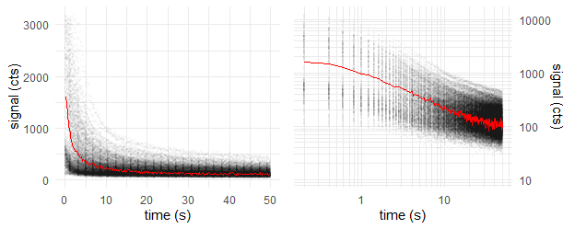

**Figure 1:** Raw data points of all OSL curves (grey opaque); First OSL record of first aliquot (red)

|  |  |
| --- | --- |
| **Sample conditions** |  |
| Sample type | coarse grain quartz |
| Expected age | ~ 50 ka |
| Environmental dose rate | 1.57 Gy ka-1 |
| Expected dose | ~ 79 Gy |
| Laboratory dose rate | 0.0825 Gy s-1 |
| Stimulation wavelength | 470 nm |
| Assumed stimulation intensity | 35 mW cm-2 |
| **Algorithm settings** |  |
| Cut measurements if exceeding | *t_max_* = 40 s |
| Maximum allowed components | *K_max_* = 5 |
| Threshold *F*-value | *F_threshold_* = 50 |
| Decomposition algorithm | det+nls |

## Data pre-treatment

Prior data evaluation, the records will be corrected for signal background, measurement over-length, etc., depending on the script settings and the provided data. The following corrections were performed by applying the function prepare_OSLdata():

* The measurement duration of 50 s exceed the preset cut time of 40 s. Because long measurements may lead to over-fitting and imprecise fast-decaying component fitting, all records are reduced to the cut time.

## Step 1 – Evaluation of component number and decay constants

For calculating the decay parameters, one representative OSL curve is needed. This is provided by combining all records to one **global mean curve**. Each data point of the global curve represents the arithmetic mean of all data point values of the same channel in all OSL curves. This increases the signal-to-noise ratio by about one to two orders of magnitude, but still maintains the decay parameter information.

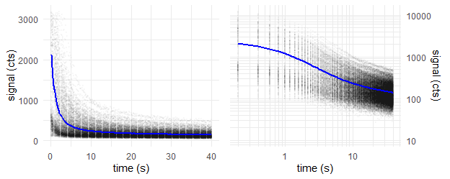

**Figure 2:** Global mean OSL curve (blue); Data points of all OSL records (grey opaque)

We take the global mean curve and perform a multiple cycles of **multi-exponential nonlinear regression**. In each cycle, the number of components *K* increases by one. With increasing number of components, decreases the signal deviation (residual curve) between the fitted model curve and the measured data and the fit gets better.

The underlying algorithm was proposed and described by Bluszcz & Adamiec [6] and realized in **R** by the function numOSL::decomp() by Peng *et al.*. Their function is used in fit_OSLcurve(), which calculated the following series of fittings, displayed with plot_OSLcurve():

The subsequent diagrams are structured the following way:  
* *Upper left:* Global mean curve (grey), fit model curve (black) and component signals (colored)  
* *Upper right:* Same as log-log diagram  
* *Lower left:* Residual curve between fit and global mean curve  
* *Lower right:* Result table with estimated type of component names (colored)

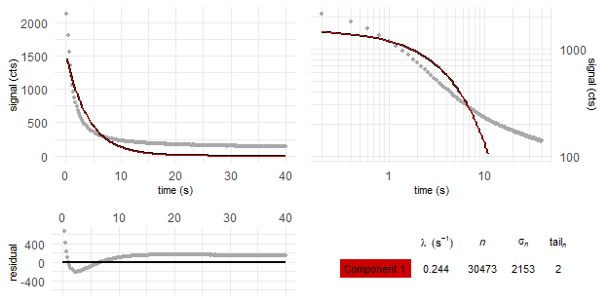

*Figure 3: Global mean curve fit with K = 1 components*

——————-

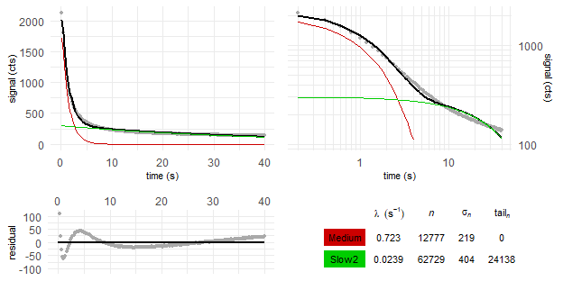

*Figure 4: Global mean curve fit with K = 2 components*

——————-

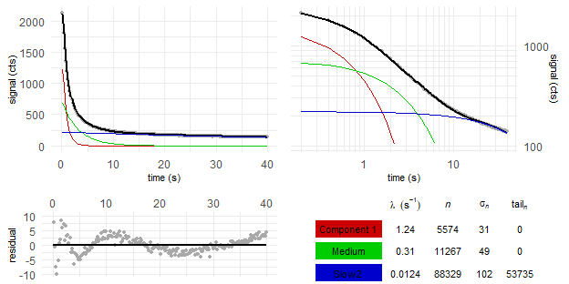

*Figure 5: Global mean curve fit with K = 3 components*

——————-

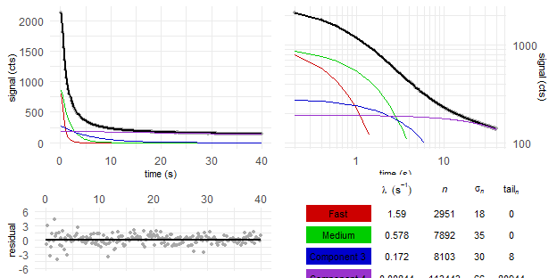

*Figure 6: Global mean curve fit with K = 4 components*

——————-

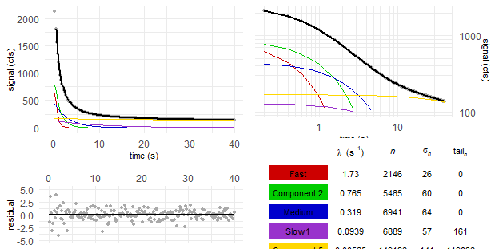

*Figure 7: Global mean curve fit with K = 5 components*

——————-

But which of these fittings gives back a sufficient model of the global mean curve, without over-fitting it? We solve this by comparing the residual square sum (*RSS*) of each fitting with the *RSS* value of the previous fitting. This is called *F*-test and was already proposed by Bluszcz & Adamiec:

$$F_{K}=\frac{(RSS_{K-1}-RSS_{K})/2}{RSS_{K}(N-2K)}$$

If *FK* falls below the preset threshold value of *Fthreshold* = 50, the new fitting model with *K* components is apparently not significantly better than the *K* - 1 model.

Table 1: Decay constants and fit quality parameters for multi-exponentional decay fitting with K components

|  |  |  |  |  |  |  |  |
| --- | --- | --- | --- | --- | --- | --- | --- |
| K | $λ_{1}$ $(s^{-1})$ | $λ_{2}$ $(s^{-1})$ | $λ_{3}$ $(s^{-1})$ | $λ_{4}$ $(s^{-1})$ | $λ_{5}$ $(s^{-1})$ | RSS | $$F_{K}$$ |
| 1 | 0.244 |  |  |  |  | 4.61e+06 |  |
| 2 | 0.723 | 0.0239 |  |  |  | 8.23e+04 | 5.39e+03 |
| 3 | 1.24 | 0.31 | 0.0124 |  |  | 1.5e+03 | 5.24e+03 |
| 4 | 1.59 | 0.578 | 0.172 | 0.00844 |  | 240 | 502 |
| 5 | 1.73 | 0.765 | 0.319 | 0.0939 | 0.00565 | 225 | 6.14 |

Here the K = 5 fit falls below the threshold value. The fitting with K = 4 components is therefore most likely the best suiting model to describe the given sample. Signal components with not-first-order kinetics, however, can lead to over-fitting. It is recommended to take the results of the 3 fitting model also into consideration.

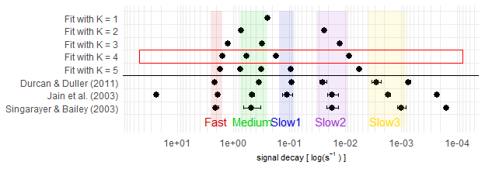

Figure 2: BlaBla

## Step 2 – Single curve decomposition

In Step 2, each of the OSL curves is decomposed into its 4 signal components.

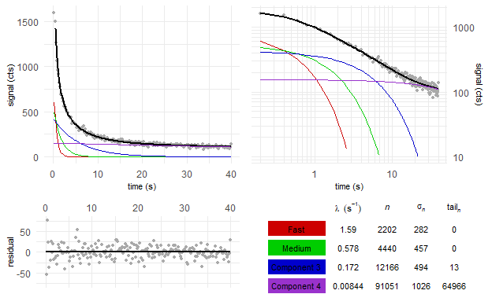

Figure 3: first OSL curve (natural dose) of example aliquot in the data set

The L/T table provides a structured overview of the signal values and dose regeneration points.

Table 2: L/T table of fast component of aliquot 1

|  |  |  |  |  |  |  |  |
| --- | --- | --- | --- | --- | --- | --- | --- |
| *i* (reg. cycle) | dose (Gy) | $L_{i}$/ $T_{i}$ | $$σ_{L_{i}/T_{i}}$$ | $$L_{i}$$ | $$σ_{L_{i}}$$ | $$T_{i}$$ | $$σ_{T_{i}}$$ |
| 0 | natural | 867.49 | 49365.55 | 2202 | 282 | 3 | 144 |
| 1 | 33 | 11.94 | 15.72 | 1047 | 255 | 88 | 113 |
| 2 | 57.75 | 11.51 | 8.79 | 2091 | 275 | 182 | 137 |
| 3 | 82.5 | 25.65 | 36.08 | 2728 | 375 | 106 | 149 |
| 4 | 132 | 24.65 | 24.36 | 3969 | 332 | 161 | 159 |
| 5 | 0 | 0.00 | 0.45 | -96 | 103 | 258 | 150 |
| 6 | 57.75 | 35.71 | 74.59 | 2154 | 205 | 60 | 126 |

## Step 3 – Component-wise dose calculation

From the above L/T table, we create a signal dose curve or “growth curve”:

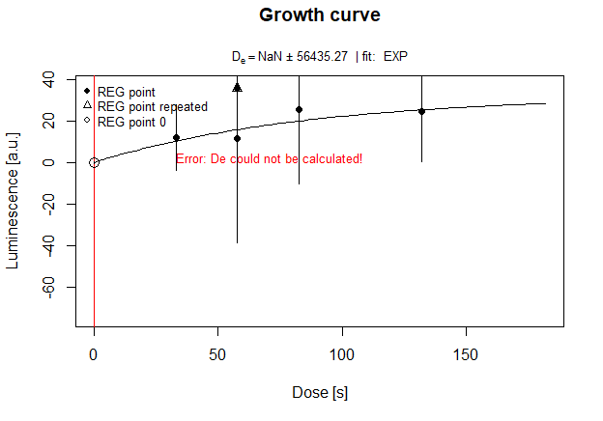

Figure 4: Growth curve

We try the exponential growth curve fitting for all components. How often is this successfull?

|  |  |  |  |  |  |  |
| --- | --- | --- | --- | --- | --- | --- |
| LB | EB | K = 1 | K = 2 | K = 3 | K = 4 | K = 5 |
| 20 | 20 | 20 | 20 | 20 | 18 | 19 |
|  |  |  | - | 19 | 20 | 20 |
|  |  |  |  | - | 20 | 19 |

What about the median doses?

|  |  |  |  |  |  |  |
| --- | --- | --- | --- | --- | --- | --- |
| LB | EB | K = 1 | K = 2 | K = 3 | K = 4 | K = 5 |
| 51.65 | 51.63 | 52.95 | 49.07 | 48.76 | 53.36 | 56.77 |
|  |  |  | - | 45.63 | 41.07 | 47.17 |
|  |  |  |  | - | 59.57 | 37.33 |

Plotted dose distribution

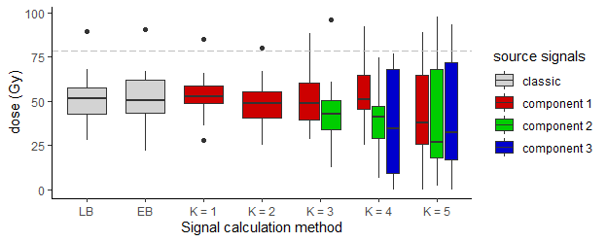

How many aliquot were not rejected?

|  |  |  |  |  |  |  |
| --- | --- | --- | --- | --- | --- | --- |
| LB | EB | K = 1 | K = 2 | K = 3 | K = 4 | K = 5 |
| 16 (20) | 9 (20) | 0 (20) | 10 (20) | 10 (20) | 4 (18) | 2 (19) |
|  |  |  | - | 6 (19) | 0 (20) | 2 (20) |
|  |  |  |  | - | 3 (20) | 1 (19) |

Recycling ratio test:

|  |  |  |  |  |  |  |
| --- | --- | --- | --- | --- | --- | --- |
| LB | EB | K = 1 | K = 2 | K = 3 | K = 4 | K = 5 |
| 1.01 +- 0.07 | 1.07 +- 0.24 | 0.96 +- 0.04 | 1.09 +- 0.11 | 1.01 +- 0.15 | 1.33 +- 0.87 | 4.87 +- 15.5 |
|  |  |  | - | 1.09 +- 0.5 | 1 +- 0.38 | 1.36 +- 1.55 |
|  |  |  |  | - | 0.9 +- 0.68 | 0.8 +- 0.69 |

Recuperation test:

|  |  |  |  |  |  |  |
| --- | --- | --- | --- | --- | --- | --- |
| LB | EB | K = 1 | K = 2 | K = 3 | K = 4 | K = 5 |
| 0.02 +- 0.01 | 0.01 +- 0.01 | 0.14 +- 0.05 | 0 +- 0 | 0.03 +- 0.02 | 0 +- 0.01 | 0.02 +- 0.06 |
|  |  |  | - | 0.33 +- 1.35 | 0.07 +- 0.05 | 0.09 +- 0.22 |
|  |  |  |  | - | 0.15 +- 0.13 | 0.07 +- 0.13 |

Let us apply the rejection criteria.

What about the median doses now?

|  |  |  |  |  |  |  |
| --- | --- | --- | --- | --- | --- | --- |
| LB | EB | K = 1 | K = 2 | K = 3 | K = 4 | K = 5 |
| 49 (16) | 51.52 (9) | - | 50.25 (10) | 48.76 (10) | 49.57 (4) | 100.64 (2) |
|  |  |  | - | 40.43 (6) | - | 83.61 (2) |
|  |  |  |  | - | 115.28 (3) | 85.87 (1) |

Plotted dose distribution

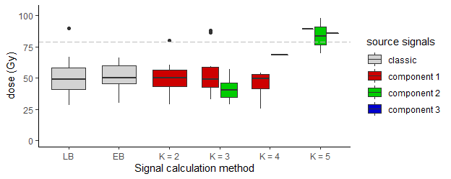

Central age model after Galbraith et al. (1999):

|  |  |  |  |  |  |  |
| --- | --- | --- | --- | --- | --- | --- |
| LB | EB | K = 1 | K = 2 | K = 3 | K = 4 | K = 5 |
| 30.87 +- 2.13 (16) | 31.74 +- 2.64 (9) | - | 30.9 +- 2.3 (10) | 32.43 +- 2.91 (10) | 23.49 +- 5.34 (4) | 57.35 +- 26.61 (2) |
|  |  |  | - | 25.97 +- 2.11 (6) | - | 52.95 +- 27.34 (2) |
|  |  |  |  | - | 106.72 +- 53 (3) | - (1) |

Minimum age model after Galbraith et al. (1999) and Wallinga & Cunningham (2012):

|  |  |  |  |  |  |  |
| --- | --- | --- | --- | --- | --- | --- |
| LB | EB | K = 1 | K = 2 | K = 3 | K = 4 | K = 5 |
| 24.67 +- 3.37 (16) | 32.03 +- 4.91 (9) | - | 30.9 +- 4.16 (10) | 29.52 +- 4.79 (10) | 23.57 +- 7.94 (4) | 57.48 +- 38.22 (2) |
|  |  |  | - | 25.1 +- 4.48 (6) | - | 52.91 +- 37.42 (2) |
|  |  |  |  | - | - (3) | - (1) |

## Summary

Time difference of 1.132172 mins

1. Y. Xie, J. J. Allaire, and G. Grolemund, R Markdown: the definitive guide. Boca Raton: Taylor & Francis, CRC Press, 2018.
2. J. Peng, Z. Dong, F. Han, H. Long, and X. Liu, ‘R package numOSL: numeric routines for optically stimulated luminescence dating’, Ancient TL, vol. 31, 2013.
3. S. Kreutzer, C. Schmidt, M. C. Fuchs, M. Dietze, and M. Fuchs, ‘Introducing an R package for luminescence dating analysis’, Ancient TL, vol. 30, 2012.
4. R. M. Bailey, B. W. Smith, and E. J. Rhodes, ‘Partial bleaching and the decay form characteristics of quartz OSL’, Radiation Measurements, vol. 27, no. 2, pp. 123–136, Apr. 1997.
5. D. Mittelstraß, ‘Decomposition of weak optically stimulated luminescence signals and its application in retrospective dosimetry at quartz’, Master thesis, TU Dresden, Dresden, 2019.
6. A. Bluszcz and G. Adamiec, ‘Application of differential evolution to fitting OSL decay curves’, Radiation Measurements, vol. 41, no. 7–8, pp. 886–891, Aug. 2006.