OSL decomposition report *(alpha version)*

Table of Contents

Preface 1

Settings 1

Step 1 – Evaluation of component number and decay constants 1

Step 2 – Single curve decomposition 5

Step 3 – Component-wise dose calculation 6

Summary 9

## Preface

This report was automatically generated using the Rmarkdown[1] script ‘EvaluateDataSet.Rmd’ and the **R** package OSLdecomposition written and maintained by Dirk Mittelstraß ([dirk.mittelstrass@luminescence.de](mailto:dirk.mittelstrass@luminescence.de)). The script inherits also functions of the R packages ‘numOSL’ by Jun Peng *et al.*[2] and Luminescence by Sebastian Kreutzer *et al.*[3]

This report and the containing results can be used, shared and published by the data set maintainer at will. If the results are published, however, it is demanded to state the used R package OSLdecomposition including it version number (0.10.16.2) It is also recommended to add this report to the supplement of your publication ~~and to state the most important data parameters (used~~ *~~F~~~~threshol~~*~~-value; background correction yes/no; channel number and channel width; measurements cutted? yes/no)~~

## Settings

## Step 1 – Evaluation of component number and decay constants

The goal of Step 1 is to determine the number of signal components *K* and their decay constants.

First, the data set is scanned for all OSL type of records. Figure 1 shows the global mean curve of these raw records.

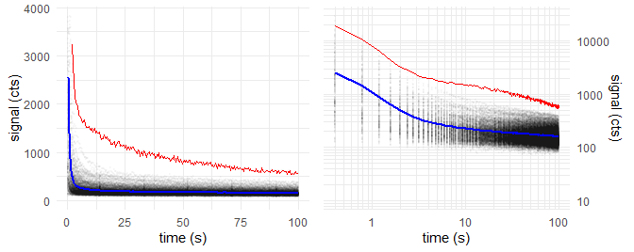

Figure 1: Global mean curve (blue); Data points of all OSL curves (grey opaque); First OSL record of first aliquot (red).

The OSL measurement time of 100 s exceed the preset cut time of 40 s. The records are cutted therefore.**Figure 2:** * Altered global mean curve*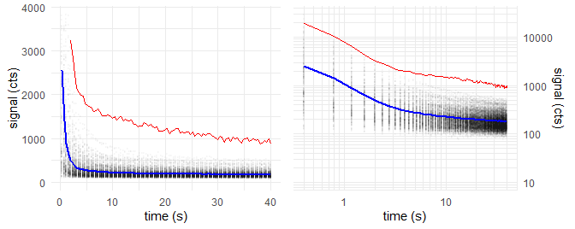

We take this global mean curve and fit it with an increasing number *K* of exponential decay components. With the increasing number of components, decreases the residual square sum between the fitting and the measured data.

Table 1: Decay constants and fit quality parameters for multi-exponentional decay fitting with K components

|  |  |  |  |  |  |  |  |
| --- | --- | --- | --- | --- | --- | --- | --- |
| K | k_1 | k_2 | k_3 | k_4 | k_5 | Chi2 | F |
| 1 | 0.861 |  |  |  |  | 3.95e+06 |  |
| 2 | 1.55 | 0.0132 |  |  |  | 3.75e+04 | 5.02e+03 |
| 3 | 2 | 0.392 | 0.00607 |  |  | 903 | 1.9e+03 |
| 4 | 2.33 | 0.933 | 0.195 | 0.00383 |  | 140 | 251 |
| 5 | 3 | 1.58 | 0.441 | 0.0861 | 0.00128 | 101 | 17.4 |

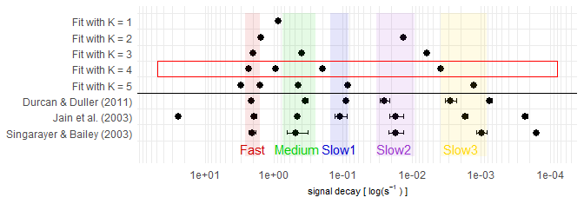

Figure 2: BlaBla

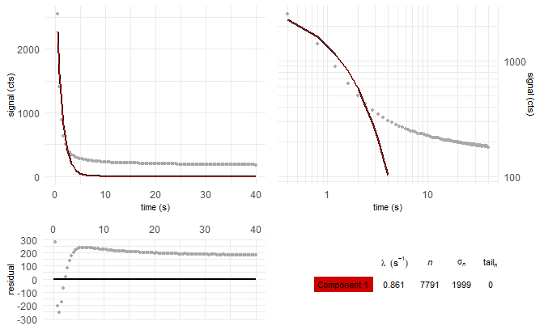

Fitting the global mean curve with K = 1 components: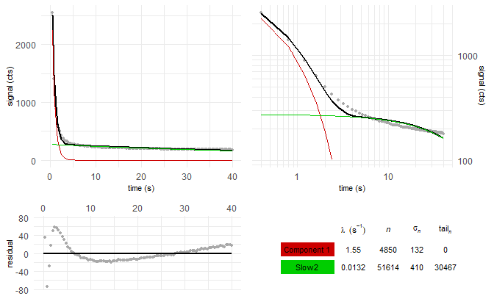

Fitting the global mean curve with K = 2 components: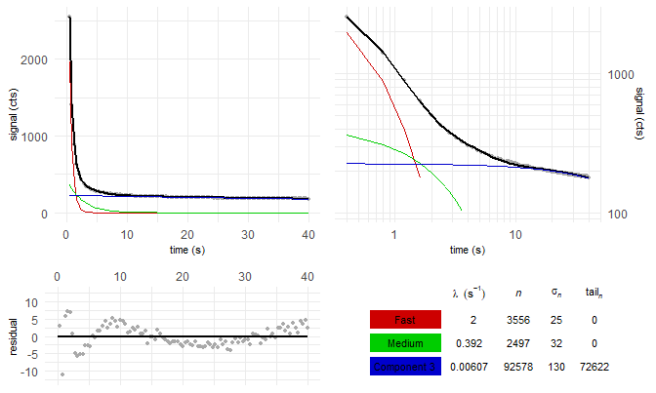

Fitting the global mean curve with K = 3 components: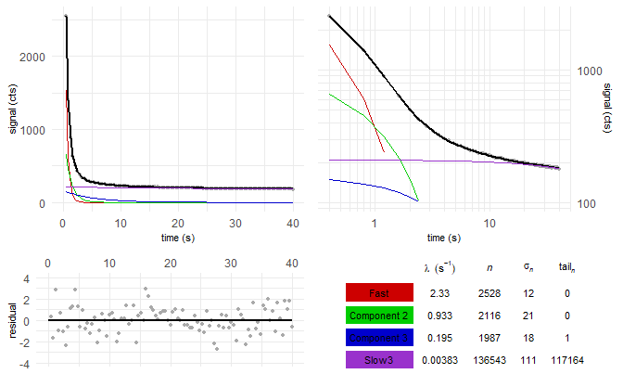

Fitting the global mean curve with K = 4 components: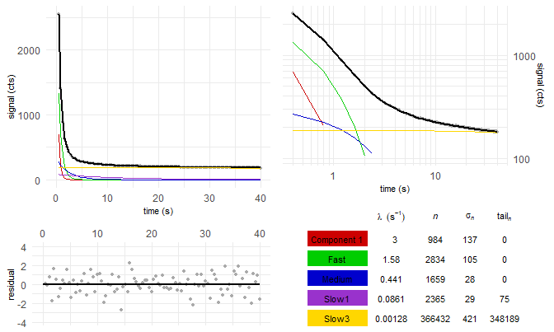

Fitting the global mean curve with K = 5 components:

## Step 2 – Single curve decomposition

In Step 2, each of the 1234 OSL curves is decomposed into its 4 signal components.

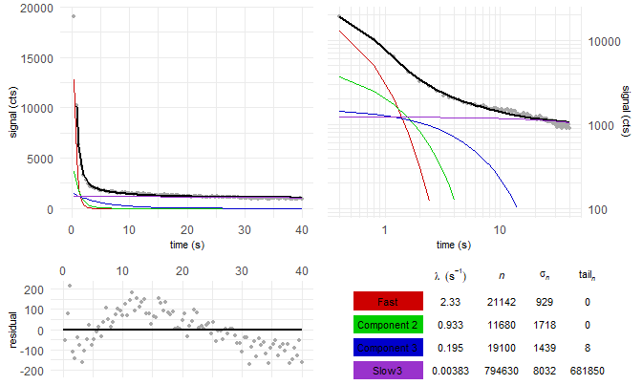

Figure 3: first OSL curve (natural dose) of example aliquot in the data set

L/T table of aliquot 1:

Table 2: …

|  |  |  |  |  |  |  |  |
| --- | --- | --- | --- | --- | --- | --- | --- |
| reg. cycle | dose (s) | n_L/n_T | sigma_n_L/n_T | n_L | sigma_L | n_T | sigma_T |
|  | natural | 9.30 | 0.99 | 21142 | 929 | 2273 | 221 |
| 1 | 49.5 | 4.52 | 0.43 | 8345 | 390 | 1847 | 152 |
| 2 | 90.75 | 5.97 | 0.45 | 11781 | 417 | 1972 | 130 |
| 3 | 123.75 | 7.20 | 0.64 | 13903 | 328 | 1930 | 165 |
| 4 | 206.25 | 10.18 | 1.61 | 16684 | 351 | 1639 | 257 |
| 5 | 0 | 0.00 | 0.07 | -39 | 151 | 2113 | 163 |
| 6 | 90.75 | 7.08 | 0.63 | 12390 | 513 | 1749 | 138 |

## Step 3 – Component-wise dose calculation

From the above L/T table, we create a signal dose curve or “growth curve”:

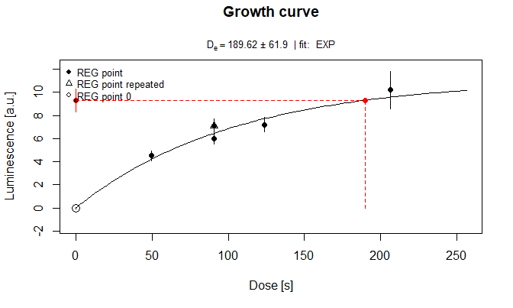

Figure 4: Growth curve

We try the exponential growth curve fitting for all components. How often is this successfull?

|  |  |  |  |  |  |  |
| --- | --- | --- | --- | --- | --- | --- |
| LB | EB | K = 1 | K = 2 | K = 3 | **K = 4** | K = 5 |
| 17 | 14 | 14 | 19 | 11 | **14** | 18 |
|  |  |  | - | 18 | **17** | 13 |
|  |  |  |  | - | **19** | 20 |

What about the median doses?

|  |  |  |  |  |  |  |
| --- | --- | --- | --- | --- | --- | --- |
| LB | EB | K = 1 | K = 2 | K = 3 | **K = 4** | K = 5 |
| 134.95 | 157.69 | 137.48 | 150.8 | 191.11 | **262.7** | 209.19 |
|  |  |  | - | 56.62 | **72** | 142.82 |
|  |  |  |  | - | **161.65** | 100.29 |

Plotted dose distribution

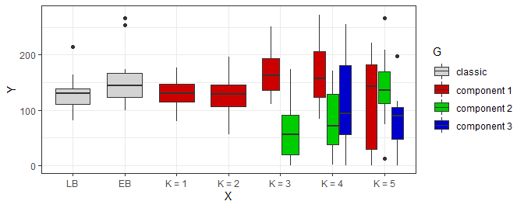

How many aliquot were not rejected?

|  |  |  |  |  |  |  |
| --- | --- | --- | --- | --- | --- | --- |
| LB | EB | K = 1 | K = 2 | K = 3 | K = 4 | K = 5 |
| 14 (17) | 4 (14) | 4 (14) | 14 (19) | 8 (11) | 3 (14) | 1 (18) |
|  |  |  | - | 4 (18) | 2 (17) | 1 (13) |
|  |  |  |  | - | 1 (19) | 2 (20) |

Recycling ratio test:

|  |  |  |  |  |  |  |
| --- | --- | --- | --- | --- | --- | --- |
| LB | EB | K = 1 | K = 2 | K = 3 | K = 4 | K = 5 |
| 1.03 +- 0.11 | 1.02 +- 0.22 | 1.01 +- 0.05 | 1.07 +- 0.25 | 1.01 +- 0.1 | 0.86 +- 0.46 | 2.12 +- 4.08 |
|  |  |  | - | 0.78 +- 0.48 | 1.46 +- 1.22 | 1.54 +- 2 |
|  |  |  |  | - | 1.52 +- 2.84 | 1.62 +- 2.16 |

Recuperation test:

|  |  |  |  |  |  |  |
| --- | --- | --- | --- | --- | --- | --- |
| LB | EB | K = 1 | K = 2 | K = 3 | K = 4 | K = 5 |
| 0.01 +- 0.01 | 0 +- 0.01 | 0.1 +- 0.08 | 0 +- 0 | 0.01 +- 0.01 | 0 +- 0.01 | 0.03 +- 0.09 |
|  |  |  | - | 0.16 +- 0.39 | 0.09 +- 0.14 | 0.02 +- 0.07 |
|  |  |  |  | - | 0.02 +- 0.06 | 0.09 +- 0.13 |

Let us apply the rejection criteria.

What about the median doses now?

|  |  |  |  |  |  |  |
| --- | --- | --- | --- | --- | --- | --- |
| LB | EB | K = 1 | K = 2 | K = 3 | K = 4 | K = 5 |
| 157.47 (14) | 280.93 (4) | 159.61 (4) | 154.13 (14) | 184.68 (8) | 411.62 (3) | 184.74 (1) |
|  |  |  | - | 73.52 (4) | 122.55 (2) | 164.39 (1) |
|  |  |  |  | - | 177.29 (1) | 186.65 (2) |

Plotted dose distribution

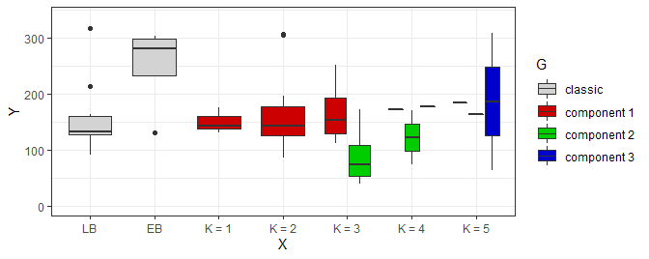

Central age model after Galbraith et al. (1999):

Error : [calc_CentralDose()] ‘data’ should have at least two columns and two rows! Error : [calc_CentralDose()] ‘data’ should have at least two columns and two rows! Error : [calc_CentralDose()] ‘data’ should have at least two columns and two rows!

|  |  |  |  |  |  |  |
| --- | --- | --- | --- | --- | --- | --- |
| LB | EB | K = 1 | K = 2 | K = 3 | **K = 4** | K = 5 |
| 129.7 +- 21.16 (14) | 140.21 +- 27.57 (4) | 143.89 +- 43.26 (4) | 114.28 +- 15.93 (14) | 132.64 +- 25.77 (8) | **232.93 +- 59.29 (3)** | - (1) |
|  |  |  | - | 49.43 +- 10.99 (4) | **50.17 +- 16.78 (2)** | - (1) |
|  |  |  |  | - | **- (1)** | 73.12 +- 38.09 (2) |

Minimum age model after Galbraith et al. (1999) and Wallinga & Cunningham (2012):

|  |  |  |  |  |  |  |
| --- | --- | --- | --- | --- | --- | --- |
| LB | EB | K = 1 | K = 2 | K = 3 | **K = 4** | K = 5 |
| 81 +- 12.96 (14) | 114.27 +- 37.12 (4) | 99.91 +- 52.02 (4) | 77.79 +- 13.67 (14) | 83.62 +- 21.07 (8) | **224.22 +- 97.2 (3)** | 117.31 +- 66.43 (1) |
|  |  |  | - | 41.74 +- 15.09 (4) | **51 +- 25.94 (2)** | 104.39 +- 57.61 (1) |
|  |  |  |  | - | **112.58 +- 197.69 (1)** | 44.4 +- 28.72 (2) |

## Summary

Time difference of 8.078511 mins

1. Y. Xie, J. J. Allaire, and G. Grolemund, R Markdown: the definitive guide. Boca Raton: Taylor & Francis, CRC Press, 2018.
2. J. Peng, Z. Dong, F. Han, H. Long, and X. Liu, ‘R package numOSL: numeric routines for optically stimulated luminescence dating’, Ancient TL, vol. 31, 2013.
3. S. Kreutzer, C. Schmidt, M. C. Fuchs, M. Dietze, and M. Fuchs, ‘Introducing an R package for luminescence dating analysis’, Ancient TL, vol. 30, 2012.