OSL decomposition report *(alpha version)*

Table of Contents

Basic idea 3

Script & data parameter 4

Data pre-treatment 5

Step 1 – Evaluation of component number and decay constants 6

Step 2 – Single curve decomposition 12

Step 3 – Equivalent dose calculation 15

Approach comparison 17

Classic signal calculation approaches | Signal interval | Background interval 17

Rejection criteria 18

Criterium | Formula | Range of acceptance 19

Paleodose and age 20

Summary 22

|  |  |
| --- | --- |
|  |  |
| Data set | FB_10Gy_SAR_RT.bin |
| Script executed at | 2019-10-23 13:35:00 |

**Preface**  
This report was automatically generated using the Rmarkdown[1] script EvaluateDataSet.Rmd in the **R** package OSLdecomposition written and maintained by Dirk Mittelstraß ([dirk.mittelstrass@luminescence.de](mailto:dirk.mittelstrass@luminescence.de)). The dose calculation deploys also functions of the R packages numOSL by Jun Peng *et al.*[2] and Luminescence by Sebastian Kreutzer *et al.*[3]

This report and the containing results can be used, shared and published by the data set maintainer at will. If the results are published, however, it is demanded to state the main **R** package OSLdecomposition including its version number (0.10.23.2). It is also recommended to add this report to the supplement of your publication.

## Basic idea

The method is based on the assumption, that every OSL curve can be described as sum of signal components[4]. It is further assumed, that each signal component can be described by an exponential decay following first order kinetics. The shape of every CW-OSL curve can then be modelled by:

$$I(t)=\sum_{i=1}^{K}{n_{i}}λ_{i}exp(-λ_{i}t)$$

Here, *I(t)* represents the luminescence signal during continuous stimulation, *K* the number signal components, *ni* the integrated signal intensities (or just ‘signal values’) of each signal component and $λ_{i}$ their decay constants. We also assume, that the set of decay constants is the same for all OSL curves in a given data set. So we can apply the following data analysis approach:

1. Determine the component number *K* and the decay parameters $λ_{i}$, …, $λ_{K}$ globally by multi-exponential decay fitting at one representative superposition OSL curve
2. Determine the signal values *n1*, …, *nK*for each OSL curve by a decomposition algorithm
3. Determine the natural dose signal component-wise by building separate signal-dose growth curves for each set of *ni* values

A full description of the method and the algorithms involved, as well as some performance tests, can be found in the master thesis of D. Mittelstraß[5].

## Script & data parameter

|  |  |
| --- | --- |
| **Script conditions** |  |
| Script version | 2019-10-23 |
| R version | 3.6.1 |
| Packages performing calculations | OSLdecomposition 0.10.23.2 |
|  | Luminescence 0.9.5 |
|  | numOSL 2.6 |
| **Data set conditions** |  |
| Evaluated record types | OSL |
| Data set entries (aliquots) | 11 |
| Indicies of dismissed aliquots | none |
| Indicies of background measurements | 11 |
| Analyzed aliquots | 10 |
| OSL records per entry | 14 |
| Channel number | *N* = 999 |
| Channel width | $Δt$ = 0.0998999 s |
| Measurement time | *tend* = 99.8000031 |

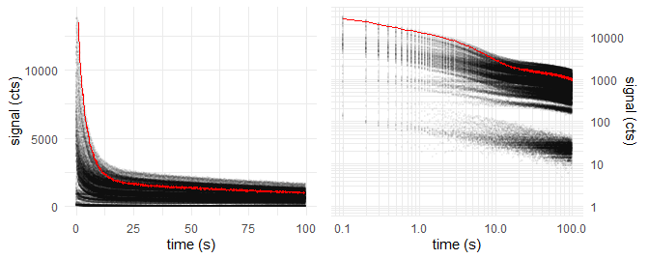

*Figure 1: Raw data points of all OSL curves (grey opaque) and natural dose OSL curve of first aliquot (red)*

|  |  |
| --- | --- |
| **Sample conditions** |  |
| Sample type | coarse grain quartz |
| Expected age | ~ NA ka |
| Environmental dose rate | NA Gy ka-1 |
| Expected dose | ~ 22 Gy |
| Laboratory dose rate | 0.055 Gy s-1 |
| Stimulation wavelength | 530 nm |
| Assumed stimulation intensity | 50 mW cm-2 |
| **Algorithm settings** |  |
| Cut measurements if exceeding | *tmax* = 200 s |
| Maximum allowed components | *Kmax* = 5 |
| Threshold *F*-value | *Fthreshold* = 50 |
| Decomposition algorithm | det+nls |

## Data pre-treatment

Prior data evaluation, the records will be corrected for signal background, measurement over-length, etc., depending on the script settings and the provided data. The following corrections were performed by applying the function prepare_OSLdata():

* Aliquot 11 is set as background measurement. All OSL records are combined to a mean curve. This mean curve is subtracted from all other records of the data set.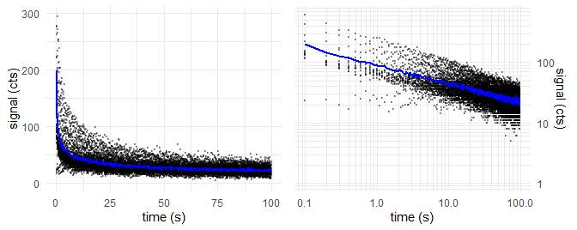
* *Figure 2: Mean curve of background measurements (blue) and data points of all background measurement (grey opaque)*

## Step 1 – Evaluation of component number and decay constants

For calculating the decay parameters, one representative OSL curve is needed. This is provided by combining all records to one **global mean curve**. Each data point of the global curve represents the arithmetic mean of all data point values of the same channel in all OSL curves. This increases the signal-to-noise ratio by about one to two orders of magnitude, but still maintains the decay parameter information.

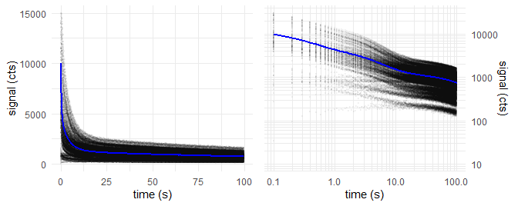

*Figure 3: Global mean OSL curve (blue) and data points of all OSL records (grey opaque)*

We take the global mean curve and perform a multiple cycles of **multi-exponential nonlinear regression**. In each cycle, the number of components *K* increases by one. With increasing number of components, decreases the signal deviation (residual curve) between the fitted model curve and the measured data and the fit gets better.

The underlying algorithm was proposed and described by Bluszcz & Adamiec [6] and realized in **R** by the function numOSL::decomp() by Peng *et al.*. Their function is used in fit_OSLcurve(), which calculated the following series of fittings, displayed with plot_OSLcurve():

The subsequent diagrams are structured the following way:

* Upper left: Global mean curve (grey), fit model curve (black) and component signals
* Upper right: Same as log-log diagram
* Lower left: Residual curve between fit and global mean curve
* Lower right: Result table with estimated type of component names (colored)

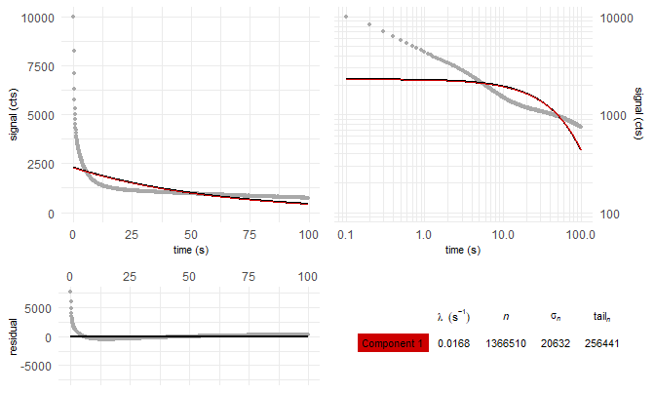

*Figure 4: Global mean curve fit with K = 1 components*

———

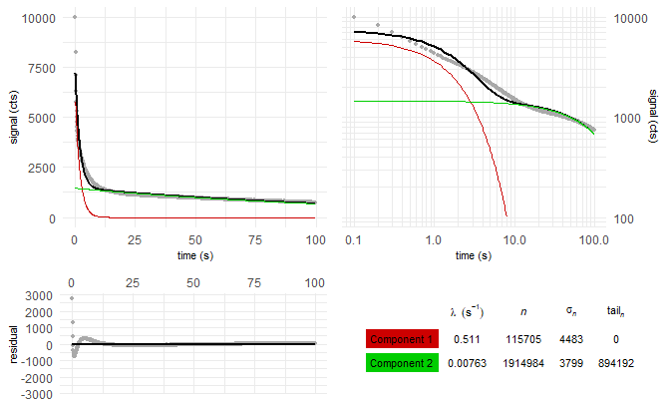

*Figure 5: Global mean curve fit with K = 2 components*

———

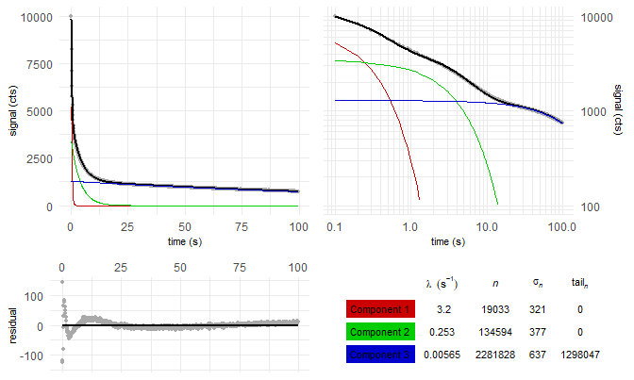

*Figure 6: Global mean curve fit with K = 3 components*

———

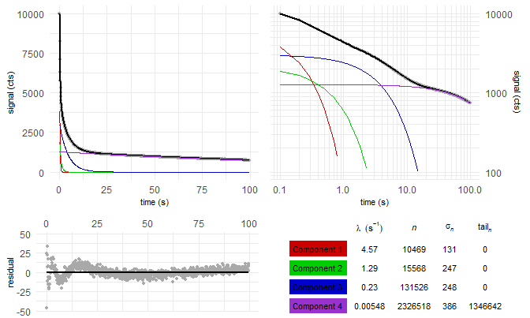

*Figure 7: Global mean curve fit with K = 4 components*

———

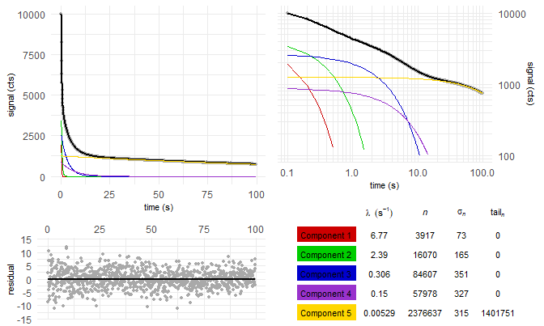

*Figure 8: Global mean curve fit with K = 5 components*

———

But which of these fittings gives back a sufficient model of the global mean curve, without over-fitting it? We solve this by comparing the residual square sum (*RSS*) of each fitting with the *RSS* value of the previous fitting. This is called *F*-test and was already proposed by Bluszcz & Adamiec:

$$F_{K}=\frac{(RSS_{K-1}-RSS_{K})/2}{RSS_{K}(N-2K)}$$

If *FK* falls below the preset threshold value of *Fthreshold* = 50, the new fitting model with *K* components is apparently not significantly better than the *K* - 1 model.

Table 1: Decay constants and fit quality parameters for multi-exponentional decay fitting with K components

|  |  |  |  |  |  |  |  |
| --- | --- | --- | --- | --- | --- | --- | --- |
| K | $λ_{1}$ $(s^{-1})$ | $λ_{2}$ $(s^{-1})$ | $λ_{3}$ $(s^{-1})$ | $λ_{4}$ $(s^{-1})$ | $λ_{5}$ $(s^{-1})$ | RSS | $$F_{K}$$ |
| 1 | 0.0168 |  |  |  |  | 2.81e+08 |  |
| 2 | 0.511 | 0.00763 |  |  |  | 2.19e+07 | 5.87e+03 |
| 3 | 3.2 | 0.253 | 0.00565 |  |  | 2e+05 | 5.4e+04 |
| 4 | 4.57 | 1.29 | 0.23 | 0.00548 |  | 3.54e+04 | 2.3e+03 |
| 5 | 6.77 | 2.39 | 0.306 | 0.15 | 0.00529 | 1.17e+04 | 1e+03 |

The fitting with *K* = 5 components is found to be the best suiting model to describe the given sample. Signal components with not-first-order kinetics, however, can lead to over-fitting. It is recommended to take the results of the *K* = 4 fitting model also into consideration.

If the stimulation light wavelength is about 470 nm and the stimulation light intensity is 50 mW cm-2 as presetted, the photoionisation cross-sections of the components can be calculated. These can be compared with the quartz LM-OSL findings, given in literature[7][8][9]

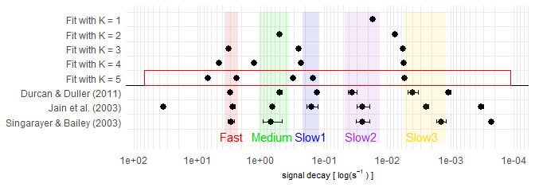

*Figure 9: Comparison of decay constants between fitting cases and comparison with reference values. Red square: Best fit

———

## Step 2 – Single curve decomposition

In Step 2, we decompose each OSL curve into its signal components. We set the decay constants found in Step 1 as fixed values for all OSL curves of the data set. This allows us to apply very robust and noise-insensitve signal decomposition methods. In case, the decomposition method “det+nls” is chosen, the following workflow is applied:

1. Divide the measurement time into *K* intervals. These intervals are calculated and optimized globally by calc_OSLintervals().
2. Integrate the signal curve of each OSL record over these intervals. From the integration values and the fitting model found in Step 1, build one equation system with *K* equations for each OSL record.
3. Solve the equation system by an analytic determinant based method, called ‘Cramer’s rule’, and get the area under the component curve or ‘intensity’ *nk* for each signal component
4. To enhance stability and precision of the method, refine the set of *nk* values in a quasi-linear regression using base::nls(). If this refining-fit fails, go on with the Cramer’s rule achieved values.
5. Calculate the standard deviation of the integration values from step 2 by the residuals between fit-model OSL curve and real data points
6. Apply the propagation of uncertainty method onto Cramer’s rule and calculate the uncertainty $σ_{k}$ for each component intensity value *nk*

All steps, beside the first step, are realized in decompose_OSLcurve(). The table in figure 10 displays the particular outcome of this method for the *K* = 5 model applied at the first OSL curve of the first aliquot as example. The parameter *tailn* gives back the area under the component which is not displayed in the OSL diagram. If the measurement was not cutted in the data-pretreatment and an appropriate background correction was performaed, *tailn* equals the not-released signal of the component.

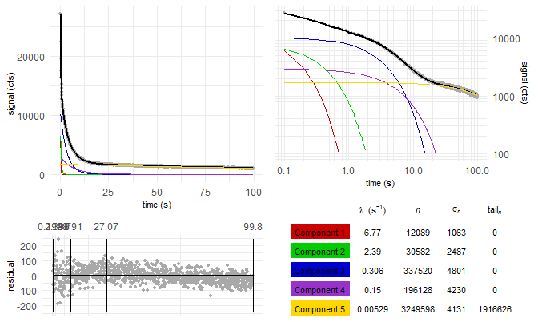

*Figure 10: 5-component decomposition results of the first OSL record in the data set. The vertical lines in the residual diagram show the integration intervals.

———

We assume the data set is measured in accordance to the SAR protocol[10]. Then every OSL measurement is followed by the regeneration of a fixed test-dose and the measurement of the OSL signal related to this test-dose. The testdose-related OSL signal is indicated by the variable *Ti*, the natural and regenerated dose OSL signal is indicated by the variable *Li*. The normalized OSL signal is therefore given by $L_{i}/T_{i}$.

A L/T table provides a structure for the signal values and dose regeneration points we need to build dose-signal curves in Step 3 and to test for signal behaviour criteria. One L/T table per signal component and aliquot is built. To avoid some potential issues in Step 3, we apply the following conditions when assigning the signal values to the table:

* If the measurement time was not cutted: Substract the value of *tailn* from the *nk* value of the subsequent OSL measurement. This enables correctly built L/T tables for slow decaying components.
* If the measurement time was cutted: Do not build L/T tables of a component, when more than 1% of the components signal would be transferred into *tailn*. So the component can not be further evaluated and misleading conclusions are avoided.
* Set negative $L_{i}/T_{i}$ values to $L_{i}/T_{i}=0$ to avoid calculation issues although negative values are mathematically and physically possible (due to photo-transfer).

Table 2: L/T table of fastest decaying component of first aliquot for the K = 5 case. Test dose for generating all Ti is: Dt = 781

|  |  |  |  |  |  |  |  |
| --- | --- | --- | --- | --- | --- | --- | --- |
| *i* | dose (Gy) | $$L_{i}/T_{i}$$ | $$σ_{L_{i}/T_{i}}$$ | $$L_{i}$$ | $$σ_{L_{i}}$$ | $$T_{i}$$ | $$σ_{T_{i}}$$ |
| 0 | natural | 2.07 | 0.33 | 12089 | 1063 | 5848 | 781 |
| 1 | 5.5 | 0.94 | 0.21 | 4619 | 782 | 4898 | 739 |
| 2 | 11 | 2.28 | 0.52 | 8866 | 889 | 3889 | 793 |
| 3 | 22 | 4.43 | 1.09 | 13222 | 1009 | 2982 | 698 |
| 4 | 33 | 4.44 | 1.29 | 14049 | 1209 | 3161 | 878 |
| 5 | 0 | 0.01 | 0.15 | 28 | 491 | 3240 | 628 |
| 6 | 5.5 | 1.15 | 0.37 | 2943 | 688 | 2562 | 580 |

## Step 3 – Equivalent dose calculation

From the L/T table, we create a signal dose curve or “growth curve” by calling the function Luminescence::plot_GrowthCurve(). The function plots the luminescence signal values $y=L_{i}/T_{i}$ against the regeneration doses *x = Di*. Several fitting models are selectable. We will use the default model:

$$y(x)=a(1-e^{-(x+c)/b})$$

Here *a*, *b* and *c* are the fitting factors. The factor The natural or ‘equivalent’ dose *De* related to the natural luminescence signal of this component and aliquot is calculated by solving $y(D_{e})=L_{0}/T_{0}$. The uncertainty of the equivalent dose *De* is calculated by a Monte Carlo simulation. The Monte Carlo simulation assumes normal distributed $L_{i}/T_{i}$ values with a standard deviation equal to the calculated error $σ_{L_{i}/T_{i}}$. This assumption is used to build 100 randomized L/T tables. The standard deviation of the *De* distribution calculated from these tables, is then the *De* error returned by Luminescence::plot_GrowthCurve().

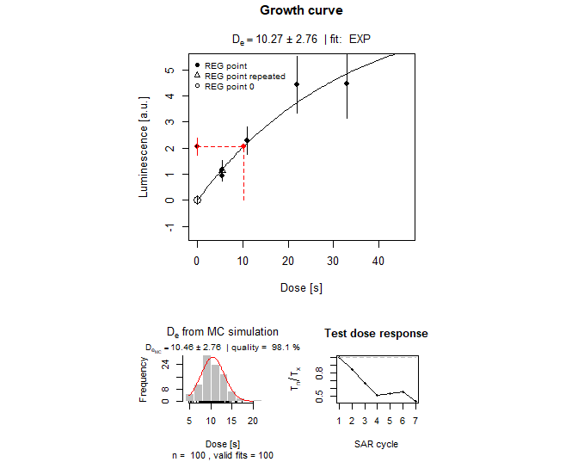

*Figure 11: Signal-dose curve of the fastest decaying component of the first aliquot, plotted by Luminescence::plot_GrowthCurve(). Lower left: Distribution of Monte Carlo simulatd* De* values, used to calculate the *De* error value. Lower right: Variation of the normalized Test dose signal over the measurement sequence, useful to display luminescence sensitivity changes.

## Approach comparison

We calculate the equivalent doses *De* for all aliquots and all components for which L/T tables were built. We do this not just for the *K* = 5 case we selected per *F*-test in Step 1. We do this also for all *K* < 5, This way, we gained dose information even if the *K* = 5 doses aren’t available or reasonable due low signal-to-noise ratio or over-fitting in Step 1. For comparison, we also calculate *De* values the common way by late light background substraction and early light background substraction. The late light background substraction approach or short ‘late background’ approach was used by Murray & Wintle in their definition of the standard SAR protocol. Here, the function calc_classisOSLsignal() performs the signal calculation and sets the integration intervals following the rules by Murray & Wintle. For the ‘early background’ approach, the rules given by Cunningham and Wallinga[11] are followed.

## Classic signal calculation approaches | Signal interval | Background interval

Late light background substraction | 0 to 0.6 s | 94 to 1e+02 s  
Early light background substraction | 0 to 0.3 s | 0.3 to 1.1 s

Table 4: Medians of the De-distributions from 10 aliquots from different signal calculation approaches. The first line lists the median values of the fastest decaying signal component, the second line the second fastest, etc.. The value inside the brackets () shows the number of sucessful calculated De’s.

|  |  |  |  |  |  |  |  |
| --- | --- | --- | --- | --- | --- | --- | --- |
| component | late b. | early b. | K = 1 | K = 2 | K = 3 | K = 4 | K = 5 |
| 1 | 15.6 Gy (10) | 12.4 Gy (10) | 18.8 Gy (10) | 17 Gy (10) | 11.6 Gy (10) | 10.6 Gy (10) | 11.5 Gy (10) |
| 2 |  |  |  | 18.3 Gy (10) | 19.2 Gy (10) | 14.7 Gy (10) | 11.5 Gy (10) |
| 3 |  |  |  |  | 15.6 Gy (10) | 19.4 Gy (10) | 21.2 Gy (10) |
| 4 |  |  |  |  |  | 15.2 Gy (10) | 16 Gy (10) |
| 5 |  |  |  |  |  |  | 15.1 Gy (10) |

Note, that in all cases fit failures are common and can happen if the $L_{i}/T_{i}$ values have to large errors or don’t follow a growth curve or if $L_{0}/T_{0}$ is larger than the fit parameter *a*.

Table 4 vizualized in a series of box plots, we get:

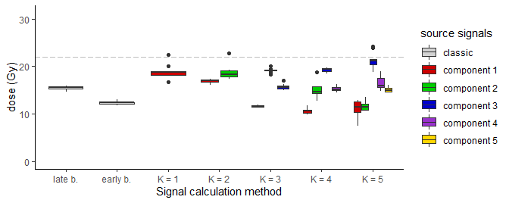 component late b. early b. K = 1 K = 2 K = 3 K = 4 1 1 15.645 Gy 12.375 Gy 18.767 Gy 16.975 Gy 11.635 Gy 10.628 Gy 2 2 18.282 Gy 19.194 Gy 14.697 Gy 3 3 15.594 Gy 19.4 Gy 4 4 15.188 Gy 5 5  
K = 5 1 11.507 Gy 2 11.503 Gy 3 21.219 Gy 4 15.991 Gy 5 15.051 Gy

*Figure 12: Box plots of the* De*-distributions from 10 aliquots from different signal calculation approaches. The dashed line shows the expected does. Box plot rules: The whiskers enclose all four quartiles besides outlier. The rectangles enclose the second and third quartile. The middle line shows the median. See ggplot2::geom_boxplot for a detailed explanation.*

## Rejection criteria

The equivalent doses calculated so far, are not necessarily physical meaningful. Murray and Wintle introduced two tests to detect and reject not trustworthy *De* values.

**Recycling ratio test**  
In the SAR protocol, the first and the last dose regeneration cycle apply usally the same dose (=recycled dose). The generated normalized luminescence signals $L_{1}/T_{1}$ and $L_{last}/T_{last}$ should be about equal. If the ratio between both differs significantly from one, it implicates that the applied doses cannt be monitored precisely.

Table 5: Mean and standard deviation of the recycling ratios from all successfully fitted aliquots

|  |  |  |  |  |  |  |  |
| --- | --- | --- | --- | --- | --- | --- | --- |
| component | late b. | early b. | K = 1 | K = 2 | K = 3 | K = 4 | K = 5 |
| 1 | 1.03 $±$ 0.02 | 1.03 $±$ 0.04 | 1.04 $±$ 0.01 | 1.03 $±$ 0.01 | 1.02 $±$ 0.04 | 1.04 $±$ 0.07 | 1.11 $±$ 0.35 |
| 2 |  |  |  | 1.03 $±$ 0.01 | 1.03 $±$ 0.01 | 0.99 $±$ 0.11 | 1.02 $±$ 0.16 |
| 3 |  |  |  |  | 1.02 $±$ 0.01 | 1.04 $±$ 0.02 | 1.04 $±$ 0.1 |
| 4 |  |  |  |  |  | 1.02 $±$ 0.02 | 1.02 $±$ 0.19 |
| 5 |  |  |  |  |  |  | 1.02 $±$ 0.01 |

Be aware, that for data sets with low signal-to-noise ratio, this recycling ratio is quite random, especially if small test doses are chosen. False positive as well as false negative aliquot rejections are likely.

**Recuperation test**  
In the regeneration cycle after the cycle with the largest applied dose, usually no dose is applied before measuring *Li*. If no dose is applied, the corresponding normalized luminescence signal $L_{i}/T_{i}$ should be about zero. The occurence of significant luminescence signal hints towards the appearance of charge transfer into the observed OSL traps unrelated to dose regeneration.

Table 6: Mean and standard deviation of the recuperation rates from all successfully fitted aliquots

|  |  |  |  |  |  |  |  |
| --- | --- | --- | --- | --- | --- | --- | --- |
| component | late b. | early b. | K = 1 | K = 2 | K = 3 | K = 4 | K = 5 |
| 1 | 0.02 $±$ 0.011 | 0 $±$ 0 | 0.289 $±$ 0.04 | 0 $±$ 0 | 0 $±$ 0 | 0 $±$ 0 | 0.007 $±$ 0.009 |
| 2 |  |  |  | 0.117 $±$ 0.013 | 0 $±$ 0 | 0.045 $±$ 0.015 | 0 $±$ 0 |
| 3 |  |  |  |  | 0.028 $±$ 0.011 | 0 $±$ 0 | 0.038 $±$ 0.019 |
| 4 |  |  |  |  |  | 0.018 $±$ 0.012 | 0 $±$ 0 |
| 5 |  |  |  |  |  |  | 0.012 $±$ 0.012 |

Murray and Wintle defined a range of acceptance for both tests:

## Criterium | Formula | Range of acceptance

Recycling ratio | |   
Recuperation rate | |

How many aliquots fullfill these criteria?

|  |  |  |  |  |  |  |  |
| --- | --- | --- | --- | --- | --- | --- | --- |
| component | late b. | early b. | K = 1 | K = 2 | K = 3 | K = 4 | K = 5 |
| 1 | 10 of 10 | 9 of 10 | 0 of 10 | 10 of 10 | 10 of 10 | 9 of 10 | 3 of 10 |
| 2 |  |  |  | 0 of 10 | 10 of 10 | 5 of 10 | 6 of 10 |
| 3 |  |  |  |  | 10 of 10 | 10 of 10 | 7 of 10 |
| 4 |  |  |  |  |  | 10 of 10 | 4 of 10 |
| 5 |  |  |  |  |  |  | 10 of 10 |

What about the median doses now?

|  |  |  |  |  |  |  |  |
| --- | --- | --- | --- | --- | --- | --- | --- |
| component | late b. | early b. | K = 1 | K = 2 | K = 3 | K = 4 | K = 5 |
| 1 | 15.645 (10) | 12.308 (9) | - | 16.975 (10) | 11.635 (10) | 10.589 (9) | 11.643 (3) |
| 2 |  |  |  | - | 19.194 (10) | 14.279 (5) | 10.951 (6) |
| 3 |  |  |  |  | 15.594 (10) | 19.4 (10) | 21.453 (7) |
| 4 |  |  |  |  |  | 15.188 (10) | 16.601 (4) |
| 5 |  |  |  |  |  |  | 15.051 (10) |

Plotted dose distribution

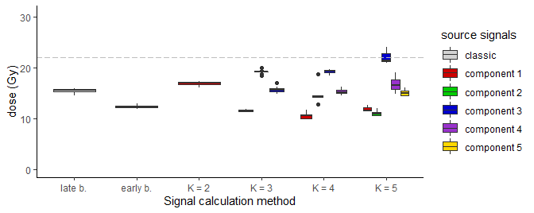

## Paleodose and age

Central age model after Galbraith et al. (1999):

|  |  |  |  |  |  |  |  |
| --- | --- | --- | --- | --- | --- | --- | --- |
| component | late b. | early b. | K = 1 | K = 2 | K = 3 | K = 4 | K = 5 |
| 1 | NA $±$ NA (10) | NA $±$ NA (9) | - | NA $±$ NA (10) | NA $±$ NA (10) | NA $±$ NA (9) | NA $±$ NA (3) |
| 2 |  |  |  | - | NA $±$ NA (10) | NA $±$ NA (5) | NA $±$ NA (6) |
| 3 |  |  |  |  | NA $±$ NA (10) | NA $±$ NA (10) | NA $±$ NA (7) |
| 4 |  |  |  |  |  | NA $±$ NA (10) | NA $±$ NA (4) |
| 5 |  |  |  |  |  |  | NA $±$ NA (10) |

Minimum age model after Galbraith et al. (1999) and Wallinga & Cunningham (2012):

|  |  |  |  |  |  |  |  |
| --- | --- | --- | --- | --- | --- | --- | --- |
| component | late b. | early b. | K = 1 | K = 2 | K = 3 | K = 4 | K = 5 |
| 1 | NA $±$ NA (10) | NA $±$ NA (9) | - | NA $±$ NA (10) | NA $±$ NA (10) | NA $±$ NA (9) | NA $±$ NA (3) |
| 2 |  |  |  | - | NA $±$ NA (10) | NA $±$ NA (5) | NA $±$ NA (6) |
| 3 |  |  |  |  | NA $±$ NA (10) | NA $±$ NA (10) | NA $±$ NA (7) |
| 4 |  |  |  |  |  | NA $±$ NA (10) | NA $±$ NA (4) |
| 5 |  |  |  |  |  |  | NA $±$ NA (10) |

## Summary

Time difference of 11.52273 mins

1. Y. Xie, J. J. Allaire, and G. Grolemund, R Markdown: the definitive guide. Boca Raton: Taylor & Francis, CRC Press, 2018.
2. J. Peng, Z. Dong, F. Han, H. Long, and X. Liu, ‘R package numOSL: numeric routines for optically stimulated luminescence dating’, Ancient TL, vol. 31, 2013.
3. S. Kreutzer, C. Schmidt, M. C. Fuchs, M. Dietze, and M. Fuchs, ‘Introducing an R package for luminescence dating analysis’, Ancient TL, vol. 30, 2012.
4. R. M. Bailey, B. W. Smith, and E. J. Rhodes, ‘Partial bleaching and the decay form characteristics of quartz OSL’, Radiation Measurements, vol. 27, no. 2, pp. 123–136, Apr. 1997.
5. D. Mittelstraß, ‘Decomposition of weak optically stimulated luminescence signals and its application in retrospective dosimetry at quartz’, Master thesis, TU Dresden, Dresden, 2019.
6. A. Bluszcz and G. Adamiec, ‘Application of differential evolution to fitting OSL decay curves’, Radiation Measurements, vol. 41, no. 7–8, pp. 886–891, Aug. 2006.
7. J. A. Durcan and G. A. T. Duller, ‘The fast ratio: A rapid measure for testing the dominance of the fast component in the initial OSL signal from quartz’, Radiation Measurements, vol. 46, no. 10, pp. 1065–1072, Oct. 2011.
8. M. Jain, A. S. Murray, and L. Bøtter-Jensen, ‘Characterisation of blue-light stimulated luminescence components in different quartz samples: implications for dose measurement’, Radiation Measurements, vol. 37, pp. 441–449, 2003.
9. J. S. Singarayer and R. M. Bailey, ‘Further investigations of the quartz optically stimulated luminescence components using linear modulation’, Radiation Measurements, vol. 37, no. 4, pp. 451–458, Aug. 2003.
10. A. S. Murray and A. G. Wintle, ‘Luminescence dating of quartz using an improved single-aliquot regenerative-dose protocol’, Radiation Measurements, vol. 32, no. 1, pp. 57–73, Feb. 2000.
11. A. C. Cunningham und J. Wallinga, „Selection of integration time intervals for quartz OSL decay curves“, Quat. Geochronol., Bd. 5, Nr. 6, S. 657–666, Dez. 2010.