**CSIS 1280 Final Project**

**Name: Sichao Kan**

**Student ID: 300109472**

**Introduction**

The Qatar World Cup has started! This website is created to celebrate the biggest sports event. The site will provide the visitors with a bit introduction to the Qatar World Cup, a short survey, and a simple game to help the users get ready for the game.

**Website Layout and Organization**

The website is consisted of three pages: index, page2(World Cup Survey), and page3(World Cup Game):

**Page 1: Index**

This page serves as the main menu for the website. There is a navigation bar under the header which can direct to the rest two pages (navigation bar is also available for page2 and page3). The nav uses float and the background color and text color will change once the user moves the mouse pointer onto specific tab. There is a YouTube video after the introductory paragraphs.

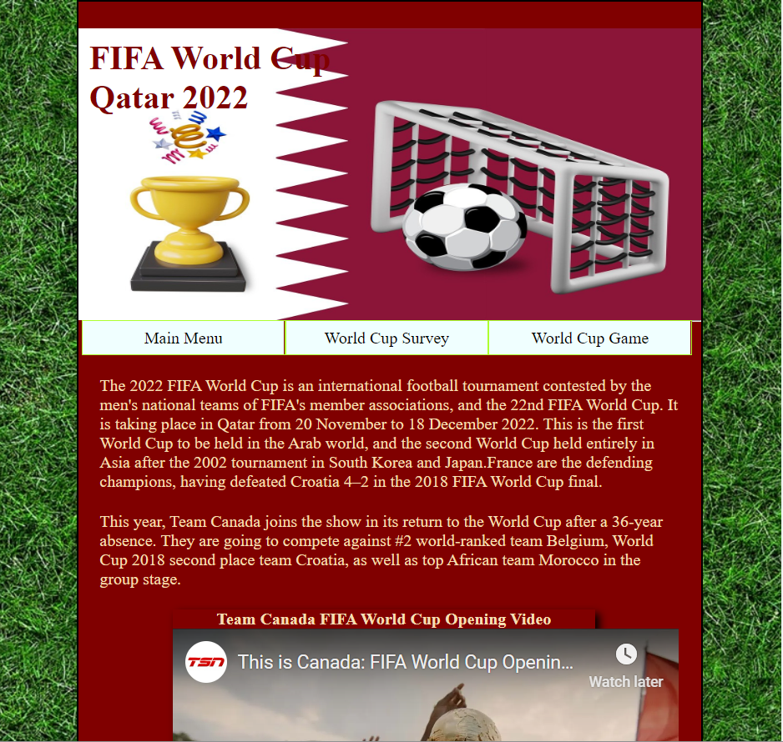

**Dom tree**

**Page 2: World Cup Survey**

This page contains a simple survey for user input. The survey uses form element with textbox, selection, radio button, and text area. When user clicks the submit button, the input of name, e-mail, selection of age, and location will be validated. The email input will also be validated with proper pattern (as Douglas College student email). Once user finishes filling the form and clicks submit, a message with an image using user-input and selection will be generated and displayed. The Clear Input button will clear all user input. The content of this page is also adjustable according to the width of the device using media query.

**

**Dom tree**

Form Validation and responsive display

**Page 3: World Cup Game**

This page contains a simple game. The survey uses JavaScript generated 20 * 20 div and allow user to control the movement of the red “player” with pressing keys (A-left, S-down, D-right, W-up). To win this game, user need to control the “player” unit carry the “ball” to the “gate” area. The game will end when: 1, the ball arrives the gate (goal). 2, the ball reaches the boundary (outside). 3, the defender takes the ball (lose). Once the game ends, an alert window pops up and tells user the result and ask user to refresh the page. The mechanism will be discussed in the Game section.

**Dom tree**

Boundary

Ball

Player

Gate

Defender

**The Game Mechanism**

1. Generate the game board

Upon the page is loaded, a 20 * 20 grid using div is generated in the “container” section using JavaScript

1. clearScreen() function

The function will set the background color for the ground, boundary, and gate

1. Initialize player, ball, and defender

Each unit in this game is a one-div unit represented by the index of the unit in the div array. The color of each unit is as follow:

Red – player

Blue – defender

Black – ball

The initial position of the units are set using the initialize() function.

1. Event listener for key down

When user press “A”, “S”, “D”, “W”, the player unit will move accordingly. The player will not be able to move outside the boundary of the board. If player moves onto the ball’s location, the ball will be “pushed” to the nearby location. The defender’s position will also shift by one around the goal.

1. Check ball position to see if the game ends

After each key down, the program will verify the location of the ball to see if it meets one the following three conditions:

1. Location of the ball is at the boundary. Ball is outside.
2. Location of the ball is the same as the defender. Defender has the ball, player loses.
3. Location of the ball is in the gate. Goal! Player wins

For each criterion, at pop-up window will show with message according and ask the user the refresh the page. Otherwise, the game will continue.

**Content Declaration**

Wikipedia entry on 2022 FIFA World Cup: [*https://en.wikipedia.org/wiki/2022_FIFA_World_Cup*](https://en.wikipedia.org/wiki/2022_FIFA_World_Cup)

Background image: <https://pixabay.com/illustrations/lawn-football-soccer-grass-game-1335365/>

Header image: <https://pixabay.com/illustrations/soccer-world-championship-world-cup-7594708/>

“From Home” image: <https://pixabay.com/photos/soccer-football-tv-watching-home-3496510/>

“From Bar” image: <https://pixabay.com/photos/bar-local-ireland-irish-pub-pub-209148/>

“From Qatar” image: <https://pixabay.com/photos/crowd-sport-stadium-fans-game-1283691/>

**Link to the GitHub**

Repositories: <https://github.com/Dirkan45/Dirkan45.github.io>

Pages: <https://dirkan45.github.io/>