Computer Communications and Networks (COMN) Course, Spring 2014

Coursework: Results Sheet

Forename and Surname: | Lukas Dirzys
Matriculation Number: | s1119520

Question 1 – Impact of retransmission timeout on number of retransmissions with stop-and-wait protocol.

Retransmission timeout (ms) | Number of  re-transmissions | Throughput  (Kilobytes per second)
10 | 6820 | 21
20 | 3226 | 19
30 | 3104 | 17
40 | 1354 | 16
50 | 1102 | 15
60 | 1068 | 14
70 | 1042 | 13
80 | 1050 | 12
90 | 1051 | 11
100 | 1086 | 10

Question 2 – How does the throughput behave when the retransmission timeout increases and why? What is the optimal value for retransmission timeout?

When retransmission timeout increases throughput decreases while the number of retransmissions decreases rapidly until the timeout is ~50ms and then stays around the same (~1100 retransmissions). When retransmission timeout is high sender waits very long for the answer to arrive, however if the packet or acknowledgment was lost – answer will never arrive and sender will waste his time until the timeout comes and try to re-send the packet again. Therefore, because of huge waiting time – sender is going to send data much slower overall. However, with higher retransmission timeout sender will not try to re-send packets so frequently. Optimal value for retransmission timeout, in my opinion, is 50ms, because at this point retransmission rate is nearly the same as for those below and much lower than for those above (taking into account the fact that throughput decreases constantly).

Question 3 – Experiments with Go-Back-N:

 | Throughput (Kilobytes per second)
Window Size | Delay = 10ms | Delay = 100ms | Delay = 300ms
Optimal Retransmission timeout(ms) | 50 | 50 | 50
1 | 23 | 2 | 1
2 | 44 | 5 | 2
4 | 79 | 10 | 3
8 | 128 | 19 | 6
16 | 174 | 37 | 13
32 | 210 | 67 | 25
64 | 192 | 106 | 45
128 | 175 | 84 | 59
256 | 130 | 68 | 41

Use the results in the above table to make the following graph:

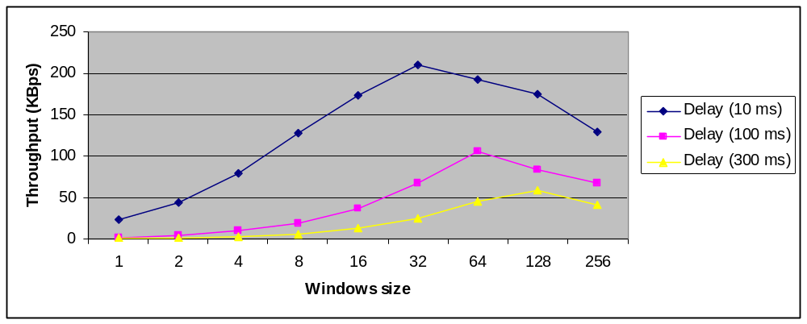

Question 4 – Explain your results from Question 3.

As we can see from the results above higher propagation delay causes much lower throughput. This is quite obvious – longer packet sending time reduces the number of data that can be send during some time (i.e. 1 second). Looking at the impact of window size, we can clearly see that, whatever the delay is, by increasing window size throughput increases rapidly (Bigger window size allows more packets to be send at the same time without necessity to wait for the acknowledgement first to be able to send next packet. Therefore, simultaneously sent packets increases the throughput) until it reaches the peak. These peaks for each of cases (10, 100 and 300ms) are when window size is 32, 64 and 128 respectively. After that – performance decreases. This is, because the number of packets sent at the same time grows fast and one single packet error causes the retransmission of many packets unnecessarily.

Question 5 – Experiments with Selective Repeat

 | Throughput (Kilobytes per second)
Window Size | Delay = 100ms
8 | 35
16 | 42
32 | 74
64 | 134
128 | 152
256 | 150

Question 6 - Compare the throughput obtained when using “Selective Repeat” with the corresponding results you got from the “Go Back N” experiment and explain the reasons behind any differences.

Corresponding throughput for “Selective Repeat” is slightly better than for “Go Back N”. As we know in “Selective Repeat” approach sender only re-sends packets for which acknowledgement was not received while receiver acknowledges all correctly received packets individually. That solves the issue with sending all packets within the window again if at least one of them was lost. “Selective Repeat” saves some time here (while not sending already acknowledged packets), however receiver might work slower, because of need to store acknowledgements. Moreover, issue with peaks also solved – sender will not need to resend all packets if one of them within the window is lost. Overall, “Selective Repeat” is better than “Go Back N”.

Question 7 – Experiments with iperf

 | Throughput (Kilobytes per second)
Window Size (KB) | Delay = 100ms
8 | 36
16 | 44
32 | 58
64 | 88
128 | 90
256 | 165

Question 8 - Compare the throughput obtained when using “Selective Repeat” and “Go Back N” with the corresponding results you got from the iperf experiment and explain the reasons behind any differences.

As we can see from the results above, “Selective Repeat” implementation works as good as iperf with TCP, even slightly better at some window sizes while “Go Back N” performs poorly comparing not only to “Selective Repeat” but to iperf as well. Therefore, we have implemented protocol that works similarly to iperf and performs equally good results. We have used unreliable data transfer protocol to get reliable one (similar to TCP) and we succeeded. However, we see that in order to have as reliable protocol as TCP iperf we need to implement “Selective Repeat”, because “Go Back N” is not fully enough, because still loses performance when sliding window size is huge.

