*[1] Zhang J , Liu Z . Calculating some inverse linear programming problem[J]. Journal of Computational and Applied Mathematics, 1996, 72(2):261-273.*

**Problem:** for solving general inverse LP problem including upper and lower bound constraints

**Algorithms:** strongly polynomial algorithms applied to inverse minimum cost flow problem or inverse assignment problem

*[2] Sokkalingam P T , Ahuja R K , Orlin J B . Solving Inverse Spanning Tree Problems Through Network Flow Techniques[J]. Operations Research, 1999, 47(2):291-298.*

**Problem 1:** the inverse spanning tree problem with $L_{1}$ norm

formulated as the dual of an assignment problem

**Algorithms 1:** a specific implementation of the successive shortest path algorithm

**Problem 2:** the weighted version of the inverse spanning tree problem in which the objective function is to minimize the sum of the weighted deviations of arc ( $L_{1}$ norm)

formulated as the dual of the transportation problem

**Algorithms 2:** a cost scaling algorithm

**Problem 3:** a minimax version of the inverse spanning tree problem ($L_{∞}$)

be solved in ${O(n}^{2})$ time

*[3] Zhang J , Liu Z , Ma Z . Some reverse location problems[J]. European Journal of Operational Research, 2000, 124(1):77-88.*

**Problem:** for a reverse location problem in tree networks.

**Algorithms:** a strongly polynomial algorithm can be extended to solve reverse two- or more-location problems.

*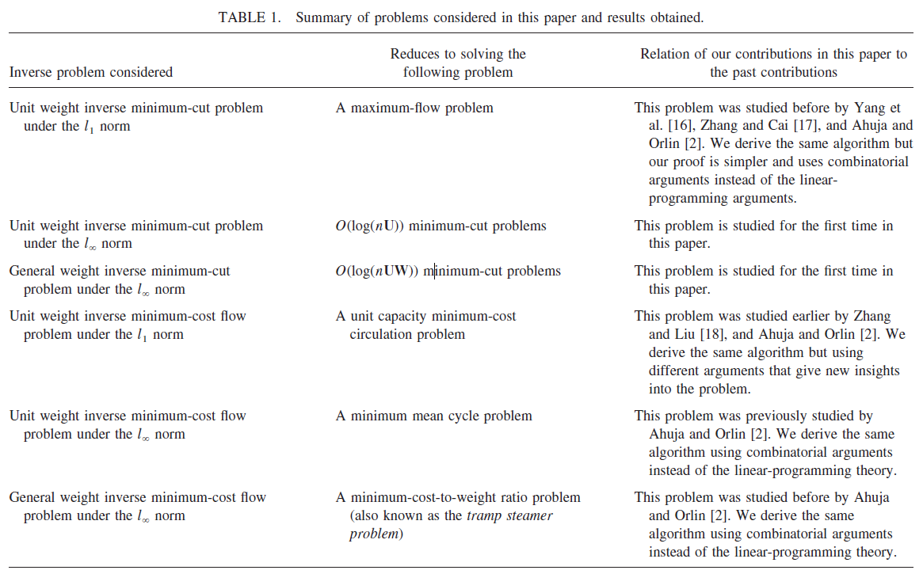[4] Ahuja R K , Orlin J B . Combinatorial algorithms for inverse network flow problems[J]. Networks, 2002, 40(4):181-187.*

*[5] Ahuja, R.K., Orlin, J.B. Inverse optimization. Operations Research, 2001, 49(5): 771–783.*

**Five results**:

(i) If the problem P is a linear programming problem, then its inverse problem under the $L_{1}$ as well as $L_{∞}$ norm is also a linear programming problem.

(ii) If the problem P is a shortest path, assignment or minimum cut problem, then its inverse problem under the $L_{1}$ norm and unit weights can be solved by solving a problem of the same kind. For the non-unit weight case, the inverse problem reduces to solving a minimum cost flow problem.

(iii) If the problem P is a minimum cost flow problem, then its inverse problem under the L1 norm and unit weights reduces to solving a unit-capacity minimum cost flow problem. For the non-unit weight case, the inverse problem reduces to solving a minimum cost flow problem.

(iv) If the problem P is a minimum cost flow problem, then its inverse problem under the $L_{∞}$ norm and unit weights reduces to solving a minimum mean cycle problem. For the non-unit weight case, the inverse problem reduces to solving a minimum cost-to-time ratio cycle problem.

(v) If the problem P is polynomially solvable for linear cost functions, then inverse versions of P under the $L_{1}$ and $L_{∞}$ norms are also polynomially solvable.

***(Overview)****[6] Heuberger C . Inverse Combinatorial Optimization: A Survey on Problems, Methods, and Results[J]. Journal of Combinatorial Optimization, 2004, 8(3):329-361.*

**Problems**:

1. Inverse problems with partially given solution
2. Reverse problems with prescribed objective function ranges
3. Reverse problems with budget constraints
4. Improvement problems with budget constraints

**Methods:**

1. Linear programming based methods:

The inverse linear programming problem;

Column generation method;

Ellipsoid method;

1. Duality for inverse problems under a general norm
2. Newton type methods
3. Feasible solutions to inverse problems

**Solved inverse and reverse combinatorial optimization problems**

Linear programming; Submodular function maximization; Polymatroidal flow; Minimum cost flow; Shortest paths; Shortest path tree; Assignment; Minimum weight bipartite perfect k-Matching; Weighted matroid intersection; Maximum matroid basis; Minimum spanning tree; Minimum spanning tree with partition constraints; Shortest arborescence; Minimum cut; Maximum flow; Maximum weight perfect matching; Fractional matching; Center location; Maximum capacity problem; Data envelopment analysis

*[7] Ahmed S, Guan Y. The inverse optimal value problem. Mathematical Programming, 2005, 102(1):91–110.*

**Problem:** the inverse optimal value problem

reduces to a concave maximization or a concave minimization problem

**Algorithms:** an algorithm based on solving linear and bilinear programming problems when the set of feasible cost vectors is polyhedral

*[8] Wang L . Cutting plane algorithms for the inverse mixed integer linear programming problem[J]. Operations Research Letters, 2009, 37(2):114-116.*

**Problem:** the inverse mixed integer linear programming problem

**Algorithms:** Cutting plane algorithms

[9] Schaefer A J. Inverse integer programming[J]. Optimization Letters, 2009, 3(4):483-489.

**Problem:** inverse integer programming problem

**Algorithms:** based superadditive duality, provide a polyhedral description of the set of inverse feasible objectives and describe two algorithmic approaches for solving the inverse integer programming problem.

*[10] Jean B. L. Inverse Polynomial Optimization. Mathematics of Operations Research 2013, 38(3):418-436.*

**Problem:** the inverse optimization problem associated with the polynomial program and a given current feasible solution

**Algorithms:** a systematic numerical scheme to compute an inverse optimal solution.

|  |  |  |  |
| --- | --- | --- | --- |
| Paper | Inverse Problem considered | Reduces to solving the following problem | Methods |
| 1992 Burton | Inverse shortest path problem(L2) |  | Golfarb-Idnani method for convex quadratic programming |
| 1997 Burton | Inverse shortest path problem with upper bounds on shortest path costs |  | NP-complete |
| 1995 Zhang &Yang | Inverse shortest path problem |  | Column generation methods |
| 1995 Xu & Zhang | Inverse weighted shortest path problem | Minimal cutset problem | Graph theory |
| 1996 Zhang & Ma | Inverse minimum spanning tree  Inverse assignment  Inverse shortest path tree | Linear \to dual problem \to maximum-weight circulation problem | Polynomial algorithm |
| 1996 Zhang | Inverse minimum spanning tree with partition constraints |  | Algorithm based on the calculation of maximum cost flow in networks |
| 1997 Zhang | Inverse minimum spanning tree |  | Use minimum covering problem as its main subproblem |
| 1997 Inverse Matroid | ICOP \generalize IMIP \to  a combinatorial linear program | Minimum cost circulation problem(MCCP) | Well-known polynomial algorithm |
| 1997 Zhang | Inverse maximum flow (IMF)  Inverse minimum cut (IMC) |  | Strongly polynomial algorithm |
| 1998 Hu & Liu | Inverse weighted shortest arborescence problem |  | O(n^3) algorithm which also can be applied to Inverse weighted shortest path problem |
| 1998 Zhang &Cai | Inverse minimum cut | Minimum cost circulation | Polynomial algorithm |
| 1999 Huang & Liu | Inverse minimum weigh perfect K-matching of bipartite graphs |  | Polynomial algorithm |
| 1999 Zhang & Liu | Inverse LP problems with solution 0-1 vectors (L1,L_\infinity) |  |  |
| 1999 Ahuja & Orlin | Inverse weighted spanning tree \to dual of the transportation problem | Cost scaling algorithm \to minimax version of inverse weighted spanning tree |  |
| 1999 Cai & Yang | Inverse polymatroidal flow problem | Minimum cost circulation problem | Polynomial algorithm |
| 1999 Zhang & Ma | Inverse shortest path problem (ISP)  Inverse minimum cut problem (IMC)  Inverse minimum spanning tree  Inverse maximum-weight matching | Characterized by solving another problem | Fulkerson’s theory of blocking and anti-blocking polyhedral with some necessary revisions |
| 1999 Zhang & Liu | Inverse fractional matching problem  \to dual of this problem | Circulation flow problem on a directed bipartite graph |  |
| 1999 Zhang | a group of inverse optimization problem called INVP | uniform LP model | Column generation method  Ellipsoid method which has polynomial algorithm if the original problem has polynomial algorithm  Generalize to Inverse symmetric transportation problem |
| 2000 Ahuja & Orlin | Inverse spanning tree problem \to dual | Bipartite node weighted matching problem \to a specially structured minimum cost flow problem | O(n^3) \to O(n^2 log(n)) |
| 2003 Dell’Amico | Inverse matroid optimization problem | LP formulation | efficient algorithm |
| 2005 Kang | Inverse linear programs | Conic programming | Linear programming duality |
| 2005 Huang | Inverse knapsack problem |  | pseudo-polynomial algorithm which can also be applied to inverse integer programming with ﬁxed number of constraints |