# 

# **QUANTUM PHOTONIC DEVICES**

Course Code: UE17EC356AB

# **End Semester Project**

**Professor in-charge: Dr. Kaustav Bhowmick**

# 

Submitted by: Dhanush S Babu

SRN: PES1201701579

**Problem Statement**

Research on the equation of propagation of a LASER light of any wavelength in free space, and implement in 2D FDTD.

**Aim**

To study and understand the propagation of LASER light and its equation and analyse it using the 2-D FDTD method (Finite Difference Time Domain).

**Introduction**

In optics and particularly in laser physics, laser beams often occur in the form of Gaussian beams, which are named after the mathematician and physicist *Johann Carl Friedrich Gauß.*

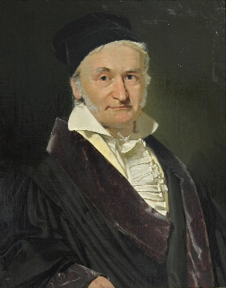Gaussian beams are light beams where the electric field profile in a plane perpendicular to the beam axis can be described with a Gaussian function, possibly with an added parabolic phase profile.

The name “Gaussian beams” results from the use of the Gaussian amplitude and intensity profile functions; it is not a concept in Gaussian optics.

The first laser was built in 1960 by Theodore H. Maiman at Hughes Research Laboratories, based on theoretical work by Charles Hard Townes and Arthur Leonard Schawlow.

Figure 1 Carl Friedrich Gauss (0 April 1777-23 February 1855)

A laser differs from other sources of light in that it emits light which is coherent. Spatial coherence allows a laser to be focused to a tight spot, enabling applications such as laser cutting and lithography. Spatial coherence also allows a laser beam to stay narrow over great distances (collimation), enabling applications such as laser pointers and LIDAR. Lasers can also have high temporal coherence, which allows them to emit light with a very narrow spectrum, i.e., they can emit a single colour of light. Alternatively, temporal coherence can be used to produce pulses of light with a broad spectrum but durations as short as a femtosecond ("ultrashort pulses").

**Gaussian Beam Optics**

The Gaussian is a radially symmetrical distribution whose electric field variation is given by the following equation:

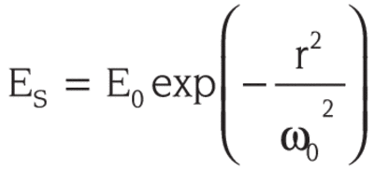

**r** is defined as the distance from the centre of the beam, and ω0 is the radius at which the amplitude is 1/e of its value on the axis.

The Fourier Transform of this equation is also a Gaussian distribution. If we were to solve the Fresnel integral itself rather than the Fraunhofer approximation, we would find that a Gaussian source distribution remains Gaussian at every point along its path of propagation through the optical system. This makes it particularly easy to visualize the distribution of the fields at any point in the optical system. The intensity is also Gaussian:

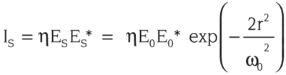

* denotes complex conjugate

This relationship is much more than a mathematical curiosity, since it is now easy to find a light source with a Gaussian intensity distribution: the laser. Most lasers automatically oscillate with a Gaussian distribution of electrical field. The basic Gaussian may also take on some particular polynomial multipliers and still remain its own transform. These field distributions are known as higher-order transverse modes and are usually avoided by design in most practical lasers.

The Gaussian has no obvious boundaries to give it a characteristic dimension like the diameter of the circular aperture, so the definition of the size of a Gaussian is somewhat arbitrary. Figure 2 shows the Gaussian intensity distribution of a typical HeNe laser.

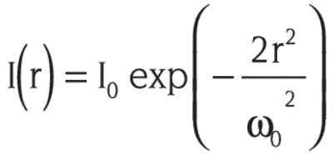

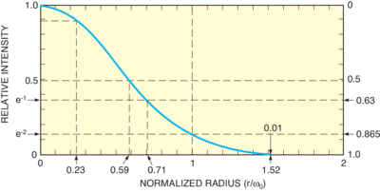

Figure 2 Gaussian intensity distribution of a typical HeNe laser

The parameter ω0, usually called the Gaussian beam radius, is the radius at which the intensity has decreased to 1/e2 or 0.135 of its axial, or peak value. Another point to note is the radius of half maximum, or 50% intensity, which is 0.59ω0. At 2ω0, or twice the Gaussian radius, the intensity is 0.0003 of its peak value, usually completely negligible.

The power contained within a radius r, P(r), is easily obtained by integrating the intensity distribution from 0 to r:

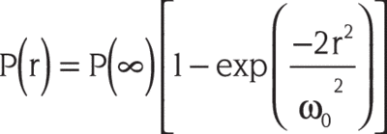

When normalized to the total power of the beam, P(∞) in watts, the curve is the same as that for intensity, but with the ordinate inverted. Nearly 100% of the power is contained in a radius r = 2ω0. One-half the power is contained within 0.59ω0, and only about 10% of the power is contained with 0.23ω0, the radius at which the intensity has decreased by 10%. The total power, P(∞) in watts, is related to the on-axis intensity, I(0) (watts/m2), by:

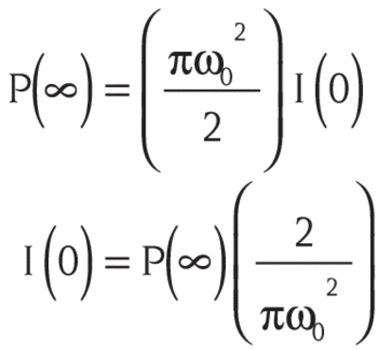

The on-axis intensity can be very high due to the small area of the beam.

Care should be taken in cutting off the beam with a very small aperture. The source distribution would no longer be Gaussian, and the far-field intensity distribution would develop zeros and other non-Gaussian features. However, if the aperture is at least three or four ω0 in diameter, these effects are negligible.

Propagation of Gaussian beams through an optical system can be treated almost as simply as geometric optics. Because of the unique self-Fourier Transform characteristic of the Gaussian, we do not need an integral to describe the evolution of the intensity profile with distance. The transverse distribution intensity remains Gaussian at every point in the system; only the radius of the Gaussian and the radius of curvature of the wavefront change. Imagine that we somehow create a coherent light beam with a Gaussian distribution and a plane wavefront at a position x=0. The beam size and wavefront curvature will then vary with x as shown in Figure 3.

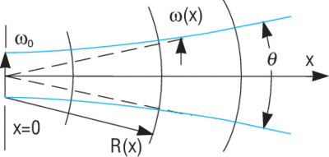

Figure 3

The beam size will increase, slowly at first, then faster, eventually increasing proportionally to x. The wavefront radius of curvature, which was infinite at x = 0, will become finite and initially decrease with x. At some point it will reach a minimum value, then increase with larger x, eventually becoming proportional to x. The equations describing the Gaussian beam radius ω(x) and wavefront radius of curvature R(x) are:

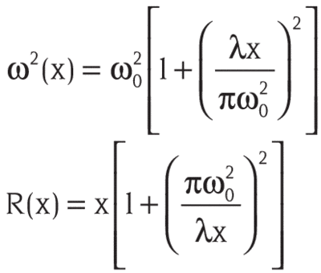

where ω0 is the beam radius at x = 0 and λ is the wavelength. The entire beam behaviour is specified by these two parameters, and because they occur in the same combination in both equations, they are often merged into a single parameter, xR, the Rayleigh range:

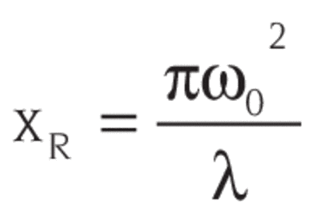

In fact, it is at x = xR that R has its minimum value.

Note that these equations are also valid for negative values of x. We only imagined that the source of the beam was at x = 0; we could have created the same beam by creating a larger Gaussian beam with a negative wavefront curvature at some x < 0.

The input to the lens is a Gaussian with diameter D and a wavefront radius of curvature which, when modified by the lens, will be R(x) given by the equation above with the lens located at -x from the beam waist at x = 0. That input Gaussian will also have a beam waist position and size associated with it. Thus we can generalize the law of propagation of a Gaussian through even a complicated optical system.

In the free space between lenses, mirrors and other optical elements, the position of the beam waist and the waist diameter completely describe the beam. When a beam passes through a lens, mirror, or dielectric interface, the wavefront curvature is changed, resulting in new values of waist position and waist diameter on the output side of the interface.

These equations, with input values for ω and R, allow the tracing of a Gaussian beam through any optical system with some restrictions: optical surfaces need to be spherical and with not-too-short focal lengths, so that beams do not change diameter too fast. These are exactly the analog of the paraxial restrictions used to simplify geometric optical propagation.

It turns out that we can put these laws in a form as convenient as the ABCD matrices used for geometric ray tracing. But there is a difference: ω(x) and R(x) do not transform in matrix fashion as r and u do for ray tracing; rather, they transform via a complex bi-linear transformation:

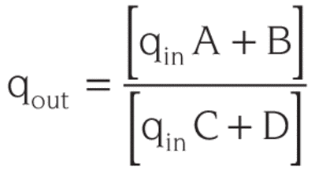

where the quantity q is a complex composite of ω and R:

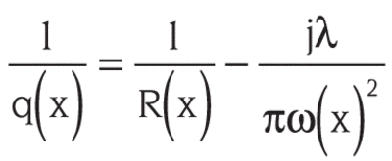

We can see from the expression for q that at a beam waist (R = ∞ and ω = ω0), q is pure imaginary and equals ixR. If we know where one beam waist is and its size, we can calculate q there and then use the bilinear ABCD relation to find q anywhere else. To determine the size and wavefront curvature of the beam everywhere in the system, you would use the ABCD values for each element of the system and trace q through them via successive bilinear transformations. But if you only wanted the overall transformation of q, you could multiply the elemental ABCD values in matrix form, just as is done in geometric optics, to find the overall ABCD values for the system, then apply the bilinear transform. Fortunately, simple approximations for spot size and depth of focus can still be used in most optical systems to select pinhole diameters, couple light into fibers, or compute laser intensities. Only when f-numbers are large should the full Gaussian equations be needed.

At large distances from a beam waist, the beam appears to diverge as a spherical wave from a point source located at the centre of the waist. Note that “large” distances mean where x»xR and are typically very manageable considering the small area of most laser beams. The diverging beam has a full angular width θ (again, defined by 1/e2 points):

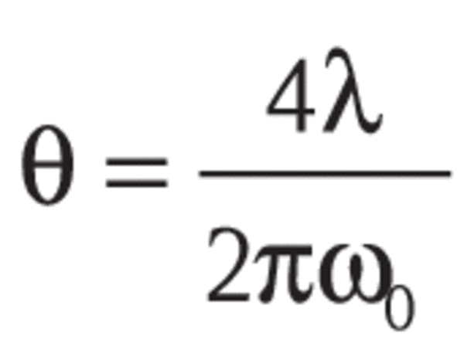

We have invoked the approximation tanθ ≈ θ since the angles are small. Since the origin can be approximated by a point source, θ is given by geometrical optics as the diameter illuminated on the lens, D, divided by the focal length of the lens.

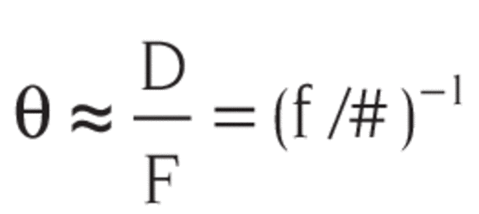

where f/# is the photographic f-number of the lens.

Equating these two expressions allows us to find the beam waist diameter in terms of the input beam parameters (with some restrictions that will be discussed later):

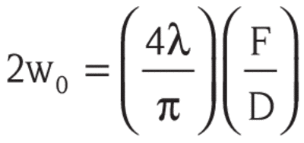

We can also find the depth of focus from the formulas above. If we define the depth of focus (somewhat arbitrarily) as the distance between the values of x where the beam is √2 times larger than it is at the beam waist, then using the equation for ω(x) we can determine the depth of focus:

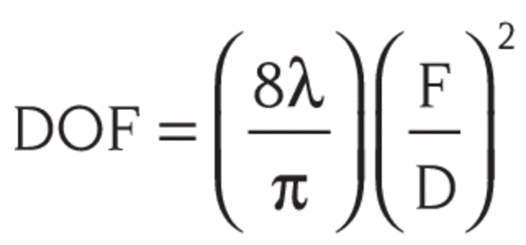

Using these relations, we can make simple calculations for optical systems employing Gaussian beams. For example, suppose that we use a 10 mm focal length lens to focus the collimated output of a helium-neon laser (632.8 nm) that has a 1 mm diameter beam. The diameter of the focal spot will be:

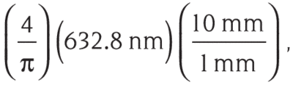

or about 8 µm. The depth of focus for the beam is then:

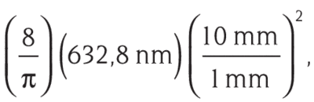

or about 160 µm. If we were to change the focal length of the lens in this example to 100 mm, the focal spot size would increase 10 times to 80 µm, or 8% of the original beam diameter. The depth of focus would increase 100 times to 16 mm. However, suppose we increase the focal length of the lens to 2,000 mm. The “focal spot size” given by our simple equation would be 200 times larger, or 1.6 mm, 60% larger than the original beam! Obviously, something is wrong. The trouble is not with the equations giving ω(x) and R(x), but with the assumption that the beam waist occurs at the focal distance from the lens. For weakly focused systems, the beam waist does not occur at the focal length. In fact, the position of the beam waist changes contrary to what we would expect in geometric optics: the waist moves toward the lens as the focal length of the lens is increased. However, we could easily believe the limiting case of this behaviour by noting that a lens of infinite focal length such as a flat piece of glass placed at the beam waist of a collimated beam will produce a new beam waist not at infinity, but at the position of the glass itself.

**Propagation of Gaussian Beams**

Gaussian beams are usually considered in situations where the beam divergence is relatively small, so that the so-called paraxial approximation can be applied. This approximation allows the omission of the term with the second-order derivative in the propagation equation (as derived from Maxwell's equations), so that a first-order differential equation results. Within this approximation, a Gaussian beam propagating in free space remains Gaussian, except that of course its parameters evolve. For a monochromatic beam, propagating in the z direction with the wavelength λ, the complex electric field amplitude (phasor) is



with the peak amplitude |E0| and beam radius ω0 at the beam waist, the wavenumber k = 2π / λ, the Rayleigh length zR and the radius of curvature R(z) of the wavefronts. The oscillating real electric field is obtained by multiplying the phasor with exp(−i 2π c t / λ) and taking the real part.

The beam radius varies along the propagation direction according to

w(z) for Gaussian beam

with the Rayleigh length

Rayleigh length of Gaussian beam

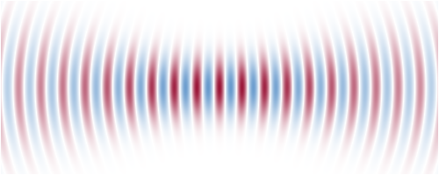

Figure 4 Snapshot of the electric field distribution around the focus of a Gaussian beam. In this example, the beam radius is only slightly larger than the wavelength, and the beam divergence is strong. According to the equation above, the field pattern is moving from left to right (i.e., toward larger z).

**FDTD and Discretization**

Finite-difference time-domain or Yee's method (named after the Chinese American applied mathematician Kane S. Yee, born 1934) is a numerical analysis technique used for modelling computational electrodynamics (finding approximate solutions to the associated system of differential equations). Since it is a time-domain method, FDTD solutions can cover a wide frequency range with a single simulation run, and treat nonlinear material properties in a natural way.

FDTD solves Maxwell's curl equations in non-magnetic materials:

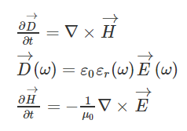

where H, E, and D are the magnetic, electric, and displacement fields, respectively, while ϵr(ω) is the complex relative dielectric constant (ϵr(ω)=n2, where n is the refractive index).

In three dimensions, Maxwell equations have six electromagnetic field components: Ex, Ey, Ez and Hx, Hy, and Hz. If we assume that the structure is infinite in the z dimension and that the fields are independent of z, specifically that

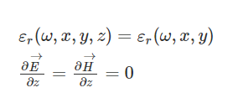

then Maxwell's equations split into two independent sets of equations composed of three vector quantities each which can be solved in the x-y plane only.  These are termed the TE (transverse electric), and TM (transverse magnetic) equations. We can solve both sets of equations with the following components:

**TE**:   Ex, Ey, Hz

**TM**:   Hx, Hy, Ez

For example, in the TM case, Maxwell's equations reduce to:

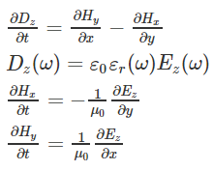

For

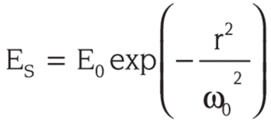,

(Esn+1/2 +Esn-1/2 **) /** Δt =

E0 * (ω0/ ω(z)) *(exp(-(t+1/2)2/ ω(z)2) - exp(-(t-1/2)2/ ω(z)2))

Using these equations, we write a program in Python3.x using the respective and required libraries and modules.

**Results and Discussion**

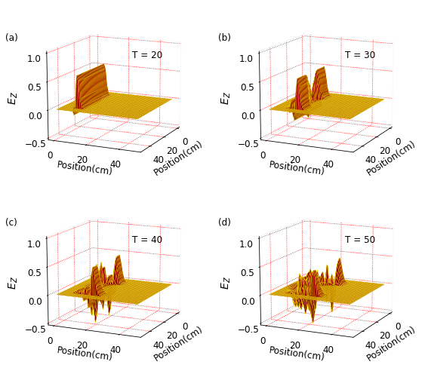

That cone then contains some 86% of the Gaussian beam's total power

Because the divergence is inversely proportional to the spot size, for a given wavelength λ, a Gaussian beam that is focused to a small spot diverges rapidly as it propagates away from the focus. Conversely, to minimize the divergence of a laser beam in the far field (and increase its peak intensity at large distances) it must have a large cross-section (w0) at the waist (and thus a large diameter where it is launched, since w(z) is never less than w0). This relationship between beam width and divergence is a fundamental characteristic of diffraction, and of the Fourier transform which describes Fraunhofer diffraction. A beam with any specified amplitude profile also obeys this inverse relationship, but the fundamental Gaussian mode is a special case where the product of beam size at focus and far-field divergence is smaller than for any other case.

Since the Gaussian beam model uses the paraxial approximation, it fails when wavefronts are tilted by more than about 30° from the axis of the beam. From the above expression for divergence, this means the Gaussian beam model is only accurate for beams with waists larger than about 2 λ / PI.

Laser beam quality is quantified by the beam parameter product (BPP). For a Gaussian beam, the BPP is the product of the beam's divergence and waist size ω0. The BPP of a real beam is obtained by measuring the beam's minimum diameter and far-field divergence, and taking their product. The ratio of the BPP of the real beam to that of an ideal Gaussian beam at the same wavelength is known as M2 ("M squared"). The M2 for a Gaussian beam is one. All real laser beams have M2 values greater than one, although very high quality beams can have values very close to one.

**Reference and Bibliography**

* <https://en.wikipedia.org/wiki/Gaussian_beam>
* <https://math.typeit.org/>
* <https://www.rp-photonics.com/gaussian_beams.html>
* <https://www.edmundoptics.com/knowledge-center/application-notes/lasers/gaussian-beam-propagation/>
* <https://www.newport.com/n/gaussian-beam-optics>
* NPTEL-NOC IITM  
  Gaussian beams introduction

youtube.com/watch?v=R1jbPdSySNc

* Gaussian beam by Lehrstuhl für Lasertechnik LLT

<https://www.youtube.com/watch?v=MU4eOJw2sBQ&t=1001s>

**Appendix**

Code:

|  |
| --- |
| # -*- coding: utf-8 -*-  """  Created on Mon May 7 13:21:00 2020  @author: dhanu  """  import numpy as np  from math import sin, exp, sqrt, atan2, cos, pi  from matplotlib import pyplot as plt  from mpl_toolkits.mplot3d.axes3d import Axes3D, get_test_data  ie = 50  je = 50  ic = int(ie / 2 - 1)  jc = int(je / 2 - 1)  ia = 7  ib = ie - ia - 1  ja = 7  jb = je - ja - 1  ez = np.zeros((ie, je))  dz = np.zeros((ie, je))  hx = np.zeros((ie, je))  hy = np.zeros((ie, je))  iz = np.zeros((ie, je))  ihx = np.zeros((ie, je))  ihy = np.zeros((ie, je))  ez_inc = np.zeros(je)  hx_inc = np.zeros(je)  ddx = 0.01 # Cell size  dt = ddx / 6e8 # Time step size  gaz = np.ones((ie, je))  gbz = np.zeros((ie, je))  # Specify the dielectric cylinder  epsr = 30  sigma = 0.3  radius = 10  # Create Dielectric Profile  epsz = 8.854e-12  for j in range(ja, jb):  for i in range(ia, ib):  xdist = (ic - i)  ydist = (jc - j)  dist = sqrt(xdist ** 2 + ydist ** 2)  if dist <= radius:  gaz[i, j] = 1 / (epsr + (sigma * dt / epsz))  gbz[i, j] = (sigma * dt / epsz)  boundary_low = [0, 0]  boundary_high = [0, 0]  # Pulse Parameters  t0 = 10  nsteps = 500  c = 2.99792458e8  # Dictionary to keep track of desired points for plotting  plotting_points = [ {'label': 'a', 'num_steps':20, 'data_to_plot': None},  {'label': 'b', 'num_steps': 30, 'data_to_plot': None},  {'label': 'c', 'num_steps': 40, 'data_to_plot': None},  {'label': 'd', 'num_steps': 50, 'data_to_plot': None}, ]  # Main FDTD Loop  for time_step in range(1, nsteps + 1):  # Incident Ez values  for j in range(1, je):  ez_inc[j]=ez_inc[j]+0.5*(hx_inc[j-1]-hx_inc[j])    # Absorbing Boundary Conditions  ez_inc[0] = boundary_low.pop(0)  boundary_low.append(ez_inc[1])  ez_inc[je - 1] = boundary_high.pop(0)  boundary_high.append(ez_inc[je - 2])    # Calculate Dz  for j in range(1, je):  for i in range(1, ie):  dz[i, j] = dz[i, j] + 0.5 * (hy[i, j] - hy[i - 1, j]-  hx[i, j] + hx[i, j - 1])    # Source  # Gaussian funtion describing a beam in free space  pulse = exp(-((((t0 - time_step))*c)**2)/(0.135*(((time_step))*c))**2)  ez_inc[5] = pulse    # Incident Dz values  for i in range(ia, ib + 1):  dz[i, ja] = dz[i, ja] + 0.5 * hx_inc[ja - 1]  dz[i, jb] = dz[i, jb] - 0.5 * hx_inc[jb]    # Calculate the Ez field  for j in range(0, je):  for i in range(0, ie):  ez[i, j] = gaz[i, j] * (dz[i, j] - iz[i, j])  iz[i, j] = iz[i, j] + gbz[i, j] * ez[i, j]      # Calculate the Incident Hx  for j in range(0, je - 1):  hx_inc[j]=hx_inc[j]+0.5*(ez_inc[j]-ez_inc[j+1])    # Calculate the Hx field  for j in range(je - 1):  for i in range(ie - 1):  hx[i, j] = hx[i, j] + 0.5 * (ez[i, j] - ez[i, j + 1])    # Incident Hx values  for i in range(ia, ib + 1):  hx[i, ja - 1] = hx[i, ja - 1] + 0.5 * ez_inc[ja]  hx[i, jb] = hx[i, jb] - 0.5 * ez_inc[jb]    # Calculate the Hy field  for j in range(je - 1):  for i in range(ie - 1):  hy[i, j] = hy[i, j] + 0.5 * (ez[i + 1, j] - ez[i, j])    # Incident Hy values  for j in range(ja, jb + 1):  hy[ia - 1, j] = hy[ia - 1, j] - 0.5 * ez_inc[j]  hy[ib, j] = hy[ib, j] + 0.5 * ez_inc[j]  # Save data at certain points for later plotting  for plotting_point in plotting_points:  if time_step == plotting_point['num_steps']:  plotting_point['data_to_plot'] = np.copy(ez)  # Plot Fig.  plt.rcParams['font.size'] = 12  plt.rcParams['grid.color'] = 'red'  plt.rcParams['grid.linestyle'] = 'dotted'  fig1 = plt.figure(figsize=(8, 7))  X, Y = np.meshgrid(range(je), range(ie))  def plot_e_field(ax, data, timestep, label):  """3d Plot of E field at a single timestep"""  ax.set_zlim(-0.5, 1)  ax.view_init(elev=15., azim=25)  ax.plot_surface(Y, X, data, rstride=1, cstride=1, color='red', edgecolor='yellow', linewidth=.25)  ax.zaxis.set_rotate_label(False)  ax.set_zlabel(r' $E_{Z}$', rotation=90, labelpad=10, fontsize=14)  ax.set_zticks([-0.5, 0, 0.5, 1])  ax.set_xlabel('Position(cm)')  ax.set_ylabel('Position(cm)')  ax.set_xticks(np.arange(0, 50, step=20))  ax.set_yticks(np.arange(0, 50, step=20))  ax.text2D(0.6, 0.7, "T = {}".format(timestep), transform=ax.transAxes)  ax.xaxis.pane.fill = ax.yaxis.pane.fill = ax.zaxis.pane.fill = False  plt.gca().patch.set_facecolor('white')  ax.text2D(-0.05, 0.8, "({})".format(label), transform=ax. transAxes)  ax.dist = 11  # Plot the E field at each of the four time steps saved earlier  for subplot_num, plotting_point in enumerate(plotting_points):  ax = fig1.add_subplot(2,2, subplot_num + 1, projection='3d')  plot_e_field(ax, plotting_point['data_to_plot'], plotting_point['num_steps'], plotting_point ['label'])    fig1.tight_layout()  plt.show() |