# COMPUTER ORGANISATION

## OPEN ENDED EXPERIMENT

HEART RATE MONITOR USING 8051 MICROCONTROLLER

AIM:

To obtain human heart rate in BPM on an LCD using a pulse sensor by interfacing it with 8051 Micro-controller.

THEORY:

Photoplethysmography is the process of optically estimating the volumetric measurement of an organ. Pulse oximetry, cardiovascular monitoring, respiration detection, heart rate monitoring etc are few common applications of photoplethysmography. Let us have a look at the application of photoplethysmography in heart rate monitoring from the figer tip. When the heart expands (diastole) the volume of blood inside the finger tip increases and when the heart contrcats (systole) the volume of blood inside the finger tip decreases. The resultant pulsing of blood volume inside the finger tip is directly proportional to the heart rate and if you could some how count the number of pulses in one minute, that’s the heart rate in beats per minute (bpm). For this an IR transmitter/receiver pair  placed in close contact with the finger tip. When the heart beats, the volume of blood cells under the sensor increases and this reflects more IR waves to sensor and when there is no beat the intensity of the reflected beam decreases. The pulsating reflection is converted to a suitable current or voltage pulse by the sensor.

For the counting purpose both the timers of 8051 (Timer0 and Timer1) are used. Timer 1 is configured as an 8 bit auto reload counter for registering the number of incoming zero going pulses and Timer0 is configured as a 16 bit timer which generate the necessary 1 second time span for the Timer1 to count.For counting the number of beats Timer0 and Timer1 are used. Timer1 is set as an 8 bit auto reload counter for counting the the number of pulses (indicating the heart beat) and Timer0 is set as a 16 bit timer which generates a 65536uS delay. When looped 230 times it will produce a 15 second time span (230 x 65536uS =15S)  for the Timer 1 to count. The number of counts obtained in 15 seconds is multiplied by 4 to obtain the heart rate in beats per minute.

 The Timer 0 which generates the 1 second time span is configured in Mode 1 (16 bit timer). So the maximum it can count is 2^16 and it is 65536. In 8051 the crystal frequency is divided by 12 using an internal frequency divider network before applying it as a clock for the timer. That means the timer will increment by one for every 1/12th of the crystal frequency. For an 8051 based system clocked by a 12MHz crystal, the time taken for one timer increment will be 1µS (ie; 1/12MHz). So the maximum time delay that can be obtained using one session of the timer will be 65536µS.

A simple LCD version of the heart rate monitor is shown below. This is just a modification of the above circuit.LCD displays are very popular now a most of the embedded system designers prefer them over multiplexed seven segment LED displays. Using LCD displays you can display text, custom characters, graphics and a lot of other stuff and it is a great advantage over the LED counterparts. JHD162 is the LCD display used here. It is a 16X2 LCD display based on the HD44780 driver IC. Go through the following link for knowing more about JHD162 and its interfacing to the 8051 microcontroller. [Interfacing LCD display to 8051](http://www.circuitstoday.com/interfacing-16x2-lcd-with-8051). The circuit diagram of the LCD version of the heart rate monitor is shown below. Data/command input pin DB0 to DB7 of the display is interfaced to Port0 of the microcontroller. Resistor network R17 is used for pulling up thePort0. Port0 needs external pull up for proper functioning. Preset resistor R1 is used for adjusting the contrast of the display. R2 limits the current through the back light LED. Other parts of the circuit are similar to the LED version.

CIRCUIT DIAGRAM:

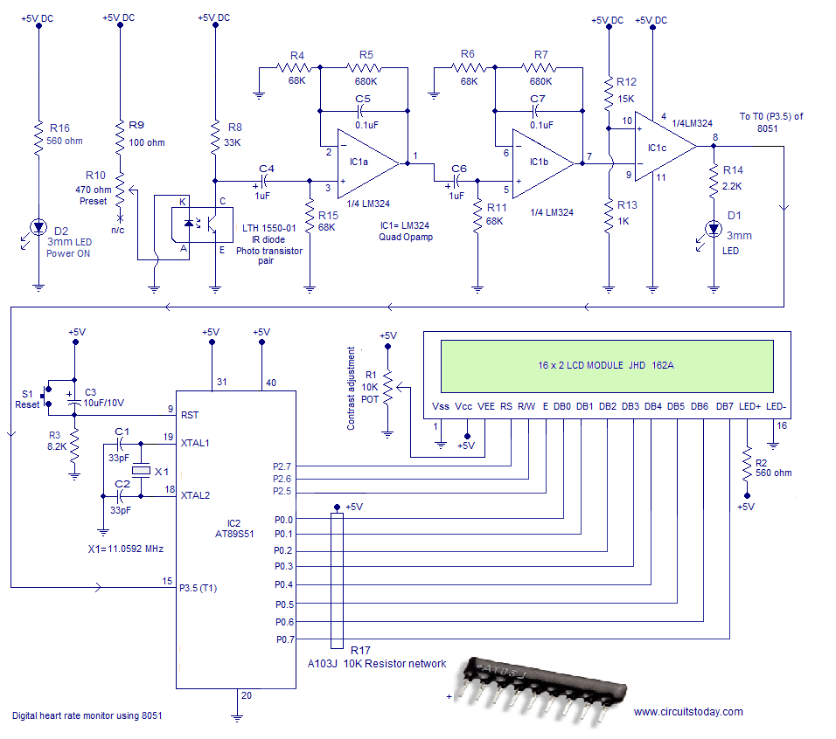

ALGORITHM:

1. Initialize E, RW, RS bits to required port bits.
2. Define an INIT, TEXT 1,2,3 functions to display.
3. Set 000h as origin.
4. Move starting address of LUT to DPTR.
5. Set P1 and P0 as output ports. Load register R6 with 230D
6. Set P3.5 as input port.
7. Set Timer1 as Mode2 counter & Timer0 as Mode1 timer. loads TL1 with initial value. loads TH1 with initial value.
8. Call subroutine DLOOP for displaying the count. jump back to the main loop and load the current count to the accumulator. Load register B with 4D.
9. Multiply the TL1 count with 4. load register B with 100D. Isolate first digit of the count.

RESULT:

Human heart rate in BPM using a pulse sensor obtained on LCD display by interfacing it with 8051 Micro-controller.