This is a bird: 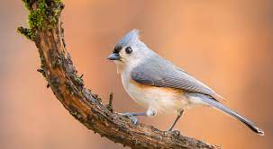  
  
**This is bold**

Size 14

Yellow

Times new roman