**This test project included the following Functionalities:**

* Local authentication
* Teacher's dashboard
* Student's dashboard
* Making Assignment by teacher
* Student can see belongs assignments
* Teacher can see belongs assignments
* Student can reply to assignment(making notification)
* Teacher can do action on the student's notification

**Technologies:**

* Asp.Net Core 2.2
* Angular 7
* EF Core (Code-First)
* Linq
* Bootstrap

Login Page

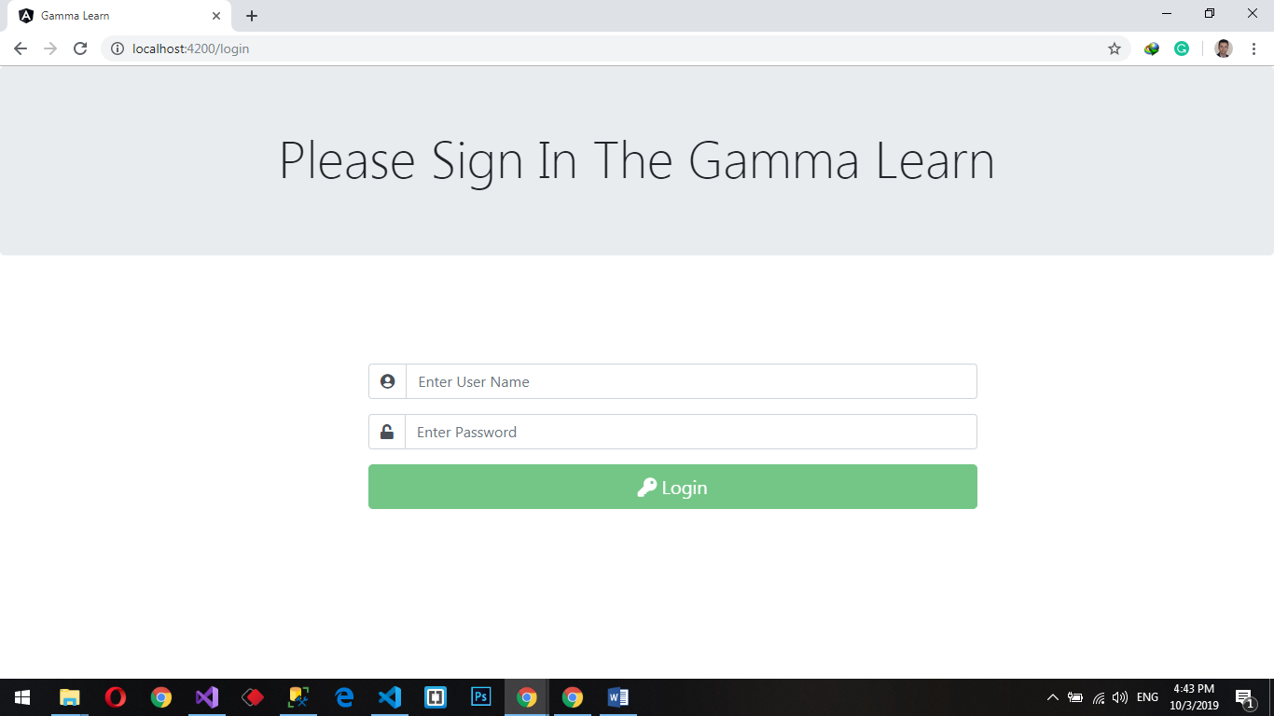

Teacher’s Dashboard

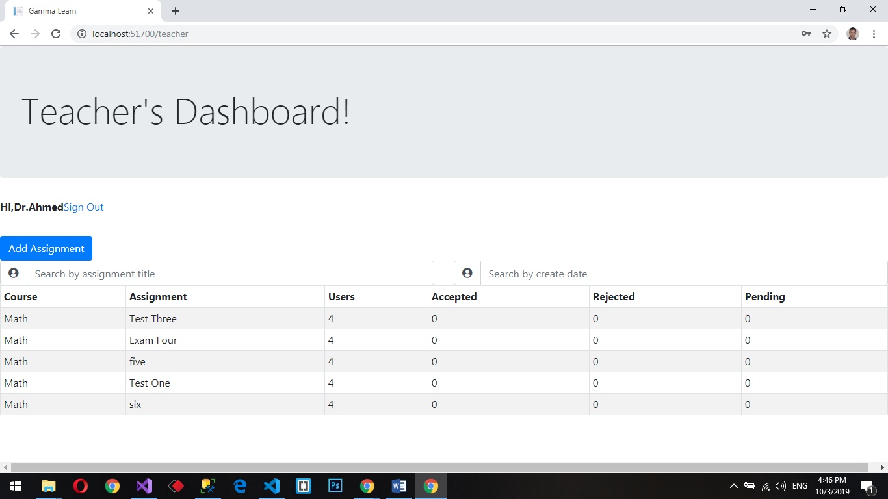

Student’s Dashboard

