Additional Plots

Sarah Pickresgill

6/24/2021

Global Heat Map of covid and intervention scale-up scenarios

ggplot(summary, aes(y=s_covid, x=s_inc*100, fill=adj.diff/1000000))+  
 geom_tile()+  
 geom_text(aes(label=paste0(signif(100*n.reaches/124, digits=2), "%")), color="black")+  
 scale_fill_gradientn(colors=ryb2_reverse, values=c(0,0.5,1))+  
 labs(fill="NCD deaths (millions) in excess \nof the most optimistic scenario")+  
 ylab("Covid scaling factor for underreporting")+  
 xlab("Maximum annual increase (%) in intervention coverage")+  
 ggtitle("Global excess NCD deaths and the number of countries \nachieving a one-third reduction in 40q30 \nby each covid and intervention scale-up scenario")+  
labs(caption = "\n*Text numbers represent the percent of LMICs achieving a 1/3 reduction in 40q30 by 2030")

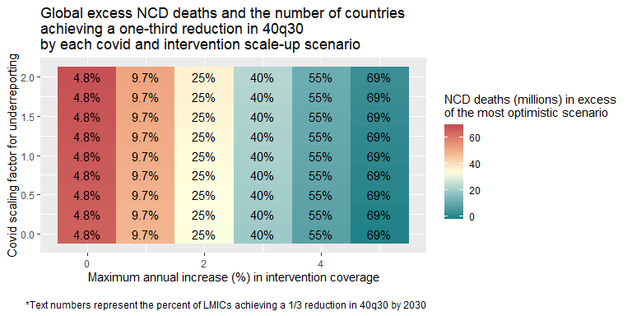

##Other way  
ggplot(summary, aes(y=s_covid, x=s_inc*100, fill=n.reaches))+   
 geom_tile()+   
 geom_text(aes(label=signif(adj.diff/1000000,digits=3)), color="black")+   
 scale_fill_gradientn(colors=ryb2, values=c(0,0.5,1))+   
 labs(fill="Number of countries achieving\n40q30 SDG target")+   
 ylab("Covid scaling factor for underreporting")+   
 xlab("Maximum annual increase (%) in intervention coverage")+   
 ggtitle("Global excess NCD deaths and the number of countries \nachieving a one-third reduction in 40q30 \nby each covid and intervention scale-up scenario")+   
 labs(caption = "\n*Text numbers represent NCD deaths (millions) in excess of the most optimistic scenario")

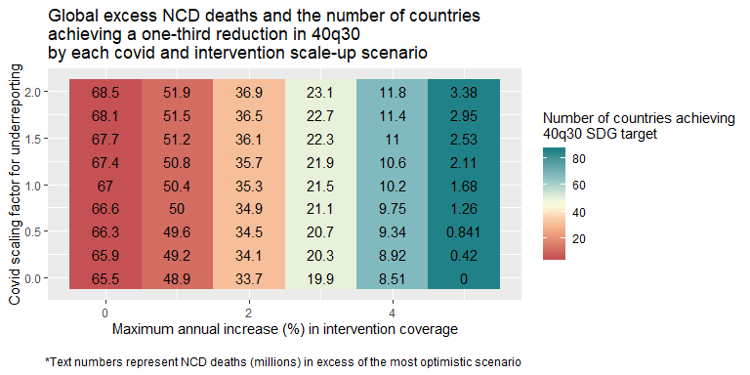

Quick look at country-specific patterns

deaths<-ncd.deaths.out%>%group_by(location, s_covid, s_inc)%>%summarise(ncd.deaths=sum(adj.ncd)/1000000)

## `summarise()` has grouped output by 'location', 's_covid'. You can override using the `.groups` argument.

progress<-goal.q30.out%>%mutate(prog=100*(Baseline_2015-Adjusted_2030)/(Baseline_2015-Target_40q30))%>%  
 rename(location = location_name)%>%select(location, s_covid, s_inc, prog)  
progress$prog[progress$prog>100]<-100  
  
plot2<-full_join(deaths, progress)

## Joining, by = c("location", "s_covid", "s_inc")

ggplot(plot2%>%filter(location=="Brazil"), aes(y=s_covid, x=s_inc, fill=prog))+  
 geom_tile()+  
 geom_text(aes(label=signif(ncd.deaths, digits=3)))+  
 scale_fill_gradientn(colors=ryb2, values=c(0,0.5,1))+  
 labs(fill="Progress towards 1/3 reduction in 40q30 (%)")+  
 xlab("Maximum annual increase (%) in intervention coverage")+  
 ylab("Covid scaling factor for underreporting")+  
 ggtitle("Total NCD deaths (millions) and progress towards 40q30 goal (%) \nby each covid and intervention scale-up scenario\n\nBrazil, 2015-2030")+  
labs(caption = "\n*Text numbers represent the total number of NCD deaths (in millions)")

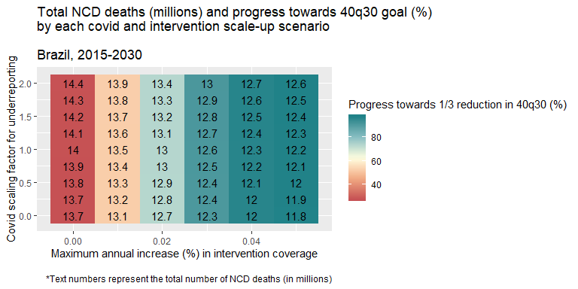

ggplot(plot2%>%filter(location=="Brazil"), aes(y=s_covid, x=s_inc, fill=ncd.deaths))+  
 geom_tile()+  
 geom_text(aes(label=paste0(signif(prog, digits=2),"%")))+  
 scale_fill_gradientn(colors=ryb2_reverse, values=c(0,0.5,1))+  
 labs(fill="Total NCD deaths (millions)")+  
 xlab("Maximum annual increase (%) in intervention coverage")+  
 ylab("Covid scaling factor for underreporting")+  
 ggtitle("Total NCD deaths (millions) and progress towards 40q30 goal (%) \nby each covid and intervention scale-up scenario\n\nBrazil, 2015-2030")+  
labs(caption = "\n*Text numbers represent the percent progress towards the 40q30 SDG target")

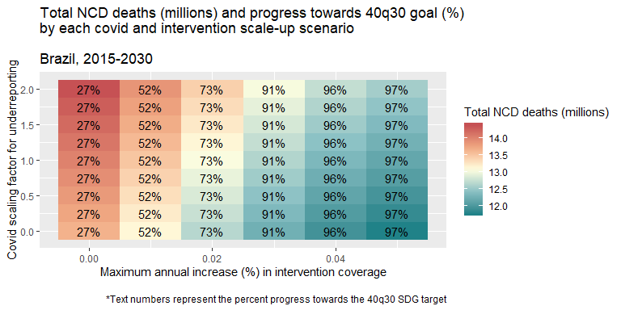

ggplot(plot2%>%filter(location=="China"), aes(y=s_covid, x=s_inc, fill=ncd.deaths))+  
 geom_tile()+  
 geom_text(aes(label=paste0(signif(prog, digits=2),"%")))+  
 scale_fill_gradientn(colors=ryb2_reverse, values=c(0,0.5,1))+  
 labs(fill="Total NCD deaths (millions)")+  
 xlab("Maximum annual increase (%) in intervention coverage")+  
 ylab("Covid scaling factor for underreporting")+  
 ggtitle("Total NCD deaths (millions) and progress towards 40q30 goal (%) \nby each covid and intervention scale-up scenario\n\nChina, 2015-2030")+  
labs(caption = "\n*Text numbers represent the percent progress towards the 40q30 SDG target")

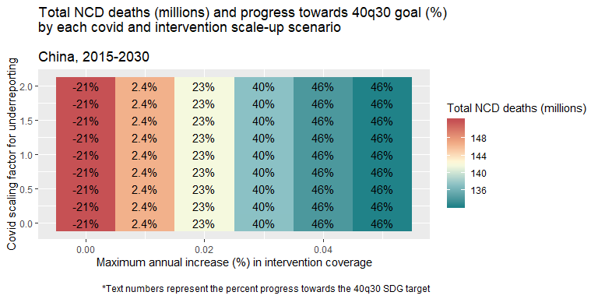

Looking at the covid shock to 40q30 over time

base<-all.q30.out%>%filter(s_covid==0 & s_inc==0)%>%mutate(scenario="Baseline")%>%  
 select(Adjusted, year_id, location_name, scenario)  
best<-all.q30.out%>%filter(s_covid==0 & s_inc==0.05 & year_id>=2019)%>%mutate(scenario="Most optimistic")%>%  
 select(Adjusted, year_id, location_name, scenario)  
middle<-all.q30.out%>%filter(s_covid==1 & s_inc==0.03 & year_id>=2019)%>%mutate(scenario="Moderate")%>%  
 select(Adjusted, year_id, location_name, scenario)  
worst<-all.q30.out%>%filter(s_covid==2 & s_inc==0 & year_id>=2019)%>%mutate(scenario="Most pessimistic")%>%  
 select(Adjusted, year_id, location_name, scenario)  
  
plot3<-bind_rows(base, best, middle, worst)  
plot3$scenario<-factor(plot3$scenario, levels=c("Baseline", "Most pessimistic", "Moderate", "Most optimistic"))  
  
#add splines  
#p1<-plot3%>%filter(scenario=="Most pessimistic", location_name=="Brazil")  
#spline1 <- as.data.frame(spline(p1$year_id, p1$Adjusted))  
#spline1$scenario<-"Most pessimistic"  
brazil_target<-base$Adjusted[base$year_id==2015 & base$location_name=="Brazil"]*(2/3)  
  
ggplot(plot3%>%filter(location_name=="Brazil"), aes(x=year_id, y=Adjusted, color=scenario))+  
 geom_point()+  
 geom_line()+  
 #stat_smooth(aes(x=year_id, y=Adjusted), formula =y~poly(x,6), method="lm", se=F)  
 #stat_smooth(aes(x=year_id, y=Adjusted), formula=y~s(x,k=10), method="gam", se=F)+  
 geom_line(y=brazil_target, color="darkgrey", lty=2)+  
 ylab("40q30 (%)")+  
 xlab("Year")+  
 ggtitle("Projected 40q30 over time, Brazil")+  
 labs(color="Scenario")+  
 coord_cartesian(ylim=c(0,40))+  
 scale_color_manual(values=c("black", "#cc415a", "#057fee", "#22a884"))+  
 annotate(geom="text", x=2027, y=brazil_target-2, label="Target: 1/3 reduction in 40q30", color="darkgrey")

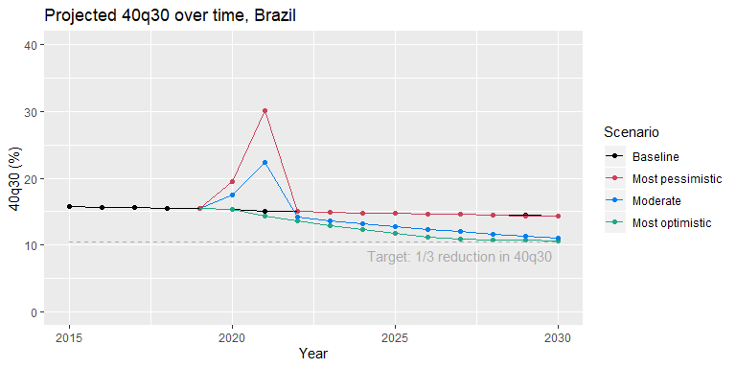

## Crude average for global plot  
  
global<-plot3%>%group_by(scenario,year_id)%>%summarise(q30=mean(Adjusted))

## `summarise()` has grouped output by 'scenario'. You can override using the `.groups` argument.

global_target<-global$q30[global$year_id==2015 & global$scenario=="Baseline"]*(2/3)  
  
ggplot(global, aes(x=year_id, y=q30, color=scenario))+  
 geom_point()+  
 geom_line()+  
 geom_line(y=global_target, color="darkgrey", lty=2)+  
 ylab("40q30 (%)")+  
 xlab("Year")+  
 ggtitle("Projected 40q30 over time, Global")+  
 labs(color="Scenario")+  
 coord_cartesian(ylim=c(0,40))+  
 scale_color_manual(values=c("black", "#cc415a", "#057fee", "#22a884"))+  
 annotate(geom="text", x=2027, y=global_target-2, label="Target: 1/3 reduction in 40q30", color="darkgrey")

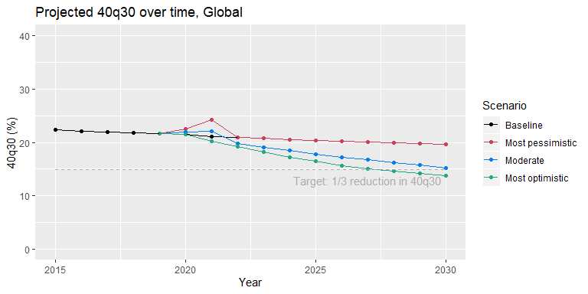

Cost per change in 40q30 vs. cost per DALY averted

cost<-read.csv("Outputs/All_ICER_2030.csv", stringsAsFactors = F)%>%select(c(increment, Code, Country, NCD_region, Revised.Intervention.Name))%>%rename(Description = Revised.Intervention.Name)  
load("Outputs/icer_rank_output.Rda")  
  
codes<-unique(read_excel("Input_Data/EfficacyData6.xlsx")%>%select(c(Description, NCD)))  
codes$NCDcode<-paste0("C", codes$NCD)  
codes$NCDcode[codes$Description=="Management of depression disorders with psycological and generic antidepressant therapy"]<-"C2.10"  
  
tot_dalys<-all.dalys%>%rename(Country = location_name)%>%group_by(Country, Code)%>%  
 summarise(DALY=sum(DALY.ave))%>%rename(NCDcode = Code)

## `summarise()` has grouped output by 'Country'. You can override using the `.groups` argument.

#just the end change in 2030?  
tot_40q30<-all.q30%>%filter(year_id==2030)%>%rename(Country = location_name)%>%  
 select(c(Country, Code, q30.ave))%>%rename(NCDcode = Code)  
  
benefits<-full_join(tot_dalys, tot_40q30, by=c("Country", "NCDcode"))  
benefits<-left_join(benefits, codes, by="NCDcode")  
  
plot<-na.omit(left_join(cost, benefits, by=c("Description", "Country")))%>%mutate(ICER1 = increment/DALY, ICER2=increment/q30.ave)  
plot$platform<-str_extract(plot$Code, "[A-Z]+")  
  
global<-plot%>%group_by(Description, platform)%>%summarise(ICER1=mean(ICER1), ICER2=mean(ICER2))

## `summarise()` has grouped output by 'Description'. You can override using the `.groups` argument.

global$platform<-factor(global$platform, levels=c("HC", "FLH", "RH"), labels=c("Health Centre", "First-level hospital", "Refereal hospital"))  
  
ggplot(global, aes(x=log(ICER1), y=log(ICER2), color=platform))+  
 geom_point()+  
 ggtitle("Incremental cost per DALY averted vs. incremental \ncost per change in 40q30 by intervention")+  
 labs(color="Platform")+  
 xlab("Log(cost per DALY averted)")+  
 ylab("Log(cost per % change in 40q30)")

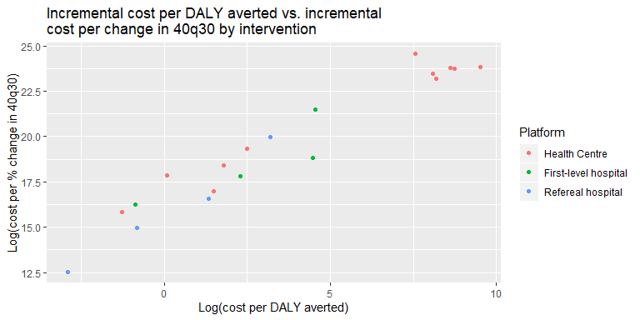

#add text?  
ggplot(global, aes(x=log(ICER1), y=log(ICER2), color=platform))+  
 geom_point()+  
 ggtitle("Incremental cost per DALY averted vs. incremental \ncost per change in 40q30 by intervention")+  
 labs(color="Platform")+  
 xlab("Log(cost per DALY averted)")+  
 ylab("Log(cost per % change in 40q30)")+  
 geom_text(size=3, aes(label=paste0(substr(Description, 0,50),"...")), hjust=-0.01, vjust=0)+  
 coord_cartesian(xlim=c(-5,20))

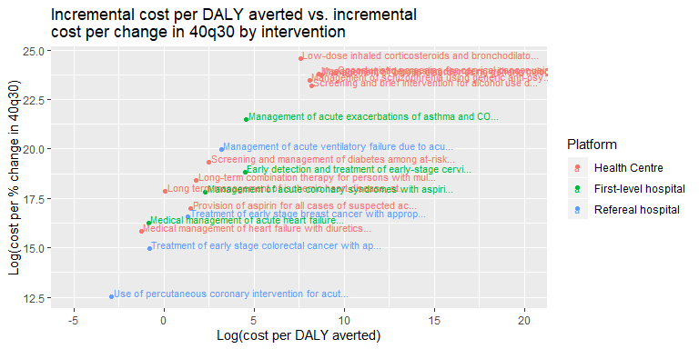

#still need to figure out how to dodge text better..