Additional Plots

Sarah Pickresgill

6/24/2021

Global Heat Maps

##need to add text label for numbers  
  
ggplot(summary, aes(x=s_covid, y=s_inc*100, fill=adj.diff))+  
 geom_tile()+  
 geom_text(aes(label=n.reaches), color="black")+  
 scale_fill_gradientn(colors=c("#3c1f5c","#33628e", "#2d7b8d","#20a386", "#fde725"), values=c(0,0.1,1))+  
 labs(fill="Excess NCD deaths")+  
 ylab("Annual absolute increase in coverage (%)")+  
 xlab("Covid adjustment factor")+  
 ggtitle("Global excess NCD deaths and the number of countries \nachieving a one-third reduction in 40q30 \nby each covid and intervention scale-up scenario")

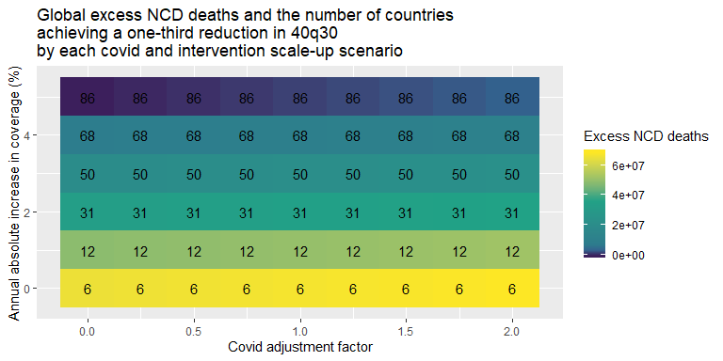

#labs(caption = "Text numbers represent number of countries achieving 40q30 target")  
  
ggplot(summary, aes(x=s_covid, y=s_inc*100, fill=n.reaches))+  
 geom_tile()+  
 geom_text(aes(label=signif(adj.diff/1000000, digits=2)), color="black")+  
 scale_fill_gradientn(colors=c("#3c1f5c","#33628e", "#2d7b8d","#20a386", "#fde725"), values=c(0,0.1,1))+  
 labs(fill="Number of countries to reach 40q30 target")+  
 ylab("Annual absolute increase in coverage (%)")+  
 xlab("Covid adjustment factor")+  
 ggtitle("Global excess NCD deaths (millions) and the \nnumber of countries achieving a one-third reduction in 40q30 \nby each covid and intervention scale-up scenario")

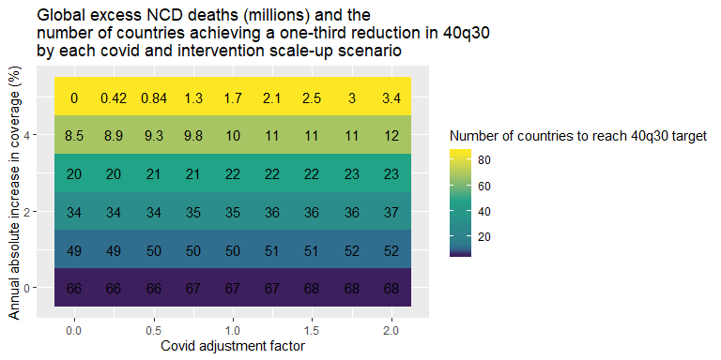

Quick look at country-specific patterns

deaths<-ncd.deaths.out%>%group_by(location, s_covid, s_inc)%>%summarise(ncd.deaths=sum(adj.ncd)/1000000)

## `summarise()` has grouped output by 'location', 's_covid'. You can override using the `.groups` argument.

progress<-goal.q30.out%>%mutate(prog=100*(Baseline_2015-Adjusted_2030)/(Baseline_2015-Target_40q30))%>%  
 rename(location = location_name)%>%select(location, s_covid, s_inc, prog)  
progress$prog[progress$prog>100]<-100  
  
plot2<-full_join(deaths, progress)

## Joining, by = c("location", "s_covid", "s_inc")

ggplot(plot2%>%filter(location=="Brazil"), aes(x=s_covid, y=s_inc, fill=prog))+  
 geom_tile()+  
 geom_text(aes(label=signif(ncd.deaths, digits=3)))+  
 scale_fill_gradientn(colors=c("#3c1f5c","#33628e", "#2d7b8d","#20a386", "#fde725"), values=c(0,0.5,1))+  
 labs(fill="Progress towards 1/3 reduction in 40q30 (%)")+  
 ylab("Annual absolute increase in coverage (%)")+  
 xlab("Covid adjustment factor")+  
 ggtitle("Total NCD deaths (millions) and progress towards 40q30 goal (%) \nby each covid and intervention scale-up scenario\n\nBrazil, 2015-2030")

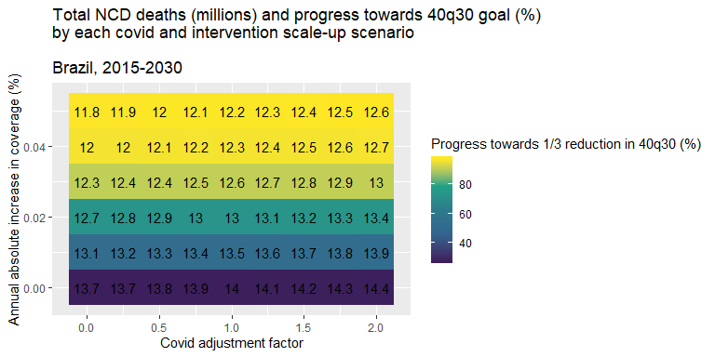

ggplot(plot2%>%filter(location=="Brazil"), aes(x=s_covid, y=s_inc, fill=ncd.deaths))+  
 geom_tile()+  
 geom_text(aes(label=paste0(signif(prog, digits=2),"%")))+  
 scale_fill_gradientn(colors=c("#3c1f5c","#33628e", "#2d7b8d","#20a386", "#fde725"), values=c(0,0.5,1))+  
 labs(fill="Total number of NCD deaths (millions)")+  
 ylab("Annual absolute increase in coverage (%)")+  
 xlab("Covid adjustment factor")+  
 ggtitle("Total NCD deaths (millions) and progress towards 40q30 goal (%) \nby each covid and intervention scale-up scenario \n\nBrazil, 2015-2030")

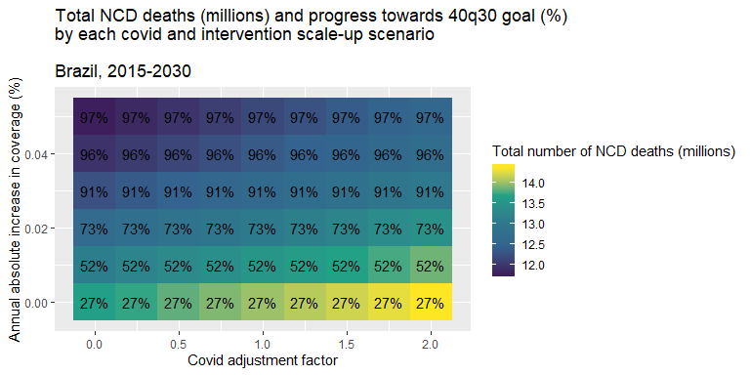

ggplot(plot2%>%filter(location=="China"), aes(x=s_covid, y=s_inc, fill=ncd.deaths))+  
 geom_tile()+  
 geom_text(aes(label=paste0(signif(prog, digits=2),"%")))+  
 scale_fill_gradientn(colors=c("#3c1f5c","#33628e", "#2d7b8d","#20a386", "#fde725"), values=c(0,0.5,1))+  
 labs(fill="Total number of NCD deaths (millions)")+  
 ylab("Annual absolute increase in coverage (%)")+  
 xlab("Covid adjustment factor")+  
 ggtitle("Total NCD deaths (millions) and progress towards 40q30 goal (%) \nby each covid and intervention scale-up scenario \n\nChina, 2015-2030")

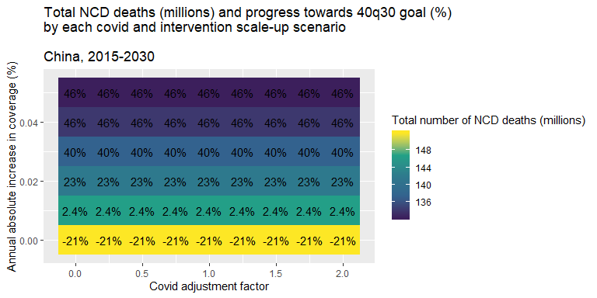

Looking at the covid shock to 40q30 over time

base<-all.q30.out%>%filter(s_covid==0 & s_inc==0)%>%mutate(scenario="Baseline")%>%  
 select(Adjusted, year_id, location_name, scenario)  
best<-all.q30.out%>%filter(s_covid==0 & s_inc==0.05 & year_id>=2019)%>%mutate(scenario="Most optimistic")%>%  
 select(Adjusted, year_id, location_name, scenario)  
middle<-all.q30.out%>%filter(s_covid==1 & s_inc==0.03 & year_id>=2019)%>%mutate(scenario="Predicted")%>%  
 select(Adjusted, year_id, location_name, scenario)  
worst<-all.q30.out%>%filter(s_covid==2 & s_inc==0 & year_id>=2019)%>%mutate(scenario="Most pessimistic")%>%  
 select(Adjusted, year_id, location_name, scenario)  
  
plot3<-bind_rows(base, best, middle, worst)  
plot3$scenario<-factor(plot3$scenario, levels=c("Baseline", "Most pessimistic", "Predicted", "Most optimistic"))  
  
ggplot(plot3%>%filter(location_name=="Brazil"), aes(x=year_id, y=Adjusted, color=scenario))+  
 geom_point()+  
 ylab("40q30 (%)")+  
 xlab("Year")+  
 ggtitle("40q30 over time, Brazil")+  
 labs(color="Scenario")

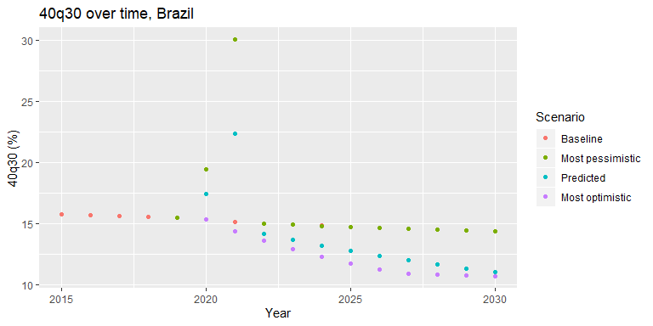

## crude average (global)  
  
global<-plot3%>%group_by(scenario,year_id)%>%summarise(q30=mean(Adjusted))

## `summarise()` has grouped output by 'scenario'. You can override using the `.groups` argument.

ggplot(global, aes(x=year_id, y=q30, color=scenario))+  
 geom_point()+  
 ylab("40q30 (%)")+  
 xlab("Year")+  
 ggtitle("40q30 over time, Global (crude mean)")+  
 labs(color="Scenario")

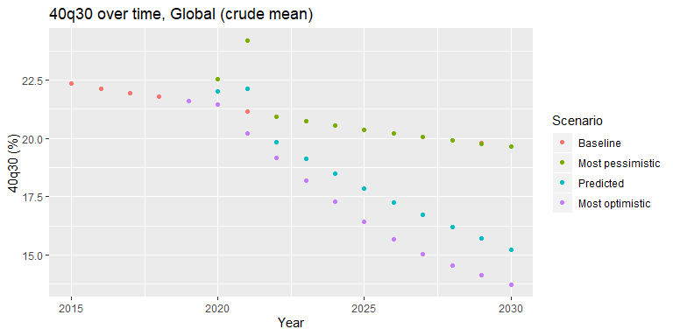

Cost per change in 40q30 vs. cost per DALY averted

cost<-read.csv("Outputs/All_ICER_2030.csv", stringsAsFactors = F)%>%select(c(increment, Code, Country, NCD_region, Revised.Intervention.Name))%>%rename(Description = Revised.Intervention.Name)  
load("Outputs/icer_rank_output.Rda")  
  
codes<-unique(read_excel("Input_Data/EfficacyData6.xlsx")%>%select(c(Description, NCD)))  
codes$NCDcode<-paste0("C", codes$NCD)  
codes$NCDcode[codes$Description=="Management of depression disorders with psycological and generic antidepressant therapy"]<-"C2.10"  
  
tot_dalys<-all.dalys%>%rename(Country = location_name)%>%group_by(Country, Code)%>%  
 summarise(DALY=sum(DALY.ave))%>%rename(NCDcode = Code)

## `summarise()` has grouped output by 'Country'. You can override using the `.groups` argument.

#just the end change in 2030?  
tot_40q30<-all.q30%>%filter(year_id==2030)%>%rename(Country = location_name)%>%  
 select(c(Country, Code, q30.ave))%>%rename(NCDcode = Code)  
  
benefits<-full_join(tot_dalys, tot_40q30, by=c("Country", "NCDcode"))  
benefits<-left_join(benefits, codes, by="NCDcode")  
  
plot<-na.omit(left_join(cost, benefits, by=c("Description", "Country")))%>%mutate(ICER1 = increment/DALY, ICER2=increment/q30.ave)  
plot$platform<-str_extract(plot$Code, "[A-Z]+")  
  
global<-plot%>%group_by(Description, platform)%>%summarise(ICER1=mean(ICER1), ICER2=mean(ICER2))

## `summarise()` has grouped output by 'Description'. You can override using the `.groups` argument.

global$platform<-factor(global$platform, levels=c("HC", "FLH", "RH"), labels=c("Health Centre", "First-level hospital", "Refereal hospital"))  
  
ggplot(global, aes(x=ICER1, y=ICER2, color=platform))+  
 geom_point()+  
 #geom_text(aes(label=Description), hjust=0, vjust=0)+  
 facet_zoom(x = ICER1 >= 0 & ICER1 <= 250)+  
 ggtitle("Incremental cost per DALY averted vs. incremental \ncost per change in 40q30 by intervention")+  
 labs(color="Platform")+  
 xlab("Cost per DALY averted")+  
 ylab("Cost per % change in 40q30")

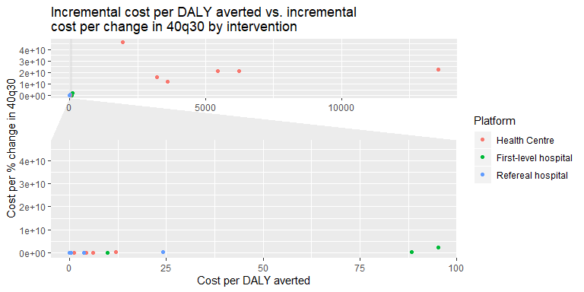

ggplot(global%>%filter(ICER1>1000), aes(x=ICER1, y=ICER2, color=platform))+  
 geom_point()+  
 geom_text(size=3, aes(label=stringr::str_wrap(Description,70)), position = position_dodge(width=0.9), hjust=0, vjust=1)+  
 ggtitle("Incremental cost per DALY averted vs. incremental \ncost per change in 40q30 by intervention")+  
 labs(color="Platform")+  
 xlab("Cost per DALY averted")+  
 ylab("Cost per % change in 40q30")

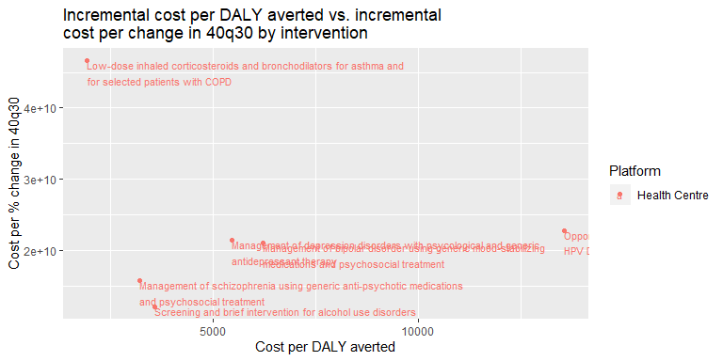

#this text labeling is horrible.