**More methods:**

The baseline distribution of physical activity in the kingdom of Saudi Arabia was estimated from a 2019 survey of the percentage of individuals with physical activity 150 minutes and more per week by age category and sex. We estimated the distribution of this population between the moderate and high activity categories based on the proportion published in an older study to establish the baseline proportion of individuals in the low, moderate, and high physical activity risk categories.

**Table:** Baseline distribution of physical activity (%) by sex and age, 2019

|  |  |  |  |  |
| --- | --- | --- | --- | --- |
| **Age** | **Sex** | **Low activity (%)** | **Moderate activity (%)** | **High activity (%)** |
| 25-29 | Male | 69.3 | 17.3 | 13.4 |
| 30-34 | Male | 74.0 | 14.7 | 11.3 |
| 35-39 | Male | 76.9 | 13.1 | 10.1 |
| 40-44 | Male | 77.8 | 17.0 | 5.2 |
| 45-49 | Male | 79.3 | 15.8 | 4.9 |
| 50-54 | Male | 78.5 | 16.4 | 5.1 |
| 55-59 | Male | 76.0 | 18.3 | 5.6 |
| 60-64 | Male | 78.6 | 16.4 | 5.0 |
| 65+ | Male | 85.7 | 11.0 | 3.4 |
| 25-29 | Female | 87.5 | 6.2 | 6.2 |
| 30-34 | Female | 87.9 | 6.1 | 6.1 |
| 35-39 | Female | 87.9 | 6.0 | 6.0 |
| 40-44 | Female | 89.0 | 5.2 | 5.8 |
| 45-49 | Female | 86.8 | 6.3 | 6.9 |
| 50-54 | Female | 87.1 | 6.1 | 6.8 |
| 55-59 | Female | 89.6 | 5.0 | 5.5 |
| 60-64 | Female | 93.9 | 2.9 | 3.2 |
| 65+ | Female | 96.5 | 1.7 | 1.8 |

**Methods:**

To estimate the effect that increased physical activity may have on population health in the Kingdom of Saudi Arabia, we modeled three different scenarios of the distribution of physical activity:

1. **Baseline**: rates of physical activity based on 2019 KSA survey data staying constant through 2040
2. **Intervention**: rates of physical activity increasing to levels based on a high preforming benchmark country (Sweden) in 2023
3. **Ideal**: rates of physical activity increasing to ‘ideal levels’ in 2023 where only 5% of the population remain physically inactive.

Intervention impact in the latter two scenarios was derived from calculating the potential impact fraction (PIF) based on the different population distributions (*P*) and relative risks (*RR*) in each risk category (*i*) as follows:

$$PIF= \frac{\sum_{i}{P_{i}*{RR}_{i}}- \sum_{i}{ {\hat{P}}_{i}*{RR}_{i}}}{\sum_{i}{P_{i}*{RR}_{i}}}$$

where $P_{i}$ is the baseline risk distribution and ${\hat{P}}_{i}$ is the counterfactual risk distribution in the intervention or ideal scenarios. The PIF was then used to estimate the reduction in age-, sex-, and cause-specific mortality.

Relative risk estimates were taken from the Global Burden of Disease study 2019 (GBD) for colon and rectum cancer, breast cancer, ischemic heart disease, ischemic stroke, and diabetes mellitus type 2 for adults ages 25-80.

Risk categories were defined as follows:

* **Low**: Below 600 MET-minutes/week
* **Moderate**: At least 150 mins of moderate exercise, achieving 600 to 2400 MET-minutes/week
* **High**: At least 2400 MET-minutes/week

We modeled impacts on mortality and derived estimates of DALYs from the cause-specific ratio of deaths to DALYs.

**Figure 1: Population attributable fractions of physical activity related mortality by cause and sex**

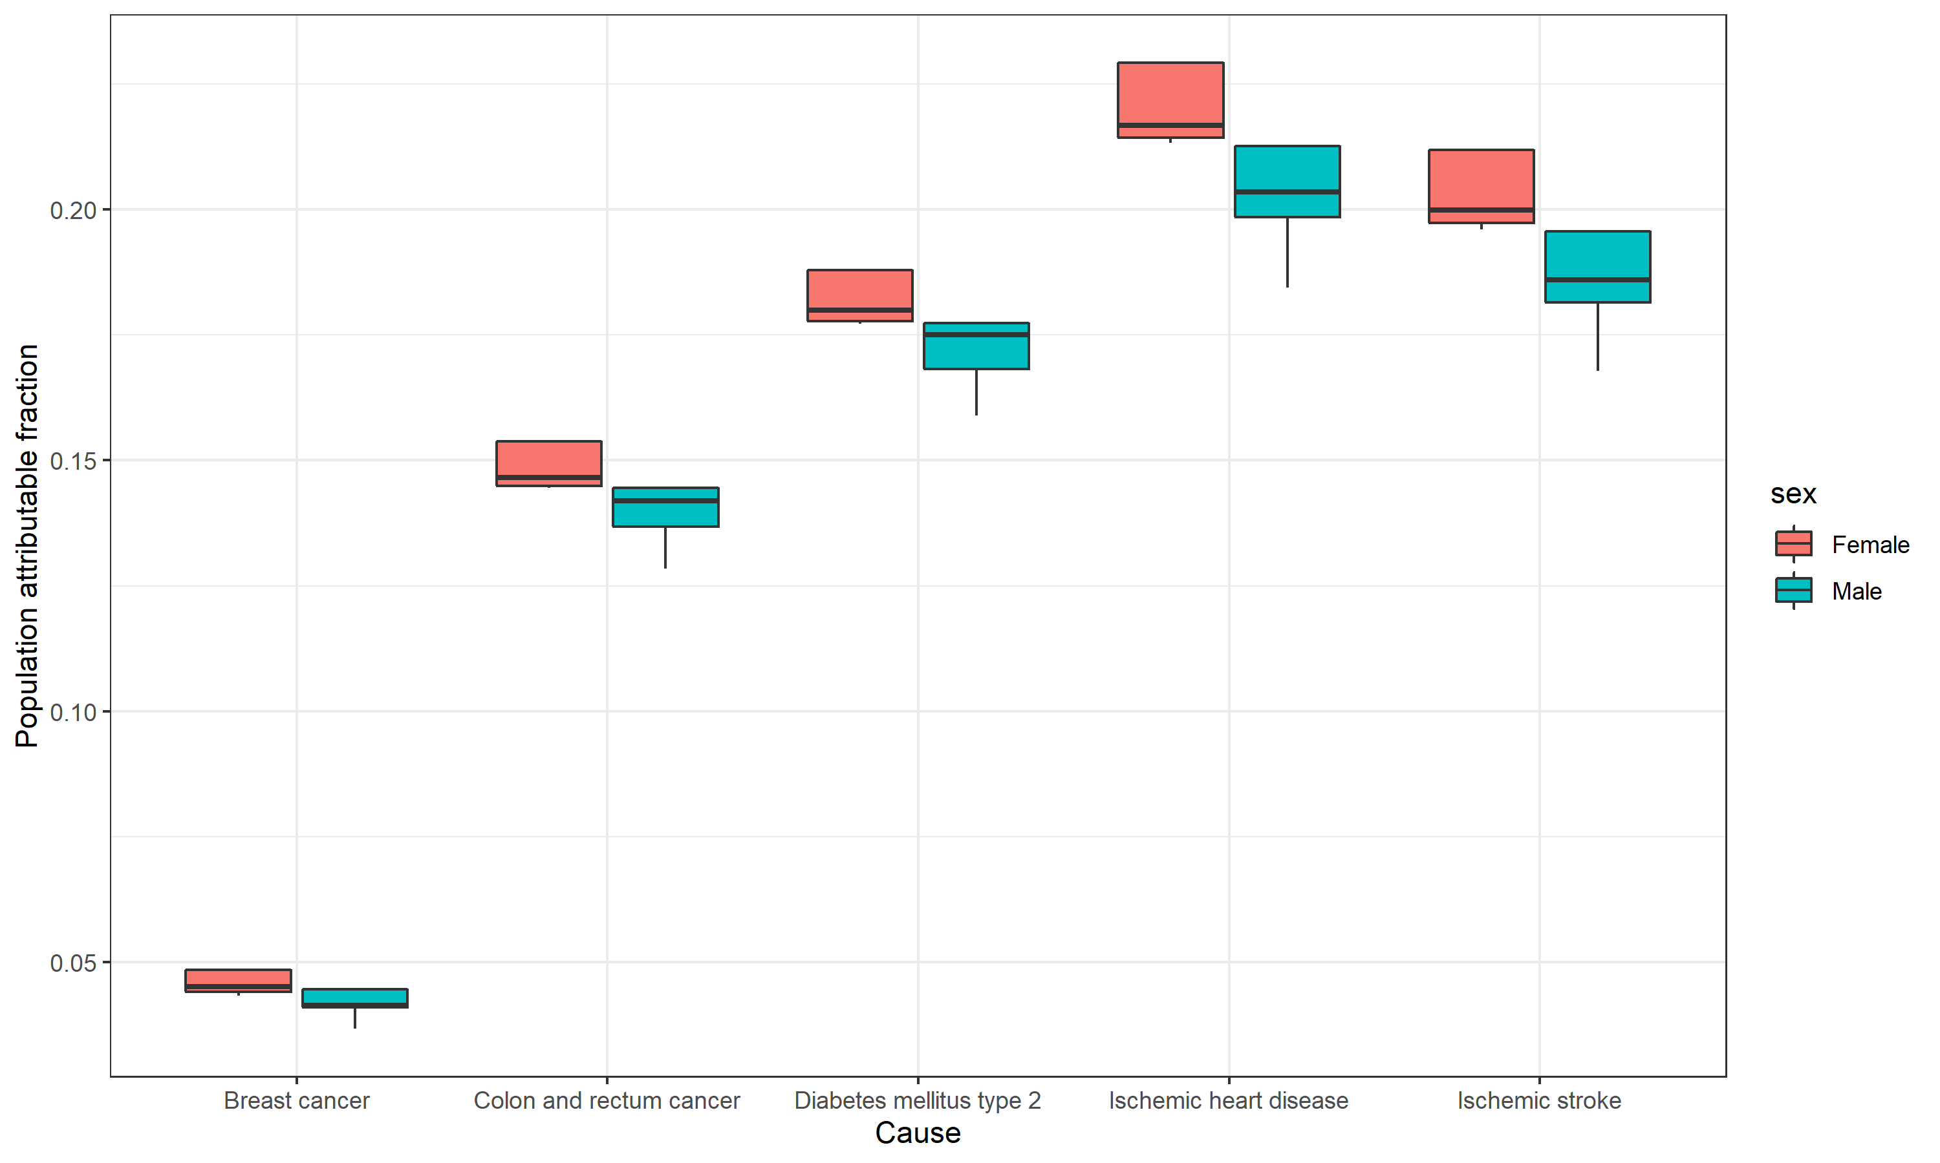

**Table 2: Calculation of total economic impact by scenario for the period 2023-2040**

|  |  |  |  |  |
| --- | --- | --- | --- | --- |
| **Scenario** | **GDP per capita**  **(2020 $USD)** | **DALYs Averted**  **(2023-2040)** | **Economic impact**  **(2020 $USD)** | **Deaths Averted (2023-2040)** |
| Intervention | $20,110.32 | 3.5 million | $160 billion | 130,000 |
| Ideal | $20,110.32 | 5.9 million | $270 billion | 170,000 |

**Figure 2: Deaths and DALYs averted by cause**

