Closing the treatment gap: projected cardiovascular health gains from achieving WHO targets for blood pressure control and lipid-lowering therapy in 186 countries, 2026-2050
WHO $⋅$ University of Washington
September 24, 2026
Table of Contents
Abstract 2
Structured abstract 2
Research in context 4
Introduction 6
Methods 7
Study design 7
Data sources 7
Intervention scenarios 8
Modelling framework 9
Calibration 9
Data and code availability 9
Outcomes 9
Sensitivity analysis 10
Reporting standard 10
Results 10
Baseline global trajectory, 2026–2050 10
Global impact of achieving the hypertension control target 11
Global impact of achieving the lipid-lowering therapy target 11
Combined impact of both targets 11
Heterogeneity across regions and income groups 12
Distribution by age and sex 12
Deterministic sensitivity analysis 13
Discussion 13
Principal findings 13
Interpretation of hypertension control findings 13
Interpretation of lipid-lowering therapy findings 14
Combined policy meaning 15
Equity and implementation implications 16
Relation to previous literature 17
Strengths 17
Limitations 18
Conclusion 18
References 20
Tables 24
Figures 31
Supplemental Material 34
Supplemental Tables 34
Supplemental Figures 34
Deterministic sensitivity analysis 44
Methodology and Mathematical Details 47
Mathematical Notation Summary 47
Key Parameter Appendix 49
Multi-State Transition Model 50
Hypertension Control Intervention Model 52
Statin Therapy Intervention Model 55
DALY Calculation Methods 57
GATHER checklist 60

Abstract

Structured abstract
Background
High systolic blood pressure and high LDL cholesterol are leading modifiable drivers of cardiovascular disease (CVD) burden worldwide, but the joint impact of achieving WHO targets for hypertension control and lipid-lowering therapy has not been quantified.
Methods
We did a comparative risk assessment modelling study using a discrete-time multi-state transition model for 186 countries, 2026 to 2050. The model projected deaths from ischaemic heart disease, ischaemic stroke, intracerebral haemorrhage, and hypertensive heart disease by age, sex, and country, using WHO Global Health Estimates, GBD 2023, UN World Population Prospects 2024, and NCD Risk Factor Collaboration data. We compared business-as-usual with three single-intervention scenarios and their combination: blood pressure control among hypertensives without diabetes and, separately, among hypertensives with diabetes, the two mutually exclusive subgroups that together deliver the WHO target of 150.0 million additional people with controlled hypertension by 2030 (control among people with diabetes capped at 80%); and statin scale-up to 50% coverage among adults aged 40 years or older by 2030. The primary outcome was cumulative CVD deaths averted during 2026 to 2050; secondary outcomes were years of life lost (YLLs), years lived with disability (YLDs), and disability-adjusted life years (DALYs) averted. We ran a one-way deterministic sensitivity analysis.
Findings
Under business-as-usual, the model projected 675.6 million CVD deaths during 2026 to 2050. Achieving all three targets together was projected to avert 33.8 million CVD deaths (5.0% of business-as-usual mortality) and 393.2 million DALYs. Individually, blood pressure control among hypertensives without diabetes averted 7.0 million deaths, blood pressure control among those with diabetes 13.7 million, and statin scale-up 13.3 million; because effects were combined multiplicatively, the combined total was marginally smaller than the arithmetic sum of the single interventions.
Interpretation
Achieving WHO targets for blood pressure control and lipid-lowering therapy could produce large, complementary reductions in CVD mortality and disability. Absolute gains were concentrated in populous middle-income regions, whereas the largest proportional reductions were projected in the Americas and in high-income settings. These estimates represent technical potential under linear scale-up and fixed baseline risk-factor distributions; a deterministic sensitivity analysis is reported, but formal probabilistic uncertainty intervals were not derived.
Funding
This work is funded by the World Health Organization.

Research in context
Evidence before this study
We did not conduct a formal systematic search. We drew on prior multi-country modelling studies of blood pressure control and lipid-lowering therapy identified through the authors’ knowledge of the field and the reference lists of key studies and WHO and NCD Countdown 2030 technical reports. The clinical case for both interventions is well established: the individual-participant meta-analysis of the Blood Pressure Lowering Treatment Trialists’ Collaboration (Blood Pressure Lowering Treatment Trialists’ Collaboration 2021) and the meta-analyses of the Cholesterol Treatment Trialists’ Collaboration (Fulcher et al. 2015) provide the trial-based effect sizes on which current WHO treatment guidelines rest. What has remained unquantified is the combined global health impact of treating both risk factors simultaneously at scale. Kontis and colleagues (2019) projected that antihypertensive scale-up to 70% coverage could delay up to 39.4 million deaths over 25 years; Pickersgill and colleagues (2022) estimated 76 to 130 million all-cause deaths averted under the 80-80-80 hypertension target but did not model statin therapy. The NCD Countdown 2030 analyses identified both interventions as among the most cost-efficient pathways to Sustainable Development Goal target 3.4 but did not quantify their joint health impact (Watkins et al. 2022; Bennett et al. 2020). To our knowledge, no published study has simultaneously projected the health consequences of achieving the combined 150-million hypertension control target across its mutually exclusive diabetes and non-diabetes subgroups together with the 50% statin coverage target across 186 countries, evaluated individually and in combination against a common business-as-usual baseline.
Added value of this study
Using a discrete-time multi-state transition model calibrated to GBD 2023, WHO Global Health Estimates, and UNWPP 2024 data, this study estimates that achieving all three WHO targets could avert 33.8 million CVD deaths and 393.2 million DALYs across 186 countries from 2026 to 2050. These projections assume linear scale-up to 2030 and no secular change in baseline risk-factor distributions; blood pressure effects assume full adherence, whereas statin effects are adjusted for real-world adherence, together defining a technical ceiling rather than a likely outcome. The model credits only coverage increments above country-specific baselines to avoid double-counting existing treatment benefits and combines intervention effects multiplicatively, so the combined benefit is slightly smaller than the arithmetic sum of the individual effects. Disaggregation by cause of death, age, sex, WHO region, and World Bank income group shows where the health gains are largest and for whom they accrue.
Implications of all the available evidence
Trial evidence, prior global modelling, and the present projections point in the same direction: blood pressure control and statin therapy are complementary rather than competing priorities, and pursuing both together yields more than either achieves alone. The largest absolute benefits fall in populous middle-income regions and countries, whereas the largest proportional reductions are in the Americas and in high-income settings. Notably, low-income countries and the African region, where current coverage is furthest from the WHO targets, show smaller proportional gains under the target allocation modelled here, an equity signal that warrants attention in how global targets are apportioned. How much of this projected ceiling is reachable in practice will depend on health-system capacity, medicine supply, and whether the political commitments made at the 2025 UN High-level Meeting on NCDs are matched by sustained financing and implementation support.

Introduction
Cardiovascular diseases (CVDs) remain the world’s leading cause of death and disability-adjusted life years (DALYs) (Mensah et al. 2023; Chong et al. 2024). Global CVD deaths rose from 13.1 million in 1990 to 19.2 million in 2023, with ischaemic heart disease, ischaemic stroke, intracerebral haemorrhage, and hypertensive heart disease among the leading causes, and the number of prevalent CVD cases more than doubled over the same period, from 311 million to 626 million (GBD 2023 Cardiovascular Diseases and Risks Collaborators 2025). Because CVD mortality rises steeply with age, the absolute burden continues to grow as populations age and expand, even where age-standardised rates are declining.
Much of this burden is attributable to modifiable risk factors, which accounted for 79.6% of CVD DALYs in 2023 (Chong et al. 2024; Agboyibor et al. 2025). Among these, high systolic blood pressure and high low-density lipoprotein (LDL) cholesterol are the two leading contributors, together explaining a greater share of ischaemic heart disease and stroke mortality than dietary risks, air pollution, or any other single factor (Geldsetzer et al. 2019; Global Cardiovascular Risk Consortium" 2023). Despite the availability of effective, low-cost therapies, substantial gaps in risk-factor control persist: an estimated 1.4 billion adults live with high blood pressure, yet only 23% have it controlled (World Health Organization 2025), and statin coverage remains far below the level needed for meaningful population-level risk reduction, particularly in low-income and middle-income countries (Marcus et al. 2022). Both risk factors can be addressed with scalable pharmacological interventions delivered through primary health care platforms, making them priorities for population-level CVD prevention (Agboyibor et al. 2025).
Growing political commitment is reflected in successive multilateral frameworks that place these two risk factors at the centre of NCD prevention. WHO Member States endorsed the 2021 Global Diabetes Compact, which committed to 80% blood pressure control and statin therapy for adults aged 40 years and above with diabetes (Hunt et al. 2021; Gregg et al. 2023); the WHO NCD Global Monitoring Framework, which set a target of at least 50% of eligible people receiving drug therapy, including statins (World Health Organization 2011); and the Political Declaration of the Fourth High-level Meeting on NCDs (2025), which called for control of blood pressure in an additional 150 million people and for wide availability of essential medicines in primary care by 2030. Although the clinical benefits of these interventions are well established, their combined population health impact when both targets are achieved simultaneously across the full range of country income levels has not been quantified; existing analyses have largely been confined to single countries, short horizons, or single interventions modelled in isolation.
This study addresses that gap. Among adults aged 20 years and older in 186 countries with complete model outputs, we estimated how many cardiovascular deaths and DALYs could be averted between 2026 and 2050 by scaling up, from 2026 and reaching WHO targets by 2030, blood pressure control among hypertensives without diabetes and among hypertensives with diabetes (the two mutually exclusive subgroups of the 150-million control target) and statin therapy to 50% coverage among adults aged 40 years and older, modelled individually and in combination, relative to a business-as-usual scenario that holds current coverage constant.

Methods

Study design
We conducted a multi-country comparative risk assessment using a discrete-time multi-state transition model projecting CVD mortality and morbidity across 186 countries from 2026 to 2050 (reporting the study window used throughout, 2026-2050). Four causes of CVD death were modelled jointly because they are the leading cardiovascular contributors to global mortality and are the causes most directly modifiable by blood pressure control and lipid-lowering therapy: ischaemic heart disease (IHD), ischaemic stroke, intracerebral haemorrhage (haemorrhagic stroke), and hypertensive heart disease. For each cause, an individual occupied one of three mutually exclusive health states: Well (alive and free of the disease), Sick (alive with prevalent disease), and Dead (died from the disease). States were tracked by single year of age (20 to 95), sex, and country, and individuals moved between them each year according to cause-specific incidence (Well to Sick), case fatality (Sick to Dead), and background mortality. The model was calibrated to observed epidemiological data and projected forward in annual steps (Supplement Section Multi-State Transition Model). Its structure and intervention framework were informed by prior global modelling and implementation evidence, including the global 80-80-80 blood pressure modelling (Pickersgill et al. 2022) and the budget impact of the WHO HEARTS technical package for cardiovascular disease management (Garcia et al. 2026).

Data sources
Death counts and mortality rates were derived from the World Health Organization Global Health Estimates (GHE). Incidence and prevalence estimates were obtained from the Global Burden of Disease (GBD) 2023 study. Population denominators were taken from the United Nations World Population Prospects 2024 revision, using single-year age- and sex-specific projections for each country. Blood pressure distributions were sourced from the NCD Risk Factor Collaboration, and baseline hypertension control rates from country-level analyses provided by WHO. Effect sizes for blood pressure lowering were taken from the individual-participant meta-analysis of the Blood Pressure Lowering Treatment Trialists’ Collaboration (Blood Pressure Lowering Treatment Trialists’ Collaboration 2021); these are relative risks of cardiovascular events per 10 mmHg reduction in systolic blood pressure, stratified by baseline blood pressure category and cause, and are applied in the model to disease incidence and case fatality rather than directly to all-cause mortality. Statin effect sizes were relative risks per approximately 1 mmol/L reduction in LDL cholesterol from the Cholesterol Treatment Trialists’ Collaboration (Fulcher et al. 2015), and statin adherence was based on a recent systematic review and meta-analysis (Basios et al. 2025). Baseline statin coverage was derived from published and imputed country-level data. COVID-19 excess mortality was applied only to 2020 and 2021.

Intervention scenarios
Three single-intervention scenarios and one combined scenario were compared with a business-as-usual (BAU) reference in which country-specific coverage of hypertension control and statin therapy was held at its most recent observed level through 2050. In every scenario, coverage increased linearly from 2026 and reached its target in 2030, after which it was held constant to 2050.
Blood pressure control was modelled as two mutually exclusive subgroups that together make up the WHO target of an additional 150.0 million people with controlled hypertension by 2030, defined on a fixed 2025 population: hypertensives without diabetes and hypertensives with diabetes. A single shared scale-up factor was applied across country and sex strata so that the two subgroups’ additions sum to exactly 150 million, with control among people with diabetes capped at 80% and control among people without diabetes capped at 100% (Section Hypertension Control Intervention Model; Table 1). Because 150 million is a global ceiling rather than a per-subgroup target, the 80% figure for people with diabetes is an upper bound, not an achieved rate: under the modelled allocation, blood pressure control among hypertensives with diabetes rises from 32.3% in 2025 to 45.3% in 2030, and control among those without diabetes from 15.7% to 22.2%. Blood pressure effect sizes were applied across eight blood pressure categories, and only coverage above each country’s baseline was credited with new effect, preventing double-counting of people already treated. For example, in a stratum where 30% of hypertensives are controlled at baseline and control rises to 45%, only the incremental 15 percentage points generate additional risk reduction; the benefit already accruing to the 30% controlled at baseline is embedded in observed rates and is not re-counted.
Statin therapy was scaled to 50% coverage among adults aged 40 years and older by 2030. Effects were restricted to IHD and ischaemic stroke: risk reductions were applied to incidence (primary prevention) through cause- and location-specific attributable fractions and to case fatality (secondary prevention) directly through trial relative risks, with only the atherosclerotic fraction (60%) of ischaemic stroke case fatality treated as statin-sensitive (Section Statin Therapy Intervention Model).
Adherence was handled asymmetrically and stated explicitly. Blood pressure effects assumed full adherence, consistent with the trial-based control definitions from which the effect sizes derive. Statin effects were multiplied by empirical adherence factors of 57.5% for incidence and 64.4% for case fatality, taken from a recent meta-analysis of statin adherence (Basios et al. 2025), reflecting the lower and better-characterised long-term persistence of statin therapy relative to the control-based blood pressure effect. In the combined scenario, the two blood pressure subgroups and statin therapy were applied together and their effects on incidence and case fatality were combined multiplicatively (Section Multi-State Transition Model); because a death cannot be averted twice, the combined benefit is slightly smaller than the arithmetic sum of the single-intervention benefits.

Modelling framework
The core model is a discrete-time state-transition framework in which individuals move between Well, Sick, and Dead states at each annual time step according to cause-specific incidence rates (Well to Sick), case fatality rates (Sick to Dead), and background mortality rates (all states to Dead). Interventions modify incidence and case fatality through multiplicative effect ratios ($ε_{IR}$, $ε_{CF}$), computed from the coverage increment above baseline. Only incremental coverage above baseline was credited with new effects, avoiding double-counting of existing treatment benefits. For blood pressure control, effect ratios are derived from a pipeline that combines blood pressure category distributions, GBD relative risks, the BPLTTC 2021 trial effect sizes per 10 mmHg reduction in systolic blood pressure (Blood Pressure Lowering Treatment Trialists’ Collaboration 2021), and population-weighted aggregation. For statin therapy, incremental coverage generates cause- and location-specific risk reductions applied to incidence and case fatality. Under the combined scenario, effects combine multiplicatively across the two blood pressure subgroups and statin therapy, for example $ε_{IR,\text{total}}=ε_{IR,\text{BP}}×ε_{IR,\text{BP,DM}}×ε_{IR,\text{statin}}$ (Supplement Section Mathematical Notation Summary).

Calibration
Incidence (IR) and case fatality (CF) parameters were calibrated jointly to ensure consistency with external data sources: incidence rates were adjusted to reproduce age-, sex-, country-, and cause-specific incidence patterns from GBD 2023, while case-fatality parameters were calibrated to match observed cause-specific mortality counts from WHO GHE within each stratum. COVID-19 excess mortality was incorporated for 2020–2021 only (see Key Parameter Appendix).

Data and code availability
All input data used in this analysis are publicly available from their original sources (e.g., WHO Global Health Estimates). Processed inputs and model code are provided in the project repository: https://github.com/Disease-Control-Priorities/uw-who-cvdtargets. Model outputs (results) can be accessed and downloaded at the same link. All analyses were conducted in R (version 4.5.1), and full scripts are openly available in the repository.

Outcomes
The primary outcome was cumulative CVD deaths averted relative to the BAU scenario over 2026–2050, disaggregated by intervention, cause of death, age group, sex, WHO region, and World Bank income group. Secondary outcomes included years of life lost (YLLs) averted, years lived with disability (YLDs) averted, and disability-adjusted life years (DALYs) averted.
Burden of disease was quantified using three complementary metrics: years of life lost (YLL), years lived with disability (YLD), and disability-adjusted life years (DALY), where $DALY=YLL+YLD$. Remaining life expectancy at each age of death was obtained from the United Nations World Population Prospects 2024 revision (medium variant), providing country- and year-specific values. Disability weights were derived from GBD 2023 data as the ratio of cause-specific YLDs to prevalence for each cause and location. No age weighting or time discounting was applied; all estimates are undiscounted (see Supplemental Material: DALY Calculation Methods).

Sensitivity analysis
The central analysis reports point estimates derived from mean input parameters. To characterise how the projections respond to key assumptions, we conducted a one-way deterministic sensitivity analysis (DSA) that varied, one at a time: the degree of target achievement (50% and 75% of the modelled coverage increment, rather than the full increment); the timing of full implementation (endpoints in 2035 and 2040 rather than 2030); statin adherence (low, moderate, and an illustrative income-group-specific set of values); and the secular case-fatality trend (retaining the full trend, removing it, and substituting an alternative externally derived trend). Each alternative setting was compared with its own matched business-as-usual and reference run. Results are summarised in the Results and in the Supplement (Section Deterministic sensitivity analysis). We did not conduct a formal probabilistic sensitivity analysis: the deterministic analysis produces one-way scenario ranges, not probabilistic uncertainty intervals, and no confidence or credible intervals are reported (see Limitations).

Reporting standard
This study is reported in accordance with the Guidelines for Accurate and Transparent Health Estimates Reporting (GATHER) (Stevens et al. 2016). A completed 18-item GATHER checklist, mapping each item to the manuscript, supplement, or repository component that addresses it, is provided at the end of the Supplement (Section GATHER checklist).

Results

Baseline global trajectory, 2026–2050
Under the business-as-usual (BAU) scenario, in which hypertension control and statin coverage were held at recent levels, the model projected 675.6 million cumulative CVD deaths from the four modelled causes across 186 countries during 2026-2050 (Figure 5). Ischaemic heart disease accounted for the largest share of deaths, followed by ischaemic stroke, intracerebral haemorrhage, and hypertensive heart disease. Incident and prevalent CVD cases rose throughout the study period, driven largely by population ageing. Although age-standardised CVD mortality declined modestly under BAU, the absolute number of deaths increased because population growth and ageing outpaced the fall in age-specific rates.

Global impact of achieving the hypertension control target
The 150-million hypertension control target was modelled as two mutually exclusive single-intervention scenarios, each compared with BAU: blood pressure control among hypertensives without diabetes and among hypertensives with diabetes. Control among hypertensives without diabetes was projected to avert 7.0 million CVD deaths during 2026-2050 (1.0% of cumulative BAU mortality; Table 2) and 91.7 million DALYs. The annual number of deaths averted increased steadily from the start of scale-up in 2026, reaching 246 thousand per year in 2030 and 358 thousand in 2050, reflecting the cumulative benefit of sustained blood pressure control (Figure 7). Benefits were observed across all four CVD causes, with the largest absolute reductions in ischaemic heart disease (2.6 million) and ischaemic stroke (1.8 million), followed by intracerebral haemorrhage (1.7 million) and hypertensive heart disease (0.8 million; Table 3).
Blood pressure control among hypertensives with diabetes, a smaller population, was projected to avert 13.7 million CVD deaths (2.0% of cumulative BAU mortality) and 139.6 million DALYs during 2026-2050. This standalone effect exceeded that of the larger no-diabetes subgroup, reflecting the substantially higher underlying cardiovascular risk of people with diabetes. Because the two subgroups are mutually exclusive, their effects are not additive extensions of one another but separate contributions that together constitute the combined blood pressure scenario.

Global impact of achieving the lipid-lowering therapy target
Scale-up of statin therapy to 50% coverage among adults aged 40 years and older by 2030 was projected to avert 13.3 million CVD deaths during 2026-2050 (2.0% of cumulative BAU mortality; Table 2). Because statin effects were restricted to ischaemic heart disease and ischaemic stroke, the distribution of averted deaths differed from the blood pressure scenarios: 13.1 million deaths averted were attributable to ischaemic heart disease and 0.8 million to ischaemic stroke (Table 3). Gains increased after 2030 as sustained coverage translated into cumulative reductions in cardiovascular risk (Figure 7). Statin scale-up was projected to avert 164.5 million DALYs; in contrast to the blood pressure scenarios, its effect on years lived with disability (YLD) was slightly negative (a change of -1.6 million), because averting fatal events leaves more people alive with prevalent disease and therefore modestly increases time lived with disability.

Combined impact of both targets
Achieving all three targets together was projected to avert 33.8 million CVD deaths during 2026-2050, representing 5.0% of cumulative BAU mortality (Table 2; Figure 1). The combined benefit exceeded that of any single intervention, but was slightly smaller than the arithmetic sum of the three single-intervention totals (33.9 million), because the effects were combined multiplicatively and a given death cannot be averted twice. This sub-additivity is expected and, here, modest. By 2050, the combined scenario was projected to avert approximately 1,735 thousand deaths per year relative to BAU (Figure 1). Across the study period it was projected to avert 393.2 million DALYs, comprising 388.1 million YLLs and 5.1 million YLDs (Table 4).
Under the combined scenario, ischaemic heart disease accounted for the largest number of deaths averted (20.1 million), followed by ischaemic stroke (6.4 million), intracerebral haemorrhage (4.5 million), and hypertensive heart disease (2.7 million; Table 3).

Heterogeneity across regions and income groups
Projected health gains varied widely across settings, driven by population size, baseline CVD burden, and the size of the coverage gap (Figure 3; Table 5). In absolute terms, the largest reductions in CVD deaths under the combined scenario were in the Western Pacific and South-East Asia regions and in upper-middle income and lower-middle income countries, reflecting their large populations and high absolute burden. In proportional terms (share of BAU mortality averted), the largest reductions were in the Americas region (7.9%) and in high income countries (6.4%).
The proportional gains did not favour the lowest-coverage settings. Low income countries showed the smallest proportional reduction (4.3%), and the African region was among the lowest, despite being furthest from the WHO targets. This pattern arises from how the fixed 150-million control target is apportioned across countries and from the concentration of statin-amenable ischaemic heart disease in higher-income settings; it is an equity signal rather than a modelling artefact, and is examined in the Discussion. DALYs averted followed the same broad ordering as deaths across both regions and income groups (Table 5).

Distribution by age and sex
The projected benefits were concentrated in older adults. Under the combined scenario, adults aged 70 years and older accounted for 25.6 million of the 33.8 million CVD deaths averted, reflecting the steep rise in cardiovascular mortality with age (Figure 2). Adults younger than 70 years, the threshold used by SDG target 3.4 to define premature non-communicable disease mortality, accounted for 8.2 million averted deaths; that is, alongside the 33.8 million reduction in all-age CVD deaths, the combined scenario would avert 8.2 million premature CVD deaths. (All figures are cause-specific CVD deaths, not all-cause mortality.)
Males accounted for 15.0 million averted deaths and females for 18.8 million, consistent with higher age-specific CVD mortality in males; the relative contributions of blood pressure control and statin therapy were broadly similar in both sexes (Figure 2). The concentration of a substantial share of avertable deaths in working-age adults reinforces the case for accelerating both interventions, particularly in settings with large treatment gaps.

Deterministic sensitivity analysis
In the one-way deterministic sensitivity analysis of the combined scenario, cumulative CVD deaths averted ranged from 15.6 million to 29.6 million across the tested settings, against a deterministic reference of 26.8 million for that analysis (Supplement Section Deterministic sensitivity analysis; Table 7). Results were most sensitive to how fully the coverage targets were achieved: reaching only half of the modelled coverage increment lowered deaths averted to 15.6 million, whereas higher assumed statin adherence raised them to 29.6 million. Substituting an alternative external case-fatality trend also reduced the estimate (to 22.4 million). Each setting was compared with its own matched business-as-usual and reference run. This analysis characterises directional sensitivity to structural assumptions; it is a one-way deterministic analysis and does not provide probabilistic uncertainty intervals, and no formal probabilistic sensitivity analysis was undertaken. The sensitivity analysis was executed on an earlier build of the model, so its reference level differs from the central estimate reported above; it should therefore be read for the relative direction and magnitude of each assumption’s effect rather than as revised central estimates (see Supplement Section Deterministic sensitivity analysis).

Discussion

Principal findings
In this study, achieving the three WHO cardiovascular risk-factor targets together across 186 countries between 2026 and 2050 was projected to avert 33.8 million CVD deaths and 393.2 million DALYs, 5.0% of cumulative business-as-usual mortality. Blood pressure control was the largest contributor overall: its two mutually exclusive subgroups together (the full 150-million control target) accounted for 20.7 million averted deaths, and statin scale-up for 13.3 million. Among the single-intervention scenarios, blood pressure control among hypertensives with diabetes (13.7 million) and statin scale-up (13.3 million) each averted more deaths than blood pressure control among the larger no-diabetes subgroup (7.0 million), reflecting the higher underlying cardiovascular risk of people with diabetes and the concentration of statin-amenable ischaemic heart disease. The combined benefit exceeded that of any single intervention but was slightly smaller than the arithmetic sum of the single-intervention totals, because effects were combined multiplicatively and a death cannot be averted twice. Blood pressure control and statin therapy act through partly independent pathways, so that each reduces some of the residual risk left by the others; pursuing both in parallel therefore yields larger health gains than prioritising either alone.

Interpretation of hypertension control findings
Blood pressure control was the largest single lever in our projections: across its two subgroups it accounted for 20.7 million averted deaths. This reflects a straightforward epidemiological reality: raised systolic blood pressure is the largest attributable risk factor for CVD mortality globally (Vollset et al. 2024), it acts across all four modelled disease pathways, and the gap between current control and the WHO target remains vast. As of 2024, approximately 1.4 billion adults were living with hypertension worldwide, yet fewer than one in four had it adequately controlled, and in 99 countries national control rates remain below 20% (World Health Organization 2025). The progressive annual trajectory of benefit, illustrated by the no-diabetes subgroup rising from 246 thousand deaths averted per year in 2030 to 358 thousand by 2050, reflects the compounding logic of sustained coverage: each year of treatment prevents incident events and builds a population with lower cumulative exposure to elevated pressure. Our estimates are of the same order as the 80-80-80 modelling by Pickersgill and colleagues (2022), who estimated 76 to 130 million all-cause deaths averted over a comparable horizon under a broader hypertension cascade target than the 150-million control goal modelled here.
That blood pressure control among people with diabetes (13.7 million deaths averted) exceeded control among the larger no-diabetes subgroup as a standalone scenario reflects the well-established amplification of cardiovascular risk in diabetes, which clusters with hypertension and dyslipidaemia in ways that make each risk factor more dangerous in combination (American Diabetes Association Professional Practice Committee 2024). It is important to note that the 80% control figure for people with diabetes is an upper bound in the allocation, not an achieved rate: under the modelled 150-million ceiling, control among people with diabetes reaches 45.3% by 2030, well short of the 80% aspiration. A cross-sectional study of 38 low-income and middle-income countries found that fewer than half of people with diagnosed diabetes had achieved blood pressure targets (Moran and Gupta 2023), and fewer than one in ten were using statins (Y. Li et al. 2024), illustrating how far current practice lies from the standard set by the Global Diabetes Compact (Gregg et al. 2023). Reaching it does not require novel technologies but the same primary-care building blocks, standardised treatment protocols, reliable drug supply, and team-based follow-up, that the HEARTS technical package has demonstrated are implementable at scale in more than 40 low-income and middle-income countries (Garcia et al. 2026; Banigbe et al. 2025).

Interpretation of lipid-lowering therapy findings
The projection that statin scale-up to 50% coverage could avert 13.3 million CVD deaths over 2026–2050 deserves to be read alongside one uncomfortable fact: across 41 low-income and middle-income countries, statin use among those eligible for primary prevention was approximately 8%, and for secondary prevention approximately 22% — and the WHO 50% coverage target was not achieved by a single income group, region, or, with one exception, country (Marcus et al. 2022). The intervention modelled here is therefore not an incremental improvement on a system approaching its target; it is a near-doubling of coverage starting from a very low base in most of the world. The 13.1 million deaths averted from ischaemic heart disease — which accounts for nearly all of the statin effect — reflects both the high atherosclerotic fraction of IHD burden globally and the size of the absolute risk reduction achievable from LDL cholesterol lowering in populations with currently near-zero treatment rates. The asymmetry between IHD and ischaemic stroke estimates — 13.1 million versus 0.8 million — is mechanistically expected: the atherosclerotic fraction of ischaemic stroke that is sensitive to statin therapy is substantially smaller than for IHD, and we applied this restriction through a 0.60 atherosclerotic proportion for ischaemic stroke case fatality, consistent with established estimates (Petty et al. 1999). The fact that statin therapy nonetheless contributes 1.9640897% of business-as-usual mortality averted despite this mechanistic constraint strengthens the argument for treating lipid-lowering access as a standalone NCD priority rather than a residual consideration after blood pressure programmes are in place. The barriers are not ones of clinical uncertainty — the evidence from the Cholesterol Treatment Trialists’ Collaboration is among the most robust in preventive medicine (Reith et al. 2026) — but structural: irregular drug supply, absence of lipid testing at primary care level, provider unfamiliarity with simplified prescribing protocols, and out-of-pocket costs that make long-term adherence inaccessible for many patients in resource-constrained settings (Marcus et al. 2022; C. Li et al. 2024; Fulcher et al. 2015).

Combined policy meaning
A central feature of these results is how the interventions combine. Because blood pressure control and LDL cholesterol lowering act through partly independent pathways, each reaches cardiovascular risk that the other largely leaves untouched: blood pressure influences multiple cardiovascular pathways, including atherosclerosis, vascular rupture, and heart failure, whereas LDL lowering acts mainly on atherosclerotic disease in coronary and cerebrovascular territories. Modelled multiplicatively, their combined benefit is slightly smaller than the sum of the individual effects, because a death cannot be averted twice, but larger than either intervention alone (Supplement Section Multi-State Transition Model). This partial independence is well established in randomised trial evidence and underpins the integrated antihypertensive-plus-statin protocols designed for primary care delivery in low-income and middle-income countries, which allow a non-physician health worker to initiate both treatments in a single visit, without waiting for lipid laboratory results, using age, diabetes status, and blood pressure level as eligibility criteria (Moran et al. 2024; Watkins et al. 2022).
The practical implication of multiplicative independence is that concentrating investment in either hypertension control or statin therapy, while treating the other as a future priority, surrenders preventable deaths that only the deferred intervention would have reached. The SECURE trial demonstrated that a polypill combining an antihypertensive with atorvastatin improved adherence and reduced major cardiovascular events by 24% relative to usual care among post-myocardial infarction patients — direct clinical evidence that co-delivery is not only biologically justified but practically achievable (Castellano et al. 2022). The cardiovascular polypill, added to the WHO Model List of Essential Medicines in 2023 as a fixed-dose combination of antihypertensive and statin therapy, extends this delivery logic to primary prevention, with cost-effectiveness analyses from low-income and middle-income country settings reporting incremental cost-effectiveness ratios well below conventional willingness-to-pay thresholds (Kohli-Lynch et al. 2025). The convergence of the HEARTS operational framework, the integrated protocol evidence, the polypill’s inclusion on the essential medicines list, and the multiplicative biology of combined risk-factor reduction collectively make the case that these are not two programmes to be sequenced but one patient-centred encounter, engineered to happen at the same moment, at the same primary care facility, for the same person.

Equity and implementation implications
The distribution of gains carries an equity message, though not the one that might be expected. Absolute reductions are concentrated in populous middle-income regions, while the largest proportional reductions accrue in the Americas and in high-income settings. Low-income countries and the African region, which are furthest from the WHO targets, show among the smallest proportional reductions under the target allocation modelled here. This is not because their need is smaller but because the fixed 150-million control target, as apportioned across countries, credits relatively less additional control to the lowest-coverage settings, and because much of the statin benefit falls on ischaemic heart disease concentrated in higher-income populations. CVD deaths in low-income countries are nonetheless projected to rise steeply by mid-century under business-as-usual (Chong et al. 2024), driven by population ageing, unchecked hypertension (Nambiema et al. 2025), and statin coverage below 10% for primary prevention across much of sub-Saharan Africa and South Asia (Marcus et al. 2022). The WHO 2025 global hypertension report found that while 93% of high-income countries report availability of the four core antihypertensive drug classes, only 28% of low-income countries do (World Health Organization 2025). Our model assumes full blood pressure adherence and linear scale-up to 2030 and cannot capture these realities: its projections define a ceiling, not a forecast, and the finding that the poorest settings gain least in proportional terms should prompt attention to how global targets are apportioned, so that scale-up narrows rather than widens the gaps it aims to close.
Closing that gap requires strong financing mechanisms, and also the kind of operational infrastructure that HEARTS has shown is achievable in resource-constrained settings: standardised treatment protocols that reduce clinical decision-making to a manageable algorithm, reliable drug supply chains that stock both antihypertensives and generic statins at the primary care level, team-based care models that allow task-sharing to non-physician providers, and information systems that track patients across visits and flag those lost to follow-up. By 2024, more than 22 million people with hypertension were being managed through HEARTS-based programmes in 34 low-income and middle-income countries — a proof of concept that the model works at scale, and that the primary bottleneck is now coverage rather than design (Moran and Gupta 2023; Banigbe et al. 2025). Expanding HEARTS to include integrated statin prescribing would extend the same infrastructure to lipid-lowering therapy without requiring a parallel programme, a separate supply chain, or additional clinic visits.
Cardiovascular interventions, including hypertension management and statin therapy, are among the most efficient components of the NCD response (Watkins et al. 2022; Bennett et al. 2020; Agboyibor et al. 2025; Garcia et al. 2026). Three political declarations since 2011 have come and gone without shifting the trajectory of CVD mortality in the countries that carry the greatest burden (The Lancet 2025). Whether the 2025 declaration produces a different outcome will depend not on the language of the text but on whether the financing, supply-chain reforms, and primary-care investments it calls for are measurably in place within the next few years, before the window for reaching the 2030 targets closes.
The economic value, budget impact, and return on investment of achieving these targets are not quantified here and will be addressed in future work.

Relation to previous literature
Our findings are broadly consistent with, and extend, previous global and regional analyses. Kontis et al. (2019) projected the probability of achieving SDG target 3.4 (a one-third reduction in premature NCD mortality by 2030) and identified inadequate cardiovascular risk-factor control as a major barrier in most countries. The NCD Countdown analyses identified blood pressure management and statin therapy as among the most efficient interventions for reducing premature CVD mortality in low- and middle-income settings (Watkins et al. 2022; Bennett et al. 2020). Our study complements this work by providing country-specific projections over a 25-year horizon, enabling direct comparison of the relative contribution of each intervention. The NCD Countdown 2025 benchmarking analysis further documented the widening gap in CVD mortality trends between high-income and low-income countries (NCD Countdown 2030 collaborators 2025), lending additional urgency to the scale-up modelled here.
The Ford et al. analysis of the decline in US coronary mortality attributed approximately half of the observed reduction to evidence-based treatments, including statins and antihypertensives, and the remainder to risk-factor improvements (Ford et al. 2007). Similarly, Critchley et al. (2004) demonstrated that unfavourable risk-factor trends could offset treatment gains in rapidly developing countries. Our projections implicitly capture this tension by holding baseline risk-factor levels constant in the BAU scenario: the modelled health gains represent the incremental benefit of treatment scale-up above current trajectories.

Strengths
This study has several notable strengths. First, it offers truly global coverage, incorporating country-specific epidemiological and demographic inputs for 186 countries rather than relying on regional aggregates. Second, the model explicitly captures the interaction between hypertension control and statin therapy using a multiplicative framework, thereby avoiding the upward bias inherent in additive effect assumptions. Third, by drawing on GBD 2023 estimates, WHO Global Health Estimates, and UNWPP 2024 population projections, the analysis reflects the latest and most robust sources of global health and demographic data. Fourth, treatment effects are appropriately de-duplicated: only gains attributable to incremental coverage beyond baseline practice are counted, preventing double-counting of existing intervention benefits. Finally, the 25-year projection horizon allows the model to account for the cumulative impact of sustained reductions in key risk factors — effects that shorter-term analyses would fail to capture.

Limitations
Several limitations should be considered when interpreting these results. First, we conducted a one-way deterministic sensitivity analysis but not a formal probabilistic sensitivity analysis; the central results are point estimates and are not accompanied by probabilistic uncertainty intervals derived from GBD inputs, meta-analytic effect sizes, or demographic projections, and the deterministic ranges reported should not be interpreted as such intervals. The deterministic analysis was moreover executed on an earlier build of the model, so it characterises the relative direction and magnitude of each assumption’s effect rather than providing revised central estimates. Second, the model assumes a static blood pressure distribution within countries, with no secular trends in population blood pressure and no endogenous updating as treatment coverage increases, which may overestimate baseline risk where risk-factor trends are favourable. Third, full adherence was assumed for blood pressure control, and although statin estimates were adjusted for adherence, real-world persistence may be lower still in settings with limited health-system capacity (C. Li et al. 2024; Reith et al. 2026; Baigent et al. 2010). Fourth, the linear scale-up assumption is a simplification; actual programme expansion may follow non-linear trajectories with initial delays and subsequent acceleration. Fifth, no explicit health-system capacity constraints were modelled, so the scenarios represent technical potential rather than implementation-ready projections. Sixth, COVID-19 excess mortality was modelled only for 2020 and 2021, and potential long-term cardiovascular sequelae of SARS-CoV-2 infection were not incorporated. Finally, the model does not capture interactions between these interventions and other population-level prevention strategies, such as dietary interventions, which could modify their marginal benefit.

Conclusion
Achieving WHO targets for blood pressure control and lipid-lowering therapy by 2030 was projected to avert 33.8 million cardiovascular deaths and 393.2 million DALYs across 186 countries between 2026 and 2050. Blood pressure control and statin therapy are not competing claims on a constrained prevention budget; they act on partly independent causal pathways, and pursuing both together produces more than either alone. The WHO HEARTS technical package provides an operational framework through which integrated delivery is already being scaled, and statin prescribing can be incorporated into the same workflows without requiring lipid-laboratory capacity (Moran et al. 2024; Banigbe et al. 2025). The projections presented here define a technical ceiling rather than a forecast. Notably, under the target allocation modelled here the smallest proportional gains fall in the lowest-income settings, which should focus attention on how global targets are apportioned and implemented, so that the countries furthest from them are not left furthest behind.

References
Agboyibor, Kouamivi Mawuenyegan, Abdramane Nambiema, Franck Gbeasor, et al. 2025. “Prevalence, Determinants, and Time Trends of Cardiovascular Health in the WHO African Region.” JAMA Cardiology 10 (11): 1166–74.
American Diabetes Association Professional Practice Committee. 2024. “10. Cardiovascular Disease and Risk Management: Standards of Care in Diabetes–2025.” Diabetes Care 48 (Supplement_1): S207–38.
Baigent, Colin, Lisa Blackwell, Jonathan Emberson, et al. 2010. “Efficacy and Safety of More Intensive Lowering of LDL Cholesterol: A Meta-Analysis of Data from 170,000 Participants in 26 Randomised Trials.” The Lancet 376 (9753): 1670–81.
Banigbe, Bolanle F., Andrew E. Moran, Reena Gupta, Danielle Cazabon, Obehioye Aimiosior, Kufor Osi, Anupam Khungar Pathni, et al. 2025. “Lessons Learned from Treating 34 Million People with Hypertension: The Global HEARTS Initiative.” Journal of the American College of Cardiology 86 (December): 2374–87. https://doi.org/10.1016/J.JACC.2025.09.324.
Basios, Athanasios, Georgios Markozannes, Evangelia E Ntzani, Konstantinos Christopoulos, Christina A Chatzi, Evangelos Liberopoulos, Konstantinos K Tsilidis, Maria Pappa, and Evangelos C Rizos. 2025. “Prevalence and Determinants of Adherence to Statin Therapy: A Systematic Review and Meta-Analysis.” European Journal of Preventive Cardiology 00 (December): 1–12. https://doi.org/10.1093/EURJPC/ZWAF769.
Bennett, James E, Vasilis Kontis, Colin D Mathers, Michel Guillot, Jürgen Rehm, Kalipso Chalkidou, Andre P Kengne, et al. 2020. “NCD Countdown 2030: Pathways to Achieving Sustainable Development Goal Target 3.4.” The Lancet 396 (September): 918–34. https://doi.org/10.1016/S0140-6736(20)31761-X.
Blood Pressure Lowering Treatment Trialists’ Collaboration. 2021. “Pharmacological Blood Pressure Lowering for Primary and Secondary Prevention of Cardiovascular Disease Across Different Levels of Blood Pressure: An Individual Participant-Level Data Meta-Analysis.” The Lancet 397: 1625–36. https://doi.org/10.1016/S0140-6736(21)00590-0.
Castellano, Jose M., Stuart J. Pocock, Deepak L. Bhatt, et al. 2022. “Polypill Strategy in Secondary Cardiovascular Prevention.” New England Journal of Medicine 387 (11): 967–77.
Chong, Bryan, Jayanth Jayabaskaran, Silingga Metta Jauhari, Siew Pang Chan, Rachel Goh, Martin Tze Wah Kueh, Henry Li, et al. 2024. “Global Burden of Cardiovascular Diseases: Projections from 2025 to 2050.” European Journal of Preventive Cardiology, September. https://doi.org/10.1093/EURJPC/ZWAE281.
Critchley, Julia, Jing Liu, Dong Zhao, Wang Wei, and Simon Capewell. 2004. “Explaining the Increase in Coronary Heart Disease Mortality in Beijing Between 1984 and 1999.” Circulation 110 (September): 1236–44. https://doi.org/10.1161/01.CIR.0000140668.91896.AE/ASSET/8DE2D8C6-674F-4BA5-BFEE-5AD659C5872D/ASSETS/GRAPHIC/13FF3.JPEG.
Ford, Earl S, Umed A Ajani, Janet B Croft, Julia A Critchley, D Phil, Darwin R Labarthe, Thomas E Kottke, Wayne H Giles, and Simon Capewell. 2007. “Explaining the Decrease in u.s. Deaths from Coronary Disease, 1980–2000.” New England Journal of Medicine 356 (June): 2388–98. https://doi.org/10.1056/NEJMSA053935.
Fulcher, Jordan, Rachel O’Connell, Merryn Voysey, Jonathan Emberson, Lisa Blackwell, Borislava Mihaylova, J. Simes, et al. 2015. “Efficacy and Safety of LDL-Lowering Therapy Among Men and Women: Meta-Analysis of Individual Data from 174 000 Participants in 27 Randomised Trials.” The Lancet 385 (January): 1397–1405. https://doi.org/10.1016/S0140-6736(14)61368-4.
Garcia, William, Obehioye Amiosior, Sohel Reza Choudhury, Emmanuel Sambo, Kufor Osi, Senait Alemayehu Beshah, Girma Dessie, et al. 2026. “Budget Impact and Investment Case for HEARTS Hypertension Control Programs in 4 Low- and Middle-Income Countries.” JACC: Advances 5: 102412. https://doi.org/https://doi.org/10.1016/j.jacadv.2025.102412.
GBD 2023 Cardiovascular Diseases and Risks Collaborators. 2025. “Global, Regional, and National Burden of Cardiovascular Diseases and Risk Factors in 204 Countries and Territories, 1990–2023.” Journal of the American College of Cardiology 86 (22): 2167–2243.
Geldsetzer, Pascal, Jennifer Manne-Goehler, M. E. Marcus, et al. 2019. “The State of Hypertension Care in 44 Low-Income and Middle-Income Countries: A Cross-Sectional Study of Nationally Representative Individual-Level Data from 1.1 Million Adults.” The Lancet 394 (10199): 652–62.
Global Cardiovascular Risk Consortium", "The. 2023. “Global Effect of Modifiable Risk Factors on Cardiovascular Disease and Mortality.” New England Journal of Medicine 389 (October): 1273–85. https://doi.org/10.1056/NEJMOA2206916/SUPPL_FILE/NEJMOA2206916_DISCLOSURES.PDF.
Gregg, Edward W., Jessica Buckley, Mohammed K. Ali, et al. 2023. “Improving Health Outcomes of People with Diabetes: Target Setting for the WHO Global Diabetes Compact.” The Lancet 401 (10384): 1302–12.
Hunt, David, Bianca Hemmingsen, Annette Matzke, et al. 2021. “The WHO Global Diabetes Compact: A New Initiative to Support People Living with Diabetes.” The Lancet Diabetes and Endocrinology 9 (6): 325–27.
Kohli-Lynch, Caroline N., Andrew E. Moran, Dhruv S. Kazi, et al. 2025. “Cost-Effectiveness of a Polypill for Cardiovascular Disease Prevention in an Underserved Population.” JAMA Cardiology 10 (3): 224–33.
Kontis, Vasilis, Laura K Cobb, Colin D Mathers, Thomas R Frieden, Majid Ezzati, and Goodarz Danaei. 2019. “Three Public Health Interventions Could Save 94 Million Lives in 25 Years.” Circulation 140 (August): 715–25. https://doi.org/10.1161/CIRCULATIONAHA.118.038160.
Li, C., G. Spencer, M. J. Husain, et al. 2024. “Barriers to Accessibility of Medicines for Hyperlipidemia in Low- and Middle-Income Countries.” PLOS Global Public Health 4 (2): e0002905.
Li, Y., M. Yan, Q. Cai, et al. 2024. “Achievement of Recommended Targets for Cardiovascular Disease Prevention in Adults with Diabetes in 38 Low- and Middle-Income Countries.” Journal of Global Health 14: 04148.
Marcus, M. E., Jennifer Manne-Goehler, Michaela Theilmann, et al. 2022. “Use of Statins for the Prevention of Cardiovascular Disease in 41 Low-Income and Middle-Income Countries: A Cross-Sectional Study of Nationally Representative, Individual-Level Data.” The Lancet Global Health 10 (3): e369–79.
Mensah, George A., Valentin Fuster, Christopher J. L. Murray, and Gregory A. Roth. 2023. “Global Burden of Cardiovascular Diseases and Risks, 1990–2022.” Journal of the American College of Cardiology 82 (25): 2350–2473.
Moran, Andrew E., Obehi Aimiosior, Reena Gupta, Anupam Pathni, Swagata Kumar Sahoo, Girma Dessie, Kufor Osi, et al. 2024. “Integrated Antihypertensive and Statin Treatment Protocols for Cardiovascular Disease Prevention in Low- and Middle-Income Countries.” Global Heart 19. https://doi.org/10.5334/GH.1376.
Moran, Andrew E., and Renu Gupta. 2023. “Implementation of Global Hearts Hypertension Control Programs in 32 Low- and Middle-Income Countries: JACC International.” Journal of the American College of Cardiology 82 (19): 1868–84.
Nambiema, Abdramane, Kouamivi Mawuenyegan Agboyibor, Jean-Marie Dangou, et al. 2025. “Prevalence, Awareness, and Treatment of Hypertension in 37 African Countries: Trends from 2003 to 2022.” Journal of the American College of Cardiology 86 (23): 2263–88.
NCD Countdown 2030 collaborators. 2025. “Benchmarking Progress in Non-Communicable Diseases: A Global Analysis of Cause-Specific Mortality from 2001 to 2019.” The Lancet 406 (10509): 1255–82.
Petty, George W., Robert D. Brown, Jack P. Whisnant, Judith D. Sicks, W. Michael O’Fallon, and David O. Wiebers. 1999. “Ischemic Stroke Subtypes.” Stroke 30 (12): 2513–16.
Pickersgill, Sarah J, William T Msemburi, Laura Cobb, Nicole Ide, Andrew E Moran, Yanfang Su, Xinpeng Xu, and David A Watkins. 2022. “Modeling Global 80-80-80 Blood Pressure Targets and Cardiovascular Outcomes.” Nature Medicine 28: 1693–99. https://doi.org/10.1038/s41591-022-01890-4.
Reith, Christina, Lisa Blackwell, Jonathan R. Emberson, et al. 2026. “Assessment of Adverse Effects Attributed to Statin Therapy in Product Labels: A Meta-Analysis of Double-Blind Randomised Controlled Trials.” The Lancet 407 (10529): 689–703.
Stevens, Gretchen A., Leontine Alkema, Robert E. Black, J. Ties Boerma, Gary S. Collins, Majid Ezzati, John T. Grove, et al. 2016. “Guidelines for Accurate and Transparent Health Estimates Reporting: The GATHER Statement.” The Lancet 388: e19–23. https://doi.org/10.1016/S0140-6736(16)30388-9.
The Lancet. 2025. “Can We Turn the Tide on NCDs in 2025?” The Lancet 405 (10472): 1.
Vollset, Stein Emil, Hazim S. Ababneh, Yohannes Habtegiorgis Abate, Cristiana Abbafati, Rouzbeh Abbasgholizadeh, Mohammadreza Abbasian, Hedayat Abbastabar, et al. 2024. “Burden of Disease Scenarios for 204 Countries and Territories, 2022–2050: A Forecasting Analysis for the Global Burden of Disease Study 2021.” The Lancet 403 (May): 2204–56. https://doi.org/10.1016/S0140-6736(24)00685-8/ATTACHMENT/92EF98AF-7EAF-4FFE-B0DE-C943208CF6F1/MMC3.PDF.
Watkins, David A, William T Msemburi, Sarah J Pickersgill, Yoshito Kawakatsu, Adrian Gheorghe, Katie Dain, Kjell Arne Johansson, et al. 2022. “NCD Countdown 2030: Efficient Pathways and Strategic Investments to Accelerate Progress Towards the Sustainable Development Goal Target 3.4 in Low-Income and Middle-Income Countries.” The Lancet 399 (March): 1266–78. https://doi.org/10.1016/S0140-6736(21)02347-3.
World Health Organization. 2011. “Global NCDs Surveillance Monitoring Framework.” World Health Organization.
———. 2025. Global Report on Hypertension 2025: High Stakes–Turning Evidence into Action. World Health Organization.

Tables
Table 1: Target populations and coverage under the combined 150-million hypertension control target and the 50% statin coverage target, by WHO region and diabetes status, on the fixed 2025 population.
Region | Diabetes status | HTN pop. 2025 (M) | Controlled 2025 (M) | Coverage 2025 | Controlled 2030 (M) | Coverage 2030 | Added 2030 (M) | Coverage change (pp) | Statin elig. 2025 (M) | Statin elig. 2030 (M) | Statin cov. 2030
Africa | No diabetes | 138.1 | 10.3 | 7.4% | 14.5 | 10.5% | 4.3 | 3.1 | — | — | —
Africa | Diabetes | 43.9 | 10.3 | 23.5% | 14.6 | 33.3% | 4.3 | 9.8 | — | — | —
Africa | Total | 182.0 | 20.6 | 11.3% | 29.1 | 16.0% | 8.5 | 4.7 | 259.6 | 326.5 | 50.0%
Americas | No diabetes | 189.0 | 59.4 | 31.4% | 84.1 | 44.5% | 24.7 | 13.1 | — | — | —
Americas | Diabetes | 84.9 | 41.0 | 48.3% | 56.4 | 66.5% | 15.5 | 18.2 | — | — | —
Americas | Total | 273.9 | 100.4 | 36.7% | 140.5 | 51.3% | 40.1 | 14.7 | 453.6 | 506.9 | 50.0%
Eastern Mediterranean | No diabetes | 113.8 | 12.2 | 10.7% | 17.3 | 15.2% | 5.1 | 4.5 | — | — | —
Eastern Mediterranean | Diabetes | 43.7 | 11.8 | 27.0% | 16.7 | 38.2% | 4.9 | 11.2 | — | — | —
Eastern Mediterranean | Total | 157.5 | 24.0 | 15.2% | 34.0 | 21.6% | 10.0 | 6.3 | 183.8 | 281.8 | 50.0%
Europe | No diabetes | 198.7 | 43.1 | 21.7% | 61.0 | 30.7% | 17.9 | 9.0 | — | — | —
Europe | Diabetes | 101.6 | 37.5 | 36.9% | 52.9 | 52.1% | 15.4 | 15.2 | — | — | —
Europe | Total | 300.3 | 80.5 | 26.8% | 113.9 | 37.9% | 33.3 | 11.1 | 492.3 | 512.5 | 50.0%
South-East Asia | No diabetes | 311.8 | 29.7 | 9.5% | 42.0 | 13.5% | 12.3 | 4.0 | — | — | —
South-East Asia | Diabetes | 113.9 | 27.6 | 24.2% | 39.0 | 34.3% | 11.5 | 10.1 | — | — | —
South-East Asia | Total | 425.8 | 57.3 | 13.4% | 81.1 | 19.0% | 23.8 | 5.6 | 762.2 | 878.6 | 50.0%
Western Pacific | No diabetes | 334.8 | 47.0 | 14.0% | 66.5 | 19.9% | 19.5 | 5.8 | — | — | —
Western Pacific | Diabetes | 121.2 | 36.5 | 30.1% | 51.2 | 42.2% | 14.7 | 12.1 | — | — | —
Western Pacific | Total | 456.1 | 83.5 | 18.3% | 117.7 | 25.8% | 34.2 | 7.5 | 913.4 | 1,085.6 | 50.0%
Global | No diabetes | 1,286.3 | 201.6 | 15.7% | 285.4 | 22.2% | 83.8 | 6.5 | — | — | —
Global | Diabetes | 509.2 | 164.6 | 32.3% | 230.9 | 45.3% | 66.2 | 13.0 | — | — | —
Global | Total | 1,795.5 | 366.2 | 20.4% | 516.2 | 28.8% | 150.0 | 8.4 | 3,256.7 | 3,592.0 | 50.0%
Note: Hypertension (HTN) coverage in 2025 and 2030 uses the fixed 2025 hypertensive population as the denominator, so additional controlled and coverage change are directly comparable; the two diabetes subgroups are mutually exclusive and their regional additions sum to 150 million globally. Control among people with diabetes is capped at 80% but reaches 45.3% globally under the shared scale-up. Statin eligibility is the population aged 40 years and older (the model’s operational eligibility); statin fields are shown on regional totals only and are not disaggregated by diabetes status (em dash). Statin coverage in 2030 is the 50% target; the 2030 eligible population is the projected 40+ population. M, millions; pp, percentage points.

Table 2: Cumulative CVD deaths averted by intervention scenario, 2026-2050.
Intervention | Deaths averted (millions) | Average per year (thousands) | % of BAU deaths
Hypertension control, no diabetes | 7.0 | 279 | 1.0%
Hypertension control, diabetes | 13.7 | 548 | 2.0%
Statin scale-up | 13.3 | 531 | 2.0%
All interventions | 33.8 | 1,351 | 5.0%
Note: Deaths averted = cumulative difference between business-as-usual and intervention scenario over 2026-2050 (25 years). The two hypertension scenarios are mutually exclusive population subgroups; “all interventions” combines both with statin therapy multiplicatively. All four CVD causes combined.

Table 3: Cumulative CVD deaths averted by intervention scenario and cause of death (millions), 2026-2050.
Intervention | Haemorrhagic stroke | Hypertensive HD | IHD | Ischaemic stroke
Hypertension control, no diabetes | 1.74 | 0.82 | 2.62 | 1.79
Hypertension control, diabetes | 3.14 | 2.12 | 4.64 | 3.78
Statin scale-up | – | – | 13.08 | 0.85
All interventions | 4.53 | 2.71 | 20.14 | 6.41
Note: Values in millions. 013 = intervention does not affect this cause. Statin effects are restricted to ischaemic heart disease (IHD) and ischaemic stroke.

Table 4: Cumulative burden of disease averted by intervention scenario (millions), 2026-2050.
Intervention | Deaths | YLLs | YLDs | DALYs
Hypertension control, no diabetes | 7.0 | 89.7 | 2.0 | 91.7
Hypertension control, diabetes | 13.7 | 135.1 | 4.5 | 139.6
Statin scale-up | 13.3 | 166.1 | -1.6 | 164.5
All interventions | 33.8 | 388.1 | 5.1 | 393.2
Note: Values in millions. Averted = business-as-usual minus intervention scenario, cumulated over 2026-2050. A negative YLD value indicates a small net increase in years lived with disability, which occurs when averting fatal events increases the prevalent (surviving) population. YLLs, years of life lost; YLDs, years lived with disability; DALYs, disability-adjusted life years.

Table 5: Cumulative CVD deaths and burden of disease averted by World Bank income group under the all-interventions scenario (millions), 2026-2050.
Income group | Deaths averted (M) | % of BAU deaths | YLLs | YLDs | DALYs
High income | 7.5 | 6.4% | 75.0 | 2.1 | 77.1
Low income | 1.6 | 4.3% | 19.4 | 0.1 | 19.5
Lower-middle income | 9.7 | 4.4% | 127.6 | 0.2 | 127.8
Upper-middle income | 15.0 | 5.0% | 165.8 | 2.7 | 168.5
Note: Values in millions unless indicated. “% of BAU deaths” is deaths averted as a share of that income group’s business-as-usual CVD deaths, 2026-2050. Income groups follow the World Bank 2026 classification; a small number of unclassified locations are omitted. YLLs, years of life lost; YLDs, years lived with disability; DALYs, disability-adjusted life years.

Figures
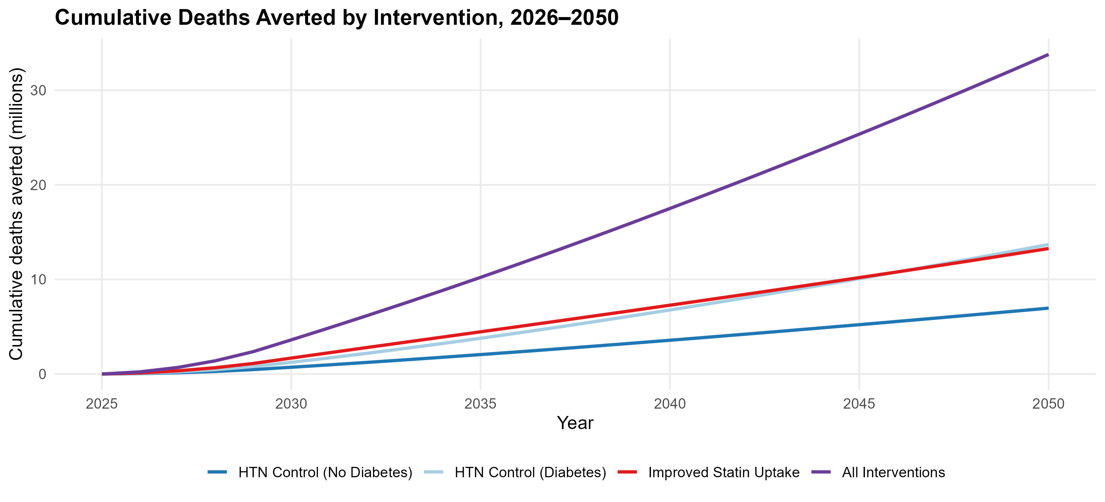
Figure 1: Cumulative CVD deaths averted over time by intervention scenario, 2026-2050. Lines show the running total of CVD deaths averted relative to business-as-usual for each single-intervention scenario (hypertension control in the general population without diabetes, hypertension control among people with diabetes, and statin scale-up) and for all interventions combined.

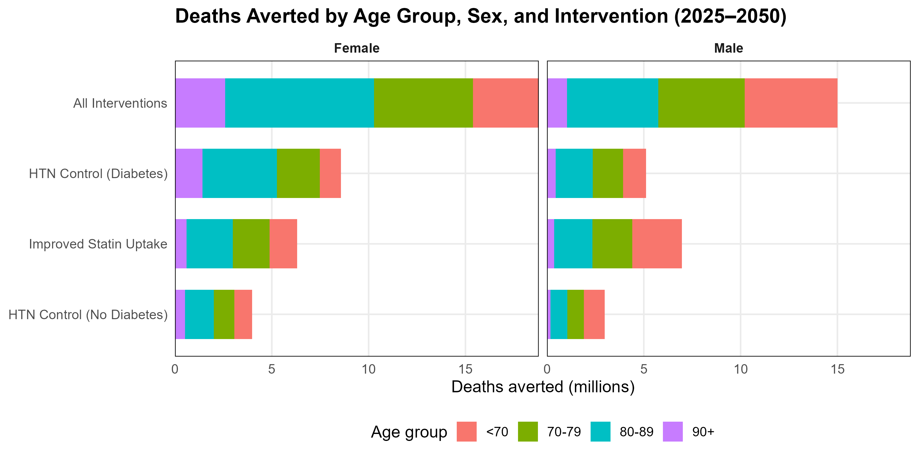
Figure 2: Distribution of projected CVD deaths averted by age group, sex, and intervention scenario, 2026-2050. Adults aged 70 years and older account for the majority of averted deaths across all interventions, consistent with the age-dependent increase in baseline CVD mortality.

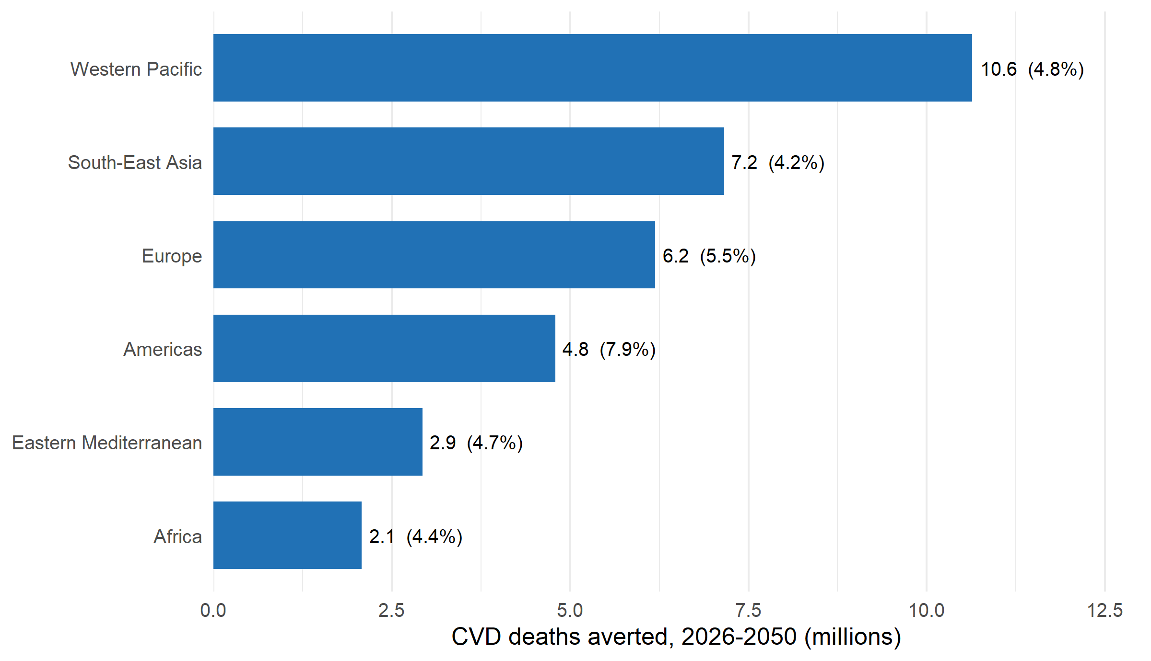
Figure 3: CVD deaths averted by WHO region under the all-interventions scenario, 2026-2050. Bars show cumulative CVD deaths averted relative to business-as-usual across all modelled countries in each region; the per-cent labels give the share of that region’s business-as-usual CVD mortality averted. Precise values, including business-as-usual denominators, are in the Supplement (Table 6).

Supplemental Material

Supplemental Tables
Full country-level results (deaths and burden of disease averted by scenario, cause, age, sex, and year) are provided in the supplementary Excel workbook exported by aim1_report.Rmd and in the project repository (see Data and code availability). Summary tables by scenario, cause, and income group appear in the main text (Tables 1, 2, 3, 4, and 5).
Table 6: Cumulative CVD deaths and DALYs averted by WHO region under the all-interventions scenario, 2026-2050.
Region | BAU deaths (M) | Deaths averted (M) | Average per year (000s) | % of BAU | DALYs averted (M)
Western Pacific | 220.3 | 10.6 | 425 | 4.8% | 114.7
South-East Asia | 170.9 | 7.2 | 286 | 4.2% | 95.8
Europe | 113.4 | 6.2 | 248 | 5.5% | 67.0
Americas | 60.9 | 4.8 | 192 | 7.9% | 52.1
Eastern Mediterranean | 62.5 | 2.9 | 117 | 4.7% | 38.7
Africa | 47.6 | 2.1 | 83 | 4.4% | 25.0
Note: BAU, business-as-usual; M, millions. “% of BAU” is deaths averted as a share of the region’s business-as-usual CVD mortality, 2026-2050. These are the precise values summarised in Figure 3.

Supplemental Figures
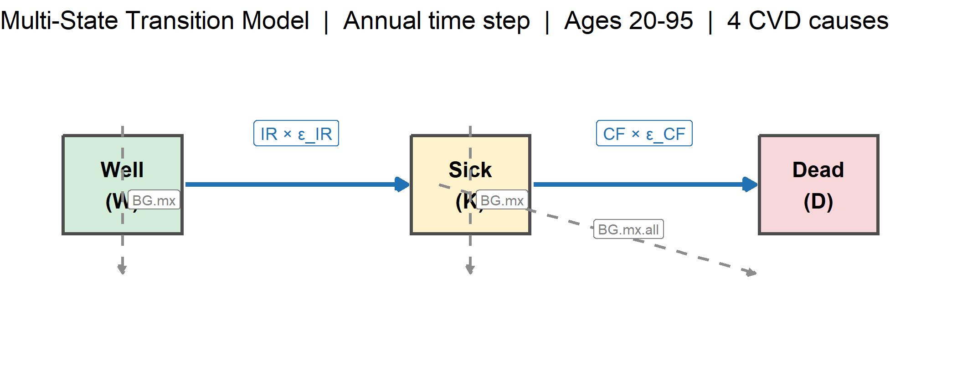
Figure 4: Conceptual framework of the multi-state transition model. Individuals move between Well (W), Sick (K), and Dead (D) states each year according to cause-specific incidence (IR), case fatality (CF), and background mortality (BG.mx, BG.mx.all). Interventions modify IR and CF through multiplicative effect ratios; COVID-19 excess mortality was applied to 2020 and 2021 only.

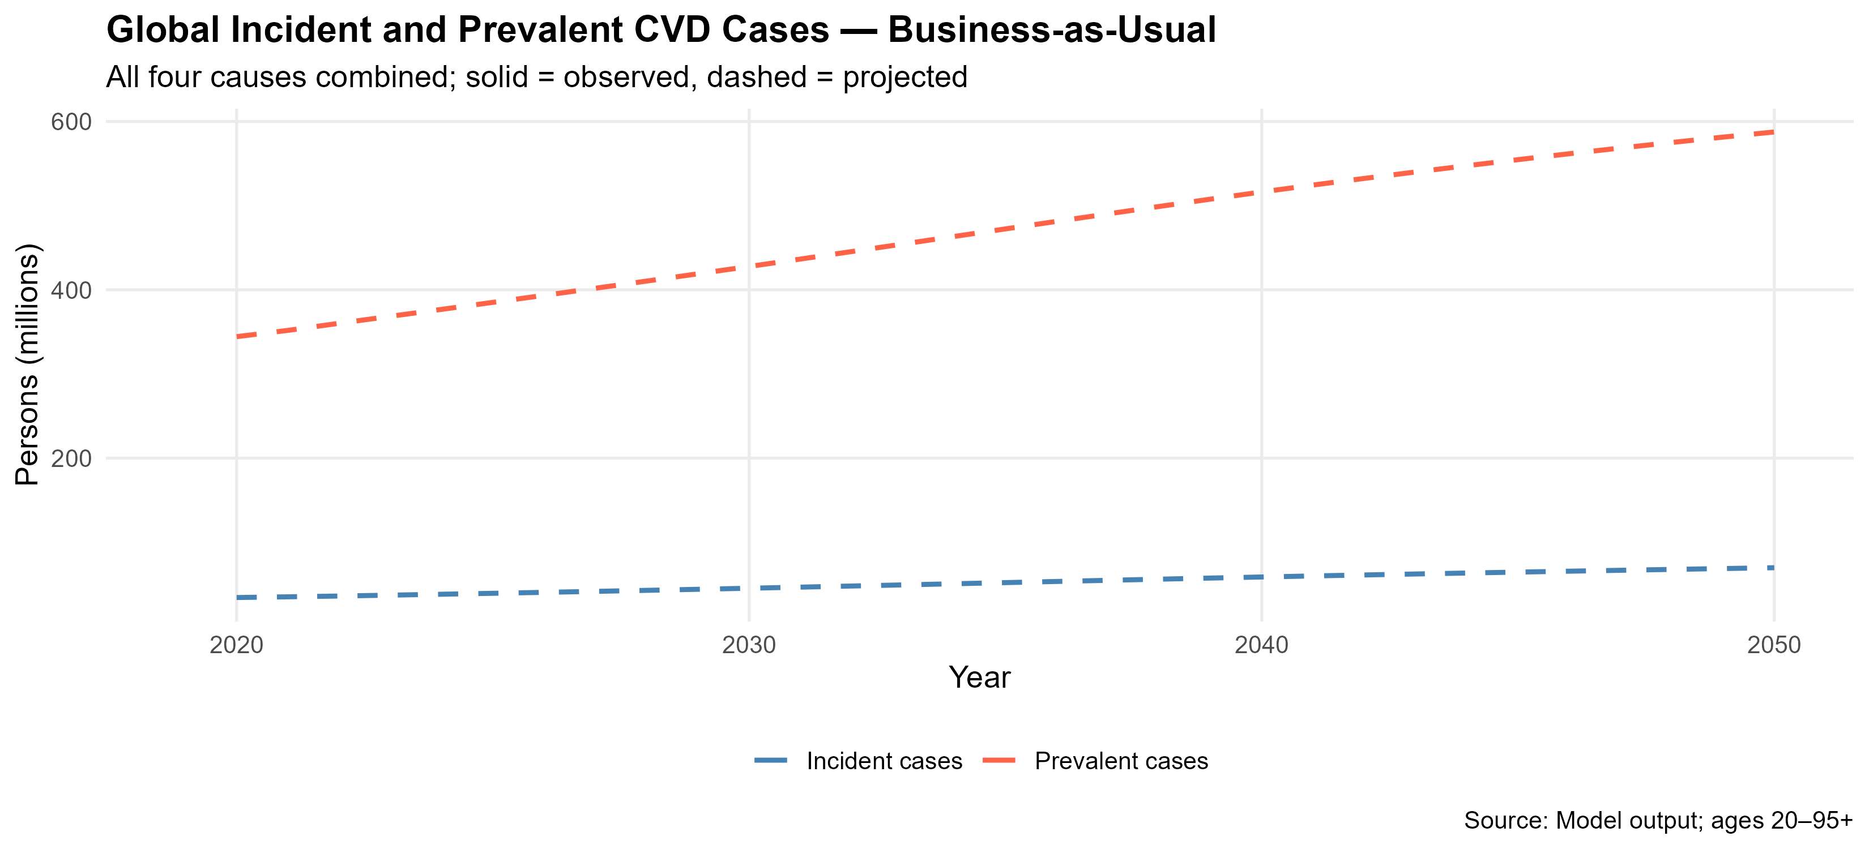
Figure 5: Supplementary figure. Projected CVD deaths by cause under the business-as-usual scenario, in which hypertension control and statin coverage are held at recent levels. Four causes are modelled jointly: ischaemic heart disease, ischaemic stroke, intracerebral haemorrhage, and hypertensive heart disease. Population denominators from UNWPP 2024; epidemiological inputs from GBD 2023.

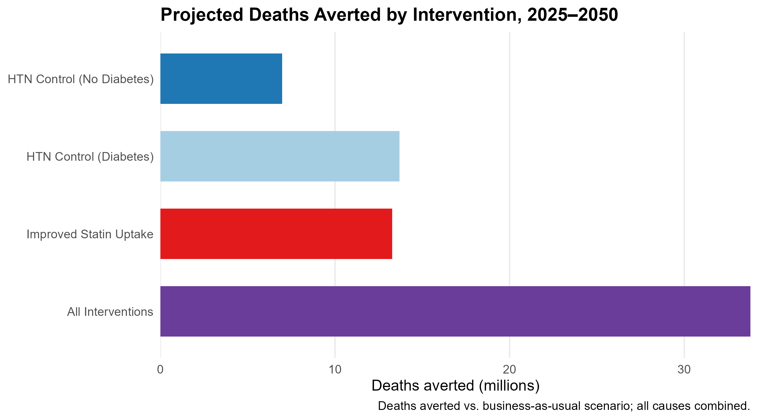
Figure 6: Supplementary figure. Cumulative CVD deaths averted by intervention scenario over the study period, across all modelled countries: hypertension control among hypertensives without diabetes and among those with diabetes (the two mutually exclusive subgroups of the 150-million control target), statin scale-up to 50% coverage among adults aged 40 years and older, and all interventions combined. All four CVD causes combined.

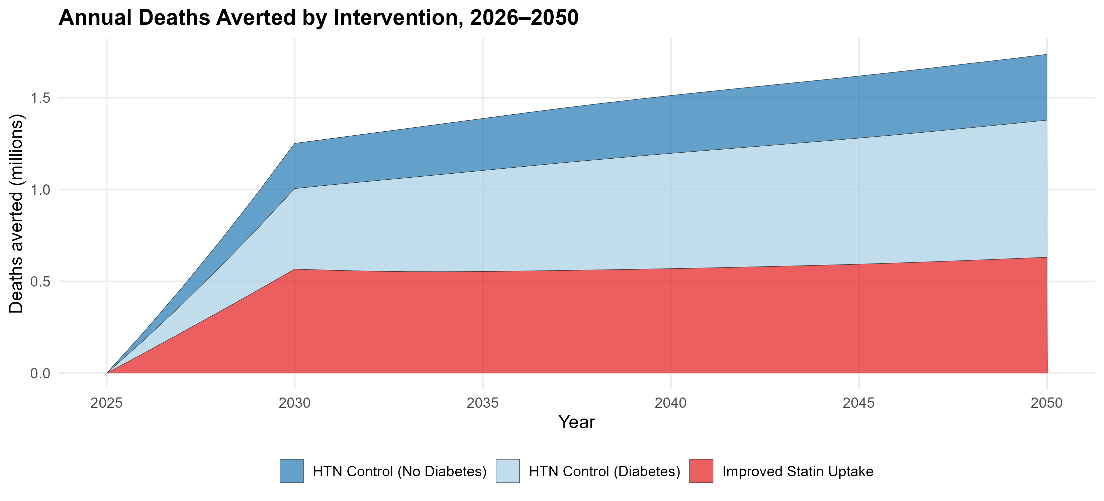
Figure 7: Supplementary figure. Annual CVD deaths averted by intervention over time. Interventions scale up linearly from 2026 to 2030 and are sustained through 2050; gains accelerate after 2030 as sustained coverage compounds cumulative risk reduction.

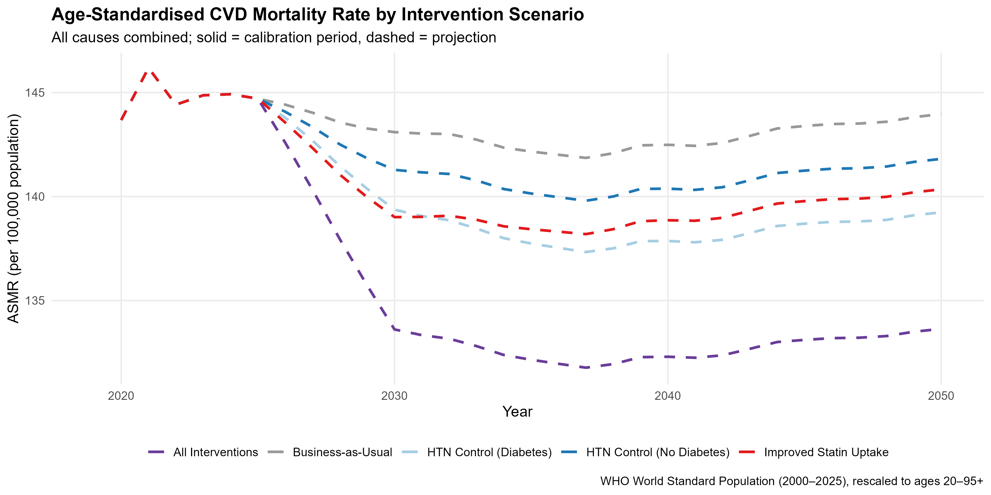
Figure 8: Supplementary figure. Age-standardised CVD mortality rate (ASMR) by intervention scenario, 2019 to 2050. Solid lines, calibration period (2019 to 2025); dashed lines, projection period (2026 to 2050). ASMR computed using the WHO World Standard Population, rescaled to ages 20 to 95+.

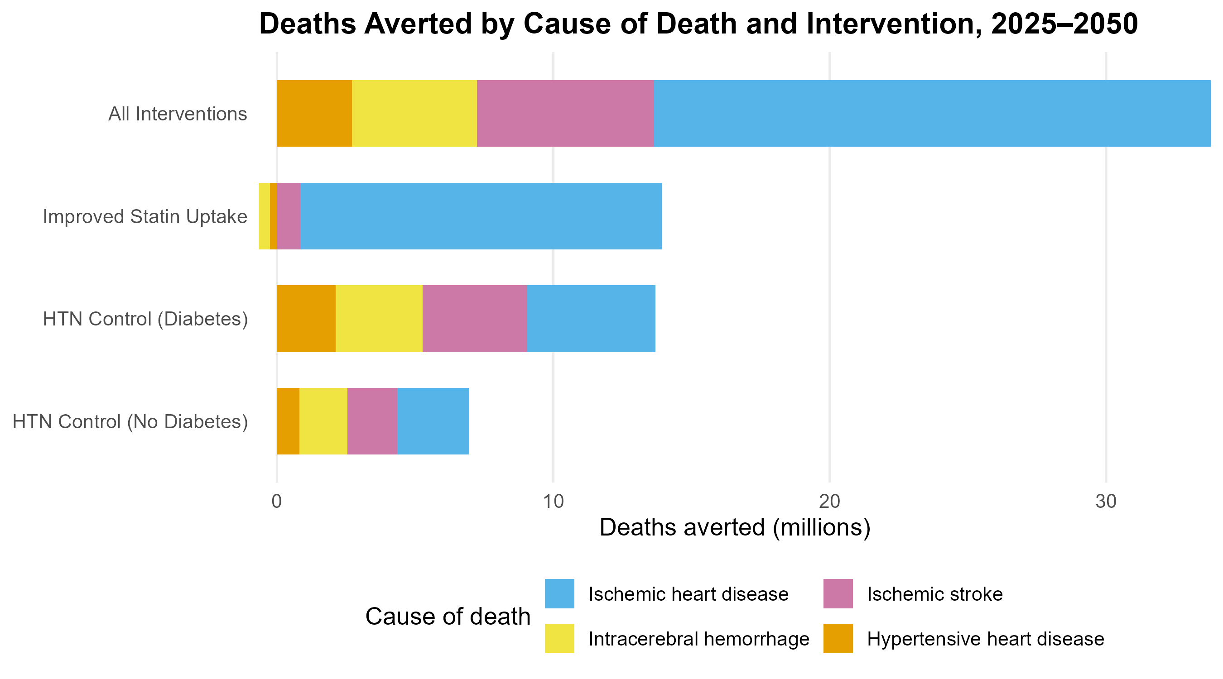
Figure 9: Supplementary figure. Cumulative CVD deaths averted by cause of death and intervention scenario. Statin effects are restricted to ischaemic heart disease and ischaemic stroke; blood pressure control affects all four causes.

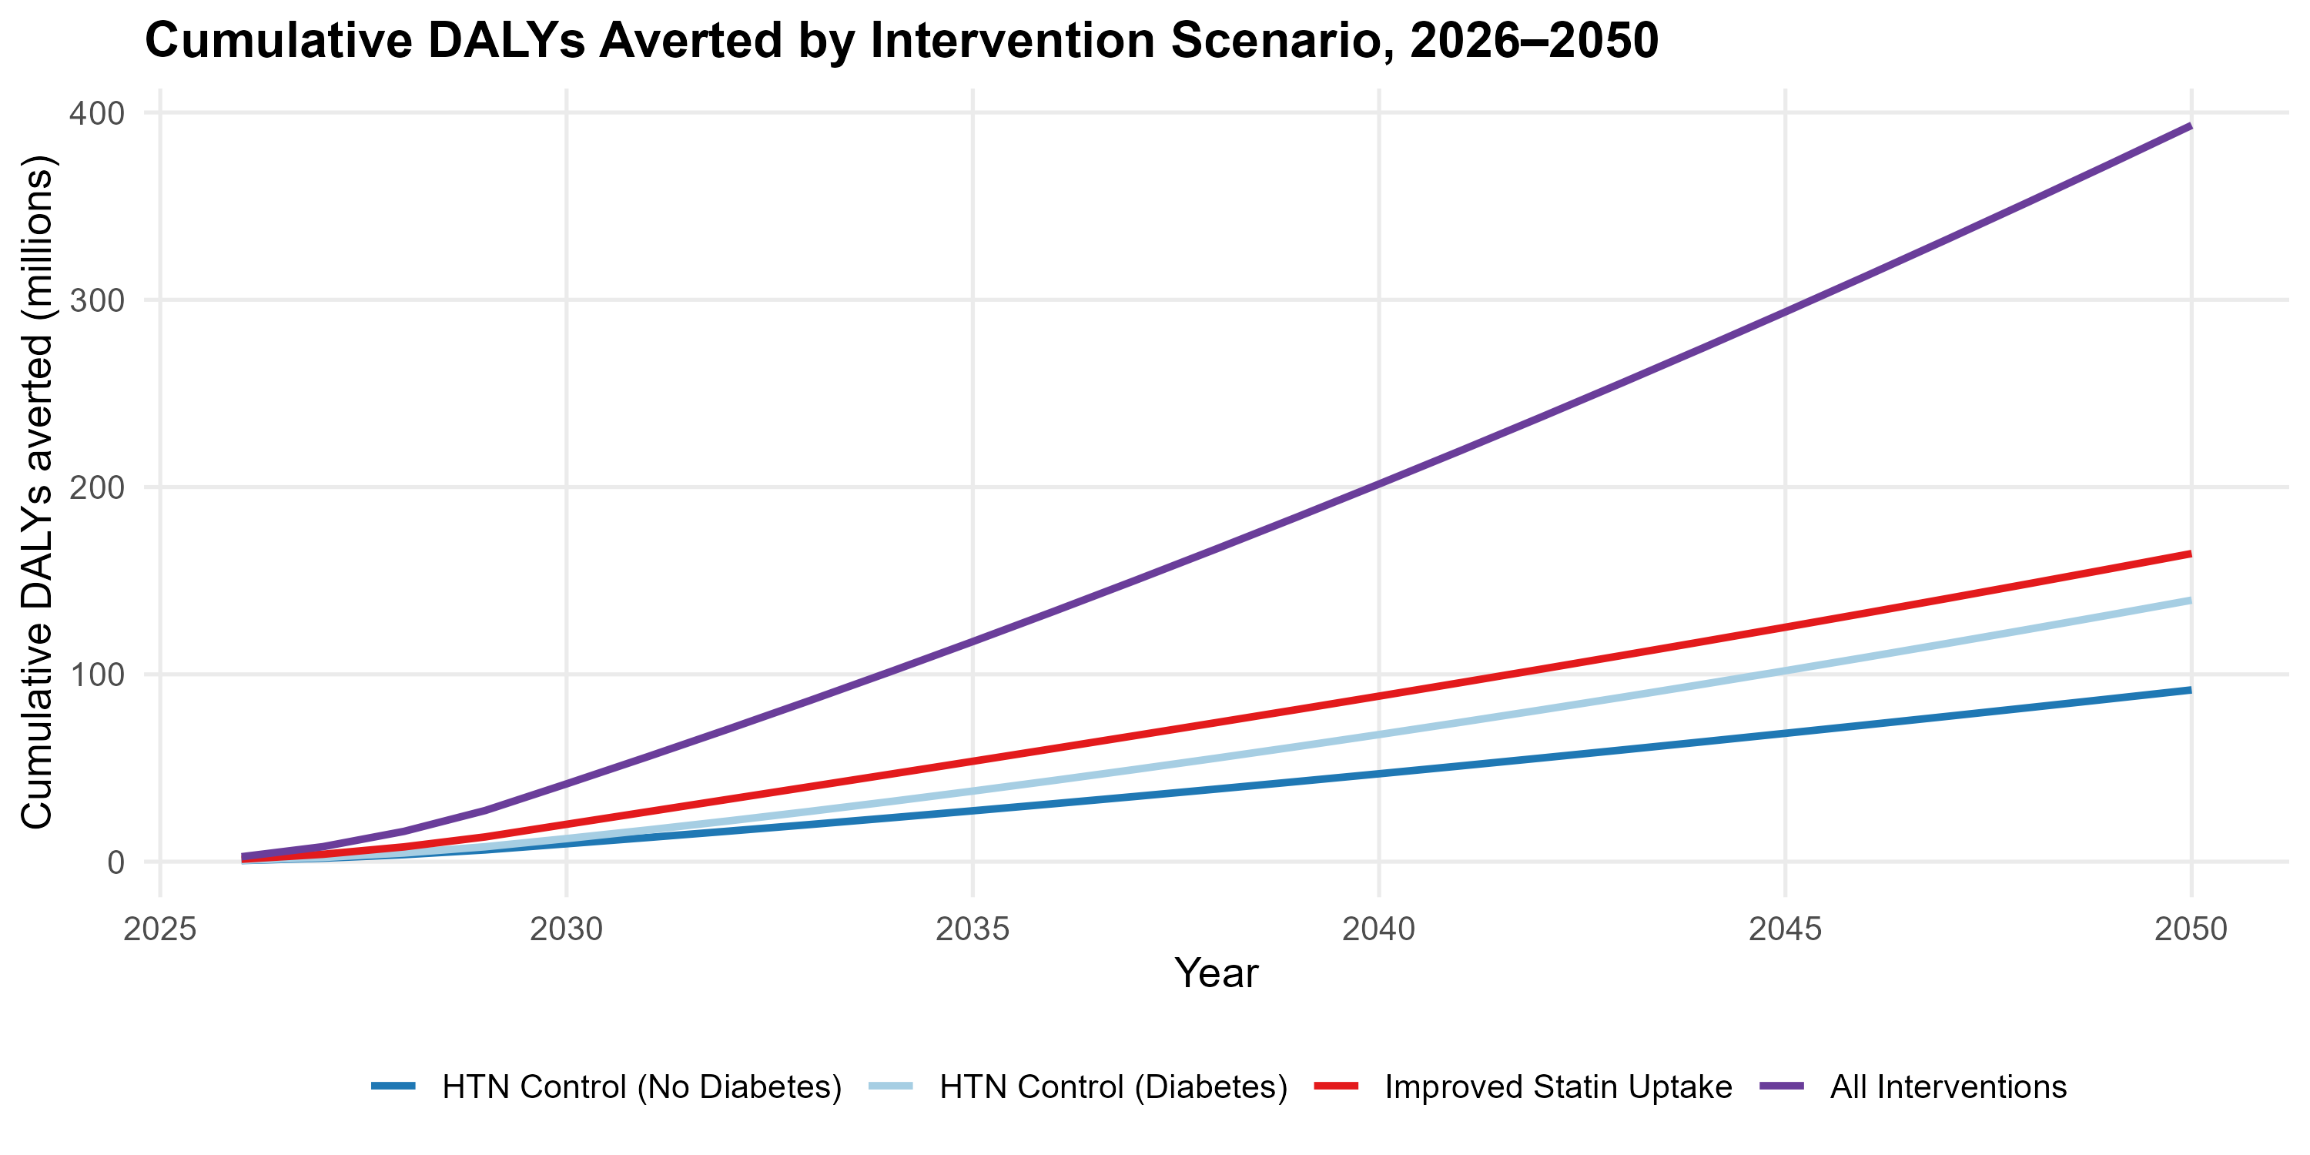
Figure 10: Supplementary figure. Cumulative disability-adjusted life years (DALYs) averted by intervention scenario over time. DALYs combine years of life lost and years lived with disability across the four modelled causes.

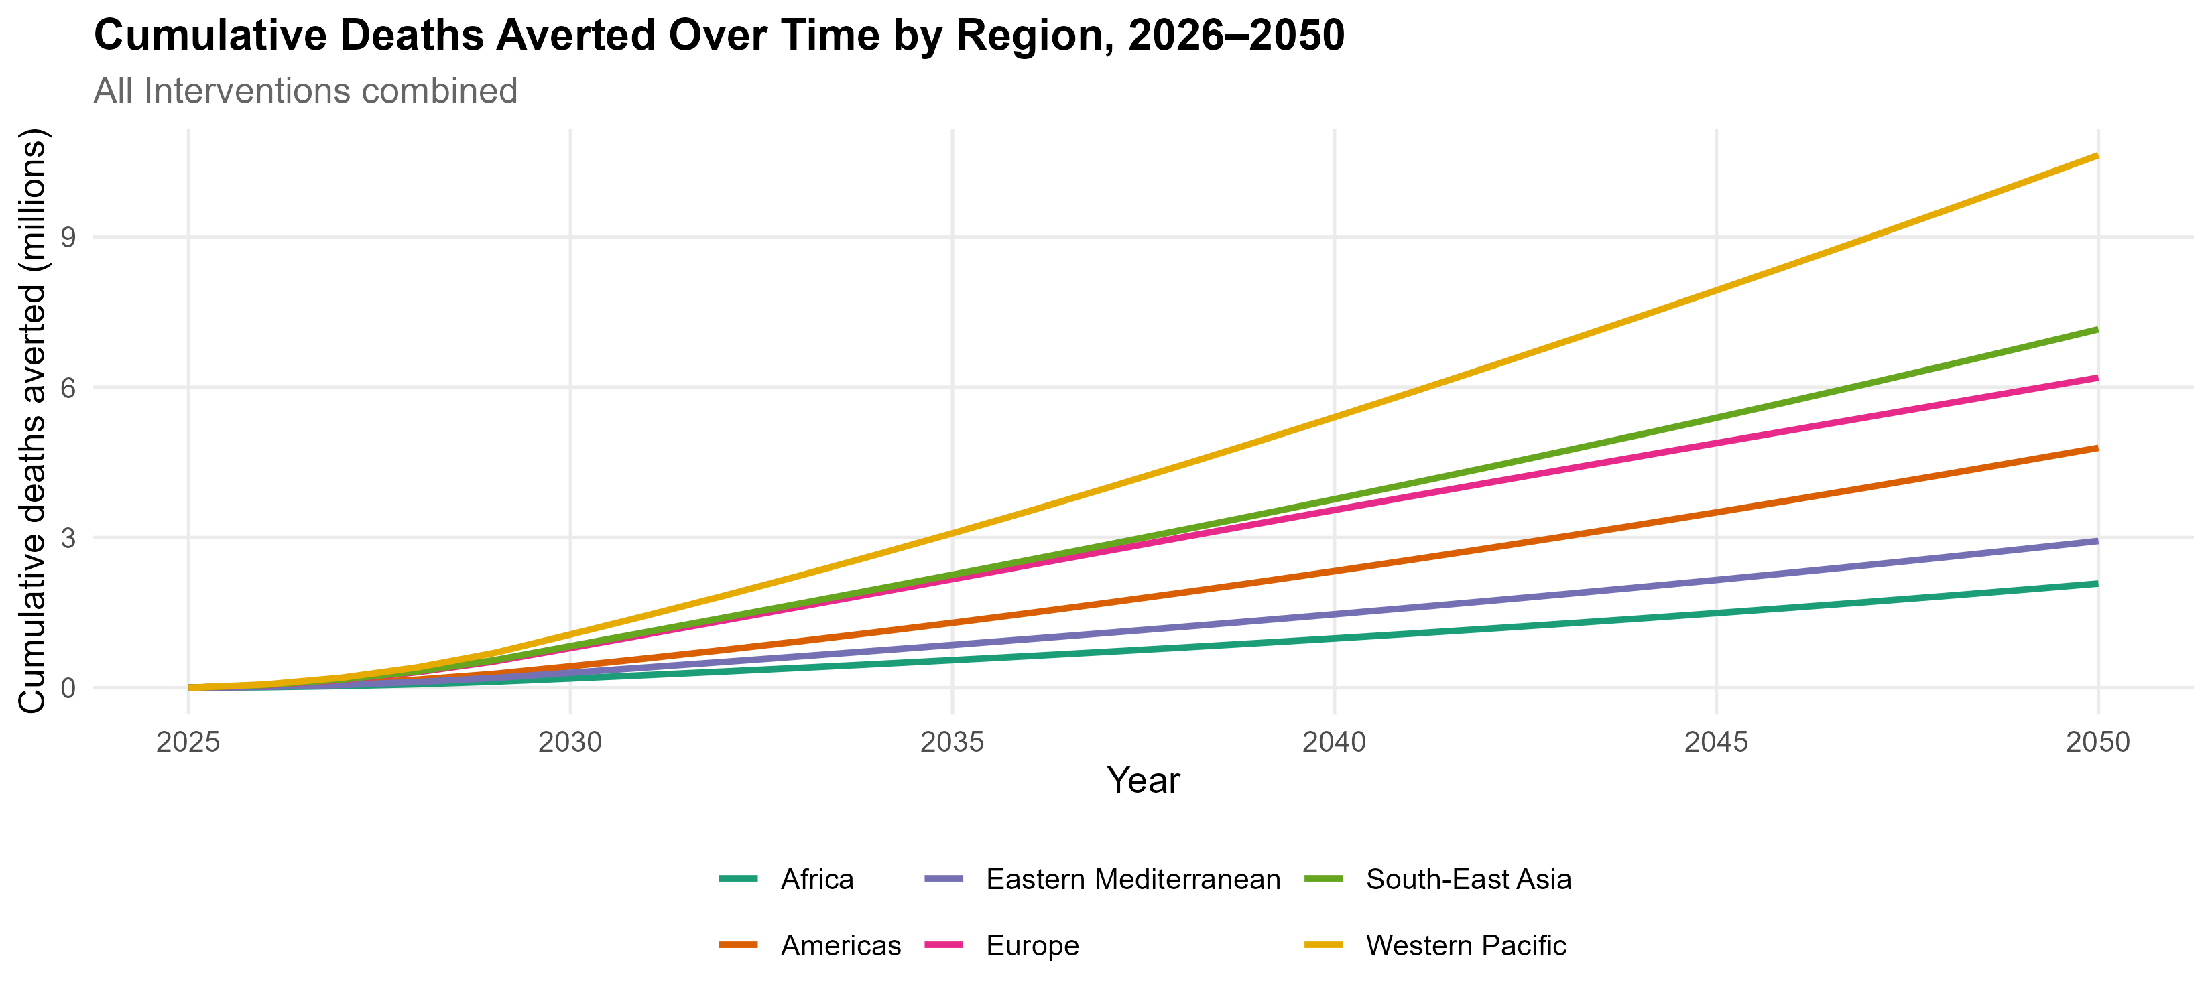
Figure 11: Supplementary figure. Cumulative CVD deaths averted over time under the all-interventions scenario, disaggregated by WHO region across all modelled countries.

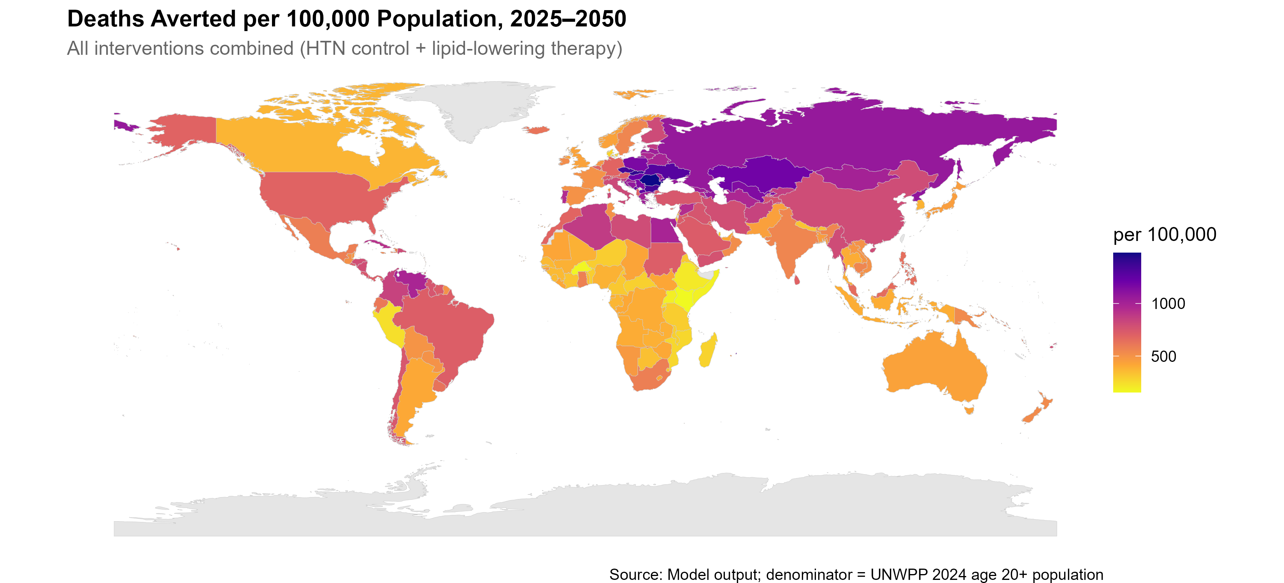
Figure 12: Supplementary figure. Cumulative CVD deaths averted per 100,000 population under the all-interventions scenario. Darker shading indicates larger per-capita health gains; variation reflects differences in baseline CVD burden, population age structure, and current treatment coverage.

Deterministic sensitivity analysis
We conducted a one-way deterministic sensitivity analysis (DSA) in which one assumption at a time was varied while all others were held at the reference values, following the approach for deliberately chosen scenario values (rather than sampled distributions) described by Briggs and colleagues. Four families were tested: the degree of target achievement, the timing of full implementation, statin adherence, and the secular case-fatality trend. Each setting was run for all 186 countries and compared with its own matched business-as-usual and reference run (Table 7; Figure 13).
This deterministic analysis produces one-way scenario ranges, not probabilistic uncertainty intervals: no distributions were sampled, and no confidence or credible intervals are implied. A formal probabilistic sensitivity analysis was not undertaken. Importantly, the sensitivity analysis was executed on an earlier build of the model than the central analysis (before a correction to the haemorrhagic-stroke incidence relative risk and an update to the blood pressure meta-analysis, and while a now-removed trans-fat component was still active). Its reference level for all interventions (26.8 million deaths averted) therefore differs from the central estimate reported in the main text (33.8 million); the DSA should be read for the relative direction and magnitude of each assumption’s effect against its own reference, not as an alternative central estimate. Re-running the DSA on the current build would require modifying the frozen analysis code and was outside the scope of this revision.
Table 7: One-way deterministic sensitivity analysis: cumulative CVD deaths and DALYs averted under the all-interventions scenario by setting, 2026-2050 (full run, 186 countries).
Setting | Family | Averted (M) | Δ vs ref. (M) | Δ (%) | % of BAU | Δ DALYs vs ref. (M)
Reference | Reference | 26.79 | 0.00 | 0.0% | 3.97% | 0.0
50% of increment | Target achievement | 15.56 | -11.23 | -41.9% | 2.30% | -135.6
75% of increment | Target achievement | 21.16 | -5.63 | -21.0% | 3.13% | -67.9
Endpoint 2035 | Implementation timing | 25.33 | -1.46 | -5.4% | 3.75% | -20.1
Endpoint 2040 | Implementation timing | 23.65 | -3.14 | -11.7% | 3.50% | -42.5
Statin adherence low | Statin adherence | 26.28 | -0.51 | -1.9% | 3.89% | -6.4
Statin adherence moderate | Statin adherence | 29.63 | 2.84 | 10.6% | 4.39% | 34.8
Statin adherence by income | Statin adherence by income group | 29.11 | 2.32 | 8.7% | 4.31% | 26.8
Perfect adherence (extra ref.) | Extra reference (not base case) | 34.25 | 7.46 | 27.9% | 5.07% | 91.5
Full CVD CF trend | CVD mortality trend | 26.80 | 0.01 | 0.0% | 3.97% | 0.1
No CVD CF trend | CVD mortality trend | 26.74 | -0.05 | -0.2% | 3.96% | -0.9
IHME Foresight CVD trend | CVD mortality trend | 22.40 | -4.39 | -16.4% | 4.10% | -70.2
Note: Deaths and DALYs averted are compared with the DSA’s own reference run; the “change versus reference” columns give the difference from that reference and “% of BAU” uses each setting’s own matched business-as-usual. Values are one-way deterministic scenario differences, not probabilistic uncertainty intervals. M, millions. The “Perfect adherence” row is an extra reference shown for context, not the base case. The reference level differs from the main-text central estimate because the analysis was run on an earlier model build (see text above).

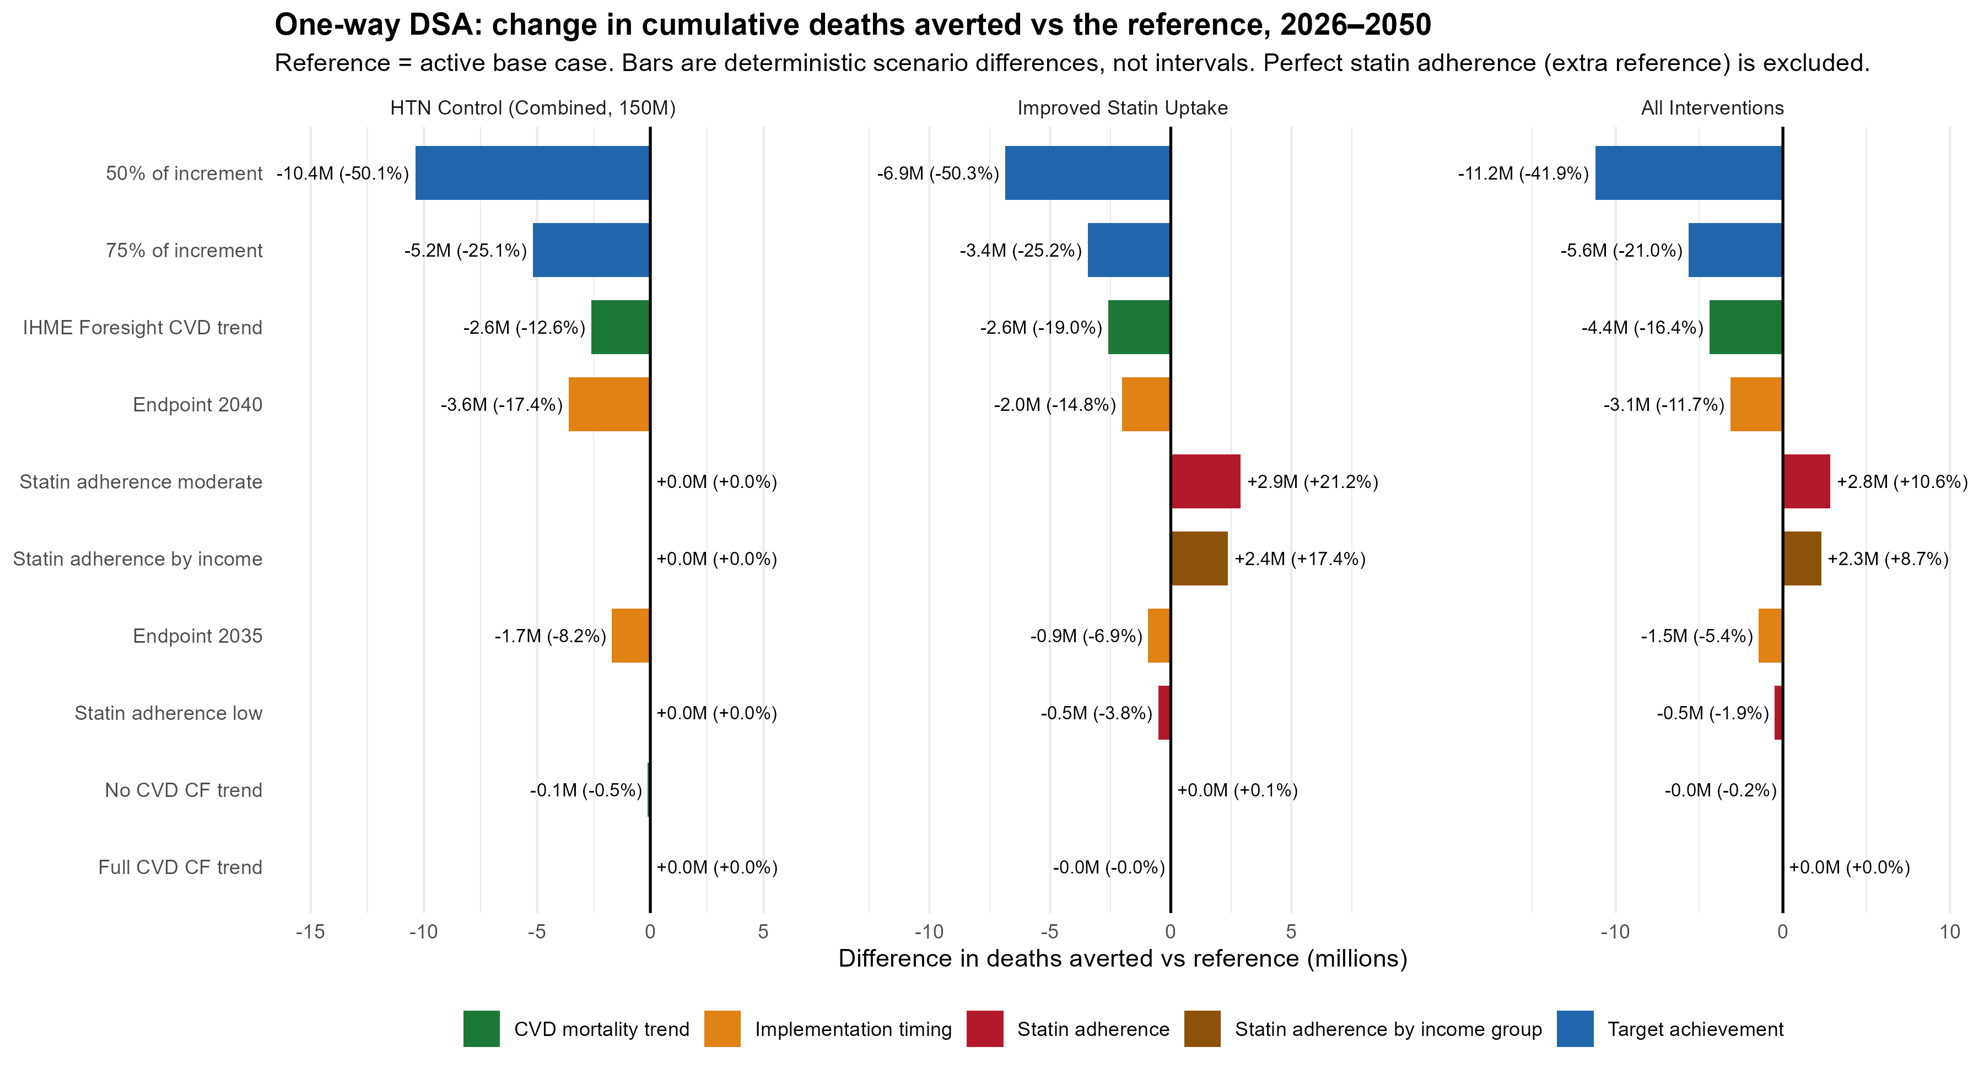
Figure 13: Supplementary figure. Tornado diagram of the one-way deterministic sensitivity analysis, showing cumulative CVD deaths averted under the all-interventions scenario across the tested settings relative to the deterministic reference. Values are deterministic scenario differences, not probabilistic uncertainty intervals.

Methodology and Mathematical Details

Mathematical Notation Summary
All symbols used in subsequent subsections are defined in the table below. R variable names from the implementation code (06_run_scenarios_multiple.R) are mapped to mathematical symbols as follows: well $→W$, sick $→K$, dead $→D$, IR $→IR$, CF $→CF$, eff_ir $→ε_{IR}$, eff_cf $→ε_{CF}$, BG.mx $→BG.mx$, BG.mx.all $→BG.mx.all$, Nx $→N$, PREVt0 $→PREV$, DIS.mx.t0 $→DIS.mx$.
Symbol | Definition
a, s, c, t, l | Age (single year, 20-95), sex, cause, time (year), location (country)
BP_cat | Blood pressure category (eight bins: <120 through 180+)
W, K, D | Well (disease-free), Sick (prevalent), and Dead (disease-specific) populations
N | Total population
IR | Incidence rate (Well to Sick transition)
CF | Case fatality rate (Sick to Dead transition)
BG.mx | Cause-deleted background mortality
BG.mx.all | All-cause background mortality
covid.mx | COVID-19 excess mortality (2020-2021 only)
PREV | Baseline disease prevalence (initial condition)
DIS.mx | Baseline disease-specific mortality rate (initial condition)
epsilon_IR, epsilon_CF | Multiplicative effect ratios for incidence and case fatality (<1 = reduction)
epsilon_IR,BP ; epsilon_CF,BP | Effect ratios from general-population hypertension control
epsilon_IR,BP,DM ; epsilon_CF,BP,DM | Effect ratios from diabetes-specific hypertension control
epsilon_IR,statin ; epsilon_CF,statin | Effect ratios from statin therapy
epsilon_IR,total ; epsilon_CF,total | Combined effect ratios (multiplicative product across interventions)
C_baseline | Baseline hypertension control rate (country-specific)
C_target | Target hypertension control rate
C_0, C_t | Baseline and time-varying coverage for hypertensive BP bins
Delta C_target | Incremental coverage target (C_target - C_baseline)
C_agg^Delta | Aggregate incremental coverage (population-weighted over hypertensive bins)
P(BP_cat) | Population probability distribution across BP categories
RR_GBD | GBD relative risk per 10 mmHg SBP increase (age- and cause-specific)
alpha (normalisation) | Normalisation factor = sum of P(BP) x RR_GBD across bins
IR_bin | Bin-specific baseline incidence
E_trial | Ettehad trial effect size (diabetes-weighted, per BP bin and cause)
E_adj | Coverage-adjusted effect size
w_DM | Diabetes prevalence weight (country-specific)
rho_CF,c | Case-fatality reduction factor per unit coverage (cause-specific)
T_start, T_end | Scale-up start and end years
U_0,l | Baseline statin coverage at start year (country-specific)
U_target | Target total statin coverage
Delta U(t,l) | Incremental statin coverage above baseline at time t
RR^IR_c, RR^CF_c | Trial-based relative risks for incidence and case fatality
delta^IR_c, delta^CF_c | Risk reductions (= 1 - RR) for incidence and case fatality
AF_c,l | Attributable fraction (cause- and location-specific; used for IR only)
psi_athero | Proportion of ischaemic stroke that is atherosclerotic (CF only)
alpha_IR, alpha_CF | Adherence for primary (IR) and secondary (CF) prevention
E^IR_c,l(t), E^CF_c,l(t) | Incremental statin effect sizes for IR and CF
Deaths averted | Cumulative difference: D_BAU - D_intervention, summed over a, s, c, t

Key Parameter Appendix
The table below lists the base parameter values actually used by the executed model run, read from the reporting artefacts (paper_params.rds) rather than transcribed by hand. All parameters are deterministic; a one-way deterministic sensitivity analysis around key settings is reported in Section Deterministic sensitivity analysis, and no probabilistic sensitivity analysis was undertaken.
Table 8: Base parameter values used in the executed model run, with achieved control rates.
Parameter | Value | Source
Time step | 1 year | Model structure
Age range | 20 to 95 | UNWPP 2024
Causes modelled | IHD, ischaemic stroke, haemorrhagic stroke, HHD | GBD 2023
Incidence rate (IR) | Country-specific | GBD 2023 / WHO GHE
Case fatality rate (CF) | Country-specific | GBD 2023 / WHO GHE
Background mortality | Country-specific | WHO GHE
Population (N) | Country-specific | UNWPP 2024
HTN control target (aggregate) | 150.0 M additional controlled by 2030 | WHO NCD targets
HTN control cap: diabetes | 80.0% cap (achieved 45.3%) | Global Diabetes Compact
HTN control cap: no diabetes | 100% cap (achieved 22.2%) | Allocation cap
HTN scale-up start / target year | 2026 / 2030 | Model assumption / WHO target year
HTN baseline control | Country-specific | WHO / country data
CF reduction factor: IHD | 0.24 | BPLTTC 2021
CF reduction factor: ischaemic stroke | 0.36 | BPLTTC 2021
CF reduction factor: haemorrhagic stroke | 0.76 | BPLTTC 2021
CF reduction factor: HHD | 0.20 | BPLTTC 2021
BP RR per 10 mmHg SBP | Cause- and BP-category-specific | BPLTTC 2021
GBD RR per 10 mmHg | Age- and cause-specific | GBD 2019
Diabetes prevalence weight | Country-specific | Country-level estimates
Statin target coverage | 50.0% | WHO NCD targets
Statin scale-up start / target year | 2026 / 2030 | Model assumption / WHO target year
Statin RR incidence: IHD | 0.74 | CTT Collaboration 2015
Statin RR incidence: ischaemic stroke | 0.80 | CTT Collaboration 2015
Statin RR case fatality: IHD | 0.80 | CTT Collaboration 2015
Statin RR case fatality: ischaemic stroke | 0.96 | CTT Collaboration 2015
Attributable fraction: IHD | 0.15 (default) | GBD (country-specific where available)
Attributable fraction: ischaemic stroke | 0.12 (default) | GBD (country-specific where available)
Atherosclerotic stroke proportion | 0.60 | Literature estimate
Statin adherence (incidence) | 0.57 | Basios et al. 2025
Statin adherence (case fatality) | 0.64 | Basios et al. 2025
Statin age eligibility | >= 40 years | WHO guidelines
Sources: BPLTTC 2021 (blood pressure relative risks per 10 mmHg) (Blood Pressure Lowering Treatment Trialists’ Collaboration 2021); Cholesterol Treatment Trialists’ Collaboration (statin relative risks) (Fulcher et al. 2015); statin adherence (Basios et al. 2025); GBD 2023 (Chong et al. 2024); UNWPP 2024. Blood pressure effects assume full adherence; statin effects are multiplied by the adherence factors shown. Control among people with diabetes is capped at 80% but the achieved rate under the shared 150-million allocation is lower (Table 1).

Multi-State Transition Model
The model comprises three mutually exclusive health states for each cause $c∈\{\text{IHD},\text{ischaemic stroke},\text{haemorrhagic stroke},\text{HHD}\}$:
- Well ($W_{a,s,c,t}$): Disease-free individuals at risk of developing cause $c$
- Sick ($K_{a,s,c,t}$): Individuals living with prevalent disease $c$
- Dead ($D_{a,s,c,t}$): Individuals who have died from cause $c$
Individuals transition between states according to cause-specific incidence rates ($IR$: Well $→$ Sick), case fatality rates ($CF$: Sick $→$ Dead), and background mortality ($BG.mx$: exits from Sick; $BG.mx.all$: all-cause mortality applied to the total population). The four causes are modelled jointly but independently within each country–age–sex stratum; population-level accounting is maintained through all-cause mortality applied to the total population.
The model operates in discrete annual time steps with simultaneous age advancement: at each step, individuals at age $a$ in year $t$ advance to age $a+1$ in year $t+1$. New cohorts enter at age 20 each year. The projection period runs from 2017 (calibration start) through 2050.
State transition equations. For each location $l$, sex $s$, cause $c$, at age $a$ in year $t$, the state occupancies at age $a+1$ in year $t+1$ are:
New cases:
$${\text{NewCases}}_{a+1,s,c,t+1}=W_{a,s,c,t}×IR_{a,s,c,t}×ε_{IR}\left(a,s,c,t\right)$$
Sick population:
$$K_{a+1,s,c,t+1}=K_{a,s,c,t}×\left[1-CF_{a,s,c,t}×ε_{CF}\left(a,s,c,t\right)-BG.mx_{a,s,c,t}-covid.mx_{a,s,t}\right]+W_{a,s,c,t}×IR_{a,s,c,t}×ε_{IR}\left(a,s,c,t\right)$$
Disease-specific deaths:
$$D_{a+1,s,c,t+1}=K_{a,s,c,t}×CF_{a,s,c,t}×ε_{CF}\left(a,s,c,t\right)$$
Total population (updated from external demographic projection):
$$N_{a+1,s,t+1}=N_{a,s,t}-ALL.mx_{a,s,t}$$
All-cause mortality:
ALL.mxa,s,t=c​Da+1,s,c,t+1+Na+1,s,t+1×BG.mx.alla,s,t+covid.mxa,s,t
Well population (computed as residual):
$$W_{a+1,s,c,t+1}=N_{a+1,s,t+1}-ALL.mx_{a+1,s,t+1}-K_{a+1,s,c,t+1}$$
where $ε_{IR}$ and $ε_{CF}$ are the multiplicative effect ratios from the intervention modules (equal to 1 under the business-as-usual scenario). COVID-19 excess mortality ($covid.mx$) is applied only for 2020–2021. All state occupancies are bounded below at zero, and transition rates are capped: $CF≤0.99$, $IR≤0.99$.
Initial conditions. At the model start year (2017) and for each new cohort entering at age 20:
$$K_{20,s,c,t_{0}}=N_{20,s,c,t_{0}}×PREV_{20,s,c}$$
$$D_{20,s,c,t_{0}}=N_{20,s,c,t_{0}}×DIS.mx_{20,s,c}$$
$$W_{20,s,c,t_{0}}=N_{20,s,c,t_{0}}×\left(1-PREV_{20,s,c}-BG.mx_{20,s,c}\right)$$
Intervention combination. When multiple interventions are applied simultaneously, their effect ratios combine multiplicatively:
$$ε_{IR,\text{total}}\left(a,s,c,t\right)=ε_{IR,\text{BP}}\left(a,s,c,t\right)×ε_{IR,\text{BP,DM}}\left(a,s,c,t\right)×ε_{IR,\text{statin}}\left(a,s,c,t\right)$$
$$ε_{CF,\text{total}}\left(a,s,c,t\right)=ε_{CF,\text{BP}}\left(a,s,c,t\right)×ε_{CF,\text{BP,DM}}\left(a,s,c,t\right)×ε_{CF,\text{statin}}\left(a,s,c,t\right)$$
Each intervention effect ratio defaults to 1 when the intervention is not active, so single-intervention and combined scenarios use the same multiplicative framework.
Primary outcome. Cumulative CVD deaths averted over the study period are computed as:
Deaths averted=a,s,c,t​Da,s,c,tBAU-a,s,c,t​Da,s,c,tintervention
(Parameter values for all transition rates are listed in the Key Parameter Appendix.)

Hypertension Control Intervention Model
The hypertension control intervention modifies incidence and case fatality rates through a multi-step pipeline that integrates blood pressure distributions, GBD relative risks, Ettehad trial effect sizes, and linear coverage scale-up. Only incremental coverage above country-specific baseline control is credited with new effects, preventing double-counting of existing treatment benefits.
Coverage scale-up. Treatment coverage increases linearly from baseline to target over a specified period. The incremental coverage target above baseline is:
$$ΔC_{\text{target}}=max\left(C_{\text{target}}-C_{\text{baseline}},0\right)$$
The time-varying incremental coverage is:
$$ΔC\left(t\right)=ΔC_{\text{target}}×min\left(\frac{t-T_{\text{start}}+1}{T_{\text{end}}-T_{\text{start}}+1}, 1\right)$$
with boundary conditions: $ΔC\left(t\right)=0$ for $t<T_{\text{start}}$ and $ΔC\left(t\right)=ΔC_{\text{target}}$ for $t>T_{\text{end}}$.
Coverage is applied only to hypertensive blood pressure bins ($≥$ 140 mmHg). For hypertensive bins: $C_{0}=C_{\text{baseline}}$ and $C_{t}\left(t\right)=C_{\text{baseline}}+ΔC\left(t\right)$. For non-hypertensive bins ($<$ 140 mmHg): $C_{0}=C_{t}=0$.
Step 1: Baseline blood pressure distribution. The untreated population distribution across eight BP bins ($<$120, 120–129, …, 180+) is obtained for each age–sex–location stratum: $P\left({\text{BP}}_{\text{cat}}∣a,s,l\right)$.
Step 2: Bin-specific baseline incidence via GBD relative risks. GBD relative risks per 10 mmHg SBP increase above the reference ($<$120 mmHg) are applied as a power function of the distance from reference:
$$RR_{\text{GBD}}\left({\text{BP}}_{\text{cat}},a,c\right)=RR_{\text{per10}}^{\left({\text{SBP}}_{\text{mid}}-120\right)/10}$$
where ${\text{SBP}}_{\text{mid}}$ is the midpoint of the BP bin. A normalisation factor anchors bin-level rates to the overall incidence:
αa,s,c,t=BPcat​PBPcat×RRGBDBPcat,a,c
Bin-specific incidence is then:
$$IR_{\text{bin}}\left({\text{BP}}_{\text{cat}}\right)=\frac{RR_{\text{GBD}}\left({\text{BP}}_{\text{cat}},a,c\right)×IR_{a,s,c,t}}{α_{a,s,c,t}}$$
Step 3: Diabetes-weighted Ettehad trial effect sizes. The cumulative BP-reduction effect size for each bin and cause is computed as a diabetes-prevalence-weighted average of Ettehad trial estimates:
$$E_{\text{trial}}\left({\text{BP}}_{\text{cat}},c\right)=\left(1-w_{\text{DM}}\right)×E_{\text{noDM}}\left({\text{BP}}_{\text{cat}},c\right)+w_{\text{DM}}×E_{\text{DM}}\left({\text{BP}}_{\text{cat}},c\right)$$
where $w_{\text{DM}}$ is the country-specific diabetes prevalence and $E_{\text{noDM}}$, $E_{\text{DM}}$ are cumulative bin-specific effect sizes from the Ettehad meta-analysis for non-diabetic and diabetic populations respectively.
Step 4–5: Coverage-adjusted effect sizes. The trial effect size is adjusted by the incremental coverage above baseline:
$$E_{\text{adj}}\left(t\right)=\frac{E_{\text{trial}}×\left(C_{t}\left(t\right)-C_{0}\right)}{1-E_{\text{trial}}×C_{0}}$$
When $C_{0}=0$ (no prior treatment), this simplifies to $E_{\text{adj}}\left(t\right)=E_{\text{trial}}×C_{t}\left(t\right)$.
Step 6: New bin-specific incidence.
$$IR_{\text{bin,new}}\left({\text{BP}}_{\text{cat}},t\right)=IR_{\text{bin}}\left({\text{BP}}_{\text{cat}}\right)×\left[1-E_{\text{adj}}\left(t,{\text{BP}}_{\text{cat}},c\right)\right]$$
Step 7: Population-weighted aggregate incidence.
IRnewa,s,c,t=BPcat​IRbin,newBPcat,t×PBPcat
Step 8: Incidence effect ratio.
$$ε_{IR,\text{BP}}\left(a,s,c,t\right)=\frac{IR_{\text{new}}\left(a,s,c,t\right)}{IR_{\text{original}}\left(a,s,c,t\right)}$$
Values of $ε_{IR,\text{BP}}<1$ indicate reductions in disease incidence attributable to the intervention.
Step 9: Case-fatality effect ratio. Case fatality reductions are computed from the incremental aggregate coverage across hypertensive bins, preventing double-counting of baseline treatment effects:
$$ΔC_{\text{delta}}\left(t,{\text{BP}}_{\text{cat}}\right)=max\left(C_{t}\left(t\right)-C_{0},0\right)$$
CaggΔa,s,c,t=BPcat∈HTN​ΔCdeltat,BPcat×PBPcatBPcat∈HTN​PBPcat
where the summation is restricted to hypertensive bins (BP $≥$ 140 mmHg). The case-fatality effect ratio is:
$$ε_{CF,\text{BP}}\left(a,s,c,t\right)=1-ρ_{CF,c}×C_{\text{agg}}^{Δ}\left(a,s,c,t\right)$$
where the cause-specific CF reduction factors are: $ρ_{CF,\text{IHD}}=0.24$, $ρ_{CF,\text{IS}}=0.36$, $ρ_{CF,\text{HS}}=0.76$, $ρ_{CF,\text{HHD}}=0.20$.
Step 10. The final output collapses across BP bins, retaining only the aggregate $IR_{\text{new}}$, $CF_{\text{new}}$, $ε_{IR,\text{BP}}$, and $ε_{CF,\text{BP}}$ per age–sex–cause–year stratum.
(See Multi-State Transition Model for the baseline transition structure into which these effect ratios enter; see Key Parameter Appendix for all intervention effect sizes and their sources.)

Diabetes Component
The diabetes-specific hypertension control intervention applies the same pipeline as the no-diabetes intervention with three key modifications:
- Coverage cap and allocation: control among people with diabetes is capped at $C_{\text{target,DM}}=0.80$ (the Global Diabetes Compact aspiration), while control among people without diabetes is capped at 100%. Both subgroups are scaled by a single shared factor so that their additional-controlled counts sum exactly to the 150-million target on the fixed 2025 population; the two subgroups are mutually exclusive. The 0.80 value is therefore an upper bound, not an achieved rate: under this allocation, achieved control among people with diabetes reaches approximately 45.3% globally by 2030 (Table 1).
- Diabetes weighting: The blood pressure effect sizes are computed with $w_{\text{DM}}=1$ (full diabetes-specific effects), rather than the country-specific diabetes prevalence weight used in the no-diabetes intervention.
- Population downscaling: Because the intervention targets only the diabetic subpopulation, the effect is downscaled by the proportion of the population with diabetes ($d_{a,s,l}$) and raised blood pressure ($ϕ_{\text{hyp}}$):
Incidence:
$$IR_{\text{bin,new}}=IR_{\text{bin}}×\left(1-d_{a,s,l}×E_{\text{adj,DM}}\left(t\right)\right)$$
Effect ratio blending (population-level):
$$ε_{IR,\text{BP,DM}}=1×\left(1-d_{a,s,l}×ϕ_{\text{hyp}}\right)+ε_{IR,\text{raw}}×d_{a,s,l}×ϕ_{\text{hyp}}$$
This ensures that the diabetes-specific intervention affects only the diabetic hypertensive fraction of the population, with the remainder retaining the baseline (unmodified) transition rate.
Case fatality is similarly downscaled: the incremental coverage delta is multiplied by the diabetes prevalence before aggregation, so that CF reductions apply only to the diabetic fraction:
$$ΔC_{\text{delta,DM}}=d_{a,s,l}×max\left(C_{t}-C_{0},0\right)$$
The same CF reduction factors ($ρ_{CF,c}$) are applied to this diabetes-adjusted aggregate coverage.
(See Hypertension Control Intervention Model above for the general-population coverage scale-up structure, which shares the same functional form.)

Statin Therapy Intervention Model
The statin intervention models the impact of scaling up lipid-lowering therapy among adults, with effects restricted to IHD and ischaemic stroke for ages $≥40$ years. The implementation: (i) scales up incremental coverage above country-specific baseline (to avoid double-counting), (ii) applies attributable fractions ($AF_{c,l}$) only for incidence effects (primary prevention), and (iii) applies trial-based relative risks directly for case fatality effects (secondary prevention), with ischaemic stroke CF effects restricted to the atherosclerotic fraction.
Eligibility. Statin effects are applied only to individuals aged $a≥40$ and for causes $c∈\{\text{IHD},\text{ischaemic stroke}\}$. For ages $a<40$ or other causes, the effect ratios are set to 1 (no effect).
Coverage scale-up. The same linear scale-up function is used as for hypertension control (see Hypertension Control Intervention Model). Let $U_{0,l}$ denote baseline statin coverage at $T_{\text{stat,start}}$. The incremental target is:
$$ΔU_{\text{target},l}=max\left(U_{\text{target}}-U_{0,l}, 0\right)$$
The time-varying incremental coverage above baseline is:
$$ΔU\left(t,l\right)=ΔU_{\text{target},l}×min\left(\frac{t-T_{\text{stat,start}}+1}{T_{\text{stat,end}}-T_{\text{stat,start}}+1}, 1\right)$$
with $ΔU\left(t,l\right)=0$ for $t<T_{\text{stat,start}}$ and $ΔU\left(t,l\right)=ΔU_{\text{target},l}$ for $t>T_{\text{stat,end}}$.
Trial-based relative risks and risk reductions. Per approximately 1 mmol/L LDL-C reduction:
Statin relative risks from the Cholesterol Treatment Trialists’ Collaboration (Fulcher et al. 2015)
Cause | $$RR_{c}^{IR}$$ | $$RR_{c}^{CF}$$ | $$δ_{c}^{IR}=1-RR_{c}^{IR}$$ | $$δ_{c}^{CF}=1-RR_{c}^{CF}$$
IHD | 0.74 | 0.80 | 0.26 | 0.20
Ischaemic stroke | 0.80 | 0.96 | 0.20 | 0.04
Incidence effect size. For $c∈\{\text{IHD},\text{ischaemic stroke}\}$ and $a≥40$, the incidence effect size incorporates the cause- and location-specific attributable fraction and a baseline-coverage adjustment in the denominator:
$$E_{c,l}^{IR}\left(t\right)=\frac{AF_{c,l}×δ_{c}^{IR}×ΔU\left(t,l\right)×α_{IR}}{1-δ_{c}^{IR}×U_{0,l}×α_{IR}}$$
where $AF_{c,l}$ is the attributable fraction from GBD 2021 (default values: $AF_{\text{IHD}}=0.15$, $AF_{\text{IS}}=0.12$; country-specific values used where available) and $α_{IR}$ is adherence for primary prevention (default: 1.0).
Case fatality effect size. CF effects are modelled directly from trial relative risks without attributable fractions. For ischaemic stroke, only the atherosclerotic fraction contributes:
$$E_{c,l}^{CF}\left(t\right)=\left\{\begin{matrix}\frac{δ_{\text{IHD}}^{CF}×ΔU\left(t,l\right)×α_{CF}}{1-δ_{\text{IHD}}^{CF}×U_{0,l}×α_{CF}} & \text{if }c=\text{IHD} \\ \frac{ψ_{\text{athero}}×δ_{\text{IS}}^{CF}×ΔU\left(t,l\right)×α_{CF}}{1-δ_{\text{IS}}^{CF}×U_{0,l}×α_{CF}} & \text{if }c=\text{ischaemic stroke}\end{matrix}\right.$$
where $ψ_{\text{athero}}=0.60$ and $α_{CF}$ is adherence for secondary prevention (default: 1.0).
Modified rates. For ages $a≥40$ and $c∈\{\text{IHD},\text{ischaemic stroke}\}$:
$$IR_{\text{new}}\left(a,s,c,t\right)=IR\left(a,s,c,t\right)×\left[1-E_{c,l}^{IR}\left(t\right)\right]$$
$$CF_{\text{new}}\left(a,s,c,t\right)=CF\left(a,s,c,t\right)×\left[1-E_{c,l}^{CF}\left(t\right)\right]$$
Statin effect ratios:
$$ε_{IR,\text{statin}}\left(a,s,c,t\right)=\left\{\begin{matrix}1-E_{c,l}^{IR}\left(t\right) & \text{if }a≥40\text{ and }c∈\{\text{IHD},\text{IS}\} \\ 1 & \text{otherwise}\end{matrix}\right.$$
$$ε_{CF,\text{statin}}\left(a,s,c,t\right)=\left\{\begin{matrix}1-E_{c,l}^{CF}\left(t\right) & \text{if }a≥40\text{ and }c∈\{\text{IHD},\text{IS}\} \\ 1 & \text{otherwise}\end{matrix}\right.$$
Combined intervention effect. When statin and hypertension control interventions are applied simultaneously, their effect ratios combine multiplicatively (see Multi-State Transition Model):
$$ε_{IR,\text{total}}=ε_{IR,\text{BP}}×ε_{IR,\text{BP,DM}}×ε_{IR,\text{statin}}$$
$$ε_{CF,\text{total}}=ε_{CF,\text{BP}}×ε_{CF,\text{BP,DM}}×ε_{CF,\text{statin}}$$
This multiplicative structure means the combined benefit is slightly smaller than the arithmetic sum of the individual effects (because a death cannot be averted twice), while remaining larger than any single intervention alone. It reflects the partly independent causal pathways through which blood pressure control and lipid lowering reduce cardiovascular risk.
(See Key Parameter Appendix for all statin effect sizes and their sources.)

DALY Calculation Methods
Burden of disease was quantified using disability-adjusted life years (DALYs), computed as the sum of years of life lost due to premature mortality (YLL) and years lived with disability (YLD). No age weighting or time discounting was applied. All computations were performed separately by age $a$, sex $s$, cause $c$, year $t$, location $l$, and intervention scenario $j$.

Years of Life Lost (YLL)
YLLs were computed as the product of the number of disease-specific deaths and the remaining life expectancy at the age of death:
$$YLL_{a,s,c,t,l,j}=D_{a,s,c,t,l,j}×e_{x}\left(a,t,l\right)$$
where $D_{a,s,c,t,l,j}$ is the number of CVD deaths from cause $c$ (the dead variable from the state-transition model output) and $e_{x}\left(a,t,l\right)$ is the remaining life expectancy at exact age $a$ in year $t$ for location $l$, taken from the United Nations World Population Prospects 2024 revision, medium variant (both sexes combined). Life expectancy values are country- and year-specific, reflecting projected demographic conditions rather than a fixed global standard.

Years Lived with Disability (YLD)
YLDs were computed using a prevalence-based approach as the product of the number of prevalent CVD cases and a cause- and location-specific disability weight:
$$YLD_{a,s,c,t,l,j}=K_{a,s,c,t,l,j}×DW_{c,l}$$
where $K_{a,s,c,t,l,j}$ is the number of individuals in the Sick (prevalent) state for cause $c$ from the state-transition model output, and $DW_{c,l}$ is the disability weight for cause $c$ in location $l$. Disability weights were derived from GBD 2023 data as the ratio of cause-specific years lived with disability to prevalence for each cause and location:
$$DW_{c,l}=\frac{YLD_{c,l}^{\text{GBD}}}{Prevalence_{c,l}^{\text{GBD}}}$$
This approach yields an implicit, frequency-weighted average disability weight that reflects the severity distribution observed in each country. No explicit duration of disability was modelled; the prevalence-based formulation captures the YLD burden attributable to the stock of prevalent cases at each time point.

Disability-Adjusted Life Years (DALY)
Total DALYs were computed as:
$$DALY_{a,s,c,t,l,j}=YLL_{a,s,c,t,l,j}+YLD_{a,s,c,t,l,j}$$
DALYs averted were computed as the difference between the business-as-usual (BAU) scenario and each intervention scenario, summed across all strata:
DALYs avertedj=a,s,c,t,l​DALYa,s,c,t,lBAU-a,s,c,t,l​DALYa,s,c,t,lj
The same differencing logic was applied separately to YLLs averted and YLDs averted.

Reference Standards and Weights
Parameter | Value or Source | Year | Notes
Life table standard | UNWPP 2024, medium variant | 2024 | Country- and year-specific remaining life expectancy at exact age x (ex), both sexes combined
Disability weight source | GBD 2023 (IHME) | 2023 | IHME-GBD_2023_DATA-52d32656-1
Disability weight derivation | YLD / Prevalence, by cause and location | 2023 | Implicit frequency-weighted severity; country-specific for IHD, ischaemic stroke, haemorrhagic stroke, HHD
Age weighting | None (K = 0) | — | Uniform weighting across all ages
Time discount rate | None — undiscounted (r = 0) | — | Future health losses valued equally regardless of when they occur
Duration of disability | Prevalence-based (not explicitly modelled) | — | YLD = prevalent cases x DW at each annual time step; no explicit incidence x duration calculation
Sources: United Nations, Department of Economic and Social Affairs, Population Division (2024). World Population Prospects 2024, Online Edition. Institute for Health Metrics and Evaluation (IHME). Global Burden of Disease Study 2023 (GBD 2023) Results. Seattle, United States: IHME, 2024.

GATHER checklist
This study follows the Guidelines for Accurate and Transparent Health Estimates Reporting (GATHER) (Stevens et al. 2016). The table below maps each of the 18 GATHER items to where it is addressed and gives an honest status; items marked “Partially addressed” note the specific remaining gap. Full GATHER compliance is not claimed.
Table 9: GATHER (Guidelines for Accurate and Transparent Health Estimates Reporting) checklist and where each item is addressed.
Item | GATHER requirement | Where addressed | Status
1 | Define the indicator(s), populations (age, sex, geography) and time period(s) estimated. | Title; Abstract; Methods (Study design, Outcomes) | Addressed
2 | List the funding sources for the work. | Funding statement | Addressed
3 | Describe how input data were identified and accessed. | Methods (Data sources); repository README and data/ folders | Addressed
4 | Specify inclusion and exclusion criteria, including any ad-hoc exclusions. | Methods (Intervention scenarios); analysis universe defined by countries with model outputs; excluded and missing-input locations recorded by the target-table build | Addressed
5 | Provide information on all included data sources and their main characteristics. | Methods (Data sources); Key Parameter Appendix | Partially addressed
6 | Identify and describe input data with potentially important biases. | Limitations (static BP distribution; adherence; no health-system constraints) | Addressed
7 | Describe and give sources for other (non-synthesised) data inputs. | Methods (Data sources); Key Parameter Appendix | Addressed
8 | Provide input data in an efficiently extractable file format, with meta-data. | Repository data/processed (CSV and RDS inputs); supplementary Excel workbook | Partially addressed
9 | Provide a conceptual overview of the analysis (a diagram may help). | Methods (Modelling framework); Supplement (Multi-State Transition Model figure) | Addressed
10 | Provide a detailed description of all analysis steps, including mathematical formulae. | Supplement (Methodology and Mathematical Details; all model equations) | Addressed
11 | Describe how candidate models were evaluated and the final model selected. | Methods (Calibration); Supplement (IR/CF calibration to GBD and WHO GHE) | Partially addressed
12 | Provide results of model-performance evaluation and any sensitivity analysis. | Methods (Sensitivity analysis); Supplement (Deterministic sensitivity analysis) | Partially addressed
13 | Describe methods for calculating uncertainty; state sources accounted for and not. | Methods (Sensitivity analysis); Limitations | Partially addressed
14 | State how analytic and statistical source code can be accessed. | Methods (Data and code availability); GitHub repository | Addressed
15 | Provide published estimates in an efficiently extractable file format. | Repository model outputs; supplementary Excel workbook; main tables | Addressed
16 | Provide a quantitative measure of the uncertainty of the estimates. | Supplement (Deterministic sensitivity analysis; one-way ranges only) | Partially addressed
17 | Interpret results in light of existing evidence; explain changes from prior estimates. | Discussion (Principal findings; Relation to previous literature) | Addressed
18 | Discuss limitations of the estimates. | Limitations | Addressed
Notes on partially addressed items. Item 5: data sources and their characteristics are described, but a single consolidated input-data table with all item-5 meta-data has not been compiled. Item 8: processed model inputs are provided in the repository in extractable formats (CSV and RDS), but a consolidated input-data spreadsheet with full meta-data is not yet assembled. Item 11: model structure and calibration are described, but a formal comparison of candidate models is limited. Item 12: calibration to GBD incidence and WHO GHE mortality is described and a one-way deterministic sensitivity analysis is reported, but formal calibration-performance diagnostics are limited. Items 13 and 16: a one-way deterministic sensitivity analysis is reported, but probabilistic uncertainty was not quantified and no confidence or credible intervals are provided; the deterministic ranges must not be interpreted as probabilistic uncertainty intervals.

