Research Article
CHARM: Comprehensive Hub of Alternative Regulatory Mapping of RNA-Binding Proteins
Alexandre Kaizeler¹,²,³*
Nuno L. Barbosa-Morais¹,²,³**

¹ Gulbenkian Institute for Molecular Medicine, 1649-035 Lisbon, Portugal
² Faculdade de Medicina, Universidade de Lisboa, 1649-028 Lisbon, Portugal
³ Comprehensive Health Research Centre (CHRC), NOVA Medical School | Faculdade de Ciências Médicas, NMS|FCM, Universidade NOVA de Lisboa, 1169-056 Lisbon, Portugal
* First Corresponding Author: Alexandre Kaizeler — alexandre.afonso@gimm.pt
** Second Corresponding Author: Nuno L. Barbosa-Morais — nuno.morais@nms.unl.pt

Abstract
RNA-binding proteins (RBPs) govern nearly every stage of RNA metabolism, and among their most consequential functions is the regulation of alternative splicing. Studying this regulation, however, requires integrating CLIP-derived binding data with RNA-seq-derived splicing and expression data through custom, code-heavy pipelines, a barrier that separates public RBP resources, notably ENCODE, from wet-lab researchers interested in RBP-splicing regulation. Here we present CHARM, a no-code web application that integrates RBP expression, splicing, eCLIP binding, and network-level data within a single interactive framework. We illustrate two of CHARM's capabilities through worked examples. First, because CHARM assesses RBP activity through binding rather than expression alone, it can detect functional alterations that are invisible to expression analysis, in which sequestration of TIA1 into stress granules produced splicing changes resembling those caused by TIA1 knockdown, despite unchanged TIA1 expression. Second, CHARM can flag indirect regulatory relationships, where knockdown of RBM39 altered the binding of U2AF1 and U2AF2, suggesting that RBM39 functions within, or in cooperation with, this complex. We present CHARM as a means of lowering the barrier to RBP functional and network discovery for researchers without computational expertise, thereby accelerating hypothesis generation in RBP biology.
Introduction
RNA-binding proteins (RBPs) constitute one of the largest and most functionally diverse classes of proteins in eukaryotic cells(1, 2). Far from being a specialised or recently evolved protein class, RBPs are thought to be among the most ancient functional proteins(3, 4). Current models of early molecular evolution suggest that the first biological systems relied not purely on protein or on RNA, but on close cooperation between the two, with short peptides interacting with structured RNAs to stabilise them and enhance their catalytic efficiency(4). In this view, primitive RNA-binding peptides associated with proto-ribosomal structures facilitated the emergence of early metabolism long before the diversification of the enzymatic, structural, and signalling proteins that dominate the modern proteome(4).
As biological complexity increased, many newly evolved proteins lost RNA-binding capacity as they specialised towards these other roles(4). A substantial fraction, however, retained it, and RBPs expanded broadly in eukaryotes to become large, central, and functionally indispensable regulators of gene expression, rather than a peripheral protein class(1, 4). At the molecular level, RBPs recognise RNA through a variety of conserved domains, including RNA-recognition motifs, KH domains, zinc fingers, and DEAD-box helicase domains, as well as through intrinsically disordered regions that enable dynamic, multivalent, and often reversible interactions(1, 5). This structural versatility underlies an equally broad functional repertoire: RBPs orchestrate RNA synthesis, 5′-capping and 3′-end processing, nuclear export, subcellular localisation, translation, editing, and degradation, acting across essentially every class of cellular RNA(1, 2, 5–7).
Individual RBPs frequently exert opposing effects at the same regulatory step depending on context. HuR/ELAVL1 binds AU-rich elements within the 3′ untranslated regions (UTRs) of target mRNAs and stabilises them, particularly transcripts involved in inflammatory responses, whereas TTP/ZFP36 recognises overlapping AU-rich-element-containing transcripts but instead promotes their deadenylation and degradation(2). A comparable dichotomy is seen in translational control. PABPC1 enhances cap-dependent translation by stabilising pre-initiation complexes(8), CPEB proteins generally act as translational repressors(8), and LARP1 has been shown both to repress and to promote translation depending on cellular conditions and signalling status(8–10). This context-dependence means that RBP function cannot be reliably predicted from sequence or expression level alone, underscoring the need for direct, binding-based readouts of RBP activity in any given cellular state. Given this central and multifaceted role in post-transcriptional regulation, it is unsurprising that RBP dysfunction has been linked to a wide range of pathological conditions, including neurodegenerative disease, viral infection, ageing, and cancer(2, 11–13).
Among RBP functions, the regulation of alternative splicing is particularly consequential and forms the primary biological focus of this work. Splicing is a defining feature of eukaryotic gene expression, occurring in the vast majority of human genes, and alternative splicing, together with the use of alternative promoters and post-transcriptional modifications, represents the principal mechanism by which the functional breadth of the genome is expanded beyond gene number alone(14–17). RBPs are essential for the assembly and regulation of the spliceosome and, beyond this constitutive role, regulate alternative splicing by promoting or repressing the inclusion of specific exons in a cell type- and context-dependent manner(7, 14, 18). This regulation is largely position-dependent. An RBP bound upstream of an alternative exon may promote its skipping, whereas the another RBP bound downstream of that exon may promote its inclusion, depending on the factor and its interaction with the core spliceosomal machinery(7, 18). RBFOX2 and QKI, for example, generally promote exon inclusion when bound downstream of the exon in intronic regions(7, 18), whereas PTBP1 typically promotes exon skipping by binding upstream intronic elements(7, 19).
This positional logic is formalised through RNA splicing maps, which integrate transcriptome-wide binding data, typically from CLIP-based assays, with splicing-outcome measurements from RNA-seq to characterise an RBP's regulatory signature across its target exons(7).
Once established for a given RBP, a splicing map is not limited to describing the effects of that RBP's own depletion: it provides a predictive framework for interpreting splicing changes arising from any perturbation that alters the RBP's activity, including changes in expression, post-translational modification, altered subcellular localisation, or disruption of interacting partners within the same regulatory complex(19, 20).
Large-scale public resources have, in principle, facilitated these analyses. The ENCODE project provides eCLIP binding data and matched knockdown RNA-seq for well over a hundred RBPs across two cell lines(21, 22), and VastDB offers curated, cross-species splicing-event annotations(18). In practice, however, converting these resources into an interpretable splicing map, let alone into a testable hypothesis about an RBP's mechanism of action, requires a pipeline that aligns eCLIP peaks to genomic coordinates, filters events to distinguish genuine alternative splicing from constitutive or cryptic noise, constructs a normalised coordinate system to allow comparison across events of heterogeneous length, and applies appropriate statistical testing at each position along that coordinate system. This is a non-trivial bioinformatics undertaking, typically requiring familiarity with command-line tools and statistical programming environments, and it is a substantially larger undertaking still when the goal is not a single RBP's splicing map but a systematic comparison across many RBPs to identify candidate regulatory relationships between them.
This computational overhead creates a structural mismatch. The researchers most likely to hold a specific, testable biological question about an RBP's mechanism, whether motivated by a knockdown phenotype, a disease association, or an unexplained splicing pattern, are frequently not the same researchers equipped to build such an analytical pipeline from public data. Two questions are especially difficult to answer without dedicated tools. The first concerns RBPs whose activity changes without a corresponding change in expression. Alterations arising from subcellular relocalisation, post-translational modification, or disruption of an interacting partner are, by definition, invisible to standard differential expression analysis and can only be resolved by examining binding behaviour directly. The second concerns indirect regulatory relationships between RBPs, in which the knockdown of one factor produces no detectable effect on its own direct splicing targets, yet measurably perturbs the binding of another RBP, implying a functional or physical relationship, such as shared complex membership, that would otherwise go undetected.
Here we describe an approach to make both categories of question tractable for researchers without a computational background. We introduce CHARM, a modular, browser-based application that integrates RBP expression, splicing, and eCLIP binding data from ENCODE within a single interactive framework spanning four modules, Expression, Splicing, Binding, and Network, that requires no programming to operate. CHARM exposes these precomputed relationships in an Explore mode, and additionally allows users to upload their own differential expression or splicing datasets for comparison against this reference resource in a Discovery mode.
Results
CHARM's overview
CHARM is an open-access, modular R/Shiny web application that requires no local installation or programming. It organises RBP-centric data across four modules: Expression, Splicing, Binding, and Network. Three of which (all but Network) can be used in either of two modes (Supplementary Figure 1).
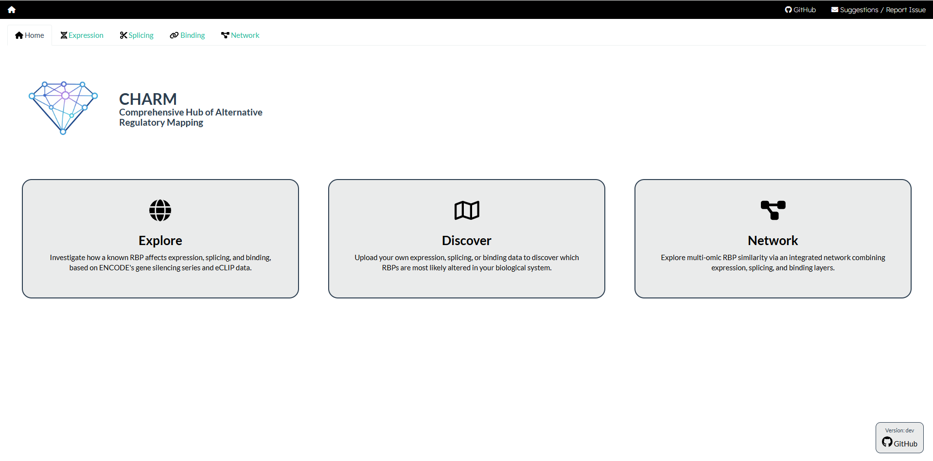
Supplementary Figure 1. CHARM's home screen. Screenshot of the CHARM application home screen, illustrating the two available usage modes as well as the Network module, together with their respective descriptions. Users select a module by clicking the corresponding tab in the upper-left panel. The source code is accessible via the GitHub link in the bottom-right corner.
In Explore mode, users query a precomputed reference resource built from ENCODE shRNA-knockdown and eCLIP data across the HepG2 and K562 cell lines, spanning the RBPs for which both data types are available(21). In Discovery mode, users upload their own differential expression or differential splicing results and compare them directly against this reference resource, without needing to reprocess raw sequencing data or reproduce the underlying pipeline themselves.
Expression
The Expression module first provides exploratory plots that allow users to evaluate shRNA knockdown efficacy against ENCODE's matched controls (Figure 1A, B).
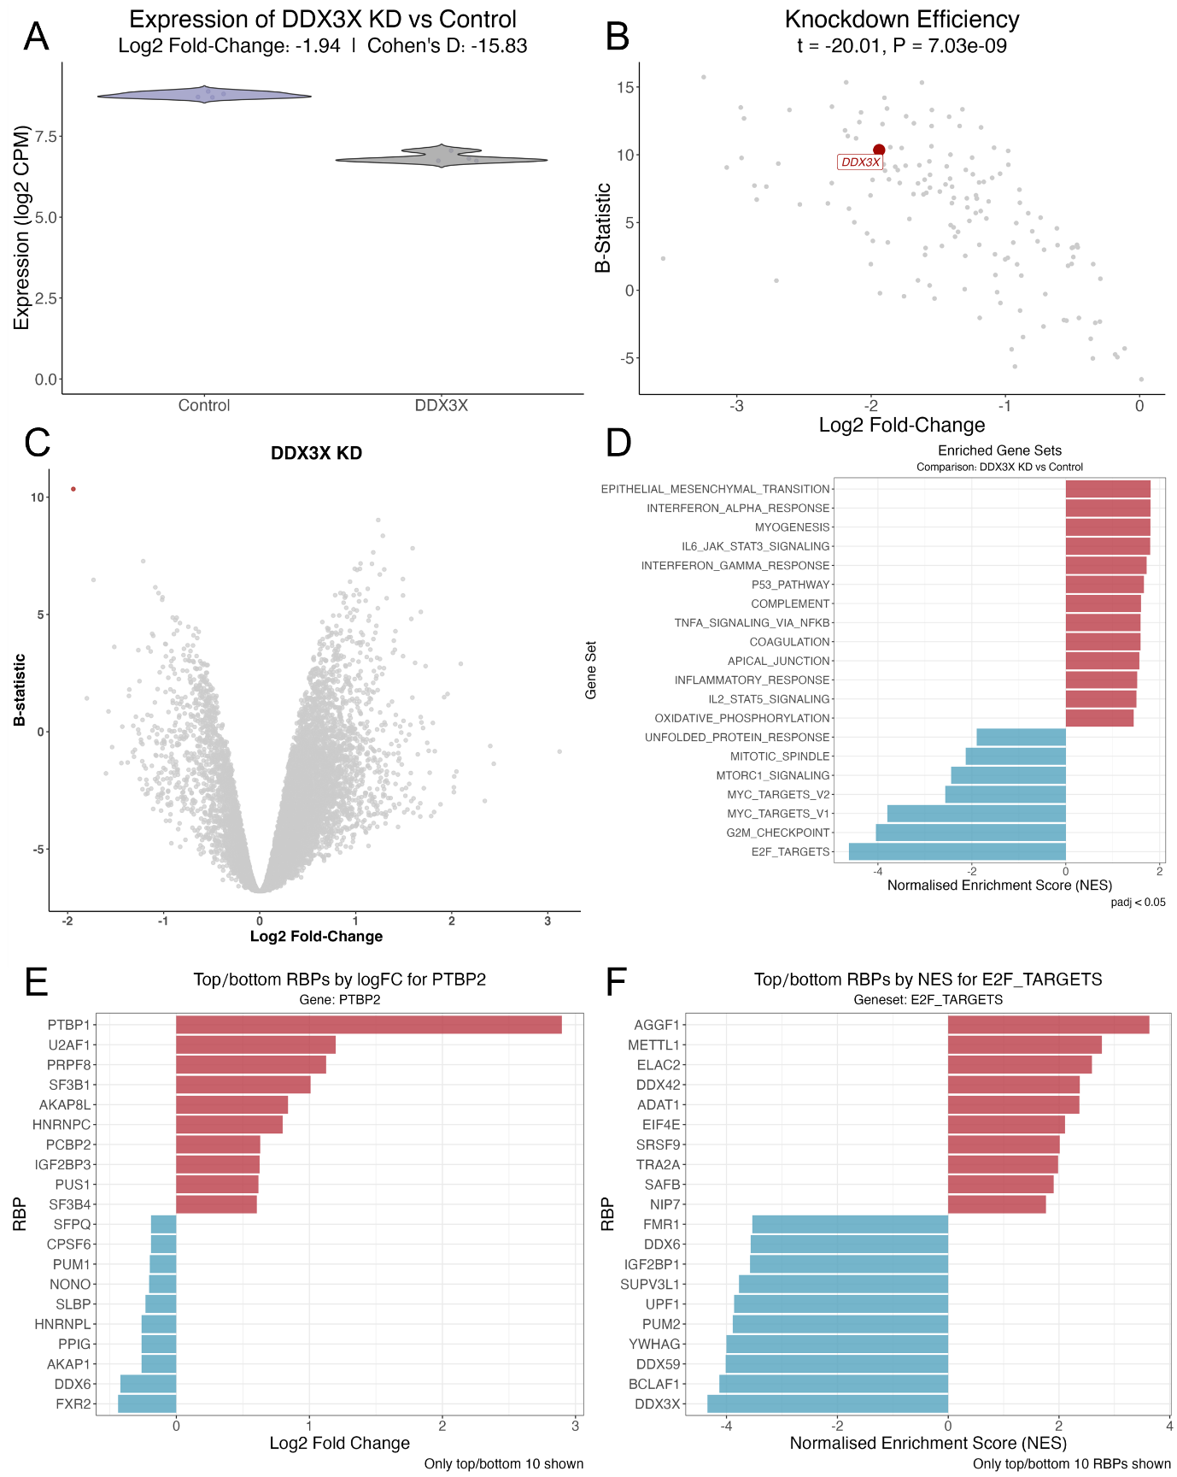
Figure 1. CHARM's Expression tab plots. (A) Violin plots of DDX3X expression (log2 CPM) in K562 and HepG2 cells exposed to shRNA against DDX3X and respective controls(21), batch-corrected for cell type; log2 fold-change and Cohen's d between the two sample types are shown above the plots. (B) Scatter plot of differential gene expression (DGE; x-axis, log2 fold-change; y-axis, B-statistic) between K562 and HepG2 cells exposed to shRNA against RBPs and respective controls(21), batch-corrected for cell type; each point is one shRNA-versus-control experiment; DDX3X is highlighted in red, with the t-statistic of DGE and the Benjamini–Hochberg-adjusted p-value shown above. (C) Volcano plot of DGE (x-axis, log2 fold-change; y-axis, B-statistic) between K562 and HepG2 cells exposed to shRNA against DDX3X and respective controls(21), batch-corrected for cell type; each point is one gene; DDX3X is highlighted in red. (D) GSEA normalised enrichment scores (NES) for Hallmark gene sets, with genes ranked by the t-statistic of differential expression, between K562 and HepG2 cells exposed to shRNA against DDX3X and respective controls(21), batch-corrected for cell type. (E) Bar plot of the log2 fold-change of PTBP2 expression across all profiled RBP knockdowns, between K562 and HepG2 cells exposed to shRNA and respective controls(21), batch-corrected for cell type (i.e. which RBP knockdown most affects PTBP2 expression). (F) GSEA NES for the Hallmark E2F-targets gene set across all profiled RBP knockdowns, with genes ranked by the t-statistic of differential expression, between K562 and HepG2 cells exposed to shRNA and respective controls(21), batch-corrected for cell type (i.e. which RBP knockdown most affects E2F-targets enrichment).
The module then presents a volcano plot of DGE between knockdown and control conditions (Figure 1C), accompanied by a table of DGE metrics from limma–voom (t-statistic, log2 fold-change, and Benjamini–Hochberg-adjusted p-value)(23), together with a Gene Set Enrichment Analysis (GSEA)(24) of the Hallmark gene collection(25) (Figure 1D) and its corresponding table (NES and adjusted p-value; see Methods). As a proof of concept, DDX3X knockdown depleted proliferation-associated gene sets (Figure 1D), consistent with DDX3X's previously reported role in cancer-cell proliferation(26). Users can also query in reverse, identifying which RBP knockdowns most affect the expression of a chosen gene (Figure 1E) or the enrichment of a chosen Hallmark gene set (Figure 1F). For example, PTBP2 expression was most strongly upregulated by PTBP1 knockdown (Figure 1E), consistent with a previously described compensatory mechanism in B cells(27), and E2F-target enrichment was most strongly depleted by IGF2BP1 knockdown (Figure 1F), consistent with both a previous report(28), as well DDX3X as described above(26).
Users can additionally select a specific RBP and identify other RBPs whose knockdown produces similar expression alterations. G3BP1 knockdown, for instance, produced expression changes resembling those of TIA1 knockdown (Supplementary Figure 2), possibly reflecting the shared role of both proteins in phase separation and stress-granule (SG) assembly(29).
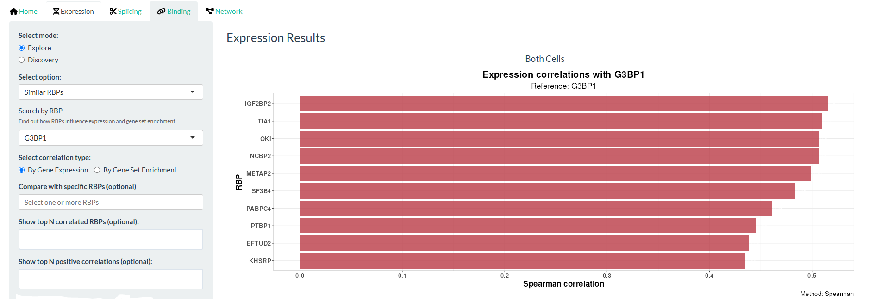
Supplementary Figure 2. Screenshot of CHARM's Similar Profiles feature, Expression tab. Bar plot of Spearman's correlation coefficient rho between the t-statistics of differential expression between K562 and HepG2 cells exposed to shRNA against G3BP1 and respective controls(21), and those of other RBP knockdowns and respective controls(21) (i.e. which knockdown produces gene-expression alterations most similar to G3BP1 knockdown). All comparisons were batch-corrected for cell type.
Finally, users can upload their own differential expression results (obtained, for example, from limma–voom) to determine how a chosen RBP's knockdown relates to their own expression alterations, how the GSEA results from their own ranked t-statistics compare with those of a given RBP, and which RBP knockdowns, in terms of expression or of GSEA, best resemble their data. As an example, we used data from U2-OS cells exposed to oxidative stress (arsenite)(30); among generally weak correlations, the strongest was with FXR1 knockdown (Supplementary Figure 3), plausibly because FXR1 silencing has been reported to activate stress-related pathways(31), consistent with the stress response resulting from arsenite(30).
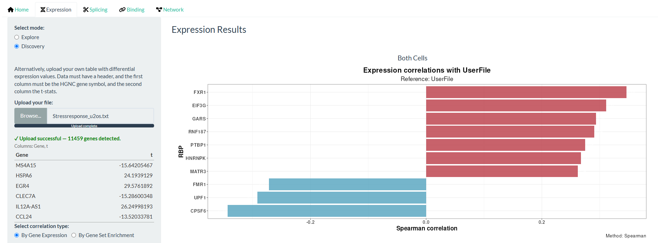
Supplementary Figure 3. Screenshot of CHARM's Discovery mode, Expression tab. Bar plot of Spearman's correlation coefficient rho between t-statistics of differential expression from a user-submitted file (U2-OS cells exposed to oxidative stress(30)) and from K562 and HepG2 cells exposed to shRNA against RBPs and respective controls(21), corrected for cell type (i.e. which knockdown produces gene-expression alterations most similar to the user-submitted file).
Splicing
The Splicing module (Figure 2) offers an analogous view for alternative splicing, quantified as percent spliced-in (PSI; the proportion of transcripts including a given alternative exon or intron) and its change between conditions (dPSI). Users can examine the effect of an RBP's knockdown on global splicing levels (Figure 2A) and inspect a volcano plot of differential splicing across VastDB events(18) (Figure 2B), with an accompanying table.
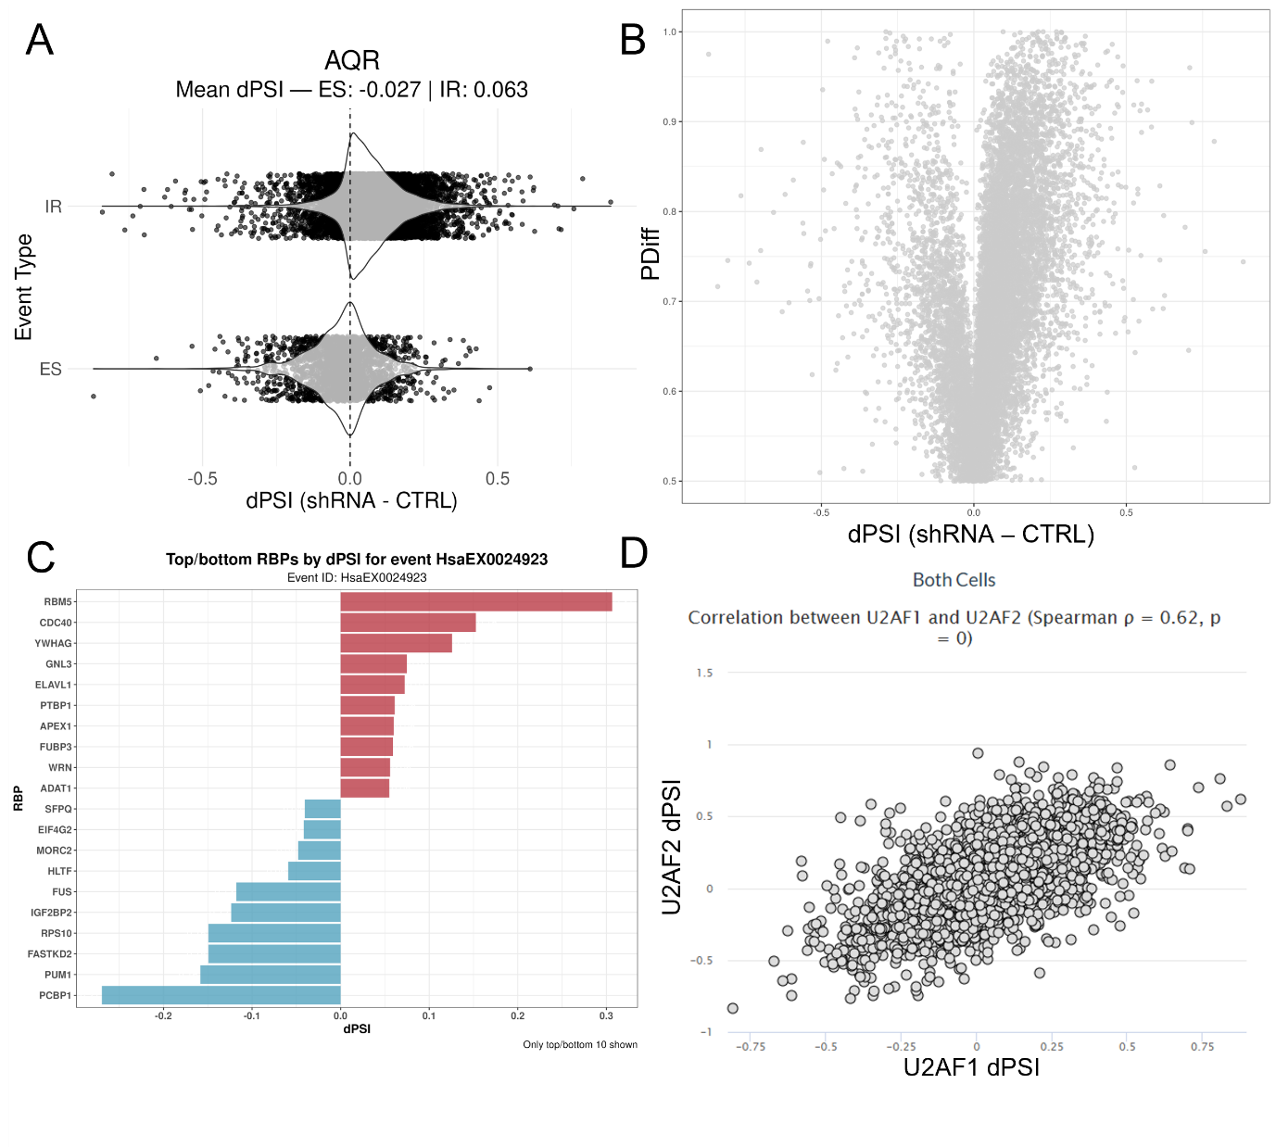
Figure 2. CHARM's Splicing tab plots. (A) Violin plots of intron retention (IR) and exon skipping (ES) alternative splicing events (dPSI) in K562 and HepG2 cells exposed to shRNA against AQR and respective controls(21), batch-corrected for cell type; the mean dPSI for each event type is shown above the plots. (B) Volcano plot of differential splicing analysis (DSA; x-axis, dPSI; y-axis, Pdiff(32)) between K562 and HepG2 cells exposed to shRNA against AQR and respective controls(21), batch-corrected for cell type; each point is one alternative splicing event. (C) Bar plot of dPSI for the event HsaEX0024923(18) across all profiled RBP knockdowns, between K562 and HepG2 cells exposed to shRNA and respective controls(21), batch-corrected for cell type (i.e. which RBP knockdown most affects inclusion of this event). (D) Scatter plot of DSA between K562 and HepG2 cells exposed to shRNA against U2AF1 (x-axis) or U2AF2 (y-axis) and respective controls(21), batch-corrected for cell type; each point is one alternative splicing event; Spearman's correlation coefficient rho and the corresponding test's p-value are shown above.
AQR knockdown, for example, increased intron retention and decreased exon skipping (Figure 2A), consistent with its established role as a core splicing factor(33). As with the Expression module, users can perform a reverse search to identify which RBP knockdowns most affect the inclusion of a chosen VastDB event(18). HsaEX0024923, corresponding to exon 6 of FAS, whose inclusion promotes apoptotic signalling, was more included upon RBM5 knockdown (Figure 2C), consistent with RBM5's established role in regulating this exon(34). Users can likewise identify which RBP knockdowns produce the most similar splicing signatures. U2AF1 knockdown, for example, produced splicing alterations closely resembling those of U2AF2 knockdown (Figure 2D), consistent with their function as an obligate heterodimer(35).
Finally, users can upload their own differential splicing results, obtained for example from the betAS app(32). Using data from U2-OS and A549 cells exposed to a viral dsRNA mimic(36), we found no correlation between these splicing alterations and those observed upon FXR1 knockdown (Supplementary Figure 4), despite FXR1's previously reported role in the stress response(31). This negative result illustrates a general principle underlying CHARM's use: the application is a hypothesis-generating tool, and correlative agreement between datasets, when present, still requires case-by-case biological interpretation, just as its absence does not by itself rule out a genuine relationship.
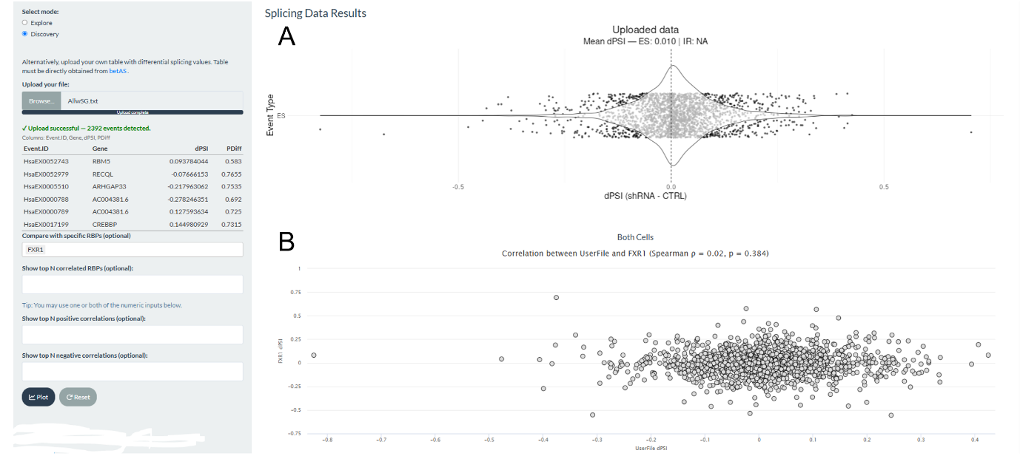
Supplementary Figure 4. Screenshot of CHARM's Discovery mode, Splicing tab. (A) Violin plot of exon skipping (ES) alternative splicing events (dPSI) in a user-supplied file (U2-OS and A549 cells exposed to a viral dsRNA mimic(36)); mean dPSI is shown above the plot. (B) Scatter plot of DSA between K562 and HepG2 cells exposed to shRNA against FXR1 and respective controls(21) (y-axis), batch-corrected for cell type, and the user-supplied file (x-axis); each point is one alternative splicing event; Spearman's correlation coefficient r and the corresponding test's p-value are shown above.
Binding
The Binding module allows users to observe how RBP knockdown alters binding across alternative splicing events, through RNA splicing maps. For a chosen knockdown, it displays the normalised eCLIP binding density of any selected RBP across increased-inclusion, increased-exclusion, and unchanged splicing-event categories, together with position-wise statistical support for differential binding, separately for exon skipping (Figure 3A) and intron retention (Figure 3B). This allows users to ask not only whether an RBP's own binding explains its own knockdown phenotype, but also whether the knockdown of one RBP alters the binding behaviour of another (Figure 3C).
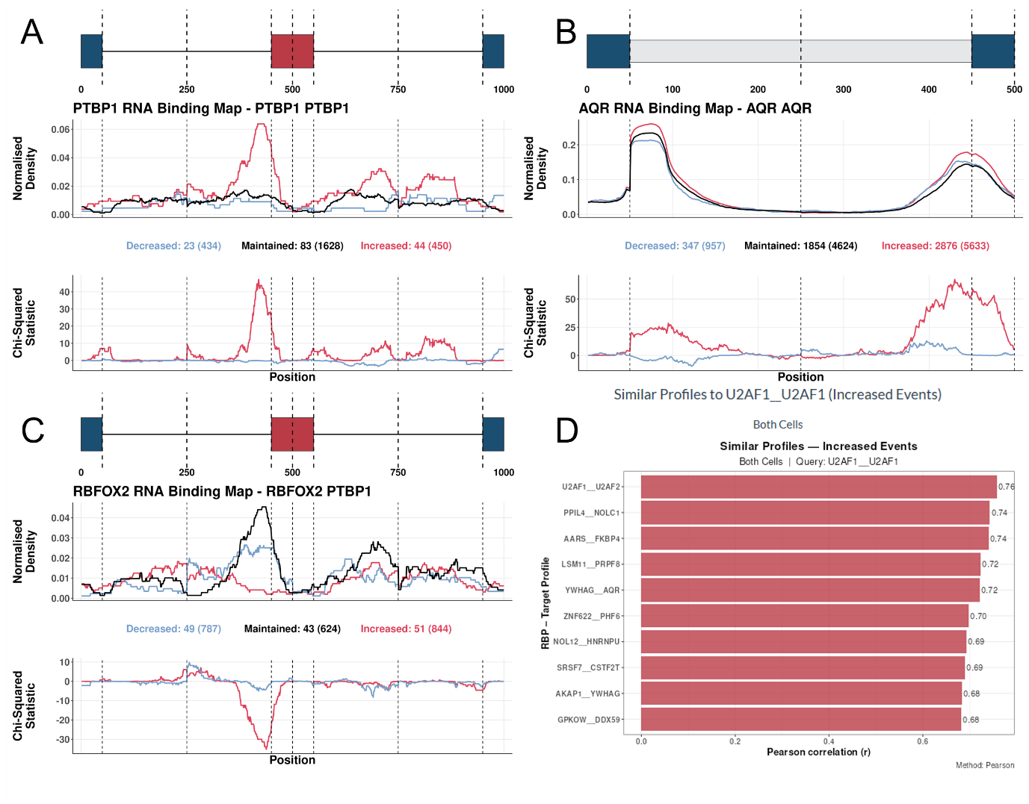
Figure 3. CHARM's Binding tab plots. (A, C) RNA binding maps of alternative exon splicing events, showing PTBP1 binding in cells treated with shRNA against PTBP1 (A) or against RBFOX2 (C). (Top) Normalised binding of PTBP1 across metagenomic regulatory sequences flanking alternative exons. The plot discriminates exons whose inclusion decreased (blue), increased (red), or was unchanged (black) upon PTBP1 (A) or RBFOX2 (C) knockdown. The total number of events in each category is given in brackets beneath the plot, preceded by the number of events for which at least one PTBP1 binding site was detected. (Bottom) Chi-squared statistic for differential binding at decreased-inclusion (blue) or increased-inclusion (red) events, relative to unchanged events. Vertical lines delimit the following metagenomic splicing regulatory regions, in order: last 50 nt of the upstream constitutive exon; first 200 nt of the upstream intron; last 200 nt of the upstream intron; first 50 nt of the alternative exon; last 50 nt of the alternative exon; first 200 nt of the downstream intron; last 200 nt of the downstream intron; first 50 nt of the downstream constitutive exon. (B) RNA binding maps of intron retention events, showing AQR binding in cells treated with shRNA against AQR. (Top) Normalised binding of AQR across metagenomic regulatory sequences flanking prospectively retained introns, discriminating introns whose retention decreased (blue), increased (red), or was unchanged (black) upon AQR knockdown; total event numbers and AQR-bound event numbers as in (A). (Bottom) Chi-squared statistic as in (A); vertical lines delimit: last 50 nt of the upstream constitutive exon; first 200 nt of the prospectively retained intron; last 200 nt of the prospectively retained intron; first 50 nt of the downstream constitutive exon. (D) Bar plot of Pearson's correlation coefficient r between the Chi-squared differential-binding statistic of U2AF1 upon U2AF1 knockdown and that of U2AF1 upon other RBP knockdowns (i.e. which RBP knockdown produces the most similar U2AF1 binding profile). All plots pertain to K562 and HepG2 cells exposed to shRNA against RBPs and respective controls(21), corrected for cell type.
As a positive control, PTBP1 binds polypyrimidine tracts to promote exon skipping(19). Accordingly, PTBP1 knockdown enriched PTBP1 binding at the polypyrimidine tracts of exons whose inclusion increased upon knockdown (i.e. exons normally skipped under wild-type conditions)(19) (Figure 3A). The same logic applies to AQR knockdown, which enriched AQR binding at downstream intronic regions, consistent with its role in intron excision(33) (Figure 3B). As an example of an indirect target, RBFOX2 knockdown depleted the enrichment of PTBP1 binding at exons whose inclusion increased (Figure 3C), suggesting antagonistic roles for the two proteins at a subset of shared target events. Indeed, a related mechanism, in which a third factor, SON, coordinates opposing PTBP1/PTBP2 and RBFOX2 activities, has been described in glioblastoma(37).
Alternatively, users can obtain a heatmap overview of the binding alterations occurring across many RBPs upon a chosen knockdown (Supplementary Figure 5). Consistent with its role as a core splicing factor(35), SF3B1 knockdown altered the binding of numerous other RBPs (Supplementary Figure 5). In Similar Profiles mode, users can select a given RBP's binding profile under a specific knockdown and identify the most similar profiles across the reference resource. The profile of U2AF1 binding under U2AF1 knockdown, for instance, was most similar to that of U2AF1 binding under U2AF2 knockdown (Figure 3D), consistent with their function as a heterodimer(35) (see Methods). Finally, users can upload their own splicing dataset to generate RNA binding maps and identify which RBPs' binding patterns are altered upon that perturbation.
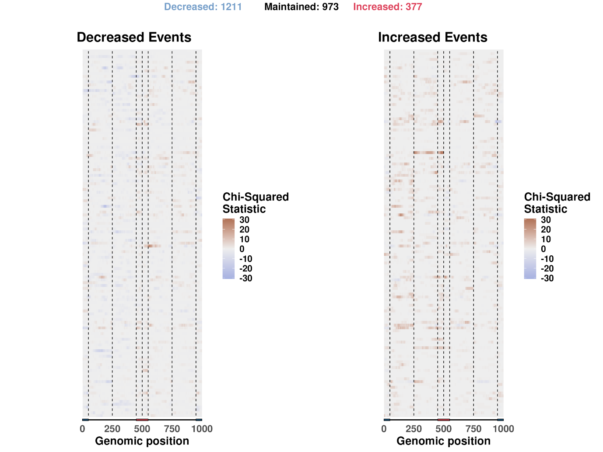
Supplementary Figure 5. Heatmap of RNA binding maps of alternative exon splicing events in cells treated with shRNA against SF3B1. Chi-squared differential-binding statistic for decreased-inclusion (left) or increased-inclusion (right) events, relative to unchanged events. Total event numbers per category are given above the heatmaps. Vertical lines delimit the metagenomic splicing regulatory regions as defined in Figure 3. Rows (individual RBP binding maps) are labelled with the respective RBP in the CHARM app but have been omitted here for clarity.
Network
The Network module builds on this capability. For each of the three data layers, expression, splicing, and binding, CHARM computes a genome-wide Spearman correlation matrix between all reference-resource RBP knockdowns (see Methods) and combines the resulting per-layer matrices into a single similarity matrix using user-adjustable weights, from which an RBP–RBP dissimilarity (1 minus the weighted correlation) is derived. Users can restrict the analysis to either cell line or use both combined, choose an ordination method for visualising this dissimilarity (PCA, MDS, t-SNE, or hierarchical clustering displayed as a dendrogram), and select which layers to include, together with their relative contribution to the combined similarity. For the binding layer specifically, users can further choose whether to include exon skipping and/or intron retention events, and whether to consider events whose inclusion increased or decreased upon knockdown. Considering all three layers with approximately equal weighting recovered previously reported interactions, including that of U2AF1 with its heterodimer partner U2AF2(35), and with SF3B1, which also acts at the 3′ splice site(35) (Figure 4). Not every expected interaction was recovered, however. TIA1 did not cluster near its close paralogue TIAR/TIAL1(7).
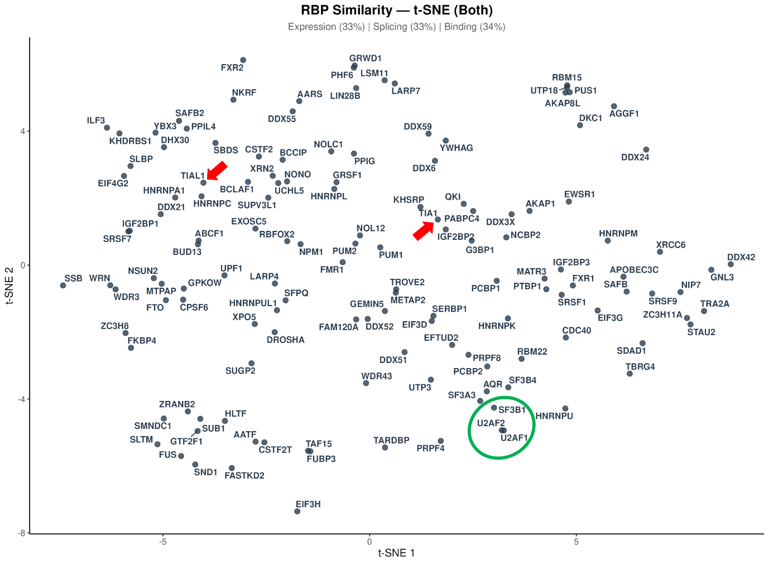
Figure 4. The CHARM Network module recovers known RBP regulatory complexes. t-Distributed Stochastic Neighbour Embedding (t-SNE) projection of pairwise RBP dissimilarity (1 − weighted Spearman correlation rho), computed by CHARM's Network module from the Expression, Splicing, and Binding layers combined with approximately equal weights (33%, 33%, and 34%, respectively; both cell lines; all binding event types and directions included; see Methods). Each point represents one of the RBPs common to all three layers within the reference resource; proximity approximates similarity in RBP-knockdown expression, splicing, and binding signatures. U2AF1, U2AF2, and SF3B1 (green circle), which cooperatively recognise the 3′ splice site, cluster closely together, recovering this known regulatory relationship. TIA1 and TIAL1 (red arrows), a closely related paralogue pair, do not cluster together under this representation.
We first considered that this might reflect the plot's combination of both cell lines, since a previous study identifying regulatory complexes from RNA maps and binding data reported that TIAL1 knockdown produced no detectable effect on differential binding specifically in K562 cells(38), an observation we reproduced in our own data (Supplementary Figure 6).
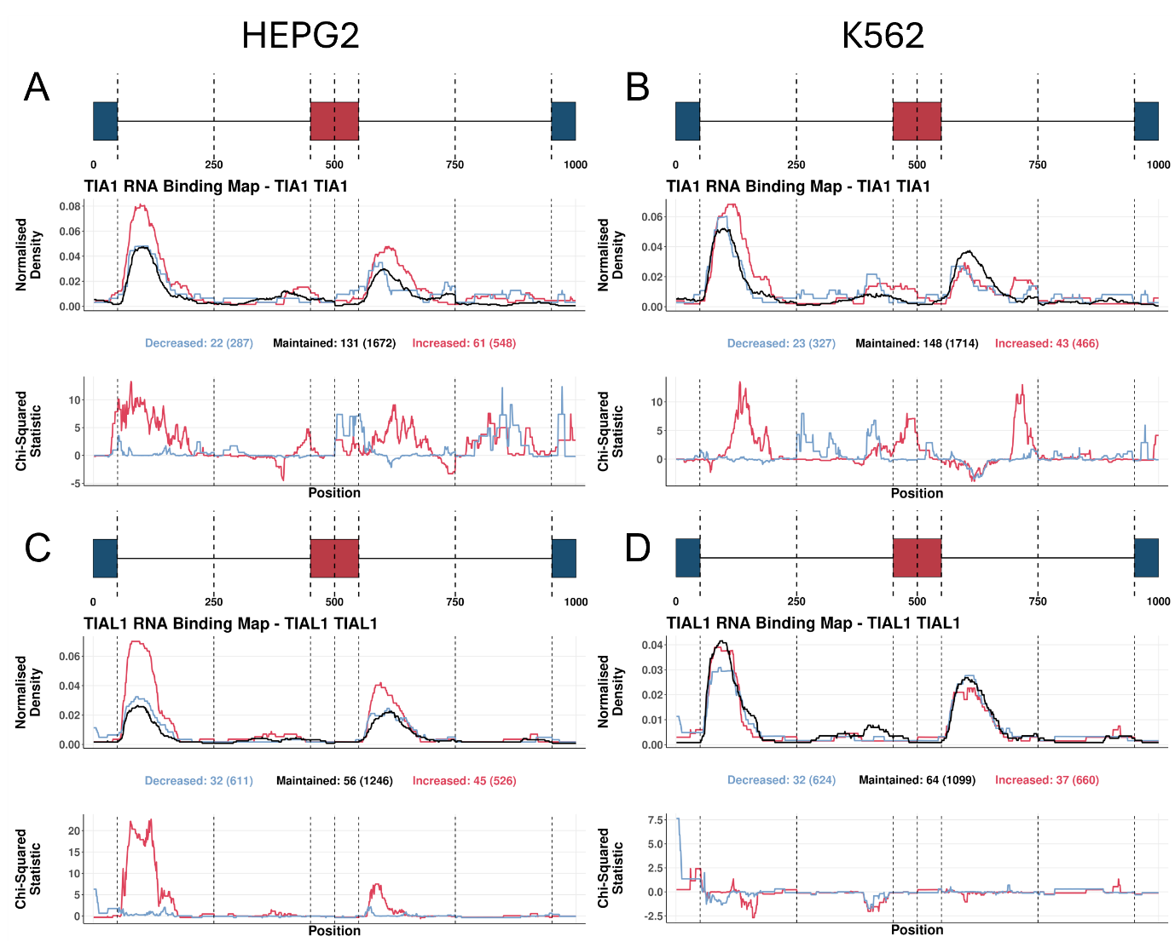
Supplementary Figure 6. RNA binding maps of alternative exon splicing events with TIA1 (A, B) or TIAL1 (C, D) binding, in HepG2 (A, C) or K562 (B, D) cells treated with shRNA against TIA1 (A, B) or TIAL1 (C, D). (Top) Normalised binding of TIA1 (A, B) or TIAL1 (C, D) across metagenomic regulatory sequences flanking alternative exons, discriminating exons whose inclusion decreased (blue), increased (red), or was unchanged (black) upon knockdown; total event numbers and bound-event numbers as in Figure 3. (Bottom) Chi-squared statistic as in Figure 3; vertical lines delimit the metagenomic splicing regulatory regions as defined in Figure 3.
Restricting the analysis to HepG2 cells alone, however, did not bring TIA1 and TIAL1 closer together. Other large-scale studies have similarly reported limited correlation between their splicing alterations(7), suggesting either that the two paralogues are functionally less redundant than commonly assumed, or that CHARM's current network representation does not capture this particular relationship.
Overall, CHARM's architecture is deliberately extensible. Additional gene-silencing experiments, eCLIP profiles for further RBPs, and alternative CLIP technologies such as iCLIP2 can be incorporated without altering the interface. CHARM is intended throughout as a hypothesis-generation platform. Every relationship it surfaces, whether an expression-independent functional alteration or a candidate indirect regulatory interaction, is a candidate for downstream experimental validation, not a substitute for it.
Biological applications of CHARM
TIA1 localisation into stress granules alters splicing
A central limitation of expression-centric RBP analysis is that many biologically meaningful changes in RBP activity leave expression entirely unaltered. Subcellular relocalisation, post-translational modification, and disruption of an interacting partner can each abolish or redirect an RBP's function without changing how much of the protein is present. Because CHARM also measures RBP activity through binding rather than inferring it from expression, it is positioned to detect exactly this class of alteration.
We used TIA1 sequestration into SGs as a worked example of this expression-independent functional detection, building on our previous work [ref to be inserted upon publication]. Under stress, TIA1 relocalises from a predominantly nuclear distribution to cytoplasmic SGs. Since splicing occurs in the nucleus, we hypothesised that this relocalisation would perturb TIA1's splicing-regulatory activity even without any change in its expression. We therefore used a dataset of U2-OS and A549 cells exposed to a viral dsRNA mimic, wild-type or knockout for G3BP1, a factor required for SG assembly under these conditions(39). Consequently, SGs form upon stress in the wild-type cells but not in the G3BP1-knockout cells(39). In both cell backgrounds, TIA1 showed little evidence of differential expression upon stress (Figure 5A). If SG sequestration impairs TIA1's splicing-regulatory function, its binding under stress should resemble binding under TIA1 knockdown, since both conditions functionally deplete TIA1 activity at its splicing targets. Consistent with this, TIA1 binding under SG-competent stress conditions correlated with TIA1 binding under TIA1 knockdown, in both HepG2 and K562 cells (Pearson's r = 0.44) (Figure 5B). This correlation could, however, reflect a generic effect of cellular stress rather than SG sequestration specifically. We therefore also examined TIA1 binding in G3BP1-knockout cells under the same viral dsRNA-mimic stress, a condition that induces stress without SG assembly, and found this binding profile to be much less similar to the knockdown profile (Pearson's r = 0.07), consistent with the effect being SG-dependent rather than a non-specific consequence of stress. As a comparison, we examined YBX3, an SG-localised protein(40) whose functional alteration under stress is reflects stress generally rather than SG formation specifically. Accordingly, YBX3 binding correlated with its knockdown profile both with and without SG assembly (r = 0.77 and r = 0.64, respectively) (Figure 5C).
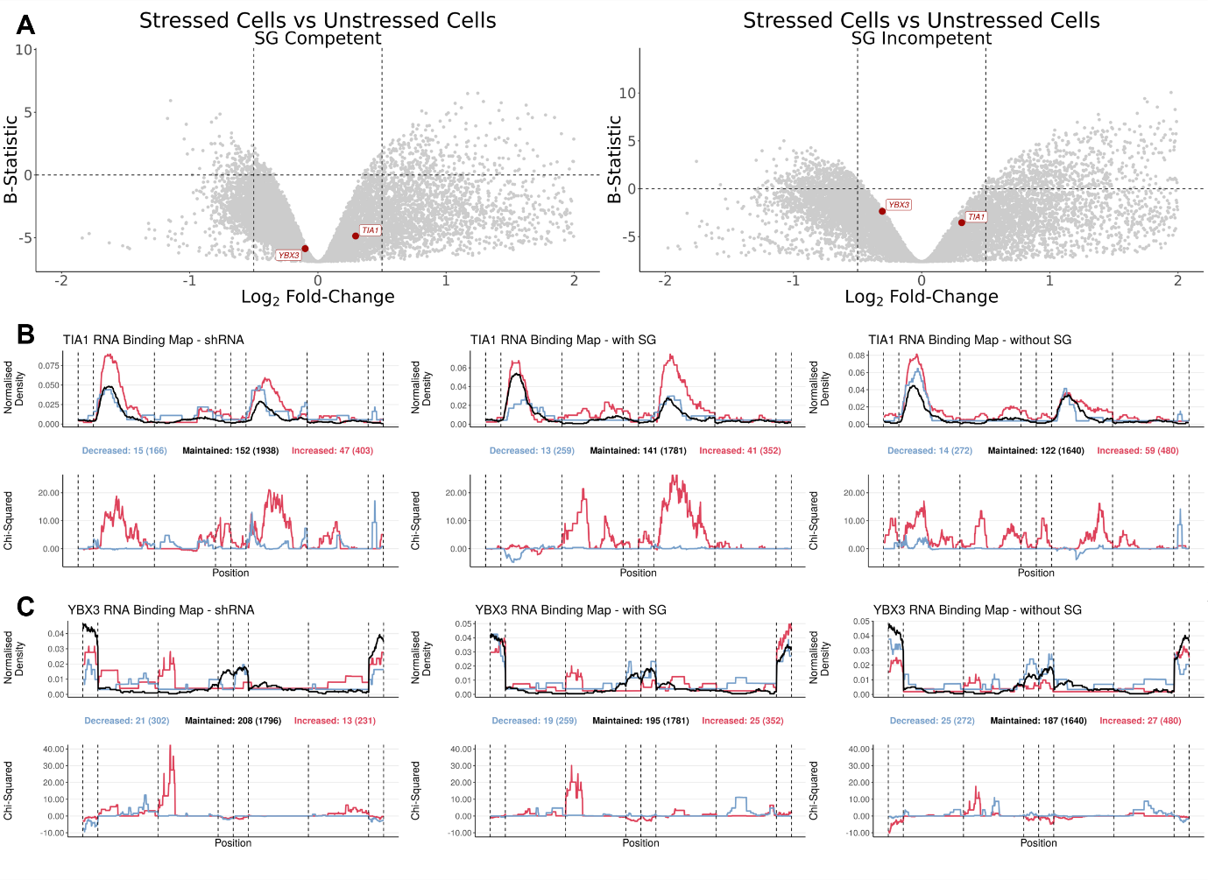
Figure 5. Alternative splicing alterations in stress-granule-competent and -incompetent cells. (A) Volcano plots of differential gene expression analysis (DGEA) between stressed and unstressed cells (x-axis, log2 fold-change; y-axis, B-statistic) in SG-competent (left) and SG-incompetent (right) U2-OS and A549 cells exposed to a viral dsRNA mimic as a stressor(41); each point is one gene, with TIA1 and YBX3 highlighted in red. Vertical dashed lines mark log2 fold-change = −0.5 and 0.5; the horizontal dashed line marks B-statistic = 0. Only genes with −2 < log2 fold-change < 2 are plotted. (B, C) RNA binding maps of alternative exon splicing events, showing TIA1 (B) or YBX3 (C) binding in shRNA-treated cells obtained from ENCODE(21) (left), in SG-competent cells (middle), and in SG-incompetent cells (right). (Top) Normalised binding of the RBP of interest across metagenomic regulatory sequences flanking alternative exons, discriminating exons whose inclusion decreased (blue), increased (red), or was unchanged (black) upon RBP knockdown (left) or upon dsRNA stress, in SG-competent (middle) and SG-incompetent (right) cells; total and bound-event numbers as in Figure 3. (Bottom) Chi-squared statistic as in Figure 3; vertical lines delimit the metagenomic splicing regulatory regions as defined in Figure 3.
Taken together, these results show that CHARM can distinguish a condition-specific loss of RBP function, arising here from subcellular sequestration, from both unrelated stress-response signal and genuine expression-driven effects, where expression data are used to rule out the latter, and binding-derived splicing signatures to detect the former. Stress-granule sequestration is just one mechanism by which this can occur; the same detection logic applies, without modification, to any other RBP whose function is altered post-translationally, through complex disruption, or through any other means that leaves expression unchanged. This general applicability, rather than the stress-granule biology specifically, is the capability that this case study is intended to demonstrate.
RBM39 and the U2AF complex
A second limitation of RBP analyses restricted to an RBP's own binding and splicing data is that they can only reveal direct regulatory relationships. Many RBPs function as members of larger complexes, or through cooperative binding with other RBPs, such that perturbing one factor can alter the activity of its partners without producing any detectable change at the perturbed factor's own direct targets. These indirect relationships are, by construction, invisible to any analysis confined to a single RBP's own eCLIP and knockdown data. Identifying them requires systematically examining how the knockdown of one RBP reshapes the binding profiles of others.
In our previous work, we found that RBM39 knockdown led to splicing alterations(42). However, the mechanism underlying these alterations was unclear, as RBM39 itself showed limited direct binding at the affected alternative splicing events(42). Examining indirect binding alterations (i.e. how the binding of other RBPs changes upon RBM39 knockdown) we found that RBM39 knockdown altered U2AF1 and U2AF2 binding in a manner consistent with their own respective knockdown profiles (Figure 6A–C). Splicing alterations induced by RBM39 knockdown also correlated with those induced by U2AF1 and U2AF2 knockdown, albeit less strongly than U2AF1 and U2AF2 knockdown correlated with each other, suggesting that RBM39 partly modulates this complex (Figure 6D).
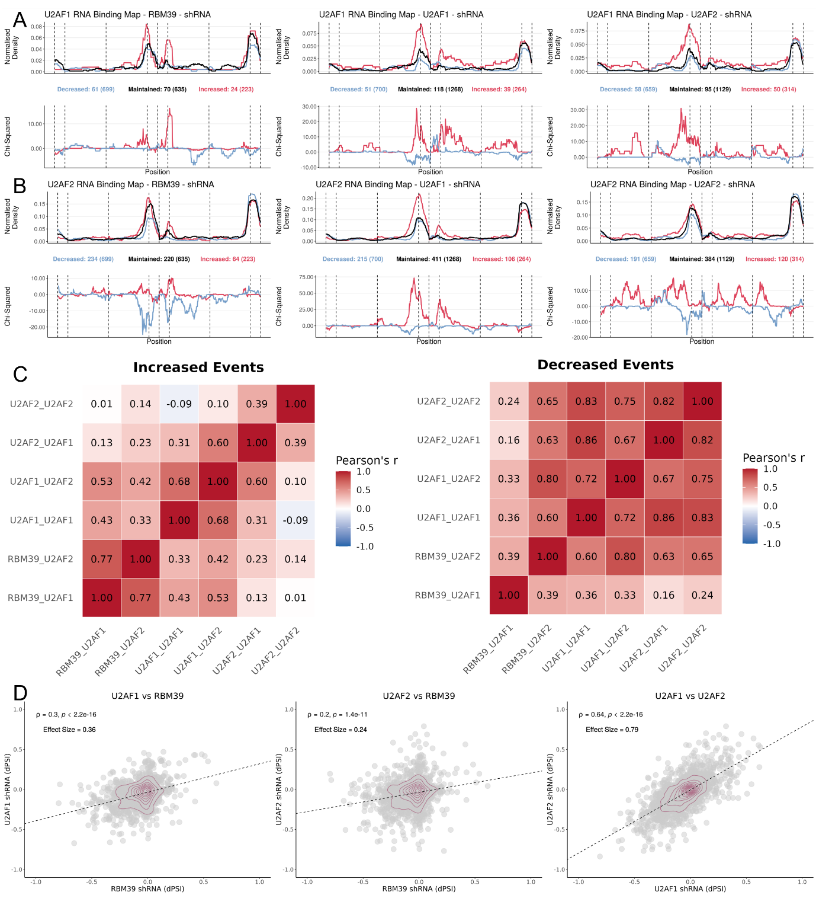
Figure 6. RBM39 knockdown produces alterations similar to U2AF1/U2AF2 knockdown. (A, B) RNA binding maps of alternative exon splicing events, showing U2AF1 (A) or U2AF2 (B) binding in shRNA-treated cells for RBM39 (left), U2AF1 (middle), or U2AF2 (right). (Top) Normalised binding of the RBP of interest across metagenomic regulatory sequences flanking alternative exons, discriminating exons whose inclusion decreased (blue), increased (red), or was unchanged (black) upon knockdown; total and bound-event numbers as in Figure 3. (Bottom) Chi-squared statistic as in Figure 3; vertical lines delimit the metagenomic splicing regulatory regions as defined in Figure 3. (C) Heatmap of Pearson's correlation coefficient between Chi-squared differential-binding statistics for several shRNA–RBP pairs, for increased- (left) or decreased-inclusion (right) events (i.e. how similar the red or blue binding profiles from (A) and (B) are to one another); labels follow the convention "shRNA treatment_RBP binding". (D) Scatter plots of DSA between K562 and HepG2 cells exposed to shRNA against U2AF1 or U2AF2(21), batch-corrected for cell type, and IMR90 cells exposed to shRNA against RBM39(42): (left) U2AF1 knockdown (y-axis) versus RBM39 knockdown (x-axis); (middle) U2AF2 knockdown (y-axis) versus RBM39 knockdown (x-axis); (right) U2AF2 knockdown (y-axis) versus U2AF1 knockdown (x-axis); each point is one alternative splicing event; density contours in dark red; Spearman's correlation coefficient rho and the corresponding test's p-value are shown above.
Because U2AF1 and U2AF2 function as an obligate heterodimer that recognises the 3′ splice site, this pattern is consistent with RBM39 functioning within, or in cooperation with, the U2AF complex, even though RBM39's own splicing alterations occur largely independently of its own direct RNA binding. This result illustrates another specific capability that CHARM is designed to provide: identifying a candidate regulatory relationship that would not have been apparent from any analysis of RBM39 in isolation, and that becomes visible only when the binding behaviour of its potential partners is examined systematically alongside it. As with all outputs from CHARM, this relationship constitutes a hypothesis rather than a demonstrated mechanism, and its confirmation is left to downstream experimental work.
Discussion
CHARM's differentiator relative to existing RBP analysis resources is not a novel statistical framework for splicing-map construction, but the integration of expression, splicing, binding, and network-level analysis within a single, browser-accessible, no-code interface built directly on public data. Tools such as rMAPS2(43) generate splicing maps from user-supplied CLIP and RNA-seq data but stop short of providing a precomputed, browsable reference resource spanning many RBPs, and tools such as RBP Browser(44) reveal putative interactions between RBPs from eCLIP and CRISPR-knockout data, but do not allow users to generate RNA binding maps directly. Studies employing methods conceptually similar to ours have also been published(38, 45), but, to our knowledge, few if any existing tools offer no-code access to indirect, complex-level RBP regulatory inference. We regard this as a genuine capability gap in currently available resources rather than a claim of analytical superiority, and we do not present CHARM as a replacement for specialised pipelines, but as a means of extending their reach to researchers who would not otherwise use them.
This distinction matters for how CHARM's outputs should be interpreted. Every relationship CHARM surfaces, whether an expression-independent functional alteration such as TIA1 sequestration, or an indirect regulatory relationship such as RBM39's association with U2AF1/U2AF2, is derived from correlative binding and splicing data and constitutes a hypothesis requiring downstream experimental confirmation, not a validated mechanistic claim. CHARM's role is to make the generation of such hypotheses accessible, not to certify their correctness.
One limitation warrants explicit acknowledgement. Presently, knockdown–cell-line combinations in the reference resource derive from a single resource, ENCODE (see Methods). Thus, the absence of replicates from other resources means that reported effects cannot be distinguished from experiment-specific technical variability.
Taken together, we present CHARM not as a comprehensive replacement for specialised RBP analysis pipelines, but as a framework that lowers the practical barrier to a specific and recurring category of question: how does a given RBP function independently of its expression, and with which other RBPs does it plausibly interact? We believe that making these questions tractable without requiring computational expertise has direct value for hypothesis generation in RBP biology, and the collaborations reported here suggest that this value extends beyond our own use of the tool.
Methods
Downloaded raw reads (in FASTQ format) were trimmed using Trimmomatic (v0.39)(46) operating in either single-end (SE) or paired-end (PE) mode, depending on the original study design, with appropriate adapter sequences and parameters. Trimmed reads were then aligned to the hg38 reference genome using STAR(47) (v2.7.9a) with the following parameters:
--outFilterType BySJout \
--alignSJoverhangMin 8 \
--alignSJDBoverhangMin 1\
--alignIntronMin 20 \
--alignIntronMax 1000000 \
--alignMatesGapMax 1000000 \
--outFilterMultimapNmax 1 \
--outFilterMismatchNmax 999 \
--outFilterMismatchNoverLmax 0.04 \
Aligned reads (BAM files) were subsequently annotated using the GENCODE v42 primary assembly(48) and quantified with featureCounts(49) (v2.0.3).
Raw read counts were first filtered to remove lowly expressed genes, independently for each dataset. For all datasets, filtering was applied across all samples. Filtered read counts, including those from TCGA, were then used to calculate library size scaling factors using the trimmed mean of M-values(50) (TMM; calcNormFactors function from edgeR (v3.36.0)(51)). Those read counts were subsequently normalised and log2-transformed using the voom(52) function from limma (v.3.50.3)(53).

Differential splicing analysis
RNA-seq data from ENCODE gene-silencing experiments targeting RBPs with matched eCLIP data were obtained for the HepG2 and K562 cell lines, using shRNA-mediated knockdown or CRISPR-based perturbation(21, 22). For each cell line and target, the default, non-archived experiment was selected, with CRISPR-based perturbations preferred when multiple default options were available. Raw reads (FASTQ format) were trimmed using Trimmomatic (v0.39)(54), and alternative splicing was quantified with VAST-TOOLS (v2.5.1), following the align (against the hg38 reference genome) and combine steps(18).
Differential splicing was assessed using a modified version of the betAS (v1.2.1) R package(32). By default, betAS's alternativeEvents function excludes events in which at least one sample does not meet the percent-spliced-in (PSI) thresholds (1 ≤ PSI ≤ 99); applying these thresholds alone, however, retained a large number of events that were effectively constitutive rather than genuinely alternative. To improve specificity, we additionally incorporated prior information from VastDB's MAIN PSI table(18): for each exon-skipping event, the average PSI and its variance were computed across the tissues and cell types in that table, and only events meeting at least one of the following empirical criteria were retained for downstream analysis: variance ≥ 750, or average PSI between 12.5 and 87.5. For the ENCODE shRNA experiments(21), HepG2 and K562 data (treated with scrambled shRNA controls) were processed jointly using this modified betAS pipeline. For the viral dsRNA mimic experiments(39), A549 and U2-OS were likewise processed jointly.
Differential gene expression analysis
Differential expression between each RBP knockdown and its matched control was assessed by fitting linear models to the expression data with standard errors moderated using empirical Bayes shrinkage. When HEPG2 and K562 were jointly processed, cell type was batch corrected using one of our previously used methods(55). Genes were then ranked by their moderated t-statistic, from most positive to most negative, for Gene Set Enrichment Analysis (GSEA)(24) of the MSigDB Hallmark collection(25) (msigdbr package), performed with fgsea (v1.20.0)(56), yielding a normalised enrichment score (NES) and Benjamini–Hochberg-adjusted p-value for each gene set; positive and negative NES indicate enrichment amongst over- and under-expressed genes, respectively. In Discovery mode, an equivalent workflow is applied live to user-uploaded expression data.
RBP binding analyses pipeline (eCLIPSE)
eCLIPSE (eCLIP for Splicing Evaluation) is a computational pipeline developed to integrate eCLIP data from the ENCODE project(21) with splicing annotations from VastDB(18), generating statistically assessed RNA splicing maps. By aligning eCLIP-derived RBP binding profiles to the genomic coordinates of annotated splicing events, eCLIPSE enables systematic assessment of how individual RBPs regulate alternative splicing, either directly, via their own binding, or indirectly, through downstream effects on other RBPs' binding. All components required to reproduce this pipeline are available on GitHub at https://github.com/DiseaseTranscriptomicsLab/CHARM and on Zenodo (doi.org/10.5281/zenodo.21724194).
Splicing-genome creation
A reference "splicing genome" was first constructed from VastDB(18) annotations. Alternative exons shorter than 10 bp were excluded. For each exon-skipping event, standardised regions of interest were defined as follows: the last 50 bp of the upstream constitutive exon; the first 200 bp and the last 200 bp of the upstream intron; the first 50 bp and the last 50 bp of the alternative exon; the first 200 bp and the last 200 bp of the downstream intron; and the first 50 bp of the downstream constitutive exon.
An analogous, four-region scheme was used for intron-retention events (last 50 bp of the upstream constitutive exon; first 200 bp and last 200 bp of the prospectively retained intron; first 50 bp of the downstream constitutive exon).
Introns shorter than 400 bp, and alternative exons shorter than 100 bp, were split proportionally between their start and end regions to preserve comparable regions of interest near the splice sites (the extra base, for odd lengths, was assigned to the end region); for alternative exons with multiple annotated start sites, the start site maximising exon length was chosen.
eCLIP samples
One eCLIP file per cell line was considered for each RBP profiled by the ENCODE project(21, 22) (252 RBP files in total). Processed GRCh38 bed narrowPeak files, labelled "default" by ENCODE, were downloaded, and binding events with a reported signal greater than 3 were retained. Of these 252 RBPs, 168 had matched shRNA-knockdown RNA-seq data available (see Differential gene expression analysis and Differential splicing analysis) and were included in CHARM's Explore-mode reference resource.
Binding metagenome assembly
RBP binding peaks were intersected with the predefined splicing regions to extract the binding signal in hg38 coordinates. For each RBP, each genomic base was coded as 0 (no binding) or 1 (binding present). To enable comparison across events of heterogeneous length, each event was mapped to a standardised splicing-genome coordinate system corresponding to its regions of interest, with each region subset and rescaled to fixed coordinates that preserved the relative position of binding within it. Because individual exons or introns can be shorter than the full reference region (exons < 100 bp or introns < 400 bp), some splicing-genome positions lack a corresponding hg38 coordinate for a given event and were coded as missing (NA). Binding information was strand-specific. All coordinate conversions were implemented in Python 3 (v3.10.11).
RNA-binding maps
betAS-derived differential splicing events were divided into increased-inclusion, decreased-inclusion, and unchanged (maintained) categories, based on a chosen dPSI threshold. Because the optimal dPSI threshold for defining these categories varies across RBPs, thresholds from 0.01 to 0.10 were systematically evaluated for each knockdown–eCLIP pair when precomputing CHARM's Explore-mode reference resource, and the threshold maximising differential-binding evidence was retained alongside the standard reference thresholds (0.05 and 0.10). For each category and each RBP, normalised binding profiles were computed across the splicing-genome coordinates, with the per-position binding signal calculated to account for missing values arising from shorter-than-reference regions in individual events, so that these events do not disproportionately weight the resulting profile. Differential binding at each position was assessed with a chi-squared test on the following contingency table.
Number of Increased/Decreased Events | Number of Maintained Events
Number of Increased/Decreased Events after Normalised Binding | Number of Maintained Events after Normalised Binding

The resulting chi-squared statistic was multiplied by −1 for positions with decreased binding, and Benjamini–Hochberg-corrected FDR was computed across positions. Position-wise normalised binding profiles, and their corresponding chi-squared statistics, were plotted along the splicing-genome coordinates for each category. This process was implemented in R (v4.1.2).

Additional datasets
Three analyses in this study used publicly available RNA-seq datasets external to the ENCODE reference resource described above, each processed with the same alignment, splicing-quantification, and differential-analysis pipelines detailed in the preceding sections.
The stress-granule case study (Figure 5) used RNA-seq data from U2-OS and A549 cells, wild-type or knockout for G3BP1, exposed to a viral dsRNA mimic as a stressor(36, 41) (GSE173953); reads were processed with VAST-TOOLS and the modified betAS pipeline (see Differential splicing analysis) for splicing quantification, and with limma–voom (see Differential gene expression analysis) for differential expression, and TIA1 and YBX3 eCLIP binding under these conditions was processed through the eCLIPSE pipeline (see above) using the same splicing-genome coordinate system built from ENCODE data.
The Expression-module Discovery-mode example (Supplementary Figure 3) used RNA-seq data from U2-OS cells exposed to oxidative stress (arsenite)(30) (GSE138988), processed with the same limma–voom differential-expression workflow.
The RBM39 case study (Figure 6) used RNA-seq and eCLIP data from IMR90 cells subjected to RBM39 knockdown(42) (GSE297268), processed identically to the ENCODE-derived data described above, using VAST-TOOLS/betAS for splicing, limma–voom for expression, and the eCLIPSE pipeline for binding, with the corresponding splicing events mapped onto the same splicing-genome coordinate system.
Network module computation
The Network module quantifies pairwise similarity between RBP knockdown profiles across up to the three data layers and visualises the resulting RBP–RBP relationships by dimensionality reduction or hierarchical clustering.
For each layer, a square RBP × RBP correlation matrix was built as follows. For the expression layer, per-RBP differential-expression t-statistics (see Differential gene expression analysis) were assembled into a wide matrix with RBPs as rows and the union of all genes tested for any RBP as columns, missing values (genes not tested for a given RBP) being coded as NA. For the splicing layer, an analogous wide matrix was built from per-RBP dPSI values at VastDB event identifiers. For the binding layer, eCLIPSE-derived, per-position chi-squared differential-binding profiles (see eCLIPSE pipeline) were first averaged across RBP–target pairs sharing the same RBP knockdown, separately for each combination of event type (exon skipping, intron retention) and direction (increased-, decreased-inclusion) selected by the user, yielding one mean binding profile per RBP knockdown per combination; these were then averaged across the selected combinations to obtain a single profile per RBP. For the expression and splicing layers, pairwise Spearman correlation coefficients were computed between all RBP pairs using pairwise-complete observations (i.e. only features shared between the two RBPs being compared contribute to their correlation), reflecting the robustness of rank-based correlation to the non-normal distribution and occasional extreme values of the per-gene and per-event statistics contributed by each layer. For the binding layer, by contrast, pairwise Pearson correlation coefficients were computed between all RBP pairs instead, using the same pairwise-complete-observations approach, because binding-signal intensity itself is directly comparable across metagenomic positions, consistent with the Pearson-based comparison used for the Binding module's own Similar Profiles feature (Figure 3D). Each of these approaches yields one [−1, 1]-bounded correlation matrix per layer.
Users select which of the three layers to include (at least one is required) and assign each an arbitrary, non-negative weight via the application's sliders (default: approximately equal weighting), which are normalised to sum to 1 before use. Only RBPs present in all selected layers are retained for the analysis. The layer-specific correlation matrices, restricted to these common RBPs, are then combined into a single weighted-average correlation matrix and converted to a dissimilarity matrix as 1 minus this weighted correlation.
This dissimilarity matrix is visualised using one of four user-selectable representations: classical (metric) multidimensional scaling (MDS; cmdscale, R stats package), with the percentage of variance explained by each of the first two dimensions estimated from the corresponding non-negative eigenvalues; principal component analysis (PCA; prcomp, R stats package; applied to the weighted-average correlation matrix, centred and scaled); t-distributed stochastic neighbour embedding (t-SNE; Rtsne package (v.0.17)(57), applied to the dissimilarity matrix with a fixed random seed for reproducibility and perplexity set to min(30, floor((n − 1)/3)), where n is the number of common RBPs); or agglomerative hierarchical clustering with Ward's minimum-variance linkage (hclust, R stats package; method = "ward.D2"), visualised as a dendrogram. In all representations, users may highlight a chosen subset of RBPs. All Network-module analyses can be restricted to either cell line (HepG2 or K562) or run on both combined.
Software and versions
Resource | Version | Source
Trimmomatic | v0.39 | Bolger et al., 2014 (54)
VAST-TOOLS | v2.5.1 | Tapial et al., 2017 (18)
betAS (modified version) | v1.2.1 | Ascensão-Ferreira et al., 2024 (32)
Bowtie | v1.2.2 | B. Langmead et al., 2009(58)
STAR | v2.7.9a | A. Dobin et al., 2013(47)
featureCounts | v2.0.3 | Y. Liao et al., 2014(59)
R | v4.1.2 | R Foundation
Python | v3.10.11 | Python Software Foundation

Data Availability
All analysis and app code are available in separate repositories in Zenodo (doi.org/10.5281/zenodo.21724194), and in GitHub (https://github.com/DiseaseTranscriptomicsLab/CHARM: Comprehensive Hub for Alternative Regulatory Mapping).

Acknowledgments
We thank all members from the Disease Transcriptomics Lab for providing valuable feedback on the manuscript, in particular Rita Martins-Silva and Francisca Xara-Brasil.
This work includes the use of generative artificial intelligence tools, specifically ChatGPT (OpenAI, GPT-4 and GPT 5.5) and Claude (Anthropic, Sonnet 4.6), to assist with language editing, text refinement, and code troubleshooting. These tools were used under the lead author’s supervision, and all generated content was critically reviewed and verified for accuracy and appropriateness. We confirm that the intellectual content, interpretation, and conclusions presented in this work are our own, with AI used solely as a supporting tool, and we take full responsibility for the content of the published article.
Further information and requests for resources, data, and/or code should be directed to, and will be fulfilled by the lead corresponding author, Alexandre Kaizeler (alexandre.afonso@gimm.pt).

Funding
This work is funded by national funds through Fundação para a Ciência e a Tecnologia, I.P. (PhD Studentship UI/BD/153363/2022 to A.K. and contract CEECIND/00436/2018 to N.L.B.-M.) and by European Union’s Horizon Europe Widening Participation and Spreading Excellence Programme under Grant Agreement No. 101159926 (Fostering Excellent Research, Training and Innovation in Biomedical Data Science).

Author contributions
A.K. conceived the project; A.K. and N.L.B.-M. designed the analyses; A.K. wrote the manuscript, with contributions from N.L.B.-M; A.K. implemented CHARM into an R Shiny app.

Declaration of interests
No author declares any competing interests.

References
1. Gerstberger,S., Hafner,M. and Tuschl,T. (2014) A census of human RNA-binding proteins. Nat Rev Genet, 15, 829–845.
2. Kelaini,S., Chan,C., Cornelius,V.A. and Margariti,A. (2021) RNA-Binding Proteins Hold Key Roles in Function, Dysfunction, and Disease. Biology (Basel), 10, 366.
3. Kerner,P., Degnan,S.M., Marchand,L., Degnan,B.M. and Vervoort,M. (2011) Evolution of RNA-Binding Proteins in Animals: Insights from Genome-Wide Analysis in the Sponge Amphimedon queenslandica. Molecular Biology and Evolution, 28, 2289–2303.
4. Farias,S.T. de and Prosdocimi,F. (2022) RNP-world: The ultimate essence of life is a ribonucleoprotein process. Genet Mol Biol, 45, e20220127.
5. Corley,M., Burns,M.C. and Yeo,G.W. (2020) How RNA-Binding Proteins Interact with RNA: Molecules and Mechanisms. Mol Cell, 78, 9–29.
6. Holmqvist,E. and Vogel,J. (2018) RNA-binding proteins in bacteria. Nat Rev Microbiol, 16, 601–615.
7. Van Nostrand,E.L., Freese,P., Pratt,G.A., Wang,X., Wei,X., Xiao,R., Blue,S.M., Chen,J.-Y., Cody,N.A.L., Dominguez,D., et al. (2020) A large-scale binding and functional map of human RNA-binding proteins. Nature, 583, 711–719.
8. Harvey,R.F., Smith,T.S., Mulroney,T., Queiroz,R.M.L., Pizzinga,M., Dezi,V., Villenueva,E., Ramakrishna,M., Lilley,K.S. and Willis,A.E. (2018) Trans-acting translational regulatory RNA binding proteins. Wiley Interdiscip Rev RNA, 9, e1465.
9. Burrows,C., Abd Latip,N., Lam,S.-J., Carpenter,L., Sawicka,K., Tzolovsky,G., Gabra,H., Bushell,M., Glover,D.M., Willis,A.E., et al. (2010) The RNA binding protein Larp1 regulates cell division, apoptosis and cell migration. Nucleic Acids Research, 38, 5542–5553.
10. Fonseca,B.D., Zakaria,C., Jia,J.-J., Graber,T.E., Svitkin,Y., Tahmasebi,S., Healy,D., Hoang,H.-D., Jensen,J.M., Diao,I.T., et al. (2015) La-related Protein 1 (LARP1) Represses Terminal Oligopyrimidine (TOP) mRNA Translation Downstream of mTOR Complex 1 (mTORC1). Journal of Biological Chemistry, 290, 15996–16020.
11. Redding,A. and Grabocka,E. (2023) Stress granules and hormetic adaptation of cancer. Trends Cancer, 9, 995–1005.
12. Wear,M.P., Kryndushkin,D., O’Meally,R., Sonnenberg,J.L., Cole,R.N. and Shewmaker,F.P. (2015) Proteins with Intrinsically Disordered Domains Are Preferentially Recruited to Polyglutamine Aggregates. PLoS ONE, 10, e0136362.
13. Marcelo,A., Koppenol,R., de Almeida,L.P., Matos,C.A. and Nóbrega,C. (2021) Stress granules, RNA-binding proteins and polyglutamine diseases: too much aggregation? Cell Death Dis, 12, 592.
14. Marasco,L.E. and Kornblihtt,A.R. (2023) The physiology of alternative splicing. Nat Rev Mol Cell Biol, 24, 242–254.
15. Martins-Silva,R., Kaizeler,A. and Barbosa-Morais,N.L. (2025) Exploring molecular signatures of senescence with markeR, an R toolkit for evaluating gene sets as phenotypic markers. 10.64898/2025.12.05.692517.
16. Rajachandran,S., Xu,Q., Cao,Q., Zhang,X., Chen,F., Mangiameli,S.M. and Chen,H. (2024) Subcellular Level Spatial Transcriptomics with PHOTON. bioRxiv, 10.1101/2024.09.10.612328.
17. Kudrin,P., Singh,A., Meierhofer,D., Kuśnierczyk,A. and Ørom,U.A.V. (2024) N4-acetylcytidine (ac4C) promotes mRNA localization to stress granules. EMBO Rep, 25, 1814–1834.
18. Tapial,J., Ha,K.C.H., Sterne-Weiler,T., Gohr,A., Braunschweig,U., Hermoso-Pulido,A., Quesnel-Vallières,M., Permanyer,J., Sodaei,R., Marquez,Y., et al. (2017) An atlas of alternative splicing profiles and functional associations reveals new regulatory programs and genes that simultaneously express multiple major isoforms. Genome Res., 27, 1759–1768.
19. Georgilis,A., Klotz,S., Hanley,C.J., Herranz,N., Weirich,B., Morancho,B., Leote,A.C., D’Artista,L., Gallage,S., Seehawer,M., et al. (2018) PTBP1-Mediated Alternative Splicing Regulates the Inflammatory Secretome and the Pro-tumorigenic Effects of Senescent Cells. Cancer Cell, 34, 85-102.e9.
20. Guo,L., Kim,H.J., Wang,H., Monaghan,J., Freyermuth,F., Sung,J.C., O’Donovan,K., Fare,C.M., Diaz,Z., Singh,N., et al. (2018) Nuclear-Import Receptors Reverse Aberrant Phase Transitions of RNA-Binding Proteins with Prion-like Domains. Cell, 173, 677-692.e20.
21. The ENCODE Project Consortium (2012) An integrated encyclopedia of DNA elements in the human genome. Nature, 489, 57–74.
22. Frankish,A., Diekhans,M., Jungreis,I., Lagarde,J., Loveland,J.E., Mudge,J.M., Sisu,C., Wright,J.C., Armstrong,J., Barnes,I., et al. (2021) GENCODE 2021. Nucleic Acids Research, 49, D916–D923.
23. Law,C.W., Chen,Y., Shi,W. and Smyth,G.K. (2014) voom: Precision weights unlock linear model analysis tools for RNA-seq read counts. Genome Biol, 15, R29.
24. Subramanian,A., Tamayo,P., Mootha,V.K., Mukherjee,S., Ebert,B.L., Gillette,M.A., Paulovich,A., Pomeroy,S.L., Golub,T.R., Lander,E.S., et al. (2005) Gene set enrichment analysis: a knowledge-based approach for interpreting genome-wide expression profiles. Proc Natl Acad Sci U S A, 102, 15545–15550.
25. Liberzon,A., Birger,C., Thorvaldsdóttir,H., Ghandi,M., Mesirov,J.P. and Tamayo,P. (2015) The Molecular Signatures Database Hallmark Gene Set Collection. Cell Systems, 1, 417–425.
26. Cannizzaro,E., Bannister,A.J., Han,N., Alendar,A. and Kouzarides,T. (2018) DDX3X RNA helicase affects breast cancer cell cycle progression by regulating expression of KLF4. FEBS Lett, 592, 2308–2322.
27. Monzón-Casanova,E., Matheson,L.S., Tabbada,K., Zarnack,K., Smith,C.W. and Turner,M. (2020) Polypyrimidine tract-binding proteins are essential for B cell development. eLife, 9, e53557.
28. Müller,S., Bley,N., Busch,B., Glaß,M., Lederer,M., Misiak,C., Fuchs,T., Wedler,A., Haase,J., Bertoldo,J.B., et al. (2020) The oncofetal RNA-binding protein IGF2BP1 is a druggable, post-transcriptional super-enhancer of E2F-driven gene expression in cancer. Nucleic Acids Res, 48, 8576–8590.
29. Kedersha,N., Panas,M.D., Achorn,C.A., Lyons,S., Tisdale,S., Hickman,T., Thomas,M., Lieberman,J., McInerney,G.M., Ivanov,P., et al. (2016) G3BP–Caprin1–USP10 complexes mediate stress granule condensation and associate with 40S subunits. Journal of Cell Biology, 212, e201508028.
30. Matheny,T., Rao,B.S. and Parker,R. (2019) Transcriptome-Wide Comparison of Stress Granules and P-Bodies Reveals that Translation Plays a Major Role in RNA Partitioning. Molecular and Cellular Biology, 39, e00313-19.
31. Majumder,M., House,R., Palanisamy,N., Qie,S., Day,T.A., Neskey,D., Diehl,J.A. and Palanisamy,V. (2016) RNA-Binding Protein FXR1 Regulates p21 and TERC RNA to Bypass p53-Mediated Cellular Senescence in OSCC. PLoS Genet, 12, e1006306.
32. Ascensão-Ferreira,M., Martins-Silva,R., Saraiva-Agostinho,N. and Barbosa-Morais,N.L. (2024) betAS: intuitive analysis and visualization of differential alternative splicing using beta distributions. RNA, 30, 337–353.
33. Hirose,T., Ideue,T., Nagai,M., Hagiwara,M., Shu,M.-D. and Steitz,J.A. (2006) A Spliceosomal Intron Binding Protein, IBP160, Links Position-Dependent Assembly of Intron-Encoded Box C/D snoRNP to Pre-mRNA Splicing. Molecular Cell, 23, 673–684.
34. Bonnal,S., Martínez,C., Förch,P., Bachi,A., Wilm,M. and Valcárcel,J. (2008) RBM5/Luca-15/H37 Regulates Fas Alternative Splice Site Pairing after Exon Definition. Molecular Cell, 32, 81–95.
35. Wilkinson,M.E., Charenton,C. and Nagai,K. (2020) RNA Splicing by the Spliceosome. Annual Review of Biochemistry, 89, 359–388.
36. Paget,M., Cadena,C., Ahmad,S., Wang,H.-T., Jordan,T.X., Kim,E., Koo,B., Lyons,S.M., Ivanov,P., tenOever,B., et al. (2023) Stress granules are shock absorbers that prevent excessive innate immune responses to dsRNA. Molecular Cell, 83, 1180-1196.e8.
37. Kim,J.-H., Jeong,K., Li,J., Murphy,J.M., Vukadin,L., Stone,J.K., Richard,A., Tran,J., Gillespie,G.Y., Flemington,E.K., et al. (2021) SON drives oncogenic RNA splicing in glioblastoma by regulating PTBP1/PTBP2 switching and RBFOX2 activity. Nat Commun, 12, 5551.
38. Van Nostrand,E.L., Pratt,G.A., Yee,B.A., Wheeler,E.C., Blue,S.M., Mueller,J., Park,S.S., Garcia,K.E., Gelboin-Burkhart,C., Nguyen,T.B., et al. (2020) Principles of RNA processing from analysis of enhanced CLIP maps for 150 RNA binding proteins. Genome Biol, 21, 90.
39. Paget,M., Cadena,C., Ahmad,S., Wang,H.-T., Jordan,T.X., Kim,E., Koo,B., Lyons,S.M., Ivanov,P., tenOever,B., et al. (2023) Stress granules are shock absorbers that prevent excessive innate immune responses to dsRNA. Molecular Cell, 83, 1180-1196.e8.
40. Nunes,C., Mestre,I., Marcelo,A., Koppenol,R., Matos,C.A. and Nóbrega,C. (2019) MSGP: the first database of the protein components of the mammalian stress granules. Database, 2019.
41. Paget,M., Cadena,C., Ahmad,S., Wang,H.-T., Jordan,T.X., Kim,E., Koo,B., Lyons,S.M., Ivanov,P., tenOever,B., et al. (2023) Stress granules are shock absorbers that prevent excessive innate immune responses to dsRNA. Molecular Cell, 83, 1180-1196.e8.
42. Wagner,V., Bousset,L., Ascensão-Ferreira,M., Sun,B., Barragan Avila,J.E., Kaizeler,A., Martins-Silva,R., Rahbari,M., Fernández-Vaquero,M., Haston,S., et al. (2026) Spliceosome induction is a druggable dependency of RAS-driven senescence and cancer. Nat Commun, 17, 5208.
43. Hwang,J.Y., Jung,S., Kook,T.L., Rouchka,E.C., Bok,J. and Park,J.W. (2020) rMAPS2: an update of the RNA map analysis and plotting server for alternative splicing regulation. Nucleic Acids Research, 48, W300–W306.
44. Khoroshkin,M., Buyan,A., Dodel,M., Navickas,A., Yu,J., Trejo,F., Doty,A., Baratam,R., Zhou,S., Lee,S.B., et al. (2024) Systematic identification of post-transcriptional regulatory modules. Nat Commun, 15, 7872.
45. Rogalska,M.E., Mancini,E., Bonnal,S., Gohr,A., Dunyak,B.M., Arecco,N., Smith,P.G., Vaillancourt,F.H. and Valcárcel,J. (2024) Transcriptome-wide splicing network reveals specialized regulatory functions of the core spliceosome. Science, 386, 551–560.
46. Bolger,A.M., Lohse,M. and Usadel,B. (2014) Trimmomatic: a flexible trimmer for Illumina sequence data. Bioinformatics, 30, 2114–2120.
47. Dobin,A., Davis,C.A., Schlesinger,F., Drenkow,J., Zaleski,C., Jha,S., Batut,P., Chaisson,M. and Gingeras,T.R. (2013) STAR: ultrafast universal RNA-seq aligner. Bioinformatics, 29, 15–21.
48. Frankish,A., Diekhans,M., Jungreis,I., Lagarde,J., Loveland,J.E., Mudge,J.M., Sisu,C., Wright,J.C., Armstrong,J., Barnes,I., et al. (2021) GENCODE 2021. Nucleic Acids Research, 49, D916–D923.
49. Liao,Y., Smyth,G.K. and Shi,W. (2014) featureCounts: an efficient general purpose program for assigning sequence reads to genomic features. Bioinformatics, 30, 923–930.
50. Robinson,M.D. and Oshlack,A. (2010) A scaling normalization method for differential expression analysis of RNA-seq data. Genome Biol, 11, R25.
51. Robinson,M.D., McCarthy,D.J. and Smyth,G.K. (2010) edgeR : a Bioconductor package for differential expression analysis of digital gene expression data. Bioinformatics, 26, 139–140.
52. Law,C.W., Chen,Y., Shi,W. and Smyth,G.K. (2014) voom: precision weights unlock linear model analysis tools for RNA-seq read counts. Genome Biol, 15, R29.
53. Ritchie,M.E., Phipson,B., Wu,D., Hu,Y., Law,C.W., Shi,W. and Smyth,G.K. (2015) limma powers differential expression analyses for RNA-sequencing and microarray studies. Nucleic Acids Research, 43, e47–e47.
54. Bolger,A.M., Lohse,M. and Usadel,B. (2014) Trimmomatic: a flexible trimmer for Illumina sequence data. Bioinformatics, 30, 2114–2120.
55. Schneider,A.L., Martins-Silva,R., Kaizeler,A., Saraiva-Agostinho,N. and Barbosa-Morais,N.L. (2024) voyAGEr, a free web interface for the analysis of age-related gene expression alterations in human tissues. Elife, 12, RP88623.
56. Korotkevich,G., Sukhov,V., Budin,N., Shpak,B., Artyomov,M.N. and Sergushichev,A. (2016) Fast gene set enrichment analysis. 10.1101/060012.
57. Maaten,L. van der and Hinton,G. (2008) Visualizing Data using t-SNE. Journal of Machine Learning Research, 9, 2579–2605.
58. Langmead,B., Trapnell,C., Pop,M. and Salzberg,S.L. (2009) Ultrafast and memory-efficient alignment of short DNA sequences to the human genome. Genome Biol, 10, R25.
59. Liao,Y., Smyth,G.K. and Shi,W. (2014) featureCounts: an efficient general purpose program for assigning sequence reads to genomic features. Bioinformatics, 30, 923–930.

