Research Article
CHARM: Comprehensive Hub of Alternative Regulatory Mapping of RNA-Binding Proteins
Alexandre Kaizeler^{1, 2, 3*}
Nuno L. Barbosa-Morais^{1, 2, 3**}

¹ Gulbenkian Institute for Molecular Medicine, 1649-035 Lisbon, Portugal
² Faculdade de Medicina, Universidade de Lisboa, 1649-028 Lisbon, Portugal
³ Comprehensive Health Research Centre (CHRC), NOVA Medical School | Faculdade de Ciências Médicas, NMS|FCM, Universidade NOVA de Lisboa, 1169-056 Lisbon, Portugal
* First Corresponding Author: Alexandre Kaizeler - alexandre.afonso@gimm.pt
** Second Corresponding Author: Nuno L. Barbosa-Morais - nuno.morais@nms.unl.pt

Abstract
RNA-binding proteins (RBPs) govern nearly every stage of RNA metabolism, and among their most consequential functions is the regulation of alternative splicing. Studying this regulation, however, requires integrating CLIP-derived binding data with RNA-seq-derived splicing and expression data through custom, code-heavy pipelines. This poses a barrier that separates public RBP resources, notably ENCODE, from wet-lab researchers interested in RBP-splicing regulation. Here we present CHARM, a no-code web application that integrates RBP expression, pre-mRNA splicing, RNA binding (through eCLIP), and integration of all these layers (network-level data) within a single interactive framework. We illustrate two of CHARM's capabilities through two case studies. First, because CHARM assesses RBP activity through binding rather than expression alone, it can detect functional alterations that are not captured by expression-based analysis. For instance, sequestration of TIA1 into stress granules resulted in splicing changes comparable to those observed following TIA1 knockdown, despite no detectable change in TIA1 expression. Second, CHARM can identify indirect regulatory relationships. As an example, the knockdown of RBM39 altered the binding of U2AF1 and U2AF2, suggesting that RBM39 participates in, or cooperates with, this complex. We present CHARM as a tool designed for RBP functional and network discovery for researchers without computational expertise, thereby accelerating hypothesis generation in RBP biology. The CHARM web app is available at https://diseasetranscriptomicslab.github.io/CHARM/.
Introduction
RNA-binding proteins (RBPs) constitute one of the largest and most functionally diverse classes of proteins in eukaryotic cells^{1,2}. Far from being a specialised or recently evolved protein class, RBPs are thought to be among the most ancient functional proteins^{3,4}.
At the molecular level, RBPs recognise RNA through a variety of conserved domains, including RNA-recognition motifs, KH domains, zinc fingers, and DEAD-box helicase domains, as well as through intrinsically disordered regions that enable dynamic, multivalent, and often reversible interactions^{1,5}. This structural versatility underlies an equally broad functional repertoire: RBPs orchestrate RNA synthesis, 5′-capping and 3′-end processing, nuclear export, subcellular localisation, translation, editing, and degradation, acting across essentially every class of cellular RNA^{1,2,5–7}.
Different RBPs frequently exert opposing effects at the same regulatory step depending on context. This context-dependence means that RBP function cannot be reliably predicted from sequence or expression level alone, underscoring the need for direct, binding-based readouts of RBP activity in any given cellular state. Given this central and multifaceted role in post-transcriptional regulation, it is unsurprising that RBP dysfunction has been linked to a wide range of pathological conditions, including neurodegenerative disease, viral infection, ageing, and cancer^{2,8–10}.
Among RBP functions, the regulation of alternative splicing is particularly consequential and forms the primary biological focus of this work. RBPs are essential for the assembly and regulation of the spliceosome and, beyond this constitutive role, regulate alternative splicing by promoting or repressing the inclusion of specific exons in a cell type- and context-dependent manner^{7,11,12}. This regulation is largely position-dependent. An RBP bound upstream of an alternative exon may promote its skipping, whereas the another RBP bound downstream of that exon may promote its inclusion, depending on the factor and its interaction with the core spliceosomal machinery^{7,12}. RBFOX2 and QKI, for example, generally promote exon inclusion when bound downstream of the exon in intronic regions^{7,12}, whereas PTBP1 typically promotes exon skipping by binding upstream intronic elements^{7,13}.
This positional logic is formalised through RNA splicing maps, which are visual and computational models that integrate transcriptome-wide binding data, typically from Crosslinking and Immunoprecipitation Sequencing (CLIP)-based assays, with splicing-outcome measurements from (RNA-sequencing) RNA-seq to characterise an RBP's regulatory signature across its target exons⁷. Once established for a given RBP, a splicing map is not limited to describing the effects of that RBP's own depletion: it provides a predictive framework for interpreting splicing changes arising from any perturbation that alters the RBP's activity, including changes in expression, post-translational modification, altered subcellular localisation, or disruption of interacting partners within the same regulatory complex^{13,14}.
Large-scale public resources have, in principle, facilitated these analyses. The ENCODE project provides enhanced CLIP (eCLIP) binding data and matched knockdown (KD) RNA-seq for well over a hundred RBPs across two cell lines^{15,16}, and VastDB offers curated, cross-species splicing-event annotations¹². In practice, however, converting these resources into an interpretable splicing map requires a pipeline that aligns eCLIP peaks to genomic coordinates, filters events to distinguish genuine alternative splicing from constitutive or near constitutive events, constructs a normalised coordinate system to allow comparison across events of heterogeneous length, and applies appropriate statistical testing at each position along that coordinate system. This is a non-trivial bioinformatics undertaking, typically requiring familiarity with command-line tools and statistical programming environments, and it is even a substantially larger undertaking still when the goal is not a single RBP's splicing map but a systematic comparison across many RBPs to identify candidate regulatory relationships between them.
Two questions are especially difficult to answer without dedicated tools. The first concerns RBPs whose activity changes without a corresponding change in expression. Alterations in RBP function arising from subcellular relocalisation, post-translational modification, or disruption of an interacting partner are, by definition, not detectable by standard differential expression analysis and can only be resolved by examining binding behaviour directly. The second concerns indirect regulatory relationships between RBPs, in which the knockdown of one factor produces no detectable effect on its own direct splicing targets, yet measurably perturbs the binding of another RBP, implying a functional or physical relationship, such as shared complex membership, that would otherwise go undetected.
Existing tools address related but narrower needs. rMAPS2¹⁷ generates splicing maps from user-supplied CLIP and RNA-seq data without providing a precomputed, browsable reference resource spanning many RBPs. RBP Browser¹⁸ reveals putative RBP–RBP interactions from eCLIP and CRISPR-knockout data without generating RNA binding maps directly, and other studies have applied conceptually similar approaches^{19,20}. To our knowledge, no existing resource combines these capabilities within a single, no-code interface accessible to researchers without computational expertise.
Here we describe an approach to make both categories of question tractable, as well as visually intuitive, for all researchers, including those without a computational background. We introduce CHARM, a modular, browser-based application that integrates RBP expression, splicing, and eCLIP binding data from ENCODE within a single interactive framework spanning four modules, Expression, Splicing, Binding, and Network, that requires no programming skills to use. CHARM exposes these precomputed relationships in an Explore mode, and additionally allows users to upload their own differential expression or splicing datasets for comparison against this reference resource in a Discovery mode. The CHARM web app is available at https://diseasetranscriptomicslab.github.io/CHARM/.
Results
CHARM's overview
CHARM is an open-access, modular R/Shiny web application that requires no local installation or programming. It organises RBP-centric data across four modules: Expression, Splicing, Binding, and Network. Three of which (all but Network) can be used in either of two modes; Explore and Discovery (Supplementary Figure 1).
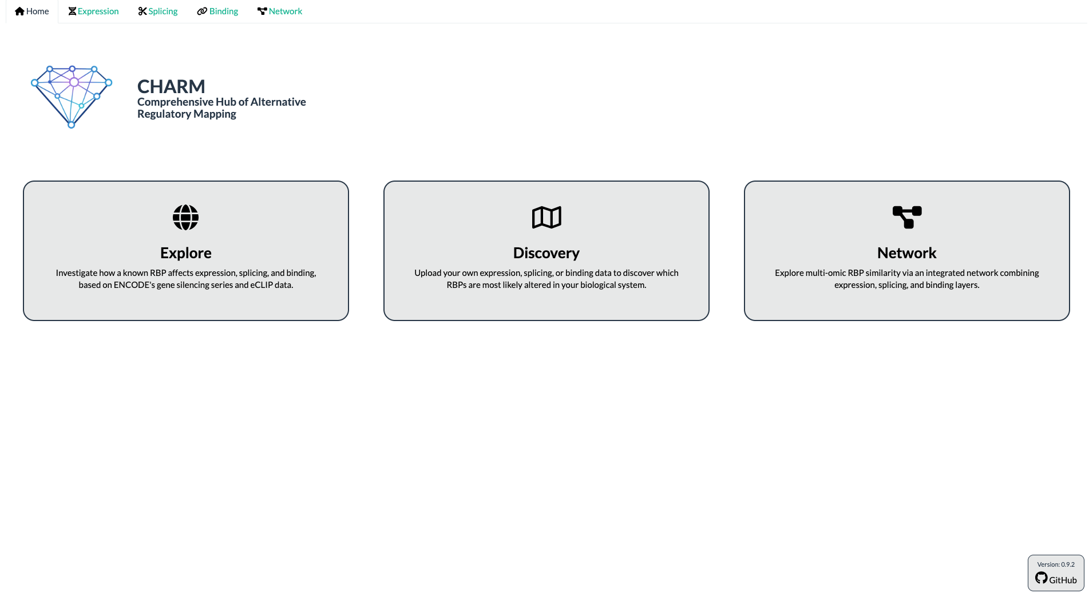
Supplementary Figure 1. CHARM's home screen. Screenshot of the CHARM application home screen, illustrating the two available usage modes as well as the Network module, together with their respective descriptions. Users select a module by clicking the corresponding tab in the upper-left panel. The source code is accessible via the GitHub link in the bottom-right corner.
In Explore mode, users query a precomputed reference resource built from ENCODE shRNA-knockdown and eCLIP data across the HepG2 and K562 cell lines, spanning the RBPs for which both data types are available¹⁵. In Discovery mode, users upload their own differential expression or differential splicing results and compare them directly against this reference data, without needing to reprocess raw sequencing data or reproduce the underlying pipeline themselves.
Expression
The Expression module first provides exploratory plots that allow users to evaluate short hairpin RNA (shRNA) knockdown efficacy against ENCODE's matched controls (Figure 1A, B).
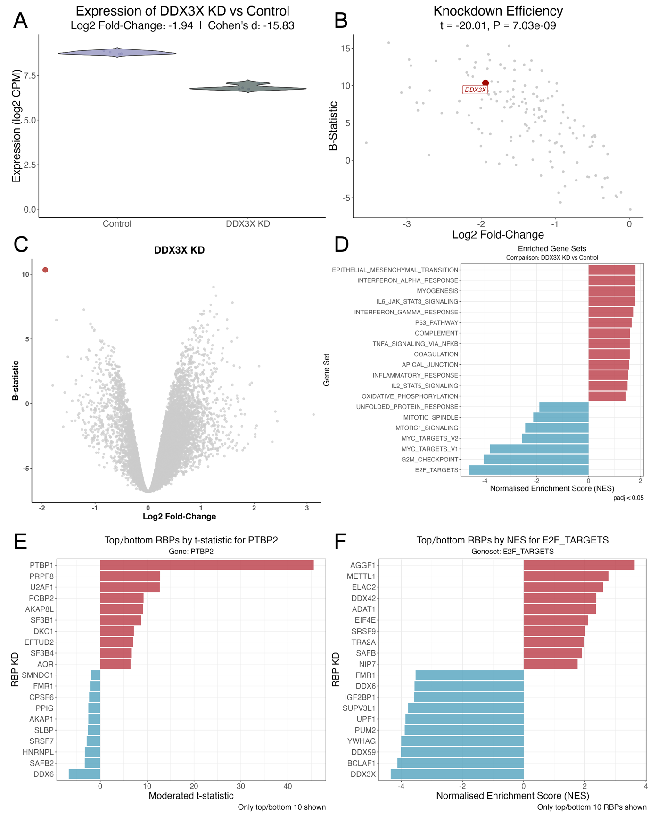
Figure 1. CHARM's Expression tab plots. (A) Violin plots of DDX3X expression (log₂ CPM) in K562 and HepG2 cells exposed to shRNA against DDX3X and respective controls¹⁵, batch-corrected for cell type (see Methods); log₂ fold-change and Cohen's d between the two sample types are shown above the plots. (B) Scatter plot of differential gene expression (DGE; x-axis, log₂ fold-change; y-axis, B-statistic) between K562 and HepG2 cells exposed to shRNA against RBPs and respective controls¹⁵, batch-corrected for cell type (see Methods); each point is one shRNA-versus-control experiment; DDX3X is highlighted in red, with the t-statistic of DGE and the Benjamini–Hochberg-adjusted p-value shown above. (C) Volcano plot of DGE (x-axis, log₂ fold-change; y-axis, B-statistic) between K562 and HepG2 cells exposed to shRNA against DDX3X and respective controls¹⁵, batch-corrected for cell type (see Methods); genes as circles; DDX3X is highlighted in red. (D) Gene set enrichment analysis (GSEA) normalised enrichment scores (NES) for Hallmark gene sets, with genes ranked by the t-statistic of differential expression, between K562 and HepG2 cells exposed to shRNA against DDX3X and respective controls¹⁵, batch-corrected for cell type. (E) Bar plot of the log₂ fold-change of PTBP2 expression across all profiled RBP knockdowns, between K562 and HepG2 cells exposed to shRNA and respective controls¹⁵, batch-corrected for cell type (i.e. which RBP knockdown most affects PTBP2 expression; top 10 highest |moderated t-statistic|). (F) GSEA NES for the Hallmark E2F-targets gene set across all profiled RBP knockdowns, with genes ranked by the t-statistic of differential expression, between K562 and HepG2 cells exposed to shRNA and respective controls¹⁵, batch-corrected for cell type (i.e. which RBP knockdown most affects E2F-targets enrichment; top 10 highest |NES|).
The module then presents a volcano plot of Differential Gene Expression (DGE) between knockdown and control conditions (Figure 1C), accompanied by a table of DGE metrics from limma–voom (t-statistic, log₂ fold-change, and Benjamini–Hochberg-adjusted p-value)²¹, together with a Gene Set Enrichment Analysis (GSEA)²² of the Hallmark gene collection²³ (Figure 1D) and its corresponding table (Normalised Enrichment Score (NES) and adjusted p-value; see Methods). As an example, DDX3X knockdown depleted proliferation-associated gene sets (Figure 1D), such as E2F targets and G2M checkpoint, consistent with DDX3X's previously reported role in cancer-cell proliferation²⁴. Users can also query in reverse, identifying which RBP knockdowns most affect the expression of a chosen gene (Figure 1E) or the enrichment of a chosen Hallmark gene set (Figure 1F). For example, PTBP2 expression was most strongly upregulated by PTBP1 knockdown (Figure 1E), consistent with a previously described compensatory mechanism in B cells²⁵, and E2F-target enrichment was most strongly depleted by IGF2BP1 knockdown (Figure 1F), consistent with both a previous report²⁶, as well as DDX3X as described above (Figure 1D)²⁴.
Users can additionally select a specific RBP KD and identify other RBPs whose KD produces similar expression alterations (Spearman’s correlation of t-statistics). G3BP1 KD, for instance, produced expression changes resembling those of TIA1 KD (Supplementary Figure 2), possibly reflecting the shared role of both proteins in phase separation and stress-granule (SG) assembly²⁷.
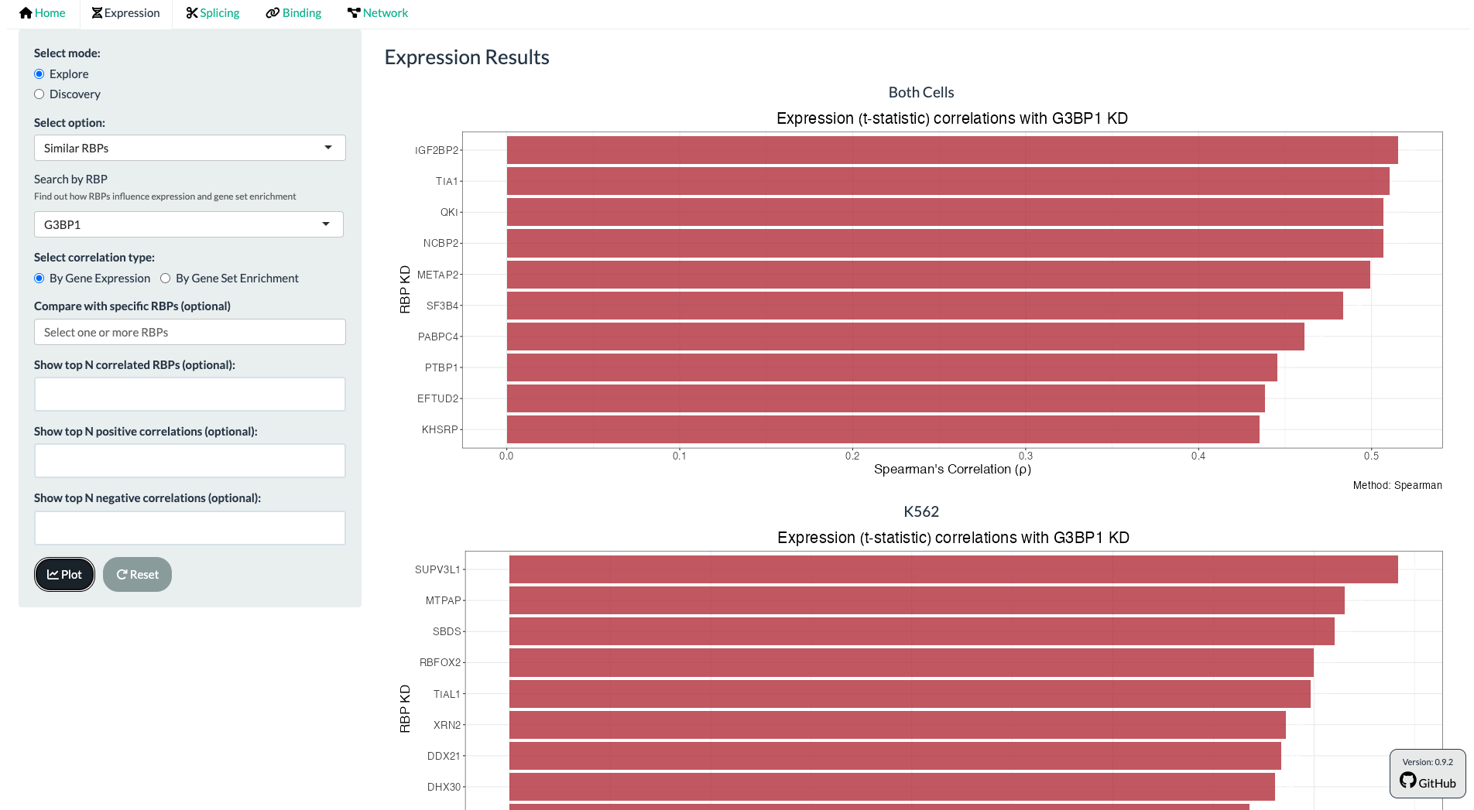
Supplementary Figure 2. Screenshot of CHARM's Similar Profiles feature, Expression tab. Bar plot of Spearman's correlation coefficient ρ between the t-statistics of differential expression between K562 and HepG2 cells exposed to shRNA against G3BP1 and respective controls¹⁵, and those of other RBP knockdowns and respective controls¹⁵ (i.e. which knockdown produces gene-expression alterations most similar to G3BP1 knockdown). All comparisons were batch-corrected for cell type (see Methods). Users can scroll down to observe results pertaining to K562 and HEPG2 cell lines alone.
Finally, users can upload their own differential expression results (obtained, for example, from limma–voom) to assess how their expression changes compare with those observed for the KD of a given RBP. They can also compare GSEA results derived from their own ranked differential expression statistics with those of individual RBP KD and identify the KDs that most closely resemble their data. As an example, we used data from U2-OS cells exposed to oxidative stress (arsenite)²⁸; among generally weak correlations, the strongest was with FXR1 KD (Supplementary Figure 3), plausibly because FXR1 silencing has been reported to activate stress-related pathways²⁹, consistent with the stress response resulting from arsenite²⁸.
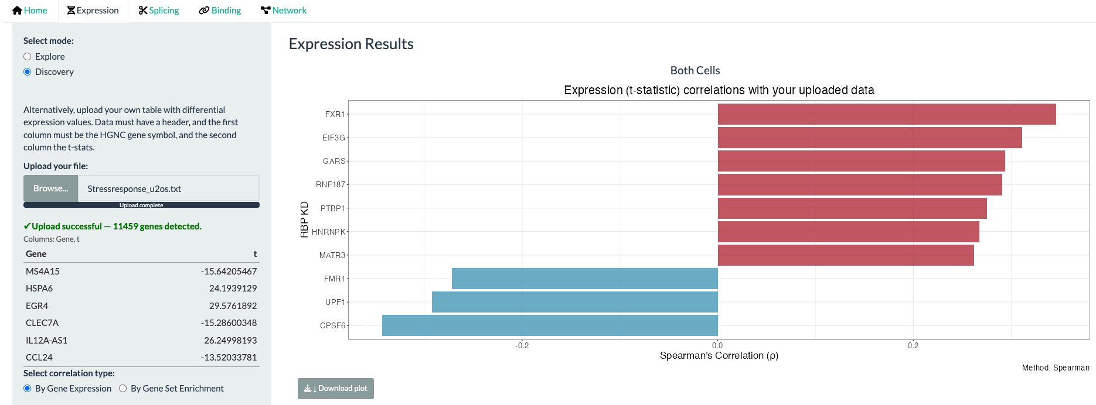
Supplementary Figure 3. Screenshot of CHARM's Discovery mode, Expression tab. Bar plot of Spearman's correlation coefficient ρ between t-statistics of differential expression from a user-submitted file (U2-OS cells exposed to oxidative stress²⁸) and from K562 and HepG2 cells exposed to shRNA against RBPs and respective controls¹⁵, corrected for cell type (i.e. which knockdown produces gene-expression alterations most similar to the user-submitted data).
Splicing
The Splicing module (Figure 2) offers an analogous view for alternative splicing, quantified as percent spliced-in (PSI; the proportion of transcripts including a given alternative exon or intron) and its change between conditions (dPSI). Users can examine the effect of an RBP's knockdown on global splicing levels (Figure 2A) and inspect a volcano plot of differential splicing across annotated VastDB events¹² (Figure 2B), with an accompanying table.
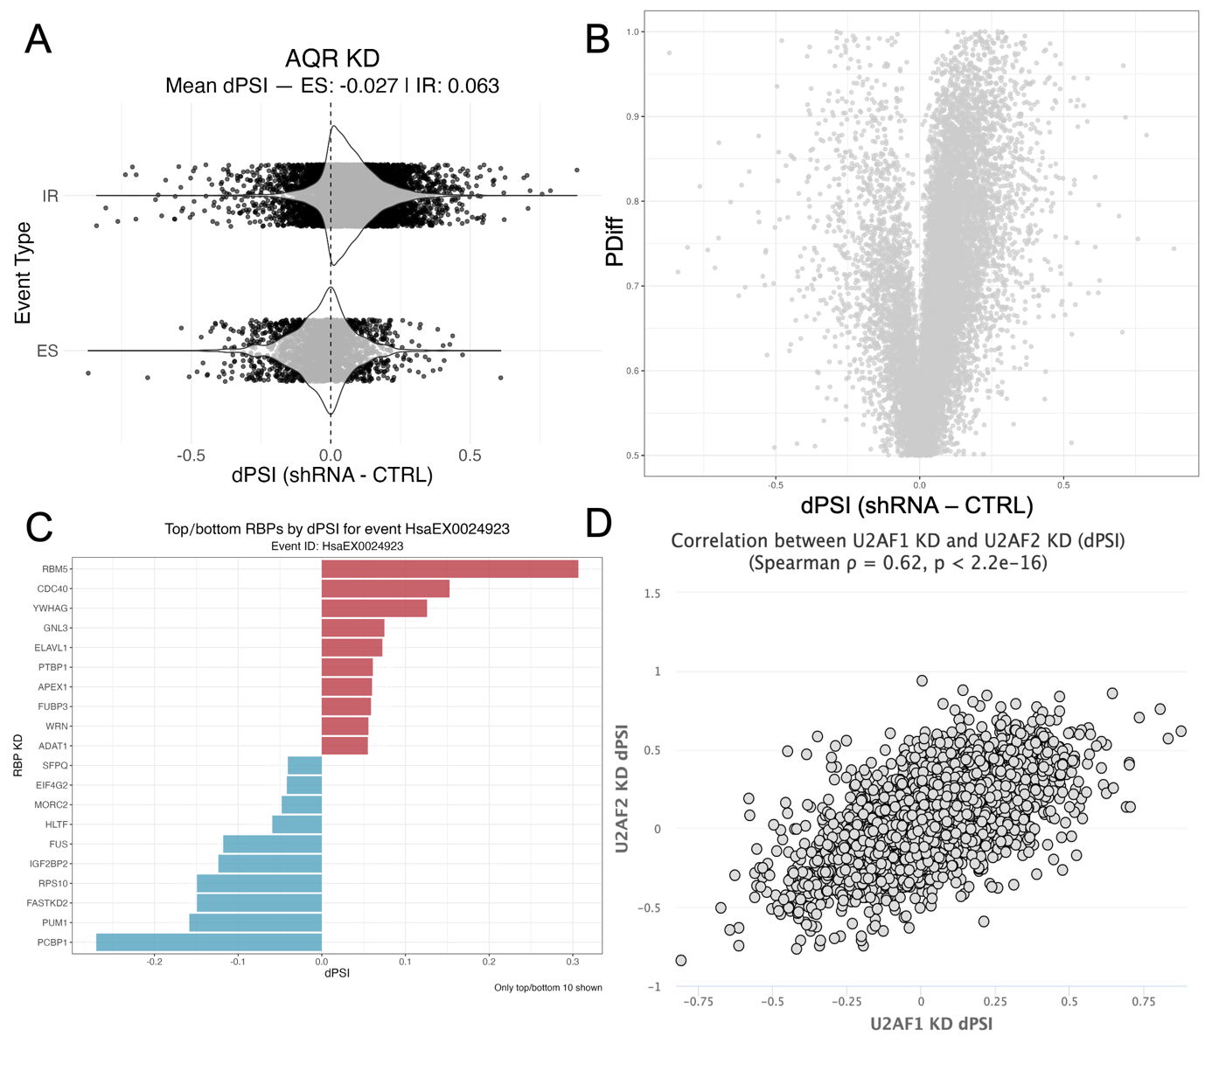
Figure 2. CHARM's Splicing tab plots. (A) Violin plots of intron retention (IR) and exon skipping (ES) alternative splicing events (dPSI) in K562 and HepG2 cells exposed to shRNA against AQR and respective controls¹⁵, batch-corrected for cell type (see Methods); the mean dPSI for each event type is shown above the plots. (B) Volcano plot of differential splicing analysis (DSA; x-axis, dPSI; y-axis, P_{diff} (probability of differential splicing)³⁰) between K562 and HepG2 cells exposed to shRNA against AQR and respective controls¹⁵, batch-corrected for cell type; each point is one alternative splicing event. (C) Bar plot of dPSI for the event HsaEX0024923¹² across all profiled RBP knockdowns, between K562 and HepG2 cells exposed to shRNA and respective controls¹⁵, batch-corrected for cell type (i.e., which RBP knockdown most affects inclusion of this event). (D) Scatter plot of DSA between K562 and HepG2 cells exposed to shRNA against U2AF1 (x-axis) or U2AF2 (y-axis) and respective controls¹⁵, batch-corrected for cell type (see Methods); each point is one alternative splicing event; Spearman's correlation coefficient ρ and the corresponding test's p-value are shown above.
AQR knockdown, for example, increased intron retention and decreased exon skipping (Figure 2A), consistent with its established role as a core splicing factor³¹. As with the Expression module, users can perform a reverse search to identify which RBP knockdowns most affect the inclusion of a chosen VastDB event¹². HsaEX0024923, corresponding to exon 6 of FAS, whose inclusion promotes apoptotic signalling, was more included upon RBM5 knockdown (Figure 2C), consistent with RBM5's established role in regulating this exon³². Users can likewise identify which RBP knockdowns produce the most similar splicing signatures. U2AF1 knockdown, for example, produced splicing alterations closely resembling those of U2AF2 knockdown (Figure 2D), consistent with their function as an obligate heterodimer³³.
Finally, users can upload their own differential splicing results, obtained, for example, from the betAS app³⁰. Using data from U2-OS and A549 cells exposed to a viral dsRNA mimic³⁴, we found no correlation between these splicing alterations and those observed upon FXR1 knockdown (Supplementary Figure 4), despite FXR1's previously reported role in the stress response²⁹. This negative result illustrates a general principle underlying CHARM's use: the application is a hypothesis-generating tool, and correlative agreement between datasets, when present, still requires case-by-case biological interpretation, just as its absence does not by itself rule out a genuine relationship.
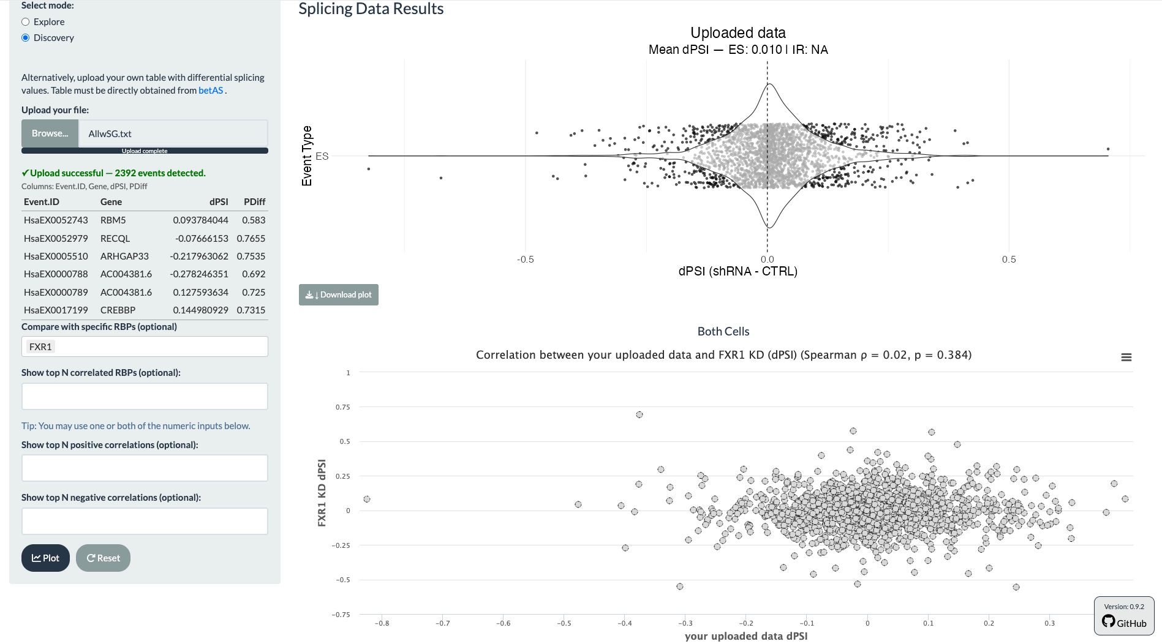
Supplementary Figure 4. Screenshot of CHARM's Discovery mode, Splicing tab. (Top) Violin plot of ES alternative splicing events (dPSI) in a user-supplied file (U2-OS and A549 cells exposed to a viral dsRNA mimic³⁴); mean dPSI is shown above the plot. (Bottom) Scatter plot of DSA between K562 and HepG2 cells exposed to shRNA against FXR1 and respective controls¹⁵ (y-axis), batch-corrected for cell type (see Methods), and the user-supplied file (x-axis); each point is one alternative splicing event; Spearman's correlation coefficient ρ and the corresponding test's p-value are shown above.
Binding
The Binding module allows users to observe how the KD of an RBP alters RBP-RNA binding across alternative splicing events, through RNA splicing maps. For a chosen knockdown, it displays the normalised eCLIP binding density of any selected RBP across increased (events which are more included), decreased (events which are less included), and maintained splicing-event categories (see Methods), together with position-wise statistical support for differential binding, separately for exon skipping (Figure 3A) and intron retention (Figure 3B). This allows users to ask not only whether an RBP's own binding is altered upon its own KD, but also whether the KD of one RBP alters the binding behaviour of another (Figure 3C).
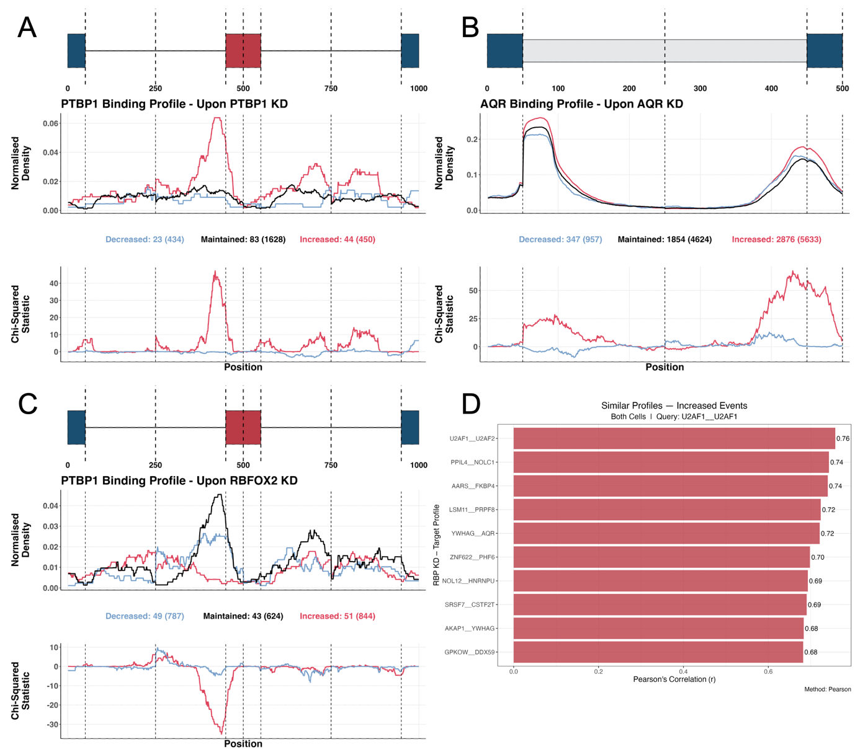
Figure 3. CHARM's Binding tab plots. (A, C) RNA binding maps of alternative exon skipping events, showing PTBP1 binding in cells treated with shRNA against PTBP1 (A) or against RBFOX2 (C). (Top) Schematic of the exon skipping event. (Middle) Normalised binding of PTBP1 across metagenomic regulatory sequences flanking alternative exons. The plot discriminates exons whose inclusion decreased (blue), increased (red), or was unchanged (black) upon PTBP1 (A) or RBFOX2 (C) knockdown. The total number of events in each category is given in brackets beneath the plot, preceded by the number of events for which at least one PTBP1 binding site was detected. (Bottom) Chi-squared statistic for differential binding at decreased-inclusion (blue) or increased-inclusion (red) events, relative to unchanged events. Vertical lines delimit the following metagenomic splicing regulatory regions, in order: last 50 nt of the upstream constitutive exon; first 200 nt of the upstream intron; last 200 nt of the upstream intron; first 50 nt of the alternative exon; last 50 nt of the alternative exon; first 200 nt of the downstream intron; last 200 nt of the downstream intron; first 50 nt of the downstream constitutive exon. (B) RNA binding maps of intron retention events, showing AQR binding in cells treated with shRNA against AQR. (Top) Schematic of the intron retention event. (Middle) Normalised binding of AQR across metagenomic regulatory sequences flanking prospectively retained introns, discriminating introns whose retention decreased (blue), increased (red), or was unchanged (black) upon AQR knockdown; total event numbers and AQR-bound event numbers as in (A). (Bottom) Chi-squared statistic as in (A); vertical lines delimit: last 50 nt of the upstream constitutive exon; first 200 nt of the prospectively retained intron; last 200 nt of the prospectively retained intron; first 50 nt of the downstream constitutive exon. (D) Bar plot of Pearson's correlation coefficient r between the Chi-squared differential-binding statistic of U2AF1 upon U2AF1 knockdown and that of U2AF1 upon other RBP knockdowns (i.e. which RBP knockdown produces the most similar U2AF1 binding profile upon U2AF1 KD). All plots pertain to K562 and HepG2 cells exposed to shRNA against RBPs and respective controls¹⁵, batch-corrected for cell type (see Methods). In all plots dPSI threshold for category definition was selected as the value which maximised the Chi-Squared Statistic (see Methods). These were 0.1 (A), 0.05 (B), 0.02 (C), and 0.09 (D).
As a positive control, PTBP1 is known to bind to polypyrimidine tracts to promote exon skipping¹³. Accordingly, PTBP1 knockdown resulted in enriched PTBP1 binding at the polypyrimidine tracts of exons whose inclusion increased upon knockdown (i.e. exons normally skipped under wild-type conditions)¹³ (Figure 3A). The same logic applies to AQR knockdown, which enriched AQR binding at downstream intronic regions, consistent with its role in intron excision³¹ (Figure 3B). As an example of an indirect target, RBFOX2 knockdown depleted the enrichment of PTBP1 binding at exons whose inclusion increased (Figure 3C), suggesting antagonistic roles for the two proteins at a subset of shared target events. Indeed, a related mechanism, in which a third factor, SON, coordinates opposing PTBP1/PTBP2 and RBFOX2 activities, has been described in glioblastoma³⁵.
Alternatively, users can obtain a heatmap overview of the binding alterations occurring across many RBPs upon a chosen knockdown (Supplementary Figure 5). Consistent with its role as a core splicing factor³³, SF3B1 knockdown altered the binding of numerous other RBPs (Supplementary Figure 5). In the Similar Profiles sub-mode, users can select a given RBP's binding profile under a specific knockdown and identify the most similar profiles across the reference resource. The profile of U2AF1 binding under U2AF1 knockdown, for instance, was most similar to that of U2AF1 binding under U2AF2 knockdown (Figure 3D), consistent with their function as a heterodimer³³ (see Methods). Finally, users can upload their own splicing dataset to generate RNA binding maps and identify which RBPs' binding patterns are altered upon that perturbation.
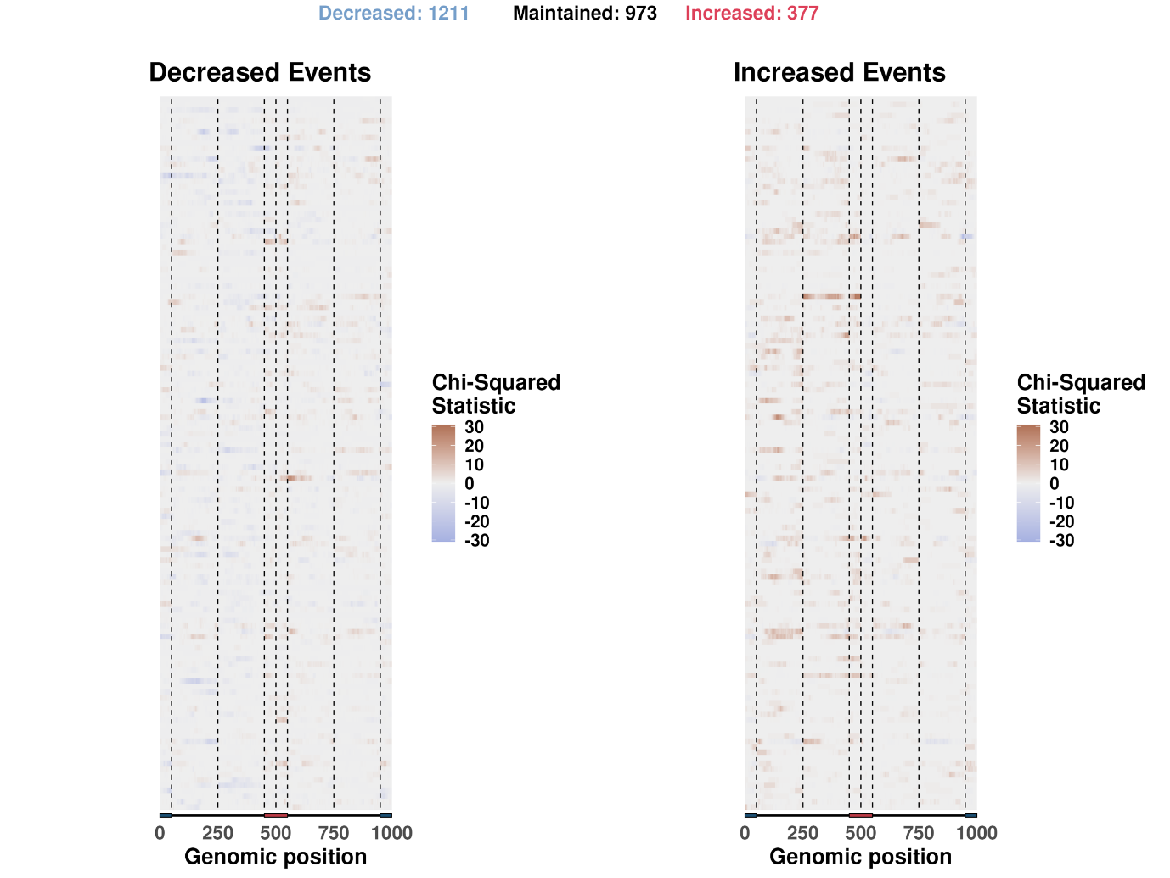
Supplementary Figure 5. Heatmap of RNA binding maps of alternative exon splicing events in cells treated with shRNA against SF3B1. Chi-squared differential-binding statistic for decreased-inclusion (left) or increased-inclusion (right) events, relative to unchanged events. Total event numbers per category are given above the heatmaps. Vertical lines delimit the metagenomic splicing regulatory regions as defined in Figure 3A/C. Rows (individual RBP binding maps) are labelled with the respective RBP in the CHARM app but have been omitted here for clarity.
Network
The Network module builds on all other layers. For each of the three data layers, expression, splicing, and binding, CHARM computes a genome-wide Spearman correlation matrix between all reference-resource RBP knockdowns (see Methods) and combines the resulting per-layer matrices into a single similarity matrix using user-adjustable weights, from which an RBP–RBP dissimilarity (1 minus the weighted correlation) is derived. Users can restrict the analysis to either cell line or use both combined, choose a method for visualising this dissimilarity (PCA, MDS, t-SNE, or hierarchical clustering displayed as a dendrogram), and select which layers to include, together with their relative contribution to the combined similarity (see Methods). For the binding layer specifically, users can further choose whether to include exon skipping and/or intron retention events, and whether to consider events whose inclusion increased or decreased upon knockdown. Considering all three layers with approximately equal weighting, we recovered previously reported interactions, including that of U2AF1 with its heterodimer partner U2AF2³³, and with SF3B1, which also acts at the 3' splice site³³ (Figure 4). Not every expected interaction was recovered, however. TIA1 did not cluster near its close paralogue TIAR/TIAL1⁷.
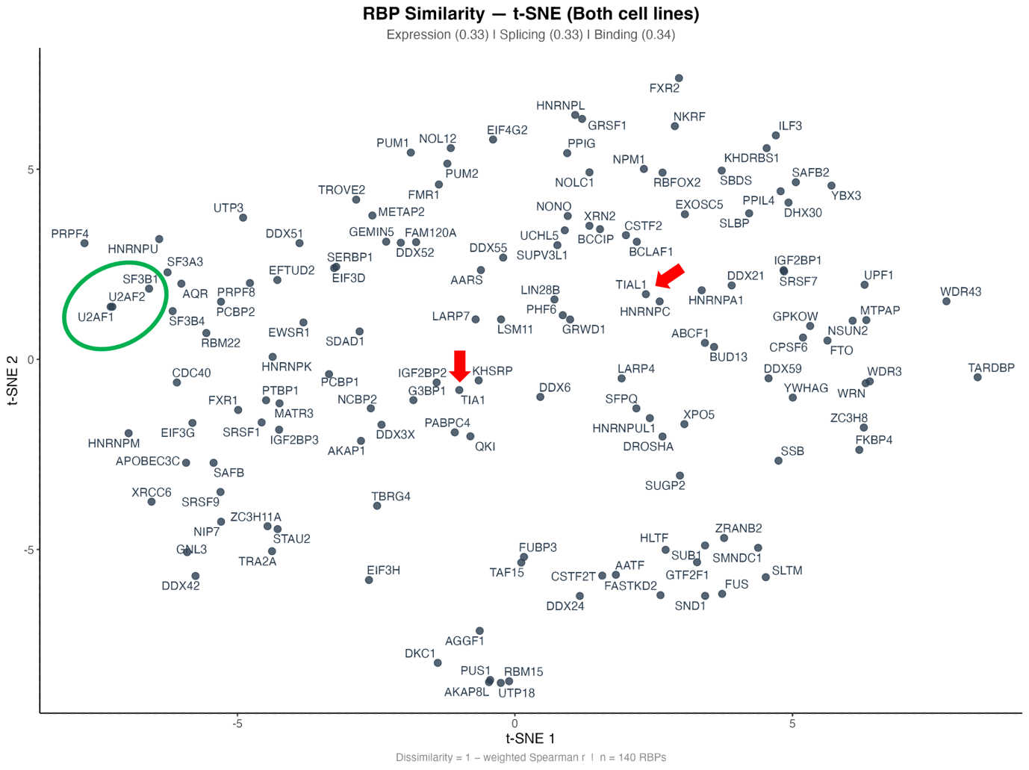
Figure 4. The CHARM Network module recovers known RBP regulatory complexes. t-Distributed Stochastic Neighbour Embedding (t-SNE) projection of pairwise RBP dissimilarity (1 − weighted Spearman correlation rho), computed by CHARM's Network module from the Expression, Splicing, and Binding layers combined with approximately equal weights (0.33, 0.33, and 0.34, respectively; both cell lines; all binding event types and directions included; see Methods). Each point represents one of the RBPs common to all three layers within the reference resource; proximity approximates similarity in RBP-knockdown expression, splicing, and binding signatures. U2AF1, U2AF2, and SF3B1 (green circle), which cooperatively recognise the 3′ splice site, cluster closely together, recovering this known regulatory relationship. TIA1 and TIAL1 (red arrows), a closely related paralogue pair, do not cluster together under this representation.
We first considered that this might reflect the plot's combination of both cell lines, since a previous study identifying regulatory complexes from RNA maps and binding data reported that TIAL1 knockdown produced no detectable effect on differential binding specifically in K562 cells¹⁹, an observation we reproduced in our own data (Supplementary Figure 6).
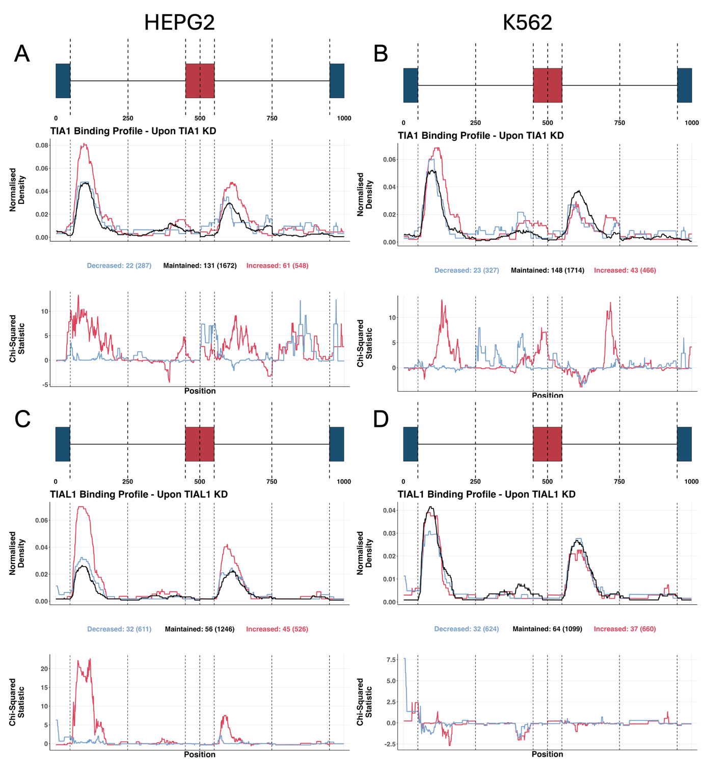
Supplementary Figure 6. RNA binding maps of alternative exon splicing events with TIA1 (A, B) or TIAL1 (C, D) binding, in HepG2 (A, C) or K562 (B, D) cells treated with shRNA against TIA1 (A, B) or TIAL1 (C, D). (Top) Schematic of the exon skipping event. (Middle) Normalised binding of TIA1 (A, B) or TIAL1 (C, D) across metagenomic regulatory sequences flanking alternative exons, discriminating exons whose inclusion decreased (blue), increased (red), or was unchanged (black) upon knockdown; total event numbers and bound-event numbers as in Figure 3A/C. (Bottom) Chi-squared statistic as in Figure 3A/C; vertical lines delimit the metagenomic splicing regulatory regions as defined in Figure 3A/C.
Restricting the analysis to HepG2 cells alone, however, did not bring TIA1 and TIAL1 closer together. Other large-scale studies have similarly reported limited correlation between their splicing alterations⁷, suggesting either that the two paralogues are functionally less redundant than commonly assumed, or that CHARM's current network representation does not capture this particular relationship.
Overall, CHARM's architecture is deliberately extensible. Additional gene-silencing experiments, eCLIP profiles for further RBPs, and alternative CLIP technologies such as iCLIP2 can be incorporated without altering the interface. CHARM is intended throughout as an ever-evolving, hypothesis-generation platform. Every relationship it surfaces, whether an expression-independent functional alteration or a candidate indirect regulatory interaction, is a candidate for downstream experimental validation, not a substitute for it.
Biological applications of CHARM
TIA1 localisation into stress granules alters splicing
A central limitation of expression-centric RBP analysis is that many biologically meaningful changes in RBP activity leave expression entirely unaltered. Subcellular relocalisation, post-translational modification, and disruption of an interacting partner can each abolish or redirect an RBP's function without changing how much of the protein is present. Because CHARM also measures RBP activity through binding rather than inferring it from expression, it is positioned to detect exactly this class of alteration.
We used TIA1 sequestration into SGs as a worked example of this expression-independent functional detection, building on our previous work [ref to be inserted upon publication]. Under stress, TIA1 relocalises from a predominantly nuclear distribution to cytoplasmic SGs. Since splicing occurs in the nucleus, we hypothesised that this sequestration would perturb TIA1's splicing-regulatory activity even without any change in its expression. We therefore used a dataset of U2-OS and A549 cells exposed to a viral dsRNA mimic, comparing cells that were wild-type or knockout for G3BP1, a factor required for SG assembly under these conditions³⁶. In both cell backgrounds, TIA1 showed little evidence of differential expression upon stress (Figure 5A). If SG sequestration impairs TIA1's splicing-regulatory function, its binding under stress should resemble binding under TIA1 knockdown, since both conditions functionally deplete TIA1 activity at its splicing targets. Consistent with this, TIA1 binding under SG-competent stress conditions correlated with TIA1 binding under TIA1 knockdown, in both HepG2 and K562 cells (Pearson's r = 0.44, see methods) (Figure 5B). This correlation could, however, reflect a generic effect of cellular stress rather than SG sequestration specifically. We therefore also examined TIA1 binding in G3BP1-knockout cells under the same viral dsRNA-mimic stress, a condition that induces stress without SG assembly, and found this binding profile to be much less similar to the knockdown profile (Pearson's r = 0.07, see methods), consistent with the effect being SG-dependent rather than a non-specific consequence of stress. As a comparison, we examined YBX3, an SG-localised protein³⁷ whose functional alteration under stress is reflects stress generally rather than SG formation specifically. Accordingly, YBX3 binding profile under YBX3 knockdown correlated with YBX3 binding profile both with and without SG assembly (r = 0.77 and r = 0.64, respectively) (Figure 5C).
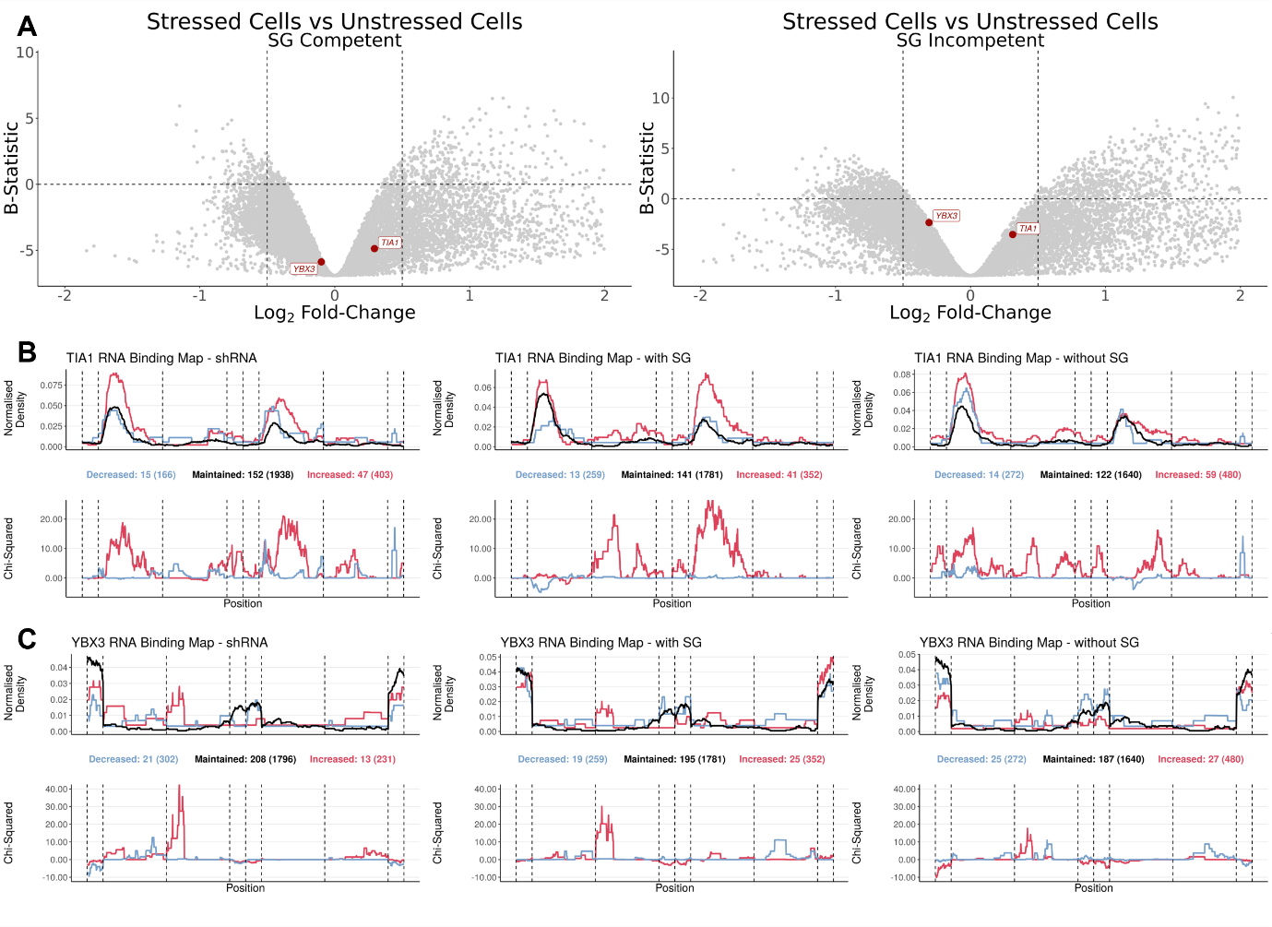
Figure 5. Alternative splicing alterations in stress-granule-competent and -incompetent cells. (A) Volcano plots of DGEA between stressed and unstressed cells (x-axis, log₂ fold-change; y-axis, B-statistic) in SG-competent (left) and SG-incompetent (right) U2-OS and A549 cells exposed to a viral dsRNA mimic as a stressor³⁸; each point is one gene, with TIA1 and YBX3 highlighted in red. Vertical dashed lines mark log₂ fold-change = −0.5 and 0.5; the horizontal dashed line marks B-statistic = 0. Only genes with −2 < log₂ fold-change < 2 are plotted. (B, C) RNA binding maps of alternative exon splicing events, showing TIA1 (B) or YBX3 (C) binding in shRNA-treated cells against TIA1 (B) or YBX3 (C) obtained from ENCODE¹⁵ (left), in SG-competent cells (middle), and in SG-incompetent cells (right). (Top) Normalised binding of the RBP of interest across metagenomic regulatory sequences flanking alternative exons, discriminating exons whose inclusion decreased (blue), increased (red), or was unchanged (black) upon RBP knockdown (left) or upon dsRNA stress, in SG-competent (middle) and SG-incompetent (right) cells; total and bound-event numbers as in Figure 3A/C. (Bottom) Chi-squared statistic as in Figure 3A/C; vertical lines delimit the metagenomic splicing regulatory regions as defined in Figure 3A/C.
Taken together, these results show that CHARM can distinguish a condition-specific loss of RBP function, arising here from subcellular sequestration, from both unrelated stress-response signal and genuine expression-driven effects, where expression data are used to rule out the latter, and binding-derived splicing signatures to detect the former.
Stress-granule sequestration is just one mechanism by which this can occur; the same detection logic applies, without modification, to any other RBP whose function is altered post-translationally, through complex disruption, or through any other means that leaves expression unchanged.
RBM39 and the U2AF complex
A second limitation of standard RBP analyses restricted to an RBP's own binding and splicing data is that they can only reveal direct regulatory relationships. Many RBPs function as members of larger complexes, or through cooperative binding with other RBPs, such that perturbing one factor can alter the activity of its partners without producing any detectable change at the perturbed factor's own direct targets. These indirect relationships are, by construction, invisible to any analysis confined to a single RBP's own eCLIP and knockdown data. Identifying them requires systematically examining how the knockdown of one RBP reshapes the binding profiles of others.
In previous work, we found that RBM39 knockdown led to splicing alterations³⁹. However, the mechanism underlying these alterations was unclear, as RBM39 itself showed limited direct binding at the affected alternative splicing events³⁹. Examining indirect binding alterations (i.e. how the binding of other RBPs changes upon RBM39 knockdown) we found that RBM39 knockdown altered U2AF1 and U2AF2 binding in a manner consistent with their own respective knockdown profiles (Figure 6A–C). Splicing alterations induced by RBM39 knockdown also correlated with those induced by U2AF1 and U2AF2 knockdown, albeit less strongly than U2AF1 and U2AF2 knockdown correlated with each other, suggesting that RBM39 partly modulates this complex (Figure 6D).
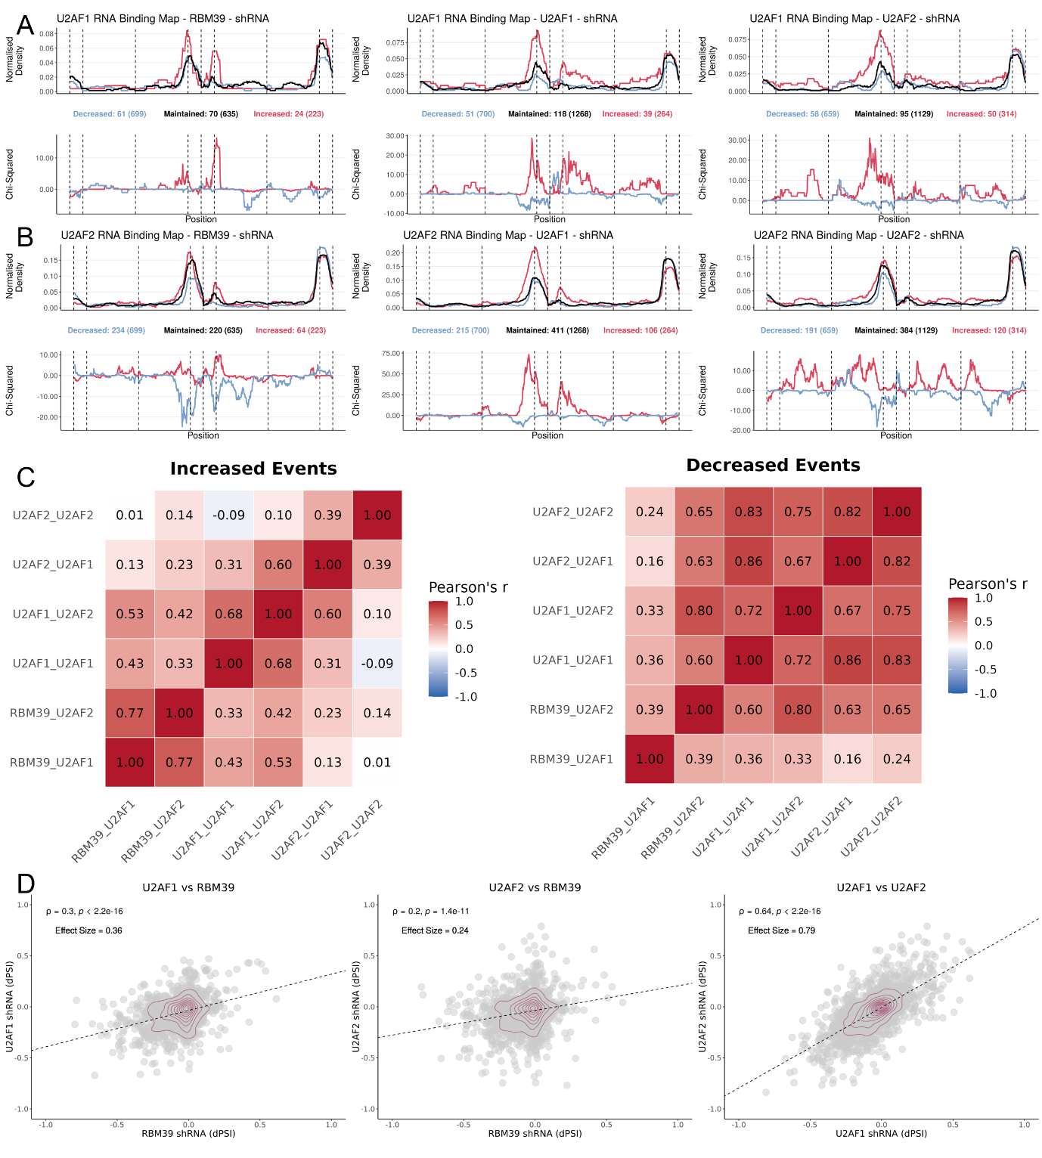
Figure 6. RBM39 knockdown produces alterations similar to U2AF1/U2AF2 knockdown. (A, B) RNA binding maps of alternative exon splicing events, showing U2AF1 (A) or U2AF2 (B) binding in shRNA-treated cells for RBM39 (left), U2AF1 (middle), or U2AF2 (right). (Top) Normalised binding of the RBP of interest across metagenomic regulatory sequences flanking alternative exons, discriminating exons whose inclusion decreased (blue), increased (red), or was unchanged (black) upon KD; total and bound-event numbers as in Figure 3A/C. (Bottom) Chi-squared statistic as in Figure 3A/C; vertical lines delimit the metagenomic splicing regulatory regions as defined in Figure 3A/C. (C) Heatmap of Pearson's correlation coefficient between Chi-squared differential-binding statistics for several shRNA–RBP pairs, for increased- (left) or decreased-inclusion (right) events (i.e. how similar the red or blue binding profiles from (A) and (B) are to one another); labels follow the convention "shRNA treatment_RBP binding". (D) Scatter plots of DSA between K562 and HepG2 cells exposed to shRNA against U2AF1 or U2AF2¹⁵, batch-corrected for cell type, and IMR90 cells exposed to shRNA against RBM39³⁹: (left) U2AF1 KD (y-axis) versus RBM39 KD (x-axis); (middle) U2AF2 KD (y-axis) versus RBM39 KD (x-axis); (right) U2AF2 KD (y-axis) versus U2AF1 KD (x-axis); each point is one alternative splicing event; density contours in dark red; Spearman's correlation coefficient ρ and the corresponding test's p-value are shown above.
Because U2AF1 and U2AF2 function as an obligate heterodimer that recognises the 3′ splice site, this pattern is consistent with RBM39 functioning within, or in cooperation with, the U2AF complex, even though RBM39's own splicing alterations occur largely independently of its own direct RNA binding. This result illustrates another specific capability that CHARM is designed to provide: identifying a candidate regulatory relationship that would not have been apparent from any analysis of RBM39 in isolation, and that becomes visible only when the binding behaviour of its potential partners is examined systematically alongside it. As with all outputs from CHARM, this relationship constitutes a hypothesis rather than a demonstrated mechanism, and its confirmation is left to downstream validation work.
Discussion
CHARM's differentiator relative to existing RBP analysis resources is not a novel statistical framework for splicing-map construction, but the integration of expression, splicing, binding, and network-level analyses within a single, browser-accessible, no-code interface built directly on public data. Tools such as rMAPS2¹⁷ generate splicing maps from user-supplied CLIP and RNA-seq data but stop short of providing a precomputed, browsable reference resource spanning many RBPs, and tools such as RBP Browser¹⁸ reveal putative interactions between RBPs from eCLIP and CRISPR-knockout data, but do not allow users to generate RNA binding maps directly. Studies employing methods conceptually similar to ours have also been published^{19,20}, but, to our knowledge, none offer no-code access to indirect, complex-level RBP regulatory inference. We regard this as a genuine capability gap in currently available resources rather than a claim of analytical superiority, and we do not present CHARM as a replacement for specialised pipelines, but as a means of extending their reach to researchers who would not otherwise use them.
Several limitations warrant explicit acknowledgement. First, knockdown–cell combinations in the reference resource derive from a single resource, ENCODE¹⁵ (see Methods). Thus, the absence of replicates from other resources means that reported effects cannot be distinguished from experiment-specific technical variability. Additionally, only two cell types are available, and in the form of cell lines, K562 and HEPG2, which accrue within-cell-type variability⁴⁰. Second, CHARM's binding data are currently derived exclusively from eCLIP. Newer techniques such as iCLIP2 offer higher spatial resolution of RBP-binding sites⁴¹, and integrating a sufficiently large iCLIP2 dataset, should one become available, represents a natural extension of the eCLIPSE pipeline. Third, CHARM's splicing analyses currently cover exon-skipping and intron-retention events only, and do not extend to alternative splice-site (5′ or 3′) usage, like alternatives like rMAPS2¹⁷ do. Extending the eCLIPSE splicing-genome framework to these event types is a natural direction for future development. Fourth, CHARM relies on VastDB’s pre-annotated catalogue of alternative splicing events¹², and consequently works exclusively with splicing quantifications generated by VAST-TOOLS¹². This dependency makes CHARM's splicing-genome framework difficult to reconcile with output from other splicing-quantification tools, such as MAJIQ⁴² or rMATS⁴³, whose event definitions and coordinate systems differ from VastDB's. rMATS, however, reports events in a fixed format that is structurally compatible with VastDB's event-based approach. We generated a corresponding rMATS-compatible splicing genome, provided as Supplementary Material, allowing rMATS-quantified data to be used locally.
Taken together, we present CHARM not as a comprehensive replacement for specialised RBP analysis pipelines, but as a framework that lowers the practical barrier to a specific and recurring category of question: how does a given RBP function independently of its expression, and with which other RBPs does it plausibly interact? We believe that making these questions tractable without requiring computational expertise has direct value for hypothesis generation in RBP biology.
Methods
Sample pre-processing
RNA-seq data from ENCODE gene-silencing experiments targeting RBPs with matched eCLIP data were obtained for the HepG2 and K562 cell lines, using shRNA-mediated knockdown or CRISPR-based perturbation^{15,16}. For each cell line and target, the default, non-archived experiment was selected, with CRISPR-based perturbations preferred when multiple default options were available. Raw reads (FASTQ format) were trimmed using Trimmomatic (v0.39)⁴⁴, and alternative splicing was quantified with VAST-TOOLS (v2.5.1), following the align (against the hg38 reference genome, Ensembl v88) and combine steps¹².
All expression analyses within CHARM were performed using the “RPKM_AND_COUNTS” files, obtained from Bowtie⁴⁵/VAST-TOOLs¹².
Raw read counts were first filtered to remove lowly expressed genes. Filtered read counts were then used to calculate library size scaling factors using the trimmed mean of M-values⁴⁶ (TMM; calcNormFactors function from edgeR (v3.36.0)⁴⁷). Those read counts were subsequently normalised and log₂-transformed using the voom⁴⁸ function from limma (v.3.50.3)⁴⁹.

Differential splicing analysis
Differential splicing was assessed using a modified version of the betAS (v1.2.1) R package³⁰. By default, betAS's alternativeEvents function excludes events in which at least one sample does not meet the percent-spliced-in (PSI) thresholds (1 ≤ PSI ≤ 99); applying these thresholds alone, however, retained a large number of events that were effectively constitutive rather than genuinely alternative. To improve specificity, we additionally incorporated prior information from VastDB's MAIN PSI table¹²: for each exon-skipping event, the average PSI and its variance were computed across the tissues and cell types in that table, and only events meeting at least one of the following empirical criteria were retained for downstream analysis: variance ≥ 750, or average PSI between 12.5 and 87.5. For the ENCODE shRNA experiments¹⁵, HepG2 and K562 data (treated with scrambled shRNA controls) were processed jointly using this modified betAS pipeline. For the viral dsRNA mimic experiments³⁶, A549 and U2-OS were likewise processed jointly.
Differential gene expression analysis
Differential expression between each RBP knockdown and its matched control was assessed by fitting linear models to the expression data with standard errors moderated using empirical Bayes shrinkage. When HEPG2 and K562 were jointly processed, cell type was batch corrected using one of our previously used methods⁵⁰. Genes were then ranked by their moderated t-statistic, from most positive to most negative, for GSEA²² of the MSigDB Hallmark collection²³ (msigdbr package), performed with fgsea (v1.20.0)⁵¹, yielding a normalised enrichment score (NES) and Benjamini–Hochberg-adjusted p-value for each gene set; positive and negative NES indicate enrichment amongst over- and under-expressed genes, respectively. In Discovery mode, an equivalent workflow is applied live to user-uploaded expression data.
Additional datasets
Three analyses in this study used publicly available RNA-seq datasets external to ENCODE.
The stress-granule case study (Figure 5) used RNA-seq data from U2-OS and A549 cells, wild-type or knockout for G3BP1, exposed to a viral dsRNA mimic as a stressor^{34,38} (GSE173953); reads were processed with VAST-TOOLS and the modified betAS pipeline (see Differential splicing analysis) for splicing quantification, and with limma–voom (see Differential gene expression analysis) for differential expression, and TIA1 and YBX3 eCLIP binding under these conditions was processed through the eCLIPSE pipeline (see above) using the same splicing-genome coordinate system built from ENCODE data.
The Expression-module Discovery-mode example (Supplementary Figure 3) used RNA-seq data from U2-OS cells exposed to oxidative stress (arsenite)²⁸ (GSE138988), processed as described elsewhere [SG Paper].
The RBM39 case study (Figure 6) used RNA-seq and eCLIP data from IMR90 cells subjected to RBM39 knockdown³⁹ (GSE297268), processed identically to the ENCODE-derived data described above, using VAST-TOOLS/betAS for splicing, limma–voom for expression, and the eCLIPSE pipeline for binding, with the corresponding splicing events mapped onto the same splicing-genome coordinate system.
RBP binding analyses pipeline (eCLIPSE)
eCLIPSE (eCLIP for Splicing Evaluation) is a computational pipeline developed to integrate eCLIP data from the ENCODE project¹⁵ with splicing annotations from VastDB¹², generating statistically assessed RNA splicing maps. By aligning eCLIP-derived RBP binding profiles to the genomic coordinates of annotated splicing events, eCLIPSE enables systematic assessment of how individual RBPs regulate alternative splicing, either directly, via their own binding, or indirectly, through downstream effects on other RBPs' binding. All components required to reproduce this pipeline are available on GitHub at https://github.com/DiseaseTranscriptomicsLab/CHARM and on Zenodo (doi.org/10.5281/zenodo.21724194), and described below.
Splicing-genome creation
A reference "splicing genome" was first constructed from VastDB¹² annotations. Alternative exons shorter than 10 bp were excluded. For each exon-skipping event, standardised regions of interest were defined as follows: the last 50 bp of the upstream constitutive exon; the first 200 bp and the last 200 bp of the upstream intron; the first 50 bp and the last 50 bp of the alternative exon; the first 200 bp and the last 200 bp of the downstream intron; and the first 50 bp of the downstream constitutive exon.
An analogous, four-region scheme was used for intron-retention events (last 50 bp of the upstream constitutive exon; first 200 bp and last 200 bp of the prospectively retained intron; first 50 bp of the downstream constitutive exon).
Introns shorter than 400 bp, and alternative exons shorter than 100 bp, were split proportionally between their start and end regions to preserve comparable regions of interest near the splice sites (the extra base, for odd lengths, was assigned to the end region); for alternative exons with multiple annotated start sites, the start site maximising exon length was chosen.
eCLIP samples
One eCLIP file per cell line was considered for each RBP profiled by the ENCODE project^{15,16} (252 RBP files in total). Processed GRCh38 bed narrowPeak files, labelled "default" by ENCODE, were downloaded, and binding events with a reported signal greater than 3 were retained. Of these 252 RBPs, 168 had matched shRNA-knockdown RNA-seq data available (see Differential gene expression analysis and Differential splicing analysis) and were included in CHARM's Explore-mode reference resource.
Binding metagenome assembly
RBP binding peaks were intersected with the predefined splicing regions to extract the binding signal in hg38 (Ensembl v88) coordinates. For each RBP, each genomic base was coded as 0 (no binding) or 1 (binding present). To enable comparison across events of heterogeneous length, each event was mapped to a standardised splicing-genome coordinate system corresponding to its regions of interest, with each region subset and rescaled to fixed coordinates that preserved the relative position of binding within it. Because individual exons or introns can be shorter than the full reference region (exons < 100 bp or introns < 400 bp), some splicing-genome positions lack a corresponding hg38 coordinate for a given event and were coded as missing (NA). Binding information was strand-specific. All coordinate conversions were implemented in Python 3 (v3.10.11).
RNA-binding maps
betAS-derived differential splicing events were divided into increased-inclusion, decreased-inclusion, and unchanged (maintained) categories, based on a chosen dPSI threshold. Because the optimal dPSI threshold for defining these categories varies across RBPs, thresholds from 0.01 to 0.10 were systematically evaluated for each knockdown–eCLIP pair when precomputing CHARM's Explore-mode reference resource, and the threshold maximising differential-binding evidence was retained alongside the standard reference thresholds (0.05 and 0.10). For each category and each RBP, normalised binding profiles were computed across the splicing-genome coordinates, with the per-position binding signal calculated to account for missing values arising from shorter-than-reference regions in individual events, so that these events do not disproportionately weight the resulting profile. Differential binding at each position was assessed with a chi-squared test on the following contingency table.
Number of Increased/Decreased Events | Number of Maintained Events
Number of Increased/Decreased Events after Normalised Binding | Number of Maintained Events after Normalised Binding

The resulting chi-squared statistic was multiplied by −1 for positions with decreased binding, and Benjamini–Hochberg-corrected FDR was computed across positions. Position-wise normalised binding profiles and their corresponding chi-squared statistics were plotted along the splicing-genome coordinates for each category. This process was implemented in R (v4.1.2).

Network module computation
The Network module quantifies pairwise similarity between RBP knockdown profiles across up to the three data layers and visualises the resulting RBP–RBP relationships by dimensionality reduction or hierarchical clustering.
For each layer, the aim was to obtain a single similarity value for every pair of RBPs. This requires representing each RBP as a set of values measured over a common set of features, so that any two RBPs can be compared directly.
For the expression layer, to compare RBPs with one another, we created a table, with one row per RBP and one column per gene. As each RBP's knockdown experiment was analysed separately, and genes with very low expression are typically excluded from differential expression testing on a per-experiment basis. Consequently, the exact set of genes tested differs slightly from one RBP to the next. The table's columns therefore include every gene tested for at least one RBP, and for any RBP whose own experiment did not test a particular gene, that cell is left blank (coded as NA) rather than filled with an artificial value such as zero. This distinction matters later, for when two RBPs are compared, only genes tested for both of them are used, so a gene missing from one RBP's experiment does not distort the comparison.
For the splicing layer, an analogous wide matrix was built from per-RBP dPSI values at VastDB event identifiers. For the binding layer, eCLIPSE-derived, per-position chi-squared differential-binding profiles (see eCLIPSE pipeline) were first averaged across RBP–target pairs sharing the same RBP knockdown, separately for each combination of event type (exon skipping, intron retention) and direction (increased-, decreased-inclusion) selected by the user, yielding one mean binding profile per RBP knockdown per combination. These were then averaged across the selected combinations to obtain a single profile per RBP.
Two different correlation methods were used, chosen to suit the kind of data in each layer. For the expression and splicing layers, RBPs were compared using Spearman's rank correlation, which asks whether two RBPs' values rise and fall together in relative order, rather than comparing their exact magnitudes. This makes it less sensitive to the occasional very large or very small t-statistic or dPSI value that could otherwise dominate a comparison based on magnitude alone.
For the binding layer, by contrast, RBPs were compared using Pearson's correlation, which does compare magnitudes directly. We considered this more appropriate here because the strength of the binding signal itself, and not just its relative ranking, is a meaningful and comparable quantity across metagenomic positions, which is the same process we used for the Binding module's own Similar Profiles feature (Figure 3D). In both cases, only the genes, events, or positions shared between the two RBPs being compared contributed to their correlation. and the resulting coefficient always falls between −1 (perfectly opposite) and +1 (perfectly matching).
Users select which of the three layers to include (at least one is required) and assign each selected layer a weight between 0 and 1 using the application's sliders (default: approximately equal weighting across the selected layers). Because the three sliders are set independently, their values do not necessarily sum to 1; before use, they are therefore normalised by dividing each by the sum of the selected weights, so that the weights used in the analysis always sum to 1. Only RBPs present in all selected layers are retained for the analysis. The layer-specific correlation matrices, restricted to these common RBPs, are then combined into a single weighted-average correlation matrix, and converted to a dissimilarity matrix as 1 minus this weighted correlation. Because an RBP's regulatory relationships can be predominantly direct and binding-mediated, or predominantly indirect and manifest only at the level of splicing or expression outcomes, no single fixed weighting is appropriate across all RBPs or biological questions. Allowing users to adjust each layer's contribution lets them tailor the similarity metric to the relationship under investigation, for example emphasising the binding layer to probe for direct physical interaction, or the splicing and expression layers to probe for shared functional consequences independent of a direct binding mechanism.
This dissimilarity matrix is visualised using one of four user-selectable representations: classical (metric) multidimensional scaling (MDS; cmdscale, R stats package (v4.1.2)), with the percentage of variance explained by each of the first two dimensions estimated from the corresponding non-negative eigenvalues; principal component analysis (PCA; prcomp, R stats package; applied to the weighted-average correlation matrix, centred and scaled); t-distributed stochastic neighbour embedding (t-SNE; Rtsne package (v.0.17)⁵², applied to the dissimilarity matrix with a fixed random seed for reproducibility and perplexity set to min(30, floor((n − 1)/3)), where n is the number of common RBPs); or agglomerative hierarchical clustering with Ward's minimum-variance linkage (hclust, R stats package; method = "ward.D2"), visualised as a dendrogram. In all representations, users may highlight a chosen subset of RBPs. All Network-module analyses can be restricted to either cell line (HepG2 or K562) or run on both combined.
Because PCA identifies the linear combinations of correlation features that capture the greatest variance across all RBP pairs globally, it is not guaranteed to separate small or subtle co-regulatory modules along its first two components, particularly when these components explain only a limited proportion of the total variance. t-SNE, by contrast, operates directly on the pairwise dissimilarity matrix and is designed specifically to preserve local neighbour relationships. It can therefore produce tighter apparent clustering of biologically coherent modules even when these do not align with the dominant global axes of variance recovered by PCA. Discrepancies in apparent cluster compactness between ordination methods should therefore be interpreted as reflecting differences in what each method optimises for. Global linear variance for PCA, versus local neighbourhood structure for t-SNE, rather than as evidence against a shared underlying similarity structure. We recommend cross-referencing multiple ordination views, together with the hierarchical clustering dendrogram, before drawing conclusions about specific RBP groupings.
Software versions
Resource | Version | Source
Trimmomatic | v0.39 | Bolger et al., 2014⁴⁴
VAST-TOOLS | v2.5.1 | Tapial et al., 2017¹²
betAS (modified version) | v1.2.1 | Ascensão-Ferreira et al., 2024³⁰
Bowtie | v1.2.2 | B. Langmead et al., 2009⁵³
R | v4.1.2 | R Foundation⁵⁴
Python | v3.10.11 | Python Software Foundation

A full list of R packages and versions used for the implementation of the CHARM web app is available on the app itself.

Data Availability
All analysis and app code are available in repositories in Zenodo (doi.org/10.5281/zenodo.21724194), and in GitHub (https://github.com/DiseaseTranscriptomicsLab/CHARM: Comprehensive Hub for Alternative Regulatory Mapping).
The CHARM web app is publicly available at https://diseasetranscriptomicslab.github.io/CHARM/.

Acknowledgments
We thank all members from the Disease Transcriptomics Lab for providing valuable feedback on the manuscript, in particular Rita Martins-Silva and Francisca Xara-Brasil.
This work includes the use of generative artificial intelligence tools, specifically ChatGPT (OpenAI, GPT-4 and GPT 5.5) and Claude (Anthropic, Sonnet 4.6), to assist with language editing, text refinement, and code troubleshooting. These tools were used under the lead author’s supervision, and all generated content was critically reviewed and verified for accuracy and appropriateness. We confirm that the intellectual content, interpretation, and conclusions presented in this work are our own, with AI used solely as a supporting tool, and we take full responsibility for the content of the published article.
Further information and requests for resources, data, and/or code should be directed to, and will be fulfilled by the lead corresponding author, Alexandre Kaizeler (alexandre.afonso@gimm.pt).

Funding
This work is funded by national funds through Fundação para a Ciência e a Tecnologia, I.P. (PhD Studentship UI/BD/153363/2022 to A.K. and contract CEECIND/00436/2018 to N.L.B.-M.) and by European Union’s Horizon Europe Widening Participation and Spreading Excellence Programme under Grant Agreement No. 101159926 (Fostering Excellent Research, Training and Innovation in Biomedical Data Science).

Author contributions
A.K. conceived the project; A.K. and N.L.B.-M. designed the analyses; A.K. wrote the manuscript, with contributions from N.L.B.-M; A.K. implemented CHARM into an R Shiny app.

Declaration of interests
No author declares any competing interests.

References
1. Gerstberger, S., Hafner, M. & Tuschl, T. A census of human RNA-binding proteins. Nat Rev Genet 15, 829–845 (2014).
2. Kelaini, S., Chan, C., Cornelius, V. A. & Margariti, A. RNA-Binding Proteins Hold Key Roles in Function, Dysfunction, and Disease. Biology (Basel) 10, 366 (2021).
3. Kerner, P., Degnan, S. M., Marchand, L., Degnan, B. M. & Vervoort, M. Evolution of RNA-Binding Proteins in Animals: Insights from Genome-Wide Analysis in the Sponge Amphimedon queenslandica. Molecular Biology and Evolution 28, 2289–2303 (2011).
4. Farias, S. T. de & Prosdocimi, F. RNP-world: The ultimate essence of life is a ribonucleoprotein process. Genet Mol Biol 45, e20220127 (2022).
5. Corley, M., Burns, M. C. & Yeo, G. W. How RNA-Binding Proteins Interact with RNA: Molecules and Mechanisms. Mol Cell 78, 9–29 (2020).
6. Holmqvist, E. & Vogel, J. RNA-binding proteins in bacteria. Nat Rev Microbiol 16, 601–615 (2018).
7. Van Nostrand, E. L. et al. A large-scale binding and functional map of human RNA-binding proteins. Nature 583, 711–719 (2020).
8. Redding, A. & Grabocka, E. Stress granules and hormetic adaptation of cancer. Trends Cancer 9, 995–1005 (2023).
9. Wear, M. P. et al. Proteins with Intrinsically Disordered Domains Are Preferentially Recruited to Polyglutamine Aggregates. PLoS ONE 10, e0136362 (2015).
10. Marcelo, A., Koppenol, R., de Almeida, L. P., Matos, C. A. & Nóbrega, C. Stress granules, RNA-binding proteins and polyglutamine diseases: too much aggregation? Cell Death Dis 12, 592 (2021).
11. Marasco, L. E. & Kornblihtt, A. R. The physiology of alternative splicing. Nat Rev Mol Cell Biol 24, 242–254 (2023).
12. Tapial, J. et al. An atlas of alternative splicing profiles and functional associations reveals new regulatory programs and genes that simultaneously express multiple major isoforms. Genome Res. 27, 1759–1768 (2017).
13. Georgilis, A. et al. PTBP1-Mediated Alternative Splicing Regulates the Inflammatory Secretome and the Pro-tumorigenic Effects of Senescent Cells. Cancer Cell 34, 85-102.e9 (2018).
14. Guo, L. et al. Nuclear-Import Receptors Reverse Aberrant Phase Transitions of RNA-Binding Proteins with Prion-like Domains. Cell 173, 677-692.e20 (2018).
15. The ENCODE Project Consortium. An integrated encyclopedia of DNA elements in the human genome. Nature 489, 57–74 (2012).
16. Frankish, A. et al. GENCODE 2021. Nucleic Acids Research 49, D916–D923 (2021).
17. Hwang, J. Y. et al. rMAPS2: an update of the RNA map analysis and plotting server for alternative splicing regulation. Nucleic Acids Research 48, W300–W306 (2020).
18. Khoroshkin, M. et al. Systematic identification of post-transcriptional regulatory modules. Nat Commun 15, 7872 (2024).
19. Van Nostrand, E. L. et al. Principles of RNA processing from analysis of enhanced CLIP maps for 150 RNA binding proteins. Genome Biol 21, 90 (2020).
20. Rogalska, M. E. et al. Transcriptome-wide splicing network reveals specialized regulatory functions of the core spliceosome. Science 386, 551–560 (2024).
21. Law, C. W., Chen, Y., Shi, W. & Smyth, G. K. voom: Precision weights unlock linear model analysis tools for RNA-seq read counts. Genome Biol 15, R29 (2014).
22. Subramanian, A. et al. Gene set enrichment analysis: a knowledge-based approach for interpreting genome-wide expression profiles. Proc Natl Acad Sci U S A 102, 15545–15550 (2005).
23. Liberzon, A. et al. The Molecular Signatures Database Hallmark Gene Set Collection. Cell Systems 1, 417–425 (2015).
24. Cannizzaro, E., Bannister, A. J., Han, N., Alendar, A. & Kouzarides, T. DDX3X RNA helicase affects breast cancer cell cycle progression by regulating expression of KLF4. FEBS Lett 592, 2308–2322 (2018).
25. Monzón-Casanova, E. et al. Polypyrimidine tract-binding proteins are essential for B cell development. eLife 9, e53557 (2020).
26. Müller, S. et al. The oncofetal RNA-binding protein IGF2BP1 is a druggable, post-transcriptional super-enhancer of E2F-driven gene expression in cancer. Nucleic Acids Res 48, 8576–8590 (2020).
27. Kedersha, N. et al. G3BP–Caprin1–USP10 complexes mediate stress granule condensation and associate with 40S subunits. Journal of Cell Biology 212, e201508028 (2016).
28. Matheny, T., Rao, B. S. & Parker, R. Transcriptome-Wide Comparison of Stress Granules and P-Bodies Reveals that Translation Plays a Major Role in RNA Partitioning. Molecular and Cellular Biology 39, e00313-19 (2019).
29. Majumder, M. et al. RNA-Binding Protein FXR1 Regulates p21 and TERC RNA to Bypass p53-Mediated Cellular Senescence in OSCC. PLoS Genet 12, e1006306 (2016).
30. Ascensão-Ferreira, M., Martins-Silva, R., Saraiva-Agostinho, N. & Barbosa-Morais, N. L. betAS: intuitive analysis and visualization of differential alternative splicing using beta distributions. RNA 30, 337–353 (2024).
31. Hirose, T. et al. A Spliceosomal Intron Binding Protein, IBP160, Links Position-Dependent Assembly of Intron-Encoded Box C/D snoRNP to Pre-mRNA Splicing. Molecular Cell 23, 673–684 (2006).
32. Bonnal, S. et al. RBM5/Luca-15/H37 Regulates Fas Alternative Splice Site Pairing after Exon Definition. Molecular Cell 32, 81–95 (2008).
33. Wilkinson, M. E., Charenton, C. & Nagai, K. RNA Splicing by the Spliceosome. Annual Review of Biochemistry 89, 359–388 (2020).
34. Paget, M. et al. Stress granules are shock absorbers that prevent excessive innate immune responses to dsRNA. Molecular Cell 83, 1180-1196.e8 (2023).
35. Kim, J.-H. et al. SON drives oncogenic RNA splicing in glioblastoma by regulating PTBP1/PTBP2 switching and RBFOX2 activity. Nat Commun 12, 5551 (2021).
36. Paget, M. et al. Stress granules are shock absorbers that prevent excessive innate immune responses to dsRNA. Molecular Cell 83, 1180-1196.e8 (2023).
37. Nunes, C. et al. MSGP: the first database of the protein components of the mammalian stress granules. Database 2019, (2019).
38. Paget, M. et al. Stress granules are shock absorbers that prevent excessive innate immune responses to dsRNA. Molecular Cell 83, 1180-1196.e8 (2023).
39. Wagner, V. et al. Spliceosome induction is a druggable dependency of RAS-driven senescence and cancer. Nat Commun 17, 5208 (2026).
40. Zhu, Q. et al. Single cell multi-omics reveal intra-cell-line heterogeneity across human cancer cell lines. Nat Commun 14, 8170 (2023).
41. Buchbender, A. et al. Improved library preparation with the new iCLIP2 protocol. Methods 178, 33–48 (2020).
42. Vaquero-Garcia, J. et al. RNA splicing analysis using heterogeneous and large RNA-seq datasets. Nat Commun 14, 1230 (2023).
43. Wang, Y. et al. rMATS-turbo: an efficient and flexible computational tool for alternative splicing analysis of large-scale RNA-seq data. Nat Protoc 19, 1083–1104 (2024).
44. Bolger, A. M., Lohse, M. & Usadel, B. Trimmomatic: a flexible trimmer for Illumina sequence data. Bioinformatics 30, 2114–2120 (2014).
45. Langmead, B., Trapnell, C., Pop, M. & Salzberg, S. L. Ultrafast and memory-efficient alignment of short DNA sequences to the human genome. Genome Biol 10, R25 (2009).
46. Robinson, M. D. & Oshlack, A. A scaling normalization method for differential expression analysis of RNA-seq data. Genome Biol 11, R25 (2010).
47. Robinson, M. D., McCarthy, D. J. & Smyth, G. K. edgeR : a Bioconductor package for differential expression analysis of digital gene expression data. Bioinformatics 26, 139–140 (2010).
48. Law, C. W., Chen, Y., Shi, W. & Smyth, G. K. voom: precision weights unlock linear model analysis tools for RNA-seq read counts. Genome Biol 15, R29 (2014).
49. Ritchie, M. E. et al. limma powers differential expression analyses for RNA-sequencing and microarray studies. Nucleic Acids Research 43, e47–e47 (2015).
50. Schneider, A. L., Martins-Silva, R., Kaizeler, A., Saraiva-Agostinho, N. & Barbosa-Morais, N. L. voyAGEr, a free web interface for the analysis of age-related gene expression alterations in human tissues. Elife 12, RP88623 (2024).
51. Korotkevich, G. et al. Fast gene set enrichment analysis. (2016) doi:10.1101/060012.
52. Maaten, L. van der & Hinton, G. Visualizing Data using t-SNE. Journal of Machine Learning Research 9, 2579–2605 (2008).
53. Langmead, B., Trapnell, C., Pop, M. & Salzberg, S. L. Ultrafast and memory-efficient alignment of short DNA sequences to the human genome. Genome Biol 10, R25 (2009).
54. R Core Team. R: A Language and Environment for Statistical Computing. (R Foundation for Statistical Computing, Vienna, Austria, 2021).

