Research Article
CHARM: Comprehensive Hub of Alternative Regulatory Mapping of RNA-Binding Proteins
Alexandre Kaizeler^{1, 2, 3*}
Nuno L. Barbosa-Morais^{1, 2, 3**}

¹ Gulbenkian Institute for Molecular Medicine, 1649-035 Lisbon, Portugal
² Faculdade de Medicina, Universidade de Lisboa, 1649-028 Lisbon, Portugal
³ Comprehensive Health Research Centre (CHRC), NOVA Medical School | Faculdade de Ciências Médicas, NMS|FCM, Universidade NOVA de Lisboa, 1169-056 Lisbon, Portugal
* First Corresponding Author: Alexandre Kaizeler - alexandre.afonso@gimm.pt
** Second Corresponding Author: Nuno L. Barbosa-Morais - nuno.morais@nms.unl.pt

Abstract
RNA-binding proteins (RBPs) govern nearly every stage of RNA metabolism, and among their most consequential functions is the regulation of alternative splicing. Studying this regulation, however, requires integrating CLIP-derived binding data with RNA-seq-derived splicing and expression data through custom, code-heavy pipelines. This poses a barrier that separates public RBP resources, notably ENCODE, from wet-lab researchers interested in RBP-splicing regulation. Here we present CHARM, a no-code web application that integrates RBP expression, pre-mRNA splicing, RNA binding (through eCLIP), within a single interactive framework. We illustrate two of CHARM's capabilities through two case studies. First, because CHARM assesses RBP activity through binding rather than expression alone, it can detect functional alterations that are not captured by expression-based analysis. For instance, sequestration of TIA1 into stress granules was concomitant with splicing changes comparable to those observed following TIA1 knockdown, despite no detectable change in TIA1 expression. Second, CHARM can identify indirect regulatory relationships. As an example, the knockdown of RBM39 altered the binding of U2AF1 and U2AF2, suggesting that RBM39 participates in, or cooperates with, this complex. We present CHARM as a tool designed for RBP functional and network discovery for researchers without computational expertise, thereby accelerating hypothesis generation in RBP biology. The CHARM web app is available at https://diseasetranscriptomicslab.github.io/CHARM/.
Introduction
RNA-binding proteins (RBPs) constitute one of the largest and most functionally diverse classes of proteins in eukaryotic cells^{1,2}. Far from being a specialised or recently evolved protein class, RBPs are thought to be among the most ancient functional proteins^{3,4}.
At the molecular level, RBPs recognise RNA through a variety of conserved domains, including RNA-recognition motifs, KH domains, zinc fingers, and DEAD-box helicase domains, as well as through intrinsically disordered regions that enable dynamic, multivalent, and often reversible interactions^{1,5}. This structural versatility underlies an equally broad functional repertoire: RBPs orchestrate RNA synthesis, 5′-capping and 3′-end processing, nuclear export, subcellular localisation, translation, editing, and degradation, acting across essentially every class of cellular RNA^{1,2,5–7}.
Different RBPs frequently exert opposing effects at the same regulatory step depending on context. This context-dependence means that RBP function cannot be reliably predicted from sequence or expression level alone, underscoring the need for direct, binding-based readouts of RBP activity in any given cellular state. Given this central and multifaceted role in co- and post-transcriptional regulation, it is unsurprising that RBP dysfunction has been linked to a wide range of pathological conditions, including neurodegenerative disease, viral infection, ageing, and cancer^{2,8–10}.
Among RBP functions, the regulation of alternative splicing is particularly consequential and forms the primary biological focus of this work. RBPs are essential for the assembly and regulation of the spliceosome and, beyond this constitutive role, regulate alternative splicing by promoting or repressing the inclusion in mRNAs of specific exons in a cell type- and context-dependent manner^{7,11,12}. This regulation is RBP and position-dependent: an RBP bound upstream of an alternative exon may promote its inclusion, whereas the same RBP bound downstream of that exon may promote its skipping (e.g., QKI)^{7,12}. RBFOX2, for example, generally promotes exon inclusion when bound downstream of the exon in intronic regions^{7,12}, whereas PTBP1 typically promotes exon skipping by binding upstream intronic elements^{7,13}.
This positional logic is formalised through RNA splicing maps, which are computational models, typically visualised as plots, that relate an RBP’s binding behaviour to its effect on splicing outcomes. The earliest splicing maps inferred likely RBP binding sites from sequence motif enrichment, rather from direct experimental measurements of binding. More recent approaches instead use transcriptome-wide binding data measured directly, typically from Crosslinking and Immunoprecipitation Sequencing (CLIP)-based assays. In either case, this binding information is combined with splicing-outcome measurements from RNA-seq (RNA-sequencing) to characterise an RBP's regulatory signature across its target exons⁷. Once established for a given RBP, a splicing map is not limited to describing the effects of that RBP's own depletion or enrichment: it provides a predictive framework for interpreting splicing changes arising from any perturbation that alters the RBP's activity, including changes in expression, post-translational modification, altered subcellular localisation, or disruption of interacting partners within the same regulatory complex^{13,14}.
Large-scale public resources have, in principle, facilitated these analyses. The ENCODE project provides enhanced CLIP (eCLIP) binding data and matched knockdown (KD) RNA-seq for well over a hundred RBPs across two cell lines^{15,16}, and VastDB offers curated, cross-species splicing-event annotations¹². In practice, however, converting these resources into an interpretable splicing map requires a pipeline that aligns eCLIP peaks to genomic coordinates, distinguishes alternative from constitutive splicing events, constructs a normalised coordinate system to allow comparison across exons and introns of heterogeneous length, and applies appropriate statistical testing at each position along that coordinate system. This is a non-trivial bioinformatics undertaking, typically requiring familiarity with command-line tools and statistical programming environments, and it is even a substantially larger undertaking still when the goal is not a single RBP's splicing map but a systematic comparison across many RBPs to identify candidate regulatory relationships between them.
Two questions are especially difficult to answer without dedicated tools. The first concerns RBPs whose activity changes without a corresponding change in expression. Alterations in RBP function arising from subcellular relocalisation, post-translational modification, or disruption of an interacting partner are, by definition, not detectable by standard differential expression analysis and can only be resolved by examining binding behaviour directly. The second concerns indirect regulatory relationships between RBPs, in which the knockdown of one factor measurably perturbs the binding of another RBP, implying a functional or physical relationship, such as shared complex membership, that would otherwise go undetected.
Existing tools address related but narrower needs. rMAPS2¹⁷ generates splicing maps from user-supplied CLIP and RNA-seq data without providing a precomputed, browsable reference resource spanning RBPs. RBP Browser¹⁸ reveals putative RBP–RBP interactions from eCLIP and CRISPR-knockout data without generating RNA binding maps directly, and other studies have applied conceptually similar approaches^{19,20}. To our knowledge, no existing resource combines these capabilities within a single, no-code interface accessible to researchers without computational expertise.
Here we introduce CHARM, an approach to make both categories of question tractable, as well as visually intuitive, for all researchers, including those without a computational background. CHARM is a modular, browser-based application that integrates RBP expression, splicing, and eCLIP binding data from ENCODE within a single interactive framework. CHARM is available at https://diseasetranscriptomicslab.github.io/CHARM/, where the web app and tutorials can be accessed.

Results
CHARM's overview
CHARM is an open-access, modular R/Shiny web application that requires no local installation or programming. It organises RBP-centric data across three modules: Expression, Splicing, and Binding, all of which can be used in either of two modes; Explore and Discovery (Supplementary Figure 1).
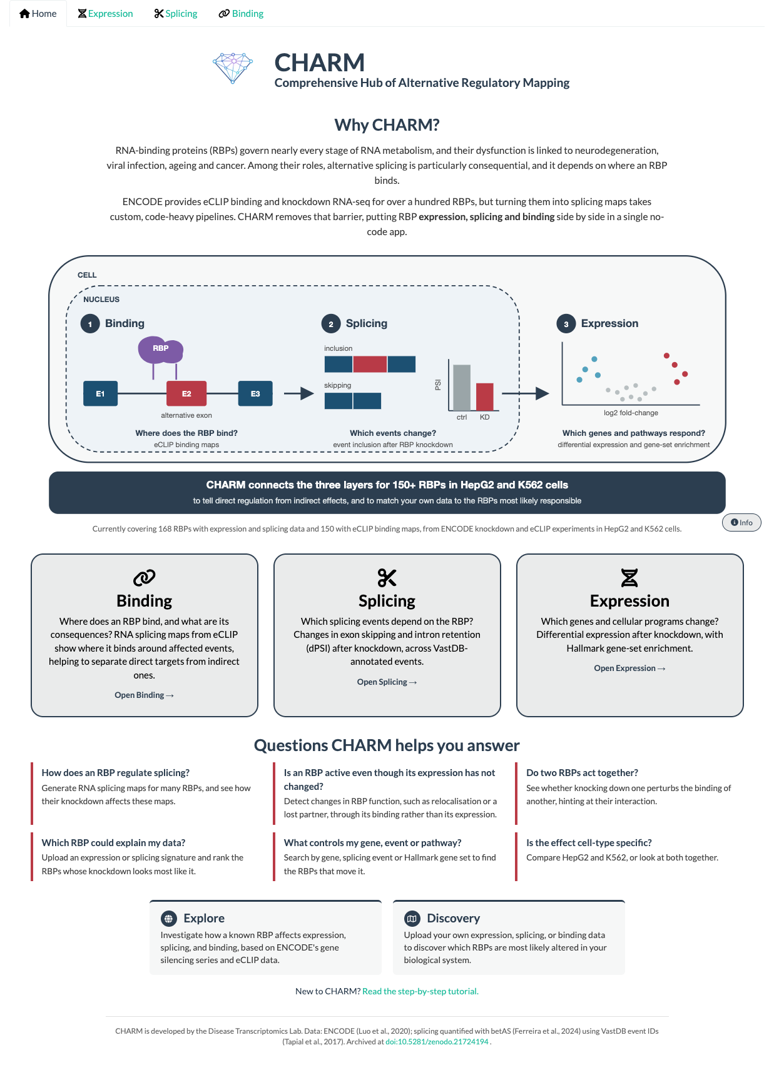
Supplementary Figure 1. CHARM's web app home screen. Screenshot of the CHARM application home screen, highlighting the three available usage modules, together with their respective descriptions, as well as some examples of the questions CHARM can help answer.
In Explore mode, users query a precomputed reference resource built from ENCODE shRNA-knockdown and eCLIP data across the HepG2 and K562 cell lines, spanning the RBPs for which both data types are available¹⁵. In Discovery mode, users upload their own differential expression or differential splicing results and compare them directly against this reference data, without needing to reprocess raw sequencing data or reproduce the underlying pipeline themselves.
Expression
The Expression module (Supplementary Figure 2) first provides exploratory plots that allow users to evaluate short hairpin RNA (shRNA) knockdown efficacy against ENCODE's matched controls (Figure 1A, B).
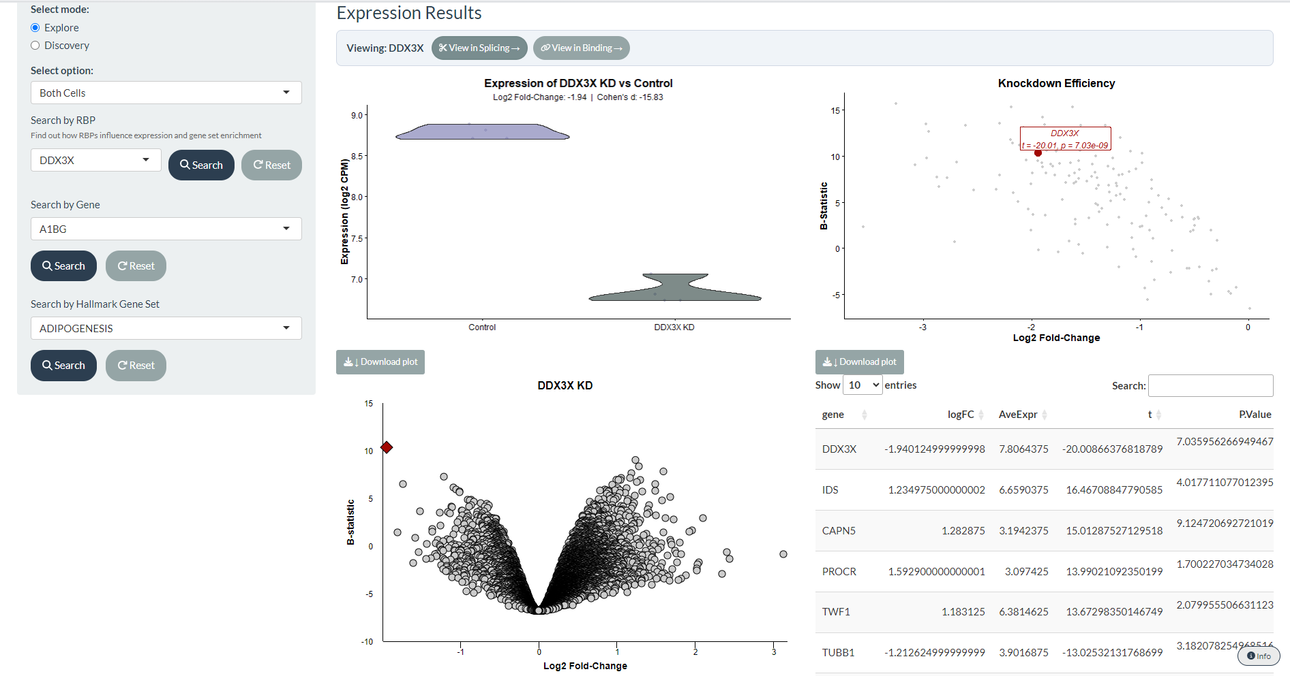
Supplementary Figure 2. Screenshot of CHARM’s Expression module. Users select a mode (Explore or Discovery), the cell-line scope of the analysis (both cell lines combined, K562 alone, or HepG2 alone), and a query type (by RBP knockdown, by gene, or by gene set); a separate Similar RBPs sub-mode allows users to identify RBPs with similar expression signatures. In the screenshot, DDX3X was selected as an example, showing the resulting expression plots for its knockdown. A full description of these plots is provided in Figure 1.
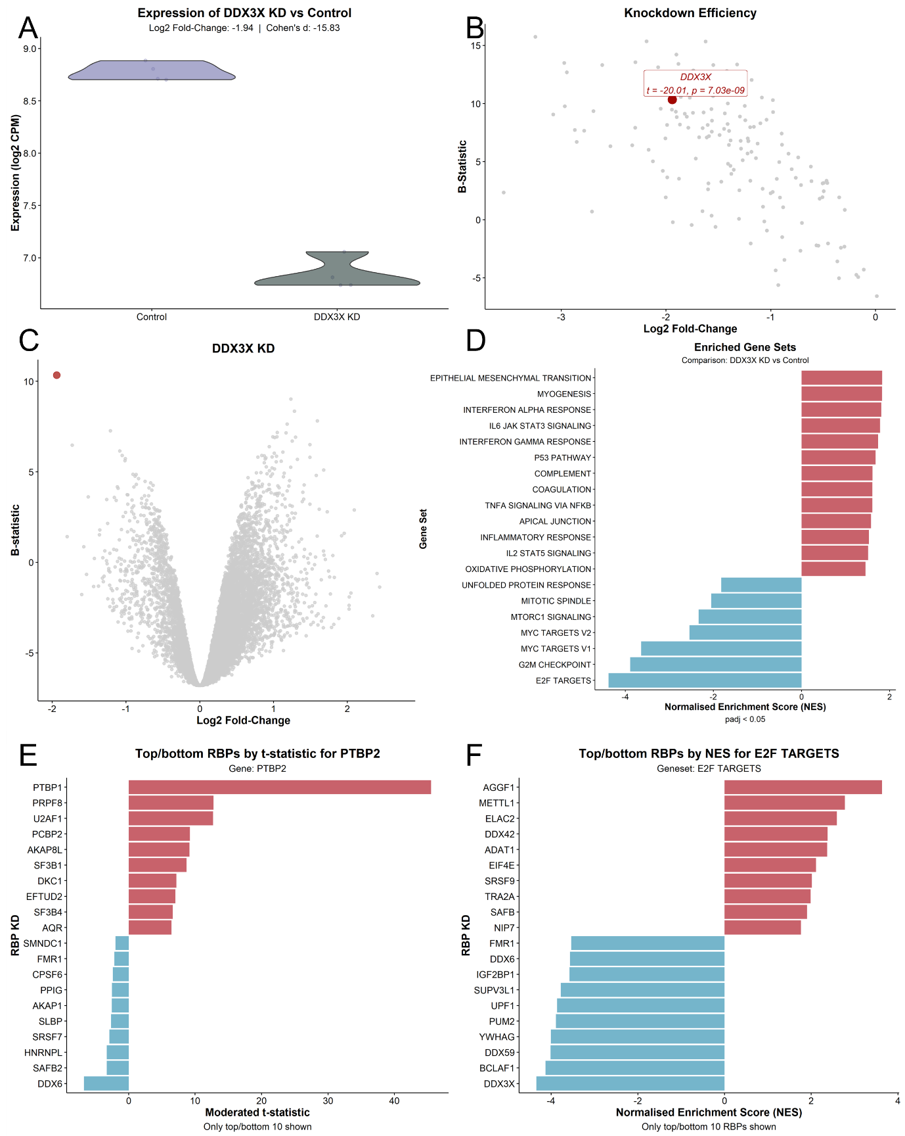
Figure 1. CHARM's Expression tab plots. (A) Violin plots of DDX3X expression (log₂ CPM) in K562 and HepG2 cells exposed to shRNA against DDX3X and respective controls¹⁵, batch-corrected for cell type (see Methods); log₂ fold-change and Cohen's d between the two sample types are shown above the plots. (B) Scatter plot of differential gene expression (DGE; x-axis, log₂ fold-change; y-axis, B-statistic) between K562 and HepG2 cells exposed to shRNA against RBPs and respective controls¹⁵, batch-corrected for cell type (see Methods); each dot is one shRNA-versus-control experiment; DDX3X is highlighted in red, with the t-statistic of DGE and the Benjamini–Hochberg-adjusted p-value shown above. (C) Volcano plot of DGE (x-axis, log₂ fold-change; y-axis, B-statistic) between K562 and HepG2 cells exposed to shRNA against DDX3X and respective controls¹⁵, batch-corrected for cell type (see Methods); genes as circles; DDX3X is highlighted in red. (D) Gene set enrichment analysis (GSEA) normalised enrichment scores (NES) for Hallmark gene sets, with genes ranked by the t-statistic of differential expression, between K562 and HepG2 cells exposed to shRNA against DDX3X and respective controls¹⁵, batch-corrected for cell type. (E) Moderated t-statistic of PTBP2 differential expression upon profiled RBP knockdowns, between K562 and HepG2 cells exposed to shRNA and respective controls¹⁵, batch-corrected for cell type (knockdowns with 10 most positive and 10 most negative t-statistics for PTBP2 DGE shown). (F) GSEA NES for the Hallmark E2F-targets gene set across profiled RBP knockdowns, with genes ranked by the t-statistic of differential expression, between K562 and HepG2 cells exposed to shRNA and respective controls¹⁵, batch-corrected for cell type (knockdowns with 10 most positive and 10 most negative NES of E2F-targets enrichment shown).
The module then presents a volcano plot of Differential Gene Expression (DGE) between knockdown and control conditions (Figure 1C), accompanied by a table of DGE metrics from limma–voom (t-statistic, log₂ fold-change, and Benjamini–Hochberg-adjusted p-value)²¹, together with a Gene Set Enrichment Analysis (GSEA)²² of the Hallmark gene collection²³ (Figure 1D) and its corresponding table (Normalised Enrichment Score (NES) and adjusted p-value; see Methods). As additional control, for GSEA results, selecting a gene set opens a window that compares the NES of the chosen RBP knockdown with (i) the distribution of the NES of that gene set across all RBP knockdowns and (ii) the distribution of NES obtained for random gene sets of the same size scored against the same rankings, from which an FPR is derived (Supplementary Figure 3; see Methods).
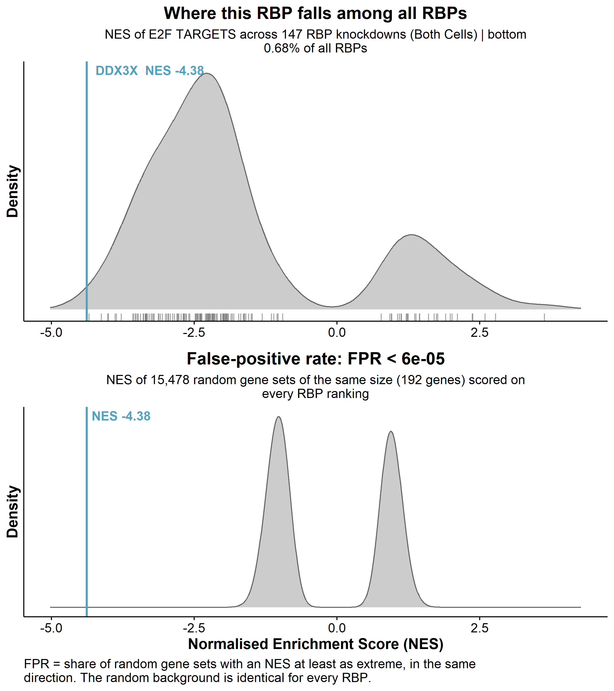
Supplementary Figure 3. CHARM’s GSEA gene-set window. In this example, the HALLMARK_E2F_TARGETS gene set was selected for DDX3X knockdown in K562 and HepG2 cells. (Top) Distribution of the Normalised Enrichment Score (NES) of the selected gene set across the knockdowns of all RBPs in the dataset. Vertical red line marks the NES observed for the selected RBP; percentile of the observed NES within this distribution reported in the subtitle. (Bottom) Distribution of NES obtained for random gene sets of the same size as the selected gene set, scored against the gene rankings of all RBP knockdowns. Vertical red line marks the NES observed for the selected RBP; the false-positive rate (FPR), the proportion of random gene sets with an NES at least as extreme as the observed one, reported in the subtitle. Together, the two panels indicate whether the enrichment is unusual for that gene set across RBPs and whether it exceeds what would be expected by chance for a gene set of that size.

As an example of the expression module capabilities, DDX3X knockdown depleted proliferation-associated gene sets (Figure 1D), such as E2F targets (Top 1% of RBPs that most deplete it, FPR < 6e-5), consistent with DDX3X's previously reported role in cancer-cell proliferation²⁴. Users can also query in reverse, identifying which RBP knockdowns most affect the expression of a chosen gene (Figure 1E) or the enrichment of a chosen Hallmark gene set (Figure 1F). For example, PTBP2 expression was most strongly upregulated by PTBP1 knockdown (Figure 1E), consistent with a previously described compensatory mechanism in B cells²⁵, and E2F-target enrichment was most strongly depleted by DDX3X (Figure 1F), consistent with what is described above (Figure 1D, Supplementary Figure 3)²⁴.
Users can additionally select a specific RBP KD and identify other RBPs whose KD produces similar expression alterations (quantified by Spearman’s correlation of t-statistics). G3BP1 KD, for instance, produced expression changes resembling those of TIA1 KD (Supplementary Figure 4), possibly reflecting the shared role of both proteins in phase separation and stress-granule (SG) assembly²⁶. As these correlations could be spurious, for each comparison CHARM also reports the percentile of the correlation among all RBP-pair correlations observed in the resource and a permutation-based false-positive rate (FPR; see Methods), plotting the displayed correlations against both background distributions (Supplementary Figure 4). A similar approach as described in Figure 1D and Supplementary Figure 3 is given if the user selects correlation by gene set enrichment.
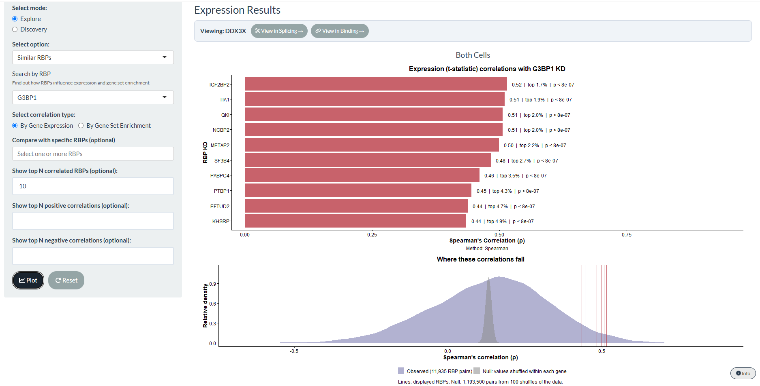
Supplementary Figure 4. Screenshot of CHARM's Similar RBPs feature, Expression tab. Bar plot of Spearman's correlation coefficient ρ between the t-statistics of differential expression between K562 and HepG2 cells exposed to shRNA against G3BP1 and respective controls¹⁵, and those of other RBP knockdowns and respective controls¹⁵ (i.e. which knockdown produces gene-expression alterations most similar to G3BP1 knockdown). All comparisons were batch-corrected for cell type (see Methods). The density plot below shows the distribution of ρ values between G3BP1 KD and all other RBP KD (observed), and the distribution of ρ values expected under a permutation null (see Methods). Vertical lines mark the ρ of the RBP KDs displayed in the bar plot. The percentile of each displayed ρ within the null distribution and the corresponding false-positive rate (FPR) are shown in the plot, next to each RBP KD’s bar. Users can scroll down to observe results pertaining to K562 and HepG2 cell lines alone, each with its own density plot and background distribution.
Finally, users can upload their own differential expression results (obtained, for example, from limma–voom) to compare them with those observed for the KD of a given RBP. They can also compare GSEA results derived from their own ranked differential expression statistics with those of individual RBP KD and identify the KDs that most closely resemble their data. As an example, we used data from U2-OS cells exposed to oxidative stress (arsenite)²⁷; The correlations with RBP knockdowns were generally weak, and even the strongest, FXR1 KD (ρ = 0.35), ranked only in the top 15% of all RBP knockdowns (Supplementary Figure 5), indicating that no single RBP KD alone closely reproduces this expression signature.
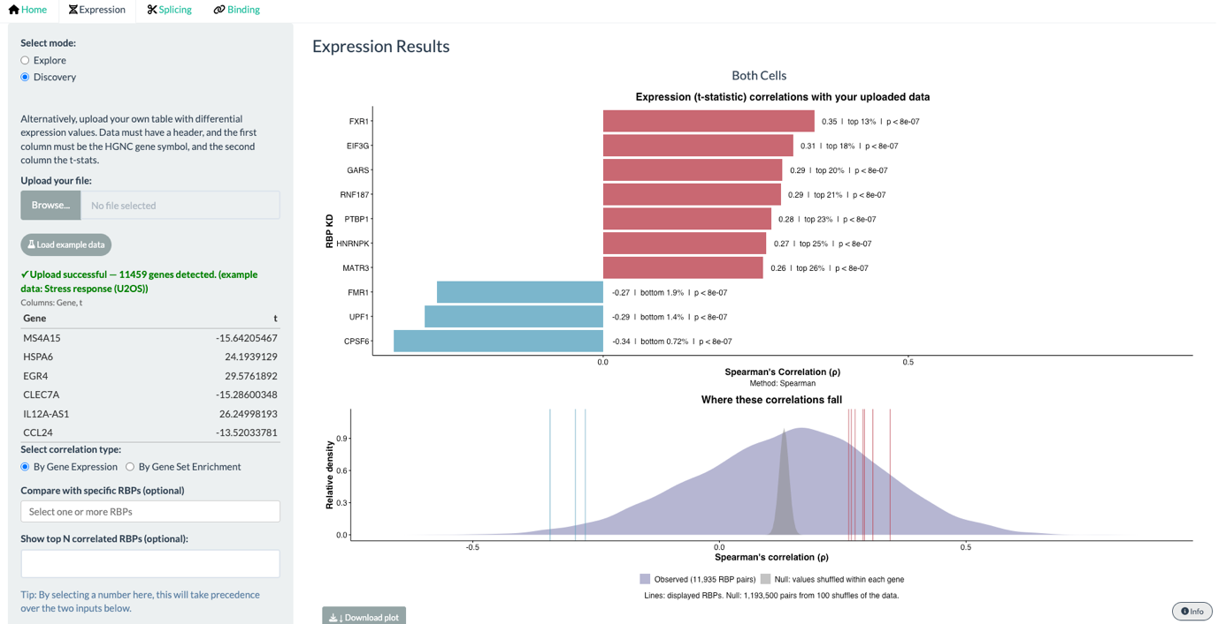
Supplementary Figure 5. Screenshot of CHARM's Discovery mode, Expression tab. Bar plot of Spearman's correlation coefficient ρ between t-statistics of differential expression from a user-submitted file (U2-OS cells exposed to oxidative stress²⁷) and from K562 and HepG2 cells exposed to shRNA against RBPs and respective controls¹⁵, corrected for cell type (i.e. which knockdown produces gene-expression alterations most similar to the user-submitted data). The density plot below shows the distribution of ρ values between the user’s submitted expression data and all other RBP KD (observed), and the distribution of ρ values expected under a permutation null (see Methods). Vertical lines mark the ρ of the RBP KDs displayed in the bar plot. The percentile of each displayed ρ within the null distribution and the corresponding false-positive rate (FPR) are shown in the plot, next to each RBP KD’s bar. Users can scroll down to observe results pertaining to K562 and HepG2 cell lines alone, each with its own density plot and background distribution.
Splicing
The Splicing module (Supplementary Figure 6; Figure 2) offers an analogous view for alternative splicing, quantified as proportion spliced-in (PSI; the proportion of transcripts including a given alternative exon or intron) and its change between conditions (dPSI). Users can visually examine the effect of an RBP's knockdown across annotated VastDB alternative splicing events¹² (Figure 2A, B), with an accompanying statistics table.
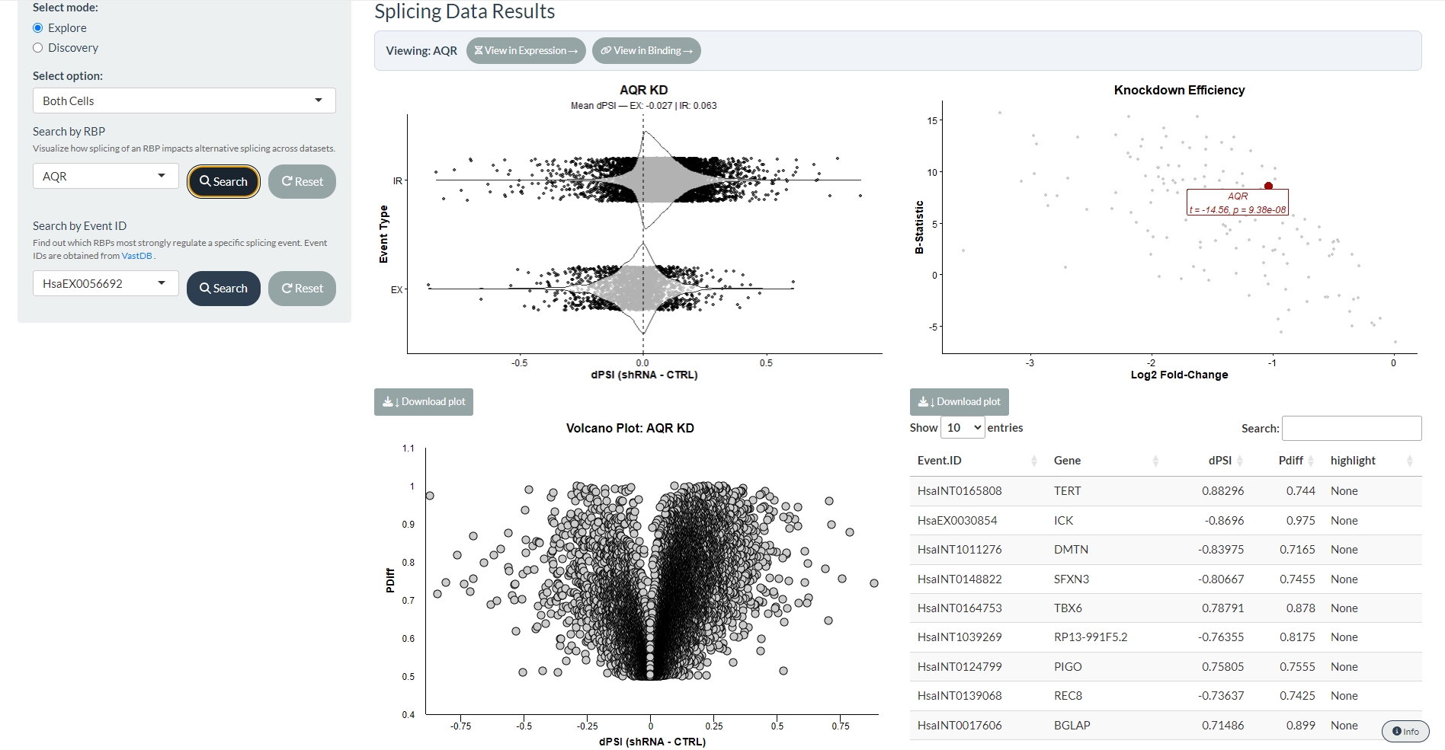
Supplementary Figure 6. Screenshot of CHARM’s Splicing module. Users select a mode (Explore or Discovery), the cell-line scope of the analysis (both cell lines combined, K562 alone, or HepG2 alone), and a query type (by RBP knockdown, or by event ID); a separate Similar RBPs sub-mode allows users to identify RBPs with similar splicing signatures. In the screenshot, AQR was selected as an example, showing the resulting splicing plots for its knockdown. A full description of these plots is provided in Figure 2.
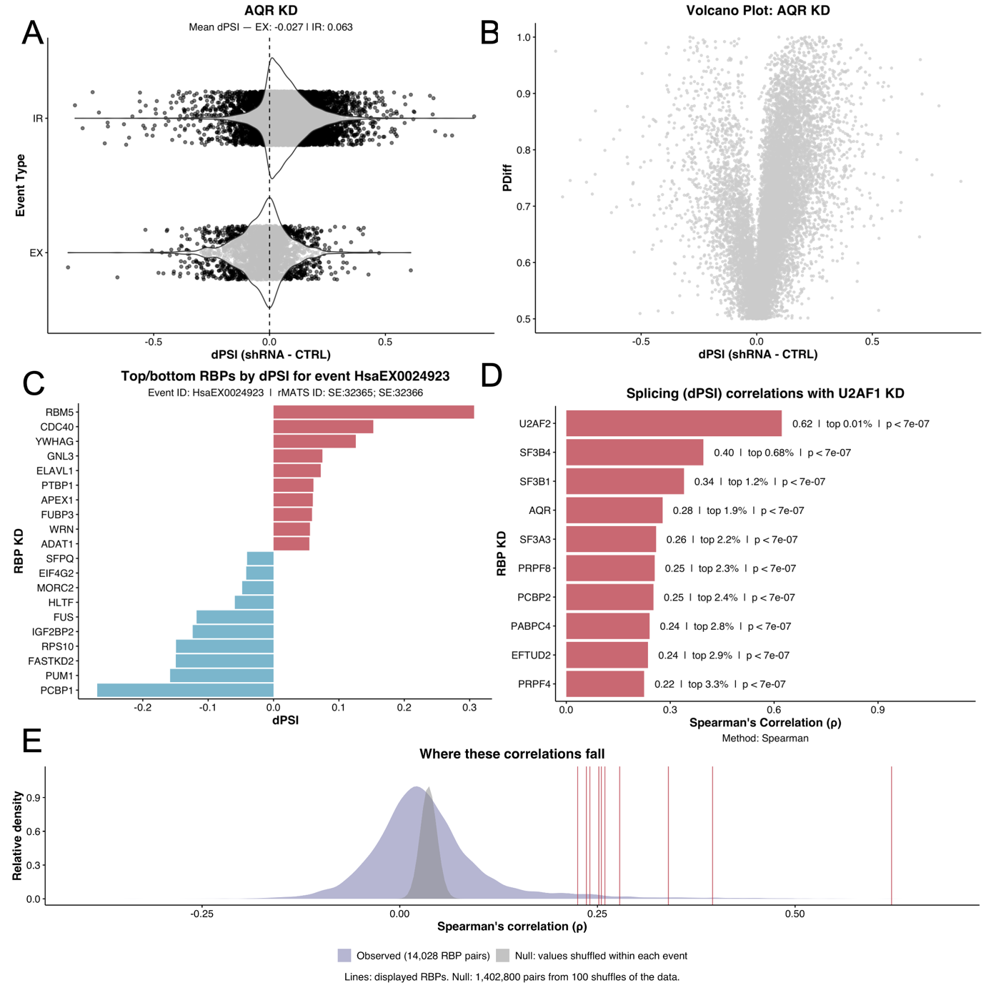

Figure 2. CHARM's Splicing tab plots. (A) Violin plots of differential intron retention (IR) and “cassette” exon inclusion (ES) events (dPSI) in K562 and HepG2 cells exposed to shRNA against AQR and respective controls¹⁵, batch-corrected for cell type (see Methods); the mean dPSI for each event type is shown above the plots. (B) Volcano plot of differential splicing analysis (DSA; x-axis, dPSI; y-axis, P_{diff} (probability of differential splicing)²⁹) between K562 and HepG2 cells exposed to shRNA against AQR and respective controls¹⁵, batch-corrected for cell type; each dot is one alternative splicing event. (C) Bar plot of dPSI of exon HsaEX0024923¹² across profiled RBP knockdowns, between K562 and HepG2 cells exposed to shRNA and respective controls¹⁵, batch-corrected for cell type (knockdowns with 10 most positive and 10 most negative effects on the exon’s inclusion shown). (D) Bar plot of Spearman’s correlation coefficient ρ between the dPSI of K562 and HepG2 cells exposed to shRNA against U2AF1 and respective controls, and those of other RBP KDs and respective controls (i.e. which knockdowns produce splicing alterations most similar to U2AF1 knockdown), batch-corrected for cell type (see Methods); the KDs with the most positive correlations are shown, with the percentile of each ρ and its permutation-based false-positive rate (FPR) indicated next to the bars. (E) Density plot of the distribution of ρ values between U2AF1 KD and all other RBP KDs (observed), together with the distribution expected under a permutation null (see Methods); vertical lines mark the ρ values of the KDs displayed in (D).

AQR knockdown, for example, increased intron retention and decreased exon inclusion (Figure 2A), consistent with its established role as a core component of the spliceosome³⁰. As with the Expression module, users can perform a reverse search to identify which RBP knockdowns most affect the inclusion of a chosen VastDB-annotated exon or intron¹². HsaEX0024923, corresponding to exon 6 of FAS, whose inclusion promotes apoptotic signalling, was more included upon RBM5 knockdown (Figure 2C), consistent with RBM5's established role in regulating this exon³¹. Users can likewise identify which RBP knockdowns produce the most similar splicing signatures. U2AF1 knockdown, for example, produced splicing alterations closely resembling those of U2AF2 knockdown (Figure 2D), consistent with their function as an obligate heterodimer³². Percentiles and permutation-based FPRs are reported for splicing correlations as for expression. To facilitate comparison with rMATS-based analyses, rMATS event IDs (exon skipping and intron retention) are displayed alongside the VastDB IDs and can be used to search for an event; these identifiers are assigned by matching coordinates and are not independently quantified (see Methods).
Finally, users can upload their own differential splicing results (e.g. from betAS²⁹). As a positive control, we used an independent SF3B1 KD in IMR90 cells³⁹, distinct from either ENCODE cell line. As expected, this dataset showed a very strong correlation with ENCODE’s SF3B1 KD (ρ = 0.65), far beyond the background distribution (percentile = 0.01%; Supplementary Figure 7).

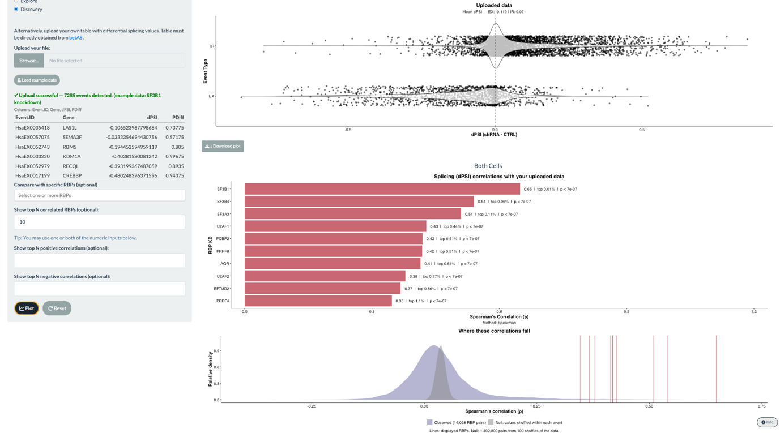
Supplementary Figure 7. Screenshot of CHARM’s Discovery mode, Splicing tab. (Top) Violin plot of user-supplied DSA of EX events (dPSI) (SF3B1 KD in IMR90 cells³⁹); mean dPSI is shown above the plot. (Bottom) Bar plot of Spearman’s correlation coefficient ρ between the user-supplied dPSI and those of K562 and HepG2 cells exposed to shRNA against RBPs and respective controls, batch-corrected for cell type (see Methods) (i.e. which knockdowns produce splicing alterations most similar to the user-supplied data). Below the bar plot, a density plot shows the distribution of ρ values between the user-supplied data and all RBP knockdowns (observed), together with the distribution expected under a permutation null (see Methods); the percentile and false-positive rate (FPR) of the displayed KDs are indicated in the plots.

Binding
The Binding module (Supplementary Figure 8) allows users to observe how the KD of an RBP alters RBP-RNA binding across alternative splicing events, through RNA splicing maps.
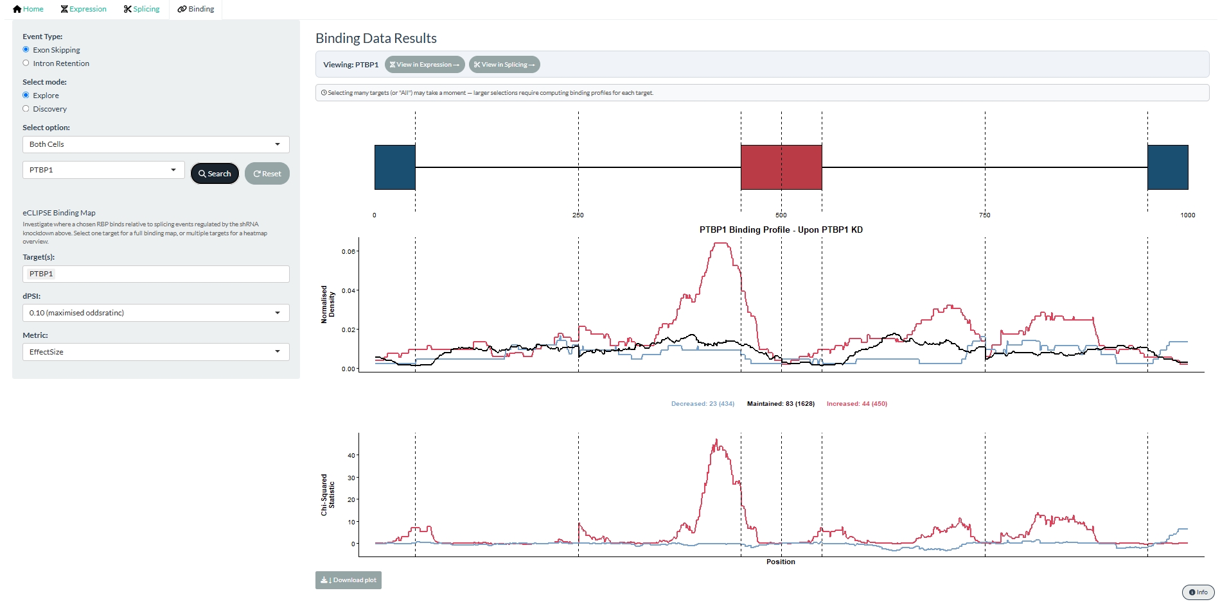
Supplementary Figure 8. Screenshot of CHARM’s Binding module. Users select a mode (Explore or Discovery) and the cell-line scope of the analysis (both cell lines combined, K562 alone, or HepG2 alone). A separate Similar Profiles sub-mode allows users to identify shRNA/eCLIP pairs with similar binding profiles. Users select the shRNA-knockdown RBP of interest, the eCLIP target RBP(s) of interest, the dPSI threshold used for event classification, and the metric to be plotted (FDR or Effect Size). In the screenshot, PTBP1 was selected as both the KD RBP and the eCLIP target, showing the resulting binding and splicing alterations associated with its own knockdown. A full description of these plots is provided in Figure 3.
For a chosen knockdown, it displays the normalised eCLIP binding density of any selected RBP across increased (more included), decreased (less included), and unchanged exons/introns upon knockdown (see Methods), together with position-wise statistical support for differential binding, separately for “cassete” exon inclusion (Figure 3A) and intron retention (Figure 3B). This allows users to ask not only whether an RBP’s baseline binding is enriched specifically at the exons whose splicing it itself regulates, consistent with a direct effect, but also whether knocking down a different RBP shifts the apparent binding-enrichment pattern of a given RBP, revealing indirect regulatory relationships (Figure 3C).
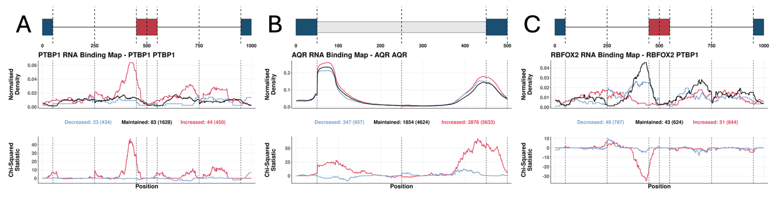
Figure 3. CHARM's Binding tab plots. (A, C) RNA binding maps of “cassette” exon events, showing PTBP1 eCLIP binding profiles in cells treated with shRNA against PTBP1 (A) or against RBFOX2 (C). (Top) Schematic of a generic pre-mRNA showing the metagenomic regulatory sequences that define the RBP binding map around an alternative exon. (Middle) Normalised binding of PTBP1 across those sequences flanking alternative exons. The plot discriminates exons whose inclusion decreased (blue), increased (red), or was unchanged (black) upon PTBP1 (A) or RBFOX2 (C) knockdown. The total number of events in each category is given in brackets beneath the plot, preceded by the number of events for which at least one PTBP1 binding site was detected. (Bottom) Chi-squared statistic for differential binding at decreased-inclusion (blue) or increased-inclusion (red) events, relative to unchanged events. Vertical lines delimit the following metagenomic splicing regulatory regions, in order: last 50 nt of the upstream constitutive exon; first 200 nt of the upstream intron; last 200 nt of the upstream intron; first 50 nt of the alternative exon; last 50 nt of the alternative exon; first 200 nt of the downstream intron; last 200 nt of the downstream intron; first 50 nt of the downstream constitutive exon. (B) RNA binding maps of intron retention events, showing AQR eCLIP binding profiles in cells treated with shRNA against AQR. (Top) Schematic of a generic pre-mRNA showing the metagenomic regulatory sequences that define the RBP binding map around an intron retention event. (Middle) Normalised binding of AQR across those sequences flanking prospectively retained introns, discriminating introns whose retention decreased (blue), increased (red), or was unchanged (black) upon AQR knockdown; total event numbers and AQR-bound event numbers as in (A). (Bottom) Chi-squared statistic as in (A); vertical lines delimit: last 50 nt of the upstream constitutive exon; first 200 nt of the prospectively retained intron; last 200 nt of the prospectively retained intron; first 50 nt of the downstream constitutive exon. In all plots dPSI threshold for category definition was selected as the value which maximised the Chi-Squared Statistic (see Methods). These were 0.1 (A), 0.05 (B), and 0.02 (C).

As a positive control, PTBP1 is known to promote exon skipping when binding to the polypyrimidine tract of the upstream intron¹³. Accordingly, PTBP1 knockdown resulted in enriched PTBP1 binding at the polypyrimidine tracts of introns upstream of exons whose inclusion increased upon knockdown (i.e. exons normally more skipped under wild-type conditions)¹³ (Figure 3A). The same logic applies to AQR knockdown, which enriched AQR binding at downstream intronic regions, consistent with its role in intron excision³⁰ (Figure 3B). As an example of an indirect target, RBFOX2 knockdown depleted the enrichment of PTBP1 binding at exons whose inclusion increased (Figure 3C), suggesting antagonistic roles for the two proteins at a subset of shared target events. Indeed, a related mechanism, in which a third factor, SON, coordinates opposing PTBP1/PTBP2 and RBFOX2 activities, has been described in glioblastoma³⁴.
Alternatively, users can obtain a heatmap overview of the binding alterations occurring across many RBPs upon a chosen knockdown (Supplementary Figure 9). Consistent with its role as a core splicing factor³², SF3B1 knockdown altered the binding of numerous other RBPs (Supplementary Figure 9).

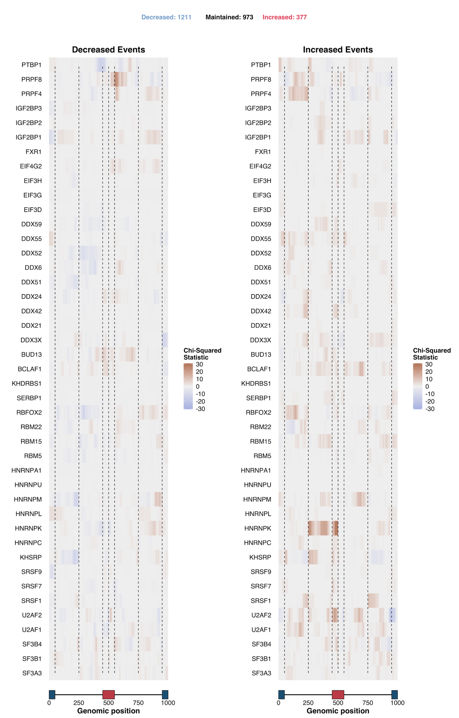
Supplementary Figure 9. Heatmap of RNA binding maps of alternative exon splicing events in cells treated with shRNA against SF3B1. Chi-squared differential-binding statistic for decreased-inclusion (left) or increased-inclusion (right) events, relative to unchanged events. Total event numbers per category are given above the heatmaps. Vertical lines delimit the metagenomic splicing regulatory regions as defined in Figure 3A/C.
In the Similar Profiles sub-mode, users can select a given RBP's binding profile under a specific knockdown and identify the most similar profiles across the reference resource. For additional context, for a chosen query profile, the correlation with the self profile of its target (the binding of the target RBP under its own knockdown) is displayed against three reference distributions: all profile pairs, profiles of the same eCLIP target under different knockdowns, and the self profile against the other profiles of that target. The profile of U2AF1 binding under U2AF1 knockdown, for instance, was most similar to that of U2AF1 binding under U2AF2 knockdown (Supplementary Figure 10), consistent with their function as a heterodimer³² (see Methods).
Finally, users can upload their own splicing dataset to generate RNA binding maps and identify which RBPs' binding patterns are altered upon a given perturbation, similar to what users can do in Explore mode, but using their own data instead of ENCODE’s shRNA.
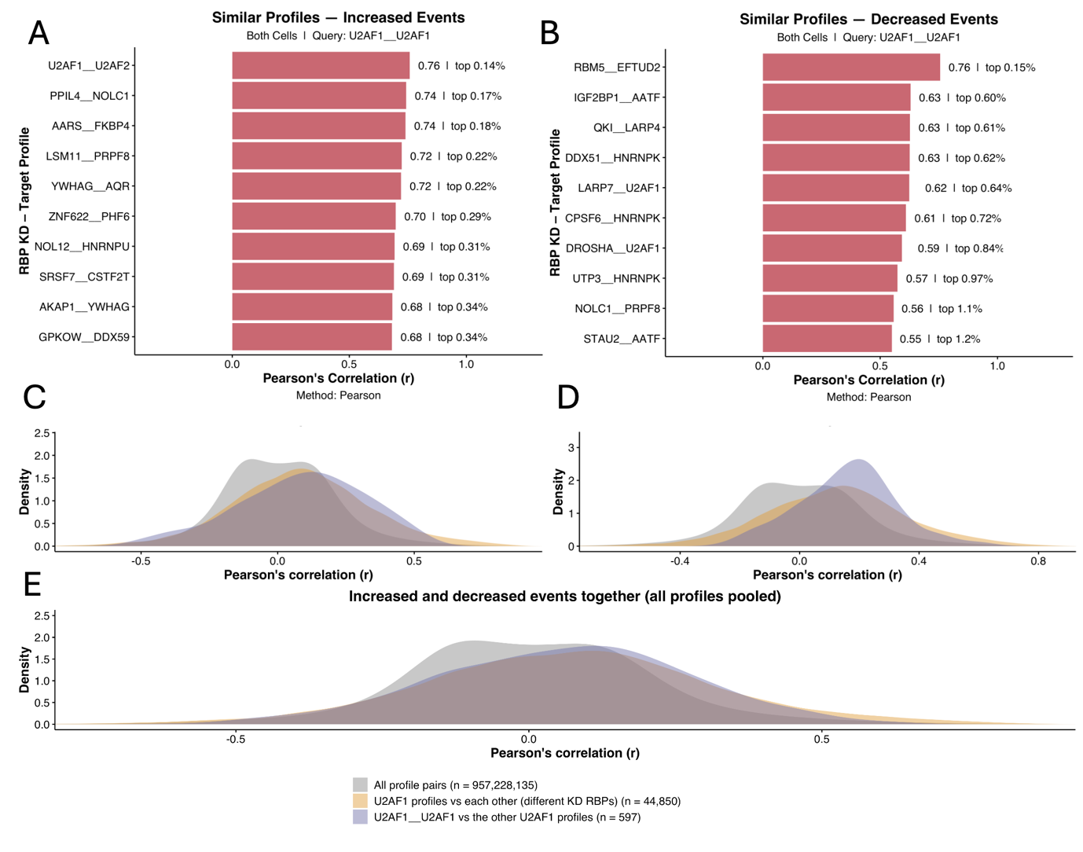Supplementary Figure 10. (A, B) Bar plots of Pearson’s correlation coefficient r between the Chi-squared differential-binding statistic of U2AF1 upon U2AF1 KD and that of U2AF1 upon other RBP KDs (i.e. which RBP KD produces the most similar binding profile to U2AF1’s upon U2AF1 KD), for events with increased (A) and decreased (B) inclusion; the percentile of each r among all profile pairs is indicated next to the bars. (C, D) Density plots of the distribution of r for increased (C) and decreased (D) events, comparing all profile pairs (grey), U2AF1 binding profiles upon different RBP knockdowns (yellow) and the U2AF1 profile upon U2AF1 KD against the remaining U2AF1 profiles (purple); densities are area-normalised and n indicates the number of profile pairs. (E) Density plot of the distribution of r for increased and decreased events pooled together (see Methods). All plots pertain to K562 and HepG2 cells exposed to shRNA against RBPs and respective controls, batch-corrected for cell type (see Methods).

Case study applications of CHARM
TIA1 localisation into stress granules alters splicing
A central limitation of expression-centric RBP analysis is that many biologically meaningful changes in RBP activity result from no mRNA expression alterations. Subcellular relocalisation, post-transcriptional or translational modifications, and disruption of an interacting partner can each abolish or redirect an RBP's function without changing how much of its mRNAis present. Because CHARM also infers RBP activity through binding rather than from expression, it is positioned to detect this class of alteration.
We used TIA1 sequestration into stress granules (SGs) as a worked example of this expression-independent functional detection, building on our previous work³⁵. Under stress, TIA1 relocalises from a predominantly nuclear distribution to cytoplasmic SGs. Since splicing occurs in the nucleus, we hypothesised that this sequestration would perturb TIA1's splicing-regulatory activity even without any change in its expression. We therefore used an RNA-seq dataset of U2-OS and A549 cells exposed to a viral dsRNA mimic, comparing cells that were wild-type or knockout for G3BP1, a factor required for SG assembly under these conditions³⁶. In both cell backgrounds, TIA1 showed little evidence of differential expression upon stress (Figure 4A). If SG sequestration impairs TIA1's splicing-regulatory function, its binding under stress should resemble binding under TIA1 knockdown, since both conditions functionally deplete TIA1 activity at its splicing targets. Consistent with this, TIA1 binding under SG-competent stress conditions correlated with TIA1 binding under TIA1 knockdown, in both HepG2 and K562 cells (Pearson's r = 0.44, see Methods) (Figure 4B). This correlation could, however, reflect a generic effect of cellular stress rather than SG sequestration specifically. We therefore also examined TIA1 binding in G3BP1-knockout cells under the same viral dsRNA-mimic stress, a condition that induces stress without SG assembly, and found this binding profile to be much less similar to the knockdown profile (Pearson's r = 0.07, see Methods), consistent with the effect being SG-dependent rather than a non-specific consequence of stress. As a comparison, we examined YBX3, an SG-localised protein³⁷ whose functional alteration under stress is reflects stress generally rather than SG formation specifically. Accordingly, YBX3 binding profile under YBX3 knockdown correlated with YBX3 binding profile both with and without SG assembly (r = 0.77 and r = 0.64, respectively) (Figure 4C).
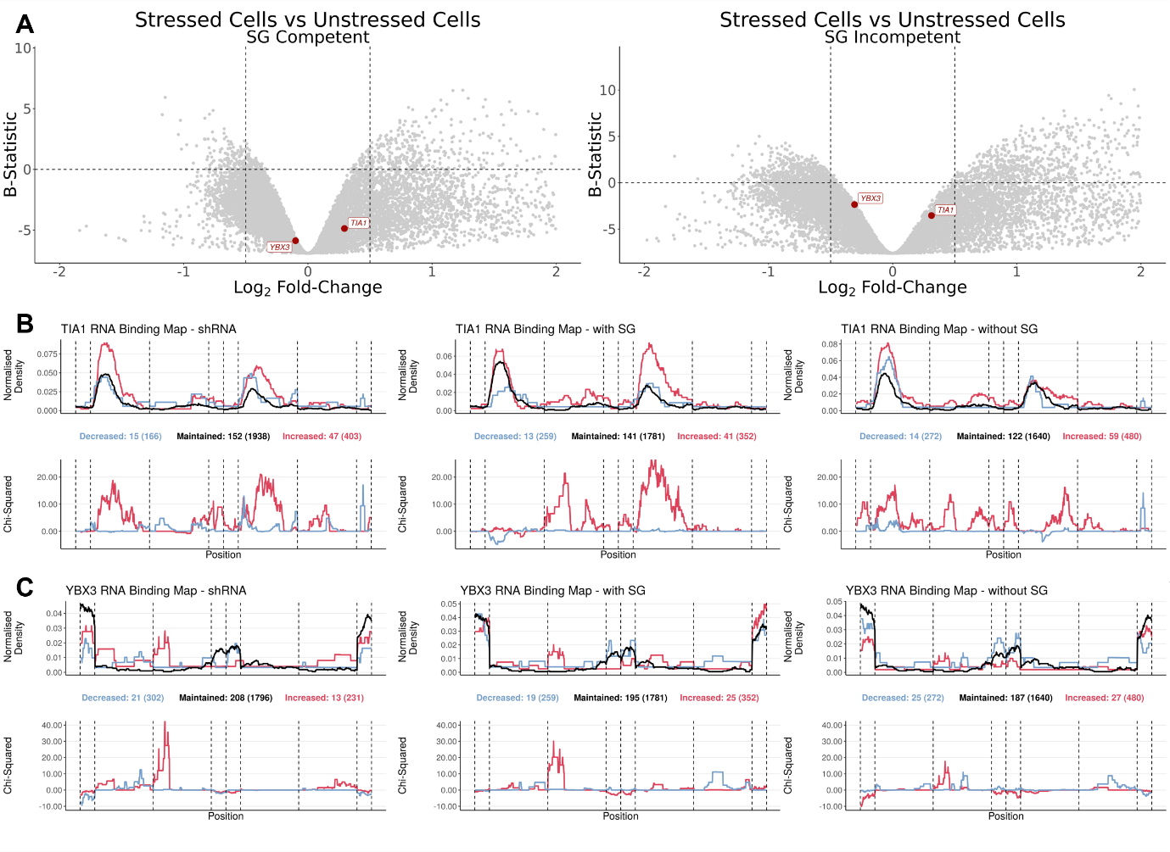
Figure 4. Alternative splicing alterations in stress-granule-competent and -incompetent cells. (A) Volcano plots of DGEA between stressed and unstressed cells (x-axis, Log₂ fold-change; y-axis, B-statistic) in SG-competent (left) and SG-incompetent (right) U2-OS and A549 cells exposed to a viral dsRNA mimic as a stressor³⁸; each dot is one gene, with TIA1 and YBX3 highlighted in red. Vertical dashed lines mark log₂ fold-change = −0.5 and 0.5; the horizontal dashed line marks B-statistic = 0. Only genes with −2 < log₂ fold-change < 2 are plotted. (B, C) RNA binding maps of “cassette” exon events, showing TIA1 (B) and YBX3 (C) eCLIP binding profiles in shRNA-treated cells against TIA1 (B) and YBX3 (C) obtained from ENCODE¹⁵ (left), in SG-competent cells (middle), and in SG-incompetent cells (right). (Top) Normalised binding of the RBP of interest across metagenomic regulatory sequences flanking alternative exons. The plot discriminates exons whose inclusion decreased (blue), increased (red), or was unchanged (black) upon RBP knockdown (left) or upon dsRNA stress, in SG-competent (middle) and SG-incompetent (right) cells. The total number of events in each category is given in brackets beneath the plot, preceded by the number of events for which at least one RBP binding site was detected (Bottom) Chi-squared statistic for differential binding at decreased-inclusion (blue) or increased-inclusion (red) events, relative to unchanged events. Vertical lines delimit the following metagenomic splicing regulatory regions, in order: last 50 nt of the upstream constitutive exon; first 200 nt of the upstream intron; last 200 nt of the upstream intron; first 50 nt of the alternative exon; last 50 nt of the alternative exon; first 200 nt of the downstream intron; last 200 nt of the downstream intron; first 50 nt of the downstream constitutive exon.

Taken together, these results show that CHARM can distinguish a condition-specific loss of RBP function, from both unrelated stress-response signal and genuine expression-driven effects, where expression data are used to rule out the latter, and binding-derived splicing signatures to detect the former.
Stress-granule sequestration is just one mechanism by which this can occur; the same detection logic applies, without modification, to any other RBP whose function is altered post-translationally, or through any other means that leaves expression unchanged.
RBM39 and the U2AF complex
A second limitation of standard RBP analyses restricted to an RBP's own binding and splicing data is that they can only reveal direct regulatory relationships. Many RBPs function as members of larger complexes, or through cooperative binding with other RBPs, such that perturbing one factor can alter the activity of its partners. These indirect relationships are, by construction, invisible to any analysis confined to a single RBP's own eCLIP and knockdown data. Identifying them requires systematically examining how the knockdown of one RBP reshapes the binding profiles of others.
In previous work, we found that RBM39 knockdown led to splicing alterations³⁹. However, the mechanism underlying these alterations was unclear, as RBM39 itself showed limited direct binding at the affected alternative splicing events³⁹. Examining indirect binding alterations,we found that RBM39 knockdown altered U2AF1 and U2AF2 binding in a manner consistent with their own respective knockdown profiles (Figure 5A–C). Splicing alterations induced by RBM39 knockdown also correlated with those induced by U2AF1 and U2AF2 knockdown, albeit less strongly than U2AF1 and U2AF2 knockdown correlated with each other, suggesting that RBM39 partly modulates this complex (Figure 5D).
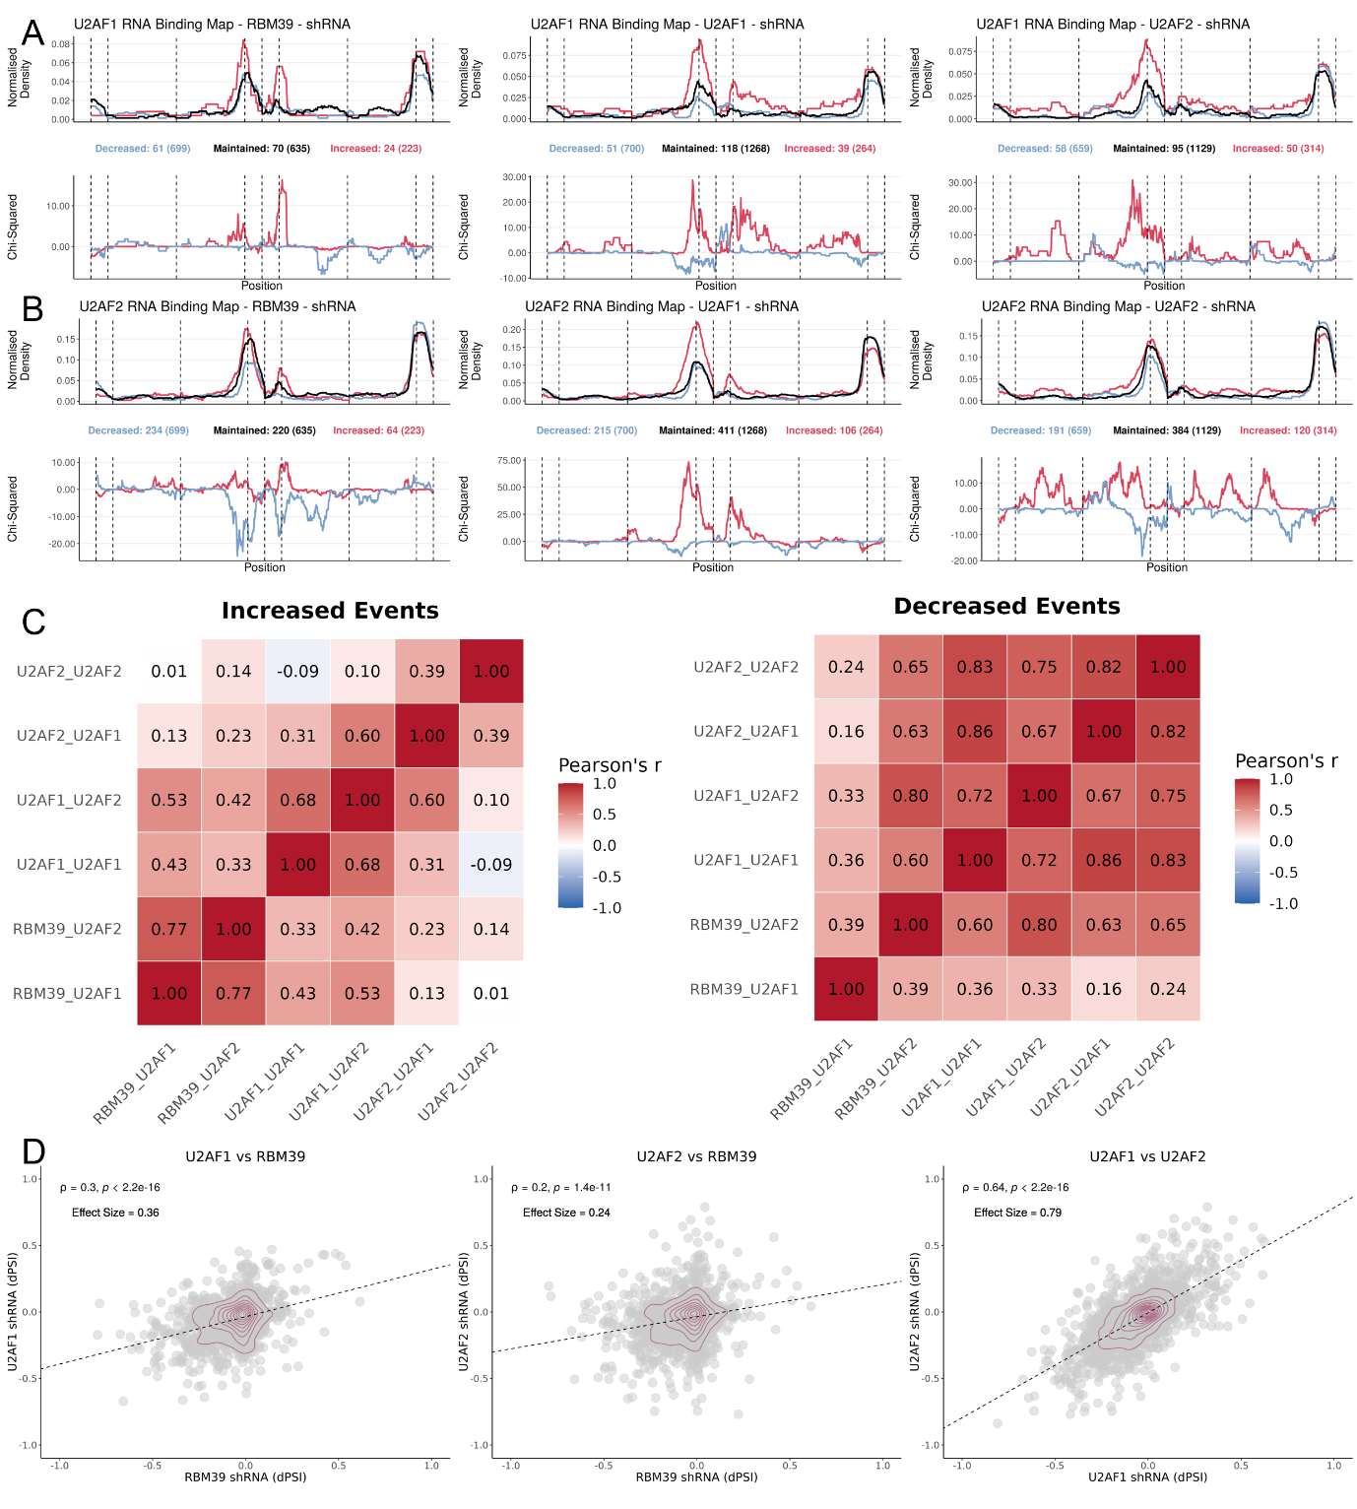
Figure 5. RBM39 knockdown produces alterations similar to U2AF1/U2AF2 knockdown. (A, B) RNA binding maps of “cassette” exon events, showing U2AF1 (A) or U2AF2 (B) eCLIP binding profiles in cells treated with shRNA against RBM39 (left), U2AF1 (middle), or U2AF2 (right). (Top) Normalised binding of the RBP of interest across metagenomic regulatory sequences flanking alternative exons. The plot discriminates exons whose inclusion decreased (blue), increased (red), or was unchanged (black) upon RBP knockdown. The total number of events in each category is given in brackets beneath the plot, preceded by the number of events for which at least one PTBP1 binding site was detected. (Bottom) Chi-squared statistic for differential binding at decreased-inclusion (blue) or increased-inclusion (red) events, relative to unchanged events. Vertical lines delimit the following metagenomic splicing regulatory regions, in order: last 50 nt of the upstream constitutive exon; first 200 nt of the upstream intron; last 200 nt of the upstream intron; first 50 nt of the alternative exon; last 50 nt of the alternative exon; first 200 nt of the downstream intron; last 200 nt of the downstream intron; first 50 nt of the downstream constitutive exon. (C) Heatmap of Pearson's correlation coefficient between chi-squared differential-binding statistics for several shRNA–RBP pairs, for increased- (left) or decreased-inclusion (right) events (i.e. how similar the red or blue binding profiles from (A) and (B) are to one another); labels follow the convention "shRNA treatment_RBP binding". (D) Scatter plots of DSA in dPSI between K562 and HepG2 cells exposed to shRNA against U2AF1 or U2AF2¹⁵, batch-corrected for cell type, and IMR90 cells exposed to shRNA against RBM39³⁹: (left) U2AF1 KD (y-axis) versus RBM39 KD (x-axis); (middle) U2AF2 KD (y-axis) versus RBM39 KD (x-axis); (right) U2AF2 KD (y-axis) versus U2AF1 KD (x-axis); each dot is one alternative splicing event; density contours in dark red; Spearman's correlation coefficient ρ and the corresponding test's p-value are shown above.

Because U2AF1 and U2AF2 function as an obligate heterodimer that recognises the 3′ splice site, this pattern is consistent with RBM39 functioning within, or in cooperation with, the U2AF complex, even though splicing alterations triggered by RBM39 knockdown occur largely independently from RBM39 direct RNA binding targets. This result illustrates another specific capability that CHARM is designed to provide: identifying a candidate regulatory relationship that would not have been apparent from any analysis of RBM39 in isolation, and that becomes visible only when the binding profile of its potential partners is examined systematically alongside it.
Discussion
CHARM's differentiator relative to existing RBP analysis resources is not a novel statistical framework for splicing-map construction, but the integration of expression, splicing, and binding analyses within a single, browser-accessible, no-code interface built directly on public data. Tools such as rMAPS2¹⁷ generate splicing maps from user-supplied CLIP and RNA-seq data but stop short of providing a precomputed, browsable reference resource spanning many RBPs, and tools such as RBP Browser¹⁸ reveal putative interactions between RBPs from eCLIP and CRISPR-knockout data, but do not allow users to generate RNA binding maps directly. To our knowledge, none of studies employing methods conceptually similar to ours ^{19,20} offers no-code access to indirect, complex-level RBP regulatory inference. We regard this as a genuine capability gap in currently available resources rather than a claim of analytical superiority, and we do not present CHARM as a replacement for specialised pipelines, but as a means of extending their reach to researchers who would not otherwise use them.
Several limitations warrant explicit acknowledgement. First, knockdown–cell combinations in the reference resource derive from a single resource, ENCODE¹⁵ (see Methods). Thus, the absence of replicates from other sources means that reported effects cannot be distinguished from experiment-specific technical variability. Additionally, only two cell types are available, and in the form of cell lines, K562 and HEPG2, which accrue within-cell-type variability⁴⁰. Second, CHARM's binding data are currently derived exclusively from eCLIP. Newer techniques such as iCLIP2 offer higher spatial resolution of RBP-binding sites⁴¹, and integrating a sufficiently large iCLIP2 dataset, should one become available, represents a natural extension of the eCLIPSE pipeline. Third, CHARM's splicing analyses currently cover ”cassette” exon and intron retention events only, not extending to alternative splice-site (5′ or 3′) usage, like rMAPS2¹⁷ does. Extending the eCLIPSE splicing-genome framework to these event types is a natural direction for future development. Fourth, CHARM relies on VastDB’s pre-annotated catalogue of alternative splicing events¹², and consequently works exclusively with splicing quantifications generated by VAST-TOOLS¹². This dependency makes CHARM's splicing-genome framework difficult to reconcile with output from other splicing-quantification tools, such as MAJIQ⁴² or rMATS⁴³, whose event definitions and coordinate systems differ from VastDB's. rMATS, however, reports events in a fixed format that is structurally compatible with VastDB's event-based approach. We generated a corresponding rMATS-compatible splicing genome, provided as Supplementary Material, allowing rMATS-quantified data to be used locally.
Taken together, we present CHARM not as a comprehensive replacement for specialised RBP analysis pipelines, but as a framework that lowers the practical barrier to a specific and recurring category of question: how does a given RBP function independently of its expression, and with which other RBPs does it plausibly interact? We believe that making these questions tractable without requiring computational expertise has direct value for hypothesis generation in RBP biology.
Methods
Sample pre-processing
RNA-seq data from ENCODE gene-silencing experiments targeting RBPs with matched eCLIP data were obtained for the HepG2 and K562 cell lines, using shRNA-mediated knockdown or CRISPR-based perturbation^{15,16}. For each cell line and target, the default, non-archived experiment was selected, with CRISPR-based perturbations preferred when multiple default options were available. Raw reads (FASTQ format) were trimmed for adapter sequences and quality filtered using Trimmomatic (v0.39)⁴⁴, and alternative splicing was quantified with VAST-TOOLS (v2.5.1), following the align (against the hg38 reference genome, Ensembl v88) and combine steps¹².
All expression analyses within CHARM were performed using the “RPKM_AND_COUNTS” files, obtained from Bowtie⁴⁵/VAST-TOOLs¹².
Raw gene read counts were first filtered to remove lowly expressed genes. For each gene, raw counts were summed across all samples within a given experiment (i.e. across both the shRNA-treated and control samples), and genes whose log10-transformed summed count fell below 2.75 were excluded from downstream analysis.. Filtered read counts were then used to calculate library size scaling factors using the trimmed mean of M-values⁴⁶ (TMM; calcNormFactors function from edgeR (v3.36.0)⁴⁷). Those read counts were subsequently normalised and log₂-transformed using the voom⁴⁸ function from limma (v.3.50.3)⁴⁹.

Differential splicing analysis
Differential splicing was assessed using a modified version of the betAS (v1.2.1) R package²⁹. By default, betAS’s alternativeEvents function excludes events in which at least one sample does not meet the PSI thresholds of 0,01 ≤ PSI ≤ 0.99. Applied alone, however, this fixed threshold retains events that are effectively constitutive, because their PSI happens to fall just inside this range across the available samples, and discards events that are genuinely alternative. This would shrink the pool of alternative events available for analysis, limiting the number of unchanged events, also informative, To improve specificity, we additionally incorporated prior information from VastDB's MAIN PSI table¹²: for each exon-skipping event, the average PSI and its variance were computed across the tissues and cell types in that table, and only events meeting at least one of the following empirical criteria were retained for downstream analysis: variance ≥ 750, or average PSI between 0.125 and 0.875 (Supplementary Figure 11). For the ENCODE shRNA experiments¹⁵, HepG2 and K562 data (treated with scrambled shRNA controls) were processed jointly using this modified betAS pipeline. For the viral dsRNA mimic experiments³⁶, A549 and U2-OS were likewise processed jointly.
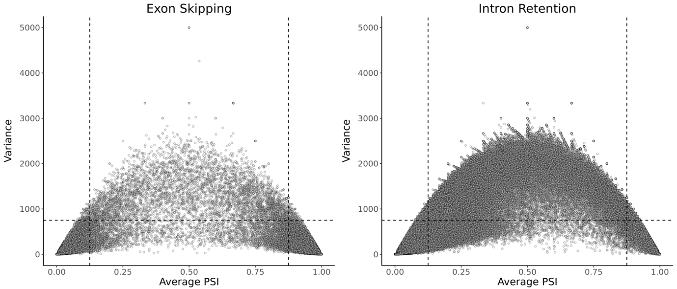
Supplementary Figure 9. Scatter plots of average PSI (X-Axis) and variance (Y-Axis) across tissues for exon skipping (Left) and intron retention (Right) events annotated in VastDB¹². Both low (i.e., close to 0) and high (i.e., close to 1) average PSI values may indicate that an event is more cryptic (i.e., an event that is almost always constitutive, but, under specific conditions, such as failure of other splice sites, is alternative instead⁵⁰) than alternatively regulated. Because these metrics are averaged across multiple tissues, low variance can reflect very tissue-specific regulation, such as an event consistently included in one tissue (e.g., neuronal) but excluded in others. For downstream analyses, only events with strong evidence of alternative inclusion were maintained. Dashed lines indicate the applied filtering thresholds: variance >= 750 (horizontal) and PSI between 0.125 and 0.875 (vertical).
Differential gene expression analysis
Differential expression between each RBP knockdown and its matched control was assessed by fitting linear models to the expression data with standard errors moderated using empirical Bayes shrinkage⁵¹. When HEPG2 and K562 were jointly processed, cell type was batch corrected following the approach employed in voyAGEr⁵². Genes were then ranked by their moderated t-statistic, from most positive to most negative, for GSEA²² of the MSigDB Hallmark collection²³ (msigdbr package), performed with fgsea (v1.20.0)⁵³, yielding a normalised enrichment score (NES) and Benjamini–Hochberg-adjusted p-value for each gene set; positive and negative NES indicate enrichment amongst over- and under-expressed genes, respectively. In Discovery mode, an equivalent workflow is applied live to user-uploaded expression data.
RBP similarity: significance testing for expression, splicing, and GSEA
Observed background distribution
To assess a given correlation between two RBPs, we first characterised the overall distribution of such correlations across all RBP pairs, for comparison. This observed background distribution was built separately for each of three analysis types: expression (per-RBP differential-expression t-statistics); splicing (per-RBP dPSI values), and GSEA (per-RBP NES); and separately for each cell-line scope (both cell lines combined, K562 alone, or HepG2 alone). Within each combination of analysis type and cell-line scope, the Spearman correlation was computed between every possible pair of RBP knockdowns, using pairwise-complete observations (i.e. only features measured for both RBPs in the pair) and requiring at least three such shared features for a pair to be included. A given correlation’s percentile is then defined as the proportion of all observed RBP-pair correlations that are at least as extreme in the same direction, reported as “top x%” for positive correlations and “bottom x%” for negative correlations.
Simulated background distribution (permutation-based)
The observed background distribution shows how a correlation compares with other real RBP-pair correlations, but it does not by itself establish whether those correlations could arise by chance. We therefore additionally built a permutation-based null distribution for each analysis type and cell-line scope, estimating what correlation values would look like between RBP pairs with no true shared signal, while preserving the same statistical structure as the real data, such as the number of features shared between each pair.
For the expression and splicing analyses, this was done by shuffling the values of each gene (expression) or splicing event (splicing) across the RBPs for which it had been measured. This randomises the association between genes or events and RBPs while leaving the number of features shared between any two RBPs unchanged, keeping the comparison fair. All pairwise Spearman correlations were then recomputed on this shuffled dataset. The shuffling-and-recomputing procedure was repeated 100 times, and the resulting correlations from all 100 repeats were pooled to form the null distribution.
For GSEA, generating a null distribution required a different approach, since gene-set enrichment depends on gene-set composition rather than on individual gene values. For each Hallmark gene set, 100 random gene sets of the same size were drawn from the pool of genes ranked in at least 95% of RBP knockdowns, and each random gene set was scored against the real ranked t-statistics of every RBP knockdown using fgsea. The pairwise Spearman correlations between RBPs (columns) of each resulting random NES matrix were then computed and pooled across all 100 replicates to form the GSEA null distribution.
Calculation of false-positive rate (FPR)
For every analysis, an observed correlation’s false-positive rate (FPR) was calculated from its corresponding permutation-based null distribution as (1 + k)/(1 + N), where k is the number of null correlations at least as extreme in the same direction as the observed value, and N is the total number of null correlations. The added 1 in both the numerator and denominator is a standard correction that avoids ever reporting an FPR of exactly zero, which would otherwise happen whenever no null correlation was as extreme as the observed one, simply because only a finite number of permutations were run. To determine which null correlations count as “at least as extreme,” correlations were grouped into narrow bins (bin width 0.001), and any null correlation falling in the same bin as the observed value was itself counted as equally extreme; this makes the resulting FPR estimate conservative, since borderline cases are resolved against statistical significance rather than in its favour.
Because the permutation procedure preserves the per-gene or per-event value distribution (for expression and splicing) or the gene-set sizes (for GSEA), the FPR indicates whether an observed correlation exceeds what would be expected by chance alone, given the number of features compared. It does not, however, account for technical structure shared between knockdown experiments, such as common controls or batch effects, which could inflate correlations between RBPs for reasons unrelated to genuine biological similarity.
Binding profile similarity
A binding profile, denoted “KD RBP__target RBP,” is the mean eCLIP binding signal of a given target RBP across metagenomic positions surrounding the splicing events altered by the knockdown of a (possibly different) RBP. For example, the profile “RBFOX2__PTBP1” is PTBP1’s binding signal around the events whose splicing changed upon RBFOX2 knockdown. Profiles were computed separately for each splicing-event type, cell-line scope, and direction of splicing change (increased or decreased inclusion). The similarity between any two such profiles was quantified using Pearson’s correlation across metagenomic positions, rather than Spearman’s, because the intensity of the binding signal itself, and not merely its relative ranking, is directly comparable across positions.
As with the other analyses, a correlation’s percentile was calculated against the observed distribution of correlations (bin width 0.001) between all pairs of binding profiles. Two additional reference distributions are shown for context, rather than as formal null distributions: (i) correlations between pairs of profiles of the same target RBP measured under different knockdowns, allowing users to assess whether an observed similarity is unusual even among profiles that already share the same target; and (ii) correlations between a knockdown RBP’s profile on its own target (a “self” profile, e.g. U2AF1__U2AF1, meaning U2AF1’s own binding around the exons altered by U2AF1’s own knockdown) and all other profiles of that same target, allowing users to assess how an indirect relationship compares with the most direct possible case.
Unlike the expression, splicing, and GSEA analyses, no permutation-based FPR is reported for binding profiles. This is because neighbouring metagenomic positions along a binding profile are not statistically independent of one another (binding tends to be spatially correlated along the sequence), so randomly shuffling positions would not produce a biologically meaningful null distribution (i.e. it would alter a structure that is itself part of the signal). Binding results are therefore interpreted using percentiles and the two reference distributions described above, rather than through an FPR.

Additional datasets
Three analyses in this study used publicly available RNA-seq datasets external to ENCODE.
The stress-granule case study (Figure 5) used RNA-seq data from U2-OS and A549 cells, wild-type or knockout for G3BP1, exposed to a viral dsRNA mimic as a stressor^{33,38} (GSE173953); reads were processed with VAST-TOOLS and the modified betAS pipeline (see Differential splicing analysis) for splicing quantification, and with limma–voom (see Differential gene expression analysis) for differential expression, and TIA1 and YBX3 eCLIP binding under these conditions was processed through the eCLIPSE pipeline (see below) using the same splicing-genome coordinate system built from ENCODE data.
The Expression-module Discovery-mode example (Supplementary Figure 3) used RNA-seq data from U2-OS cells exposed to oxidative stress (arsenite)²⁷ (GSE138988), processed as described elsewhere³⁵.
The RBM39 case study (Figure 6) used RNA-seq and eCLIP data from IMR90 cells subjected to RBM39 knockdown³⁹ (GSE297268), processed identically to the ENCODE-derived data described above, using VAST-TOOLS/betAS for splicing, limma–voom for expression, and the eCLIPSE pipeline for binding, with the corresponding splicing events mapped onto the same splicing-genome coordinate system.
RBP binding analyses pipeline (eCLIPSE)
eCLIPSE (eCLIP for Splicing Evaluation) is a computational pipeline developed to integrate eCLIP data from the ENCODE project¹⁵ with splicing annotations from VastDB¹², generating statistically assessed RNA splicing maps. By aligning eCLIP-derived RBP binding profiles to the genomic coordinates of annotated splicing events, eCLIPSE enables systematic assessment of how individual RBPs regulate alternative splicing, either directly, via their own binding, or indirectly, through downstream effects on other RBPs' binding. All components required to reproduce this pipeline are available on GitHub at https://github.com/DiseaseTranscriptomicsLab/CHARM and on Zenodo (doi.org/10.5281/zenodo.21724194), and described below.
Splicing-genome creation
A reference "splicing genome" was first constructed from VastDB¹² annotations. Alternative exons shorter than 10 bp were excluded. For each alternative exon event, standardised regions of interest were defined as follows: the last 50 bp of the upstream constitutive exon; the first 200 bp and the last 200 bp of the upstream intron; the first 50 bp and the last 50 bp of the alternative exon; the first 200 bp and the last 200 bp of the downstream intron; and the first 50 bp of the downstream constitutive exon.
An analogous, four-region scheme was used for intron-retention events (last 50 bp of the upstream constitutive exon; first 200 bp and last 200 bp of the prospectively retained intron; first 50 bp of the downstream constitutive exon).
Introns shorter than 400 bp, and alternative exons shorter than 100 bp, were split proportionally between their start and end regions to preserve comparable regions of interest near the splice sites (the extra base, for odd lengths, was assigned to the end region); for alternative exons with multiple annotated start sites, the start site maximising exon length was chosen.
eCLIP samples
One eCLIP file per cell line was considered for each RBP profiled by the ENCODE project^{15,16} (252 RBP files in total). Processed GRCh38 (hg38) bed narrowPeak files, labelled "default" by ENCODE, were downloaded, and binding events with a reported signal greater than 3 were retained. Of these 252 RBPs, 168 had matched shRNA-knockdown RNA-seq data available (see Differential gene expression analysis and Differential splicing analysis) and were included in CHARM's Explore-mode reference resource.
Binding metagenome assembly
Genomic coordinates of RBP binding peaks were intersected with those of predefined splicing regulatory regions to extract the binding signal in hg38 (Ensembl v88) coordinates. For each RBP, each genomic base was coded as 0 (no binding) or 1 (binding present). To enable comparison across events of heterogeneous length, each event was mapped to a standardised splicing-genome coordinate system corresponding to its regions of interest, with each region subset and rescaled to fixed coordinates that preserved the relative position of binding within it. Because individual exons or introns can be shorter than the full reference region (exons < 100 bp or introns < 400 bp), some splicing-genome positions lack a corresponding hg38 coordinate for a given event and were coded as missing (NA). This distinction matters, as at each position, the normalised binding signal is calculated as the number of events with binding present divided by the number of events with a valid (non-NA) coordinate at that position (see subsection below), so that events coded as NA there are excluded from the denominator entirely. This ensures that shorter-than-reference events do not artificially dilute the apparent binding signal. Binding information was strand-specific. All coordinate conversions were implemented in Python 3 (v3.10.11).
RNA-binding maps
Relying on betAS-derived differential splicing results, events were divided into increased-inclusion, decreased-inclusion, and unchanged (maintained), based on a chosen dPSI threshold. Thresholds from 0.01 to 0.10 were systematically evaluated for each knockdown–eCLIP pair when precomputing CHARM's Explore-mode reference resource, and the threshold maximising differential-binding evidence (i.e. the one maximising its chi-squared statistic) was retained alongside the standard reference thresholds (0.05 and 0.10). For each category and each RBP, binding profiles were normalised across the splicing-genome coordinates, with the per-position binding signal calculated to account for missing values (NA) arising from shorter-than-reference regions in individual events, so that these events do not disproportionately weight the resulting profile. Differential binding at each position was assessed with a chi-squared test on the following contingency table.
Number of Increased/Decreased Events | Number of Maintained Events
Number of Increased/Decreased Events after Normalised Binding | Number of Maintained Events after Normalised Binding

The resulting chi-squared statistic was multiplied by −1 for positions with decreased binding, and Benjamini–Hochberg-corrected FDR was computed across positions. Position-wise normalised binding profiles and their corresponding chi-squared statistics were plotted along the splicing-genome coordinates for each category. This process was implemented in R (v4.1.2).

Mapping of VAST-TOOLS to rMATS event identifiers
To allow users to look up CHARM’s splicing events using rMATS identifiers, without needing to reprocess any data themselves, exon-skipping and retained-intron events from the full event lists produced by rMATS (hg38; Gencode v42) were matched to the corresponding VastDB events by genomic coordinates. Because rMATS and VastDB use different coordinate conventions (rMATS reports a 0-based start coordinate with an end-exclusive end coordinate, whereas VastDB uses a 1-based, fully inclusive convention) rMATS coordinates were first converted to VastDB’s convention before comparison. For exon-skipping events, the coordinates of the alternative exon and, where available, of its flanking exons were compared between the two annotations; for intron-retention events, the coordinates of the retained intron were compared instead.
Because the two annotation sources can place exon or intron boundaries a base or two apart even when describing the same underlying event, a tolerance of 1 nt was allowed when comparing coordinates. A single VAST-TOOLS event can match several rMATS events, most commonly because VastDB and rMATS define exon-skipping events differently. VastDB identifies an event primarily by the alternative exon’s own genomic coordinates, independently of which specific exons flank it in any particular transcript. rMATS, by contrast, enumerates a separate event for every distinct combination of upstream and downstream flanking exons annotated for that same alternative exon across all GENCODE transcript models.
Consequently, an alternative exon that is flanked by different neighbouring exons in different annotated transcripts corresponds to a single VAST-TOOLS event but to several rMATS events. Some VAST-TOOLS events, conversely, have no rMATS match at all, for example when no annotated transcript combination in the rMATS event list represents that particular exon-skipping event.
Software versions
Resource | Version | Source
Trimmomatic | v0.39 | Bolger et al., 2014⁴⁴
VAST-TOOLS | v2.5.1 | Tapial et al., 2017¹²
betAS (modified version) | v1.2.1 | Ascensão-Ferreira et al., 2024²⁹
Bowtie | v1.2.2 | B. Langmead et al., 2009⁵⁴
R | v4.1.2 | R Foundation⁵⁵
Python | v3.10.11 | Python Software Foundation
rMATS Turbo | v4.1.1

A full list of R packages and versions used for the implementation of the CHARM web app is available on the app itself.

Data Availability
All analysis and app code are available in repositories in Zenodo (doi.org/10.5281/zenodo.21724194), and in GitHub (https://github.com/DiseaseTranscriptomicsLab/CHARM: Comprehensive Hub for Alternative Regulatory Mapping).
CHARM is publicly available at https://diseasetranscriptomicslab.github.io/CHARM/.

Acknowledgments
We thank all members from the Disease Transcriptomics Lab for providing valuable feedback on the manuscript, in particular Rita Martins-Silva and Francisca Xara-Brasil.
This work includes the use of generative artificial intelligence tools, specifically Claude (Anthropic, Sonnet 5), to assist with language editing, text refinement, and code troubleshooting. These tools were used under the lead author’s supervision, and all generated content was critically reviewed and verified for accuracy and appropriateness. We confirm that the intellectual content, interpretation, and conclusions presented in this work are our own, with AI used solely as a supporting tool, and we take full responsibility for the content of the published article.
Further information and requests for resources, data, and/or code should be directed to, and will be fulfilled by the lead corresponding author, Alexandre Kaizeler (alexandre.afonso@gimm.pt).

Funding
This work is funded by national funds through Fundação para a Ciência e a Tecnologia, I.P. (PhD Studentship UI/BD/153363/2022 to A.K. and contract CEECIND/00436/2018 to N.L.B.-M.) and by European Union’s Horizon Europe Widening Participation and Spreading Excellence Programme under Grant Agreement No. 101159926 (Fostering Excellent Research, Training and Innovation in Biomedical Data Science).

Author contributions
A.K. conceived the project; A.K. and N.L.B.-M. designed the analyses; A.K. wrote the manuscript, with contributions from N.L.B.-M; A.K. implemented CHARM into an R Shiny app.

Declaration of interests
No author declares any competing interests.

References
1. Gerstberger, S., Hafner, M. & Tuschl, T. A census of human RNA-binding proteins. Nat Rev Genet 15, 829–845 (2014).
2. Kelaini, S., Chan, C., Cornelius, V. A. & Margariti, A. RNA-Binding Proteins Hold Key Roles in Function, Dysfunction, and Disease. Biology (Basel) 10, 366 (2021).
3. Kerner, P., Degnan, S. M., Marchand, L., Degnan, B. M. & Vervoort, M. Evolution of RNA-Binding Proteins in Animals: Insights from Genome-Wide Analysis in the Sponge Amphimedon queenslandica. Molecular Biology and Evolution 28, 2289–2303 (2011).
4. Farias, S. T. de & Prosdocimi, F. RNP-world: The ultimate essence of life is a ribonucleoprotein process. Genet Mol Biol 45, e20220127 (2022).
5. Corley, M., Burns, M. C. & Yeo, G. W. How RNA-Binding Proteins Interact with RNA: Molecules and Mechanisms. Mol Cell 78, 9–29 (2020).
6. Holmqvist, E. & Vogel, J. RNA-binding proteins in bacteria. Nat Rev Microbiol 16, 601–615 (2018).
7. Van Nostrand, E. L. et al. A large-scale binding and functional map of human RNA-binding proteins. Nature 583, 711–719 (2020).
8. Redding, A. & Grabocka, E. Stress granules and hormetic adaptation of cancer. Trends Cancer 9, 995–1005 (2023).
9. Wear, M. P. et al. Proteins with Intrinsically Disordered Domains Are Preferentially Recruited to Polyglutamine Aggregates. PLoS ONE 10, e0136362 (2015).
10. Marcelo, A., Koppenol, R., de Almeida, L. P., Matos, C. A. & Nóbrega, C. Stress granules, RNA-binding proteins and polyglutamine diseases: too much aggregation? Cell Death Dis 12, 592 (2021).
11. Marasco, L. E. & Kornblihtt, A. R. The physiology of alternative splicing. Nat Rev Mol Cell Biol 24, 242–254 (2023).
12. Tapial, J. et al. An atlas of alternative splicing profiles and functional associations reveals new regulatory programs and genes that simultaneously express multiple major isoforms. Genome Res. 27, 1759–1768 (2017).
13. Georgilis, A. et al. PTBP1-Mediated Alternative Splicing Regulates the Inflammatory Secretome and the Pro-tumorigenic Effects of Senescent Cells. Cancer Cell 34, 85-102.e9 (2018).
14. Guo, L. et al. Nuclear-Import Receptors Reverse Aberrant Phase Transitions of RNA-Binding Proteins with Prion-like Domains. Cell 173, 677-692.e20 (2018).
15. The ENCODE Project Consortium. An integrated encyclopedia of DNA elements in the human genome. Nature 489, 57–74 (2012).
16. Frankish, A. et al. GENCODE 2021. Nucleic Acids Research 49, D916–D923 (2021).
17. Hwang, J. Y. et al. rMAPS2: an update of the RNA map analysis and plotting server for alternative splicing regulation. Nucleic Acids Research 48, W300–W306 (2020).
18. Khoroshkin, M. et al. Systematic identification of post-transcriptional regulatory modules. Nat Commun 15, 7872 (2024).
19. Van Nostrand, E. L. et al. Principles of RNA processing from analysis of enhanced CLIP maps for 150 RNA binding proteins. Genome Biol 21, 90 (2020).
20. Rogalska, M. E. et al. Transcriptome-wide splicing network reveals specialized regulatory functions of the core spliceosome. Science 386, 551–560 (2024).
21. Law, C. W., Chen, Y., Shi, W. & Smyth, G. K. voom: Precision weights unlock linear model analysis tools for RNA-seq read counts. Genome Biol 15, R29 (2014).
22. Subramanian, A. et al. Gene set enrichment analysis: a knowledge-based approach for interpreting genome-wide expression profiles. Proc Natl Acad Sci U S A 102, 15545–15550 (2005).
23. Liberzon, A. et al. The Molecular Signatures Database Hallmark Gene Set Collection. Cell Systems 1, 417–425 (2015).
24. Cannizzaro, E., Bannister, A. J., Han, N., Alendar, A. & Kouzarides, T. DDX3X RNA helicase affects breast cancer cell cycle progression by regulating expression of KLF4. FEBS Lett 592, 2308–2322 (2018).
25. Monzón-Casanova, E. et al. Polypyrimidine tract-binding proteins are essential for B cell development. eLife 9, e53557 (2020).
26. Kedersha, N. et al. G3BP–Caprin1–USP10 complexes mediate stress granule condensation and associate with 40S subunits. Journal of Cell Biology 212, e201508028 (2016).
27. Matheny, T., Rao, B. S. & Parker, R. Transcriptome-Wide Comparison of Stress Granules and P-Bodies Reveals that Translation Plays a Major Role in RNA Partitioning. Molecular and Cellular Biology 39, e00313-19 (2019).
28. Majumder, M. et al. RNA-Binding Protein FXR1 Regulates p21 and TERC RNA to Bypass p53-Mediated Cellular Senescence in OSCC. PLoS Genet 12, e1006306 (2016).
29. Ascensão-Ferreira, M., Martins-Silva, R., Saraiva-Agostinho, N. & Barbosa-Morais, N. L. betAS: intuitive analysis and visualization of differential alternative splicing using beta distributions. RNA 30, 337–353 (2024).
30. Hirose, T. et al. A Spliceosomal Intron Binding Protein, IBP160, Links Position-Dependent Assembly of Intron-Encoded Box C/D snoRNP to Pre-mRNA Splicing. Molecular Cell 23, 673–684 (2006).
31. Bonnal, S. et al. RBM5/Luca-15/H37 Regulates Fas Alternative Splice Site Pairing after Exon Definition. Molecular Cell 32, 81–95 (2008).
32. Wilkinson, M. E., Charenton, C. & Nagai, K. RNA Splicing by the Spliceosome. Annual Review of Biochemistry 89, 359–388 (2020).
33. Paget, M. et al. Stress granules are shock absorbers that prevent excessive innate immune responses to dsRNA. Molecular Cell 83, 1180-1196.e8 (2023).
34. Kim, J.-H. et al. SON drives oncogenic RNA splicing in glioblastoma by regulating PTBP1/PTBP2 switching and RBFOX2 activity. Nat Commun 12, 5551 (2021).
35. Kaizeler, A., Coutinho, D., Vieira, D. V., Morais, V. A. & Barbosa-Morais, N. L. Revisiting Stress Granule Transcriptomes Suggests Mitochondrial RNA Enrichment Despite Methodological Bias. Preprint at https://doi.org/10.64898/2026.09.08.749846 (2026).
36. Paget, M. et al. Stress granules are shock absorbers that prevent excessive innate immune responses to dsRNA. Molecular Cell 83, 1180-1196.e8 (2023).
37. Nunes, C. et al. MSGP: the first database of the protein components of the mammalian stress granules. Database 2019, (2019).
38. Paget, M. et al. Stress granules are shock absorbers that prevent excessive innate immune responses to dsRNA. Molecular Cell 83, 1180-1196.e8 (2023).
39. Wagner, V. et al. Spliceosome induction is a druggable dependency of RAS-driven senescence and cancer. Nat Commun 17, 5208 (2026).
40. Zhu, Q. et al. Single cell multi-omics reveal intra-cell-line heterogeneity across human cancer cell lines. Nat Commun 14, 8170 (2023).
41. Buchbender, A. et al. Improved library preparation with the new iCLIP2 protocol. Methods 178, 33–48 (2020).
42. Vaquero-Garcia, J. et al. RNA splicing analysis using heterogeneous and large RNA-seq datasets. Nat Commun 14, 1230 (2023).
43. Wang, Y. et al. rMATS-turbo: an efficient and flexible computational tool for alternative splicing analysis of large-scale RNA-seq data. Nat Protoc 19, 1083–1104 (2024).
44. Bolger, A. M., Lohse, M. & Usadel, B. Trimmomatic: a flexible trimmer for Illumina sequence data. Bioinformatics 30, 2114–2120 (2014).
45. Langmead, B., Trapnell, C., Pop, M. & Salzberg, S. L. Ultrafast and memory-efficient alignment of short DNA sequences to the human genome. Genome Biol 10, R25 (2009).
46. Robinson, M. D. & Oshlack, A. A scaling normalization method for differential expression analysis of RNA-seq data. Genome Biol 11, R25 (2010).
47. Robinson, M. D., McCarthy, D. J. & Smyth, G. K. edgeR : a Bioconductor package for differential expression analysis of digital gene expression data. Bioinformatics 26, 139–140 (2010).
48. Law, C. W., Chen, Y., Shi, W. & Smyth, G. K. voom: precision weights unlock linear model analysis tools for RNA-seq read counts. Genome Biol 15, R29 (2014).
49. Ritchie, M. E. et al. limma powers differential expression analyses for RNA-sequencing and microarray studies. Nucleic Acids Research 43, e47–e47 (2015).
50. Aldalaqan, S. et al. Cryptic splicing: common pathological mechanisms involved in male infertility and neuronal diseases. Cell Cycle 21, 219–227 (2022).
51. Smyth, G. K. Linear models and empirical Bayes methods for assessing differential expression in microarray experiments. 2004. Statistical applications in genetics and molecular biology 3,.
52. Schneider, A. L., Martins-Silva, R., Kaizeler, A., Saraiva-Agostinho, N. & Barbosa-Morais, N. L. voyAGEr, a free web interface for the analysis of age-related gene expression alterations in human tissues. Elife 12, RP88623 (2024).
53. Korotkevich, G. et al. Fast gene set enrichment analysis. (2016) doi:10.1101/060012.
54. Langmead, B., Trapnell, C., Pop, M. & Salzberg, S. L. Ultrafast and memory-efficient alignment of short DNA sequences to the human genome. Genome Biol 10, R25 (2009).
55. R Core Team. R: A Language and Environment for Statistical Computing. (R Foundation for Statistical Computing, Vienna, Austria, 2021).

