Supplemental Information
Revisiting Stress Granule Transcriptomes Reveals Mitochondrial RNA Enrichment Despite Methodological Bias
Alexandre Kaizeler^{1,2,3}*
Diogo Coutinho¹
Diana V. Vieira¹
Vanessa A. Morais^{1,2,}**
Nuno L. Barbosa-Morais^{1,2,3}***
¹ GIMM - Gulbenkian Institute for Molecular Medicine, 1649-035 Lisbon, Portugal
² Faculdade de Medicina, Universidade de Lisboa, 1649-028 Lisbon, Portugal
³ Comprehensive Health Research Centre (CHRC), NOVA Medical School|Faculdade de Ciências Médicas, NMS|FCM, Universidade NOVA de Lisboa, 1169-056 Lisbon, Portugal
* First Corresponding Author: Alexandre Kaizeler – alexandre.afonso@gimm.pt
** Second Corresponding Author: Vanessa A. Morais – vanessa.morais@gimm.pt
*** Third Corresponding Author: Nuno L. Barbosa-Morais – nuno.morais@nms.unl.pt

Supplementary Data

Methods

Sampling bias simulations (Mimi-Seq)
To assess potential sampling bias, we simulated RNA-seq fragmentation using expression and fragment length distributions derived from GSE99304¹ WC and SG samples. For each sample, paired-end alignments were used to extract two metrics from BAM files:
- the observed template length (TLEN) field, which reports the observed fragment size;
- the median fragment position, calculated for each read pair as:
$\frac{start \left({read}_{1}\right)+start \left({read}_{2}\right)+read length}{2}$ (1)

For each fragmentation event, fragment lengths were randomly sampled from the corresponding empirical size distribution, and transcripts were iteratively fragmented until no additional fragment could be accommodated within the remaining sequence. This approach preserved both transcript identity and fragment length characteristics in the simulated reads.

Following simulation, transcript abundances were converted back to discrete read counts to generate sequencing-like count matrices, allowing downstream differential expression analyses, while preserving the intended total library depth of empirical SG datasets. Three simulated WC and three simulated SG samples were generated to assess whether subsampling to approximately 10% of total reads, mimicking the SG fraction, was sufficient to induce length-dependent transcript representation biases.

Results

Sampling bias does not explain the RNA length bias in DC-derived SGs
Since SGs contain only about 10% of the total cellular mRNA¹, the RNAs detected in SGs may not fully represent the diversity of the whole-cell transcriptome. In small mRNA samples, longer transcripts may be overrepresented. This occurs because the RNA-seq library preparation process involves fragmentation, which yields more short sequencing reads per full molecule for longer transcripts. Standard normalization methods that account for transcript length do not fully correct for this overrepresentation bias^{2,3}.
To formally assess whether technical or sampling effects could contribute to a length bias, we performed in silico RNA sequencing (RNA-seq) simulations using empirical RNA expression levels and fragment length distributions from the original SG and WC samples¹ (Supplementary Figures 2, 3A). Additional simulations, in which expression data from one population were paired with the alternate fragmentation profile, demonstrated that fragmentation patterns depended only on the input expression, confirming equivalence of SG and WC fragmentation profiles (Supplementary Figure 3B). Finally, we simulated WC and SG samples by drawing reads from the full WC transcriptome, with SG samples representing a 10% subset of that expression. These simulated SG transcriptomes exhibited a negative length bias, in contrast to the positive bias in DC-purified SG transcriptomes (Supplementary Figure 3C). This reversal is most likely due to the high abundance of short RN7SL1–3 RNAs in the original WC transcriptome, which constitute approximately 50% of total reads¹, and outweigh contributions from longer transcripts in the simulation.
Even in this simplified scenario, designed to maximize technical enrichment of longer RNAs, the positive length bias in SGs was not reproduced. In fact, library complexity and sequencing depth of SGs in the original study¹ appear sufficient to prevent the hypothesized sampling bias (Supplementary Figure 3D).
Collectively, these results suggest that the positive length bias in DC-purified SG transcriptomes is unlikely to arise from either sampling bias or other RNA-seq technical effects owing to the lower number of RNA molecules in SGs, when compared to the remainder of the cell.

Supplementary Figures
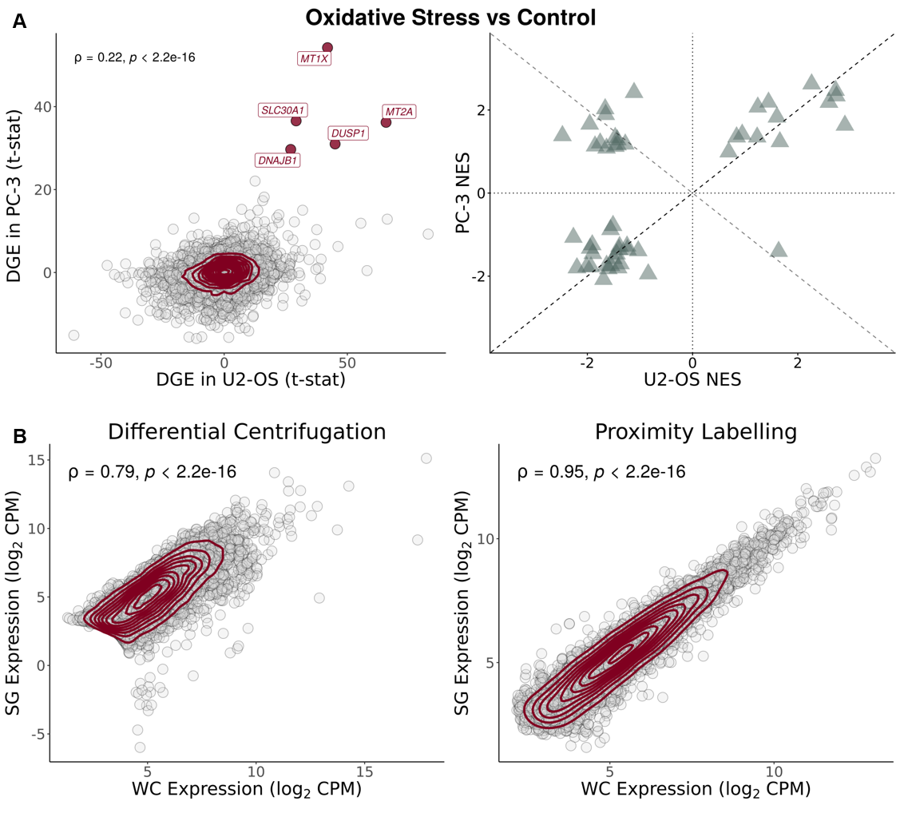
Supplementary Figure 1. U2-OS and PC-3 cells have a similar stress response. (A) (left) Scatter plot of t-statistics of DGE between SGs and WCs in PC-3⁴ (Y-Axis) and U2-OS⁵ (X-Axis) cell lines exposed to oxidative stress through arsenite; genes as circles, density contour lines in dark red, Spearman’s correlation coefficient ρ and associated test’s p-value on top left corner; strongly upregulated genes in both cell lines (t-statistic > 25) are labelled and highlighted in dark red. (right) Scatter plot of GSEA NES of Hallmarks, ranked by t-statistics of DGE, in PC-3⁴ (Y-axis) versus U2-OS⁵ (X-axis) cell lines, exposed to oxidative stress through arsenite. Dashed lines correspond to identity lines (Y = X; Y = -X). (B) Scatter plots of gene expression (in log₂ counts-per-million (CPM)) in SGs (Y-Axis) versus WCs (X-Axis), for SG purification by DC¹ (left) and PL⁴ (right); genes as circles, density contour lines in dark red, Spearman’s correlation coefficient ρ and associated test’s p-value on top left corner.
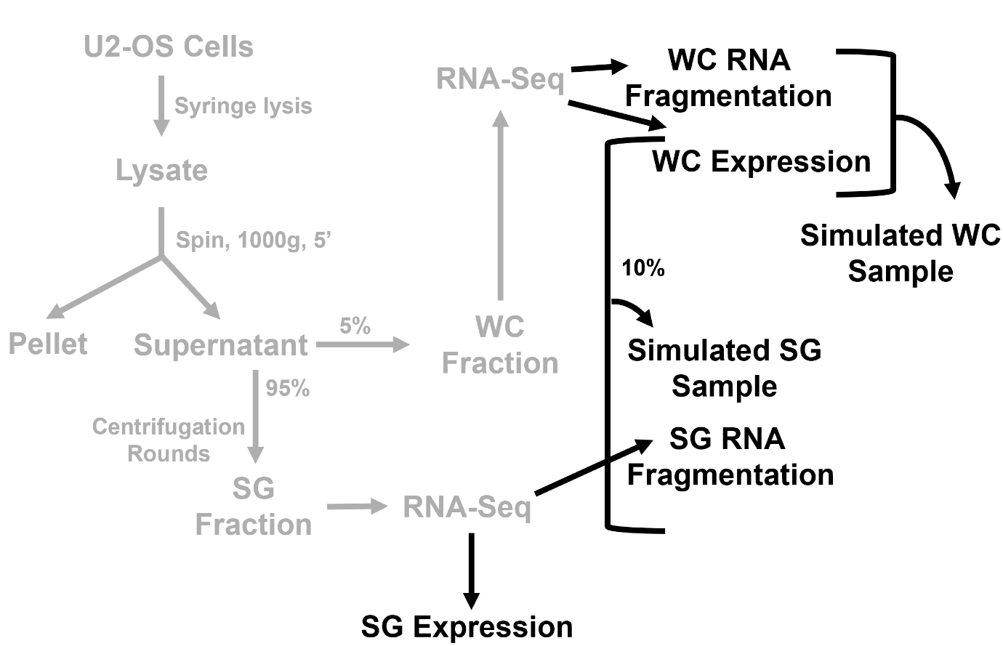
Supplementary Figure 2. Sampling bias simulation pipeline. The diagram depicts the experimental workflow from the original study for obtaining WC and SG samples¹ (steps in grey) and the additional in silico steps performed in our analyses (steps in black).
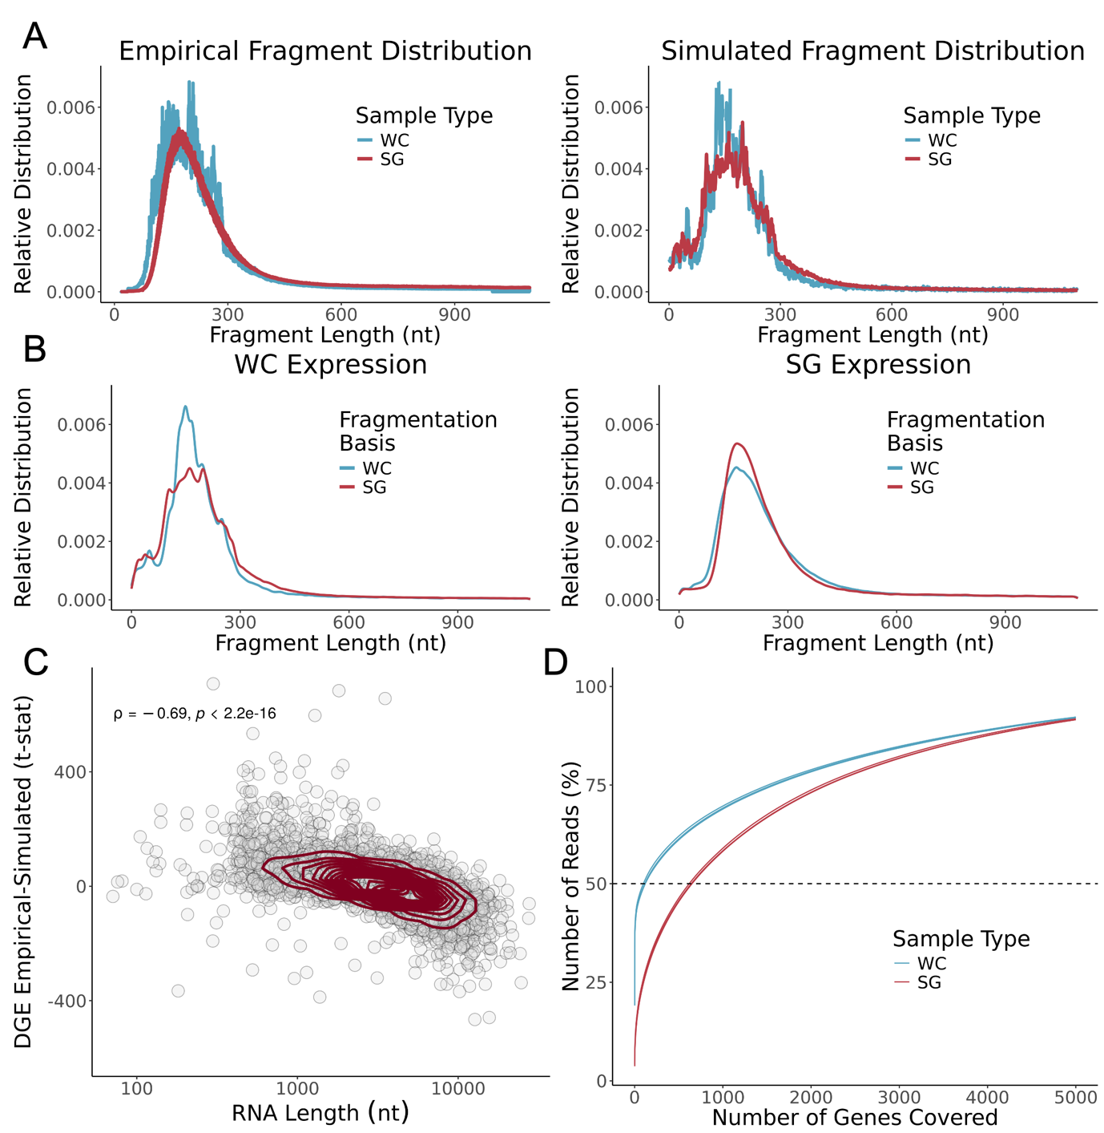
Supplementary Figure 3. Transcriptomes of DC-isolated SGs show no evidence for RNA fragmentation-associated sampling bias. (A) Relative distribution (density) of fragment length (nt) in original samples [28] RNA-seq (Left) and simulated samples (Right). (B) Relative distribution (density) of representative RNA fragment length (nt) in simulated samples, using WC (Left) or SG (Right) expression as basis, and WC or SG fragmentation distributions as basis. (C) Scatter plot of t-statistics of DGEA between SG and WC simulated samples (Y-Axis) and representative RNA transcript length (nt) (X-Axis, log scale); genes as circles, density contour lines in dark red, Spearman’s correlation coefficient ρ and associated test’s p-value are also shown. The original WC expression¹ was used as the basis for both simulated WC and SG samples, with their respective fragment size distribution as the basis. (D) Cumulative distribution of the percentage of RNA-seq reads mapping to the increasing number of genes, ordered by decreasing read coverage, in the original dataset¹. More genes account for 50% of the reads in SG samples than their WC counterparts, suggesting greater RNA library complexity.

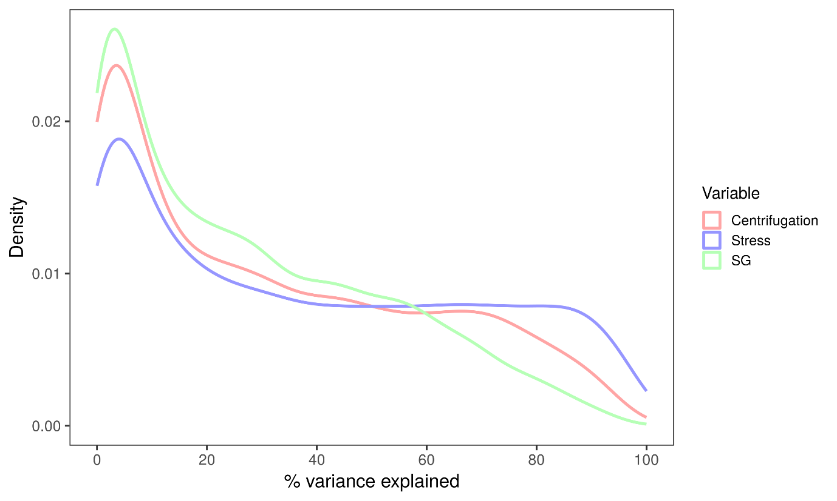
Supplementary Figure 4. Relative contributions of different sources to gene expression variance in the Matheny 2019⁵ dataset. SG contributes less to gene expression variance than the stress itself or the centrifugation effect.
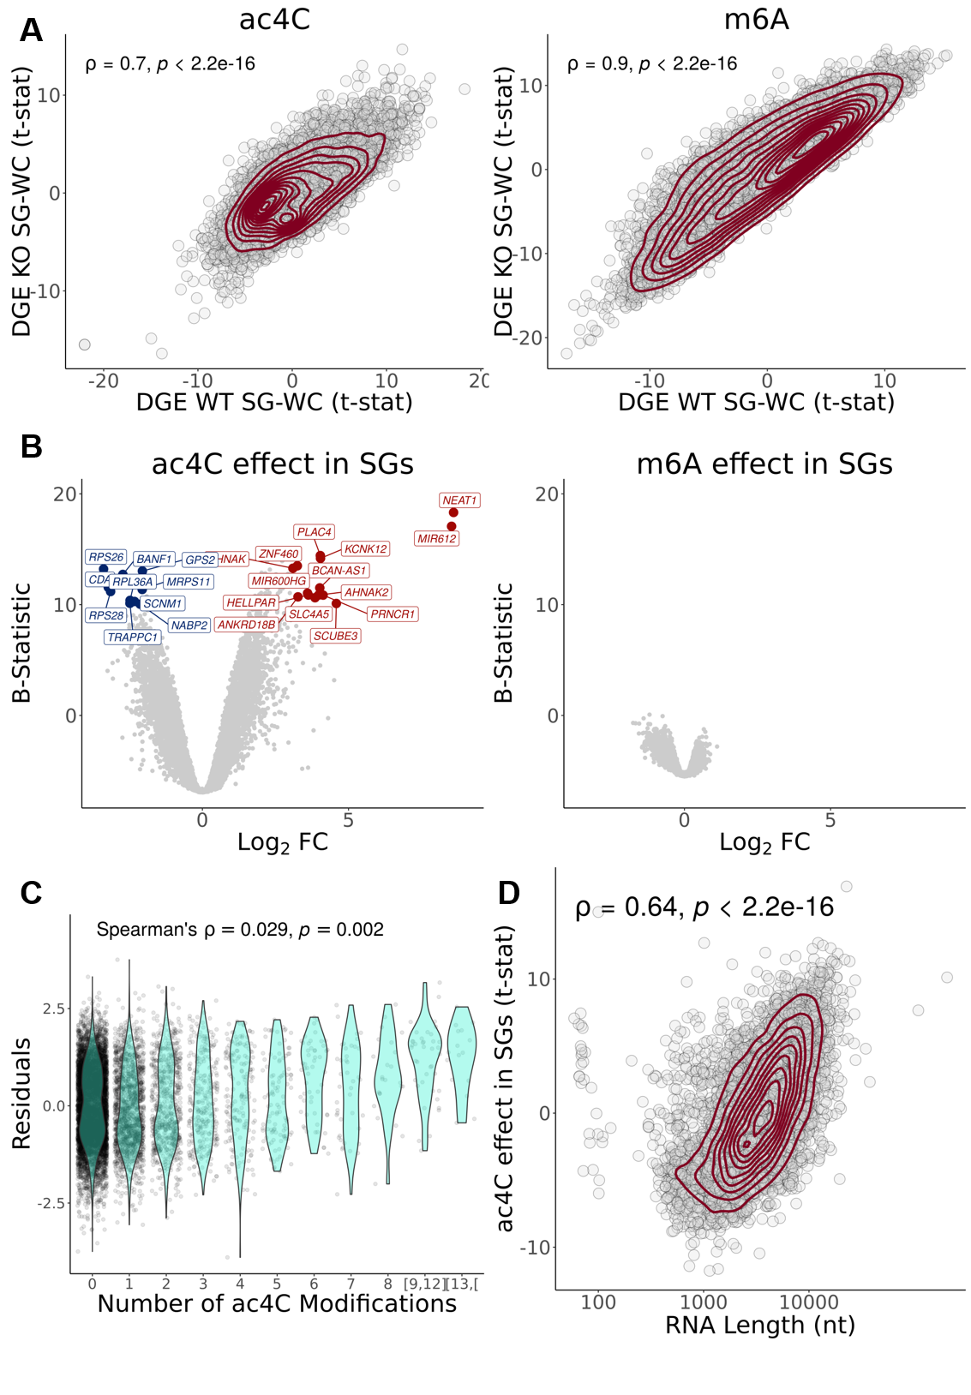
Supplementary Figure 5. AC4C, but not m6A, is associated with altered SG transcript enrichment, driven by RNA length. (A) Scatter plots of t-statistics of differential gene expression in WT SGs vs. WCs (Y-axis) and in SGs vs. WCs in cells without RNA modifications (X-axis) - ac4C KO⁶ (Left) and m6A KO⁷ cells (Right); transcripts as circles, density contour lines in dark red, Spearman’s correlation coefficient ρ and associated test’s p-value on the top left corner. (B) Volcano plots of the transcriptomic effect (given by linear modelling with interaction) of ac4C (Left) and m6A (Right) modifications in SG samples. (C) Violin plots of residuals (the difference between the actual value and the value predicted by the linear model applied for any given transcript) as a function of the number of ac4C modifications per transcript; Spearman’s correlation coefficient ρ and associated test’s p-value shown on the top left corner. (D) Scatter plot of residuals (Y-axis) vs. transcript length (nt) (X-axis); transcripts as circles, density contour lines in dark red, Spearman’s correlation coefficient ρ and associated test’s p-value shown on the top left corner. For all panels concerning ac4C, the GSE212380 dataset was used⁶. For those concerning m6A, the GSE242766 dataset was used⁷.

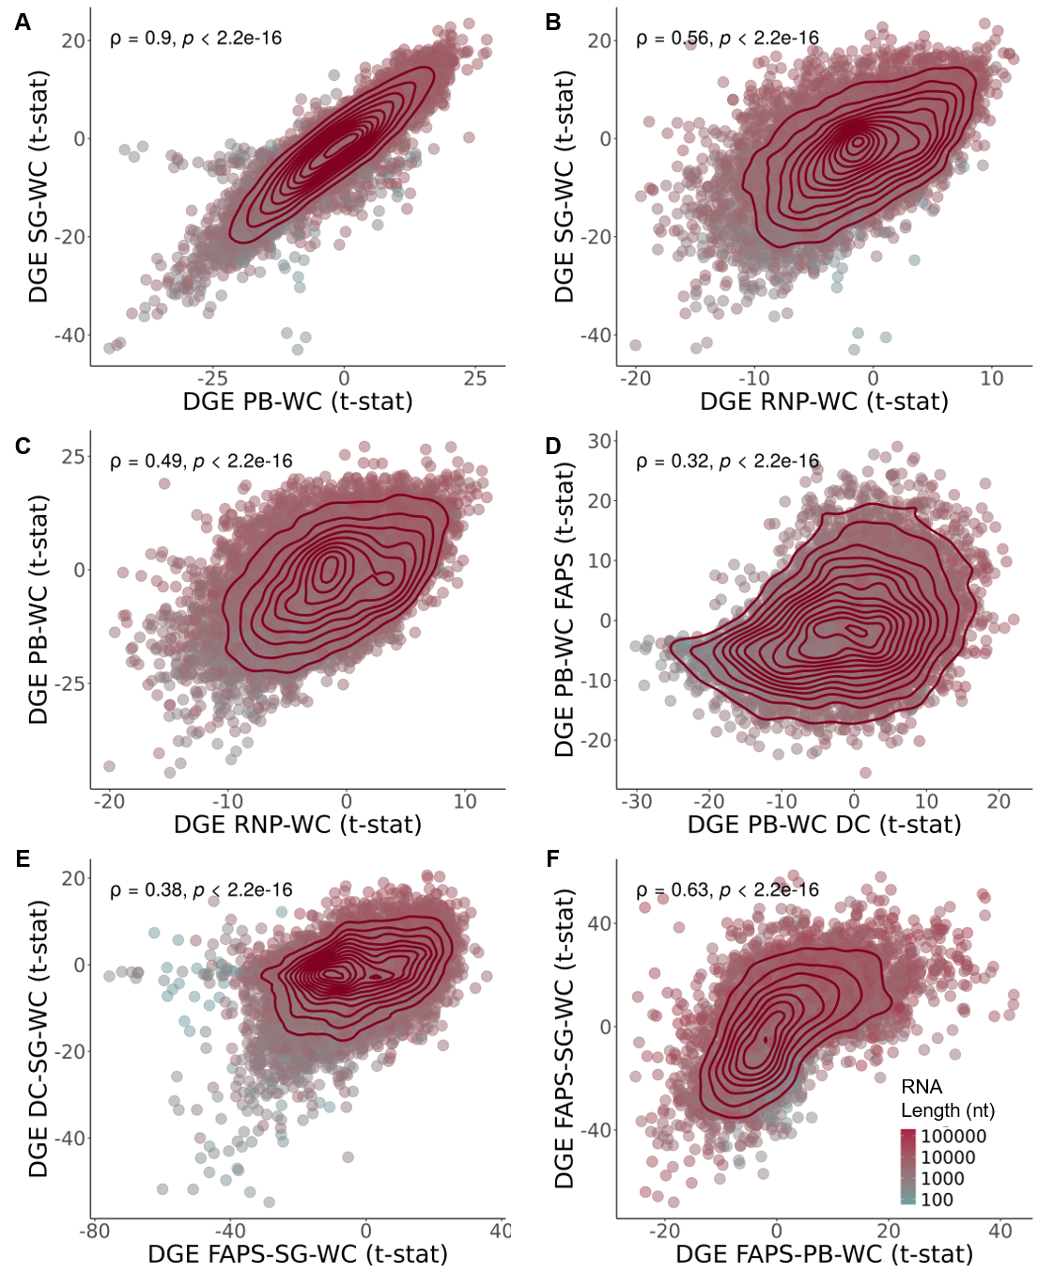
Supplementary Figure 6. Samples isolated through DC are highly correlated. (A) Scatter plot of t-statistics of DGEA in SGs vs. WCs¹ (Y-Axis) and in PBs vs. WCs⁵ (X-Axis). (B) Scatter plot of t-statistics of DGEA in SGs vs. WCs¹ (Y-Axis) and in RNP granules vs. WCs⁵ (X-Axis). (C) Scatter plot of t-statistics of DGEA in PBs vs. WCs⁵ (Y-Axis) and in RNP granules vs. WCs⁵ (X-Axis). (D) Scatter plot of t-statistics of DGEA in PBs purified by FAPS⁸ (Y-Axis) and by DC⁵, compared to WCs (X-Axis). (E) Scatter plot of t-statistics of DGEA in SGs purified by DC¹ (Y-Axis) and by FAPS/FANCI⁹ (X-Axis), comparing to WCs, after batch correction for cell type and stress. (F) Scatter plot of t-statistics of DGEA in SG (Y-Axis) and PB (X-Axis) purified by FAPS/FANCI^{8,9} comparing to WCs, after batch correction for stress. In all panels, genes as circles colored by RNA length (nt); density contour lines in dark red, Spearman’s correlation coefficient ρ and associated test’s p-value on top left corner.

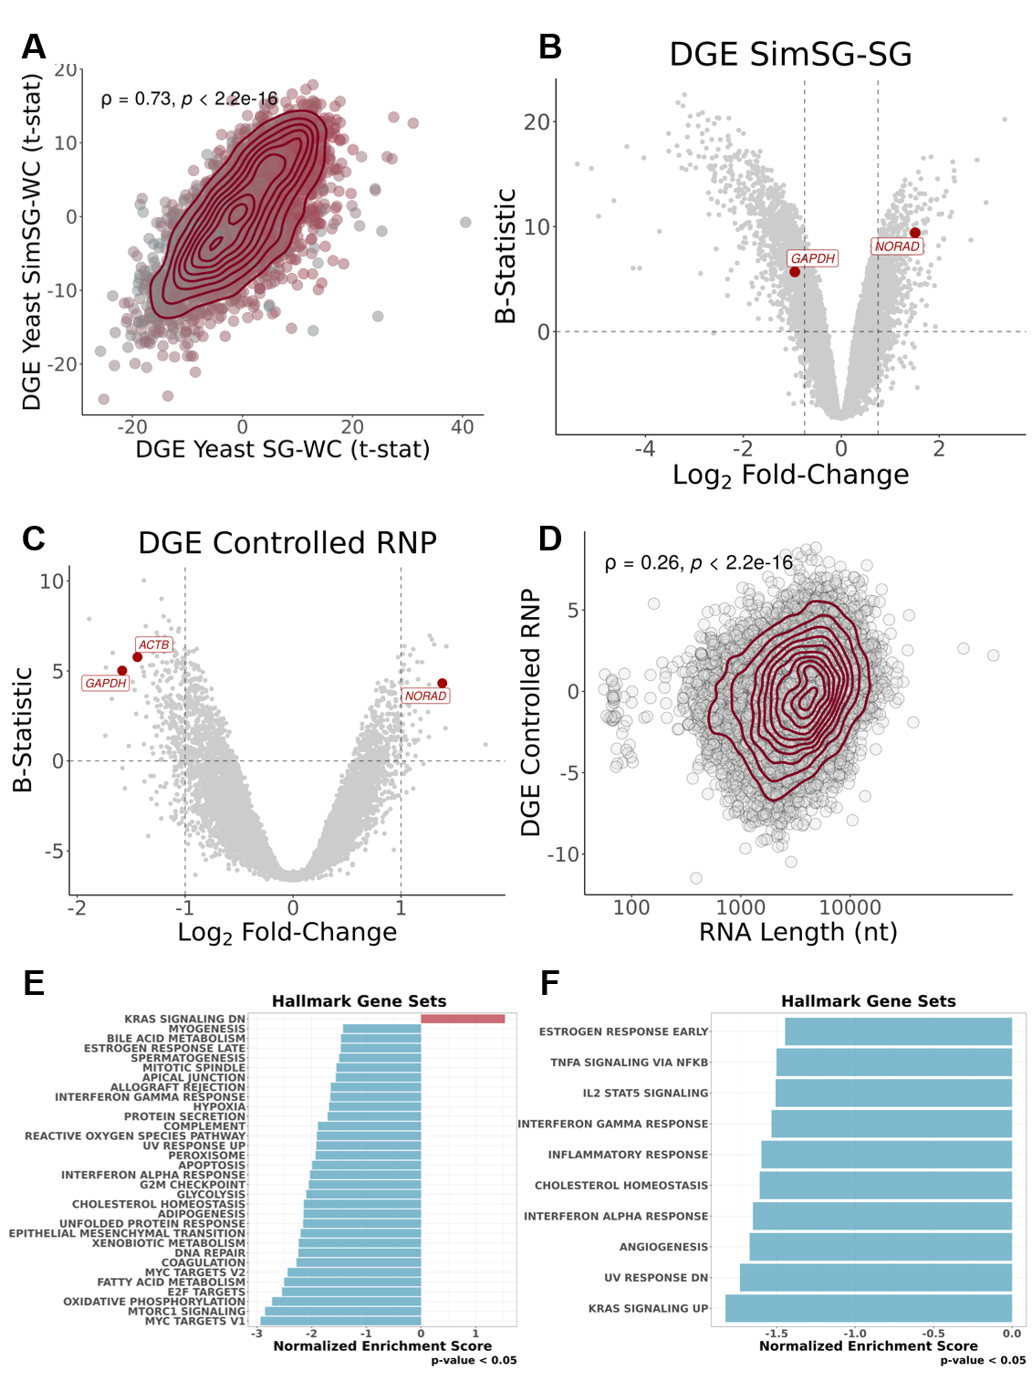
Supplementary Figure 7. (A) Scatter plot of t-statistics of DGE of simulated yeast SG versus WC (Y-Axis), with S estimations based on Sed-seq data³¹, and t-statistics of DGE in yeast SGs purified by DC²⁹ (X-Axis); transcripts as circles colored by RNA length; density contour lines in dark red, Spearman’s correlation coefficient ρ and associated test’s p-value on top left corner. (B) Volcano plot of DGEA (Y-Axis – B-Statistic; X-Axis - log2 Fold-Change) between original SGs¹ and simulated SGs, based on Sed-Seq¹⁰ data; transcripts as circles, with commonly used RNA FISH controls¹ in red. Vertical dashed lines correspond to -0.75 and 0.75 log 2FC. Horizontal dashed line corresponds to B-statistic = 0. (C) Volcano plot of DGEA (Y-Axis – B-Statistic; X-Axis - Log2 Fold-Change) of interception of stress with RNP sample types, given by linear modeling (i.e., corresponding to DC-isolated RNP granules stress specific sequestration)⁵; transcripts as circles, with commonly used RNA FISH controls¹ in red. Vertical dashed lines correspond to -1 and 1 log2FC. Horizontal dashed line corresponds to B-statistic = 0. (D) Scatter plot of t-statistics of DGE in linear modelled DC-isolated RNP granules stress-specific sequestration⁵ (Y-Axis) and RNA length (X-Axis); transcripts as circles; density contour lines in dark red, Spearman’s correlation coefficient r and associated test’s p-value on top left corner. (E) GSEA NES of Hallmark gene sets, ranked by t-statistic, in linear modelled DC-isolated RNP granules stress-specific sequestration⁵. (F) GSEA NES of Hallmark gene sets, ranked by t-statistic, in SG-bearing WC samples versus their Non-SG-bearing counterparts^{5,11}.
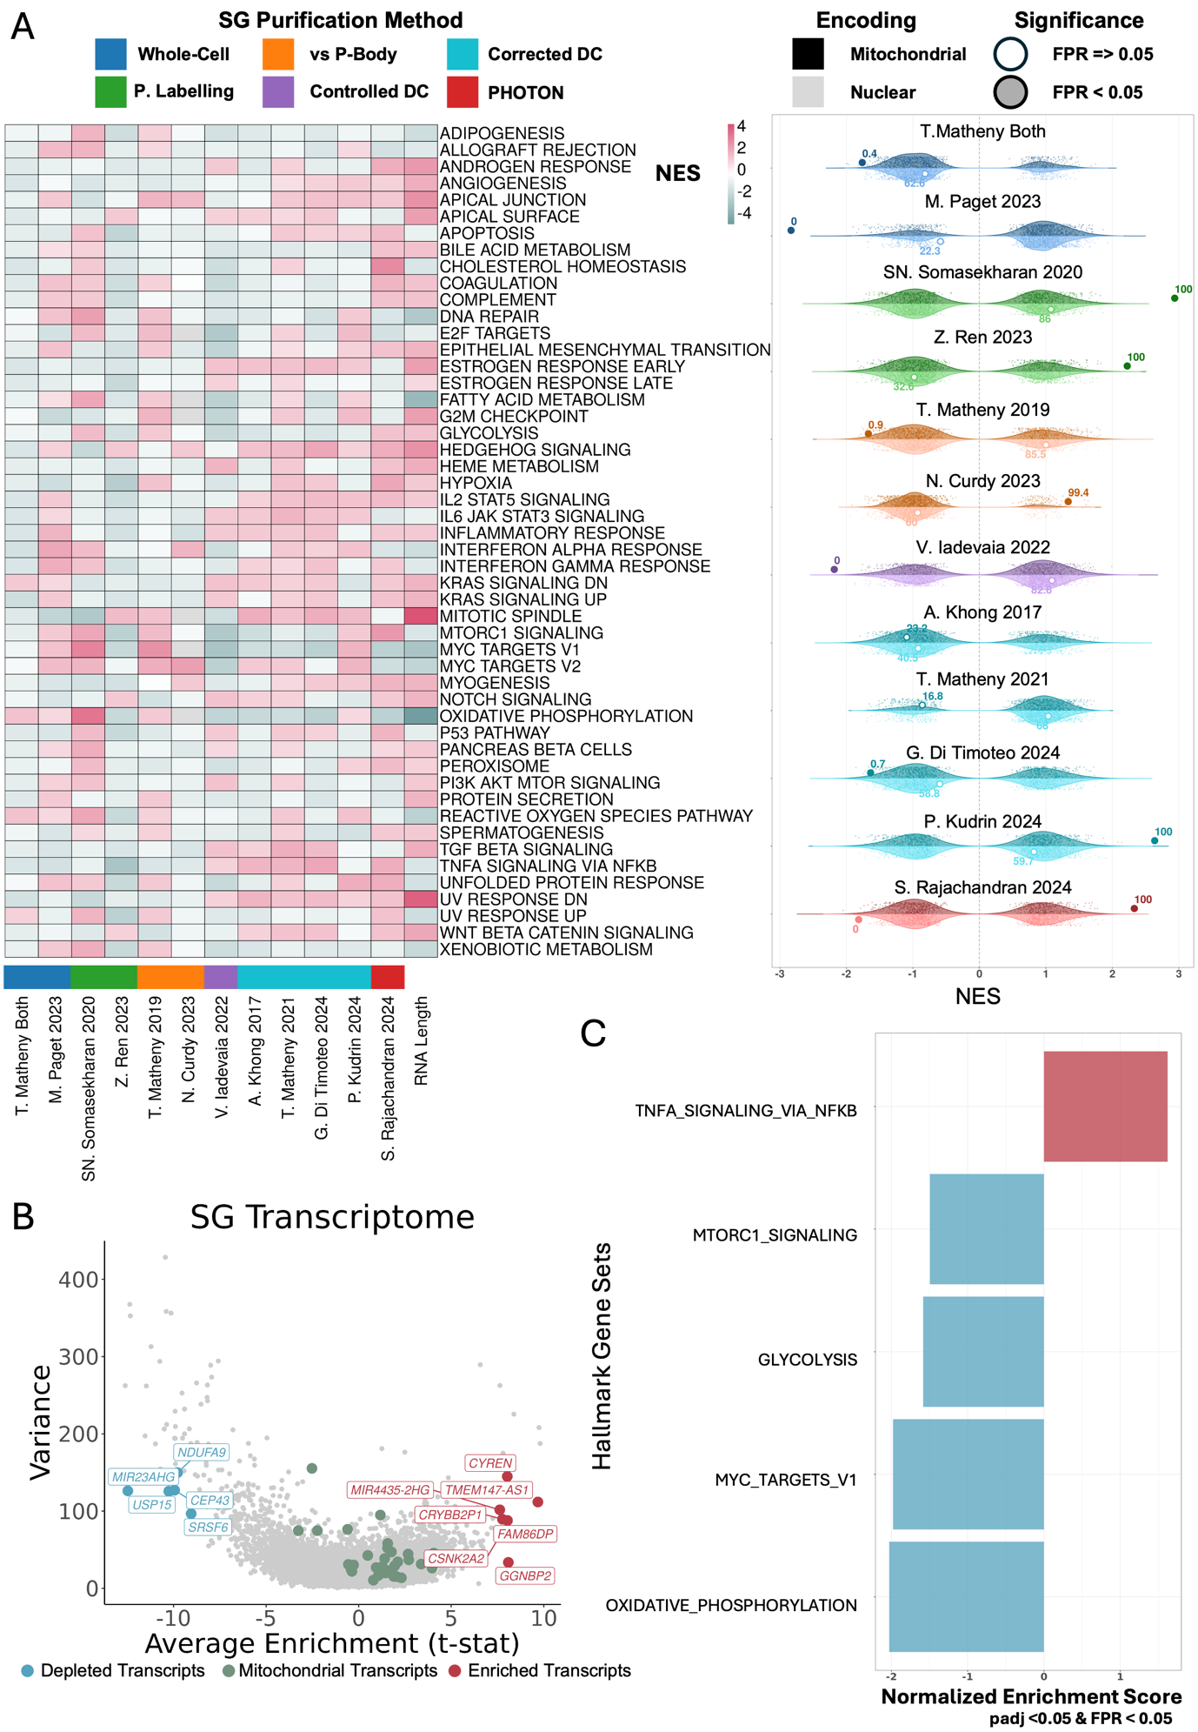
Supplementary Figure 8. Mitochondrial RNA Enrichment Across SG Transcriptomes. (A) (Left) NES from GSEA using Hallmark gene sets, based on genes ranked by t-statistic of differential gene expression between centrifugation-corrected SGs and WCs or between WCs with and without SGs across multiple studies. (Right) Paired half-violin plots showing the distribution of NES values obtained from GSEA using 1000 size-matched random gene sets (violins), for mitochondrially encoded (darker shades) or nuclear-encoded mitochondrially localized genes (lighter shades), across the transcriptomic profiles of corrected/controlled SGs from different studies. The observed NES for each gene set is shown as a large dot; filled dots indicate empirical FPR < 0.05. Numbers adjacent to each dot indicate the percentile of the observed NES within the corresponding null distribution. Color of each violin indicates SG purification method, as indicated above the image. (B) Variance of t-statistic of differential gene expression in SGs plotted against its average across datasets; transcripts as circles, colored green if mitochondrial encoded, blue if “strongly depleted" (Variance t < 150 and Average t < -9), and red if “strongly enriched" (Variance t < 150 and Average t > 7.5). (C) GSEA NES of Hallmark gene sets ranked by the average t-statistic across the same datasets; only gene sets with adjusted p-value <0.05 and empirical FPR < 0.05 based on 100 random gene sets of matched size are shown.

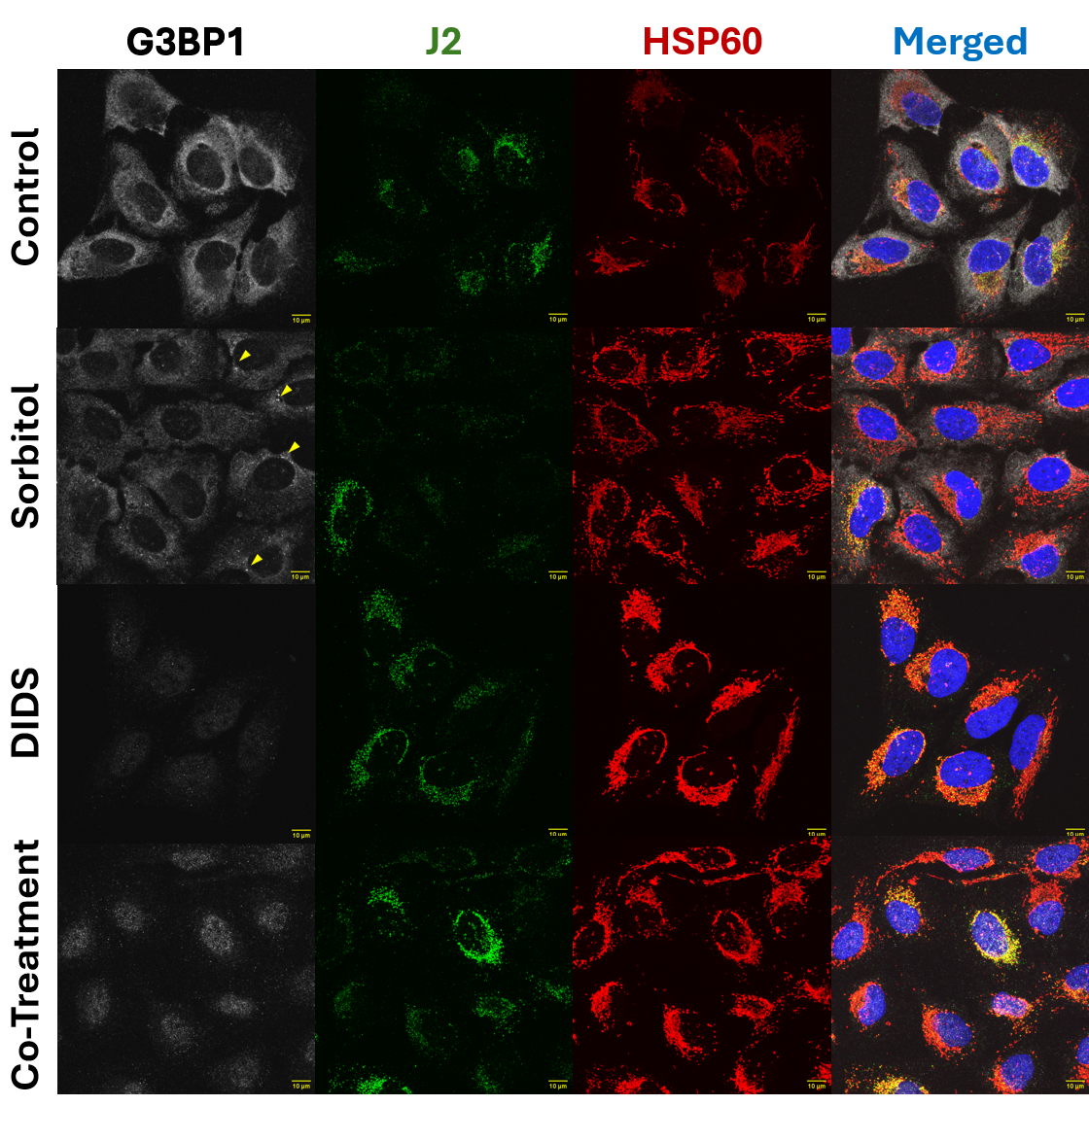
Supplementary Figure 9. Blockage of mitochondrial permeability is compatible with SG assembly inhibition. Representative Immunofluorescence images of U2-OS cells untreated or treated with sorbitol (0.4M), DIDS (50 μM), or both. G3BP1 (SG marker, v. Figure 1B) is shown in white, J2 in green (dsRNA marker¹²), HPS60 in red (mitochondrial marker¹³), and nuclei (DAPI) in blue. Merged images are also provided. Yellow arrows in Sorbitol treated samples on the G3BP1 column highlight representative SGs. Scale bar is shown on bottom right corner of each image, in yellow.
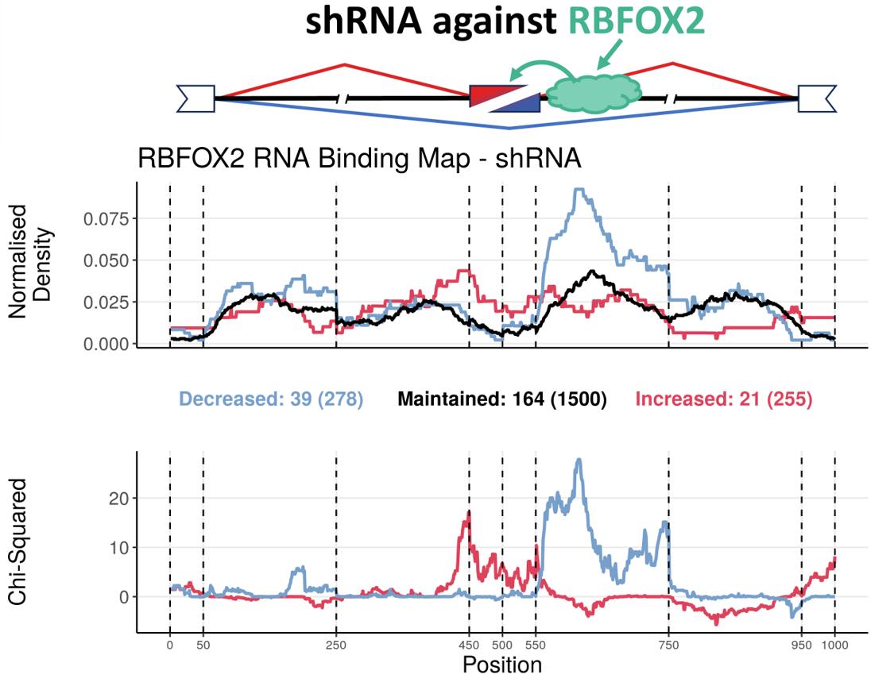
Supplementary Figure 10. RNA binding map of RBFOX2 in HepG2 and K562 cells exposed to shRNA against RBFOX2. (Top) Schematic of an alternative exon skipping event, regulated by an RBP, RBFOX2. (Middle) Normalized binding of RBFOX2 to metagenomic regulatory sequences of alternative exons. The plot discriminates excluded (blue), included (red) or maintained (black) alternative exons upon RBFOX2 knockdown, obtained from ENCODE^{14,15}. The total number of events in each category can be found in brackets beneath the plot, preceded by the number of events for which there is at least one binding site for that RBP. (Bottom) Chi-Squared Statistic of excluded (blue) or included (red) normalised binding, in relation to maintained events. Vertical lines delimitate the following metagenomic splicing regulatory sequences, in order: last 50 nt of upstream constitutive exon; first 200 nt of upstream intron; last 200 nt of upstream intron; first 50 nt of alternative exon; last 50 nt of alternative exon; first 200 nt of downstream intron; last 200 nt of downstream intron; first 50 nt of downstream constitutive exon. This example shows normalized RBFOX2 binding enriched downstream of alternative exon. Upon RBFOX2 knockdown, this binding is therefore lost, consistent with increased exon skipping. These results align with the known role of RBFOX2 in promoting exon inclusion¹⁶, providing a proof of concept for our approach.
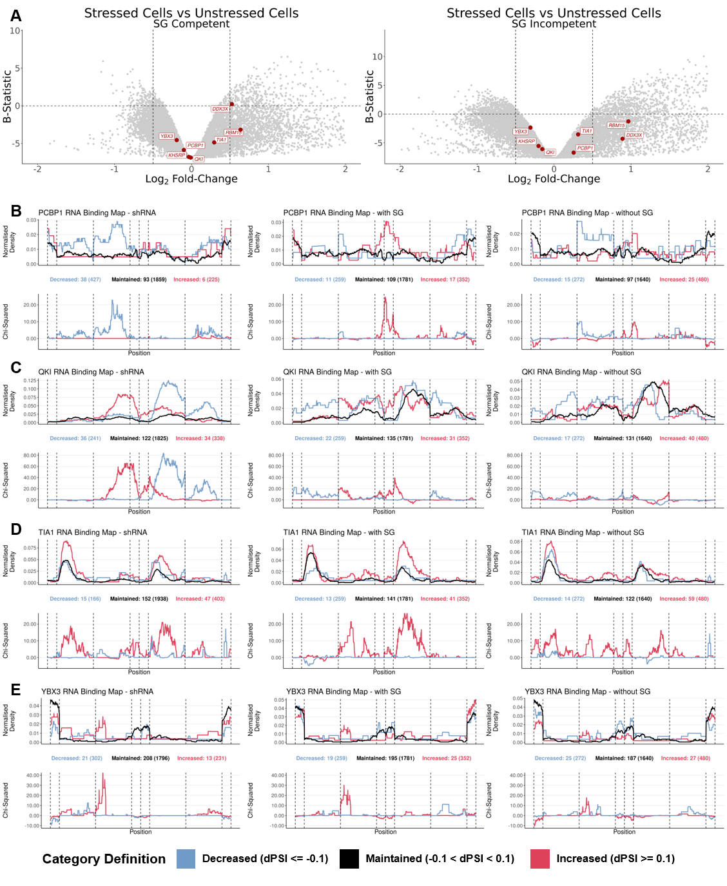
Supplementary Figure 11. Alternative splicing alterations in SG competent and incompetent cells (A) Volcano plot of DGEA between stressed and unstressed WCs (X-Axis – Log₂ Fold-Change; Y-Axis – B-Statistic) in SG competent (Left) and incompetent (Right) U2-OS and A549 cell lines subjected to dsRNA as a stressor¹⁷; genes as circles, with RBPs with significant enrichment or depletion targets amongst differentially spliced sequences labelled and in red. Vertical dashed lines correspond to -0.5 and 0.5 log₂FC. Horizontal dashed line corresponds to B-statistic = 0. Only genes with -2 < log2FC < 2 are plotted. (B-E) RNA binding maps of alternative exon splicing events in shRNA treated cells for PCBP1 (B), QKI (C), TIA1 (D), and YBX3 (E) obtained from ENCODE¹⁴ (Left), in SG competent cells (Middle) and in SG incompetent cells (Right). (Top) Normalised binding of RBP of interest to metagenomic regulatory sequences of alternative exons. The plot discriminates excluded (blue), included (red) or maintained (black) alternative exons upon RBP knockdown (Left) or upon dsRNA stress stimuli, in SG competent (Middle) and incompetent (Right) cells. The total number of events in each category can be found in brackets beneath the plot, preceded by the number of events for which there is at least one binding site for that RBP. (Bottom) Chi-Squared Statistic of excluded (blue) or included (red) normalised binding, in relation to maintained events. Vertical lines delimitate the following metagenomic splicing regulatory sequences, in order: last 50 nt of upstream constitutive exon; first 200 nt of upstream intron; last 200 nt of upstream intron; first 50 nt of alternative exon; last 50 nt of alternative exon; first 200 nt of downstream intron; last 200 nt of downstream intron; first 50 nt of downstream constitutive exon.

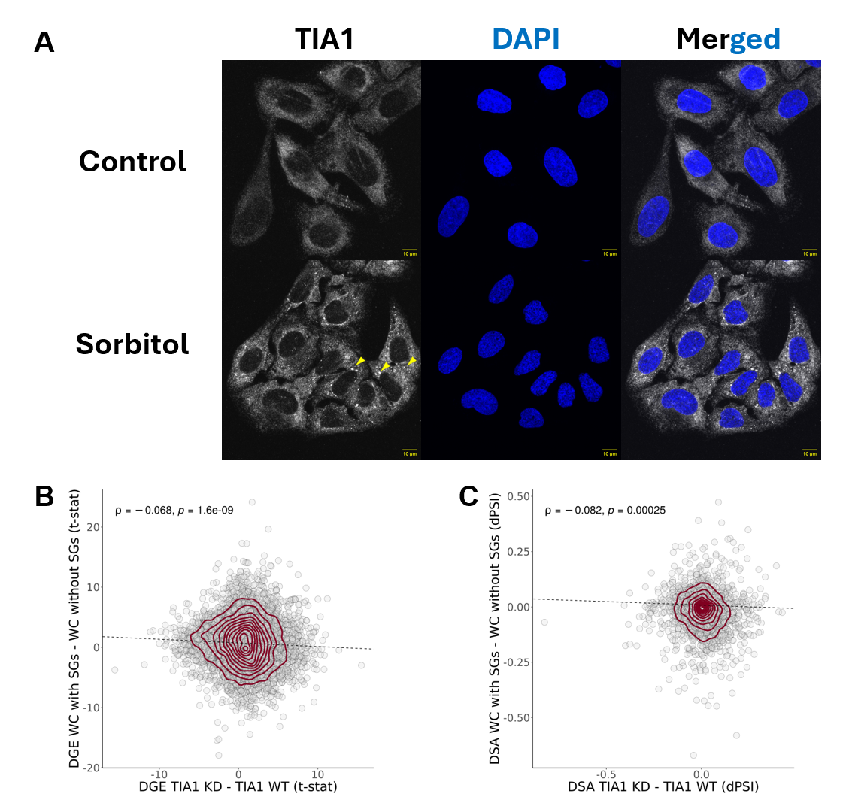
Supplementary Figure 12. Alterations of TIA1 function upon KD and SG assembly. (A) Immunofluorescence images of U2-OS cells untreated or treated with sorbitol (0.4M). TIA1 is shown in white and nuclei (DAPI) in blue. Yellow arrows highlight putative SGs. Scale bar is shown on bottom right corner of each image, in yellow. (B) Scatter plot of t-statistics of DGE between HEPG2 and K562 cells treated with shRNA against TIA1 and those with untargeted shRNA^{14,15} (X-Axis) and between U2-OS and A549 WT Cells (SG-Competent) exposed to dsRNA as a stressor against their G3BP1/G3BP2 KO counterparts (SG-Incompetent)¹⁷ (Y-Axis); genes as circles; density contour lines in dark red, Spearman’s correlation coefficient r and associated test’s p-value on top left corner. (C) Scatter plot of differential splicing (in difference in percent spliced-in (dPSI)) between HEPG2 and K562 cells treated with shRNA against TIA1 and those with untargeted shRNA^{14,15} (X-Axis) and between U2-OS and A549 WT Cells (SG-Competent) exposed to dsRNA as a stressor and their G3BP1/G3BP2 KO counterparts (SG-Incompetent)¹⁷ (Y-Axis); alternative splicing events as circles; density contour lines in dark red, Spearman’s correlation coefficient r and associated test’s p-value on top left corner. The dashed line corresponds to the least-squares linear regression fit between the two variables (B, C).
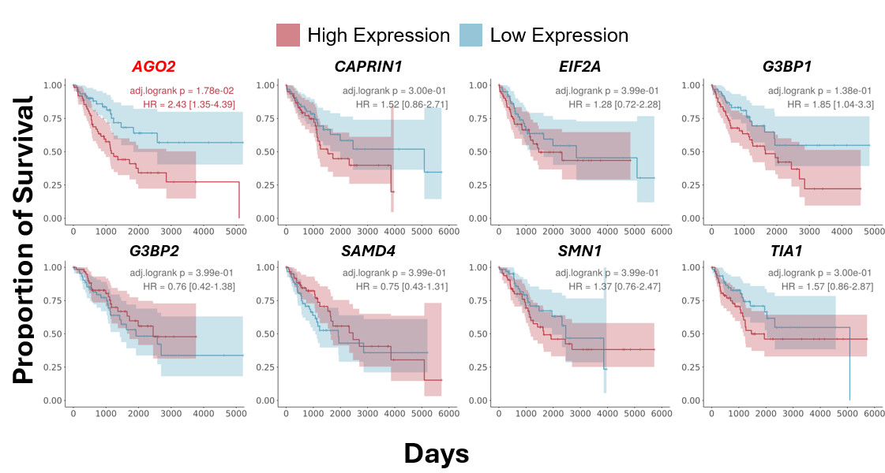
Supplementary Figure 13. Overall survival analysis based on the expression of genes encoding SG-related proteins. Kaplan–Meier plots showing proportion of overall survival (Y-Axis) per day (X-Axis) of patients from GDC-TCGA’s SARC dataset (The Cancer Genome Atlas sarcoma)¹⁸, stratified by expression of the indicated genes, as plot titles. Patients were grouped into high and low expression cohorts based on the bottom and top quartiles expression values. BH-adjusted Log-rank p-values, and HR, are shown in the top right corner of each plot. Genes with an adjusted Log-rank p-value <0.05 are shown in red.
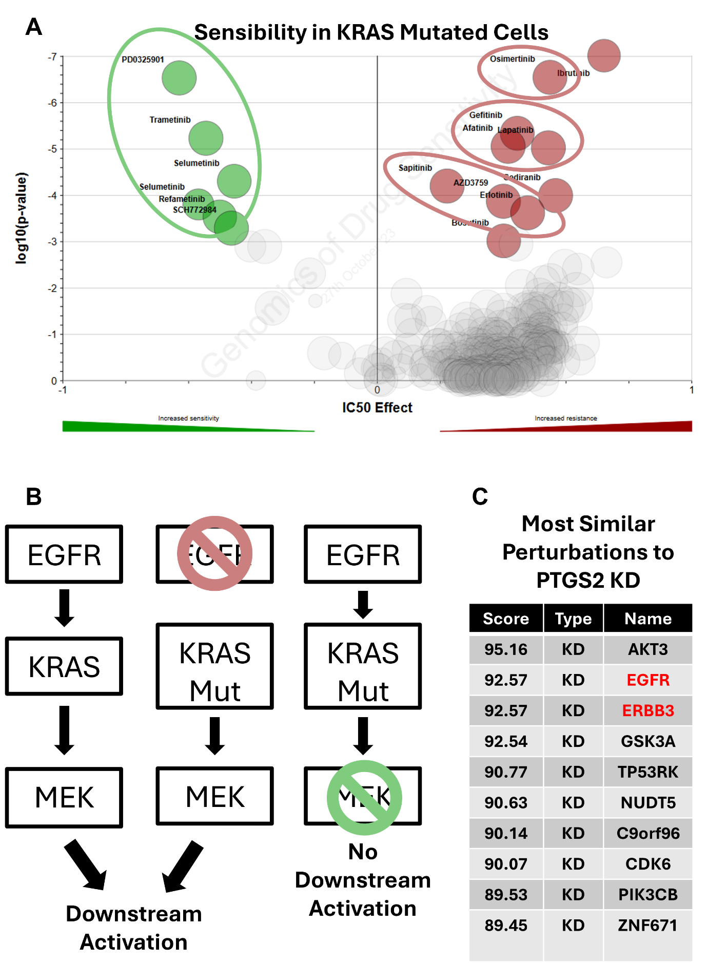
Supplementary Figure 14. KRAS mutation and associated drug sensitivities and resistances. (A) Volcano plot of half maximal inhibitory concentration (X-Axis – IC50 Effect) and corresponding significance, given by MANOVA¹⁹ (Y-Axis – log₁₀(p-value)) in KRAS mutant cells; drugs/chemicals as circles, with drugs with the most differential IC50 effect labelled and coloured in green (if with increased sensitivity) or in red (if with increased resistance). Green circle around drugs which target MEK, and red circles around drugs with target EGFR. Analysis and images are obtained from GDSC¹⁹, using the GDSC2 dataset. (B) Simplified schematic of the EGFR signaling pathway. (Left) In wild-type cells, EGFR activation triggers KRAS activation, which in turn activates MEK and downstream signaling. (Middle) In KRAS-mutant cells, inhibition of EGFR with targeted drugs (red drugs, see (A)) does not block signaling, as mutant KRAS activates MEK independently. This explains resistance of KRAS-mutant cells to anti-EGFR therapy. (Right) In KRAS-mutant cells, inhibition of MEK with targeted drugs (green drugs, see (A)) blocks downstream signaling, rendering these cells sensitive to anti-MEK therapy. (C) Table representing alterations with highest correlation to PTGS2 KD. Values represent CMap connectivity scores, which reflect the degree of similarity between gene expression signatures. Knockdowns of EGFR and ERBB3 are highlighted in red. Analysis and visualisation were performed and adapted from the Connectivity Map (CMap) platform²⁰.
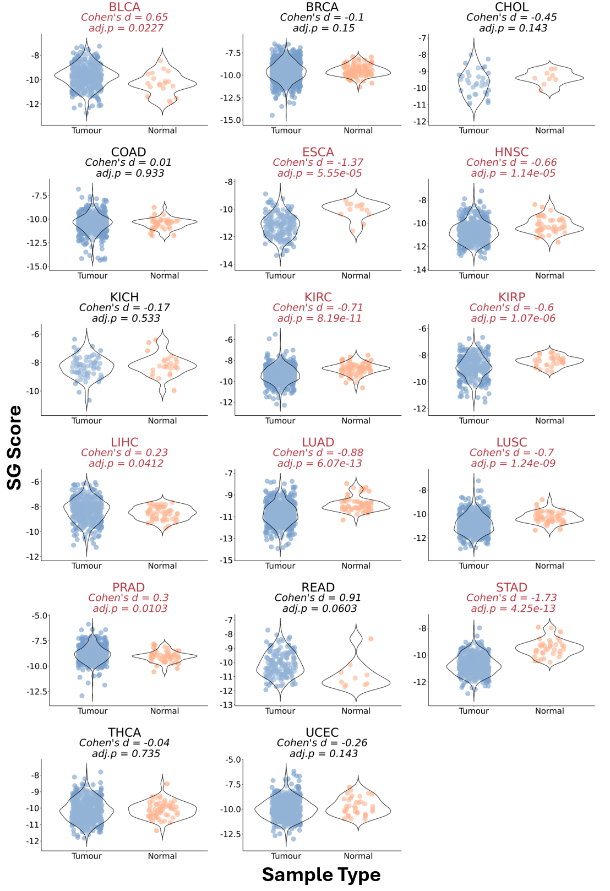
Supplementary Figure 15. Signature score in various GDC-TCGA datasets. Violin plots of SG signature scores, calculated through a ranking metric (see Methods), in tumor (blue) and normal tissue (orange) samples from several GDC-TCGA datasets^{18,21}. Effect Size (Cohen’s d) and corresponding statistical significance given by Welch’s t-test (adjusted p-value) are shown above plots. Only GDC-TCGA^{18,21} datasets with at least 5 normal and tumor samples were considered for this analysis.

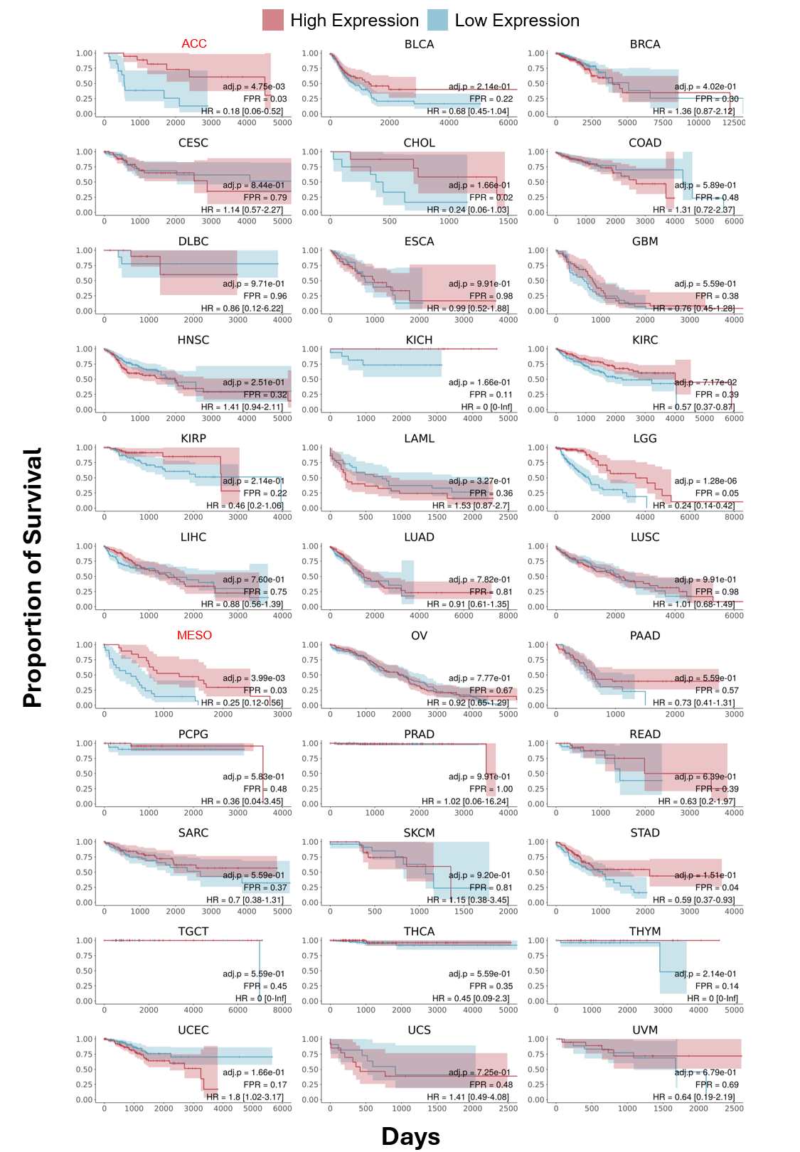
Supplementary Figure 16. Kaplan–Meier plots showing proportion of overall survival (Y-Axis) per days (X-Axis) of patients of GDC-TCGA datasets^{18,21}, stratified by SG score, with dataset identification as plot title. Patients were grouped into high and low expression cohorts based on bottom and upper quartile SG Score values. BH-adjusted Log-rank p-value, HR, and FPR compared to 100 random signatures is shown on bottom right of each plot; datasets with FPR > 0.05 are highlighted in red.

References

1. Khong, A. et al. The Stress Granule Transcriptome Reveals Principles of mRNA Accumulation in Stress Granules. Mol. Cell 68, 808-820.e5 (2017).
2. Zhao, Y. et al. TPM, FPKM, or Normalized Counts? A Comparative Study of Quantification Measures for the Analysis of RNA-seq Data from the NCI Patient-Derived Models Repository. J. Transl. Med. 19, 269 (2021).
3. Mandelboum, S., Manber, Z., Elroy-Stein, O. & Elkon, R. Recurrent functional misinterpretation of RNA-seq data caused by sample-specific gene length bias. PLOS Biol. 17, e3000481 (2019).
4. Somasekharan, S. P. et al. G3BP1-linked mRNA partitioning supports selective protein synthesis in response to oxidative stress. Nucleic Acids Res. 48, 6855–6873 (2020).
5. Matheny, T., Rao, B. S. & Parker, R. Transcriptome-Wide Comparison of Stress Granules and P-Bodies Reveals that Translation Plays a Major Role in RNA Partitioning. Mol. Cell. Biol. 39, e00313-19 (2019).
6. Kudrin, P., Singh, A., Meierhofer, D., Kuśnierczyk, A. & Ørom, U. A. V. N4-acetylcytidine (ac4C) promotes mRNA localization to stress granules. EMBO Rep. 25, 1814–1834 (2024).
7. Di Timoteo, G. et al. M6A reduction relieves FUS-associated ALS granules. Nat. Commun. 15, 5033 (2024).
8. Kodali, S. et al. RNA sequestration in P-bodies sustains myeloid leukaemia. Nat. Cell Biol. 26, 1745–1758 (2024).
9. Zhou, Y. et al. RNA damage compartmentalization by DHX9 stress granules. Cell 187, 1701-1718.e28 (2024).
10. Glauninger, H. et al. Transcriptome-wide mRNA condensation precedes stress granule formation and excludes stress-induced transcripts. Preprint at https://doi.org/10.1101/2024.04.15.589678 (2024).
11. Matheny, T., Van Treeck, B., Huynh, T. N. & Parker, R. RNA partitioning into stress granules is based on the summation of multiple interactions. RNA 27, 174–189 (2021).
12. Krieger, M. R. et al. Trafficking of mitochondrial double-stranded RNA from mitochondria to the cytosol. Life Sci. Alliance 7, e202302396 (2024).
13. El Manaa, W. et al. Transcription- and phosphorylation-dependent control of a functional interplay between XBP1s and PINK1 governs mitophagy and potentially impacts Parkinson disease pathophysiology. Autophagy 17, 4363–4385 (2021).
14. The ENCODE Project Consortium. An integrated encyclopedia of DNA elements in the human genome. Nature 489, 57–74 (2012).
15. Luo, Y. et al. New developments on the Encyclopedia of DNA Elements (ENCODE) data portal. Nucleic Acids Res. 48, D882–D889 (2020).
16. Van Nostrand, E. L. et al. A large-scale binding and functional map of human RNA-binding proteins. Nature 583, 711–719 (2020).
17. Paget, M. et al. Stress granules are shock absorbers that prevent excessive innate immune responses to dsRNA. Mol. Cell 83, 1180-1196.e8 (2023).
18. TCGA Research Network. The Cancer Genome Atlas. https://www.cancer.gov/tcga.
19. Yang, W. et al. Genomics of Drug Sensitivity in Cancer (GDSC): a resource for therapeutic biomarker discovery in cancer cells. Nucleic Acids Res. 41, D955–D961 (2012).
20. Subramanian, A. et al. A Next Generation Connectivity Map: L1000 Platform and the First 1,000,000 Profiles. Cell 171, 1437-1452.e17 (2017).
21. Heath, A. P. et al. The NCI Genomic Data Commons. Nat. Genet. 53, 257–262 (2021).

