Research Article
Revisiting Stress Granule Transcriptomes Suggests Mitochondrial RNA Enrichment Despite Methodological Bias
Alexandre Kaizeler^{1,2,3}*
Diogo Coutinho¹
Diana V. Vieira¹
Vanessa A. Morais^{1,2,}**
Nuno L. Barbosa-Morais^{1,2,3}***
¹ Gulbenkian Institute for Molecular Medicine, 1649-035 Lisbon, Portugal
² Faculdade de Medicina, Universidade de Lisboa, 1649-028 Lisbon, Portugal
³ Comprehensive Health Research Centre (CHRC), NOVA Medical School|Faculdade de Ciências Médicas, NMS|FCM, Universidade NOVA de Lisboa, 1169-056 Lisbon, Portugal
* First Corresponding Author: Alexandre Kaizeler – alexandre.afonso@gimm.pt
** Second Corresponding Author: Vanessa A. Morais – vanessa.morais@gimm.pt
*** Third Corresponding Author: Nuno L. Barbosa-Morais – nuno.morais@nms.unl.pt

Highlights
- Stress granule transcriptomes vary widely across stressors, cell lines, and purification methods.
- Differential centrifugation skews stress granule RNA profiles toward longer transcripts.
- Methodological discrepancies across stress granule purification call for cautious interpretation of their transcriptomes.
- Mitochondrial RNAs are consistently enriched in stress granules, suggesting a role in anti-inflammation by prevention of damage-associated molecular patterns.

Summary
Stress granules (SGs) are dynamic, membraneless cytoplasmic condensates that form in response to diverse cellular stressors. Although proposed to modulate stress responses by selectively sequestering proteins and RNAs, their precise molecular composition and function remain unclear. Reported SG transcriptomes differ substantially due to methodological discrepancies, notably between differential centrifugation (DC) and proximity labeling (PL). Here, we reanalyze publicly available human SG transcriptomes across multiple stressors, cell types, and isolation strategies. DC-based profiles were strongly shaped by RNA length, consistent with a physical bias inherent to the sedimentation-based separation. Correcting for this effect reveals limited concordance between studies, yet enrichment of mitochondrially encoded RNAs emerges as a consistent feature. Immunofluorescence experiments further support dsRNA uptake by SGs upon stress. Since leakage of mitochondrial nucleic acids is a well-characterized damage-associated molecular pattern linked to inflammation, their sequestration in SGs suggests a potential role in modulating immune-related stress responses. These findings refine our understanding of SG composition, underscore the need to control for technical artifacts in SG isolation, and provide a framework to distinguish genuine biological signals from methodological noise in SG research.

Graphical Abstract

Keywords
Stress granules; RNA-binding proteins; transcriptomics; mitochondrial RNA; proximity labelling; differential centrifugation; RNA length bias; immune modulation; cellular stress response

Introduction
Stress Granules (SGs) are membraneless cytoplasmic structures formed in response to a wide variety of stimuli¹, including hypoxia, nutrient deprivation, viral infection, T cell activation, heat-shock and oxidative stress^{2–7}. SGs comprise aggregations of RNA, stalled preinitiation complexes, and proteins³, of which around half are RNA-binding proteins (RBPs)⁸. Characterized by rapid formation and swift disassembly upon cessation of the triggering stimuli (15 and 30 minutes with oxidative and heat-shock stress, respectively)⁹, SGs are highly dynamic structures, with their protein constituents continuously transitioning into and out of them¹⁰. While SGs were first suggested to play a pivotal role in the global suppression of translation concurrent with cellular stress, they are now theorized to selectively sequester specific constituents, as stressed SG-deficient cells still exhibit repressed translation¹¹. As such, they may modulate and fine-tune the cellular response to environmental and biotic stress, through sequestration of particular proteins and mRNAs: pro-apoptotic factors such as active caspases¹², or DDX3X to impede pyrocitosis, thereby improving cell survival¹³; RB1, protecting it from degradation in an RBFOX2-dependent manner¹⁴; and PAI-1, hampering cell senescence¹⁵. Notably, senescent cells actively deplete core SG components such as G3BP1 and TIA1, and G3BP1 itself is required for expression of the senescence-associated secretory phenotype (SASP) but not for the senescent state per se^{16,17}, pointing to a dynamic interplay between SG assembly and senescence programs
Nevertheless, the biological significance of these mechanisms remains ambiguous, with the function of the sequestered mRNAs uncertain, as studies have demonstrated their continued translation within the SG¹⁸.
In addition to those physiological roles, SGs have been implicated in several pathologies. Mutations in certain SG-localized proteins, such as TIA1, TDP43 or ATXN2, are linked with amyotrophic lateral sclerosis^{19–21}, and certain mutations in DDX3X are suggested to originate stress granule-like formations that impair neurogenesis²². Still, these results may be spurious, as both SGs and the physiopathology of these diseases rely on protein aggregation. SGs have also been implicated in antiviral responses. Viruses across essentially all major classes have evolved mechanisms to inhibit SG assembly, most commonly by targeting G3BP1 or upstream eIF2α signalling^{23,24}. While this convergence suggests a genuine antiviral function, many of these strategies act on the integrated stress response (ISR) as a whole or on G3BP1 functions beyond SGs, making it difficult to attribute the antiviral effect to SGs specifically^{23,24}. Cancer cells experience heightened stress due to factors such as hypoxia, nutrient deprivation, and chemotherapy/radiotherapy, all of which are reported to induce SG formation^{2,25,26}. SGs are observed in multiple tumours where they are postulated to promote metastasis while conferring resistance to chemotherapy, as their abrogation by G3BP1 and COX-1/2 inhibition impedes so^{27,28}. However, it is not known if these results solely arise from the blockade of SG formation or involve other functions of the targeted proteins, such as G3BP1 and COX-1/2, beyond their role in SGs. For example, only 20% of G3BP1 localizes to SG, reiterating how these targets may be nonspecific for SG blockage²⁹.
Despite the absence of direct evidence for their functions, SGs continue to garner significant attention in various physiological and pathological contexts, owing to their supposed role in selective mRNA and protein sequestration, hypothesized to contribute to the downregulation of specific pathways in numerous diseases. Research efforts have led to the curation of two databases housing information on their protein constituents^{8,30}, revealing that RNA-binding proteins are their main component (>50%). Two main methodologies have emerged for elucidating their RNA content: differential centrifugation³¹ (DC), and proximity RNA labelling via APEX-Seq²⁹ (PL), both relying on core SG proteins (usually G3BP1). Regardless, even when the same SG core protein and stress induction were used, notable disparities between transcriptomes isolated with the different techniques were observed^{29,31}. DC highlights RNA length as a significant predictor of SG enrichment³¹, but this effect is absent with PL²⁹. The enrichment in longer RNAs has been hypothesized to have a biological nature, as SGs are formed by aggregation, longer transcripts equate to more potential binding sites for RBPs³¹. Moreover, it is plausible that PL also captures G3BP1 that does not localize to SGs²⁹, and that therefore part of the obtained enrichment is not SG-specific. Nevertheless, concerns have been raised regarding the inherent bias of DC towards isolating longer transcripts, as longer RNAs tend to precipitate more readily given their greater number of intermolecular interaction sites, forming condensates with increased molecular weight^{32,33}.
To resolve discrepancies in SG characterization and identify authentic transcript features and their functional implications, we performed an unbiased analysis of publicly available human SG transcriptomic datasets spanning multiple cell lines, purification methods, and stressors. We found that transcriptomic profiles of SGs purified by differential centrifugation are strongly shaped by the method itself. Even after correcting for this bias, substantial differences between studies remained, with one reproducible feature being the enrichment of mitochondrially encoded RNAs.
Our analyses further suggest that SGs may modulate the cellular stress response, potentially dampening rather than amplifying it, which could help limit downstream effects such as excessive inflammation. Although the functional significance of mitochondrial RNA enrichment is not yet resolved, immunofluorescence experiments strongly suggest that mitochondrial dsRNAs are taken up by SGs upon stress, supporting a potential role in modulating immune signaling.

Results

Different SG purification techniques yield different SG transcriptomes
We first compiled publicly available transcriptomic datasets of human SGs isolated through various methods (Table 1). For each dataset, we compared gene (mRNA) expression between SGs and the corresponding whole-cell or cytoplasmic fraction (henceforth collectively referred to as WC). SGs isolated by DC consistently contained longer transcripts on average (Figure 1A, left; Khong 2017 study³¹ shown as example), irrespective of stress stimuli and cell type (Figure 1B). Gene expression profiles of DC-purified SGs exhibit a consistently high correlation with each other (Figure 1B). In contrast, PL-based SG transcriptomes showed a weak enrichment for shorter transcripts (Figure 1A, right; Somasekharan 2020 study²⁹ given as example) and exhibited minimal correlation between SG gene expression profiles, even under the same stress stimulus (Figure 1B).
We performed Gene Set Enrichment Analysis (GSEA)³⁴ for the Hallmarks collection³⁵ (designed to minimize redundancy between gene sets) on differentially expressed genes (DEGs) in SGs induced by oxidative stress in the DC and PL example datasets, compared with their WC fraction (Figure 1A,B). In DC-purified transcriptomes, Hallmark enrichment in SGs was strongly confounded with transcript length (Fisher’s p < 1.5e-5, Odds Ratio = 23.77), with several enriched and depleted Hallmarks associated with long (e.g., mitotic spindle) and short (e.g., oxidative phosphorylation) transcripts, respectively (Figure 1C). In PL-purified transcriptomes, the observed enrichment in short transcripts in SGs (Figure 1A, right) also reflected on the Hallmark enrichment analysis (Figure 1C; p < 0.0001, Odds Ratio = 0.06).
Notably, these datasets differ in cell lines and arsenite concentrations, factors previously suggested to influence SG transcript composition^{29,36}. To evaluate whether these biological variables could explain the observed differences, we examined the transcriptomic oxidative stress response across the corresponding cell lines (Supplementary Figure 1A). Arsenite-treated U2-OS and PC-3 cells share highly upregulated genes, including MT1X and MT2A (metallothioneins, a protein class protective against oxidative stress³⁷), DUSP1 (upregulated during oxidative stress³⁸), and DNAJB1/HSP40 (which mitigates oxidative stress–induced cytotoxicity³⁹). Furthermore, GSEA on the DEGs between stressed and unstressed states in both cell lines revealed similar Hallmark enrichment (Supplementary Figure 1B; Fisher’s p < 3.5e-4, Odds Ratio = 21.66). Consistent with this, WC transcriptomes from these cell lines under oxidative stress also showed a degree of correlation in the stress response (Supplementary Figure 1A), together indicating that cell line alone is unlikely to account for the differences seen in SG transcriptomes. Most likely, the variation in SG transcriptomes reflects the different isolation methods used in these example datasets.

Simulation of the centrifugation process yields RNA length bias compatible with that observed in DC-isolated SGs
SG assembly is driven by molecular aggregation, suggesting that longer RNAs, with greater potential for multivalent interactions, may be preferentially enriched. Nevertheless, the strong correlation observed between SG and WC transcriptomes (Supplementary Figure 1B) is compatible with the null hypothesis that the SG transcriptome is just a sample of the cell's cytosolic transcriptome. This raises the possibility of the RNA length bias in DC-purified SGs not being biological but rather a technical artefact.
We first considered whether this bias could originate from sampling artefacts inherent to RNA-seq library preparation; however, in silico simulations ruled out this possibility (Supplementary Data, Supplementary Figures 2 and 3).
RNAs tend to naturally form condensates in the cell, independently of their localization to SGs^{32,33}. Thus, DC purification, which isolates condensate-rich fractions prior to their immunoprecipitation, may also capture RNA condensates other than SGs. To test this, we simulated centrifugation in silico using WC expression data³¹, modelling RNA precipitation as dependent primarily on transcript molecular weight under the assumption of uniform condensate shape (Figure 2A). Although RNAs sediment as part of condensates, we modeled each transcript as sedimenting independently, using its molecular weight as a proxy for the condensate (see Methods). This approach yields a gene expression profile attributable solely to the technical effect of centrifugation, which we interpret as putative SGs. The simulated SGs displayed a positive RNA length bias relative to WC samples, matching that seen in the original DC data³¹ (Figure 2B). GSEA for Hallmarks on DEGs between simulated SGs and WC samples was also confounded by transcript size (Fisher's p < 1e-9, Odds Ratio = 44.18) (Figure 2C), consistent with previous results (Figure 1C).
We found a strong correlation between simulated and DC-purified SGs in DEGs relative to WC samples (Figure 2D). Since the simulated SGs are derived only from WC expression and lack SG-specific biological signals, we interpret them as representing the centrifugation component of the DC method. Comparing transcriptomes between the simulated SGs and the DC-purified ones allows us to identify transcripts sequestered beyond what would be expected from molecular weight alone. These "corrected” SG transcriptomes show no length bias (Figure 2E) , suggesting that the reported length bias in the original studies likely stems from centrifugation-related artefacts in the purification process. Although this simulation relies on coarse approximations, most notably the assumption that each RNA transcript behaves as an independent sphere, the fact that even this simplified model closely reproduces the DC length bias strengthens the interpretation that centrifugation is a dominant contributor to this effect.
If the SG signal is confounded by natural RNA condensation, a more appropriate control for DC-purified SGs requires identically processed samples lacking SGs. In the Matheny 2019 dataset⁴⁰, WC and ribonucleoprotein (RNP) granule fractions were collected under stressed and unstressed conditions, using DC but without immunopurification⁴⁰. Stressed RNPs fractions contain SGs together with other granules, such as processing bodies (PBs), a type of cytoplasmic granules also present in unstressed cells and linked with RNA degradation, whereas unstressed RNPs lack SGs⁴⁰. If SG-specific RNA sequestration occurs beyond effects of stress and centrifugation, stressed versus unstressed RNP transcriptome differences would noticeably deviate from those observed in homologous WC comparisons. The two comparisons are strongly correlated (ρ = 0.71; Figure 2F), indicating that the SG transcriptome predominantly mirrors the cellular transcriptome, be it stressed or unstressed, with minimal transcript-specific sequestration. Variance analysis further shows that SG-specific effects are smaller than those attributable to stress and centrifugation (Supplementary Figure 4). Notably, this study did not perform immunopurification for a core SG protein⁴⁰, thus potentially diluting the SG-specific signal among other RNA condensates and explaining their lack of clear detection. Also, one fewer centrifugation step was performed compared to other DC protocols, which may explain the weaker RNA length bias observed in this dataset, even relative to other DC studies using the same cell types and stress conditions (Figure 1B).
Beyond RNA length and translation efficiency³², RNA modifications such as m⁶A and ac⁴C have been associated with SG enrichment obtained through DC^{41–44}. To evaluate whether this association is genuine, we compared differential SG versus WC expression in modification-knockout cells relative to wild-type counterparts, using interaction model residuals to isolate modification-dependent effects on SG sequestration (Supplementary Figure 5A). While m⁶A knockout produced no discernible shift in SG enrichment, ac⁴C knockout was associated with a modest but detectable effect (Supplementary Figure 5B). However, the magnitude of this shift correlated only weakly with the per-transcript number of ac⁴C modifications (Supplementary Figure 5C), arguing against a direct causal role for the modification itself. In silico simulations taking into account the additional weight from these modifications showed only limited correlation with enrichment. Instead, RNA length substantially accounted for the observed differences (Supplementary Figure 5D), suggesting that the ac⁴C-associated signal reflects a length-dependent bias rather than a direct effect of the modification on SG transcript sequestration.

Differential centrifugation yields similar transcriptomes for stress granules and other RNP granules
Based on the observations above, we hypothesize that the SG transcriptome isolated by DC is substantially confounded by the centrifugation process itself rather than representing exclusive biological sequestration. Consequently, other samples isolated by similar DC protocols, regardless of their identity, should yield comparable profiles, with enrichment for longer RNAs.
In the Matheny 2019 dataset⁴⁰, stressed PBs and bulk RNP granules were purified by DC, with PBs distinguished by an additional immunoprecipitation step using EDC3⁴⁰. The original Khong 2017 dataset³¹ used a similar three-round DC protocol to isolate SGs (using G3BP for immunoprecipitation).
Despite representing distinct cytoplasmic granules, DC-purified SGs and PBs displayed similar transcriptomes (Supplementary Figure 6A), as noted by the authors⁴⁰. Moreover, both SGs and PBs were more similar to each other than to bulk RNP granules purified by two rounds of centrifugation (Supplementary Figure 6B-C). It is unclear if this pattern reflects the contribution of multiple other condensate types in the bulk RNP granule preparations or, more simply, the additional centrifugation step applied to both SGs and PBs.
Additionally, in Matheny 2019⁴⁰, these DC-isolated stressed PBs showed lower similarity to unstressed PBs isolated by fluorescence activated particle sorting (FAPS) from Hubstenberger 2017⁴⁵, than to to SG. We confirmed this observation using another independent FAPS dataset, Kodali 2024⁴⁶, where, albeit correlated, stressed DC-isolated PBs still exhibited higher similarity to either DC-isolated SGs or RNPs (Supplementary Figure 6A-D).
In Zhou 2024⁴⁷, stress granules were isolated using fluorescence-activated non-membrane condensates isolation (FANCI), a flow cytometry–based approach similar to FAPS. Notably, even after batch correction for cell type and stress (see Methods), FANCI/FAPS-isolated SGs remained less similar to DC-isolated SGs than the latter are to PB-isolated SGs, despite SGs and PBs being distinct structures (Supplementary Figure 6E).
While Matheny 2019⁴⁰ posits that stress causes a shift in the PB transcriptome by increasing the pool of available nontranslating mRNAs in the cell⁴⁰, hence increasing their similarities to SGs, our reanalysis does not support this explanation.
We integrated the Zhou 2024⁴⁷ and Kodali 2024⁴⁶ datasets, which used these flow cytometry-based methods in HeLa cells. Both studies included unstressed WC controls, allowing batch correction for stress (see Methods). This adjustment confirmed that similarities between SGs and PBs isolated by FAPS/FANCI persist even after controlling for stress, but they remain far weaker than those observed with DC isolation (Supplementary Figure 6F).
It is important to note that this batch correction approach relies on the assumption of equivalent stress effects in SG and PBs, which may not fully capture more complex biological interactions. Nevertheless, in the absence of stressed PB data purified by FAPS, it remains uncertain whether the divergence between DC and FAPS datasets reflects genuine stress-induced remodeling of PBs or, instead, an artifact introduced by centrifugation, such as length-dependent RNA bias.

Method-specific corrections for distinct confounders reveal SG-specific RNA sequestration
To assess the generalizability of our centrifugation hypothesis, we analyzed publicly available Sed-seq data³³, which measured RNA sedimentation by sequencing pelleted and unpelleted fractions from stressed and unstressed yeast cells. This experimental dataset enabled us to derive transcript-specific sedimentation coefficients (S) (i.e., how much a particle sediments, see Methods), offering a more precise estimate of RNA sedimentation than our first weight-based-only approximations. Interestingly, we observed that mitochondrially encoded transcripts exhibited greater S than expected based on their length (Figure 3A, teal circles).
Applying these coefficients to simulate SG transcript-sequestration against WC in an independent yeast dataset³¹ yielded a strong correlation with observed SG profiles (Supplementary Figure 7A). These results support our hypothesis in an experimental system, albeit in a different organism.
We next extended this framework to human cells, by deriving formulas linking S to RNA length (see Methods). We used separate equations for nuclear and mitochondrial transcripts, as the latter showed systematically higher S values than other RNAs of comparable length, perhaps owing to their polycistronic nature⁴⁸ (Figure 3A, teal circles). These formulas enabled us to estimate theoretical S values for human RNAs and simulate their expected sedimentation in human samples, providing an in silico model of putative SGs. Simulations based on S values more closely matched empirical data than our earlier weight-based approach (Figure 3B vs. Figure 2D). Comparing observed SG sequestration³¹ with these simulations allowed us to identify transcripts enriched or depleted beyond their predicted S values, thereby isolating a corrected SG signal that reflects sequestration independent of centrifugation effects. As a proof of concept, this approach recovered known SG markers, such as NORAD as enriched and GAPDH as depleted, consistent with previous RNA FISH validation³¹ (Supplementary Figure 7B). The corrected SG signal exhibited no meaningful correlation with RNA length (Figure 3C), differing from the original study³¹. GSEA reveals that corrected SG transcriptomes were enriched for mitotic spindle-related transcripts (Figure 3D), consistent with the possibility that SGs selectively sequester cell-cycle-associated RNAs to reduce cell division during stress. However, this interpretation is challenged by concurrent signatures of TNF-α signalling via NF-κB pathway downregulation (a core stress response pathway) and upregulation of metabolic pathways, leaving the functional implications of SG sequestration in cellular regulation unresolved.
To further refine our understanding of SG composition in human cells, we applied a correction strategy to account for both centrifugation and stress effects using the Matheny 2019 dataset⁴⁰. This dataset includes both unstressed and stressed RNP and WC samples, which can control for centrifugation effects from the DC method. However, directly comparing RNPs from stressed and unstressed cells (which, as abovementioned, contain SGs in the former) is likely to primarily reflect stress-induced changes rather than SG-specific composition. To disentangle SG-specific signal from general stress responses, we applied linear models that accounted for both centrifugation and stress effects (see Methods and Resource Availability). This yielded a refined SG profile showing enrichment for NORAD and depletion of GAPDH and ACTB (Supplementary Figure 4C), as originally validated with RNA FISH³¹. This controlled RNP/SG-specific signal exhibited a positive, but weaker than previously reported, correlation with RNA length (Supplementary Figure 7D). Mirroring the DC-corrected data (Figure 3D), GSEA shows downregulation of pathways related to metabolism (Supplementary Figure 7E). However, it also suggests downregulation of apoptosis pathways (Supplementary Figure 7E), challenging the hypothesis that SGs inhibit apoptosis by sequestering pro-apoptotic transcripts^{12,13}.
PL methods, although not relying on centrifugation, are also subjected to confounding factors. Notably, the labelling protein G3BP1 does not exclusively localize to SGs²⁹, and thus PL may capture RNAs beyond bona fide SGs. Although we cannot directly control for this, we used linear models with interaction effects, similar to our approach with the Matheny 2019⁴⁰ dataset, and controlled for other confounding variables (see Methods) to isolate the SG-specific gene expression signal. In PL-purified SGs, this showed a negative correlation with RNA length (Figure 3E), and GSEA revealed upregulation of metabolism and stress response pathways, consistent with selective transcript sequestration (Figure 3F).
While the previous corrections provided a putative SG-specific gene expression signal, WC transcriptomes can offer complementary insights into the effects of SGs across the cell. Importantly, as the majority of publicly available datasets do not purify SGs, infering their presence and effects in the cell from WC transcriptomes would prove invaluable in studying their effect/function on other biological contexts. However, a major challenge in analyzing the WC transcriptome is separating the general stress response from SG-specific contributions. G3BP1/G3BP2 KO cells, which do not form visibly detectable SGs under oxidative stress, allowed us to distinguish these effects^{40,49,50}. By comparing KO and WT cells under stressed and unstressed conditions, we isolated the contributions of SGs, stress, and the KO itself to the WC transcriptome (see Methods)^{40,49,50}. Contrary to their theorized function in increasing the efficacy of the stress response, SGs appear to hamper it, as evidenced by the downregulation of inflammation-related pathways (Supplementary Figure 7F).

Meta-analysis of SG transcriptomes suggests SG-related dampening of inflammatory signalling
Given the differing results across SG purification methods, we applied our correction strategies to the remaining datasets we deemed suitable (see Methods), and compared them (Figure 4A).
Despite our corrections, substantial discrepancies remain across datasets (Figure 4A), independent of purification method. The exception are the transcriptomes of DC-purified SGs corrected for centrifugation, consistent with one another, suggesting transcript-specific sequestration is minimal. SGs may largely reflect a random sample of cellular transcripts, with a difficult to detect small minority of specifically-sequestred RNAs, and each purification method may introduce biases that shape observed profiles. WC transcriptomes generated with standard RNA-seq are also relatively similar. Notably, the PL dataset from Somasekharan 2020²⁹ more closely resembles WC transcriptomes than other SG datasets (Figure 4A), perhaps reflecting that only ~20% of G3BP1 localizes to SGs. In contrast, the PL-derived dataset from Ren 2023⁵¹, targeting the same protein, does not, therefore challenging that interpretation.
Our corrections largely remove length bias in the transcriptomes of DC-purified SGs (Figure 4A). By contrast, the two PL studies diverge: Somasekharan 2020²⁹ finds enrichment for short RNAs, whereas Ren 2023⁵¹ reports enrichment for long RNAs. PHOTON (Rajachandran 2024⁵²) and FANCI (Zhou 2024⁴⁷) preferentially capture longer transcripts, with FANCI showing a stronger bias (Figure 4A). These inconsistencies underscore the persistent challenge of reliably purifying and characterizing SG transcriptomes.
Individual gene enrichment in SGs varied across studies and GSEA also revealed no pathways consistently enriched or depleted in SGs across all methods (Supplementary Figure 8A-Left).
Because WC-transcriptomes are less affected by technical biases from purification methods, we first focused on these datasets, integrating and analyzing them together (Matheny 2019⁴⁰, 2021^{49,50} and Paget 2023⁷). GSEA identified consistent downregulation of stress- and inflammation-related pathways in SG-containing WC transcriptomes, including interferon responses, TNF signaling via NF-κB, and IL6–JAK–STAT signaling (Figure 4B). Apoptosis pathways were also downregulated, supporting the proposed role of SGs as inhibitors of apoptosis. Functionally, SGs may act as “shock absorbers”, preventing excessive immune responses, a phenomenon previously observed by M. Paget with dsRNA⁷. Notably, similar patterns were observed regardless of the stressor, as the T. Matheny^{40,49,50} datasets used oxidative and hyperosmotic stresses.
Looking directly at upregulated and downregulated genes, we observed downregulation of FOS, an immediate-early stress-responsive gene⁵³, and upregulation of SERPINE1, a senescence-inducing gene and component of the senescence-associated secretory phenotype (SASP)¹⁵ (Figure 4C).
Some datasets exhibited increased presence of mitochondrially encoded genes in the putative SG. To investigate this further, we performed GSEA across all datasets using a gene set containing the thirty-six mitochondrially encoded transcripts obtained from Ensembl⁵⁴ (Supplementary Figure 8). As a control, we analyzed nuclear-encoded transcripts localized to mitochondria, selecting top-scoring genes from the RNALocate database⁵⁵ (Supplementary Figure 9A-Right). Among SG datasets, some studies showed strong depletion whereas others displayed strong enrichment of mitochondrially encoded transcripts in SGs (Supplementary Figure 8). Only one study exhibited enrichment for nuclear-encoded mitochondrial genes (Supplementary Figure 9A-Right). To assess the specificity of these signals, we repeated the analysis using 100 random gene sets matched in size to each mitochondrial group, thereby deriving an empirical False Positive Rate (FPR). This yielded FPR < 0.05 in eight mito-encoded datasets, four enriched and four depleted, as well as in one nuclear-encoded depleted dataset, and depletion in both WC-transcriptome studies. The opposing directions of enrichment and depletion across datasets may reflect genuine variation in experimental conditions, such as cell line, stress type, and duration, rather than noise, as the specificity of the signal relative to size-matched random gene sets argues against a chance finding. Notably, the absence of a consistent signal for nuclear-encoded mitochondrial genes suggests that this effect is specific to mitochondrially encoded transcripts rather than a general property of mitochondria-associated biology. Collectively, these results suggest that mitochondrially encoded transcripts may be dynamically regulated in the context of SG formation in a condition-dependent manner, warranting further investigation.
Intriguingly, this pattern was not easily reconciled with known transcript properties. Mitochondrial transcripts are generally short, yet, the Rajachandran et al. 2025⁵² dataset, which showed a strong bias toward longer RNAs in SGs, also displayed enrichment of these short mitochondrial transcripts. Moreover, the Kudrin et al. 2024 study⁴⁴, which employed a centrifugation-corrected method, also showed mitochondrial gene enrichment in SGs. Although several other DC datasets showed similar enrichment prior to correction, this signal disappeared after our methodology was applied. We nonetheless opted to integrate all of these datasets to uncover whether these or other genes were enriched in SGs.
To derive a consensus SG enrichment signal, we averaged t-statistics of differential gene expression across all these SG-transcriptome datasets. Although mito-encoded RNAs are typically enriched in SGs, they are not among the most strongly enriched transcripts overall (Supplementary Figure 9B), but comparison with 100 random signatures yielded a FPR < 0.01 suggesting that this enrichment is unlikely to be owed to stochasticity alone (Supplementary Figure 9C), and could thus be originating from biological effects or from technical biases. Among the most enriched transcripts are several of uncertain biological relevance in this context⁵⁴, including non-coding or pseudogenic such as MIR4435-2HG (miRNA host gene), TMEM147-AS1 (lncRNA), CRYBB2P1 (pseudogene), RNF216P1 (pseudogene), and FAM86DP (pseudogene).
GSEA of this consensus SG signal revealed enrichment of TNF signaling via NF-κB (Supplementary Figure 9D), potentially linked to the attenuation of inflammatory signalling upon SG assembly⁵⁶ together with depletion of several metabolic pathways, including glycolysis, MYC targets, and oxidative phosphorylation, highlighting biological processes potentially associated with SG-mediated transcript sequestration.

Mechanistic model of SG-mediated inflammation dampening via mitochondrial RNA sequestration
To explore mechanisms underlying the dampening of stress and inflammatory signaling suggested by our meta-analysis, we compared the transcriptomic signal in WCs of bearing SGs with that of SGs when compared with their host WCs (Figure 5A), althought overall correlation was observed (Figure 5A).
Consistent with SG’s reported role as senescence inhibitors¹⁵, we found that a recent study targeting the SASP showed downregulation of pathways similar to those we observed in SG assembly⁵⁷. However, a direct comparison reveals notable differences in gene expression between SASP inhibition and SG formation (Figure 5B). Nevertheless, both conditions shared downregulation of mitochondrially encoded RNAs and, although overall correlations were weak, GSEA revealed broad suppression of inflammation-related pathways (Figure 5C).
Since senescent cells exhibit cytoplasmic accumulation of mitochondrial dsRNA that drives inflammation⁵⁷, and SGs have been reported to counteract senescence¹⁵, we propose a working model (Figure 5D). In the absence of SGs, cellular stress promotes cytoplasmic leakage of mitochondrial dsRNA, which activates the RIG-I/MDA5/MAVS innate immune pathways⁵⁷. These innate immune pathways normally detect viral nucleic acids (like dsRNA) and trigger interferon and inflammatory responses, ultimately promoting SASP⁵⁸. Despite its cellular intrinsic origin, it has been previously shown that mitochondrial dsRNA can activate these pathways⁵⁸. When SGs are present, they may sequester these leaked nucleic acids, possibly explaining their frequent proximity to mitochondria⁵⁹, thereby dampening inflammatory signaling and perhaps even delaying SASP onset.
Indeed, several recent studies have shown that mitochondrial dsRNA can localize to SGs, either through increased mitochondrial permeability⁶⁰ or stress-induced release through fibrosis⁶¹ or aging⁶². However, this raises an important issue: both fibrosis and aging are strongly linked to oxidative stress^{63,64}, which in turn promotes mitochondrial dysfunction and nucleic acid leakage⁶⁵. It therefore remains unclear whether the proposed mitochondria–SG–inflammation axis represents a general stress response, or whether it is specific to stresses that directly disrupt mitochondrial integrity.

Immunofluorescence shows evidence for selective sequestration of mitochondrial dsRNA into SGs during hyperosmotic stress
To avoid confounding effects of oxidative stress, which is tightly linked to mitochondrial dysfunction and nucleic acid leakage⁶⁵, we instead used hyperosmotic stress (through sorbitol exposure) in U2-OS cells, a widely employed model in SG research (reviewed in Figure 1B). Although hyperosmotic stress can impact mitochondrial function⁶⁶, we reasoned that it would perturb mitochondria less directly than oxidative stress, allowing us to better assess stress granule-associated RNA dynamics.
Previous work has shown that inhibition of either BAX/BAK or the mitochondrial porins VDAC1/2 prevents leakage of mitochondrial dsRNA into the cytoplasm⁶⁰. We hypothesized that this mechanism would also apply during hyperosmotic stress and therefore included the VDAC1/2 inhibitor 4,4´-diisothiocyanatostilbene-2,2´-disulfonate (DIDS)⁶⁰ as an additional control. Detecting dsRNA within SGs under these conditions would strengthen the case that its origin is mitochondrial rather than from alternative sources, especially if SGs are absent in DIDS treatment.
To test our model and directly visualize the putative SG–mitochondria–inflammation axis, we performed immunofluorescence using G3BP1 (SG marker, reviewed in Figure 1B), HSP60 (mitochondrial marker⁶⁷), J2 (dsRNA marker⁶⁰), and DAPI (nuclei).
Using the conditions described in Matheny 2021^{49,50}, we confirmed by 63× confocal imaging that U2-OS cells exposed to 0.4 M sorbitol for 3 h robustly formed SGs, visualized as G3BP1-circular foci, which were absent in unstressed controls (Supplementary Figure 10). Strikingly, co-treatment with the VDAC inhibitor DIDS⁶⁰ (50 μM) completely abrogated SG assembly (Supplementary Figure 10). This finding suggests that mitochondrial permeability, or at least VDAC channel activity, is required for SG formation under hyperosmotic stress (or that it impedes G3BP1 localization into SGs).
Notably, SGs have previously been reported to modulate mitochondrial permeability by regulating VDAC activity⁵⁹. The observation that VDAC inhibition blocks SG assembly could point toward a reciprocal relationship, in which SGs both influence and depend on mitochondrial signaling.
At the same time, closer inspection showed that in both stressed and unstressed cells treated with DIDS, G3BP1 displayed a broadly similar diffuse distribution (Supplementary Figure 10). This suggests that DIDS may also exert off-target or global cellular effects, making it difficult to attribute the phenotype exclusively to VDAC inhibition.
Nevertheless, the requirement for VDAC activity is consistent with a model in which mitochondrial-derived signals contribute to SG assembly. While leakage of mitochondrial nucleic acids remains a plausible mechanism, especially given VDAC’s reported role in their transport⁶⁰, other damage-associated products (e.g., cytochrome, cardiolipin, metabolites) could also serve as triggers for could also serve as triggers for inflammatory signalling and subsequent SG assembly⁶⁸ . Alternatively, impaired import of mitochondrial factors might explain the effect.
Because SGs preferentially formed near mitochondria⁵⁹, this imaging setup did not provide sufficient spatial resolution to directly quantify dsRNA colocalization within SGs.
To overcome the resolution limitations of conventional confocal microscopy, we re-imaged the same samples using Airyscan with joint deconvolution, which markedly improved spatial resolution. Because DIDS treatment altered the baseline distribution of G3BP1, we restricted our comparisons to stressed versus unstressed conditions only. At this resolution, G3BP1 signal appeared as small, spherical foci in both stressed and unstressed cells, rather than the diffuse distribution typically observed in unstressed cells with conventional confocal imaging (Figure 6A). This made it more challenging to distinguish bona fide SGs from background G3BP1 signal. This observation highlights a broader issue in the field: image-processing choices for SG detection are rarely reported in detail, yet they can substantially influence what is interpreted as an SG.
First, we calculated the fraction of mitochondrial volume that colocalized with dsRNA volume (in voxels) (Figure 6A, in Cyan). Unexpectedly, mitochondrial–dsRNA overlap was greater in stressed than in unstressed cells. This may reflect stress-induced remodelling of mitochondrial morphology that increases measured colocalization, or enhanced dsRNA production under acute stress. Alternatively, even under nominally unstressed culture conditions, cells may experience a baseline level of stress insufficient to trigger SG assembly yet sufficient to promote mitochondrial dsRNA leakage, consistent with our observation that TIA1 displayed a cytoplasmic rather than nuclear distribution even in unstressed cells. Because SGs are thought to have protective functions⁷, their assembly during acute stress might reduce such leakage, independently of any direct uptake. Moreover, evidence from C. elegans suggests that inhibition of protein synthesis enhances mitochondrial function⁶⁹. Since protein synthesis is typically suppressed under strong stress¹¹, this could paradoxically increase mitochondrial activity and dsRNA production.
To accurately assess SG-associated uptake, we excluded dsRNAs overlapping both mitochondria and SGs before quantifying their colocalization with G3BP1. Using this filtered signal, we then measured the proportion of dsRNA volume colocalizing with G3BP1 signal (Figure 6A, in Magenta). Colocalization was higher under stress, both within mitochondria (Figure 6B) and in SGs, the latter being consistent with dsRNA sequestration into SGs (Figure 6C). To account for the limited sample size, data were modelled using beta distributions (see Methods). The small sample size (3 vs. 3) makes statistical significance meaningless but the large observed effect size (AUC = 0.969; Cohen’s d = 2.847) (Figure 6C) suggests the hypothesis that SGs sequester cytoplasmic dsRNA under hyperosmotic stress is worthy of further exploration. Given the technical limitations and modest sample size, these data should be regarded as supportive rather than definitive, and further experimental validation will be required to consolidate this model.
Taken together, these observations suggest the hypothesis that SGs sequester cytoplasmic dsRNA under hyperosmotic stress. However, given the technical limitations and modest sample size, these data should be interpreted as supportive rather than definitive, and additional experiments will be required to fully validate this model.

Sequestration of TIA1 in SGs recapitulates splicing alterations from TIA1 depletion
In addition to transcriptomes, we investigated SG-associated proteins, with a focus on RBPs, which account for roughly 50% of the SG proteome⁸. Because only a fraction of the total amount of these proteins in the cell are sequestered in SGs (e.g., only ~20% of G3BP1²⁹), the functional impact of their partial sequestration remains unclear. RBPs are multifunctional, with roles spanning splicing regulation, translational control, and RNA stability, among others. When sequestered inside SGs, they are displaced from the nucleus, potentially impairing their functions therein, namely splicing regulation, and leading to downstream biological effects.
To test this, we compiled a set of RBPs known to localise to SGs^{8,30} and mapped their RNA targets using eCLIP data (see Methods). We then performed a differential alternative splicing analysis (DSA) between dsRNA-stressed cells and unstressed cells⁷, focusing on exon skipping events classified as increased, unchanged, or decreased, assessing binding enrichment for each of these categories (see Methods, Supplementary Figure 11 as example). This analysis identified six RBPs (TIA1, QKI, DDX3X, RBM15, PCBP1, and YBX3) with significant binding enrichment or depletion in these splicing events. To minimize confounding between expression-driven splicing alterations, we excluded RBPs whose expression differed between stressed and unstressed cells, in both SG-assembly competent and incompetent cells⁷ (Supplementary Figure 12A), resulting in a final list of 4 potential targets, QKI, TIA1, PCBP1, and YBX3.
To assess whether these splicing changes were consistent with RBP sequestration, we compared splicing patterns in cells with shRNA-mediated knockdown of each candidate RBP^{70,71} (Supplementary Figure 12B-F – Left). RBPs whose RNA binding profiles resembled the splicing changes observed upon knockdown were considered likely to affect cellular function through SG sequestration (Supplementary Figure 12B-F – Middle). Of the four RBPs, only TIA1 and YBX3 showed visually similar patterns, with Pearson correlations of 0.44 and 0.77, respectively, between their binding profiles and KD-induced splicing changes (using the Chi-Squared statistic) . However, these effects may stem from general stress-induced changes in RBP localization or function, rather than SG sequestration specifically.
To determine whether these effects were SG-specific, we repeated the splicing analysis in G3BP1/G3BP2 knockout cells exposed to dsRNA, a condition under which SGs do not form⁷ (Supplementary Figure 12B-F – Right). Without SG assembly, the correlation for TIA1 dropped markedly (r = 0.07), suggesting that its impact on splicing is specifically contingent on SG formation and thus consistent with functional impairment through SG sequestration. In contrast, the correlation for YBX3 remained substantial (r = 0.64), indicating that the pattern of its impact on splicing reflects a general stress response independent of SG assembly.
We next performed immunofluorescence for TIA1 under control and hyperosmotic stress conditions. Although we initially considered including DIDS to block SG formation under stress, providing a closer parallel to our in silico comparisons, the compound’s broad off-target and cell-wide effects (Supplementary Figure 13A) led us to focus instead on a direct comparison between stressed and unstressed cells. Under homeostasic conditions, TIA1 is typically nuclear^{72,73}, but in our experiments the signal was predominantly cytoplasmic, likely reflecting the baseline stress inherent to cell culture. Despite this, we did not detect obvious differences in TIA1 localization between stressed and unstressed samples. Nevertheless, TIA1 staining reliably marked SGs, consistent with its canonical role (Supplementary Figure 13A).
Beyond its roles in SG-assembly⁷⁴, TIA1 is a known splicing regulator⁷⁵, implicated in various neurological disorders⁷⁶. Alongside TIAR, it participates in viral infection and replication⁷⁷, with viruses such as West Nile and dengue shown to interact with both proteins, inhibiting SG formation⁷⁷. Whether this reflects a viral strategy to disrupt SG function or an indirect consequence of altering TIA1 activity remains unresolved. Importantly, the gene expression changes (Supplementary Figure 13B), and the splicing alterations (Supplementary Figure 13C) following TIA1 knockdown^{70,71} did not reproduce the differences observed upon SG-assembly in U2-OS and A549 treated with dsRNA⁷. TIA1 sequestration is therefore unlikely to fully explain the anti-inflammatory phenotype associated with SG assembly.

Proposed links between SGs and cancer may reflect indirect mechanisms
Given the established link between inflammation and cancer⁷⁸, SGs’ involvement in inflammatory regulation may help explain this association. Namely, SGs have been reported to enhance the metastatic potential of sarcoma cells²⁷, based on comparisons between SG competent and SG deficient cells. However, SG ablation in these studies was achieved via G3BP1 knockout, a protein with functions beyond SG assembly, which may have influenced the phenotype. Recent studies describing SGs as tumor promoting in pancreatic cancer specifically disrupted G3BP1’s domain responsible for SG assembly⁷⁹, but functions of this domain beyond those could similarly affect the phenotype. Moreover, G3BP1 knockout cells can still form SGs under certain stressors, such as hyperosmotic stress⁴⁹, which may occur in the tumour microenvironment. Thus, it remains unclear whether SGs were truly ablated, complicating interpretation of their direct role in metastasis.
Multiple genes, including G3BP1⁸⁰, AGO2⁸¹, BRF1⁸², CAPRIN1⁸³, CPEB1⁸⁴, DDX6⁸⁴, DISC1⁸⁵, EIF2A⁸⁶, FASTK⁸⁷, FMR1⁸⁸, FXR1⁸⁸, G3BP2⁸⁰, L1TD1⁸⁹, SAMD4A⁹⁰, SMN1⁹¹, TIA1⁹², TIAL1⁹² and ZFP36⁸², are known to induce spontaneous SG assembly when overexpressed (compiled elsewhere⁹³). We hypothesized that, if SGs directly drive tumour aggressiveness, high expression of these SG-nucleating genes would correlate with poorer patient survival. Analysis of Genomic Data Commons’s The Cancer Genome Atlas (GDC-TCGA)^{94,95} sarcoma’s dataset revealed that only AGO2 expression was significantly associated with patient survival (Supplementary Figure 14; HR = 2.43, Benjamini-Hochberg-adjusted p.value = 0.0178). Notably, G3BP1, the primary SG nucleator implicated in the sarcoma metastasis study, showed no significant association (Supplementary Figure 14). While the AGO2 association is nominally consistent with a pro-tumourigenic role of SG assembly, it is more parsimoniously explained by its well-established SG-independent function as a core component of the RNA-induced silencing complex (RISC) whose dysregulation has been independently linked to cancer progression⁹⁶.
SGs have also been proposed to promote chemotherapy resistance²⁸. KRAS mutant cells reportedly enhance SG assembly paracrinally via PTGS2 upregulation²⁸. However, PTGS2 has SG-independent roles, and observed resistance may not be solely due to SG assembly. KRAS mutant cells exhibit constitutive activation of the EGFR pathway⁹⁷. As KRAS functions downstream of EGFR, its mutation predicts poor response to EGFR inhibitors but improved response to MEK inhibitors, which act further downstream⁹⁸ (Supplementary Figure 15A,B). PTGS2 KD or inhibition leads to expression changes that correlate with EGFR KD (and ERBB3 KD, another protein from the same family), suggesting that PTGS2 may indeed be part of the same pathway (Supplementary Figure 15C). Hypothesising that PTGS2 acts downstream of KRAS, its inhibition may mimic MEK inhibition, targeting a key oncogenic driver and explaining increased treatment sensitivity. While PTGS2 is known to be regulated by the EGFR pathway (reviewed in⁹⁹), this proposed mechanism remains to be experimentally validated.

A SG gene signature and its clinical value in cancer
The results above highlight the limitations of single-gene analyses in isolating SG-specific effects due to overlapping roles in other stress-related pathways. To address this, we developed a custom SG transcriptomic signature. First, we integrated datasets from Matheny 2019 and 2021^{40,49}, as this combination had stressed samples with and without SGs, applying batch effect correction for cell genotype, stressor type, and study of origin. We then used an elastic net regression model with bootstrapping to derive a SG signature (see Methods). Genes retained in nearly all (>90%) bootstrap iterations were used to construct the final signature, comprising 41 genes, which we dubbed the SG Score. Both were validated on an independent dataset, Paget 2024⁷, which had also undergone batch correction for the abovementioned variables, and successfully distinguished SG-positive from SG-negative samples (Figure 7A,B). Nevertheless, it is important to note that the SG Score provides a relative, not binary, measure of SG presence. This means that higher scores indicate a greater likelihood but do not confirm SGs are exclusive to samples with elevated values.
We next evaluated the performance of our SG signature GDC-TCGA datasets^{94,95}. These datasets include: Acute Myeloid Leukemia (LAML); Adrenocortical Cancer (ACC); Bile Duct Cancer (CHOL); Bladder Cancer (BLCA); Breast Cancer (BRCA); Cervical Cancer (CESC); Colon Cancer (COAD); Endometrioid Cancer (UCEC); Esophageal Cancer (ESCA); Glioblastoma (GBM); Head and Neck Cancer (HNSC); Kidney Chromophobe (KICH); Kidney Clear Cell Carcinoma (KIRC); Kidney Papillary Cell Carcinoma (KIRP); Large B-cell Lymphoma (DLBC); Liver Cancer (LIHC); Lower Grade Glioma (LGG); Lung Adenocarcinoma (LUAD); Lung Squamous Cell Carcinoma (LUSC); Melanoma (SKCM); Mesothelioma (MESO); Ocular melanomas (UVM); Ovarian Cancer (OV); Pancreatic Cancer (PAAD); Pheochromocytoma & Paraganglioma (PCPG); Prostate Cancer (PRAD); Rectal Cancer (READ); Sarcoma (SARC); Stomach Cancer (STAD); Testicular Cancer (TGCT); Thymoma (THYM); Thyroid Cancer (THCA); Uterine Carcinosarcoma (UCS).
Given that cancer cells often encounter conditions known to promote SG formation^{2,25,26}, we hypothesized that our SG signature would yield higher scores in tumor samples compared to their normal counterparts. Among the 17 TCGA cancer types with at least 5 normal and tumour samples, only three: BLCA, LIHC, and PRAD, showed an increased SG Score in tumour samples (t-test, p < 0.05). In contrast, seven cancer types: ESCA, HNSC, KIRC, KIRP, LUAD, LUSC, and STAD, displayed lower SG Scores in tumors compared to normal tissue (t-test, p < 0.05), in particular ESCA and STAD (Cohen’s d < -1) (Supplementary Figure 16).
To assess prognostic relevance, we performed a survival analysis comparing patients with tumor samples in the top and bottom quartiles of SG scores, based on the hypothesis that more aggressive, therapy-resistant cancers would show higher scores, and thus lower overall survival^{27,28} (Supplementary Figure 17).
Since random signatures tend to exhibit prognostic value in cancer^{100,101}, we further tested our signatures against randomly generated signatures to assess their specificity (see Methods; Supplementary Figure 17). Compared to 100 random signatures, our signature showed a false positive rate (FPR) < 0.05 in two cancer types (ACC and MESO). In both, higher SG Scores were consistently associated with improved patient survival, contrary to the hypothesis that SG assembly promotes tumour aggressiveness. One possible interpretation is that SG formation in these tumour types reflects an intact stress response capacity, which may correlate with a less aggressive phenotype or greater sensitivity to therapy.
To better understand why SGs showed prognostic potential only in these specific cancer types, we compared tumor samples from the two relevant GDC-TCGA cohorts with the remaining GDC-TCGA datasets^{94,95}, while controlling for tissue of origin. This revealed strong upregulation of MAMSTR (Figure 7C), a MEF2 coactivator previously linked to EMT and improved survival^{102,103}, alongside downregulation of proliferation-associated Hallmarks and upregulation of EMT and inflammation-related programmes (Figure 7D). The association between elevated inflammatory signalling and improved survival in high SG Score samples was unexpected, given the proposed role of SGs in attenuating inflammation⁷. This raises the possibility that, at least in these cancers, this increased inflammation may be boosting anti-tumour immunity, thus impairing tumour growth (Figure 7D) (potential mechanisms reviewed elsewhere¹⁰⁴).
To further investigate the basis of this association, we compared the top and bottom quartiles of SG Score within each of the two cancer types, while controlling for tissue of origin. DGE analysis identified upregulation of HK2 (Figure 7E), which binds VDAC to promote pore opening¹⁰⁵. While this typically facilitates ATP release¹⁰⁵, previous results⁶⁰ (Figure 5A) suggest it could also permit mitochondrial nucleic acid leakage, which we previously linked to SG assembly and inflammation (Figure 4 and 6). Consistent with this, GSEA revealed an apparent “inversion” relative to the basal state (Figure 7F): tumors with higher SG scores showed reduced EMT (previously upregulated) and enhanced proliferation-associated programs (previously downregulated). However, increased interferon-α and -γ responses persisted, seemingly at odds with the idea that SGs suppress inflammation. One possibility is that we are not detecting a net anti-inflammatory effect but rather comparing tumors under stress with tumors under lesser amounts of stress. In this comparison, SGs may mitigate, but not eliminate, stress-induced inflammation.

Discussion
SGs have long been purpoted to fine-tune the stress response by selectively sequestering specific proteins and transcripts, thereby protecting cells from stress-induced damage^{12–15}. Because cancer cells experience elevated stress, SGs have been proposed as contributors to tumour aggressiveness and therapeutic resistance^{27,28,79}. However, purified SG transcriptomes reported to date vary substantially across studies (Figure 1B), motivating our meta-analysis of published human SG transcriptomes. This analysis was particularly challenging due to problems in several analysed third-party datasets (see Supplementary Methods).
Transcriptomes isolated by DC consistently contained longer RNAs than those obtained by other methods, even using the same cells and stressors (Figure 1B).

In silico simulations of SG isolation, using empirical sedimentation values derived from yeast³³, reproduced this length bias (Figures 2D, 3B), supporting a technical origin. Centrifugation, being weight-dependent, preferentially enriches longer/heavier RNA-containing condensates. Correcting for this technical signal reduced or eliminated the length bias in DC-derived transcriptomes (Figure 4A).
This correction also revealed that mitochondrially encoded transcripts sediment more than their length alone would predict (Figure 3A), a property we incorporated into our model. Across our corrected meta-analysis, mito-encoded transcripts showed no consistent direction of enrichment or depletion across datasets, but the signal was specific, present above chance levels (permutation-based FPR<0.05) and absent for nuclear-encoded mitochondrial genes, and, in our consensus SG signature, mito-encoded transcripts were modestly but detectably enriched relative to random gene sets (FPR<0.01), but without ranking among the most strongly enriched transcripts overall. Although this computational signal was too modest and inconsistent across datasets to support a strong claim of mtRNA enrichment in SGs on its own, its specificity motivated us to test directly whether SGs sequester mitochondrial dsRNA.

We next compared stressed cells with and without SGs using linear models. This analysis pointed to depletion of inflammation-related pathways in cells containing SGs (Supplementary Figure 9). These results are consistent with a model in which SGs dampen the stress response, in line with previous work linking dsRNA sensing to inflammatory signalling⁷, and extend this observation to oxidative and hyperosmotic stress.
Mitochondrial nucleic acids act as damage-associated molecular patterns that trigger inflammation⁵⁸. We hypothesized that SGs may sequester mitochondrial dsRNA, limiting its release and downstream activation of MDA5/RIG-I signalling. Consistent with this, inhibiting VDAC pores with DIDS, previously shown to block mitochondrial dsRNA efflux⁶⁰, abolished SG assembly (Supplementary Figure 10), indicating that mitochondrial permeability is required for SG formation, although we cannot rule out nonspecific effects of DIDS or contributions from other mitochondrial factors.
High-resolution Airyscan imaging revealed that SG-like foci, readily distinguishable by conventional confocal microscopy, became harder to resolve from the broader G3BP1 signal (Supplementary Figure 10 vs Figure 6A), highlighting a broader definitional challenge. SGs are identified almost entirely by size-based imaging criteria that likely underestimate their presence under moderate stress. Within this imaging framework, dsRNA showed greater colocalization with G3BP1-positive foci under hyperosmotic stress than at baseline (Figure 6B–D). We interpret this as supportive of, rather than definitive evidence for, our model, as the J2 antibody detects dsRNA broadly, we cannot formally exclude non-mitochondrial sources. The convergent evidence from the VDAC perturbation and imaging experiments nonetheless argues for a mitochondria-derived origin.

We also found that TIA1-regulated splicing events in SG-containing cells resembled those in TIA1 knockdown cells (Supplementary Figure 12), consistent with substantial TIA1 sequestration into SGs during stress. However, we cannot distinguish a direct functional consequence of SG assembly from a parallel effect, as SG assembly itself depends on G3BP1/G3BP2. Immunofluorescence showed predominantly cytoplasmic TIA1 even in unstressed cells (Supplementary Figure 6), which is not fully consistent with the canonical model in which stress drives TIA1 to the cytoplasm for SG sequestration^{72,73}. We do not currently have an explanation for this observation and flag it as an open question.
Because SG-associated genetic models typically involve proteins with functions beyond SG formation, disentangling SGs' contribution to tumour aggressiveness from these pleiotropic effects is difficult^{27,28,79}. Using the null hypothesis that these additional functions explain the reported SG–aggressiveness link, our analysis could not reject this alternative explanation (Supplementary Figures 14, 15), indicating that single-gene knockout approaches are insufficient to isolate SGs' specific contribution.

As an orthogonal approach, we developed an SG gene-expression signature (SG-Score) via elastic net regression, validated in an independent dataset (Figure 7A,B), and applied it to GDC-TCGA tumour transcriptomes^{94,95}. Elevated SG-Score in tumour samples was restricted to a subset of cancer types, arguing against a universal increase in SG formation across cancers (Supplementary Figure 16) and consistent with SG formation requiring stress conditions more severe than typical physiological ones³². Survival analysis, benchmarked against 100 randomly generated signatures, identified two cancer types (ACC, MESO) where lower SG-Score was associated with poorer outcomes, opposite to the expectation that SG assembly promotes aggressiveness. In these cancers, higher SG-Score correlated with higher proliferation and sustained interferon responses (Figure 14B/C), suggesting SGs may mitigate but not fully suppress stress-induced inflammation, with implications for the balance between tumour progression and immune activation.

A further notable finding was upregulation of HK2 (Figure 7E), a modulator of VDAC activity and mitochondrial-to-cytosolic ATP transport¹⁰⁵. Given VDAC's role in mitochondrial dsRNA efflux ⁶⁰, we hypothesize that this axis could link SG formation to inflammatory signalling in these cancers. We present this explicitly as a hypothesis for future functional validation.
In summary, we identify recurring technical sources of variability across published SG transcriptomes and propose a corrected, consolidated SG transcriptome alongside the transcriptomic changes accompanying SG assembly. SG formation was associated with downregulation of stress- and inflammation-related pathways, suggesting a stressor-independent protective response, and our data support a model in which SGs modulate inflammatory signalling via sequestration of mitochondrial dsRNA, with translational relevance suggested by the SG-Score's behaviour in a subset of cancers.

Limitations of the Study
This study has several limitations. Analysis of published SG transcriptomic datasets was complicated by dataset-specific technical issues, including sample mislabelling, limited specificity of SG-purification techniques, and inadequate gene filtration (see Supplementary Methods).
Our correction for centrifugation-associated length bias relied on sedimentation parameters derived from yeast, which may not fully capture human mitochondrial RNA dynamics. Additionally, mitochondrial RNA enrichment in SGs was not consistently observed across studies or purification methods after correction, and should be interpreted cautiously rather than as an established feature of SGs.
SGs are defined operationally by imaging-based size and marker criteria. Higher-resolution microscopy revealed structures not resolved by conventional confocal imaging, indicating that current criteria may underestimate SG presence under moderate stress and that image-processing choices for SG detection are not consistently reported in the field.
Our dsRNA–SG colocalization and TIA1-splicing analyses were correlational and based on limited sample sizes. We cannot exclude non-mitochondrial contributions to the dsRNA signal, and cannot distinguish a direct effect of SG assembly on splicing from effects mediated by G3BP1/G3BP2 loss.
Multiple SG subtypes have been described based on their dependence on eIF2α phosphorylation, and differ in protein composition¹⁰⁶. Our analyses did not distinguish between subtypes, which may contribute to variability across datasets. Our differential expression analyses used linear models assuming additive, constant effects, which may not capture non-linear, threshold-dependent, or epistatic regulatory relationships.

Finally, the prognostic value of the SG-Score was identified in a small subset of cancer types and requires independent, prospective validation before translational application.

Methods

Key Resources Table
Reagent or Resource | Source | Identifier
Antibodies
Rabbit Anti-G3BP1 | Atlas Antibodies | Cat # HPA004052, RRID:AB_1849348
Rabbit Anti-TIA1 | Atlas Antibodies | Cat # HPA056961, RRID:AB_2683289
Mouse Anti-dsRNA J2 | Jena Bioscience | Cat # RNT-SCI-10010200,  RRID:AB_2922431
Chicken Anti-HSP60 | Bio-Techne Sales Corp. | Cat # NBP3-05536-50ul,  RRID:AB_3086708
Donkey anti-Rabbit IgG (H+L) Highly Cross-Adsorbed Secondary Antibody, Alexa Fluor™ 647 | Thermo Fisher | Cat # A-31573,  RRID:AB_2536183
Donkey anti-Mouse IgG (H+L) Highly Cross-Adsorbed Secondary Antibody, Alexa Fluor™ 488 | Thermo Fisher | Cat # A-21202,  RRID:AB_141607
Donkey anti-Chicken IgY (H+L) Highly Cross Adsorbed Secondary Antibody, Alexa Fluor™ 568 | Thermo Fisher | Cat # A78950,  RRID:AB_2921072
Chemicals, dyes and other reagents
DAPI | Sigma-Aldrich | Cat # D9452
D-Sorbitol | Sigma-Aldrich | Cat # S6021
DIDS | Sigma-Aldrich | Cat # 309795
Triton X-100 | Sigma-Aldrich | Cat # T8787
Goat Serum | Agilent Dako | Cat # X090710
DMEM/F-12, no phenol red | Gibco | Cat # 21041025
Fetal Bovine Serum, one shot | Gibco | Cat # A5209401
Paraformaldehyde 16% Aqueous Solution EM Grade | Electron Microscopy Sciences | Cat # 15710
Costar® 24-well Clear TC-treated Multiple Well Plates | Corning | Cat # 3524
VECTASHIELD® Antifade Mounting Medium | Vector Laboratories | Cat # H-1000
VWR®, Microscope Slides | Avantor | Cat # 564378
Cover Glasses Circular | Marienfeld Superior | Cat # 0111530
Cell Lines
U2-OS | Carmo-Fonseca Lab | NA, RRID:CVCL_0042
Software and algorithms
FIJI (v1.54p) | NIH | ImageJ
ZEN (v3.4.91) | Zeiss | ZEISS ZEN Microscopy Software
Imaris (v10.2.0) | Oxford Instruments | Imaris - Oxford Instruments
Microsoft PowerPoint (v16.0.1) | Microsoft | PowerPoint | Microsoft 365
R (v4.1.2) | R Foundation | R: The R Project for Statistical Computing
Perl (v5.26.1) | The Perl Foundation | The Perl Programming Language
Bowtie (v.1.2.2) | B. Langmead et al., 2009¹⁰⁷ | Bowtie: An ultrafast, memory-efficient short read aligner
STAR (v2.7.9a) | A. Dobin et al., 2013¹⁰⁸ | alexdobin/STAR: RNA-seq aligner
Trimmomatic (v0.3.9) | AM. Bolger et al., 2014¹⁰⁹ | USADELLAB.org - Trimmomatic: A flexible read trimming tool for Illumina NGS data
featureCounts (v2.0.3) | Y. Liao et al., 2014¹¹⁰ | The Subread package
VAST-TOOLS (v2.5.1) | J. Tapial et al., 2017¹¹¹ | vastgroup/vast-tools: A toolset for profiling alternative splicing events in RNA-Seq data.

Datasets
For dataset procurement, we searched GEO Datasets using the term “stress granule”, filtering for expression profiling by high-throughput sequencing and restricting to human samples, excluding microarray studies. Using this approach, no single-cell datasets were retrieved. All publicly available studies up to September 1, 2024, were included. From the studies initially considered during the screening, we excluded specifically the dataset associated with Yi et al. (GSE245209 and GSE245210)¹¹², given that its CoCLIP method required peak-based analyses across conditions, more analogous to CLIP than standard differential expression. Part of the study from Sato et al. (GSE188397)¹¹³ also featured samples more akin to CLIP, but, as these had considerably higher read depth, we found they could be analyzed as regular RNA-Seq samples, and were thus kept.
For the final set of SG and WC transcriptomes corrected for centrifugation-associated RNA length biases (Figure 4A), studies were maintained if they had appropriate technical controls (i.e., not just SG samples, but also equivalent cellular fractions, empty vectors, in stressred and unstressed conditions, etc.) and at least 3 SG replicate samples (see Supplementary Methods). Even though most DC studies had no appropriate technical controls, we considered that our simulated SG samples could serve as such, and thus these studies were maintained.
The following datasets were used throughout this work:
- For the SG transcriptomes: GSE99304³¹; GSE138988⁴⁰; GSE121575¹¹⁴; GSE138058²⁹; GSE119977^{49,50}; GSE143413¹¹⁵; GSE171792¹¹⁶; GSE188397¹¹³; GSE171655¹¹⁷; GSE197001⁶; GSE223295⁵¹; GSE226161¹¹⁸; GSE218180⁴⁷; GSE212380⁴⁴; GSE242766⁴³; PRJNA1152621⁵².
- For the WC transcriptomes: GSE138988⁴⁰; GSE119977^{49,50}; GSE173953⁷.
- For the PB transcriptomes: GSE138988⁴⁰; GSE224858/GSE224752⁴⁶.
- The dataset for the yeast centrifugation modulation: GSE265963³³.
- The MAVS KD (senescence inhibition) dataset: GSE236521⁵⁷.
Canonical transcript lengths were obtained from ENSEMBL (v. 108)¹¹⁹.
ac4C RNA modification information was obtained from Arango 2022¹²⁰ Supplementary Table 2, “ac4C_gene_summary” sheet.
m6A RNA modification information was obtained from Khong 2022¹²¹ Supplementary Data 1.

TCGA expression data
Expression data generated by the TCGA Research Network were downloaded from the GDC Data Portal (https://portal.gdc.cancer.gov/) ^{94,95}.
Read count data for each cancer type were pre-processed separately. We started by filtering out genes deemed uninformative due to their very low expression across samples: only genes with a normalized expression of at least 1 CPM in at least 40% of the samples were kept for analysis, using the same filtering criterion previously adopted in our analysis of other large-scale transcriptomic datasets¹²².

Dataset pre-processing
Downloaded raw reads (in FASTQ format) were trimmed using Trimmomatic (v0.39)¹⁰⁹ operating in either single-end (SE) or paired-end (PE) mode, depending on the original study design, with appropriate adapter sequences and parameters. Trimmed reads were then aligned to the hg38 reference genome using STAR¹⁰⁸ (v2.7.9a) with the following parameters:
--outFilterType BySJout \
--alignSJoverhangMin 8 \
--alignSJDBoverhangMin 1\
--alignIntronMin 20 \
--alignIntronMax 1000000 \
--alignMatesGapMax 1000000 \
--outFilterMultimapNmax 1 \
--outFilterMismatchNmax 999 \
--outFilterMismatchNoverLmax 0.04 \
Aligned reads (BAM files) were subsequently annotated using the GENCODE v42 primary assembly¹²³ and quantified with featureCounts¹¹⁰ (v2.0.3).

Read count data pre-processing
Raw read counts were first filtered to remove lowly expressed genes, independently for each dataset. For all datasets, filtering was applied across all samples. Filtered read counts, including those from TCGA, were then used to calculate library size scaling factors using the trimmed mean of M-values¹²⁴ (TMM; calcNormFactors function from edgeR (v3.36.0)¹²⁵). Those read counts were subsequently normalized and log2-transformed using the voom¹²⁶ function from limma (v.3.50.3)¹²⁷.

Differential expression analysis
To model expression changes between conditions (e.g., SGs vs WCs, stressed vs unstressed cells, or stressed cells with vs without SGs), we fitted linear models to the gene expression data. The exact linear models used for each dataset is provided in the project’s GitHub repository, under each studies’ GEOID. Standard errors for the models were then moderated using empirical Bayes shrinkage, and differentially expressed genes were defined separately for each dataset using empirical dataset-specific log₂ fold-change (log₂FC) values and B-statistics, rather than fixed thresholds. For splicing and RBP analysis, RBP-encoding genes with |log₂FC| < 0.5 and adjusted p.value > 0.05 were considered non-differentially expressed.

Correlations
Unless otherwise indicated, Spearman’s correlation coefficients (ρ) and the associated tests’ p-values were calculated for comparison between gene-level moderated t-statistics of differential expression. For correlations involving transcript length, the canonical (or the longest, in case of ambiguity) transcript obtained from ENSEMBL (v. 108)¹¹⁹ was used.

GSEA
For each gene expression contrast of interest, such as SG enrichment, GSEA³⁴ was performed using the fgsea (v1.20.0)¹²⁸ R package. Genes were ranked by t-statistics of differential expression, ordered from most positive to most negative, and analyzed against the Hallmark gene sets¹²⁹. The normalized enrichment score (NES) was extracted to quantify the extent to which a given gene set is enriched at the extremes of the ranked gene list. Positive and negative NESs indicate gene sets enriched amongst over- and under-expressed genes, respectively. For transcript length enrichment analysis, genes were ordered from the longest to the shortest.

Centrifugation simulation (Spin-Sim)
Transcript read counts were first normalized to Transcripts Per Million (TPM). Canonical nucleotide sequences for each transcript were retrieved from ENSEMBL¹¹⁹ to determine nucleotide composition and calculate the molecular weight (MW) of each RNA using¹³⁰:
MW = (A × 329.2) + (U × 306.2) + (C × 305.2) + (G × 345.2) + 159 g/mol (1)
To simulate RNA sedimentation during centrifugation, we applied a simplified particle sedimentation model¹³¹:
Distance = Sedimentation Coefficient × Acceleration × Time (2)
Since precise sedimentation coefficients depend on transcript-specific features (e.g., shape, folding, and hydration), we used a heuristic approximation¹³² assuming spherical RNA behavior and sedimentation coefficients proportional to the cube root of MW:
Distance = ∛kMW × Acceleration × Time (3)
The centrifugation process was modelled after Khong et al. 2017³¹, assuming initiation from the 1 mL mark in standard 2 mL microcentrifuge tubes (distance from bottom ~2 cm). Each transcript’s sedimentation distance was scaled proportionally to estimate the fraction of each RNA that would sediment. These sedimented proportions were converted back to read counts using:
Counts = ((TPM × Transcript Length) / 10⁶) × Original Read Depth (4)
where Original Read Depth corresponds to the total number of reads in the associated SG sample, ensuring consistency between original and simulated datasets. This approach was used for the analyses presented in Figure 2.
For RNA modification experiments, transcript MW was adjusted by +14 g/mol for each m6A site¹³³ and +42 g/mol for each ac4C site¹³⁴.
Additional simulations used empirical data from Glauninger 2024³³, which measured RNA sedimentation in centrifuged yeast samples. From these dataset’s azide stressed samples, which we considered was the most similar to the commonly used arsenite (Figure 1B) as they both cause oxidative stress¹³⁵, we derived a linear model relating RNA length to sedimentation coefficient, which showed slightly stronger correlation than MW. After testing different models, we used the cube root of RNA length to fit the final model:
Sedimentation Coefficient = ∛(RNA Length) × 6.09 × 10⁻¹¹ + 3.88 × 10⁻¹⁰ (5)
Mitochondrial RNAs exhibited disproportionately high sedimentation relative to size, so we derived a separate equation for them using a linear model relating RNA length to sedimentation coefficient, considering only mitochondrial encoded RNAs:
MT Sedimentation Coefficient = ∛(RNA Length) × 3.23 × 10⁻¹¹ + 1.17 × 10⁻⁹ (6)
As before, sedimented RNA abundances were converted back to read counts using equation (4).

U-2 OS growth conditions
Human osteosarcoma U-2 OS cells were cultured in DMEM (high glucose) supplemented with 10% fetal bovine serum. Cells were plated on glass coverslips in 24-well plates and used for all experimental procedures.
Reagents and material references are supplied in the Key Resources Table.

Stress conditions
To examine mRNA localization under stress, when 80% confluency was reached, cells were exposed to 0.4 M sorbitol for 3 hours. To inhibit mitochondrial dsRNA leakage into the cytosol, 50 μM 4,4′-diisothiocyanatostilbene-2,2′-disulfonate (DIDS) (as previously described⁶⁰) was applied either in combination with sorbitol or alone (control) for the same duration.
Reagents and material references are supplied in the Key Resources Table.

Immunofluorescence
Following stress treatments, cells were washed three times with PBS+/+. Fixation was performed with 4% formaldehyde in PBS+/+ (pH 7.4) for 20 min at room temperature, after which cells were washed three additional times with PBS+/+. Permeabilization was carried out using 0.1% Triton X-100 in PBS+/+ for 10 min at room temperature, followed by three washes in unsupplemented PBS.
Glass coverslips were then removed from the 24-well plates and transferred to a humid chamber prepared with 20 µL droplets of blocking buffer (5% goat serum in PBS). Coverslips were inverted onto the droplets (cell side facing down) and incubated for 60 min at room temperature. Primary antibodies against HSP60 (mitochondria), J2 (dsRNA), and G3BP1 or TIA1 (stress granules) were diluted 1:200 in blocking buffer and applied to coverslips using the drop technique (10 µL per coverslip). Incubation proceeded for 2 h at room temperature in the humid chamber. Afterward, coverslips were washed three times in unsupplemented PBS.
Secondary antibodies were diluted 1:500 in blocking buffer together with DAPI (1:1000) and applied to coverslips (10 µL per coverslip) for 1 h in the dark at room temperature. Coverslips were then washed three times in unsupplemented PBS with agitation (5 min each wash). For mounting, 2 µL of Vectashield was placed on each microscope slide, and two coverslips were carefully placed cell-side down onto the drops. Coverslips were sealed with nail polish prior to imaging.
Reagents and material references are supplied in the Key Resources Table.

Microscopy and image analysis
For Supplementary Figures 10 and 13, after fixation, cells were imaged on a ZEISS LSM 880 confocal microscope, using a 63x/1.4 Plan-Apochromat DIC oil immersion objective. For each condition, a z-stack of a single field of view (1024x1024px, with a px size of 0.13 µm) was acquired, comprising 10–20 Z-planes, with a 0.48 µm step size, according to Nyquist, with a scan zoom of 1.0. G3BP1 and TIA1 were excited using a 633 nm laser, HSP60 with a 561 nm laser, dsRNA J2 with a 488 nm laser, and DAPI with a 405 nm laser. Images were observed in FIJI, with maximum intensity thresholds defined for each channel using sorbitol-stressed samples. These same parameters were then applied to all other conditions to ensure consistency across images.
For Figure 6, the same samples from Supplementary Figure 10 were re-acquired using a ZEISS LSM 980 with Airyscan 2 confocal microscope, with a 63x/1.4 Plan-Apochromat DIC oil immersion objective, using the Airyscan 2 in Super Resolution mode (Airyscan SR). Three fields of view were acquired per condition (2245x2245px, with a px size of 0.035 µm), with each z-stack comprising 35–65 Z-planes with a 0.130 µm step size, according to Nyquist, with a scan zoom of 1.7. G3BP1 was excited using a 639 nm laser, HSP60 with a 561 nm laser, dsRNA J2 with a 488 nm laser, and DAPI with a 405 nm laser. Raw Airyscan data were processed using Airyscan Joint Deconvolution to improve resolution (Sample structure "Dense" and 5 Maximum Iterations). Basal autofluorescence levels were determined from a control sample incubated with secondary antibodies only and used as a minimal threshold for normalizing fluorescence signals in experimental images.
Colocalization analysis was performed in Imaris 10.2.0 CF, using the Coloc module, quantifying the percentage of overlapping voxels across different channels. Initially, colocalization between HSP60 (mitochondria) and J2 (dsRNA) was measured. Negative controls were used to define the minimum intensity threshold for colocalization of each channel. A new channel was subsequently generated, containing only the J2 signal that did not overlap with HSP60. This non-mitochondrial J2 signal was then analyzed for colocalization with G3BP1 (stress granules) under both unstressed and sorbitol-stressed conditions. All image processing and quantifications were performed on an image analysis and processing workstation with support from the Bioimaging Platform of the Gulbenkian Institute for Molecular Medicine Foundation.
Image analysis software references are supplied in the Key Resources Table.
Colocalization proportions were compared between stressed and unstressed samples using Student’s t-tests. Given the limited sample size, beta distributions were also fitted to the three replicates per condition. From these fitted distributions, 1000 random samples were drawn and compared across several statistical metrics, including Cohen’s d and Area Under the Curve (AUC). Student’s test p-value was calculated using the 3 vs 3 original values.

Alternative hypothesis testing for SGs implication in cancer
To explore mechanisms beyond SG assembly that could account for the phenotypes observed in G3BP1 and PTGS2 knockout cells, specifically the effects on survival and drug sensitivity, we leveraged multiple computational resources. PTGS2 perturbagens were identified using the Connectivity Map¹³⁶. Drug sensitivity profiles were obtained from the Genomics of Drug Sensitivity in Cancer (GDSC¹³⁷) database.

SG signatures
To define an expression signature indicative of SG presence in a given sample, we first created a “discovery” dataset by integrating GSE138988⁴⁰ and GSE119977^{49,50}. This integration allowed comparison of stressed cells with and without SGs while controlling for confounding variables, including cell type, genotype, stressor, and study of origin. Batch effects arising from these variables were corrected prior to analysis, following the methodology we had previously applied to the analysis of other large-scale transcriptomic datasets¹²². We then employed an elastic net regression with 1000 bootstrapping iterations with a mixing parameter (alpha) of 0.75, yielding a relatively stringent signature. Genes consistently selected in at least 900 iterations were retained. This signature included genes both up- (positive) and down-regulated (negative) in SG positive cells.
SG score for individual samples was calculated using a non-parametric gene ranking method. Within each sample, all genes were ranked by expression. The SG score for a given sample was computed as the sum of the ranks of the genes in the signature, weighted by (i.e. multiplied by) +1 for positive or -1 for negative genes, and normalized by the number of genes in the set. This signature was validated on an independent dataset, GSE173953⁷, with the same batch effect correction as mentioned above¹²².
For the tumor vs normal tissue comparison, resulting Welch’s t-test p-values were corrected for the number of tissues tested through the Benjamini-Hochberg (BH) procedure.
For survival analysis, GDC-TCGA samples^{94,95} were stratified into top and bottom quartiles based on SG scores (or expression of a specific gene, in Supplementary Figure 14). Kaplan-Meier survival curves were generated and statistical significance was assessed using the log-rank test. To evaluate the significance of observed survival associations, 100 random signatures matching the original SG score signature in size and gene directionality (positive/negative weight) were generated by sampling gene names from the TCGA LAML dataset^{94,95}. This dataset was chosen for its large number of expressed genes after filtering. Log-rank p-values were corrected for the number of tissues tested through the BH procedure. Survival analyses were repeated for each random signature, and false discovery rates were calculated as the proportion of random signatures with log-rank p-values lower than those obtained from the original SG signatures.

Differential splicing analysis
We used GEO dataset GSE173953⁷, which profiles U2-OS and A549 cells stressed with dsRNA, both with and without SG formation, because its sequencing depth was substantially higher than that of our alternative option (the “Discovery Dataset”^{40,49,50}). High read depth is particularly critical for splicing analyses, as exon-exon junction reads and low-abundance isoforms are often underrepresented, making shallow sequencing insufficient to reliably capture alternative splicing events. Raw reads (FASTQ format) were first trimmed using Trimmommatic (v0.3.9)¹⁰⁹ in PE mode. Alternative splicing was quantified with VAST-TOOLS (v. 2.5.1), following the align (against human reference genome hg38) and combine steps¹¹¹.
Differential splicing analysis was then conducted using the betAS (v1.2.1)¹³⁸ R package, with modifications to the default filtering procedure. By default, the alternativeEvents function excludes events in which at least one sample does not meet the percent spliced-in (PSI) thresholds (1<=PSI<=99)¹³⁸. However, applying these thresholds resulted in the inclusion a large number of events that appeared constitutive, showing minimal variation rather than true alternative.
To improve specificity for alternative splicing, we incorporated prior information from the MAIN PSI TABLE from VASTDB (https://vastdb.crg.eu/wiki/Downloads)¹¹¹. For exon-skipping events, we computed the average PSI and variance across tissues and cell types. Events were classified as alternative if they satisfied at least one of the following empirical criteria: variance >= 750 or 12.5 <= PSI average <= 87.5. Only events meeting these criteria were retained for downstream filtering of the VAST-TOOLS output.
For shRNA experiments, data from ENCODE project^{70,71} (HepG2 and K562 treated with scrambled shRNAs controls) were processed jointly using our modified betAS splicing pipeline¹³⁸. The same process was applied to the samples from GSE173953⁷, with U2-OS and A549 jointly processed. Although this approach yielded fewer differentially spliced events overall, the events identified are likely to represent more robust and reproducible changes.

RBP binding analyses pipeline (eCLIPSE)
eCLIPSE (eCLIP for Splicing Evaluation) is a (as of yet unpublished) computational pipeline developed to integrate eCLIP data from the ENCODE project with splicing annotations from VastDB¹¹¹, generating RNA splicing maps. By aligning eCLIP-derived RBP binding profiles to the genomic coordinates of annotated splicing events, eCLIPSE enables the systematic assessment of how individual RBPs regulate alternative splicing, either directly (via their own binding) or indirectly (through downstream effects on other RBPs). All components required to reproduce this pipeline are available on GitHub (at https://github.com/DiseaseTranscriptomicsLab/CHARM).
A brief description of each relevant step is shared on the sections below.

Splicing-genome creation
A reference “splicing-genome” was first created from VastDB annotations. Alternative exons shorter than 10 bp were excluded. For each exon skipping event, specific regions of interest (as exemplified on Supplementary Figure 10) were defined as follows:
- Upstream exon end: −50 bp to the exon boundary
- Upstream intron start: intron boundary to +200 bp
- Upstream intron end: −200 bp to the intron boundary
- Alternative exon start: exon boundary to +50 bp
- Alternative exon end: −50 bp to the exon boundary
- Downstream intron start: intron boundary to +200 bp
- Downstream intron end: −200 bp to the intron boundary
- Downstream exon start: exon boundary to +50 bp
Additional rules for handling short exons or introns (<100 bp or <400 bp, respectively) were defined. When upstream or downstream introns were shorter than 400 bp, they were divided between the start and end regions, to ensure we maintained comparable regions of interest (i.e., near the splice sites) for these events. For even-length introns, the split was equal; for odd-length introns, the extra base was assigned to the end. For alternative exons shorter than 100 bp, the same rule was applied. For alternative exons with alternative start sites, the start site that maximized exon length was chosen.

eCLIP samples
One eCLIP file per cell line for each available RBP from the ENCODE project^{70,71} (252 RBP files) was considered. Processed GRCh38 bed narrowPeak files from each RBP, labelled as “default” were downloaded, and binding events with “Signal” greater than 3 were retained.

Binding Metagenome Assembly
RBP binding peaks were intersected with the predefined splicing regions to extract the binding signal in hg38 coordinates. For each RBP, each base in the original genome was coded as 0 (no binding) or 1 (binding present). To enable comparison across events of different lengths, each event was mapped to a standardized “splicing genome” coordinate system corresponding to the regions of interest (e.g., upstream exon, upstream intron, alternative exon, downstream intron, downstream exon). Each splicing event was subsetted and rescaled to fixed splicing genome coordinates (e.g., 1–50 corresponding to −50 bp to upstream exon end in hg38, 51–250 corresponding to upstream intron start to +200 bp, …), preserving the relative position of binding within the region. As stated above, because individual exons or introns can be shorter than the full reference ROI (i.e., exons <100 bp or introns <400 bp), some positions in the splicing genome may not have corresponding hg38 coordinates with binding information. These positions are assigned NA to indicate missing binding data. Binding information in splicing genome coordinates were strand-specific. All conversions were implemented in Python3 (v3.10.11). Since Python indexing starts at 0, a +1 was added to Python defined coordinates, to ensure consistency with R defined coordinates, whose indexing starts at 1.

RNA-binding maps
betAS-derived¹³⁸ differential splicing events were divided into categories as maintained, increased, or decreased, based on a chosen difference in PSI (dPSI) threshold (|10| in this analysis). For each of these categories, and per RBP, normalized binding profiles were computed across the metagenome coordinates for the corresponding events. Specifically, for each nucleotide position in the metagenome, the binding signal was calculated to ensure a per-position signal that accounts for missing values due to shorter regions in individual events, which would otherwise be overrepresented:
$\text{Normalized binding}=\frac{\text{\# of events with binding}}{\text{Total \# of events}-\text{ \# of NAs}}$ (7)
For assessment of differential binding, a Chi-Squared Test was applied to each position using the following contingency matrix:
Number of Increased/Decreased Events | Number of Maintained Events
Number of Increased/Decreased Events after Normalized Binding | Number of Maintained Events after Normalized Binding

The resulting Chi-Squared statistic values from the test are then multiplied by -1 for positions with decreased binding.
Finally, position-wise normalized binding profiles were plotted along the metagenome coordinates for each category, with the corresponding Chi-Squared statistic shown in the bottom half of the plot. An example of this analysis and respective plots is given as Supplementary Figure 11, using RBFOX2 as a case-study,
Taken together, these steps generate statistically assessed RBP binding maps for maintained, increased, and decreased exon inclusion events. This process was performed in R (v. 4.1.2).

Resource Availability
Further information and requests for resources, data, and/or code should be directed to, and will be fulfilled by the lead corresponding author, Alexandre Kaizeler (alexandre.afonso@gimm.pt).

Data and code availability
All analysis code is available in a public GitHub repository (https://github.com/DiseaseTranscriptomicsLab/StressGranules), organized into: Datasets (analysis of each dataset referenced under “Datasets used”), Files (including the SG Score signature and the WC and SG meta-analyzed profiles), Scripts (bash scripts for preprocessing and analysis), and Simulations (files and scripts for reproducing Mimi-Seq and Spin-Sim simulations).
The eCLIPSE pipeline is still under active development and not yet fully public. However, preliminary components and related work are available in a separate repository (https://github.com/DiseaseTranscriptomicsLab/CHARM: Comprehensive Hub for Alternative Regulatory Mapping), and the full pipeline will be provided upon request.

Declaration of generative AI and AI-assisted technologies This work includes the use of generative artificial intelligence tools, specifically ChatGPT (OpenAI, GPT-4 and GPT 5.5) and Claude (Anthropic, Sonnet 4.6), to assist with language editing, text refinement, and code troubleshooting. These tools were used under the lead author’s supervision, and all generated content was critically reviewed and verified for accuracy and appropriateness. We confirm that the intellectual content, interpretation, and conclusions presented in this work are our own, with AI used solely as a supporting tool, and we take full responsibility for the content of the published article.

Acknowledgments
We thank all members from the Disease Transcriptomics Lab for providing valuable feedback on the manuscript, in particular Rita Martins-Silva and Francisca Xara-Brasil. We thank all members from the Mitochondria Biology & Neurodegeneration lab for support during laboratorial experiments. This work is funded by national funds through Fundação para a Ciência e a Tecnologia, I.P. (PhD Studentship UI/BD/153363/2022 to A.K. and contract CEECIND/00436/2018 to N.L.B.-M.) and by European Union’s Horizon Europe Widening Participation and Spreading Excellence Programme under Grant Agreement No. 101159926 (Fostering Excellent Research, Training and Innovation in Biomedical Data Science). We thank the technical support of the Bioimaging Platform of the Gulbenkian Institute for Molecular Medicine, funded by PPBI-POCI-01-0145-FEDER-022122. We are also grateful to the Maria Carmo-Fonseca Lab for providing U2-OS cells and to the Leonor Saúde Lab for providing Sorbitol, as detailed in the Key Resources Table.

Author contributions
A.K. conceived the project; A.K., V.A.M., and N.L.B.-M. designed the experiments; A.K. wrote the manuscript, with contributions from all the other authors; A.K. performed all experimental work; A.K, D.C and D.V.V performed image acquisition, under support of the Bioimaging Platform of the Gulbenkian Institute for Molecular Medicine; D.C performed image analysis; A.K. performed all other data analyses.

Declaration of interests
No author declares any competing interests.

1. Shin, Y. & Brangwynne, C. P. Liquid phase condensation in cell physiology and disease. Science 357, eaaf4382 (2017).
2. Anderson, P., Kedersha, N. & Ivanov, P. Stress granules, P-bodies and cancer. Biochim. Biophys. Acta BBA - Gene Regul. Mech. 1849, 861–870 (2015).
3. Anderson, P. & Kedersha, N. Stress granules. Curr. Biol. 19, R397–R398 (2009).
4. McCormick, C. & Khaperskyy, D. A. Translation inhibition and stress granules in the antiviral immune response. Nat. Rev. Immunol. 17, 647–660 (2017).
5. Wallace, E. W. J. et al. Reversible, Specific, Active Aggregates of Endogenous Proteins Assemble upon Heat Stress. Cell 162, 1286–1298 (2015).
6. Curdy, N. et al. The proteome and transcriptome of stress granules and P bodies during human T lymphocyte activation. Cell Rep. 42, 112211 (2023).
7. Paget, M. et al. Stress granules are shock absorbers that prevent excessive innate immune responses to dsRNA. Mol. Cell 83, 1180-1196.e8 (2023).
8. Nunes, C. et al. MSGP: the first database of the protein components of the mammalian stress granules. Database 2019, (2019).
9. Hofmann, S., Cherkasova, V., Bankhead, P., Bukau, B. & Stoecklin, G. Translation suppression promotes stress granule formation and cell survival in response to cold shock. Mol. Biol. Cell 23, 3786–3800 (2012).
10. Ivanov, P., Kedersha, N. & Anderson, P. Stress Granules and Processing Bodies in Translational Control. Cold Spring Harb. Perspect. Biol. 11, a032813 (2019).
11. Kedersha, N. et al. G3BP–Caprin1–USP10 complexes mediate stress granule condensation and associate with 40S subunits. J. Cell Biol. 212, e201508028 (2016).
12. Fujikawa, D. et al. Stress granule formation inhibits stress-induced apoptosis by selectively sequestering executioner caspases. Curr. Biol. 33, 1967-1981.e8 (2023).
13. Samir, P. et al. DDX3X acts as a live-or-die checkpoint in stressed cells by regulating NLRP3 inflammasome. Nature 573, 590–594 (2019).
14. Park, C. et al. Stress Granules Contain Rbfox2 with Cell Cycle-related mRNAs. Sci. Rep. 7, 11211 (2017).
15. Omer, A. et al. Stress granules counteract senescence by sequestration of PAI‐1. EMBO Rep. 19, e44722 (2018).
16. Omer, A. et al. G3BP1 controls the senescence-associated secretome and its impact on cancer progression. Nat. Commun. 11, 4979 (2020).
17. Moujaber, O. et al. Dissecting the molecular mechanisms that impair stress granule formation in aging cells. Biochim. Biophys. Acta BBA - Mol. Cell Res. 1864, 475–486 (2017).
18. Mateju, D. et al. Single-Molecule Imaging Reveals Translation of mRNAs Localized to Stress Granules. Cell 183, 1801-1812.e13 (2020).
19. Mackenzie, I. R. et al. TIA1 Mutations in Amyotrophic Lateral Sclerosis and Frontotemporal Dementia Promote Phase Separation and Alter Stress Granule Dynamics. Neuron 95, 808-816.e9 (2017).
20. Arai, T. et al. TDP-43 is a component of ubiquitin-positive tau-negative inclusions in frontotemporal lobar degeneration and amyotrophic lateral sclerosis. Biochem. Biophys. Res. Commun. 351, 602–611 (2006).
21. Elden, A. C. et al. Ataxin-2 intermediate-length polyglutamine expansions are associated with increased risk for ALS. Nature 466, 1069–1075 (2010).
22. Lennox, A. L. et al. Pathogenic DDX3X Mutations Impair RNA Metabolism and Neurogenesis during Fetal Cortical Development. Neuron 106, 404-420.e8 (2020).
23. Yi, Z. et al. Hepatitis C Virus Co-Opts Ras-GTPase-Activating Protein-Binding Protein 1 for Its Genome Replication. J. Virol. 85, 6996–7004 (2011).
24. Zheng, Z.-Q., Wang, S.-Y., Xu, Z.-S., Fu, Y.-Z. & Wang, Y.-Y. SARS-CoV-2 nucleocapsid protein impairs stress granule formation to promote viral replication. Cell Discov. 7, 38 (2021).
25. Szaflarski, W. et al. Vinca alkaloid drugs promote stress-induced translational repression and stress granule formation. Oncotarget 7, 30307–30322 (2016).
26. Moeller, B. J., Cao, Y., Li, C. Y. & Dewhirst, M. W. Radiation activates HIF-1 to regulate vascular radiosensitivity in tumors. Cancer Cell 5, 429–441 (2004).
27. Somasekharan, S. P. et al. YB-1 regulates stress granule formation and tumor progression by translationally activating G3BP1. J. Cell Biol. 208, 913–929 (2015).
28. Grabocka, E. & Bar-Sagi, D. Mutant KRAS Enhances Tumor Cell Fitness by Upregulating Stress Granules. Cell 167, 1803-1813.e12 (2016).
29. Somasekharan, S. P. et al. G3BP1-linked mRNA partitioning supports selective protein synthesis in response to oxidative stress. Nucleic Acids Res. 48, 6855–6873 (2020).
30. Youn, J.-Y. et al. Properties of Stress Granule and P-Body Proteomes. Mol. Cell 76, 286–294 (2019).
31. Khong, A. et al. The Stress Granule Transcriptome Reveals Principles of mRNA Accumulation in Stress Granules. Mol. Cell 68, 808-820.e5 (2017).
32. Glauninger, H., Wong Hickernell, C. J., Bard, J. A. M. & Drummond, D. A. Stressful steps: Progress and challenges in understanding stress-induced mRNA condensation and accumulation in stress granules. Mol. Cell 82, 2544–2556 (2022).
33. Glauninger, H. et al. Transcriptome-wide mRNA condensation precedes stress granule formation and excludes stress-induced transcripts. Preprint at https://doi.org/10.1101/2024.04.15.589678 (2024).
34. Subramanian, A. et al. Gene set enrichment analysis: a knowledge-based approach for interpreting genome-wide expression profiles. Proc. Natl. Acad. Sci. U. S. A. 102, 15545–15550 (2005).
35. Liberzon, A. et al. The Molecular Signatures Database Hallmark Gene Set Collection. Cell Syst. 1, 417–425 (2015).
36. Mandelboum, S., Manber, Z., Elroy-Stein, O. & Elkon, R. Recurrent functional misinterpretation of RNA-seq data caused by sample-specific gene length bias. PLOS Biol. 17, e3000481 (2019).
37. Ruttkay-Nedecky, B. et al. The Role of Metallothionein in Oxidative Stress. Int. J. Mol. Sci. 14, 6044–6066 (2013).
38. Liu, Y.-X. et al. DUSP1 Is Controlled by p53 during the Cellular Response to Oxidative Stress. Mol. Cancer Res. 6, 624–633 (2008).
39. Kim, S.-A., Chang, S., Yoon, J.-H. & Ahn, S.-G. TAT‐Hsp40 inhibits oxidative stress‐mediated cytotoxicity via the inhibition of Hsp70 ubiquitination. FEBS Lett. 582, 734–740 (2008).
40. Matheny, T., Rao, B. S. & Parker, R. Transcriptome-Wide Comparison of Stress Granules and P-Bodies Reveals that Translation Plays a Major Role in RNA Partitioning. Mol. Cell. Biol. 39, e00313-19 (2019).
41. Fu, Y. & Zhuang, X. m6A-binding YTHDF proteins promote stress granule formation. Nat. Chem. Biol. 16, 955–963 (2020).
42. Ries, R. J., Pickering, B. F., Poh, H. X., Namkoong, S. & Jaffrey, S. R. m6A governs length-dependent enrichment of mRNAs in stress granules. Nat. Struct. Mol. Biol. 30, 1525–1535 (2023).
43. Di Timoteo, G. et al. M6A reduction relieves FUS-associated ALS granules. Nat. Commun. 15, 5033 (2024).
44. Kudrin, P., Singh, A., Meierhofer, D., Kuśnierczyk, A. & Ørom, U. A. V. N4-acetylcytidine (ac4C) promotes mRNA localization to stress granules. EMBO Rep. 25, 1814–1834 (2024).
45. Hubstenberger, A. et al. P-Body Purification Reveals the Condensation of Repressed mRNA Regulons. Mol. Cell 68, 144-157.e5 (2017).
46. Kodali, S. et al. RNA sequestration in P-bodies sustains myeloid leukaemia. Nat. Cell Biol. 26, 1745–1758 (2024).
47. Zhou, Y. et al. RNA damage compartmentalization by DHX9 stress granules. Cell 187, 1701-1718.e28 (2024).
48. Mercer, T. R. et al. The human mitochondrial transcriptome. Cell 146, 645–658 (2011).
49. Matheny, T., Van Treeck, B., Huynh, T. N. & Parker, R. RNA partitioning into stress granules is based on the summation of multiple interactions. RNA 27, 174–189 (2021).
50. Matheny, T., Van Treeck, B., Huynh, T. N. & Parker, R. Corrigendum: RNA partitioning into stress granules is based on the summation of multiple interactions. RNA 29, 1837–1837 (2023).
51. Ren, Z., Tang, W., Peng, L. & Zou, P. Profiling stress-triggered RNA condensation with photocatalytic proximity labeling. Nat. Commun. 14, 7390 (2023).
52. Rajachandran, S. et al. Subcellular level spatial transcriptomics with PHOTON. Nat. Commun. 16, 4457 (2025).
53. Zhou, H. et al. Role of c‐Fos/JunD in protecting stress‐induced cell death. Cell Prolif. 40, 431–444 (2007).
54. Cunningham, F. et al. Ensembl 2022. Nucleic Acids Res. 50, D988–D995 (2022).
55. Wu, L. et al. RNALocate v3.0: Advancing the Repository of RNA Subcellular Localization with Dynamic Analysis and Prediction. Nucleic Acids Res. 53, D284–D292 (2025).
56. Paget, M. et al. Stress granules are shock absorbers that prevent excessive innate immune responses to dsRNA. Mol. Cell 83, 1180-1196.e8 (2023).
57. López-Polo, V. et al. Release of mitochondrial dsRNA into the cytosol is a key driver of the inflammatory phenotype of senescent cells. Nat. Commun. 15, 7378 (2024).
58. Dhir, A. et al. Mitochondrial double-stranded RNA triggers antiviral signalling in humans. Nature 560, 238–242 (2018).
59. Amen, T. & Kaganovich, D. Stress granules inhibit fatty acid oxidation by modulating mitochondrial permeability. Cell Rep. 35, 109237 (2021).
60. Krieger, M. R. et al. Trafficking of mitochondrial double-stranded RNA from mitochondria to the cytosol. Life Sci. Alliance 7, e202302396 (2024).
61. Travers, J. et al. Mitochondria-derived dsRNA-induced stress granules promote IRF3-mediated fibrotic responses. Preprint at https://doi.org/10.1101/2025.05.14.654103 (2025).
62. Rhine, K. et al. RNA triggers chronic stress during neuronal aging. Preprint at https://doi.org/10.1101/2025.08.04.668575 (2025).
63. Antar, S. A., Ashour, N. A., Marawan, M. E. & Al-Karmalawy, A. A. Fibrosis: Types, Effects, Markers, Mechanisms for Disease Progression, and Its Relation with Oxidative Stress, Immunity, and Inflammation. Int. J. Mol. Sci. 24, 4004 (2023).
64. Liguori, I. et al. Oxidative stress, aging, and diseases. Clin. Interv. Aging 13, 757–772 (2018).
65. Xu, X., Pang, Y. & Fan, X. Mitochondria in oxidative stress, inflammation and aging: from mechanisms to therapeutic advances. Signal Transduct. Target. Ther. 10, 190 (2025).
66. Ikizawa, T. et al. Mitochondria directly sense osmotic stress to trigger rapid metabolic remodeling via regulation of pyruvate dehydrogenase phosphorylation. J. Biol. Chem. 299, 102837 (2023).
67. El Manaa, W. et al. Transcription- and phosphorylation-dependent control of a functional interplay between XBP1s and PINK1 governs mitophagy and potentially impacts Parkinson disease pathophysiology. Autophagy 17, 4363–4385 (2021).
68. Lin, M., Liu, N., Qin, Z. & Wang, Y. Mitochondrial-derived damage-associated molecular patterns amplify neuroinflammation in neurodegenerative diseases. Acta Pharmacol. Sin. 43, 2439–2447 (2022).
69. Mallick, A. et al. AMP accumulation during mitochondrial stress induces transcription of cytosolic and mitochondrial protein synthesis components via NHR-180. Preprint at https://doi.org/10.1101/2025.01.22.634344 (2025).
70. The ENCODE Project Consortium. An integrated encyclopedia of DNA elements in the human genome. Nature 489, 57–74 (2012).
71. Luo, Y. et al. New developments on the Encyclopedia of DNA Elements (ENCODE) data portal. Nucleic Acids Res. 48, D882–D889 (2020).
72. The Human Protein Atlas.
73. Thul, P. J. et al. A subcellular map of the human proteome. Science 356, eaal3321 (2017).
74. Gilks, N. et al. Stress granule assembly is mediated by prion-like aggregation of TIA-1. Mol. Biol. Cell 15, 5383–5398 (2004).
75. Del Gatto-Konczak, F. et al. The RNA-binding protein TIA-1 is a novel mammalian splicing regulator acting through intron sequences adjacent to a 5’ splice site. Mol. Cell. Biol. 20, 6287–6299 (2000).
76. Mackenzie, I. R. et al. TIA1 Mutations in Amyotrophic Lateral Sclerosis and Frontotemporal Dementia Promote Phase Separation and Alter Stress Granule Dynamics. Neuron 95, 808-816.e9 (2017).
77. Emara, M. M. & Brinton, M. A. Interaction of TIA-1/TIAR with West Nile and dengue virus products in infected cells interferes with stress granule formation and processing body assembly. Proc. Natl. Acad. Sci. U. S. A. 104, 9041–9046 (2007).
78. Zhao, H. et al. Inflammation and tumor progression: signaling pathways and targeted intervention. Signal Transduct. Target. Ther. 6, 263 (2021).
79. Fonteneau, G. et al. Stress Granules Determine the Development of Obesity-Associated Pancreatic Cancer. Cancer Discov. 12, 1984–2005 (2022).
80. Tourrière, H. et al. The RasGAP-associated endoribonuclease G3BP mediates stress granule assembly. J. Cell Biol. 222, e200212128072023new (2023).
81. Leung, A. K. L., Calabrese, J. M. & Sharp, P. A. Quantitative analysis of Argonaute protein reveals microRNA-dependent localization to stress granules. Proc. Natl. Acad. Sci. 103, 18125–18130 (2006).
82. Stoecklin, G. et al. MK2-induced tristetraprolin:14-3-3 complexes prevent stress granule association and ARE-mRNA decay. EMBO J. 23, 1313–1324 (2004).
83. Solomon, S. et al. Distinct Structural Features ofCaprin-1 Mediate Its Interaction with G3BP-1 and Its Induction of Phosphorylation of Eukaryotic Translation InitiationFactor 2 α , Entry to Cytoplasmic Stress Granules, and Selective Interaction with a Subset of mRNAs. Mol. Cell. Biol. 27, 2324–2342 (2007).
84. Wilczynska, A., Aigueperse, C., Kress, M., Dautry, F. & Weil, D. The translational regulator CPEB1 provides a link between dcp1 bodies and stress granules. J. Cell Sci. 118, 981–992 (2005).
85. Ogawa, F., Kasai, M. & Akiyama, T. A functional link between Disrupted-In-Schizophrenia 1 and the eukaryotic translation initiation factor 3. Biochem. Biophys. Res. Commun. 338, 771–776 (2005).
86. Kedersha, N. L., Gupta, M., Li, W., Miller, I. & Anderson, P. RNA-Binding Proteins Tia-1 and Tiar Link the Phosphorylation of Eif-2α to the Assembly of Mammalian Stress Granules. J. Cell Biol. 147, 1431–1442 (1999).
87. Kedersha, N. et al. Stress granules and processing bodies are dynamically linked sites of mRNP remodeling. J. Cell Biol. 169, 871–884 (2005).
88. Mazroui, R. Trapping of messenger RNA by Fragile X Mental Retardation protein into cytoplasmic granules induces translation repression. Hum. Mol. Genet. 11, 3007–3017 (2002).
89. Goodier, J. L., Zhang, L., Vetter, M. R. & Kazazian, H. H. LINE-1 ORF1 Protein Localizes in Stress Granules with Other RNA-Binding Proteins, Including Components of RNA Interference RNA-Induced Silencing Complex. Mol. Cell. Biol. 27, 6469–6483 (2007).
90. Baez, M. V. & Boccaccio, G. L. Mammalian Smaug Is a Translational Repressor That Forms Cytoplasmic Foci Similar to Stress Granules. J. Biol. Chem. 280, 43131–43140 (2005).
91. Hua, Y. & Zhou, J. Survival motor neuron protein facilitates assembly of stress granules. FEBS Lett. 572, 69–74 (2004).
92. Gilks, N. et al. Stress Granule Assembly Is Mediated by Prion-like Aggregation of TIA-1. Mol. Biol. Cell 15, 5383–5398 (2004).
93. Anderson, P. & Kedersha, N. Stress granules: the Tao of RNA triage. Trends Biochem. Sci. 33, 141–150 (2008).
94. TCGA Research Network. The Cancer Genome Atlas. https://www.cancer.gov/tcga.
95. Heath, A. P. et al. The NCI Genomic Data Commons. Nat. Genet. 53, 257–262 (2021).
96. Iwakawa, H. & Tomari, Y. Life of RISC: Formation, action, and degradation of RNA-induced silencing complex. Mol. Cell 82, 30–43 (2022).
97. Huang, L., Guo, Z., Wang, F. & Fu, L. KRAS mutation: from undruggable to druggable in cancer. Signal Transduct. Target. Ther. 6, 386 (2021).
98. Hondo, N. et al. MEK inhibitor and anti-EGFR antibody overcome sotorasib resistance signals and enhance its antitumor effect in colorectal cancer cells. Cancer Lett. 567, 216264 (2023).
99. Wang, D., Xia, D. & DuBois, R. N. The Crosstalk of PTGS2 and EGF Signaling Pathways in Colorectal Cancer. Cancers 3, 3894–3908 (2011).
100. Venet, D., Dumont, J. E. & Detours, V. Most Random Gene Expression Signatures Are Significantly Associated with Breast Cancer Outcome. PLoS Comput. Biol. 7, e1002240 (2011).
101. Shimoni, Y. Association between expression of random gene sets and survival is evident in multiple cancer types and may be explained by sub-classification. PLOS Comput. Biol. 14, e1006026 (2018).
102. Creemers, E. E., Sutherland, L. B., Oh, J., Barbosa, A. C. & Olson, E. N. Coactivation of MEF2 by the SAP Domain Proteins Myocardin and MASTR. Mol. Cell 23, 83–96 (2006).
103. Pon, J. R. & Marra, M. A. MEF2 transcription factors: developmental regulators and emerging cancer genes. Oncotarget 7, 2297–2312 (2016).
104. Nishida, A. & Andoh, A. The Role of Inflammation in Cancer: Mechanisms of Tumor Initiation, Progression, and Metastasis. Cells 14, 488 (2025).
105. Haloi, N. et al. Structural basis of complex formation between mitochondrial anion channel VDAC1 and Hexokinase-II. Commun. Biol. 4, 667 (2021).
106. Advani, V. M. & Ivanov, P. Stress granule subtypes: an emerging link to neurodegeneration. Cell. Mol. Life Sci. CMLS 77, 4827–4845 (2020).
107. Langmead, B., Trapnell, C., Pop, M. & Salzberg, S. L. Ultrafast and memory-efficient alignment of short DNA sequences to the human genome. Genome Biol. 10, R25 (2009).
108. Dobin, A. et al. STAR: ultrafast universal RNA-seq aligner. Bioinforma. Oxf. Engl. 29, 15–21 (2013).
109. Bolger, A. M., Lohse, M. & Usadel, B. Trimmomatic: a flexible trimmer for Illumina sequence data. Bioinforma. Oxf. Engl. 30, 2114–2120 (2014).
110. Liao, Y., Smyth, G. K. & Shi, W. featureCounts: an efficient general purpose program for assigning sequence reads to genomic features. Bioinformatics 30, 923–930 (2014).
111. Tapial, J. et al. An atlas of alternative splicing profiles and functional associations reveals new regulatory programs and genes that simultaneously express multiple major isoforms. Genome Res. 27, 1759–1768 (2017).
112. Yi, S., Singh, S. S., Rozen-Gagnon, K. & Luna, J. M. Mapping RNA-protein interactions with subcellular resolution using colocalization CLIP. RNA N. Y. N 30, 920–937 (2024).
113. Sato, K., Takayama, K.-I. & Inoue, S. Stress granules sequester Alzheimer’s disease-associated gene transcripts and regulate disease-related neuronal proteostasis. Aging 15, 3984–4011 (2023).
114. Padrón, A., Iwasaki, S. & Ingolia, N. T. Proximity RNA Labeling by APEX-Seq Reveals the Organization of Translation Initiation Complexes and Repressive RNA Granules. Mol. Cell 75, 875-887.e5 (2019).
115. Honda, M. et al. High-depth spatial transcriptome analysis by photo-isolation chemistry. Nat. Commun. 12, 4416 (2021).
116. Shen, H. et al. Sexually dimorphic RNA helicases DDX3X and DDX3Y differentially regulate RNA metabolism through phase separation. Mol. Cell 82, 2588-2603.e9 (2022).
117. Iadevaia, V. et al. Novel stress granule-like structures are induced via a paracrine mechanism during viral infection. J. Cell Sci. 135, jcs259194 (2022).
118. Xiao, Y. et al. Profiling of RNA-binding protein binding sites by in situ reverse transcription-based sequencing. Nat. Methods 21, 247–258 (2024).
119. Cunningham, F. et al. Ensembl 2022. Nucleic Acids Res. 50, D988–D995 (2022).
120. Arango, D. et al. Direct epitranscriptomic regulation of mammalian translation initiation through N4-acetylcytidine. Mol. Cell 82, 2797-2814.e11 (2022).
121. Khong, A., Matheny, T., Huynh, T. N., Babl, V. & Parker, R. Limited effects of m6A modification on mRNA partitioning into stress granules. Nat. Commun. 13, 3735 (2022).
122. Schneider, A. L., Martins-Silva, R., Kaizeler, A., Saraiva-Agostinho, N. & Barbosa-Morais, N. L. voyAGEr, a free web interface for the analysis of age-related gene expression alterations in human tissues. eLife 12, RP88623 (2024).
123. Frankish, A. et al. GENCODE 2021. Nucleic Acids Res. 49, D916–D923 (2021).
124. Robinson, M. D. & Oshlack, A. A scaling normalization method for differential expression analysis of RNA-seq data. Genome Biol. 11, R25 (2010).
125. Robinson, M. D., McCarthy, D. J. & Smyth, G. K. edgeR : a Bioconductor package for differential expression analysis of digital gene expression data. Bioinformatics 26, 139–140 (2010).
126. Law, C. W., Chen, Y., Shi, W. & Smyth, G. K. voom: precision weights unlock linear model analysis tools for RNA-seq read counts. Genome Biol. 15, R29 (2014).
127. Ritchie, M. E. et al. limma powers differential expression analyses for RNA-sequencing and microarray studies. Nucleic Acids Res. 43, e47–e47 (2015).
128. Korotkevich, G. et al. Fast gene set enrichment analysis. Preprint at https://doi.org/10.1101/060012 (2016).
129. Liberzon, A. et al. The Molecular Signatures Database (MSigDB) hallmark gene set collection. Cell Syst. 1, 417–425 (2015).
130. Thermo Fisher. DNA and RNA Molecular Weights and Conversions.
131. Svedberg, T. & Pedersen, K. O. The ultracentrifuge. (1940).
132. Balch, J. & Guéguen, C. Effects of molecular weight on the diffusion coefficient of aquatic dissolved organic matter and humic substances. Chemosphere 119, 498–503 (2015).
133. National Center for Biotechnology Information. PubChem Compound Summary for CID 102175, N6-Methyladenosine. (2025).
134. National Center for Biotechnology Information. PubChem Compound Summary for CID 107461, N4-Acetylcytidine. (2025).
135. Garg, M., Poornima, G. & Rajyaguru, P. I. Elucidation of the RNA-granule inducing sodium azide stress response through transcriptome analysis. Genomics 112, 2978–2989 (2020).
136. Subramanian, A. et al. A Next Generation Connectivity Map: L1000 Platform and the First 1,000,000 Profiles. Cell 171, 1437-1452.e17 (2017).
137. Yang, W. et al. Genomics of Drug Sensitivity in Cancer (GDSC): a resource for therapeutic biomarker discovery in cancer cells. Nucleic Acids Res. 41, D955–D961 (2012).
138. Ascensão-Ferreira, M., Martins-Silva, R., Saraiva-Agostinho, N. & Barbosa-Morais, N. L. betAS: intuitive analysis and visualization of differential alternative splicing using beta distributions. RNA 30, 337–353 (2024).

Tables and Images
Table 1. Gene Expression Omnibus (GEO) datasets used for human SG transcriptome analyses. For each Study, the table lists the SG isolation Method, Stress stimulus, Target used for SG isolation, Cell types involved, and associated Transcriptome alterations (including transient changes), and GEO accession number (GSEID). G3BP refers to G3BP1 alone or both G3BP1 and G3BP2. For the PIC, PHOTON, and FANCI methods, Target refers to the antibody used to mark SGs via immunofluorescence, enabling photo-based or fluorescence-activated isolation. DC – Differential centrifugation; DC* – Differential centrifugation without immunoprecipitation; PL – Proximity labelling; PL** – Proximity labelling-derived technique; PIC – Photo-isolation chemistry; eCLIP-Seq – Enhanced cross-linking and immunoprecipitation sequencing; ARTR-Seq – Assay for reverse transcription-based RBP binding site sequencing; FANCI – Fluorescence-activated non-membrane condensate isolation; PHOTON – Photoselection of transcriptome over nanoscale.

Study | Method | Stress | Target | Cell | Transcriptome | GSEID
A. Khong 2017³¹ | DC | Oxidative | G3BP | U2-OS | G3BP-GFP | GSE99304
T. Matheny 2019⁴⁰ | DC* | Oxidative | None | U2-OS | Wild-Type | GSE138988
A. Padrón 2019¹¹⁴ | PL | Heat-shock and Hippuristanol | eIF4A | HEK293T | APEX2-eIF4A | GSE121575
SP. Somasekharan 2020²⁹ | PL | Oxidative | G3BP | PC-3 | APEX2-G3BP | GSE138058
T. Matheny 2021^{49,50} | DC | Oxidative and Hyperosmotic | PABPC1 and G3BP | U2-OS | Wild-Type, G3BP-GFP and G3BP KO | GSE119977
M. Honda 2021¹¹⁵ | PIC | Oxidative | G3BP | HeLa | Wild-Type | GSE143413
H. Shen 2022¹¹⁶ | PL | Oxidative | DDX3X and DDX3Y | HeLa | APEX2-DDX3X and APEX2-DDX3Y | GSE171792
V. Iadevaia 2022¹¹⁷ | DC | Viral Infection | G3BP | U2-OS | G3BP-GFP | GSE171655
K. Sato 2023¹¹³ | DC and eCLIP-Seq | Oxidative | G3BP | SH-SY-5Y | Wild-Type | GSE188397
N. Curdy 2023⁶ | DC | T-Cell Activation | G3BP | Donor T-Cells | Wild-Type | GSE19700
Z. Ren 2023⁵¹ | PL** | Oxidative and Hyperosmotic | G3BP | HEK293T and U2-OS | G3BP-miniSOG | GSE223295
Y. Xiao 2024¹¹⁸ | ARTR-Seq | Oxidative | G3BP | HeLa | Wild-Type | GSE226161
Y. Zhou 2024⁴⁷ | FANCI | Oxidative, Hyperosmotic, Heat-shock and UV Irradiation | G3BP | HeLa | DHX9-eGFP and G3BP-mCherry | GSE218180
P. Kudrin 2024⁴⁴ | DC | Oxidative | G3BP | HeLa | Wild-Type and NAT10 KO | GSE212380
G. Di Timoteo 2024⁴³ | DC | Oxidative | G3BP | SK-N-BE | Wild-Type, METTL3 KD, and FUS-P525L | GSE242766
S. Rajachandran 2024⁵² | PHOTON | Oxidative | eIF3eta | HeLa | Wild-Type and METTL3 KO | PRJNA1152621

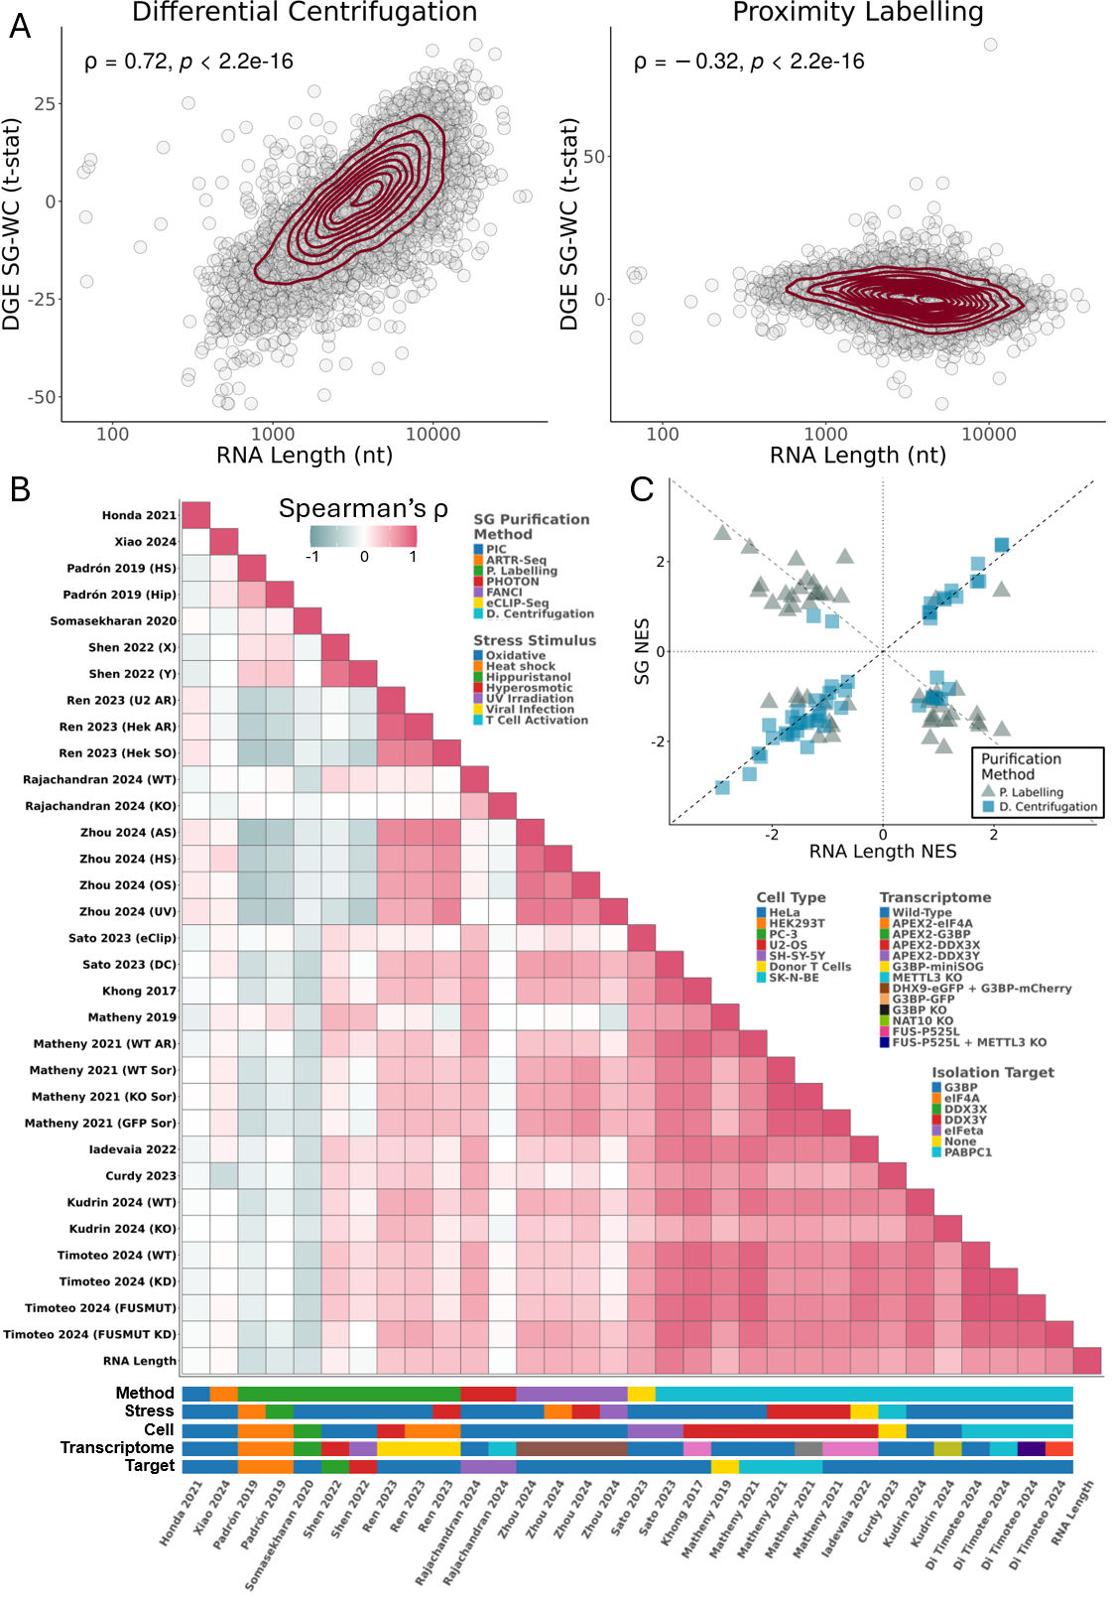
Figure 1. SGs purified by different methods have distinct transcriptomes. (A) Scatter plots of t-statistics of differential gene expression (DGE) between SGs and WCs (Y-axis) versus length of gene’s representative RNA transcript in number of nucleotides (nt) (X-axis), for SG purification by DC³¹ (left) and PL²⁹ (right); genes as circles, density contour lines in dark red, Spearman’s correlation coefficient ρ and associated test’s p-value on top left corner. (B) Heatmap of Spearman’s correlations between t-statistics of DGE between SGs and WCs, from different studies, and RNA length. Stress stimulus, cell type, transcriptome of origin, SG purification method, and target molecule used for purification of each study are given below the heatmap. G3BP refers to G3BP1 alone or both G3BP1 and G3BP2. METTL3 knockdown and knockout are marked with the same color. (C) Scatter plot of GSEA Normalized Enrichment Scores (NES) of Hallmarks between SGs and WCs, based on genes ranked by t-statistics of differential expression, for SG purification by DC³¹ or PL²⁹ (SG NES - Y-axis) versus genes ranked by length of representative transcript (RNA Length NES - X-axis). Dashed lines depict identity (Y = X; Y = -X), and axis lines.
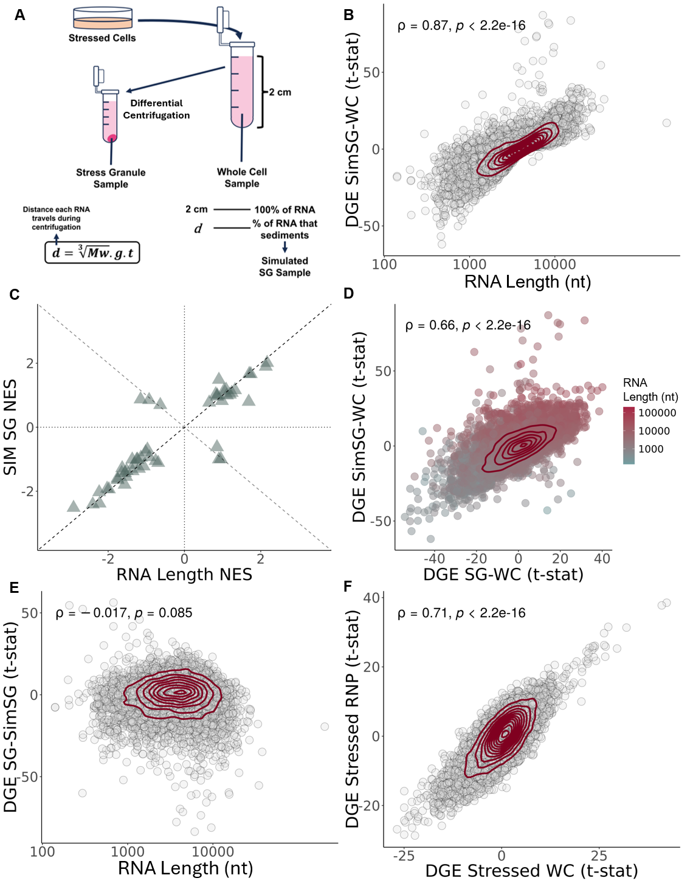
Figure 2. Length bias in DC-isolated SGs is compatible with inherent RNA condensation. (A) Schematic representation of standard DC protocol alongside our in silico pipeline for simulating the centrifugation process. d = distance travelled by each RNA during centrifugation; Mw = Molecular weight of each RNA transcript, in g/mol; g = centrifugation acceleration, in g; t = time of centrifugation, in seconds. (B) Scatter plot of t-statistics of DGE between simulated SGs, and WCs (Y-axis) versus length of gene’s representative RNA transcript (nt) (X-axis). (C) Scatter plot of GSEA NES of Hallmark gene sets in DGE between simulated SGs and WC samples, with genes ranked by t-statistics of differential expression (Y-axis) versus genes ranked by length (nt) (X-axis). Fisher’s test Odds Ratio (OR) and associated p-value on top right corner. Dashed lines depict identity (Y = X; Y = -X), and axis lines. (D) Scatter plots of t-statistics of DGE in simulated SGs (Y-axis) and DC-purified SGs (X-axis), relative to WC samples; genes as circles colored by RNA length in nt; density contour lines in dark red, Spearman’s correlation coefficient ρ and associated test’s p-value on top left corner. (E) Scatter plots of t-statistics of DGE in DC-purified SGs versus simulated SGs (Y-axis) versus length of gene’s representative RNA transcript (nt) (X-axis, log scale); transcripts as circles; density contour lines in dark red, Spearman’s correlation coefficient ρ and associated test’s p-value on top left corner. (F) Scatter plots of t-statistics of DGE between stressed vs unstressed RNP samples (Y-axis) and between stressed vs unstressed WC samples (X-axis). Genes as circles; density contour lines in dark red, Spearman’s correlation coefficient ρ and associated test’s p-value on top left corner (B,D,E,F).The original WC expression from Khong 2017³¹ was used to simulate SG samples.
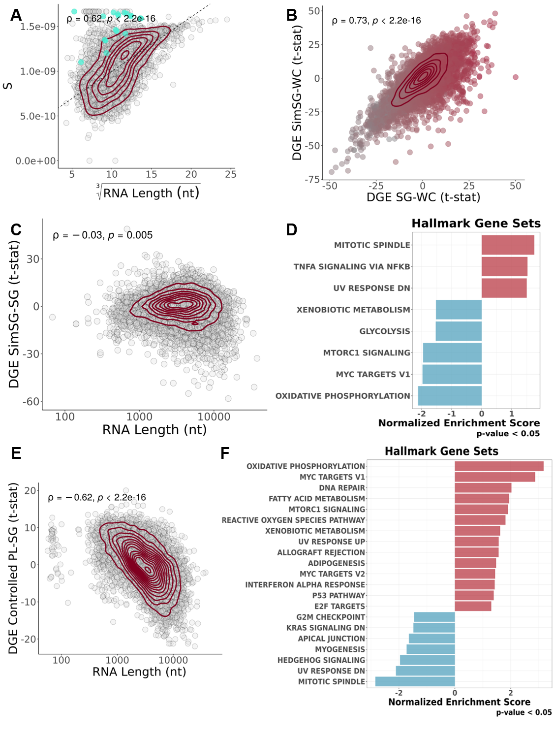

Figure 3. Method-specific corrections for SGs transcriptomes unveil their specificities. (A) Scatter plot of yeast S values obtained from Sed-seq data³³ (Y-Axis) and cubic root of yeast RNA length (nt) (X-Axis); Each circle denotes a transcript, with mitochondrially encoded transcripts colored in cyan; density contour lines in dark red, Spearman’s correlation coefficient ρ and associated test’s p-value on top left corner. The dashed line corresponds to the least-squares linear regression fit between the two variables. (B) Scatter plot of t-statistics of DGE of simulated SGs versus WCs, with S estimations based on Sed-seq data³³ (Y-Axis) and DGE of DC-purified SGs versus WCs³¹ (X-Axis); transcripts as circles colored by RNA length; density contour lines in dark red, Spearman’s correlation coefficient ρ and associated test’s p-value on top left corner. (C) Scatter plot of RNA length (X-Axis, log scale) and t-statistics of DGE of Simulated SGs versus DC-Purified SGs³¹ (thus what we consider to be centrifugation-corrected SGs) (Y-Axis); transcripts as circles; density contour lines in dark red, Spearman’s correlation coefficient ρ and associated test’s p-value on top left corner. (D) GSEA NES of Hallmark gene sets, with genes ranked by t-statistics of differential expression, in Simulated SGs versus DC-Purified SGs³¹. (E) Scatter plot of t-statistics of DGE in linear modelled PL-isolated SGs²⁹ (Y-Axis) and RNA length (X-Axis, log scale); transcripts as circles; density contour lines in dark red, Spearman’s correlation coefficient ρ and associated test’s p-value on top left corner. (F) GSEA NES of Hallmark gene sets, with genes ranked by t-statistics of differential expression, in linear modelled PL-isolated SGs²⁹.
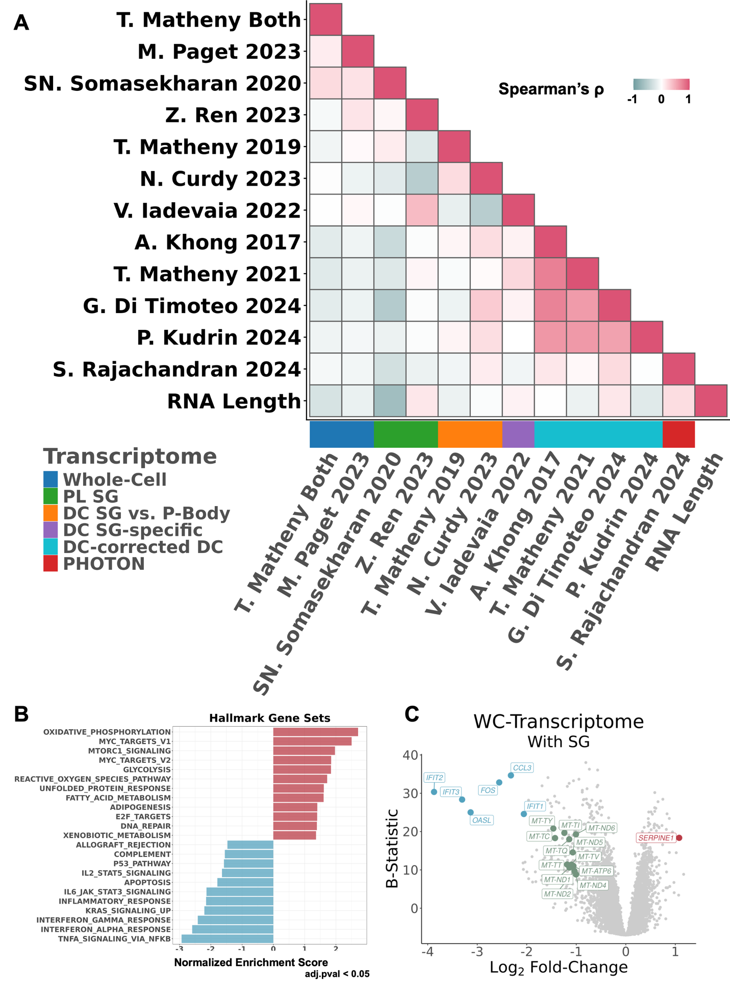
Figure 4. Meta-analysis of SG transcriptomes reveal SG assembly-specific gene expression alterations in whole cells. (A) Heatmap of Spearman’s correlations between SG and WC transcriptomes, corrected for centrifugation-associated RNA length biases, from different studies and RNA length. The SG purification method of each study is given by the color below the heatmap. (B) GSEA NES of Hallmark gene sets, with genes ranked by t-statistics of differential expression, of the SG-specific signal (i.e., what changes in the cells’ gene expression upon SG assembly)^{7,40,49}. (C) Volcano plot of DGE (X-Axis – Log2 Fold-Change; Y-Axis – B-Statistic) of the SG-specific signal; transcripts as circles; most differentially expressed transcripts are colored red (if upregulated, log2FC>1 with B-Statistic>15), blue (if downregulated, log2FC< -2 with B-Statistic>15), or green (if mitochondrially encoded, log2FC< -1).

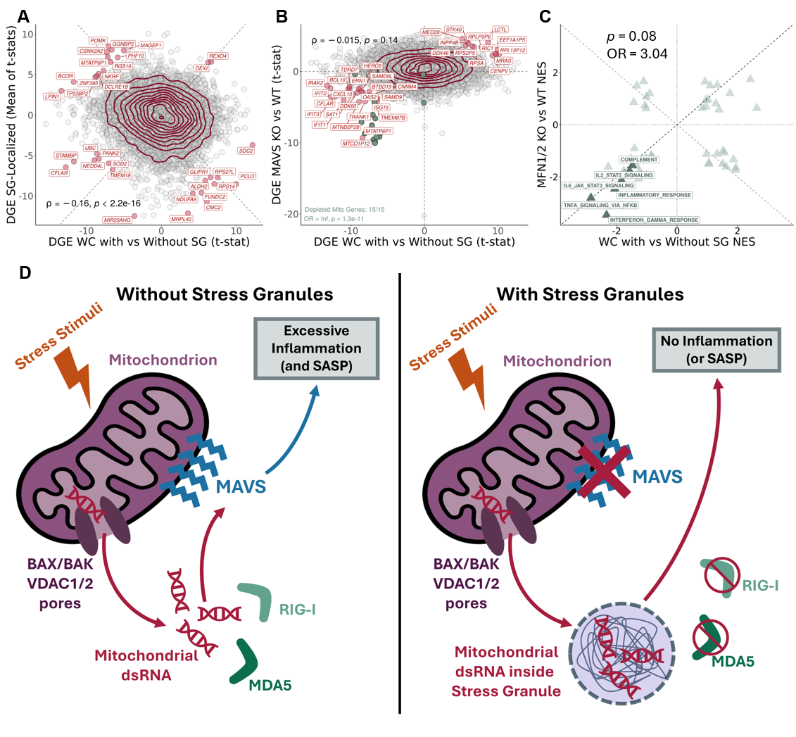
Figure 5. Mechanistic model of mitochondrial dsRNA–SG axis in inflammation control. (A) Scatter plot of t-statistics of DGE between SG-bearing WC samples and their non-bearing counterparts^{7,40,49} (X-Axis), and mean of t-statistics of DGE between SGs and WCs across studies (Y-Axis); transcripts as circles; transcripts with most differential/concurrent enrichment between axes labelled and colored dark red (|WC Enrichment * SG Enrichment| > 40 t-statistic); density contour lines in dark red, Spearman’s correlation coefficient ρ and associated test’s p-value on bottom left corner. (B) Scatter plot of t-statistics of DGE between SASP-inhibited WC samples and their non-inhibited counterparts⁵⁷, through siRNA treatment against MFN1/2⁵⁷ (Y-Axis – SASP Inhibition), and t-statistics of DGE between SG-bearing WC and their non-bearing counterparts^{7,40,49}; transcripts as circles; trancripts with most conserved enrichment between axes labelled and colored dark red (SG Enrichment * SASP Inhibition > 20), and green if mitochondrially-encoded; density contour lines in dark red, Spearman’s correlation coefficient ρ and associated test’s p-value on top left corner; dotted lines depitct X=0 and Y=0; Fisher’s test for mitochondrially-encoded transcripts on bottom left corner. (C) Scatter plot of GSEA NES of Hallmark gene sets, with genes ranked by t-statistics of differential expression, in SG-bearing cells compared to their non-bearing counterparts^{29,44,47,52} (X-Axis) and SASP inhibited samples against their non-inhibited counterparts⁵⁷ (Y-Axis). Fisher’s test OR and associated p-value are shown in the plot. Hallmarks linked to inflammation are highlighted. (D) Schematic of the proposed mitochondrial dsRNA–SG axis in inflammation control. In the absence of SGs (left), cellular stress promotes mitochondrial nucleic acid leakage, likely via BAX/BAK and VDAC1/2 pores⁵⁷. Leaked dsRNA is sensed by RIG-I and MDA5, which signal through MAVS to trigger an inflammatory cascade⁵⁷. When SGs are present (right), leaked dsRNAs are sequestered within them, shielding these RNAs from RIG-I and MDA5 recognition and thereby preventing or attenuating inflammatory signaling. In A and C, dashed lines depict identity (Y = X; Y = -X). In C, dotted lines depict X = 0 and Y = 0.

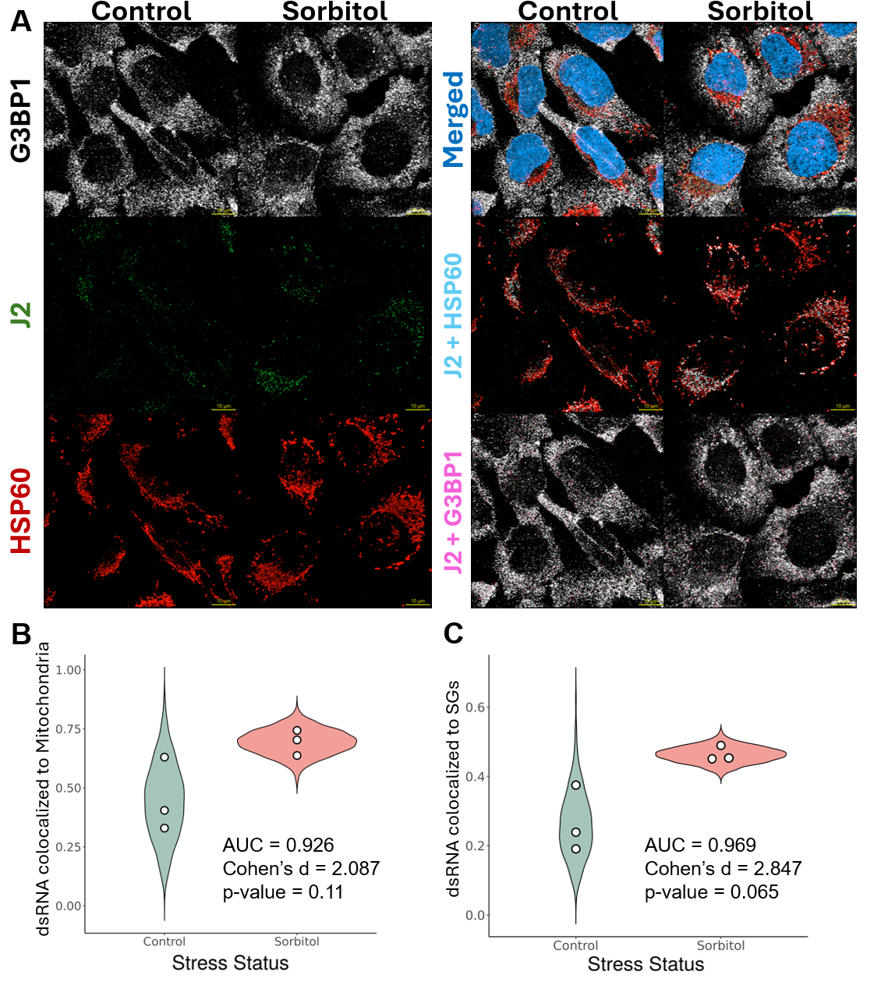
Figure 6. SG potentially uptake leaked mitochondrial dsRNA. (A) Representative immunofluorescence images of U2-OS cells untreated or treated with sorbitol (0.4M). G3BP1 (SG marker, v. Figure 1B) is shown in white, J2 in green (dsRNA marker⁶⁰), HPS60 in red (mitochondrial marker⁶⁷), and nuclei (DAPI) in blue. Merged images of these previous channels are also provided. In the “Cyan” row, a merge of J2 is shown with HSP60. Colocalization of these volumes (in voxels) is colored in cyan. In the “Magenta” row, a merge of J2, that did not colocalize with HSP60, is shown with G3BP1. Colocalization of these volumes (in voxels) is colored in magenta. Scale bar is shown on bottom right corner of each image, in yellow. (B-C) Colocalization proportions between J2 and HSP60 (B) or G3BP1 (C) were first quantified across all images acquired in the experiment (n = 3). For each condition, beta distributions were then fitted to both the empirical measurements and the corresponding null distributions generated from randomized colocalization controls. Shown are violin plots representing 1000 values sampled from these fitted beta distributions for each condition. White dots denote the observed empirical colocalization values. Statistical metrics (AUC, Cohen’s d, p-value) are displayed directly on the plot. AUC: probability that a randomly selected Sorbitol sample has a higher value than a randomly chosen Control sample; p-value obtained from a Student’s t-test. In B and C, AUC and Cohen's d values were obtained by comparing the two sets of 1000 values sampled from the emited beta distributions, whereas the p-value was obtained by comparing the two sets of empirical triplicates.

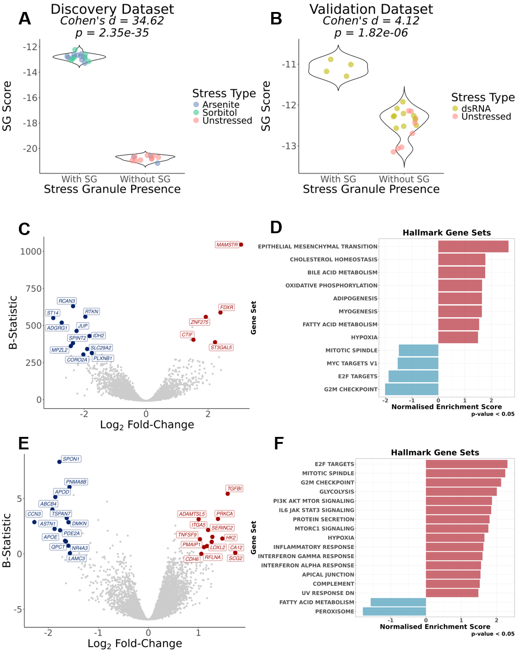
Figure 7. Development and validation of SG Score and its prognostic potential in GDC-TCGA datasets. (A/B) Violin plots of SG signature scores, calculated through a ranking metric (see Methods), in cells without and with SGs. WC samples are colored in accordance to stress type stimuli. The discovery dataset (A) refers to Matheny 2019 and Matheny 2021^{40,49}, whereas as the validation dataset (B) refers to Paget 2024⁷. Effect Size (Cohen’s d) and corresponding statistical significance, given by Welch’s t-test (p-value) are shown above plots. (C) Volcano plot of DGE (X-Axis – Log₂ Fold-Change; Y-Axis – B-Statistic) between ACC, and MESO tumour samples, and remaining GDC-TCGA tumor cohorts^{94,95}, corrected for dataset of origin; genes as circles; most differentially expressed genes are colored red (if upregulated, log2FC>1.5 with B-Statistic>300) or blue (if downregulated, log2FC< -1.75 with B-Statistic>300); (D) GSEA NES of Hallmark gene sets, with genes ranked by t-statistics of differential expression, between ACC, and MESO tumour samples, and remaining GDC-TCGA cohorts^{94,95}, corrected for dataset of origin; (E) Volcano plot of DGE (X-Axis – Log₂ Fold-Change; Y-Axis – B-Statistic) between top 25% and bottom 25% of SG-Score tumour samples in ACC, and MESO, corrected for dataset of origin; genes as circles; most differentially expressed genes are colored red (if upregulated, log2FC>1 with B-Statistic>0) or blue (if downregulated, log2FC< -1.5 with B-Statistic>0); (F) GSEA NES of Hallmark gene sets, with genes ranked by t-statistics of differential expression, between top 25% and bottom 25% of SG-Score tumor samples in ACC, and MESO, corrected for dataset of origin.

