Research Article
Revisiting Stress Granule Transcriptomes Reveals Mitochondrial RNA Enrichment Despite Methodological Bias
Alexandre Kaizeler^{1,2,3}*
Diogo Coutinho¹
Diana V. Vieira¹
Vanessa A. Morais^{1,2,}**
Nuno L. Barbosa-Morais^{1,2,3}***
¹ Gulbenkian Institute for Molecular Medicine, 1649-028 Lisbon, Portugal
² Faculdade de Medicina, Universidade de Lisboa, 1649-028 Lisbon, Portugal
³ Comprehensive Health Research Centre (CHRC), NOVA Medical School|Faculdade de Ciências Médicas, NMS|FCM, Universidade NOVA de Lisboa, 1169-056 Lisbon, Portugal
* First Corresponding Author: Alexandre Kaizeler – alexandre.afonso@gimm.pt
** Second Corresponding Author: Vanessa A. Morais – nuno.morais@gimm.pt
*** Third Corresponding Author: Nuno L. Barbosa-Morais – nuno.morais@nms.unl.pt

Highlights
- Stress granule transcriptomes vary widely across stressors, cell lines, and purification methods.
- Differential centrifugation skews stress granule RNA profiles toward longer transcripts.
- Methodological discrepancies across stress granule purification call for cautious interpretation of their transcriptome.
- Mitochondrial RNAs are consistently enriched in stress granules, suggesting a role in anti-inflammation by prevention of damage-associated molecular patterns.

Summary
Stress granules (SGs) are dynamic, membraneless cytoplasmic condensates that form in response to diverse cellular stressors. Although proposed to modulate stress responses by selectively sequestering proteins and RNAs, their precise molecular composition and function remain unclear. Reported SG transcriptomes differ substantially due to methodological discrepancies, notably between differential centrifugation (DC) and proximity labeling (PL). Here, we reanalyze publicly available human SG transcriptomes across multiple stressors, cell types, and isolation strategies. DC-based profiles were strongly shaped by RNA length, consistent with a dominant biophysical bias. Correcting for this effect reveals limited concordance between studies, yet enrichment of mitochondrially encoded RNAs emerges as a consistent feature. Immunofluorescence experiments further support dsRNA uptake by SGs upon stress. Since leakage of mitochondrial nucleic acids is a well-characterized damage-associated molecular pattern linked to inflammation, their sequestration in SGs suggests a potential role in modulating immune-related stress responses. These findings refine our understanding of SG composition, underscore the need to control for technical artifacts in SG isolation, and provide a framework to distinguish genuine biological signals from methodological noise in SG research.

Graphical Abstract
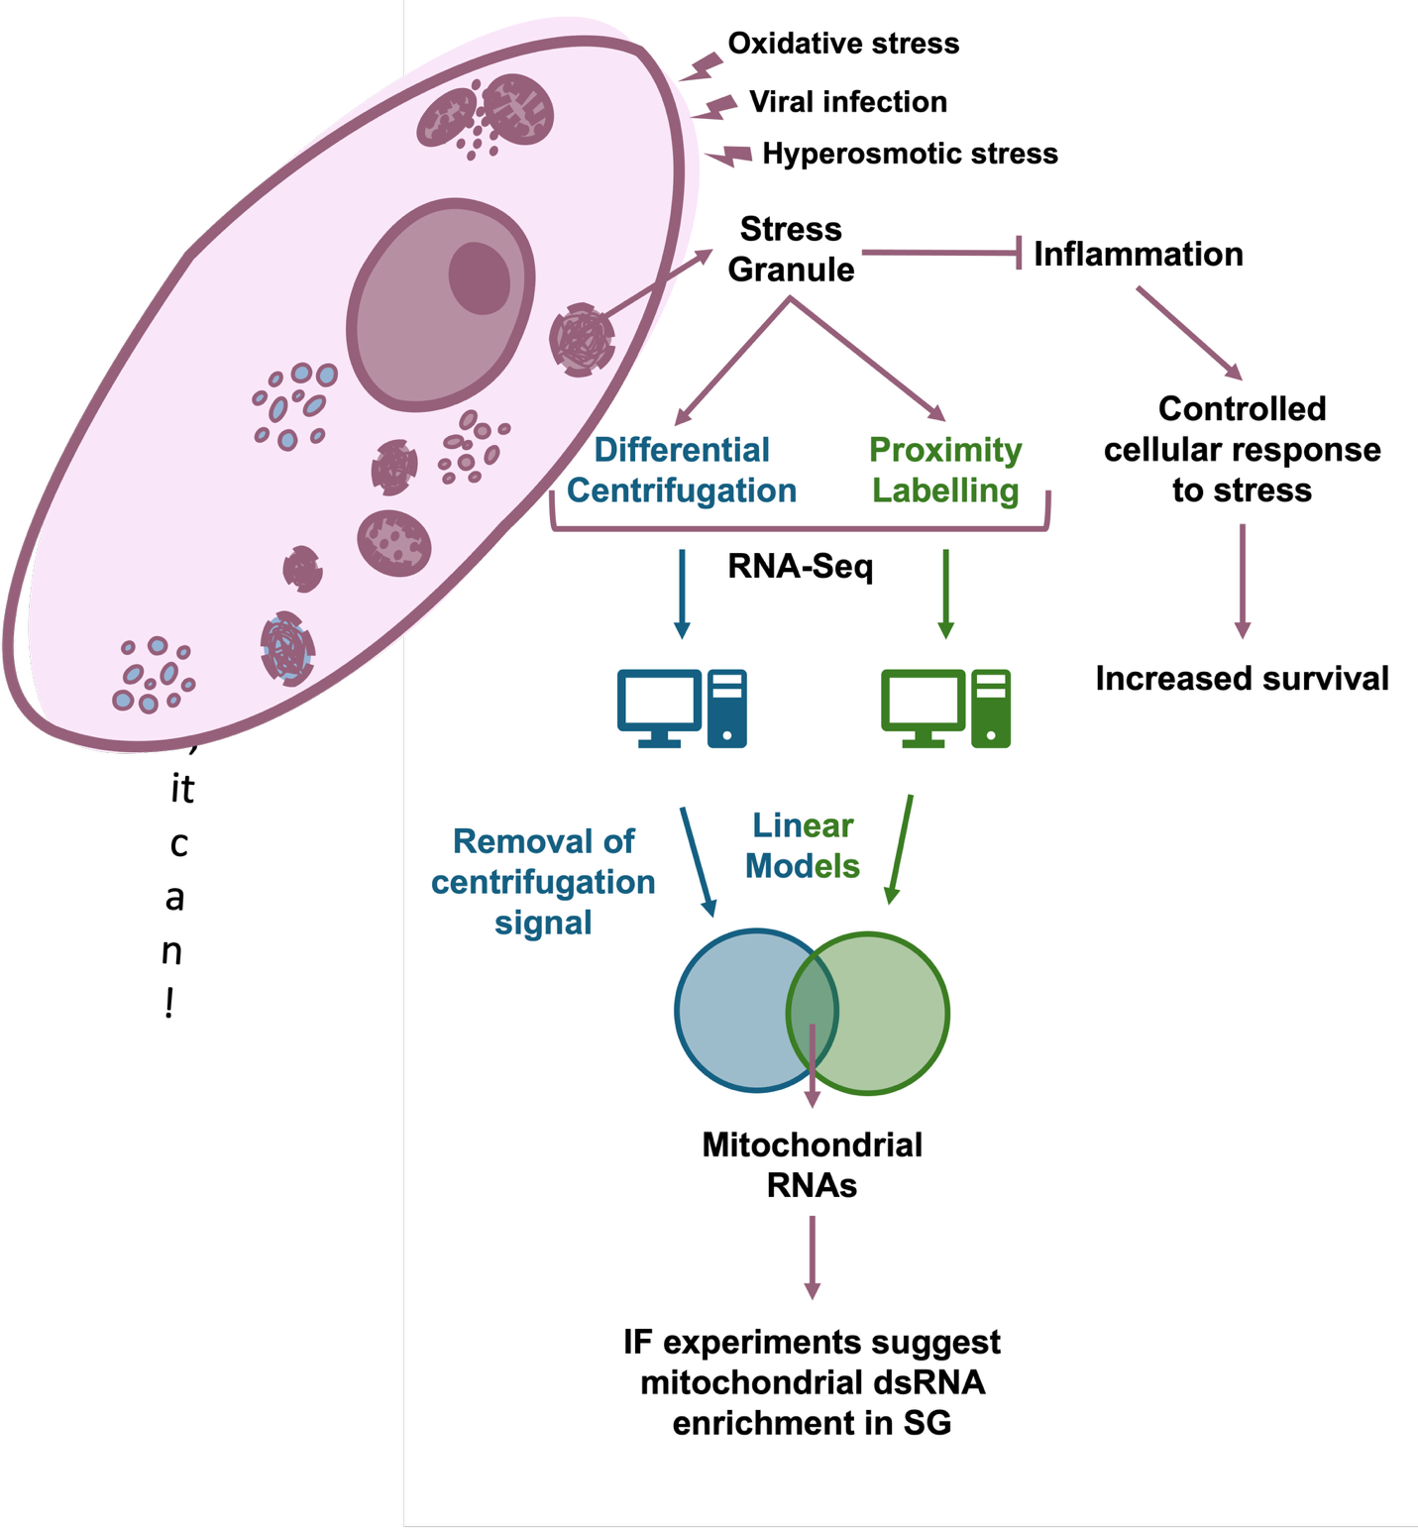

Keywords
Stress granules; RNA-binding proteins; transcriptomics; mitochondrial RNA; proximity labelling; differential centrifugation; RNA length bias; immune modulation; cellular stress response

Introduction
Stress Granules (SGs) are membraneless cytoplasmic structures formed in response to a wide variety of stimuli¹, including hypoxia, nutrient deprivation, viral infection, T cell activation, heat-shock and oxidative stress^{2–7}. SGs comprise aggregations of RNA, stalled preinitiation complexes, and proteins³, of which around half are RNA-binding proteins (RBPs)⁸. Characterized by rapid formation and swift disassembly upon cessation of the triggering stimuli (15 and 30 minutes with oxidative and heat-shock stress, respectively)⁹, SGs are highly dynamic structures, with their protein constituents continuously transitioning into and out of them¹⁰. While SGs were first suggested to play a pivotal role in the global suppression of translation concurrent with cellular stress, they are now theorized to selectively sequester specific constituents, as stressed SG-deficient cells still exhibit repressed translation¹¹. As such, they may modulate and fine-tune the cellular response to environmental and biotic stress, through sequestration of particular proteins and mRNAs: pro-apoptotic factors such as active caspases¹², or DDX3X to impede pyrocitosis, thereby improving cell survival¹³; PAI-1, hampering cell senescence¹⁴; RB1, protecting the cell from degradation in an RBFOX2-dependent manner¹⁵, among others.
Nevertheless, the biological significance of these mechanisms remains ambiguous, with the function of the sequestered mRNAs uncertain, as studies have demonstrated their continued translation within the SG¹⁶.
In addition to those physiological roles, SGs have been implicated in several pathologies. Mutations in certain SG-localized proteins, such as TIA1, TDP43 or ATXN2, are linked with amyotrophic lateral sclerosis^{17–19}, and certain mutations in DDX3X are suggested to originate stress granule-like formations that impair neurogenesis²⁰. Still, these results may be spurious, as both SGs and the physiopathology of these diseases rely on protein aggregation. SGs have also been implicated in antiviral responses, as viruses such as hepatitis-C and SARS-CoV-2 can disrupt G3BP1 function, one of the core SG-nucleating proteins, consequently inhibiting SG formation^{21,22}. Cancer cells experience heightened stress due to factors such as hypoxia, nutrient deprivation, and chemotherapy/radiotherapy, all of which are reported to induce SG formation^{2,23,24}. SGs are observed in multiple tumours where they are postulated to promote metastasis while conferring resistance to chemotherapy, as their abrogation by G3BP1 and COX-1/2 inhibition impedes so^{25,26}. However, it is not known if these results solely arise from the blockade of SG formation or involve other functions of the targeted proteins, such as G3BP1 and COX-1/2, beyond their role in SGs. For example, only 20% of G3BP1 localizes to SG, reiterating how these targets may be nonspecific for SG blockage²⁷.
Despite the absence of direct evidence for their functions, SGs continue to garner significant attention in various physiological and pathological contexts, owing to their supposed role in selective mRNA and protein sequestration, hypothesized to contribute to the downregulation of specific pathways in numerous diseases. Research efforts have led to the curation of two databases housing information on their protein constituents^{8,28}, revealing that RNA-binding proteins are their main component (>50%). Two main methodologies have emerged for elucidating their RNA content: differential centrifugation²⁹ (DC), and proximity RNA labelling via APEX-Seq²⁷ (PL), both relying on core SG proteins (usually G3BP1). Regardless, even when the same SG core protein and stress induction were used, notable disparities between transcriptomes isolated with the different techniques were observed^{27,29}. DC highlights RNA length as a significant predictor of SG enrichment²⁹, but this effect is absent with PL²⁷. The enrichment in longer RNAs has been hypothesized to have a biological nature, as SGs are formed by aggregation, longer transcripts equate to more potential binding sites for RBPs²⁹. Moreover, it is plausible that PL also captures G3BP1 that does not localize to SGs²⁷, and that therefore part of the obtained enrichment is not SG-specific. Nevertheless, concerns have been raised regarding the inherent bias of DC towards isolating longer transcripts, as longer RNAs tend to precipitate more readily given their augmented ligations, forming condensates which in turn have increased molecular weight^{30,31}.
To resolve discrepancies in SG characterization and identify authentic transcript features and their functional implications, we performed an unbiased analysis of publicly available human SG transcriptomic datasets spanning multiple cell lines, purification methods, and stressors. We found that transcriptomic profiles of SGs purified by differential centrifugation are strongly shaped by the method itself. Even after correcting for this bias, substantial differences between studies remained, with one reproducible feature being the enrichment of mitochondrially encoded RNAs.
Our analyses further suggest that SGs may modulate the cellular stress response, potentially dampening rather than amplifying it, which could help limit downstream effects such as excessive inflammation. Although the functional significance of mitochondrial RNA enrichment is not yet resolved, immunofluorescence experiments strongly suggest that mitochondrial dsRNAs are taken up by SGs upon stress, supporting a potential role in modulating immune signaling.

Results

Different SG purification techniques yield different SG transcriptomes
We first compiled publicly available transcriptomic datasets of human SGs isolated through various methods (Table 1). For each dataset, we compared gene (mRNA) expression between SGs and the corresponding whole-cell or cytoplasmic fraction (henceforth collectively referred to as WC). SGs isolated by DC consistently contained longer transcripts on average (Figure 1A, left; Khong 2017 study²⁹ shown as example), irrespective of stress stimuli and cell type (Figure 1B). Gene expression profiles of DC-purified SGs exhibit a consistently high correlation with each other (Figure 1B). In contrast, PL-based datasets showed no marked RNA length bias in SGs (Figure 1A, right; Somasekharan 2020 study²⁷ given as example) and exhibited minimal correlation between SG gene expression profiles, even under the same stress stimulus (Figure 1B).
We performed Gene Set Enrichment Analysis (GSEA)³² for the Hallmarks collection³³ (designed to minimize redundancy between gene sets) on differentially expressed genes (DEGs) in SGs induced by oxidative stress in the DC and PL example datasets, compared with their WC fraction (Figure 1A,B). In DC-purified transcriptomes, Hallmark enrichment in SGs was strongly confounded with transcript length (Fisher’s p < 1.5e-5, Odds Ratio = 23.77), with several enriched and depleted Hallmarks associated with long (e.g., mitotic spindle) and short (e.g., oxidative phosphorylation) transcripts, respectively (Figure 1C). In PL-purified transcriptomes, the observed enrichment in short transcripts in SGs (Figure 1A, right) also reflected on the Hallmark enrichment analysis (Figure 1C; p < 0.0001, Odds Ratio = 0.06).
Notably, these datasets differ in cell lines and arsenite concentrations, factors previously suggested to influence SG transcript composition²⁷. To evaluate whether these biological variables could explain the observed differences, we examined the transcriptomic oxidative stress response across the corresponding cell lines (Supplementary Figure 1A). Arsenite-treated U2-OS and PC-3 cells share highly upregulated genes, including MT1X and MT2A (metallothioneins, a protein class protective against oxidative stress³⁵), DUSP1 (upregulated during oxidative stress³⁶), and DNAJB1/HSP40 (which mitigates oxidative stress–induced cytotoxicity³⁷). Furthermore, GSEA on the DEGs between stressed and unstressed states in both cell lines revealed similar Hallmark enrichment (Supplementary Figure 1B; Fisher’s p < 3.5e-4, Odds Ratio = 21.66). Consistent with this, WC transcriptomes from these cell lines under oxidative stress, also showed a degree of correlation in the stress response (Supplementary Figure 1A), together indicating that cell line alone is unlikely to account for the differences seen in SG transcriptomes. Most likely, the variation in SG transcriptomes reflects the different isolation methods used in these example datasets.

Simulation of the centrifugation process yields RNA length bias compatible with that observed in DC-isolated SGs
SG assembly is driven by molecular aggregation, suggesting that longer RNAs, with greater potential for multivalent interactions, may be preferentially enriched. Nevertheless, the strong correlation observed between SG and WC transcriptomes (Supplementary Figure 1B) is compatible with the null hypothesis that the SG transcriptome is just a sample of the cell's cytosolic transcriptome. This raises the possibility of the RNA length bias in DC-purified SGs not being biological but rather a technical artefact.
We first hypothesized that this bias could originate from sampling biasas in small mRNA samples, longer transcripts may be overrepresented. This occurs because the RNA-seq library preparation process involves fragmentation, which yields more short sequencing reads per full molecule for longer transcripts. Nevertheless, after an in silico simulation of this process (Supplementary File), we found that the longer length enrichment was unlikely to originate from sampling bias.
RNAs tend to naturally form condensates in the cell, independently of their localization to SGs^{30,31}. Thus, DC purification, which isolates condensate-rich fractions prior to their immunoprecipitation, may also capture RNA condensates other than SGs. To test this, we simulated centrifugation in silico using WC expression data²⁹, modelling RNA precipitation as dependent primarily on transcript molecular weight under the assumption of uniform condensate shape (Figure 3A). Although RNAs sediment as part of condensates, we modeled each transcript as sedimenting independently, using its molecular weight as a proxy for the condensate (v. Methods). This approach yields a gene expression profile attributable solely to the technical effect of centrifugation, which we interpret as putative SGs. The simulated SGs displayed a positive RNA length bias relative to WC samples, matching that seen in the original DC data²⁹ (Figure 3B). GSEA for Hallmarks on DEGs between simulated SGs and WC samples was also confounded by transcript size (Figure 3C, p-value < 1e-9, Odds Ratio = 44.18), consistent with previous results (Figure 1C).
We found a strong correlation between simulated and DC-purified SGs in DEGs relative to WC samples (Figure 3D). Since the simulated SGs are derived only from WC expression and lack SG-specific biological signals, we interpret them as representing the centrifugation component of the DC method. Comparing the simulated SGs to the original ones allows us to identify transcripts sequestered beyond what would be expected from molecular weight alone. These "corrected” SG transcriptomes show no length bias (Figure 3E), a pattern consistent across most corrected DC-purified SGs (Figure 12-A), suggesting that the reported length bias in the original studies likely stems from centrifugation-related artefacts in the purification process.
If the SG signal is confounded by natural RNA condensation, a more appropriate control for DC-purified SGs requires identically processed samples lacking SGs. In the Matheny 2019 dataset³⁴, WC and ribonucleoprotein (RNP) granule fractions were collected under stressed and unstressed conditions, using DC but without immunopurification³⁴. Stressed RNPs fractions contain SGs together with other granules, such as processing bodies (PBs), a type of cytoplasmic granules also present in unstressed cells³⁴ and linked with RNA degradation, whereas unstressed RNPs lack SGs³⁴. If SG-specific RNA sequestration occurs beyond effects of stress and centrifugation, stressed versus unstressed RNP transcriptome changes would noticeably deviate from those observed in homologous WC comparisons. The two comparisons are strongly correlated (ρ = 0.71; Figure 3F), indicating that the SG transcriptome predominantly mirrors the cellular transcriptome, be it stressed or unstressed, with minimal transcript-specific sequestration. Variance analysis further shows that SG-specific effects are smaller than those attributable to stress and centrifugation (Supplementary Figure 3). Notably, this study did not perform immunopurification for a core SG protein³⁴, thus potentially diluting the SG-specific signal among other RNA condensates and explaining their lack of clear detection. Also, one fewer centrifugation step was performed compared to other DC protocols, which may explain the weaker RNA length bias observed in this dataset, even relative to other DC studies using the same cell types and stress conditions (Figure 1B).

Beyond RNA length and translation efficiency³⁰, RNA modifications such as m6A and ac4C have been associated with SG enrichment obtained through DC^{40–43}. To evaluate whether these modifications genuinely influence enrichment, we compared differential SG versus WC expression in modification-knockout cells relative to wild-type counterparts, using interaction model residuals to isolate modification-dependent effects on SG sequestration (Future Suppl). While m⁶A knockout produced no discernible shift in SG enrichment, ac⁴C knockout was associated with a modest but detectable effect (Figure Future Suppl). However, the magnitude of this shift correlated only weakly with the per-transcript number of ac⁴C modifications (Future Sup), arguing against a direct causal role for the modification itself. Instead, RNA length substantially accounted for the observed differences (Future Sup), suggesting that the ac⁴C-associated signal reflects a length-dependent bias rather than a direct effect of the modification on SG transcript sequestration.

Differential centrifugation yields similar transcriptomes for stress granules and other RNP granules
Based on the observations above, we hypothesize that the SG transcriptome isolated by DC is substantially confounded by the centrifugation process itself rather than representing exclusive biological sequestration. Consequently, other samples isolated by similar DC protocols, regardless of their identity, should yield comparable profiles, with enrichment for longer RNAs.
In the T. Matheny 2019 dataset³⁴, stressed PBs and bulk RNP granules were purified by DC, with PBs distinguished by an additional immunoprecipitation step using EDC3³⁴. The original A. Khong 2017 dataset²⁹ used a similar three-round DC protocol to isolate SGs (using G3BP for immunoprecipitation).
Despite representing distinct cytoplasmic granules, DC-purified SGs and PBs displayed similar transcriptomes (Fig. 5A), as noted by the authors³⁴. Moreover, both SGs and PBs were more similar to each other than to bulk RNP granules purified by two rounds of centrifugation (Fig. 5B-C). It is unclear if this pattern reflects the contribution of multiple other condensate types in the bulk RNP granule preparations or, more simply, the additional centrifugation step applied to both SGs and PBs.
Additionally, in T. Matheny 2019³⁴, these DC-isolated stressed PBs showed lower similarity to unstressed PBs isolated by fluorescence activated particle sorting (FAPS) from A. Hubstenberger 2017⁴⁶, than to to SG. We confirmed this observation using another independent FAPS dataset, S. Kodali 2024⁴⁷, where, albeit correlated, stressed DC-isolated PBs still exhibited higher similarity to either DC-isolated SGs or RNPs (Figure 5A-D).
In Y. Zhou 2024⁴⁸, stress granules were isolated using fluorescence-activated non-membrane condensates isolation (FANCI), a flow cytometry–based approach similar to FAPS. Notably, even after batch correction for cell type and stress (v. Methods), FANCI/FAPS-isolated SGs remained less similar to DC-isolated SGs than the latter are to PB-isolated SGs, despite SGs and PBs being distinct structures (Figure 5E).
While T. Matheny 2019³⁴ posits that stress causes a shift in the PB transcriptome by increasing the pool of available nontranslating mRNAs in the cell³⁴, hence increasing their similarities to SGs, our reanalysis does not support this explanation.
we integrated the Y. Zhou 2024⁴⁸ and S. Kodali 2024⁴⁷ datasets, which used these flow cytometry–based methods in HeLa cells. Both studies included unstressed WC controls, allowing batch correction for stress (v. Methods). This adjustment confirmed that similarities between SGs and PBs isolated by FAPS/FANCI persist even after controlling for stress, but they remain far weaker than those observed with DC isolation (Figure 5F).
It is important to note that this batch correction approach relies on the assumption of equivalent stress effects in SG and PBs, which may not fully capture more complex biological interactions. Nevertheless, in the absence of stressed PB data purified by FAPS, it remains uncertain whether the divergence between DC and FAPS datasets reflects genuine stress-induced remodeling of PBs or, instead, an artefact introduced by centrifugation, such as length-dependent RNA bias.

Method-specific corrections accounting for distinct confounders reveal selective SG RNA sequestration and divergent transcriptomic signatures
To support our centrifugation hypothesis, we analyzed publicly available Sed-seq data³¹, which measured RNA sedimentation by sequencing pelleted and unpelleted fractions from stressed and unstressed yeast cells. This experimental dataset enabled us to derive transcript-specific sedimentation coefficients (S) (v. Methods), offering a more precise estimate of RNA sedimentation than our first weight-based-only approximations. Interestingly, we observed that mitochondrially encoded transcripts exhibited greater S than expected based on their length (Figure 6A, teal circles).
Applying these coefficients to simulate SG transcript-sequestration against WC in an independent yeast dataset²⁹ yielded a strong correlation with observed SG profiles (Supplementary Figure 4A). These results support our hypothesis in an experimental system, although in a different organism.
We next extended this framework to human cells, by deriving formulas linking S to RNA length (v. Methods). We used separate equations for nuclear and mitochondrial transcripts, as the latter showed a systematically higher S values than other RNAs of comparable length, perhaps owing to their polycistronic nature⁴⁹ (Figure 6A, teal circles). These formulas enabled us to estimate theoretical S values for human RNAs and simulate their expected sedimentation in human samples, providing an in silico model of putative SGs. Simulations based on S values more closely matched empirical data than our earlier weight-based approach (Figure 6B vs. Figure 3D). Comparing observed SG sequestration²⁹ with these simulations allowed us to identify transcripts enriched or depleted beyond their predicted S values, thereby isolating a “corrected SG signal” that reflects sequestration independent of centrifugation effects. As a proof of concept, this approach recovered known SG markers such as NORAD as enriched, and GAPDH as depleted, consistent with previous RNA FISH validation²⁹ (Supplementary Figure 4B). The “corrected SG signal” correlated only modestly with RNA length (Figure 6C), far less than reported in the original study²⁹. GSEA reveals that “corrected SGs” were enriched for mitotic spindle-related transcripts (Figure 6D), consistent with the possibility that SGs selectively sequester cell-cycle-associated RNAs to reduce cell division during stress. However, this interpretation is challenged by concurrent signatures of TNF-α signalling via NF-κB pathway downregulation (a core stress response pathway) and upregulation of metabolic pathways, leaving the functional implications of SG sequestration in cellular regulation unresolved.
To further refine our understanding of SG composition in human cells, we applied a correction strategy to account for both centrifugation and stress effects using the T. Matheny 2019 dataset³⁴. This dataset includes both unstressed and stressed RNP and WC samples, which can control for centrifugation effects from the DC method. However, directly comparing RNPs from stressed and unstressed cells (which as abovementioned contain SGs in the former) is likely to primarily reflect stress-induced changes rather than SG-specific composition. To disentangle SG-specific signal from general stress responses, we applied linear models that accounted for both centrifugation and stress effects (v. Methods and Data Availability). This yielded a refined SG profile showing enrichment for NORAD and depletion of GAPDH and ACTB (Supplementary Figure 4C), as originally validated with RNA FISH²⁹. This controlled RNP/SG signal exhibited a positive, but weaker than previously reported, correlation with RNA length (Supplementary 4D). Mirroring the DC-corrected data (Figure 6D), GSEA shows downregulation of pathways related to metabolism (Supplementary Figure 4E). However, it also suggests downregulation of apoptosis pathways (Supplementary Figure 4E), challenging the hypothesis that SGs inhibit apoptosis by sequestering pro-apoptotic transcripts^{12,13}.
PL methods, although not relying on centrifugation, are also subjected to confounding factors. Notably, the labelling protein G3BP1 does not exclusively localize to SGs²⁷, and thus PL may capture RNAs beyond bona fide SGs. Although we cannot directly control for this, we used linear models, similar to our approach with the Matheny 2019³⁴ dataset, and controlled for other confounding variables (v. Methods) to isolate the “SG-specific signal”. In PL-purified SGs, this “controlled signal” showed a negative correlation with RNA length (Figure 6E), and GSEA revealed upregulation of metabolism and stress response pathways, consistent with selective transcript sequestration (Figure 6F).
Although the previous corrections provided a “controlled SG-specific signal”, WC transcriptomes can offer complementary insights into the effects of SGs across the cell. Importantly, as the majority of publicly available datasets do not purify SGs, infering their presence and effects in the cell from WC transcriptomes, would prove invaluable in studying their effect/function on other biological contexts. However, a major challenge in analyzing the WC transcriptome is separating the general stress response from SG-specific contributions. G3BP1/G3BP2 KO cells, which do not form visibly detectable SGs under oxidative stress, allowed us to distinguish these effects^{34,50,51}. By comparing KO and WT cells under stressed and unstressed conditions, we isolated the contributions of SGs, stress, and the KO itself to the WC transcriptome (v. Methods)^{34,50,51}. Contrary to their theorized function in fine-tuning the stress response, SGs appear to hamper this response, as evidenced by the downregulation of inflammation-related pathways (Supplementary Figure 4F).

Meta-analysis suggests SG-related dampening of inflammatory signalling
Given the differing results across SG purification methods, we applied our correction strategies to the remaining datasets we deemed suitable (v. Methods for exclusion criteria) and compared their similarity (Figure 7A).
Despite our corrections, substantial discrepancies remain across datasets (Figure 7A), independent of purification method. The exception is DC-purified SGs “corrected for centrifugation,” which are internally consistent, suggesting transcript-specific sequestration is minimal or below detection in whole-transcriptome analyses (using Spearman’s ρ). SGs may largely reflect a random sample of cellular transcripts, with a difficult to detect small minority of specifically-sequestred RNAs, or each method may introduce biases that shape observed profiles. WC-transcriptome datasets, generated via standard RNA-seq, also show internal consistency. Notably, the PL dataset from SN. Somasekharan 2020²⁷ aligns more closely with WC transcriptomes than other SG datasets (Figure 7A), perhaps reflecting that only ~20% of G3BP1 localizes to SGs. In contrast, the PL-derived dataset from Z. Ren 2023⁵², targeting the same protein, does not, which challenges this interpretation.
RNA length adds a further layer of complexity. In DC-purified SGs, corrections or alternative controls largely remove length bias (Figure 12A). By contrast, the two PL studies diverge: S.N. Somasekharan 2020²⁷ finds enrichment for short RNAs, whereas Z. Ren 2023⁵² reports enrichment for long RNAs. PHOTON (S. Rajachandran 2024⁵³) and FANCI (Y. Zhou 2024⁴⁸) preferentially capture longer transcripts, with FANCI showing a stronger bias (Figure 7A). These inconsistencies underscore the persistent challenge of reliably purifying and characterizing SG transcriptomes.
Although individual gene enrichment varied across studies, we used GSEA to uncover broader trends in gene set regulation (Supplementary Figure 5). However, no pathways were consistently enriched or depleted across all methods.
Because WC-transcriptomes are less affected by technical biases from purification methods, we first focused on these datasets, integrating and analyzing them together (T. Matheny 2019³⁴, 2021^{50,51} and M. Paget 2023⁷). GSEA identified consistent downregulation of stress- and inflammation-related pathways in WC datasets, including interferon responses, TNF signaling via NF-κB, and IL6–JAK–STAT signaling (Figure 7B). Apoptosis pathways were also downregulated, supporting the proposed role of SGs as inhibitors of apoptosis. Functionally, SGs may act as “shock absorbers,” preventing excessive immune responses, a phenomenon previously observed by M. Paget with dsRNA⁷. Notably, similar patterns were observed regardless of the stressor, as the T. Matheny^{34,50,51} datasets used oxidative and hyperosmotic stress.
Looking directly at upregulated and downregulated genes, we observed downregulation of FOS, an immediate-early stress-responsive gene⁵⁴, and upregulation of SERPINE1, a senescence-inducing gene and component of the senescence-associated secretory phenotype (SASP)¹⁴ (Figure 7C).
Additionally, we observed consistent downregulation of several mitochondrially encoded genes (Figure 7C). Given that fewer than 40 such genes exist in the human genome⁵⁵, the likelihood of this being given by mere change is low, making the trend particularly noteworthy.
We opted to focus on this finding, and performed GSEA across all datasets, using a gene set of the 36 mitochondrially encoded RNAs (obtained from Ensembl’s Biomart⁵⁶). As a control, we analyzed nuclear-encoded but mitochondrially localized RNAs, selecting top-scoring transcripts from RNALocate v3.0⁵⁷. Among SG-isolated datasets, two (V. Iadevaia 2022⁵⁸ and Y. Zhou 2024⁴⁸) also showed strong downregulation (NES < –2), whereas four (SN. Somasekharan 2020²⁷, Z. Ren 2023⁵², P. Kudrin 2024⁴³, and S. Rajachandran 2024⁵³) showed strong upregulation (NES > 2) (Figure 7D). No enrichment was observed for nuclear encoded mitochondrial genes.
This result was surprising, given that mitochondrially encoded genes are short and both Z. Ren 2023⁵² and S. Rajachandran 2024⁵³ datasets already exhibited a positive length bias. Moreover, the P. Kudrin 2024⁴³ dataset, using a DC-corrected method, also showed enrichment. Several other DC-based methods displayed similar enrichment prior to correction, but this signal disappeared after correction (v. Data Availabity). We therefore concentrated on the four datasets with persistent enrichment.
To capture a “purified SG–enrichment” signal, we averaged t-statistics across these four datasets (see Supplementary Material for a complete table). Among the top hits,excluding mitochondrially encoded RNAs which were the majority, were CHAC1, SESN2, ATF4, ASNS, and PPP1R15A, all stress-response genes and targets of ATF4^{59–62}.
Their sequestration in SGs may contribute to suppression of inflammatory pathways by limiting cytoplasmic availability. Notably, in addition to mitochondrially encoded RNAs, CHAC1, SESN2, and ASNS also have mitochondrial functions^{59–61}.
GSEA of this purified signal revealed enrichment for MTORC1 signaling and cholesterol homeostasis transcripts, with depletion of mitotic spindle transcripts, highlighting pathways selectively associated with these SGs (Figure 7E). Interestingly, several of these upregulated pathways are also observed in SG-containing cells, supporting the idea that SGs largely reflect the overall cellular transcriptome, with only a minority of transcripts selectively sequestered (Figure 7B;E).

Mechanistic model of SG-mediated inflammation dampening via mitochondrial RNA sequestration
To explore mechanisms underlying the dampening of stress and inflammatory signaling suggested by our meta-analysis, we compared our WC transcriptomes from SG-bearing cells to our SG-enriched transcripts. Althought these showed no overall correlation, mitochondrial RNAs were consistently anti-correlated (Figure 8A).
Consistent with SG’s reported role as senescence inhibitors¹⁴, we found that a recent study targeting the SASP showed downregulation of pathways similar to those we observed in SG assembly⁶³. However, a direct comparison reveals notable differences in gene expression between SASP inhibition and SG formation (Figure 8B). Nevertheless, Both conditions shared downregulation of mitochondrially encoded RNAs, and although overall correlations were weak, GSEA revealed broad suppression of inflammation-related pathways (Figure 8C).
Since senescent cells exhibit cytoplasmic accumulation of mitochondrial dsRNA that drives inflammation⁶³, and SGs have been reported to counteract senescence¹⁴, we propose a working model (Figure 8D). In the absence of SGs, stress promotes leakage of mitochondrial RNA and DNA into the cytoplasm, where they activate cGAS–STING and RIG-I/MDA5/MAVS pathways⁶³. These innate immune pathways normally detect viral nucleic acids (like dsRNA) and trigger interferon and inflammatory responses, ultimately promoting SASP⁶⁴. Despite its cellular intrinsic origin, it has been previously shown that mitochondrial dsRNA can activate these pathways⁶⁴. When SGs are present, they may sequester these leaked nucleic acids, possibly explaining their frequent proximity to mitochondria⁶⁴, thereby dampening inflammatory signaling and perhaps even delaying SASP onset.
Indeeed, several recent studies have shown that mitochondrial dsRNA can localize to SGs, either through increased mitochondrial permeability⁶⁵ or stress-induced release through fibrosis⁶⁶ or aging⁶⁷. However, this raises an important issue: both fibrosis and aging are strongly linked to oxidative stress^{68,69}, which in turn promotes mitochondrial dysfunction and nucleic acid leakage⁷⁰. It therefore remains unclear whether the proposed mitochondria–SG–inflammation axis represents a general stress response, or whether it is specific to stresses that directly disrupt mitochondrial integrity.

Immunofluorescence shows evidence for selective sequestration of mitochondrial dsRNA into SGs during hyperosmotic stress
To avoid confounding effects of oxidative stress, which is tightly linked to mitochondrial dysfunction and nucleic acid leakage⁷⁰, we instead used hyperosmotic stress (through sorbitol exposure) in U2-OS cells, a widely employed model in SG research (reviewed in Figure 1B). Although hyperosmotic stress can impact mitochondrial function⁷¹, we reasoned that it would perturb mitochondria less directly than oxidative stress, allowing us to better assess stress granule–associated RNA dynamics.
Previous work has shown that inhibition of either BAX/BAK or the mitochondrial porins VDAC1/2 prevents leakage of mitochondrial dsRNA into the cytoplasm⁶⁵. We hypothesized that this mechanism would also apply during hyperosmotic stress and therefore included the VDAC1/2 inhibitor 4,4′-diisothiocyanatostilbene-2,2′-disulfonate (DIDS)⁶⁵ as an additional control. Detecting dsRNA within SGs under these conditions would strengthen the case that its origin is mitochondrial rather than from alternative sources.
To test our model and directly visualize the putative SG–mitochondria–inflammation axis, we performed immunofluorescence using G3BP1 (SG marker, reviewed in Figure 1B), HSP60 (mitochondrial marker⁷²), J2 (dsRNA marker⁶⁵), and DAPI (nuclei).
Using the conditions described in T. Matheny 2021^{50,51}, we confirmed by 63× confocal imaging that U2-OS cells exposed to 0.4 M sorbitol for 3 h robustly formed SGs, visualized as G3BP1-circular foci, which were absent in unstressed controls (Figure 9). Strikingly, co-treatment with the VDAC inhibitor DIDS⁶⁵ (50 μM) completely abrogated SG assembly (Figure 9). This finding suggests that mitochondrial permeability, or at least VDAC channel activity, is required for SG formation under hyperosmotic stress.
Notably, SGs have previously been reported to modulate mitochondrial permeability by regulating VDAC activity⁷³. The observation that VDAC inhibition blocks SG assembly could point toward a reciprocal relationship, in which SGs both influence and depend on mitochondrial signaling.
At the same time, closer inspection showed that in both stressed and unstressed cells treated with DIDS, G3BP1 displayed a broadly similar diffuse distribution (Figure 9). This suggests that DIDS may also exert off-target or global cellular effects, making it difficult to attribute the phenotype exclusively to VDAC inhibition.
Nevertheless, the requirement for VDAC activity is consistent with a model in which mitochondrial-derived signals contribute to SG assembly. While leakage of mitochondrial nucleic acids remains a plausible mechanism, especially given VDAC’s reported role in their transport⁶⁵, other damage-associated products (e.g., cytochrome, cardiolipin, metabolites) could also serve as triggers for inflammation/stress⁷⁴ and sequential SG assembly. Alternatively, impaired import of mitochondrial factors might explain the effect.
Because SGs preferentially formed near mitochondria, as previously reported⁷³, this imaging setup did not provide sufficient spatial resolution to directly quantify dsRNA colocalization within SGs.
To overcome the resolution limitations of conventional confocal microscopy, we re-imaged the same samples using Airyscan with joint deconvolution, which markedly improved spatial resolution. Because DIDS treatment altered the baseline distribution of G3BP1, we restricted our comparisons to stressed versus unstressed conditions only. Unexpectedly, at this resolution G3BP1 signal appeared as small, spherical foci in both stressed and unstressed cells, rather than the diffuse distribution typically observed in unstressed cells with conventional confocal imaging (Figure 10A). This made it more challenging to distinguish bona fide SGs from background G3BP1 signal. Nevertheless, given that these were the same samples as in our prior analysis, we proceeded with quantitative colocalization measurements.
First, we calculated the fraction of mitochondrial volume that colocalized with dsRNA volume (in voxels) (Figure 10A, in Teal). Unexpectedly, we observed higher mitochondrial–dsRNA overlap in unstressed cells compared to stressed conditions. This counterintuitive result suggests that at least in the case of hyperosmotic stress, dsRNA clearance may be enhanced through nucleases or autophagic pathways, or alter mitochondrial morphology in ways that reduce measured colocalization. An alternative explanation is that even under “unstressed” culture conditions, cells experience baseline stress that may not be sufficient to trigger SG formation but could still promote mitochondrial dsRNA leakage. Because SGs are thought to have protective functions⁷, their assembly during acute stress might reduce such leakage, independently of any direct uptake. Moreover, evidence from C. elegans suggests that inhibition of protein synthesis enhances mitochondrial function⁷⁵. Since protein synthesis is typically suppressed under strong stress¹¹, this could paradoxically increase mitochondrial activity and dsRNA production.
To accurately assess SG-associated uptake, we excluded dsRNAs overlapping both mitochondria and SGs before quantifying their colocalization with G3BP1. Using this filtered signal, we then measured the proportion of dsRNA volume colocalizing with G3BP1 signal (Figure 10A, in Magenta). Colocalization was higher under stress, both within mitochondria (Figure 10B), and in SGs, the latter being consistent with dsRNA sequestration into SGs (Figure 10C). To account for our limited sample size, we modeled the data with a beta distribution, and compared these distributions (v. Methods). Although statistical significance was not achieved due to low power, the analysis revealed a large effect size between stressed and unstressed conditions (Area under the curve (AUC) = 0.969, Cohen’s d = 2.847) (Figure 10C), and differences between the two distributions (Bhattacharyya coefficient (BC) = 0.247) supporting a robust difference.
Taken together, these observations provide strong support for our hypothesis that SGs sequester cytoplasmic dsRNA under hyperosmotic stress. However, given the technical limitations and modest sample size, these data should be interpreted as supportive rather than definitive, and additional experiments will be required to fully validate this model.

Sequestration of TIA1 in SGs recapitulates splicing alterations from TIA1 depletion
In addition to transcriptome analyses, we investigated SG-associated proteins, with a focus on RBPs, which account for roughly 50% of the SG proteome⁸. Because only a fraction of the total amount of these proteins in the cell are sequestered in SGs (e.g., only ~20% of G3BP1 is sequestered into SGs²⁶), the functional impact of their partial sequestration remains unclear. RBPs are multifunctional, with many involved in splicing regulation, for example. When sequestered inside SGs, they are displaced from the nucleus, potentially impairing their splicing functions and leading to downstream biological effects (Supplementary Figure 6A).
To test this, we compiled a set of RBPs known to localise to SGs^{8,28} and mapped their RNA targets using eCLIP data (v. Methods). We then performed a differential alternative splicing analysis (DSA) between dsRNA-stressed cells and unstressed cells⁷, focusing on exon skipping events classified as increased, unchanged, or decreased, assessing binding enrichment for each of these categories (v. Methods, Supplementary Figure 7 as example). This analysis identified seven RBPs (TIA1, QKI, DDX3X, RBM15, KHSRP, PCBP1, and YBX3) with significant binding enrichment or depletion in these splicing events (Supplementary Figure 8). To minimize confounding between expression driven splicing alterations, we excluded RBPs whose expression differed between stressed and unstressed cells, in both SG-assembly competent and incompetent cells⁷ (Figure 11A), resulting in a final list of 5 potential targets, KHSRP, QKI, TIA1, PCBP1, and YBX3.
To assess whether these splicing changes were consistent with RBP sequestration, we compared splicing patterns in cells with shRNA-mediated knockdown of each candidate RBP^{76,77} (Figure 11B-F – Left). RBPs whose RNA binding profiles resembled the splicing changes observed upon knockdown were considered likely to affect cellular function through SG sequestration (Figure 11B-F – Middle). Of the five RBPs, only TIA1 and YBX3 showed visually similar patterns, confirmed with a Kolmogorov–Smirnov test comparing FDR distributions (p = 0.16, and p = 0.9, respectively). However, these effects may stem from general stress-induced changes in RBP localisation or function, rather than SG sequestration specifically.
To determine whether these effects were SG-specific, we repeated the splicing analysis in G3BP1/G3BP2 knockout cells exposed to dsRNA (Supplementary Figure 9), a condition under which SGs do not form⁷ (Figure 11B-F – Right). Without SG assembly, TIA1 no longer displayed a similar binding pattern (Kolmogorov-Smirnov test with p-value < 0.02), suggesting that sufficient sequestration within SGs may impair its function. YBX3, remained with a similar binding pattern (Kolmogorov-Smirnov test with p-value 0.46). These results suggest that TIA1’s binding patterns is altered in the presence of SGs.
We next performed immunofluorescence for TIA1 under control and hyperosmotic stress conditions. Although we initially considered including DIDS to block SG formation under stress, providing a closer parallel to our in silico comparisons, the compound’s broad off-target and cell-wide effects (Figure 9) led us to focus instead on a direct comparison between stressed and unstressed cells. Under homeostasic conditions, TIA1 is typically nuclear^{78,79}, but in our experiments the signal was predominantly cytoplasmic, likely reflecting the baseline stress inherent to cell culture. Despite this, we did not detect obvious differences in TIA1 localization between stressed and unstressed samples. Nevertheless, TIA1 staining reliably marked SGs, consistent with its canonical role (Supplementary Figure 6B).
Beyond its roles in SG-assembly⁸⁰, TIA1 is a known splicing regulator⁸¹, implicated in various neurological disorders⁸². Alongside TIAR, it participates in viral infection and replication⁸³, with viruses such as West Nile and dengue shown to interact with both proteins, inhibiting SG formation⁸³. Whether this reflects a viral strategy to disrupt SG function or an indirect consequence of altering TIA1 activity remains unresolved. Importantly, the gene expression changes (Supplementary Figure 6C), and the splicing alterations (Supplementary Figure 6D) per se following TIA1 knockdown^{76,77} did not reproduce the differences observed upon SG-assembly in U2-OS and A549 treated with dsRNA⁷. TIA1 sequestration is therefore unlikely to fully explain the anti-inflammatory phenotype associated with SG assembly.

Proposed links between SGs and cancer may reflect indirect mechanisms
Given the established link between inflammation and cancer⁸⁴, SGs’ involvement in inflammatory regulation may help explain this association. Namely, SGs have been reported to enhance the metastatic potential of sarcoma cells²⁵, based on comparisons between SG competent and SG deficient cells. However, SG ablation in these studies was achieved via G3BP1 knockout, a protein with functions beyond SG assembly, which may have influenced the phenotype. Moreover, G3BP1 knockout cells can still form SGs under certain stressors, such as hyperosmotic stress⁵⁰, which may occur in the tumour microenvironment. Thus, it remains unclear whether SGs were truly ablated, complicating interpretation of their direct role in metastasis.
Multiple genes, including G3BP1⁸⁵, AGO2⁸⁶, BRF1⁸⁷, CAPRIN1⁸⁸, CPEB1⁸⁹, DDX6⁸⁹, DISC1⁹⁰, EIF2A⁹¹, FASTK⁹², FMR1⁹³, FXR1⁹³, G3BP2⁸⁵, L1TD1⁹⁴, SAMD4A⁹⁵, SMN1⁹⁶, TIA1⁹⁷, TIAL1⁹⁷ and ZFP36⁸⁷, are known to induce spontaneous SG assembly when overexpressed (compiled elsewhere⁹⁸). We hypothesised that, if SGs directly drive tumour aggressiveness, high expression of these SG-nucleating genes would correlate with poorer patient survival. Analysis of Genomic Data Commons’s The Cancer Genome Atlas (GDC-TCGA)^{99,100} sarcoma’s dataset revealed that only G3BP1 expression was significantly associated with survival differences (Figure 12), suggesting that its prognostic value likely reflects roles beyond SG assembly rather than a direct effect of SGs.
SGs have also been proposed to promote chemotherapy resistance²⁶. KRAS mutant cells reportedly enhance SG assembly paracrinally via PTGS2 upregulation²⁶. However, PTGS2 has SG-independent roles, and observed resistance may not be solely due to SG assembly. KRAS mutant cells exhibit constitutive activation of the EGFR pathway¹⁰¹. As KRAS functions downstream of EGFR, its mutation predicts poor response to EGFR inhibitors but improved response to MEK inhibitors, which act further downstream¹⁰² (Figure 13A-B). PTGS2 KD or inhibition leads to expression changes that correlate with EGFR KD (and ERBB3 KD, another protein from the same family), suggesting that PTGS2 may indeed be part of the same pathway (Figure 13C). Hypothesising that PTGS2 acts downstream of KRAS, its inhibition may mimic MEK inhibition, targeting a key oncogenic driver and explaining increased treatment sensitivity. While PTGS2 is known to be regulated by the EGFR pathway (reviewed in¹⁰³), this proposed mechanism remains to be experimentally validated.

A SG gene signature and its clinical value in cancer
The results above highlight the limitations of single-gene analyses in isolating SG-specific effects due to overlapping roles in other stress-related pathways. To address this, we developed a custom SG transcriptomic signature. First, we integrated datasets from T. Matheny 2019 and 2021^{34,50}, as this combination had stressed samples with and without SGs, applying batch effect correction for cell genotype, stressor type, and study of origin. We then used an elastic net regression model with bootstrapping to derive a SG signature (v. Methods). Genes retained in nearly all bootstrap iterations (>90% of iterations) were used to construct the final signature, comprised of 41 genes, which we dubbed the SG Score. Both were validated on an independent dataset, M. Paget 2024⁷, which had also undergone batch correction for the abovementioned variables, and successfully distinguished SG-positive from SG-negative samples (Figure 14A/B). Nevertheless, it is important to note that the SG Score provides a relative, not binary, measure of SG presence. This means that higher scores indicate a greater likelihood but do not confirm SGs are exclusive to samples with elevated values.
We next evaluated the performance of our SG signature GDC-TCGA datasets^{99,100}. These datasets include: Acute Myeloid Leukemia (LAML); Adrenocortical Cancer (ACC); Bile Duct Cancer (CHOL); Bladder Cancer (BLCA); Breast Cancer (BRCA); Cervical Cancer (CESC); Colon Cancer (COAD); Endometrioid Cancer (UCEC); Esophageal Cancer (ESCA); Glioblastoma (GBM); Head and Neck Cancer (HNSC); Kidney Chromophobe (KICH); Kidney Clear Cell Carcinoma (KIRC); Kidney Papillary Cell Carcinoma (KIRP); Large B-cell Lymphoma (DLBC); Liver Cancer (LIHC); Lower Grade Glioma (LGG); Lung Adenocarcinoma (LUAD); Lung Squamous Cell Carcinoma (LUSC); Melanoma (SKCM); Mesothelioma (MESO); Ocular melanomas (UVM); Ovarian Cancer (OV); Pancreatic Cancer (PAAD); Pheochromocytoma & Paraganglioma (PCPG); Prostate Cancer (PRAD); Rectal Cancer (READ); Sarcoma (SARC); Stomach Cancer (STAD); Testicular Cancer (TGCT); Thymoma (THYM); Thyroid Cancer (THCA); Uterine Carcinosarcoma (UCS).
Given that cancer cells often encounter conditions known to promote SG formation^{2,23,24}, we hypothesised that our SG signature would yield higher scores in tumor samples compared to their normal counterparts. Among the 17 TCGA cancer types with at least 5 normal and tumour samples, only four: BLCA, LIHC, PRAD, and READ, showed an increased SG Score in tumour samples (t-test, p < 0.05). In contrast, seven cancer types: ESCA, HNSC, KIRC, KIRP, LUAD, LUSC, and STAD, displayed lower SG Scores in tumors compared to normal tissue (t-test, p < 0.05), in particular ESCA and STAD (Cohen’s d < -1) (Supplementary Figure 10).

To assess prognostic relevance, we performed a survival analysis comparing the top and bottom quartiles of SG scores, based on the hypothesis that more aggressive, therapy-resistant cancers would show higher scores, and thus lower overall survival^{25,26} (Supplementary Figure 11).
Since random signatures tend to exhibit prognostic value in cancer^{104,105}, we further tested our signatures against randomly generated signatures to assess their specificity (v. Methods; Supplementary Figure 11). Compared to 100 random signatures, our signature showed a false positive rate (FPR) < 0.05 in four cancer types (ACC, CHOL, MESO, and STAD). This suggests SG presence may relate to tumour aggressiveness in these cancers, as higher SG scores consistently lead to worse outcomes. Importantly, STAD had lower SG scores in tumours than in normal tissue, so its prognostic significance should be interpreted cautiously.
To better understand why SGs showed prognostic potential only in these specific cancer types, we compared tumor samples from the four relevant GDC-TCGA cohorts with the remaining GDC-TCGA datasets^{99,100}, while controlling for tissue of origin. This analysis revealed reduced expression of BCL2¹⁰⁶ (Figure 14C), suggesting a pro-apoptotic environment¹⁰⁶, along with GSEA of downregulated proliferation-associated gene sets and enrichment of epithelial–mesenchymal transition (EMT) and inflammation-related gene sets (Figure 14D).
Given the proposed role of SGs in attenuating inflammatory signaling⁷, it was unexpected that higher SG scores correlated with worse survival in cancers characterized by heightened inflammatory pathways. This raises the possibility that, at least in these cancers, this increased inflammation may be boosting anti tumour immunity, thus impairing tumour growth (Figure 14D) (potential mechanisms reviewed elsewhere¹⁰⁷).
To further investigate the basis of this association, we compared the top and bottom quartiles of SG Score within each of the four cancer types, while controlling for tissue of origin. DGE analysis identified upregulation of HK2 (Figure 14E), which binds VDAC to promote pore opening¹⁰⁸. While this typically facilitates ATP release¹⁰⁸, previous results⁶⁵ (Figure 10A) suggest it could also permit mitochondrial nucleic acid leakage, which we previously linked to SG assembly and inflammation (Figure 9 and 10). Consistent with this, GSEA revealed an apparent “inversion” relative to the basal state (Figure 14F): tumors with higher SG scores showed reduced EMT (previously upregulated) and enhanced proliferation-associated programs (previously downregulated). However, increased interferon-α and -γ responses persisted, seemingly at odds with the idea that SGs suppress inflammation. One possibility is that we are not detecting a net anti-inflammatory effect but rather comparing tumors under stress vs tumors under lesser amounts of stress. In this comparison SGs may mitigate, but not eliminate, stress-induced inflammation. Consistent with this hypothesis of simple mitigation, there is a strong downregulation of EMT, and thus potentially metastization, which has been shown to be reliant on chronic inflammation¹⁰⁷.
To test whether survival differences were driven by baseline pathway activity, we repeated survival analyses using the top two enriched basal gene sets (TNFα signaling and EMT). However, neither pathway showed prognostic value in these cancers (TNFα signaling only had FPR < 0.05 in ESCA, and EMT in LGG), suggesting that these results are more particular to our SG Score than to these general processes.

Discussion
Since their discovery, stress granules have remained enigmatic due to their unclear functions. Given that they form in response to stress, it was initially hypothesised that they play a direct role in the translation arrest observed during stress conditions¹¹. However, this assumption was later disproved, as translation is blocked independently of SG formation¹¹. Recently, the prevailing view has shifted, suggesting that SGs may instead contribute to the fine-tuning of the stress response by selectively sequestering specific proteins and transcripts^{12–15}. This sequestration prevents their function or translation, allowing the cell to prioritise its response to the stress^{12–15}. For instance, the sequestration of apoptotic proteins can protect the cell from undergoing apoptosis in response to stress¹². Given that cancer cells are frequently exposed to elevated levels of stress, such as nutrient deprivation, hypoxia, and replicative stress, it is tantalising to consider that SGs may play a role in cancer progression^{2,23,24}. Indeed, recent findings have linked SGs to increased tumour aggressiveness and therapeutic resistance, suggesting that they could represent a promising novel target for anticancer therapies^{25,26}.
This theory led to the advent of several techniques that vowed to elucidate the SG transcriptome^{29,48,53,109,110}, with the potential of uncovering their assembly mechanisms and identifying inhibited pathways that may play a critical role in cancer progression. However, these purified SG transcriptomes vary significantly, particularly when different purification methods are employed (Summarized in Figure 1B). Despite this, since all methods aim to isolate the same structure, it seemed logical that there must be an underlying explanation for the differences and some level of commonality once those differences are accounted for. With this in mind, we conducted a meta-analysis of published human SG transcriptomes.
This analysis was particularly challenging due to numerous issues present in several transcriptome datasets. These included improper sample labelling, which was corrected by the authors following our correspondence⁵¹, unclear specificity of the techniques, as SGs share similarities with the nucleus and nucleoplasm^{48,110}, and inadequate gene filtration^{109,111}. In the latter case, applying a more stringent filtration threshold led to the exclusion of some initial conclusions, as a greater proportion of gene expression alterations fell within the noise range. Notably, one such instance highlighted the consequences of inadequate filtration, as Y chromosome-specific proteins were detected in SGs isolated from female cells¹⁰⁹.
Despite these limitations, it became immediately clear that transcriptomes isolated using differential centrifugation consistently contained longer RNAs than those from whole-cell transcriptomes, even when using the same cells and stressors as other methods (Figure 1B). We considered that this discrepancy could stem from the technique itself, as longer RNAs are heavier, and the condensates they form are also heavier. Given that centrifugation is a weight-dependent physical separation technique, these heavier condensates would precipitate more easily, resulting in an enrichment of longer RNAs in the precipitate³⁰. Our in silico simulations of SG isolation produced results remarkably similar to the observed length bias, using both crude methods and empirical values from yeast³¹ (Figure 3D and Figure 6B). This suggests that the technique itself may be responsible for the length bias observed in these SGs. Indeed, a study in yeast showed that at least in this organism this is partially the case³¹, as RNAs tended to form condensates irrespective of their size, and so using differential centrifugation would naturally bias for longer/heavier transcripts.
We decided to remove the theoretical signal attributed to centrifugation and compared these “corrected” SG transcriptomes to those obtained through other methods. Although the corrected SGs still differed from those purified by other techniques, the length bias was either absent or greatly reduced (Figure 7A). Additionally, several of the purified SGs showed an enrichment of mitochondrial encoded RNAs (Figure 7D). While most DC-purified SGs already exhibited mt-RNA enrichment, after our correction, this was greatly attenuated. This attenuation may reflect an overcorrection on our part, as our approach assumed that mitochondrial RNAs possess higher sedimentation coefficients than nuclear-encoded transcripts. Recently, several studies did find the presence of mitochondrial encoded dsRNA within stress granules^{65–67}. Beyond this, it seems that SGs are simply a “sample” of the whole-cell transcriptome, sequestering RNAs without any particular preference/criteria.
Besides mitochondrial RNAs, since nothing particularly notable emerged from the purified transcriptomes, we shifted our focus to the whole-cell transcriptome, aiming to identify pathways enriched or depleted in the presence of SGs. A simple comparison between stressed and unstressed cells proved inadequate, as it primarily highlighted general stress signals. To address this, we applied linear models that included unstressed cells and stressed cells, both with and without SGs. This approach revealed a curious trend: mitochondrial RNA was consistently downregulated, and inflammation-related pathways were significantly depleted (Figure 7B-D). These findings suggest that SGs fine-tune the stress response by dampening it, possibly protecting the cell from excessive activation of inflammatory pathways. While this behaviour had been previously observed in response to dsRNA⁷ (and validated through our analysis), we found it also occurs under other stress conditions, such as oxidative and hyperosmotic stress. This was a similar response to what was observed in senescent cells treated with inhibition of the MAVS pathway⁶³ (Figure 8B/C), suggesting that these processes could play antagonistic roles within the cell, or even be part of the same overarching stress sensing pathway.
Mitochondrial nucleic acids act as damage-associated molecular patterns that trigger inflammation⁶⁴. Because we observed an apparent enrichment of mitochondrially encoded RNAs, but not nuclear-encoded mitochondrial RNAs, we hypothesized that the captured molecules were predominantly mitochondrial dsRNAs, which arise naturally during transcription⁶⁴. Once released into the cytoplasm, these dsRNAs activate MDA5 and RIG-I, initiating inflammatory signaling⁶⁴. SGs could therefore mitigate inflammation by sequestering mitochondrial dsRNAs. To test this hypothesis, we exposed U2-OS cells to hyperosmotic stress, which perturbs but does not directly damage mitochondria⁷¹, and to DIDS, a VDAC pore inhibitor previously shown to block mitochondrial dsRNA release into the cytosol⁶⁵. Unexpectedly, DIDS treatment completely abolished SG assembly (Figure 9). This finding suggests that mitochondrial permeability is required for SG formation, potentially implicating dsRNA export as a trigger. However, the effect could also reflect the release or uptake of other mitochondrial factors, or nonspecific, cell-wide effects of DIDS.
Because SGs often form in close proximity to mitochondria⁷³, standard confocal microscopy limited our ability to accurately quantify colocalization. We therefore used Airyscan imaging with joint deconvolution to improve spatial resolution. Unexpectedly, although SG-like foci were readily identifiable by conventional confocal microscopy, their distinction from the broader G3BP1 signal became noticeably less clear at higher resolution (Figure 9 vs 10A). This observation highlights a broader issue in the field: image-processing choices for SG detection are rarely reported in detail, yet they can substantially influence what is interpreted as an SG.
A related conceptual challenge is that SGs are defined almost entirely by imaging,typically through the appearance of G3BP1- or TIA1-positive puncta. Implicit in this definition is an empirical size threshold: SGs must reach a certain diameter to be visible by standard microscopy, which generally requires strong stress conditions, beyond what is typically experienced in natural conditions³⁰. Higher-resolution imaging, however, reveals much smaller G3BP1-positive structures, suggesting that current size-based criteria may underestimate the presence of SGs under moderate or physiological stress. If small G3BP1 condensates also recruit canonical SG components, then a purely visual definition may be insufficient, unless one explicitly specifies a size cutoff for “bona fide” SGs.
Despite these challenges, we proceeded to quantify dsRNA localization within these G3BP1-positive foci. Mitochondrial colocalization with dsRNA appeared lower in untreated cells, although the difference was not statistically significant (Figure 10B). This may reflect baseline stress in cultured cells, which could promote low-level leakage of mitochondrial RNA. SGs may mitigate this leakage when present, and in C. elegans, translational inhibition, common in stress¹¹, has been shown to enhance mitochondrial function⁷⁵ and thus potentially mtRNA production, potentially contributing to these observations. To isolate dsRNA uptake into SGs, we excluded signals colocalizing with mitochondria and then measured overlap with G3BP1. By design, this approach was conservative, as triple colocalization was assigned to mitochondria, and unstressed cells served as a baseline lacking bona fide SGs. Even under these stringent conditions, our analysis revealed a large effect size, with increased dsRNA–SG colocalization during hyperosmotic stress (Figure 10C/D). Importantly, these findings should be viewed as supportive rather than definitive. Although they are fully consistent with our model that SGs selectively sequester mitochondrial dsRNA, the limited statistical power and potential confounders prevent us from drawing firm causal conclusions at this stage. A further limitation is that we did not directly determine the origin of the dsRNA detected by J2. Since J2 recognizes any dsRNA species, we cannot exclude contributions from non-mitochondrial sources. Nonetheless, several observations argue that the signal is likely mitochondrial: mitochondrial dsRNA is a well-known byproduct of bidirectional mtDNA transcription⁶⁴, and inhibition of VDAC pores, the proposed conduits for mitochondrial dsRNA efflux⁶⁵, prevents SG formation, consistent with mitochondria-derived RNA acting upstream of SG assembly.
We also performed a differential splicing analysis and, using RNA-binding maps, found that TIA1-regulated splicing events resembled those observed in cells subjected to TIA1 knockdown (Figure 11). This suggests that a substantial fraction of TIA1 is sequestered into SGs during stress. However, whether the observed splicing dysregulation represents a direct functional consequence of SG assembly or a parallel effect remains unresolved. Our immunofluorescence experiments were similarly inconclusive: although TIA1 normally localizes to the nucleus^{78,79}, we observed predominantly cytoplasmic signal in both stressed and unstressed cultured cells (Supplementary Figure 6), likely reflecting the elevated basal stress of in vitro conditions.
SGs have been extensively implicated in cancer, where they are associated with tumour aggressiveness^{25,26}. However, knockout models used as controls in these studies typically target genes that have additional functions beyond SG formation^{25,26}. To account for this, we adopted the null hypothesis that these additional functions could explain the observed link between SGs and aggressiveness. Our findings indicate that this hypothesis cannot be easily rejected (Figure 12 and 13). This does not imply that SGs have no role in cancer but rather highlights the limitations of single-gene approaches in studying their impact.
As an alternative approach to studying the role of SGs in cancer, we developed a gene expression signature^{34,50,51}, which we term SG-Score, using elastic net regression. Following validation in an independent transcriptomic dataset⁷ (Figure 14A/B), we applied these signatures to cancer datasets from GDC-TCGA^{99,100}. Elevated SG signature scores in tumor versus normal tissues were observed only in a subset of cancer types, suggesting that the widely hypothesised global increase in SGs across cancers may not be consistent (Supplementary Figure 10). This is further supported by experimental observations, where SG formation typically requires stress conditions that are more severe than those commonly found in physiological settings³⁰. We also evaluated the utility of the signature as a potential prognosis marker. Survival analysis based on stratification by SG score revealed potential prognostic relevance in four cancer types, ACC, CHOL, MESO, and STAD, where higher SG scores were associated with poorer outcomes (Supplementary Figure 11).
To explore why the SG-Score showed prognostic value only in this subset of cancers, we examined their transcriptional landscape compared with other GDC-TCGA tumors^{99,100} (Figure 14 B/C). These cancers exhibited reduced BCL2 expression, lower proliferation, and enrichment of EMT and inflammatory pathways, raising the possibility that inflammation may support anti-tumor immunity in these contexts¹⁰⁷ (Figure 14 B/C). Unexpectedly, within these cancers, higher SG scores correlated with an inversion of these basal features, exhibiting lower EMT and higher proliferation programs, while interferon responses remained elevated (Figure 14 D/E). This pattern suggests that SGs may mitigate, but not fully suppress, stress-induced inflammation, potentially altering the balance between tumor progression and immune activation. It is also possible that high SG-Score tumors are simply more stressed than their low-score counterparts. While SGs can attenuate inflammation, this does not imply that less-stressed cells are inherently more inflammatory. Additionally, repeating the survival analysis with EMT and TNFα signaling showed no significant effects on prognosis, suggesting that the SG-Score captures biology distinct from these pathways.
Another notable finding from this analysis was the upregulation of HK2 (Figure 14D), a gene known to modulate VDAC activity and promote ATP transport from mitochondria to the cytosol¹⁰⁸. Since VDAC pores have also been shown to permit mitochondrial dsRNA leakage⁶⁵, it is tempting to speculate that this mechanism could link SG formation to inflammatory signaling in these cancers. However, confirming whether our proposed model operates in this context will require additional experimental validation. We present this as a hypothesis rather than a conclusion, with the hope that it may guide future studies.
In conclusion, we identified and addressed several challenges associated with SG-related transcriptomic datasets and compiled what we propose to be an accurate representation of the SG transcriptome, along with transcriptomic changes that accompany SG assembly. Notably, SG formation was associated with the downregulation of stress- and inflammation-related pathways, potentially reflecting a protective cellular response that occurs independently of the specific stressor.
However, it is important to acknowledge that several aspects of this study likely represent simplifications of a more complex biological reality. Multiple SG subtypes have been described, in accordance to their assembly, some of which are dependent on eIF2α phosphorylation while others are not, and they differ in key protein components. Our analysis did not distinguish between these SG subtypes, which may contribute to the variability observed across datasets.
As additional caveats, mitochondrial RNA enrichment was not observed in all studies that passed our quality thresholds. This is partly because our centrifugation correction reduced this signal in some DC datasets (although this enrichment was also absent in other methods of SG-isolation), potentially due to overcorrection based on assumptions about higher sedimentation of mtRNAs derived from yeast studies³¹, which may differ from human mitochondrial dynamics. Alternatively, yeast pellets may have contained incidental SGs, artificially increasing sedimentation, although higher values could also reflect the polycistronic nature of mtRNAs⁴⁹.
Our imaging experiments further highlight a methodological limitation in the field: SG detection and analysis are often vaguely described. Despite these caveats, our high-resolution imaging, although limited by sample size, revealed apparent enrichment of dsRNA within SGs, providing experimental support for our model that SGs sequester mitochondrial nucleic acids to modulate stress-induced inflammatory signaling.
Finally, while the SG signature shows promise as a biomarker, its predictive value in complex cancer datasets remains to be validated. Collectively, these findings establish a conceptual framework linking SG assembly, mitochondrial RNA dynamics, and inflammation, and highlight a new avenue for mechanistic and translational studies

STAR Methods

Key Resources Table
Reagent or Resource | Source | Identifier
Antibodies
Rabbit Anti-G3BP1 | Atlas Antibodies | Cat # HPA004052, RRID:AB_1849348
Rabbit Anti-TIA1 | Atlas Antibodies | Cat # HPA056961, RRID:AB_2683289
Mouse Anti-dsRNA J2 | Jena Bioscience | Cat # RNT-SCI-10010200,  RRID:AB_2922431
Chicken Anti-HSP60 | Bio-Techne Sales Corp. | Cat # NBP3-05536-50ul,  RRID:AB_3086708
Donkey anti-Rabbit IgG (H+L) Highly Cross-Adsorbed Secondary Antibody, Alexa Fluor™ 647 | Thermo Fisher | Cat # A-31573,  RRID:AB_2536183
Donkey anti-Mouse IgG (H+L) Highly Cross-Adsorbed Secondary Antibody, Alexa Fluor™ 488 | Thermo Fisher | Cat # A-21202,  RRID:AB_141607
Donkey anti-Chicken IgY (H+L) Highly Cross Adsorbed Secondary Antibody, Alexa Fluor™ 568 | Thermo Fisher | Cat # A78950,  RRID:AB_2921072
Chemicals, dyes and other reagents
DAPI | Sigma-Aldrich | Cat # D9452
D-Sorbitol | Sigma-Aldrich | Cat # S6021
DIDS | Sigma-Aldrich | Cat # 309795
Triton X-100 | Sigma-Aldrich | Cat # T8787
Goat Serum | Agilent Dako | Cat # X090710
DMEM/F-12, no phenol red | Gibco | Cat # 21041025
Fetal Bovine Serum, one shot | Gibco | Cat # A5209401
Paraformaldehyde 16% Aqueous Solution EM Grade | Electron Microscopy Sciences | Cat # 15710
Costar® 24-well Clear TC-treated Multiple Well Plates | Corning | Cat # 3524
VECTASHIELD® Antifade Mounting Medium | Vector Laboratories | Cat # H-1000
VWR®, Microscope Slides | Avantor | Cat # 564378
Cover Glasses Circular | Marienfeld Superior | Cat # 0111530
Cell Lines
U2-OS | Carmo-Fonseca Lab | NA, RRID:CVCL_0042
Software and algorithms
FIJI (v1.54p) | NIH | ImageJ
ZEN (v3.4.91) | Zeiss | ZEISS ZEN Microscopy Software
Imaris (v10.2.0) | Oxford Instruments | Imaris - Oxford Instruments
Microsoft PowerPoint (v16.0.1) | Microsoft | PowerPoint | Microsoft 365
R (v4.1.2) | R Foundation | R: The R Project for Statistical Computing
Perl (v5.26.1) | The Perl Foundation | The Perl Programming Language
Bowtie (v.1.2.2) | B. Langmead et al., 2009¹¹² | Bowtie: An ultrafast, memory-efficient short read aligner
STAR (v2.7.9a) | A. Dobin et al., 2013¹¹³ | alexdobin/STAR: RNA-seq aligner
Trimmomatic (v0.3.9) | AM. Bolger et al., 2014¹¹⁴ | USADELLAB.org - Trimmomatic: A flexible read trimming tool for Illumina NGS data
featureCounts (v2.0.3) | Y. Liao et al., 2014¹¹⁵ | The Subread package
Vast-tools (v2.5.1) | J. Tapial et al., 2017¹¹⁶ | vastgroup/vast-tools: A toolset for profiling alternative splicing events in RNA-Seq data.

Datasets used
For dataset procurement, we searched GEO Datasets using the term “stress granule”, filtering for expression profiling by high-throughput sequencing and restricting to human samples. All publicly available studies up to September 1, 2024, were included. The study by S. Yi 2024¹¹⁷ was initially considered; however, because its coCLIP method required peak-based analyses across conditions, more analogous to eCLIP than standard differential expression, it was ultimately excluded.
The following datasets, divided by their usage, were used throughout this work:
For the SG transcriptomes: GSE99304²⁹; GSE138988³⁴; GSE121575¹⁰⁹; GSE138058²⁷; GSE119977^{50,51}; GSE143413¹¹⁰; GSE171792¹¹¹; GSE188397¹¹⁸; GSE171655⁵⁸; GSE197001⁶; GSE223295⁵²; GSE226161¹¹⁹; GSE218180⁴⁸; GSE212380⁴³; GSE242766⁴²; PRJNA1152621⁵³.
For the WC transcriptomes: GSE138988³⁴; GSE119977^{50,51}; GSE173953⁷.
For the PB transcriptomes: GSE138988³⁴; GSE224858/GSE224752⁴⁷.
The dataset for the yeast centrifugation modulation: GSE265963³¹.
The MAVS KD (senescence inhibition) dataset: GSE236521⁶³.
Canonical transcript lengths were obtained from ENSEMBL⁵⁶.
ac4C RNA modification information was obtained from D. Arango 2022¹²⁰ Supplementary Table 2, from the “ac4C_gene_summary” sheet.
m6A RNA modification information was obtained from A. Khong 2022¹²¹ Supplementary Data 1.

TCGA expression data
Expression data generated by the TCGA Research Network were downloaded from the GDC Data Portal (https://portal.gdc.cancer.gov/) ^{99,100}.
Read count data for each cancer type were pre-processed separately. We started by filtering out genes deemed uninformative due to their very low expression across samples: only genes with at least one CPM in at least 40% of the samples were kept for analysis, akin to what we previously described in other large scale datasets¹²².

Dataset pre-processing
Downloaded raw reads (in FASTQ format) were trimmed using Trimmomatic (v0.39)¹¹⁴ operating in either single-end (SE) or paired-end (PE) mode, depending on the original study design, with appropriate adapter sequences and parameters. Trimmed reads were then aligned to the hg38 reference genome using STAR¹¹³ (v2.7.9a) with the following parameters:
--outFilterType BySJout \
--alignSJoverhangMin 8 \
--alignSJDBoverhangMin 1\
--alignIntronMin 20 \
--alignIntronMax 1000000 \
--alignMatesGapMax 1000000 \
--outFilterMultimapNmax 1 \
--outFilterMismatchNmax 999 \
--outFilterMismatchNoverLmax 0.04 \
Aligned reads (BAM files) were subsequently annotated using the GENCODE v42 primary assembly¹²³ and quantified with featureCounts¹¹⁵ (v2.0.3).

Read count data pre-processing
Raw read counts were first filtered to remove lowly expressed genes, with filtering performed independently for each dataset. For most datasets, filtering was applied across all samples. However, when substantial differences in gene complexity were observed between sample types (i.e., the fraction of reads represented by a given proportion of genes), filtering was performed per sample type to ensure adequate representation of condition-specific genes and minimize effects in normalization. This approach was also used for simulated SG samples, as the SpinSim pipeline occasionally generated outliers that could otherwise distort normalization. Filtered read counts, including those from TCGA, were then used to calculate library size scaling factors using the trimmed mean of M-values¹²⁴ (TMM; calcNormFactors function from edgeR (v3.36.0)¹²⁵). These were subsequently normalised and log2-transformed using the voom¹²⁶ function from limma (v.3.50.3)¹²⁷.

Differential expression analysis
To model expression changes between conditions (e.g., SGs vs WCs, stressed vs unstressed cells, or stressed cells with vs without SGs), we fitted linear models to the gene expression data. The exact linear models used for each dataset is provided in the supplementary material. Standard errors were then moderated using empirical Bayes shrinkage, and differentially expressed genes were defined separately for each dataset using dataset-specific log2FC values and B-statistics, rather than fixed thresholds. For splicing and RBP analysis, RBPs considered non-differentially expressed, were defined as those with |log2FC| < 0.5 and adjusted p.value > 0.05.

Correlations
Unless otherwise indicated, correlations shown in scatter plots and heatmaps were calculated using the t-statistic from differential expression, with Spearman’s correlation coefficient (ρ) and the associated test’s p-value. For correlations involving gene length, the canonical transcript length (in number of nucleotides), obtained from ENSEMBL⁵⁶ was used, with the longest transcript chosen in cases of ambiguity⁵⁶.

GSEA
For each variable of interest, such as SG enrichment, GSEA³² was performed using the fgsea (v1.20.0)¹²⁸ R package. Genes were ranked by t-statistics from differential expression analysis, ordered from most positive to most negative, and analysed against the Hallmark Pathways gene sets¹²⁹. The NES was extracted to quantify the extent to which a given gene set is enriched at the extremes of the ranked gene list. A positive NES indicates that the gene set is enriched amongst over-expressed genes, whereas a negative NES indicates depletion. For gene length enrichment analysis, the log₁₀ of canonical transcript length (in number of nucleotides), obtained from ENSEMBL⁵⁶ was used in place of the differential expression t-statistic, with the longest transcript chosen in cases of ambiguity⁵⁶.

Sampling bias simulations (Mimi-Seq)
To assess potential sampling bias, we simulated RNA-seq fragmentation using expression and fragment length distributions derived from GSE99304²⁹ WC and SG samples. For each sample, paired-end alignments were used to extract two metrics from BAM files: (i) the observed Template LENgth (TLEN) field, which reports the observed fragment size, and (ii) the median fragment position, calculated for each read pair as (start(read1)+start(read2)+read length)/2. For this dataset, read length was 152 nucleotides. Fragment length distributions were stored as probability tables representing the frequency of each observed size. Transcript expression values were normalized to TPM, scaled to reflect the sequencing depth of WC (1,000,000) or SG (100,000) libraries, and used to determine the number of fragmentation events per transcript. For each event, fragment lengths were randomly drawn from the relevant empirical size distribution, and the transcript was iteratively fragmented until no fragment length could be accommodated by the remaining sequence. This procedure preserved both the transcript origin and fragment size of each simulated read. Simulated TPMs were then converted back to read counts, maintaining total read depth equivalent to empirical SG datasets. All simulations were implemented in Python 3 (v3.10.11), and the complete pipeline is provided in the supplementary material (Mimi-Seq.py).

Centrifugation simulation (Spin-Sim)
In this section, “RNA” refers to the average enrichment/sedimentation across all condensates containing a given RNA transcript.
Read counts were first normalized to TPM. Canonical nucleotide sequences for each transcript were retrieved from ENSEMBL⁵⁶ to determine nucleotide composition and calculate the molecular weight (MW) of each RNA using¹³⁰:
MW = (A × 329.2) + (U × 306.2) + (C × 305.2) + (G × 345.2) + 159 g/mol (1)
To simulate RNA sedimentation during centrifugation, we applied a simplified particle sedimentation model¹³¹:
Distance = Sedimentation Coefficient × Acceleration × Time (2)
Since precise sedimentation coefficients depend on transcript-specific features (e.g., shape, folding, and hydration), we used a heuristic approximation¹³² assuming spherical RNA behavior and sedimentation coefficients proportional to the cube root of MW:
Distance = ∛MW × Acceleration × Time (3)
The centrifugation process was modelled after Khong et al. 2017²⁹, assuming initiation from the 1 mL mark in standard 2 mL microcentrifuge tubes (distance from bottom ~2 cm). Each transcript’s sedimentation distance was scaled proportionally to estimate the fraction of each RNA that would sediment. These sedimented proportions were converted back to read counts using:
Counts = ((TPM × Transcript Length) / 1e6) × Original Read Depth (4)
where Original Read Depth corresponds to the total number of reads in the associated SG sample, ensuring consistency between original and simulated datasets. This approach was used for the analyses presented in Figure 3.
For RNA modification experiments, transcript MW was adjusted by +14 g/mol for each m6A site⁴⁴ and +42 g/mol for each ac4C site⁴⁵. These adjusted values were used in the sedimentation model described above and applied in Figure 4.
Additional simulations used empirical data from H Glauninger 2024³¹, which measured RNA sedimentation in centrifuged yeast samples. From these dataset’s azide stressed samples, which we considered was the most similar to the commonly used arsenite (Figure 1B), as they both cause oxidative stress¹³³, we derived a linear model relating RNA length to sedimentation coefficient, which showed slightly stronger correlation than MW. After testing different models, we used the cube root of RNA length to fit the final model:
Sedimentation Coefficient = ∛(RNA Length) × 6.09 × 10⁻¹¹ + 3.88 × 10⁻¹⁰ (5)
Mitochondrial RNAs exhibited disproportionately high sedimentation relative to size, so we derived a separate equation for them using a linear model relating RNA length to sedimentation coefficient, considering only mitochondrial encoded RNAs:
MT Sedimentation Coefficient = ∛(RNA Length) × 3.23 × 10⁻¹¹ + 1.17 × 10⁻⁹ (6)
As before, sedimented RNA abundances were converted back to read counts using the same formula.

U-2 OS growth conditions
Human osteosarcoma U-2 OS cells were cultured in DMEM (high glucose) supplemented with 10% fetal bovine serum. Cells were plated on glass coverslips in 24-well plates and used for all experimental procedures.
Reagents and material references are supplied in the Key Resources Table.

Stress conditions
To examine mRNA localization under stress, when 80% confluency was reached, cells were exposed to 0.4 M sorbitol for 3 hours. To inhibit mitochondrial dsRNA leakage into the cytosol, 50 μM 4,4′-diisothiocyanatostilbene-2,2′-disulfonate (DIDS) (as previously described⁶⁵) was applied either in combination with sorbitol or alone (control) for the same duration.
Reagents and material references are supplied in the Key Resources Table.

Immunofluorescence
Following stress treatments, cells were washed three times with PBS+/+. Fixation was performed with 4% formaldehyde in PBS+/+ (pH 7.4) for 20 min at room temperature, after which cells were washed three additional times with PBS+/+. Permeabilization was carried out using 0.1% Triton X-100 in PBS+/+ for 10 min at room temperature, followed by three washes in unsupplemented PBS.
Glass coverslips were then removed from the 24-well plates and transferred to a humid chamber prepared with 20 µL droplets of blocking buffer (5% goat serum in PBS). Coverslips were inverted onto the droplets (cell side facing down) and incubated for 60 min at room temperature. Primary antibodies against HSP60 (mitochondria), J2 (dsRNA), and G3BP1 or TIA1 (stress granules) were diluted 1:200 in blocking buffer and applied to coverslips using the drop technique (10 µL per coverslip). Incubation proceeded for 2 h at room temperature in the humid chamber. Afterward, coverslips were washed three times in unsupplemented PBS.
Secondary antibodies were diluted 1:500 in blocking buffer together with DAPI (1:1000) and applied to coverslips (10 µL per coverslip) for 1 h in the dark at room temperature. Coverslips were then washed three times in unsupplemented PBS with agitation (5 min each wash). For mounting, 2 µL of Vectashield was placed on each microscope slide, and two coverslips were carefully placed cell-side down onto the drops. Coverslips were sealed with nail polish prior to imaging.
Reagents and material references are supplied in the Key Resources Table.

Microscopy and image analysis
For Figure 9 and Supplementary Figure 6, after fixation, cells were imaged on a ZEISS LSM 880 confocal microscope, using a 63x/1.4 Plan-Apochromat DIC oil immersion objective. For each condition, a z-stack of a single field of view (1024x1024px, with a px size of 0.13 µm) was acquired, comprising 10–20 Z-planes, with a 0.48 µm step size, according to Nyquist, with a scan zoom of 1.0. G3BP1 and TIA1 were excited using a 633 nm laser, HSP60 with a 561 nm laser, dsRNA J2 with a 488 nm laser, and DAPI with a 405 nm laser. Images were observed in FIJI, with maximum intensity thresholds defined for each channel using sorbitol-stressed samples. These same parameters were then applied to all other conditions to ensure consistency across images.
For Figure 10, the same samples from Figure 9 were re-acquired using a ZEISS LSM 980 with Airyscan 2 confocal microscope, with a 63x/1.4 Plan-Apochromat DIC oil immersion objective, using the Airyscan 2 in Super Resolution mode (Airyscan SR). Three fields of view were acquired per condition (2245x2245px, with a px size of 0.035 µm), with each z-stack comprising 35–65 Z-planes with a 0.130 µm step size, according to Nyquist, with a scan zoom of 1.7. G3BP1 was excited using a 639 nm laser, HSP60 with a 561 nm laser, dsRNA J2 with a 488 nm laser, and DAPI with a 405 nm laser. Raw Airyscan data were processed using Airyscan Joint Deconvolution to improve resolution (Sample structure "Dense" and 5 Maximum Iterations). Basal autofluorescence levels were determined from a control sample incubated with secondary antibodies only and used as a minimal threshold for normalizing fluorescence signals in experimental images.
Colocalization analysis was performed in Imaris 10.2.0 CF, using the Coloc module, quantifying the percentage of overlapping voxels across different channels. Initially, colocalization between HSP60 (mitochondria) and J2 (dsRNA) was measured. Negative controls were used to define the minimum intensity threshold for colocalization of each channel. A new channel was subsequently generated, containing only the J2 signal that did not overlap with HSP60. This non-mitochondrial J2 signal was then analyzed for colocalization with G3BP1 (stress granules) under both unstressed and sorbitol-stressed conditions. All image processing and quantifications were performed on an image analysis and processing workstation with support from the Bioimaging Platform of the Gulbenkian Institute for Molecular Medicine Foundation.
Software references are supplied in the Key Resources Table.

Regarding the statistical analysis of the data, colocalization percentages were initially compared between stressed and unstressed samples using Student’s t-tests. However, given the limited sample size, beta distributions were fitted to the three replicates per condition. From these fitted distributions, 1000 random samples were drawn and compared across several statistical metrics, including Cohen’s d, probability of difference (p-diff), Bhattacharyya coefficient (BC), and Area Under the Curve (AUC).

Alternative hypothesis testing for SGs implication in cancer
To explore mechanisms beyond SG assembly that could account for the phenotypes observed in G3BP1 and PTGS2 knockout cells, specifically the effects on survival and drug sensitivity, we leveraged multiple computational resources. PTGS2 perturbagens were identified using the Connectivity Map¹³⁴. Drug sensitivity profiles were obtained from the Genomics of Drug Sensitivity in Cancer (GDSC¹³⁵) database. Survival analyses were performed using GEPIA¹³⁶, with samples stratified by median expression of each gene.

SG signatures
To define an expression signature indicative of SG presence in a given sample using a machine learning approach, we first created a “discovery” dataset by integrating GSE138988³⁴ and GSE119977^{50,51}. This integration allowed comparison of stressed cells with and without SGs while controlling for confounding variables, including cell type, genotype, stressor and study of origin. Batch effects arising from these variables were corrected prior to analysis, following our previously applied methodology¹²². We then employed an elastic net regression with 1000 bootstrapping iterations with an elastic net mixing parameter (alpha) of 0.75, yielding a more stringent signature. Genes consistently selected in at least 900 iterations were retained. This signature included positive genes (i.e., upregulated in SG positive cells) and negative genes (i.e., downregulated in SG positive cells), thus including bi-directionality.
SG score for individual samples was calculated using a non-parametric gene ranking method. Within each sample, all genes were ranked by expression. The SG score for a given sample was computed as the sum of the ranks of the genes in the signature, weighted by (i.e. multiplied by) +1 for positive genes or -1 for negative genes, and normalised by the number of genes in the set. This signature was validated on an independent dataset, GSE173953⁷, with the same batch effect correction as mentioned above¹²².
For survival analysis, GDC-TCGA samples^{99,100} were stratified into top and bottom quartiles based on SG scores. Kaplan-Meier survival curves were generated and statistical significance was assessed using the log-rank test. To evaluate the significance of observed survival associations, 100 random signatures matching the original SG score signature in size and gene directionality (positive/negative weight) were generated by sampling gene names from the TCGA LAML dataset^{99,100}. This dataset was chosen for its large number of expressed genes after filtering. Survival analyses were repeated for each random signature, and false discovery rates were calculated as the proportion of random signatures with log-rank p-values lower than those obtained from the original SG signatures.

Differential splicing analysis
To ensure sufficient coverage for splicing analysis, we used the GEO dataset GSE173953⁷, which profiles U2-OS and A549 cells stressed with dsRNA, both with and without SG formation. This dataset was selected because its sequencing depth was substantially higher than that of our alternative option (the abovementioned “Discovery Dataset”^{34,50,51}). High read depth is particularly critical for splicing analyses, as exon–exon junction reads and low-abundance isoforms are often underrepresented, making shallow sequencing insufficient to reliably capture alternative splicing events. Raw reads (FASTQ format) were first trimmed using Trimmommatic (v0.3.9)¹¹⁴ and then processed using VAST-TOOLS (v. 2.5.1)¹¹⁶. Processing included alignment to the human genome assembly hg38 with bowtie (v1.2.2)¹¹², following the standard VAST-TOOLS pipeline¹¹⁶ (vastgroup/vast-tools: A toolset for profiling alternative splicing events in RNA-Seq data.).
Following vast-tools align and vast-tools combine commands, differential splicing analysis was performed using the betAS (v1.2.1)¹³⁷ R package, with modifications to the default filtering procedure. By default, the alternativeEvents function discards events in which at least one sample fails the percent spliced-in (PSI) thresholds (1<=PSI<=99)¹³⁷. However, under these thresholds, we observed a large number of events that appeared to be constitutive events with minimal alterations rather than truly alternative. To refine the analysis, we incorporated information from the MAIN PSI TABLE from VASTDB (https://vastdb.crg.eu/wiki/Downloads)¹¹⁶. We calculated the average PSI and variance for all exon skipping events across tissues and cell types. Events were classified as alternative if they met either of the following empirical threshold: variance >= 750 or 12.5 <= PSI average <= 87.5. Only event IDs meeting these criteria were retained to filter the VAST-TOOLS output.
For shRNA experiments, data from ENCODE project^{76,77} (HepG2 and K562 treated with scrambled shRNAs controls), was processed jointly using our modified betAS splicing pipeline¹³⁷. The same process was applied to the samples from GSE173953⁷, with U2-OS and A549 jointly processed. Although this approach yielded fewer differentially spliced events overall, the events identified are likely to represent more robust and reproducible changes.

RBP binding analyses pipeline (eCLIPSE)
eCLIPSE (eCLIP for Splicing Evaluation) is a (as of yet unpublished) computational pipeline developed to integrate eCLIP data from the ENCODE project with splicing annotations from VastDB (Tapial et al., 2017), generating RNA splicing maps. By aligning RBP binding profiles to the genomic coordinates of annotated splicing events, eCLIPSE enables the systematic assessment of how individual RBPs regulate alternative splicing, either directly (via their own binding) or indirectly (through downstream effects on other RBPs). A brief description of each relevant step is shared on the sections below.

Splicing-genome creation
A reference “splicing-genome” was first created from vast-tools annotations. Exon skipping events with alternative exons shorter than 10 bp were excluded. For each exon skipping event, specific regions of interest (as exemplified on Supplementary Figure 7) were defined as follows:
- Upstream exon end: −50 bp to the exon boundary
- Upstream intron start: intron boundary to +200 bp
- Upstream intron end: −200 bp to the intron boundary
- Alternative exon start: exon boundary to +50 bp
- Alternative exon end: −50 bp to the exon boundary
- Downstream intron start: intron boundary to +200 bp
- Downstream intron end: −200 bp to the intron boundary
- Downstream exon start: exon boundary to +50 bp
Additional rules for handling short exons or introns (<100 bp or <400 bp, respectively) were defined. When upstream or downstream introns were shorter than 400 bp, they were divided between the start and end regions, to ensure we maintained comparable regions of interest for these events. For even-length introns, the split was equal; for odd-length introns, the extra base was assigned to the end. For alternative exons shorter than 100 bp, the same rule was applied. For alternative exons with alternative start sites, the start site that maximised exon length was chosen.

eCLIP samples
All available eCLIP datasets from the ENCODE project^{76,77} (252 RBP files) were considered. Processed GRCh38 bed narrowPeak files from each RBP were downloaded, and binding events with the “Signal” column superior to 3 were retained.

Binding Metagenome Assembly
RBP binding peaks were intersected with the predefined splicing regions to extract the binding signal in hg38 coordinates. Each nucleotide in the original genome was coded as 0 (no binding) or 1 (binding present). To enable comparison across events of different lengths, each event was mapped to a standardized “metagenome” coordinate system corresponding to the regions of interest (e.g., upstream exon, upstream intron, alternative exon, downstream intron, downstream exon). Each splicing event was subsetted and rescaled to fixed metagenome coordinates (e.g., 1–50 corresponding to −50 bp to upstream exon end in hg38, 51–250 corresponding to upstream intron start to +200 bp, …), preserving the relative position of binding within the region. As stated above, because individual exons or introns can be shorter than the full reference ROI (i.e., exons <100 bp or introns <400 bp), some positions in the metagenome may not have corresponding hg38 coordinates with binding information. These positions are assigned NA to indicate missing binding data. Binding information in metagenome coordinates were strand-specific. All conversions were implemented in Python3 (v3.10.11).

RNA-binding maps
Events from our diffenrtial splicing analysis using betAS (v1.2.1)¹³⁷ were defined as maintained, increased, or decreased, based on a chosen ΔPSI threshold (|0.1| in this analysis). For assessment of differential binding, a Chi-Squared Test was applied to each position using the following contingency matrix:
Number of Increased/Decreased Events | Number of Maintained Events
Number of Increased/Decreased Events after Normalised Binding | Number of Maintained Events after Normalised Binding

The resulting p-values from the test are then log₁₀-transformed and corrected for multiple testing using the Benjamini-Hochberg procedure, resulting on the False Discovery Rate (FDR). FDR values were multiplied by -1 for positions with decreased binding.
For each category, and per RBP, normalized binding profiles were computed across the metagenome coordinates for the corresponding events. Specifically, for each nucleotide position in the metagenome, the binding signal was calculated as such, ensuring a per-position signal that accounts for missing values due to shorter regions in individual events, which would otherwise be overrepresented:
$\text{Normalized binding}=\frac{\text{Sum of events with binding}}{\text{Total events}-\text{Sum of NAs}}$ (7)
Finally, position-wise normalized binding profiles were plotted along the metagenome coordinates for each category, with the corresponding FDR values shown in the bottom half of the plot. Taken together, these steps generate statistically assessed RBP binding maps for maintained, increased, and decreased exon-skipping events. This process was performed in R (v. 4.1.2).

Resource Availability
Further information and requests for resources, data, and/or code should be directed to, and will be fulfilled by the lead corresponding author, Alexandre Kaizeler (alexandre.afonso@gimm.pt).

Data and code availability
All analysis code is available in a public GitHub repository (https://github.com/DiseaseTranscriptomicsLab/StressGranules), organized into: Datasets (analysis of each dataset referenced under “Datasets used”), Files (including the SG Score signature and the WC and SG meta-analyzed profiles), Scripts (bash scripts for preprocessing and analysis), and Simulations (files and scripts for reproducing Mimi-Seq and Spin-Sim simulations).
The eCLIPSE pipeline is still under active development and not yet fully public. However, preliminary components and related work are available in a separate repository (https://github.com/DiseaseTranscriptomicsLab/CHARM: Comprehensive Hub for Alternative Regulatory Mapping), and the full pipeline will be provided upon request.

Acknowledgments
We thank all members from the Disease Transcriptomics Lab for providing valuable feedback on the manuscript, in particular Rita Martins-Silva and Francisca Xara-Brasil. We thank all members from the Mitochondria Biology & Neurodegeneration lab for support during laboratorial experiments. This work was supported by PhD Studentship UI/BD/153363/2022. We thank the technical support of the Bioimaging Platform of the Gulbenkian Institute for Molecular Medicine, funded by PPBI-POCI-01-0145-FEDER-022122. We are also grateful to the Maria Carmo-Fonseca Lab for providing U2-OS cells and to the Leonor Saúde Lab for providing Sorbitol, as detailed in the Key Resources Table.

Author contributions
A.K. conceived the project; A.K, V.A.M, and N.B.M designed the experiments; A.K. wrote the manuscript, with contributions from all the other authors; A.K. performed all experimental work; A.K, D.C and D.V.V performed image acquisition, under support of the Bioimaging Platform of the Gulbenkian Institute for Molecular Medicine; D.C performed image analysis; A.K. performed all other data analyses.

Declaration of interests
No author declares any competing interests.

1. Shin, Y. & Brangwynne, C. P. Liquid phase condensation in cell physiology and disease. Science 357, eaaf4382 (2017).
2. Anderson, P., Kedersha, N. & Ivanov, P. Stress granules, P-bodies and cancer. Biochim. Biophys. Acta BBA - Gene Regul. Mech. 1849, 861–870 (2015).
3. Anderson, P. & Kedersha, N. Stress granules. Curr. Biol. 19, R397–R398 (2009).
4. McCormick, C. & Khaperskyy, D. A. Translation inhibition and stress granules in the antiviral immune response. Nat. Rev. Immunol. 17, 647–660 (2017).
5. Wallace, E. W. J. et al. Reversible, Specific, Active Aggregates of Endogenous Proteins Assemble upon Heat Stress. Cell 162, 1286–1298 (2015).
6. Curdy, N. et al. The proteome and transcriptome of stress granules and P bodies during human T lymphocyte activation. Cell Rep. 42, 112211 (2023).
7. Paget, M. et al. Stress granules are shock absorbers that prevent excessive innate immune responses to dsRNA. Mol. Cell 83, 1180-1196.e8 (2023).
8. Nunes, C. et al. MSGP: the first database of the protein components of the mammalian stress granules. Database 2019, (2019).
9. Hofmann, S., Cherkasova, V., Bankhead, P., Bukau, B. & Stoecklin, G. Translation suppression promotes stress granule formation and cell survival in response to cold shock. Mol. Biol. Cell 23, 3786–3800 (2012).
10. Ivanov, P., Kedersha, N. & Anderson, P. Stress Granules and Processing Bodies in Translational Control. Cold Spring Harb. Perspect. Biol. 11, a032813 (2019).
11. Kedersha, N. et al. G3BP–Caprin1–USP10 complexes mediate stress granule condensation and associate with 40S subunits. J. Cell Biol. 212, e201508028 (2016).
12. Fujikawa, D. et al. Stress granule formation inhibits stress-induced apoptosis by selectively sequestering executioner caspases. Curr. Biol. 33, 1967-1981.e8 (2023).
13. Samir, P. et al. DDX3X acts as a live-or-die checkpoint in stressed cells by regulating NLRP3 inflammasome. Nature 573, 590–594 (2019).
14. Omer, A. et al. Stress granules counteract senescence by sequestration of PAI‐1. EMBO Rep. 19, e44722 (2018).
15. Park, C. et al. Stress Granules Contain Rbfox2 with Cell Cycle-related mRNAs. Sci. Rep. 7, 11211 (2017).
16. Mateju, D. et al. Single-Molecule Imaging Reveals Translation of mRNAs Localized to Stress Granules. Cell 183, 1801-1812.e13 (2020).
17. Mackenzie, I. R. et al. TIA1 Mutations in Amyotrophic Lateral Sclerosis and Frontotemporal Dementia Promote Phase Separation and Alter Stress Granule Dynamics. Neuron 95, 808-816.e9 (2017).
18. Arai, T. et al. TDP-43 is a component of ubiquitin-positive tau-negative inclusions in frontotemporal lobar degeneration and amyotrophic lateral sclerosis. Biochem. Biophys. Res. Commun. 351, 602–611 (2006).
19. Elden, A. C. et al. Ataxin-2 intermediate-length polyglutamine expansions are associated with increased risk for ALS. Nature 466, 1069–1075 (2010).
20. Lennox, A. L. et al. Pathogenic DDX3X Mutations Impair RNA Metabolism and Neurogenesis during Fetal Cortical Development. Neuron 106, 404-420.e8 (2020).
21. Yi, Z. et al. Hepatitis C Virus Co-Opts Ras-GTPase-Activating Protein-Binding Protein 1 for Its Genome Replication. J. Virol. 85, 6996–7004 (2011).
22. Zheng, Z.-Q., Wang, S.-Y., Xu, Z.-S., Fu, Y.-Z. & Wang, Y.-Y. SARS-CoV-2 nucleocapsid protein impairs stress granule formation to promote viral replication. Cell Discov. 7, 38 (2021).
23. Szaflarski, W. et al. Vinca alkaloid drugs promote stress-induced translational repression and stress granule formation. Oncotarget 7, 30307–30322 (2016).
24. Moeller, B. J., Cao, Y., Li, C. Y. & Dewhirst, M. W. Radiation activates HIF-1 to regulate vascular radiosensitivity in tumors. Cancer Cell 5, 429–441 (2004).
25. Somasekharan, S. P. et al. YB-1 regulates stress granule formation and tumor progression by translationally activating G3BP1. J. Cell Biol. 208, 913–929 (2015).
26. Grabocka, E. & Bar-Sagi, D. Mutant KRAS Enhances Tumor Cell Fitness by Upregulating Stress Granules. Cell 167, 1803-1813.e12 (2016).
27. Somasekharan, S. P. et al. G3BP1-linked mRNA partitioning supports selective protein synthesis in response to oxidative stress. Nucleic Acids Res. 48, 6855–6873 (2020).
28. Youn, J.-Y. et al. Properties of Stress Granule and P-Body Proteomes. Mol. Cell 76, 286–294 (2019).
29. Khong, A. et al. The Stress Granule Transcriptome Reveals Principles of mRNA Accumulation in Stress Granules. Mol. Cell 68, 808-820.e5 (2017).
30. Glauninger, H., Wong Hickernell, C. J., Bard, J. A. M. & Drummond, D. A. Stressful steps: Progress and challenges in understanding stress-induced mRNA condensation and accumulation in stress granules. Mol. Cell 82, 2544–2556 (2022).
31. Glauninger, H. et al. Transcriptome-wide mRNA condensation precedes stress granule formation and excludes stress-induced transcripts. Preprint at https://doi.org/10.1101/2024.04.15.589678 (2024).
32. Subramanian, A. et al. Gene set enrichment analysis: a knowledge-based approach for interpreting genome-wide expression profiles. Proc. Natl. Acad. Sci. U. S. A. 102, 15545–15550 (2005).
33. Liberzon, A. et al. The Molecular Signatures Database Hallmark Gene Set Collection. Cell Syst. 1, 417–425 (2015).
34. Matheny, T., Rao, B. S. & Parker, R. Transcriptome-Wide Comparison of Stress Granules and P-Bodies Reveals that Translation Plays a Major Role in RNA Partitioning. Mol. Cell. Biol. 39, e00313-19 (2019).
35. Ruttkay-Nedecky, B. et al. The Role of Metallothionein in Oxidative Stress. Int. J. Mol. Sci. 14, 6044–6066 (2013).
36. Liu, Y.-X. et al. DUSP1 Is Controlled by p53 during the Cellular Response to Oxidative Stress. Mol. Cancer Res. 6, 624–633 (2008).
37. Kim, S.-A., Chang, S., Yoon, J.-H. & Ahn, S.-G. TAT‐Hsp40 inhibits oxidative stress‐mediated cytotoxicity via the inhibition of Hsp70 ubiquitination. FEBS Lett. 582, 734–740 (2008).
38. Zhao, Y. et al. TPM, FPKM, or Normalized Counts? A Comparative Study of Quantification Measures for the Analysis of RNA-seq Data from the NCI Patient-Derived Models Repository. J. Transl. Med. 19, 269 (2021).
39. Mandelboum, S., Manber, Z., Elroy-Stein, O. & Elkon, R. Recurrent functional misinterpretation of RNA-seq data caused by sample-specific gene length bias. PLOS Biol. 17, e3000481 (2019).
40. Fu, Y. & Zhuang, X. m6A-binding YTHDF proteins promote stress granule formation. Nat. Chem. Biol. 16, 955–963 (2020).
41. Ries, R. J., Pickering, B. F., Poh, H. X., Namkoong, S. & Jaffrey, S. R. m6A governs length-dependent enrichment of mRNAs in stress granules. Nat. Struct. Mol. Biol. 30, 1525–1535 (2023).
42. Di Timoteo, G. et al. M6A reduction relieves FUS-associated ALS granules. Nat. Commun. 15, 5033 (2024).
43. Kudrin, P., Singh, A., Meierhofer, D., Kuśnierczyk, A. & Ørom, U. A. V. N4-acetylcytidine (ac4C) promotes mRNA localization to stress granules. EMBO Rep. 25, 1814–1834 (2024).
44. National Center for Biotechnology Information. PubChem Compound Summary for CID 102175, N6-Methyladenosine. (2025).
45. National Center for Biotechnology Information. PubChem Compound Summary for CID 107461, N4-Acetylcytidine. (2025).
46. Hubstenberger, A. et al. P-Body Purification Reveals the Condensation of Repressed mRNA Regulons. Mol. Cell 68, 144-157.e5 (2017).
47. Kodali, S. et al. RNA sequestration in P-bodies sustains myeloid leukaemia. Nat. Cell Biol. 26, 1745–1758 (2024).
48. Zhou, Y. et al. RNA damage compartmentalization by DHX9 stress granules. Cell 187, 1701-1718.e28 (2024).
49. Mercer, T. R. et al. The human mitochondrial transcriptome. Cell 146, 645–658 (2011).
50. Matheny, T., Van Treeck, B., Huynh, T. N. & Parker, R. RNA partitioning into stress granules is based on the summation of multiple interactions. RNA 27, 174–189 (2021).
51. Matheny, T., Van Treeck, B., Huynh, T. N. & Parker, R. Corrigendum: RNA partitioning into stress granules is based on the summation of multiple interactions. RNA 29, 1837–1837 (2023).
52. Ren, Z., Tang, W., Peng, L. & Zou, P. Profiling stress-triggered RNA condensation with photocatalytic proximity labeling. Nat. Commun. 14, 7390 (2023).
53. Rajachandran, S. et al. Subcellular Level Spatial Transcriptomics with PHOTON. BioRxiv Prepr. Serv. Biol. 2024.09.10.612328 (2024) doi:10.1101/2024.09.10.612328.
54. Zhou, H. et al. Role of c‐Fos/JunD in protecting stress‐induced cell death. Cell Prolif. 40, 431–444 (2007).
55. Rackham, O. & Filipovska, A. Organization and expression of the mammalian mitochondrial genome. Nat. Rev. Genet. 23, 606–623 (2022).
56. Cunningham, F. et al. Ensembl 2022. Nucleic Acids Res. 50, D988–D995 (2022).
57. Wu, L. et al. RNALocate v3.0: Advancing the Repository of RNA Subcellular Localization with Dynamic Analysis and Prediction. Nucleic Acids Res. 53, D284–D292 (2025).
58. Iadevaia, V. et al. Novel stress granule-like structures are induced via a paracrine mechanism during viral infection. J. Cell Sci. 135, jcs259194 (2022).
59. Sun, J. et al. CHAC1: a master regulator of oxidative stress and ferroptosis in human diseases and cancers. Front. Cell Dev. Biol. 12, 1458716 (2024).
60. Garaeva, A. A., Kovaleva, I. E., Chumakov, P. M. & Evstafieva, A. G. Mitochondrial dysfunction induces SESN2 gene expression through Activating Transcription Factor 4. Cell Cycle Georget. Tex 15, 64–71 (2016).
61. Krall, A. S. et al. Asparagine couples mitochondrial respiration to ATF4 activity and tumor growth. Cell Metab. 33, 1013-1026.e6 (2021).
62. Sano, R. & Reed, J. C. ER stress-induced cell death mechanisms. Biochim. Biophys. Acta 1833, 3460–3470 (2013).
63. López-Polo, V. et al. Release of mitochondrial dsRNA into the cytosol is a key driver of the inflammatory phenotype of senescent cells. Nat. Commun. 15, 7378 (2024).
64. Dhir, A. et al. Mitochondrial double-stranded RNA triggers antiviral signalling in humans. Nature 560, 238–242 (2018).
65. Krieger, M. R. et al. Trafficking of mitochondrial double-stranded RNA from mitochondria to the cytosol. Life Sci. Alliance 7, e202302396 (2024).
66. Travers, J. et al. Mitochondria-derived dsRNA-induced stress granules promote IRF3-mediated fibrotic responses. Preprint at https://doi.org/10.1101/2025.05.14.654103 (2025).
67. Rhine, K. et al. RNA triggers chronic stress during neuronal aging. Preprint at https://doi.org/10.1101/2025.08.04.668575 (2025).
68. Antar, S. A., Ashour, N. A., Marawan, M. E. & Al-Karmalawy, A. A. Fibrosis: Types, Effects, Markers, Mechanisms for Disease Progression, and Its Relation with Oxidative Stress, Immunity, and Inflammation. Int. J. Mol. Sci. 24, 4004 (2023).
69. Liguori, I. et al. Oxidative stress, aging, and diseases. Clin. Interv. Aging 13, 757–772 (2018).
70. Xu, X., Pang, Y. & Fan, X. Mitochondria in oxidative stress, inflammation and aging: from mechanisms to therapeutic advances. Signal Transduct. Target. Ther. 10, 190 (2025).
71. Ikizawa, T. et al. Mitochondria directly sense osmotic stress to trigger rapid metabolic remodeling via regulation of pyruvate dehydrogenase phosphorylation. J. Biol. Chem. 299, 102837 (2023).
72. El Manaa, W. et al. Transcription- and phosphorylation-dependent control of a functional interplay between XBP1s and PINK1 governs mitophagy and potentially impacts Parkinson disease pathophysiology. Autophagy 17, 4363–4385 (2021).
73. Amen, T. & Kaganovich, D. Stress granules inhibit fatty acid oxidation by modulating mitochondrial permeability. Cell Rep. 35, 109237 (2021).
74. Lin, M., Liu, N., Qin, Z. & Wang, Y. Mitochondrial-derived damage-associated molecular patterns amplify neuroinflammation in neurodegenerative diseases. Acta Pharmacol. Sin. 43, 2439–2447 (2022).
75. Mallick, A. et al. AMP accumulation during mitochondrial stress induces transcription of cytosolic and mitochondrial protein synthesis components via NHR-180. Preprint at https://doi.org/10.1101/2025.01.22.634344 (2025).
76. The ENCODE Project Consortium. An integrated encyclopedia of DNA elements in the human genome. Nature 489, 57–74 (2012).
77. Luo, Y. et al. New developments on the Encyclopedia of DNA Elements (ENCODE) data portal. Nucleic Acids Res. 48, D882–D889 (2020).
78. The Human Protein Atlas.
79. Thul, P. J. et al. A subcellular map of the human proteome. Science 356, eaal3321 (2017).
80. Gilks, N. et al. Stress granule assembly is mediated by prion-like aggregation of TIA-1. Mol. Biol. Cell 15, 5383–5398 (2004).
81. Del Gatto-Konczak, F. et al. The RNA-binding protein TIA-1 is a novel mammalian splicing regulator acting through intron sequences adjacent to a 5’ splice site. Mol. Cell. Biol. 20, 6287–6299 (2000).
82. Mackenzie, I. R. et al. TIA1 Mutations in Amyotrophic Lateral Sclerosis and Frontotemporal Dementia Promote Phase Separation and Alter Stress Granule Dynamics. Neuron 95, 808-816.e9 (2017).
83. Emara, M. M. & Brinton, M. A. Interaction of TIA-1/TIAR with West Nile and dengue virus products in infected cells interferes with stress granule formation and processing body assembly. Proc. Natl. Acad. Sci. U. S. A. 104, 9041–9046 (2007).
84. Zhao, H. et al. Inflammation and tumor progression: signaling pathways and targeted intervention. Signal Transduct. Target. Ther. 6, 263 (2021).
85. Tourrière, H. et al. The RasGAP-associated endoribonuclease G3BP mediates stress granule assembly. J. Cell Biol. 222, e200212128072023new (2023).
86. Leung, A. K. L., Calabrese, J. M. & Sharp, P. A. Quantitative analysis of Argonaute protein reveals microRNA-dependent localization to stress granules. Proc. Natl. Acad. Sci. 103, 18125–18130 (2006).
87. Stoecklin, G. et al. MK2-induced tristetraprolin:14-3-3 complexes prevent stress granule association and ARE-mRNA decay. EMBO J. 23, 1313–1324 (2004).
88. Solomon, S. et al. Distinct Structural Features ofCaprin-1 Mediate Its Interaction with G3BP-1 and Its Induction of Phosphorylation of Eukaryotic Translation InitiationFactor 2 α , Entry to Cytoplasmic Stress Granules, and Selective Interaction with a Subset of mRNAs. Mol. Cell. Biol. 27, 2324–2342 (2007).
89. Wilczynska, A., Aigueperse, C., Kress, M., Dautry, F. & Weil, D. The translational regulator CPEB1 provides a link between dcp1 bodies and stress granules. J. Cell Sci. 118, 981–992 (2005).
90. Ogawa, F., Kasai, M. & Akiyama, T. A functional link between Disrupted-In-Schizophrenia 1 and the eukaryotic translation initiation factor 3. Biochem. Biophys. Res. Commun. 338, 771–776 (2005).
91. Kedersha, N. L., Gupta, M., Li, W., Miller, I. & Anderson, P. RNA-Binding Proteins Tia-1 and Tiar Link the Phosphorylation of Eif-2α to the Assembly of Mammalian Stress Granules. J. Cell Biol. 147, 1431–1442 (1999).
92. Kedersha, N. et al. Stress granules and processing bodies are dynamically linked sites of mRNP remodeling. J. Cell Biol. 169, 871–884 (2005).
93. Mazroui, R. Trapping of messenger RNA by Fragile X Mental Retardation protein into cytoplasmic granules induces translation repression. Hum. Mol. Genet. 11, 3007–3017 (2002).
94. Goodier, J. L., Zhang, L., Vetter, M. R. & Kazazian, H. H. LINE-1 ORF1 Protein Localizes in Stress Granules with Other RNA-Binding Proteins, Including Components of RNA Interference RNA-Induced Silencing Complex. Mol. Cell. Biol. 27, 6469–6483 (2007).
95. Baez, M. V. & Boccaccio, G. L. Mammalian Smaug Is a Translational Repressor That Forms Cytoplasmic Foci Similar to Stress Granules. J. Biol. Chem. 280, 43131–43140 (2005).
96. Hua, Y. & Zhou, J. Survival motor neuron protein facilitates assembly of stress granules. FEBS Lett. 572, 69–74 (2004).
97. Gilks, N. et al. Stress Granule Assembly Is Mediated by Prion-like Aggregation of TIA-1. Mol. Biol. Cell 15, 5383–5398 (2004).
98. Anderson, P. & Kedersha, N. Stress granules: the Tao of RNA triage. Trends Biochem. Sci. 33, 141–150 (2008).
99. TCGA Research Network. The Cancer Genome Atlas. https://www.cancer.gov/tcga.
100. Heath, A. P. et al. The NCI Genomic Data Commons. Nat. Genet. 53, 257–262 (2021).
101. Huang, L., Guo, Z., Wang, F. & Fu, L. KRAS mutation: from undruggable to druggable in cancer. Signal Transduct. Target. Ther. 6, 386 (2021).
102. Hondo, N. et al. MEK inhibitor and anti-EGFR antibody overcome sotorasib resistance signals and enhance its antitumor effect in colorectal cancer cells. Cancer Lett. 567, 216264 (2023).
103. Wang, D., Xia, D. & DuBois, R. N. The Crosstalk of PTGS2 and EGF Signaling Pathways in Colorectal Cancer. Cancers 3, 3894–3908 (2011).
104. Venet, D., Dumont, J. E. & Detours, V. Most Random Gene Expression Signatures Are Significantly Associated with Breast Cancer Outcome. PLoS Comput. Biol. 7, e1002240 (2011).
105. Shimoni, Y. Association between expression of random gene sets and survival is evident in multiple cancer types and may be explained by sub-classification. PLOS Comput. Biol. 14, e1006026 (2018).
106. Vogler, M. et al. The BCL2 family: from apoptosis mechanisms to new advances in targeted therapy. Signal Transduct. Target. Ther. 10, 91 (2025).
107. Nishida, A. & Andoh, A. The Role of Inflammation in Cancer: Mechanisms of Tumor Initiation, Progression, and Metastasis. Cells 14, 488 (2025).
108. Haloi, N. et al. Structural basis of complex formation between mitochondrial anion channel VDAC1 and Hexokinase-II. Commun. Biol. 4, 667 (2021).
109. Padrón, A., Iwasaki, S. & Ingolia, N. T. Proximity RNA Labeling by APEX-Seq Reveals the Organization of Translation Initiation Complexes and Repressive RNA Granules. Mol. Cell 75, 875-887.e5 (2019).
110. Honda, M. et al. High-depth spatial transcriptome analysis by photo-isolation chemistry. Nat. Commun. 12, 4416 (2021).
111. Shen, H. et al. Sexually dimorphic RNA helicases DDX3X and DDX3Y differentially regulate RNA metabolism through phase separation. Mol. Cell 82, 2588-2603.e9 (2022).
112. Langmead, B., Trapnell, C., Pop, M. & Salzberg, S. L. Ultrafast and memory-efficient alignment of short DNA sequences to the human genome. Genome Biol. 10, R25 (2009).
113. Dobin, A. et al. STAR: ultrafast universal RNA-seq aligner. Bioinforma. Oxf. Engl. 29, 15–21 (2013).
114. Bolger, A. M., Lohse, M. & Usadel, B. Trimmomatic: a flexible trimmer for Illumina sequence data. Bioinforma. Oxf. Engl. 30, 2114–2120 (2014).
115. Liao, Y., Smyth, G. K. & Shi, W. featureCounts: an efficient general purpose program for assigning sequence reads to genomic features. Bioinformatics 30, 923–930 (2014).
116. Tapial, J. et al. An atlas of alternative splicing profiles and functional associations reveals new regulatory programs and genes that simultaneously express multiple major isoforms. Genome Res. 27, 1759–1768 (2017).
117. Yi, S., Singh, S. S., Rozen-Gagnon, K. & Luna, J. M. Mapping RNA-protein interactions with subcellular resolution using colocalization CLIP. RNA N. Y. N 30, 920–937 (2024).
118. Sato, K., Takayama, K.-I. & Inoue, S. Stress granules sequester Alzheimer’s disease-associated gene transcripts and regulate disease-related neuronal proteostasis. Aging 15, 3984–4011 (2023).
119. Xiao, Y. et al. Profiling of RNA-binding protein binding sites by in situ reverse transcription-based sequencing. Nat. Methods 21, 247–258 (2024).
120. Arango, D. et al. Direct epitranscriptomic regulation of mammalian translation initiation through N4-acetylcytidine. Mol. Cell 82, 2797-2814.e11 (2022).
121. Khong, A., Matheny, T., Huynh, T. N., Babl, V. & Parker, R. Limited effects of m6A modification on mRNA partitioning into stress granules. Nat. Commun. 13, 3735 (2022).
122. Schneider, A. L., Martins-Silva, R., Kaizeler, A., Saraiva-Agostinho, N. & Barbosa-Morais, N. L. voyAGEr, a free web interface for the analysis of age-related gene expression alterations in human tissues. eLife 12, RP88623 (2024).
123. Frankish, A. et al. GENCODE 2021. Nucleic Acids Res. 49, D916–D923 (2021).
124. Robinson, M. D. & Oshlack, A. A scaling normalization method for differential expression analysis of RNA-seq data. Genome Biol. 11, R25 (2010).
125. Robinson, M. D., McCarthy, D. J. & Smyth, G. K. edgeR : a Bioconductor package for differential expression analysis of digital gene expression data. Bioinformatics 26, 139–140 (2010).
126. Law, C. W., Chen, Y., Shi, W. & Smyth, G. K. voom: precision weights unlock linear model analysis tools for RNA-seq read counts. Genome Biol. 15, R29 (2014).
127. Ritchie, M. E. et al. limma powers differential expression analyses for RNA-sequencing and microarray studies. Nucleic Acids Res. 43, e47–e47 (2015).
128. Korotkevich, G. et al. Fast gene set enrichment analysis. Preprint at https://doi.org/10.1101/060012 (2016).
129. Liberzon, A. et al. The Molecular Signatures Database (MSigDB) hallmark gene set collection. Cell Syst. 1, 417–425 (2015).
130. Thermo Fisher. DNA and RNA Molecular Weights and Conversions.
131. Svedberg, T. & Pedersen, K. O. The ultracentrifuge. (1940).
132. Balch, J. & Guéguen, C. Effects of molecular weight on the diffusion coefficient of aquatic dissolved organic matter and humic substances. Chemosphere 119, 498–503 (2015).
133. Garg, M., Poornima, G. & Rajyaguru, P. I. Elucidation of the RNA-granule inducing sodium azide stress response through transcriptome analysis. Genomics 112, 2978–2989 (2020).
134. Subramanian, A. et al. A Next Generation Connectivity Map: L1000 Platform and the First 1,000,000 Profiles. Cell 171, 1437-1452.e17 (2017).
135. Yang, W. et al. Genomics of Drug Sensitivity in Cancer (GDSC): a resource for therapeutic biomarker discovery in cancer cells. Nucleic Acids Res. 41, D955–D961 (2012).
136. Tang, Z. et al. GEPIA: a web server for cancer and normal gene expression profiling and interactive analyses. Nucleic Acids Res. 45, W98–W102 (2017).
137. Ascensão-Ferreira, M., Martins-Silva, R., Saraiva-Agostinho, N. & Barbosa-Morais, N. L. betAS: intuitive analysis and visualization of differential alternative splicing using beta distributions. RNA 30, 337–353 (2024).
138. Van Nostrand, E. L. et al. A large-scale binding and functional map of human RNA-binding proteins. Nature 583, 711–719 (2020).

Images
Table 1. Gene Expression Omnibus (GEO) datasets used for human SG transcriptome analyses. For each Study, the table lists the SG isolation Method, Stress stimulus, Target used for SG isolation, Cell types involved, and associated Transcriptome alterations (including transient changes), and GEO accession number (GSEID). G3BP refers to G3BP1 alone or both G3BP1 and G3BP2. For the PIC, PHOTON, and FANCI methods, "Target" refers to the antibody used to mark SGs via immunofluorescence, enabling photo-based or fluorescence-activated isolation. DC – Differential centrifugation; DC* – Differential centrifugation without immunoprecipitation; PL – Proximity labelling; PL** – Proximity labelling-derived technique; PIC – Photo-isolation chemistry; eCLIP-Seq – Enhanced cross-linking and immunoprecipitation sequencing; ARTR-Seq – Assay for reverse transcription-based RBP binding site sequencing; FANCI – Fluorescence-activated non-membrane condensate isolation; PHOTON – Photoselection of transcriptome over nanoscale.
Study | Method | Stress | Target | Cell | Transcriptome | GSEID
A. Khong 2017²⁹ | DC | Oxidative | G3BP | U2-OS | G3BP-GFP | GSE99304
T. Matheny 2019³⁴ | DC* | Oxidative | None | U2-OS | Wild-Type | GSE138988
A. Padrón 2019¹⁰⁹ | PL | Heat-shock and Hippuristanol | eIF4A | HEK293T | APEX2-eIF4A | GSE121575
SP. Somasekharan 2020²⁷ | PL | Oxidative | G3BP | PC-3 | APEX2-G3BP | GSE138058
T. Matheny 2021^{50,51} | DC | Oxidative and Hyperosmotic | PABPC1 and G3BP | U2-OS | Wild-Type, G3BP-GFP and G3BP KO | GSE119977
M. Honda 2021¹¹⁰ | PIC | Oxidative | G3BP | HeLa | Wild-Type | GSE143413
H. Shen 2022¹¹¹ | PL | Oxidative | DDX3X and DDX3Y | HeLa | APEX2-DDX3X and APEX2-DDX3Y | GSE171792
V. Iadevaia 2022⁵⁸ | DC | Viral Infection | G3BP | U2-OS | G3BP-GFP | GSE171655
K. Sato 2023¹¹⁸ | DC and eCLIP-Seq | Oxidative | G3BP | SH-SY-5Y | Wild-Type | GSE188397
N. Curdy 2023⁶ | DC | T-Cell Activation | G3BP | Donor T-Cells | Wild-Type | GSE19700
Z. Ren 2023⁵² | PL** | Oxidative and Hyperosmotic | G3BP | HEK293T and U2-OS | G3BP-miniSOG | GSE223295
Y. Xiao 2024¹¹⁹ | ARTR-Seq | Oxidative | G3BP | HeLa | Wild-Type | GSE226161
Y. Zhou 2024⁴⁸ | FANCI | Oxidative, Hyperosmotic, Heat-shock and UV Irradiation | G3BP | HeLa | DHX9-eGFP and G3BP-mCherry | GSE218180
P. Kudrin 2024⁴³ | DC | Oxidative | G3BP | HeLa | Wild-Type and NAT10 KO | GSE212380
G. Di Timoteo 2024⁴² | DC | Oxidative | G3BP | SK-N-BE | Wild-Type, METTL3 KD, and FUS-P525L | GSE242766
S. Rajachandran 2024⁵³ | PHOTON | Oxidative | eIF3eta | HeLa | Wild-Type and METTL3 KO | PRJNA1152621

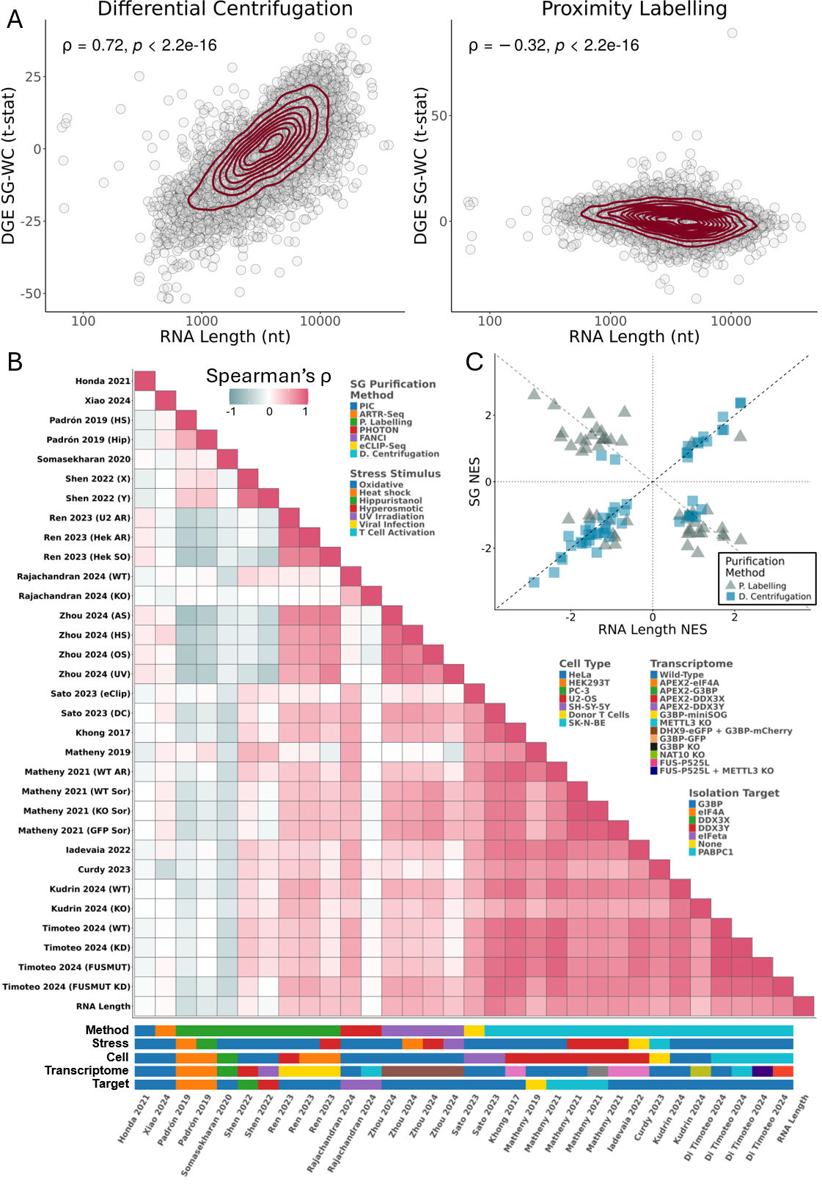
Figure 1. Different purification methods yield distinct SG trancriptomes. (A) Scatter plots of t-statistics of differential gene expression (DGE) between SGs and WCs (Y-axis) versus length of gene’s representative RNA transcript in number of nucleotides (nt) (X-axis), for SG purification by DC²⁹ (left) and PL²⁷ (right); genes as circles, density contour lines in dark red, Spearman’s correlation coefficient ρ and associated test’s p-value on top left corner. (B) Heatmap of Spearman’s correlations between t-statistics of DGE between SGs and WCs, from different studies, and RNA length in log₁₀ of the number of nucleotides. Stress stimulus, cell type, and SG purification method of each study are given below the heatmap. G3BP refers to G3BP1 alone or both G3BP1 and G3BP2. METTL3 knockdown and knockout are marked with the same color. (C) Scatter plot of GSEA Normalized Enrichment Scores (NES) of Hallmarks in DGEs between SGs and WCs, ranked by t-statistic, for SG purification by DC²⁹ or PL²⁷ (Y-axis) versus genes ranked by representative RNA length (X-axis).
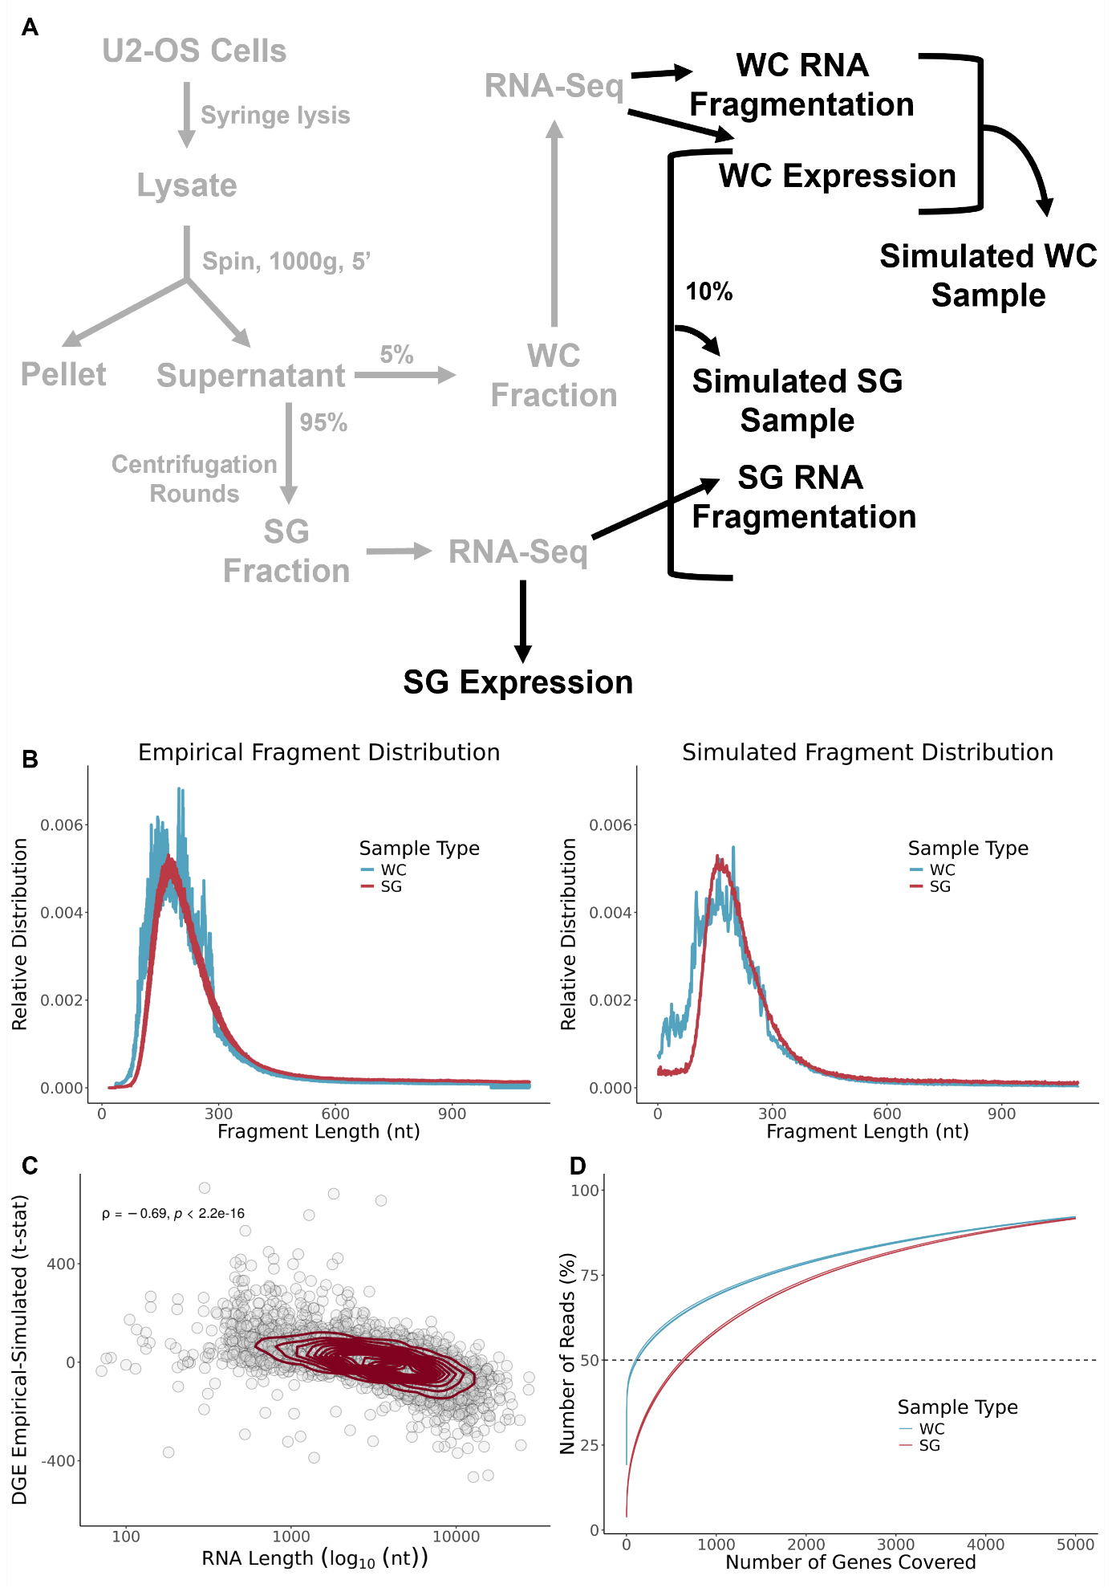
Figure 2. Transcriptomes of DC-isolated SGs show no evidence for RNA fragmentation-associated sampling bias. (A) The diagram depicts the experimental workflow from the original study for obtaining WC and SG samples²⁹ (grey) and our additional in silico analyses (black). (B) Relative distribution of fragment length in number of nucleotides in Khong 2017²⁹ RNA-seq samples (left) and simulated samples (right). (C) Scatter plot of t-statistics of DGE between SG and WC simulated samples (Y-axis) and representative RNA transcript length in number of nucleotides (X-axis); genes as circles, density contour lines in dark red, Spearman’s correlation coefficient ρ and associated test’s p-value are also shown. The original WC expression from Khong 2017²⁹ was used to simulate both WC and SG samples, based on their respective fragment size distributions. (D) Cumulative distributions of the percentage of RNA-seq reads mapping to the increasing number of genes ordered by decreasing read coverage, in the Khong 2017²⁹ WC (cyan) and SG (red) samples. More genes account for 50% of the reads in SG samples than their WC counterparts, suggesting greater RNA library complexity.
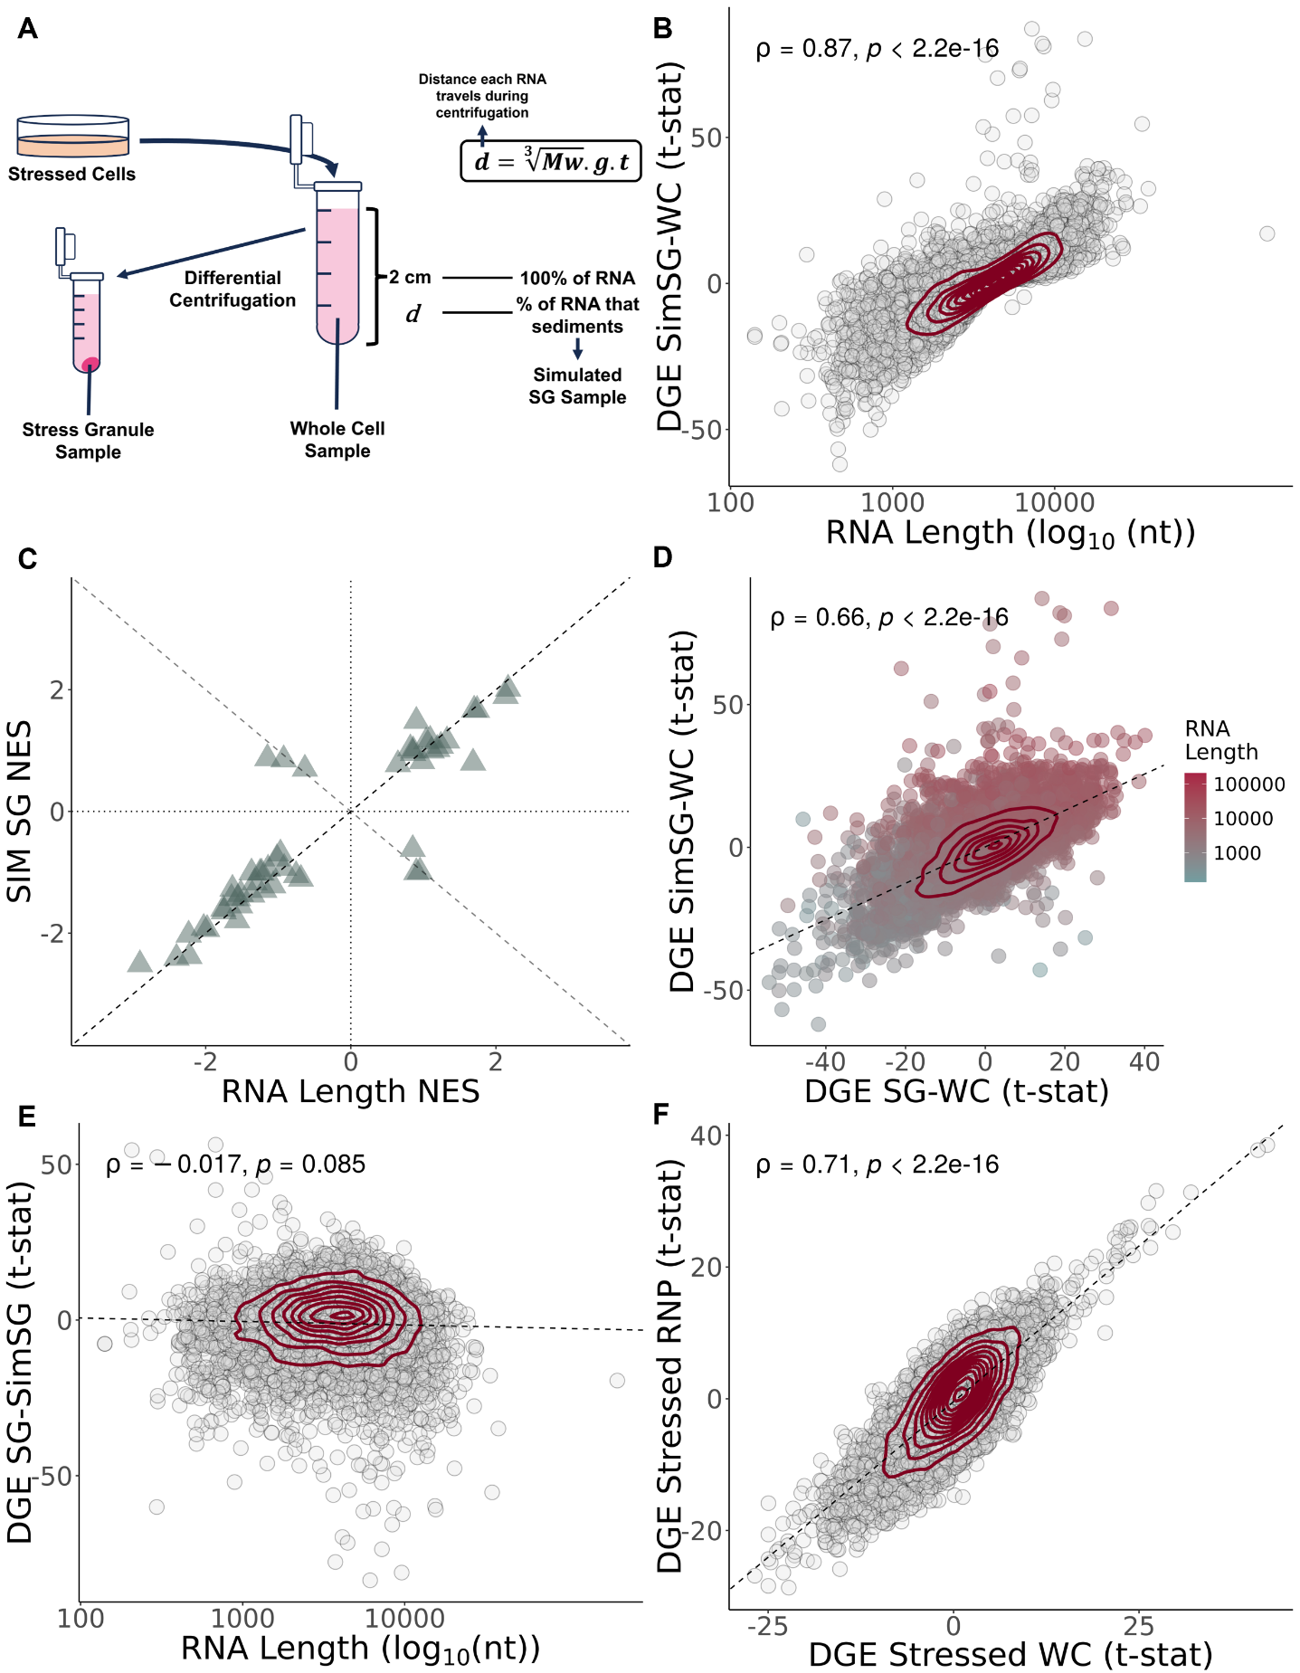
Figure 3. Length bias in DC-isolated SGs is compatible with inherent RNA condensation. (A) Schematic representation of standard DC protocol alongside our in silico pipeline for simulating the centrifugation process. d = distance travelled by each RNA during centrifugation; Mw = Molecular weight of each RNA transcript, in g/mol; g = centrifugation acceleration, in g; t = time of centrifugation, in seconds. (B) Scatter plot of t-statistics of DGE between simulated SGs and WCs (Y-axis) versus length of gene’s representative RNA transcript in number of nucleotides (X-axis). (C) Scatter plot of GSEA NES of Hallmark gene sets in DGE between simulated SGs and WC samples, ranked by t-statistic (Y-axis) versus genes ranked by number of nucleotides (X-axis). (D) Scatter plots of t-statistics of DGE in simulated SGs (Y-axis) and DC-purified SGs (X-axis), relative to WC samples; genes as circles colored by RNA length in number of nucleotides; density contour lines in dark red, Spearman’s correlation coefficient ρ and associated test’s p-value on top left corner. (E) Scatter plots of t-statistics of DGE in DC-purified SGs versus simulated SGs (Y-axis) versus length of gene’s representative RNA transcript in number of nucleotides (X-axis); transcripts as circles; density contour lines in dark red, Spearman’s correlation coefficient ρ and associated test’s p-value on top left corner. (F) Scatter plots of t-statistics of DGE between stressed vs unstressed RNP samples (Y-axis) and between stressed vs unstressed WC samples (X-axis). Genes as circles; density contour lines in dark red, Spearman’s correlation coefficient ρ and associated test’s p-value on top left corner (B,D,E,F). The original WC expression from Khong 2017²⁹ was used to simulate SG samples.
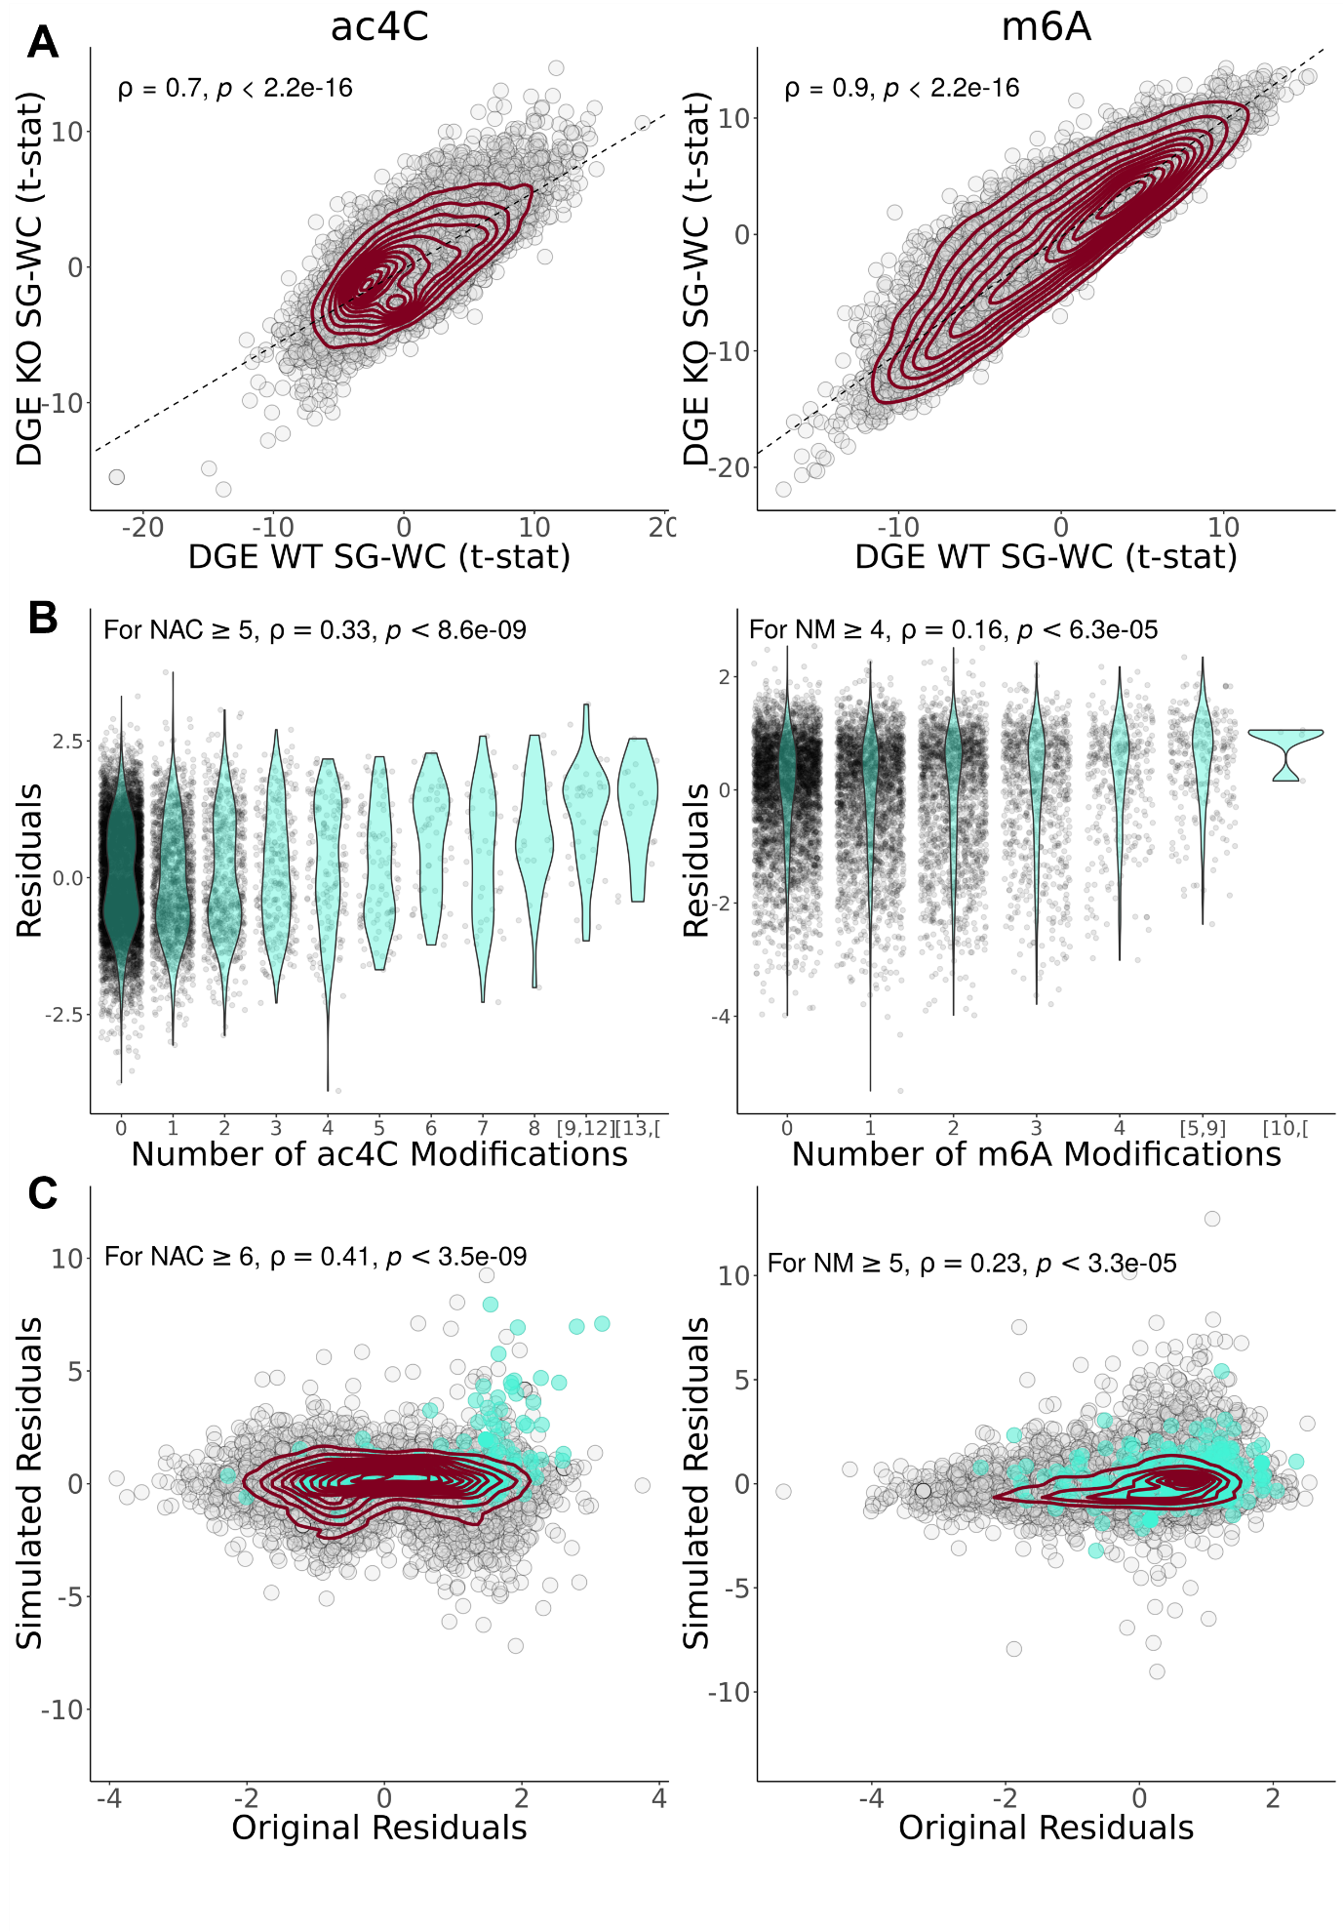
Figure 4. DC-purified SG-enriched transcripts with RNA modifications are compatible with centrifugation biases. (A) Scatter plots of t-statistics of DGE between WT SGs and WCs (Y-axis), and between SGs and WCs in cells without RNA modifications (X-axis) - ac4C KO⁴³ (left) and m6A KO⁴² (right) cells; transcripts as circles, density contour lines in dark red, Spearman’s correlation coefficient ρ and associated test’s p-value on top left corner. (B) Violin plots of residuals (i.e., deviations from the line) of linear regressions in (A) as a function of the number of ac4C (left) or m6A (right) modifications; Spearman’s correlation coefficient ρ and associated test’s p-value, for transcripts with at least 5 ac4C modifications (NAC) (left) and at least 4 m6A modifications (NM) (right), on top left corner. (C) Scatter plot of residuals of linear regression between DGE t-statistics of simulated WT SG versus simulated SG KO for ac4C (left) or m6A (right) (Y-axis) and respective empirical residuals in (B) (X-axis); transcripts as circles, with transcripts with at least 6 ac4C modifications (NAC) (left) or at least 5 m6A (NM) modifications (right) coloured teal; density contour lines in dark red, Spearman’s correlation coefficient ρ and associated test’s p-value, for transcripts with at least 5 ac4C modifications (NAC) (left) or at least 4 m6A modifications (NM) (right), on top left corner. For all ac4C relative plots, P. Kudrin 2024 data were used⁴³. For all m6A relative plots, only the FUS-P525L group from G. Di Timoteo 2024 was used⁴², as it exhibited a lower ρ for the corresponding comparison in (A-left), and thus, a bigger impact of m6A on mRNA sequestration in SGs was expected.

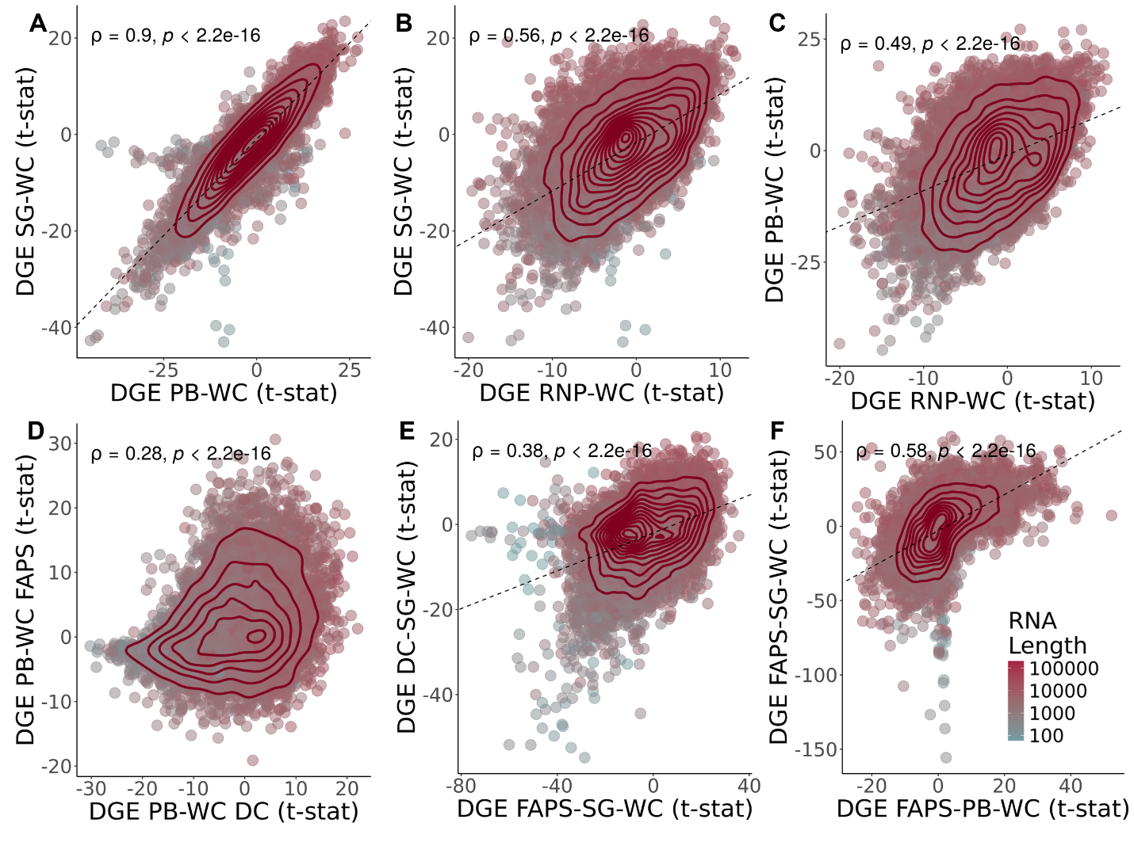
Figure 5. Samples isolated through DC are highly correlated. (A) Scatter plot of t-statistics of DGE in SGs versus WCs²⁹ (Y-Axis) and in PBs versus WCs³⁴ (X-Axis); genes as circles coloured by RNA length in log₁₀ of the number of nucleotides; density contour lines in dark red, Spearman’s correlation coefficient ρ and associated test’s p-value on top left corner. (B) Scatter plot of t-statistics of DGE in SGs versus WCs²⁹ (Y-Axis) and in RNP granules versus WCs³⁴ (X-Axis); genes as circles coloured by RNA length in log₁₀ of the number of nucleotides; density contour lines in dark red, Spearman’s correlation coefficient ρ and associated test’s p-value on top left corner. (C) Scatter plot of t-statistics of DGE in PBs versus WCs³⁴ (Y-Axis) and in RNP granules versus WCs³⁴ (X-Axis); genes as circles coloured by RNA length in log₁₀ of the number of nucleotides; density contour lines in dark red, Spearman’s correlation coefficient ρ and associated test’s p-value on top left corner. (D) Scatter plot of t-statistics of DGE in PBs purified by FAPS⁴⁷ (Y-Axis) and by DC³⁴, compared to WCs (X-Axis); genes as circles coloured by RNA length in log₁₀ of the number of nucleotides; density contour lines in dark red, Spearman’s correlation coefficient ρ and associated test’s p-value on top left corner (E) Scatter plot of t-statistics of DGE in SGs purified by DC²⁹ (Y-Axis) and by FAPS/FANCI⁴⁸ (X-Axis), comparing to WCs, after batch correction for cell type and stress; genes as circles coloured by RNA length in log₁₀ of the number of nucleotides; density contour lines in dark red, Spearman’s correlation coefficient ρ and associated test’s p-value on top left corner. (F) Scatter plot of t-statistics of DGE in SG (Y-Axis) and PB (X-Axis) purified by FAPS/FANCI^{47,48},comparing to WCs, after batch correction for stress; genes as circles coloured by RNA length in log₁₀ of the number of nucleotides; density contour lines in dark red, Spearman’s correlation coefficient ρ and associated test’s p-value on top left corner.

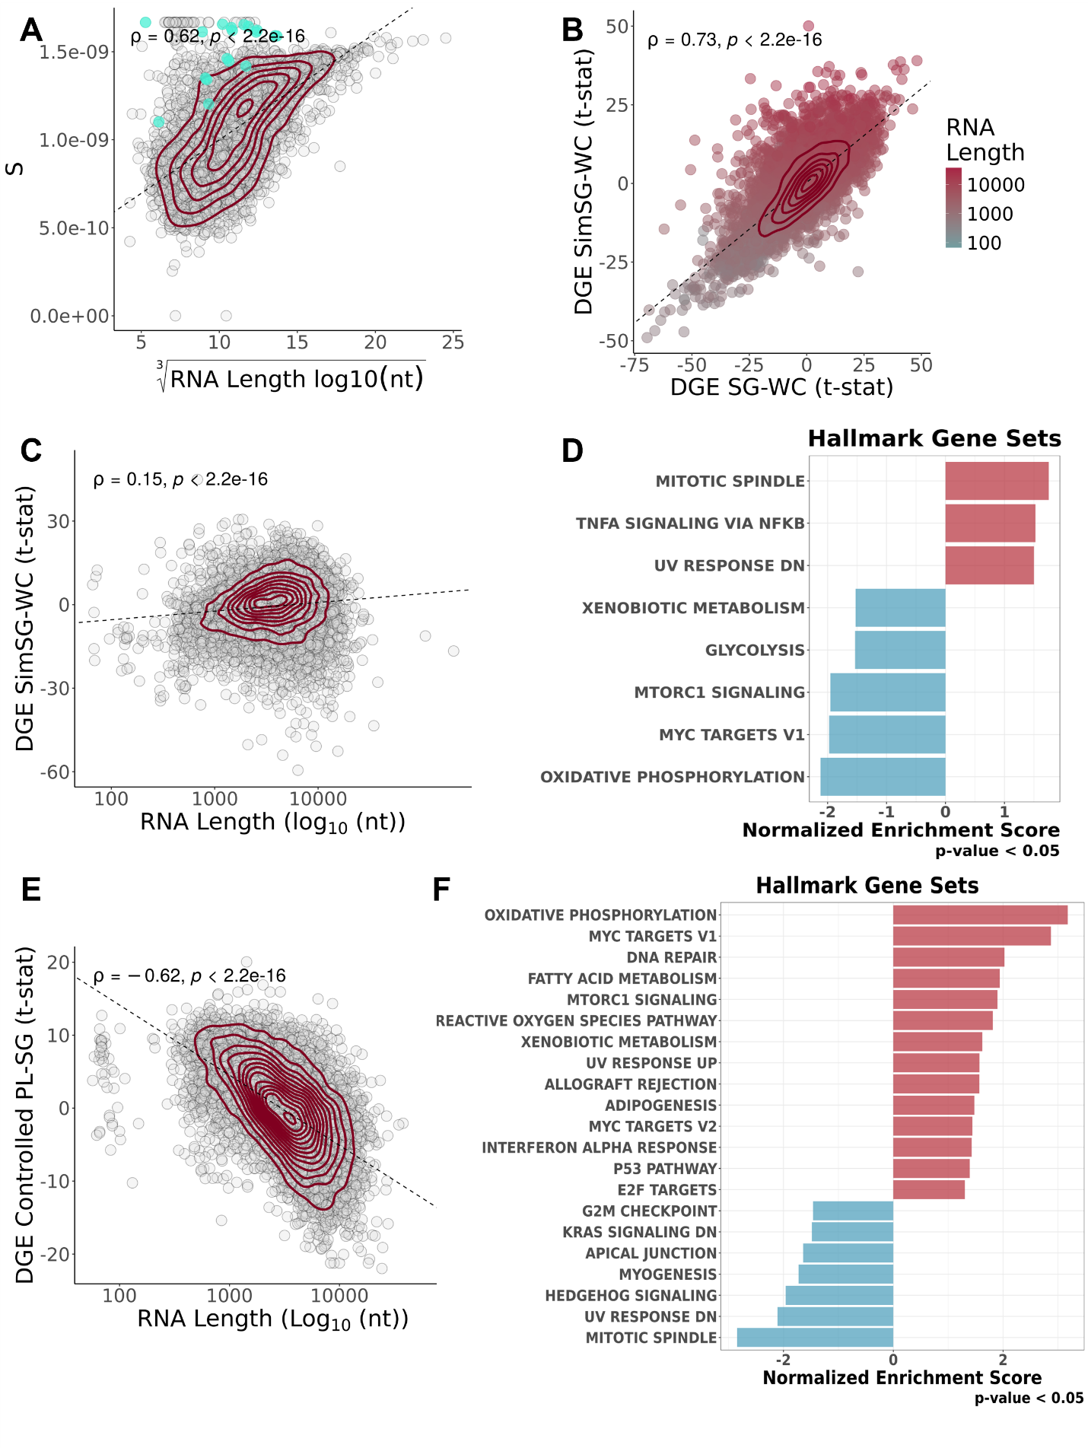

Figure 6. Method-specific corrections for SGs transcriptomes reveal distinct outcomes (A) Scatter plot of yeast S values obtained from Sed-seq data³¹ (Y-Axis) and cubic root of yeast RNA length in log₁₀ of the number of nucleotides (Y-Axis); Each circle denotes a transcript, with mitochondrially encoded transcripts coloured in teal; density contour lines in dark red, Spearman’s correlation coefficient ρ and associated test’s p-value on top left corner. (B) Scatter plot of t-statistics of DGE of simulated SGs versus WCs, with S estimations based on Sed-seq data³¹ (Y-Axis) and DGE of DC-purified SGs versus WCs²⁹ (X-Axis); transcripts as circles coloured by RNA length in log₁₀ of the number of nucleotides; density contour lines in dark red, Spearman’s correlation coefficient ρ and associated test’s p-value on top left corner. (C) Scatter plot of RNA length in log₁₀ of the number of nucleotides (Y-Axis) and t-statistics of DGE of Simulated SGs versus DC-Purified SGs²⁹, thus what we considered “Centrifugation Corrected SGs) (X-Axis); transcripts as circles; density contour lines in dark red, Spearman’s correlation coefficient ρ and associated test’s p-value on top left corner. (D) GSEA NES of Hallmark gene sets in DGE, ranked by t-statistic, in Simulated SGs versus DC-Purified SGs²⁹. (E) Scatter plot of t-statistics of DGE expression in linear modelled PL-isolated SGs²⁷ (X-Axis) and RNA length in log₁₀ of the number of nucleotides (Y-Axis); transcripts as circles; density contour lines in dark red, Spearman’s correlation coefficient ρ and associated test’s p-value on top left corner. (F) GSEA NES of Hallmark gene sets in DGE ranked by t-statistic, in linear modelled PL-isolated SGs²⁷.
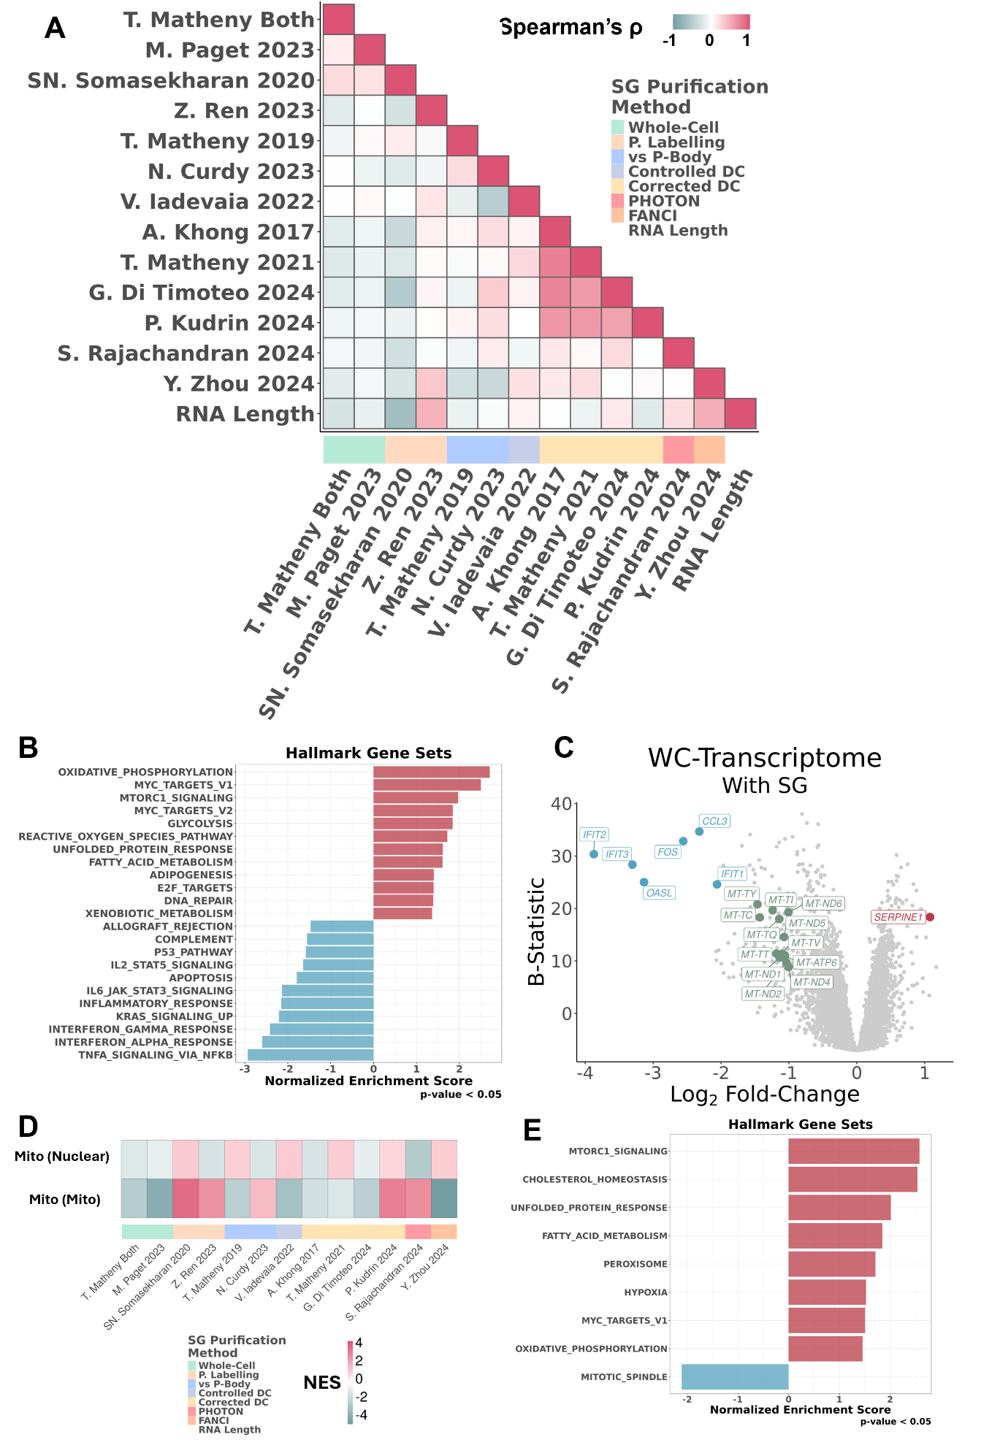
Figure 7. Meta-analysis of SG transcriptome and cell-wide alterations. (A) Heatmap of Spearman’s correlations between transcriptomic profiles of corrected/controlled SGs from different studies, controlled WC alterations, and RNA length in log₁₀ of the number of nucleotides. SG purification method of each study is given below the heatmap; (B) GSEA NES of Hallmark gene sets in DGE, ranked by t-statistic, in SG-bearing WC samples versus Non-SG-bearing samples^{7,34,50}; (C) Volcano plot of differential expression (X-Axis - Log2 Fold-Change) and corresponding significance (Y-Axis – B-Statistic) in linear modelled SG-bearing WC samples^{7,34,50}; transcripts as circles; Most differentially expressed transcripts are coloured red (if upregulated, log2FC>1 with B-Statistic>15), blue (if downregulated, log2FC< -2 with B-Statistic>15), or green (if mitochondrially encoded, log2FC< -1); (D) GSEA NES of mitochondrial located, mitochondrial encoded or nuclear encoded genes, in DGE, across the transcriptomic profiles of corrected/controlled SGs from different studies and controlled WC alterations. SG purification method of each study is given below the heatmap; (E) GSEA NES of Hallmark gene sets in DGE, ranked by average of t-statistics, in SG-isolated datasets enriched in mitochondrially encoded RNAs^{27,43,52,53}.

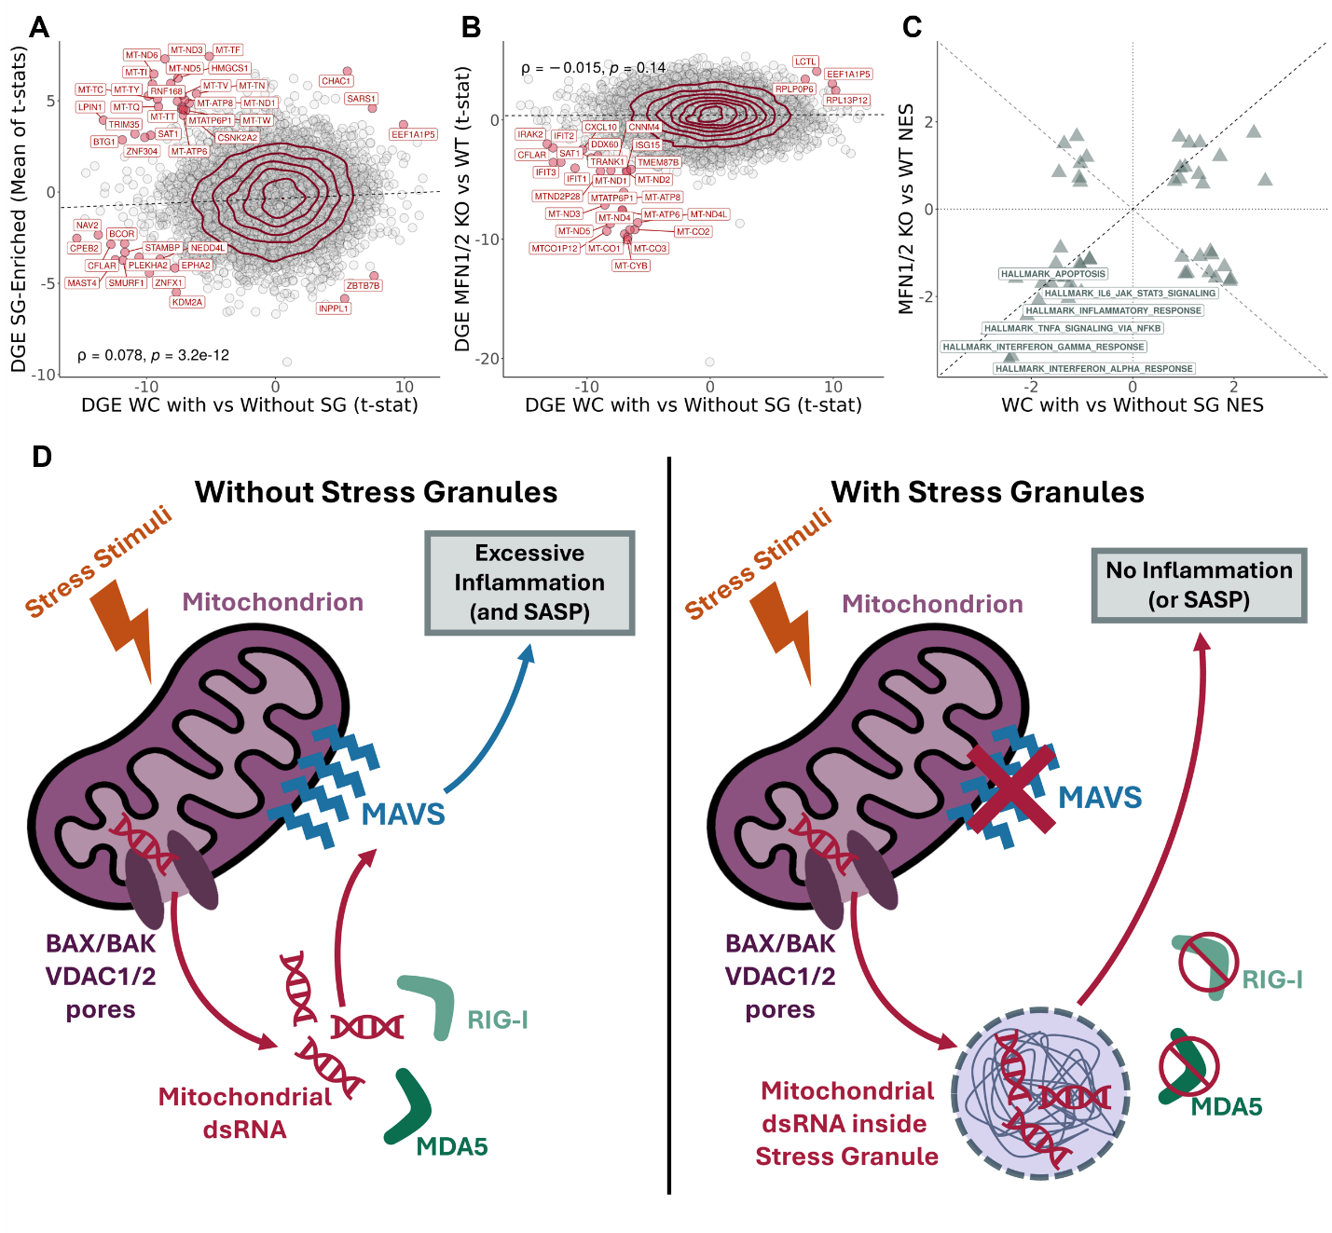

Figure 8. Mechanistic model of mitochondrial dsRNA–SG axis in inflammation control. (A) Scatter plot of t-statistics of DGE in SG-bearing WC samples versus their non-bearing counterparts^{7,34,50} (X-Axis – WC Enrichment) and mean of t-statistics of DGE of SG-sequestration enrichment in 4 selected studies: SN. Somasekharan 2020²⁷, P. Kudrin 2024⁴³, S. Rajachandran 2024⁵³ and Y. Zhou 2024⁴⁸ (Y-Axis – SG Enrichment); transcripts as circles; transcripts with most differential enrichment between axes labelled and coloured dark red (|WC Enrichment * SG Enrichment| > 30 t-statistic); density contour lines in dark red, Spearman’s correlation coefficient ρ and associated test’s p-value on bottom left corner. (B) SN. Somasekharan 2020²⁷, P. Kudrin 2024⁴³, S. Rajachandran 2024⁵³ and Y. Zhou 2024⁴⁸ (Y-Axis – SG Enrichment), and in SASP inhibited samples⁶³, through siRNA treatment against MFN1/2 and their WT counterparts⁶³ (Y-Axis – SASP Inhibition); transcripts as circles; trancripts with most conserved enrichment between axes labelled and coloured dark red (SG Enrichment * SASP Inhibition > 20 t-statistic); density contour lines in dark red, Spearman’s correlation coefficient ρ and associated test’s p-value on top left corner. (C) Scatter plot of GSEA NES of Hallmark gene sets in DGE, ranked by t-statistic, in corrected SG-enrichment in 4 selected studies^{27,43,48,53} (X-Axis) versus SASP inhibited samples⁶³ (Y-Axis). (D) Schematic of the proposed mitochondrial dsRNA–SG axis in inflammation control. In the absence of SGs (left), cellular stress promotes mitochondrial nucleic acid leakage, likely via BAX/BAK and VDAC1/2 pores⁶³. Leaked dsRNA is sensed by RIG-I and MDA5, which signal through MAVS to trigger an inflammatory cascade⁶³. When SGs are present (right), leaked dsRNAs are sequestered within them, shielding these RNAs from RIG-I and MDA5 recognition and thereby preventing or attenuating inflammatory signaling.
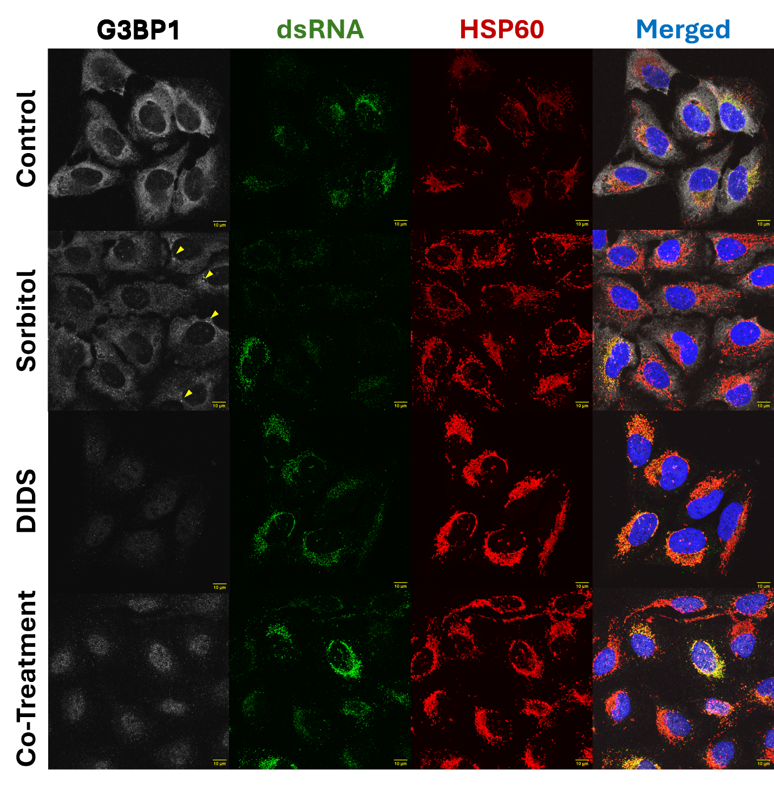
Figure 9. Blockage of mitochondrial permeability is compatible with SG assembly inhibition. Representative Immunofluorescence images of U2-OS cells untreated or treated with sorbitol (0.4M), DIDS (50 μM), or both. G3BP1 (SG marker, v. Figure 1B) is shown in white, dsRNA in green (using J2 antibody⁶⁵), HPS60 in red (mitochondrial marker⁷²), and nuclei (DAPI) in blue. Merged images are also provided. Yellow arrows in Sorbitol treated samples on the G3BP1 column highlight representative SGs. Scale bar is shown on bottom right corner of each image, in yellow.

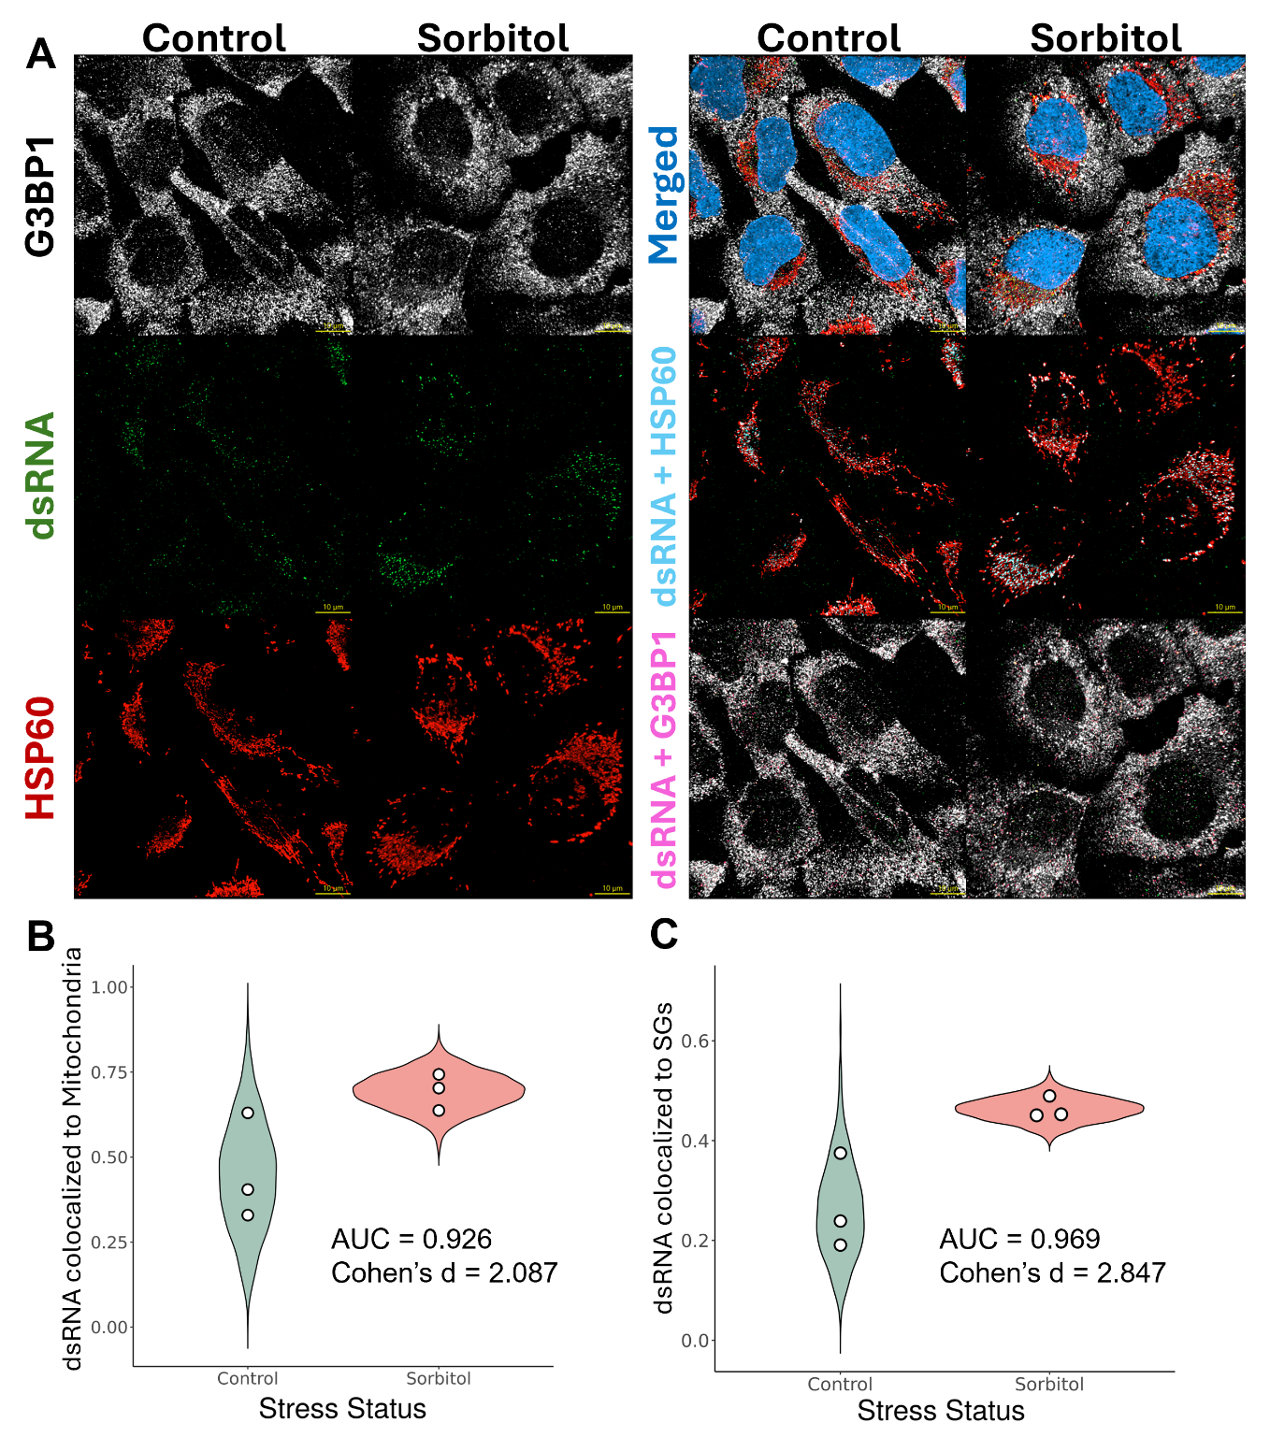
Figure 10. SG potentially uptake leaked mitochondrial dsRNA. (A) Representative Immunofluorescence images of U2-OS cells untreated or treated with sorbitol (0.4M). G3BP1 (SG marker, v. Figure 1B) is shown in white, dsRNA in green (using J2 antibody⁶⁵), HPS60 in red (mitochondrial marker⁷²), and nuclei (DAPI) in blue. Merged images of these previous channels are also provided. In the “Teal” row, a merge of dsRNA is shown with HSP60. Colocalization of these volumes (in voxels) is colored in teal. In the “Magenta” row, a merge of dsRNA, that did not colocalize with HSP60, is shown with G3BP1. Colocalization of these volumes (in voxels) is colored in magenta. Scale bar is shown on bottom right corner of each image, in yellow. (B-C) Colocalization percentages between dsRNA and HSP60 (B) or G3BP1 (C) were first quantified across all images acquired in the experiment (n = 3). For each condition, beta distributions were then fitted to both the empirical measurements and the corresponding null distributions generated from randomized colocalization controls. Shown are violin plots representing 1000 values sampled from these fitted beta distributions for each condition. White dots denote the observed empirical colocalization values. Statistical metrics (AUC, Cohen’s d) are displayed directly on the plot.); AUC: probability that a randomly chosen Sorbitol sample has a higher value than a randomly chosen Control sample; Cohen’s d: standardized effect size (how many standard deviations apart the two group means are).

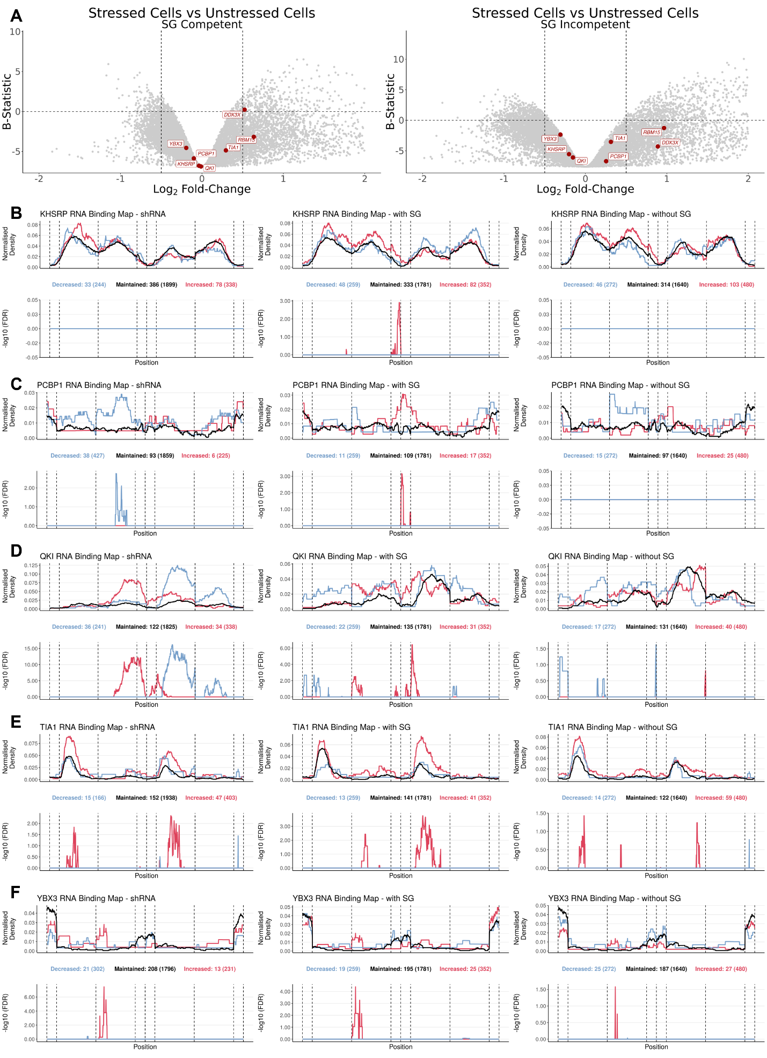
Figure 11. Alternative splicing alterations in SG competent and incompetent cells (B) Volcano plot of DGE between stressed and unstressed WCs (X-Axis - Log2 Fold-Change) and corresponding significance (Y-Axis – B-Statistic) in SG competent (left) and incompetent (right) U2-OS and A549 cell lines subjected to dsRNA as a stressor⁷; genes as circles, with RBPs with differential binding across event types (Supplementary Figure 8) labelled and in red. Vertical dashed lines correspond to -0.5 and 0.5 log2FC. Horizontal dashed line corresponds to B-statistic = 0. Only genes with -2 < log2FC < 2 are plotted. (B-F) RNA binding maps of alternative exon splicing events in shRNA treated cells for KHSRP (B), PCBP1 (C), QKI (D), TIA1 (E), and YBX3 (F) obtained from ENCODE⁷⁶ (left), in SG competent cells (middle) and in SG incompetent cells (right). (Top) Normalised binding of RBP of interest to metagenomic regulatory sequences of alternative exons. The plot discriminates excluded (blue), included (red) or maintained (black) alternative exons upon RBP knockdown (left) or upon dsRNA stress stimuli, in SG competent (middle) and incompetent (right) cells. The total number of events in each category can be found beneath the plot in brackets, preceded by the number of events for which there is at least one binding site for that RBP. (Bottom) False discovery rate (FDR) of excluded (blue) or included (red) normalised binding, in relation to maintained events. Vertical lines delimitate the following metagenomic splicing regulatory sequences, in order: last 50 nt of upstream constitutive exon; first 200 nt of upstream intron; last 200 nt of upstream intron; first 50 nt of alternative exon; last 50 nt of alternative exon; first 200 nt of downstream intron; last 200 nt of downstream intron; first 50 nt of downstream constitutive exon.
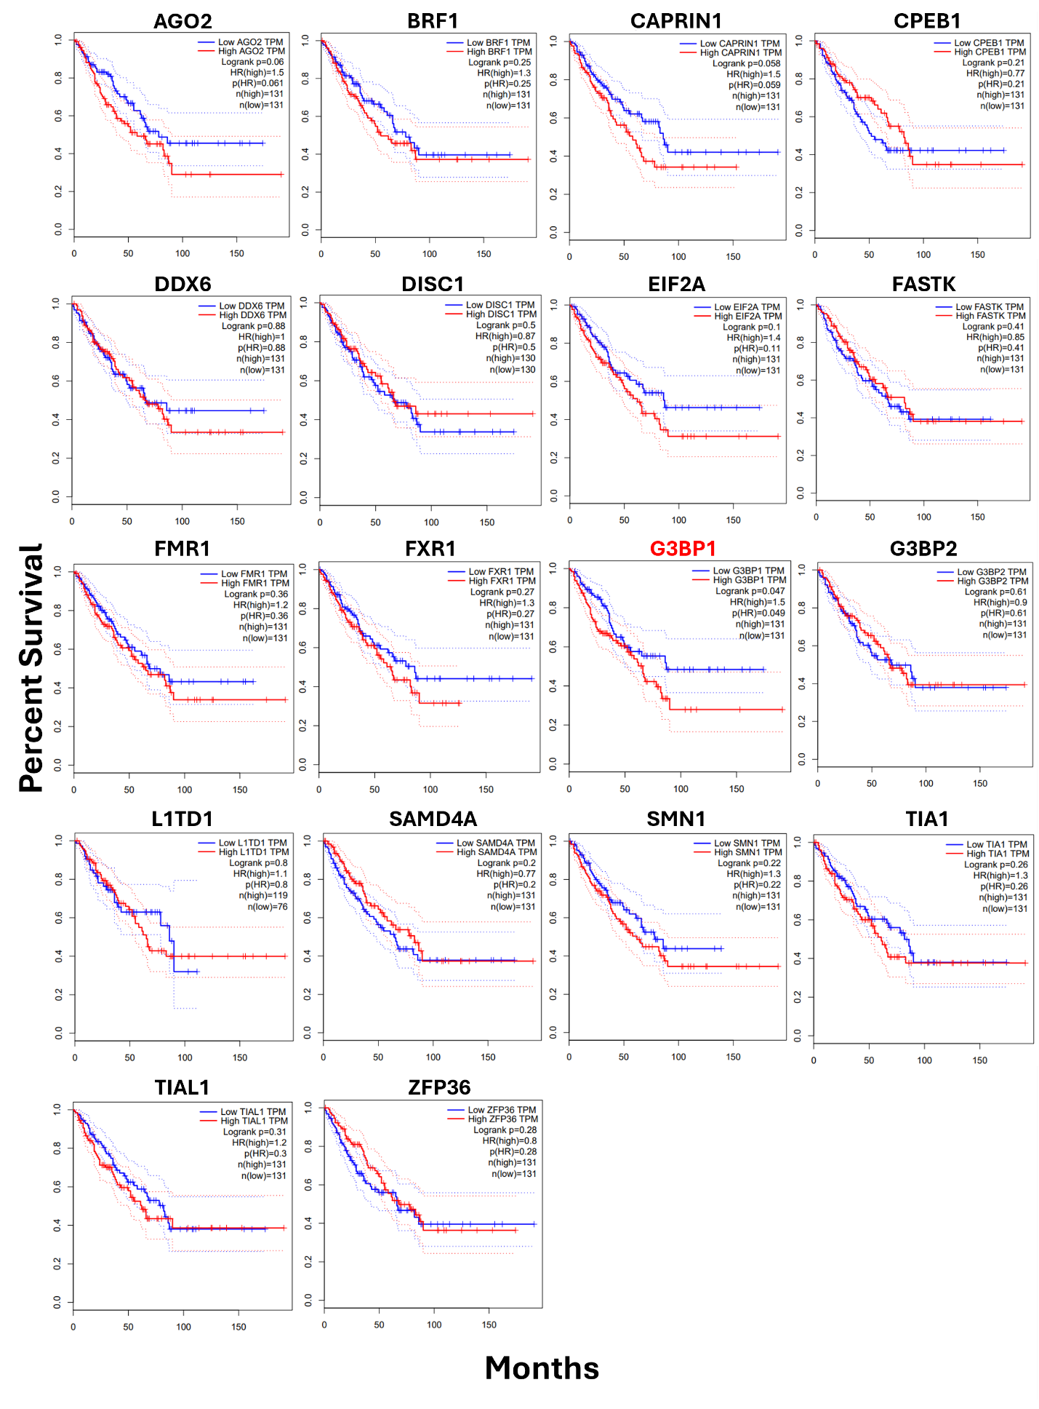
Figure 12. Overall survival analysis based on gene expression of SG-related proteins. Kaplan–Meier plots showing overall survival (Y-Axis) per month (X-Axis) of patients from TCGA SARC (The Cancer Genome Atlas sarcoma) dataset⁹⁹, stratified by expression of the indicated genes, as plot titles. Patients were grouped into high and low expression cohorts based on the median expression value. Log-rank p-values, hazard ratios (HR), and number of samples (n) are shown in the top right corner of each plot. Genes with a Log-rank p-value <0.05 are shown in red. Survival analyses and plots were generated using the GEPIA web server¹³⁶.
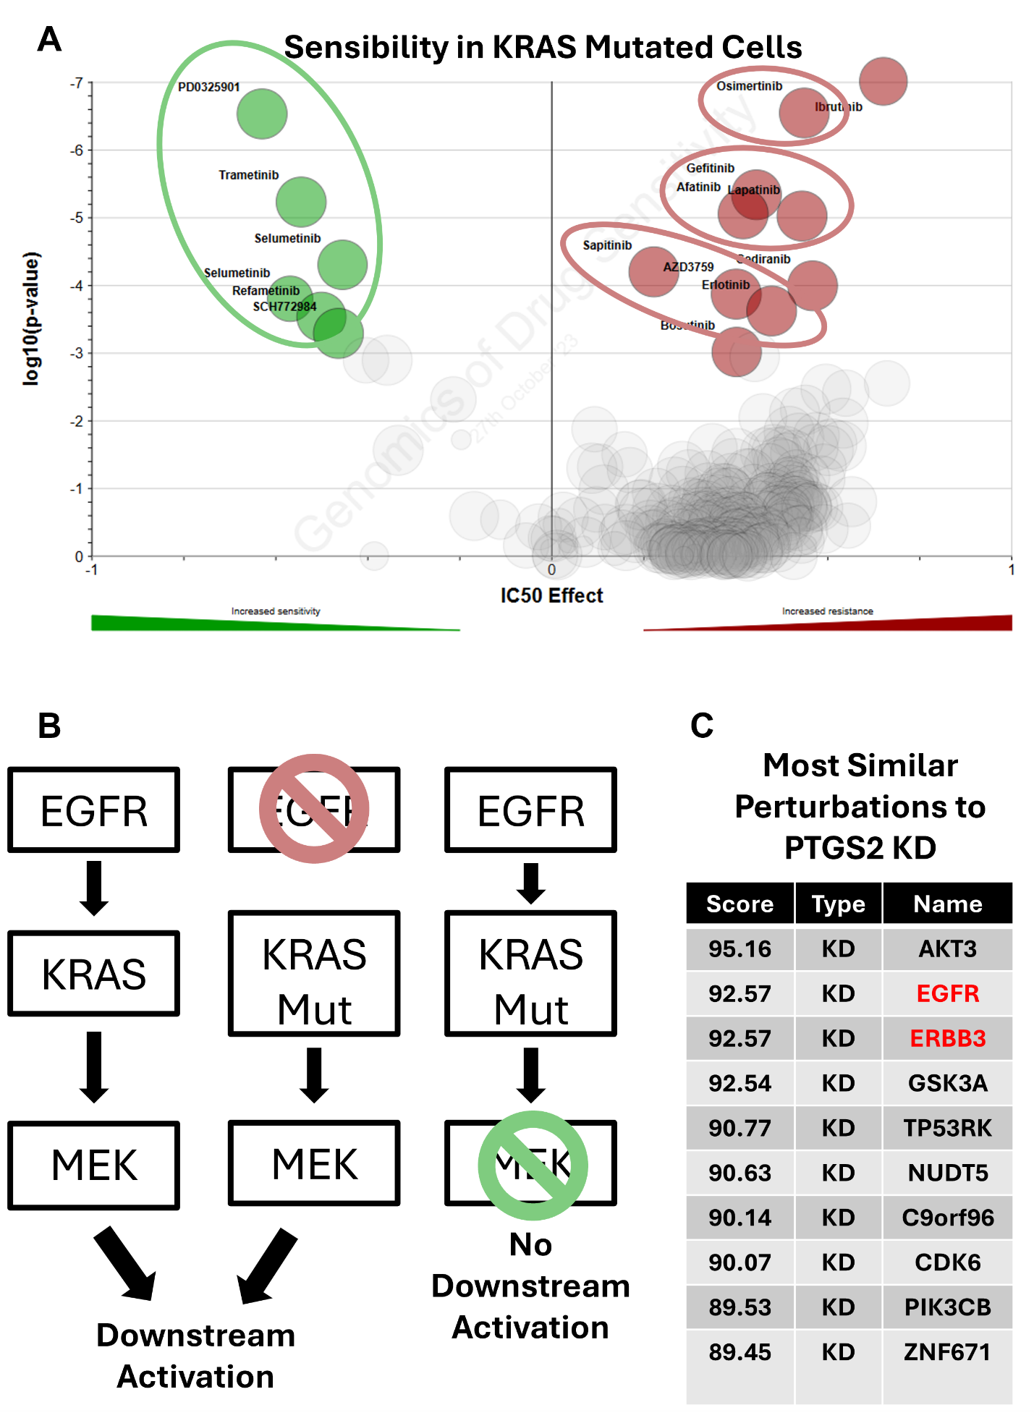
Figure 13. KRAS mutation and associated drug sensitivities and resistances. (A) Volcano plot of half maximal inhibitory concentration (X-Axis - IC50 Effect) and corresponding significance (Y-Axis – log10(p-value)) in KRAS mutant cells; drugs/chemicals as circles, with drugs with the most differential IC50 effect labelled and coloured in green (if with increased sensitivity) or in red (if with increased resistance). Green circle around drugs which target MEK, and red circles around drugs with target EGFR. Analysis and images are obtained from GDSC¹³⁵, using the GDSC2 dataset. (B) Simplified schematic of the EGFR signaling pathway. (left) In wild-type cells, EGFR activation triggers KRAS activation, which in turn activates MEK and downstream signaling. (middle) In KRAS-mutant cells, inhibition of EGFR with targeted drugs (red drugs, see (A)) does not block signaling, as mutant KRAS activates MEK independently. This explains resistance of KRAS-mutant cells to anti-EGFR therapy. (right) In KRAS-mutant cells, inhibition of MEK with targeted drugs (green drugs, see (A)) blocks downstream signaling, rendering these cells sensitive to anti-MEK therapy. (C) Table representing alterations with highest correlation to PTGS2 KD. Values represent CMap connectivity scores, which reflect the degree of similarity between gene expression signatures. Knockdowns of EGFR and ERBB3 are highlighted in red. Analysis and visualisation were performed and adapted from the Connectivity Map (CMap) platform¹³⁴.

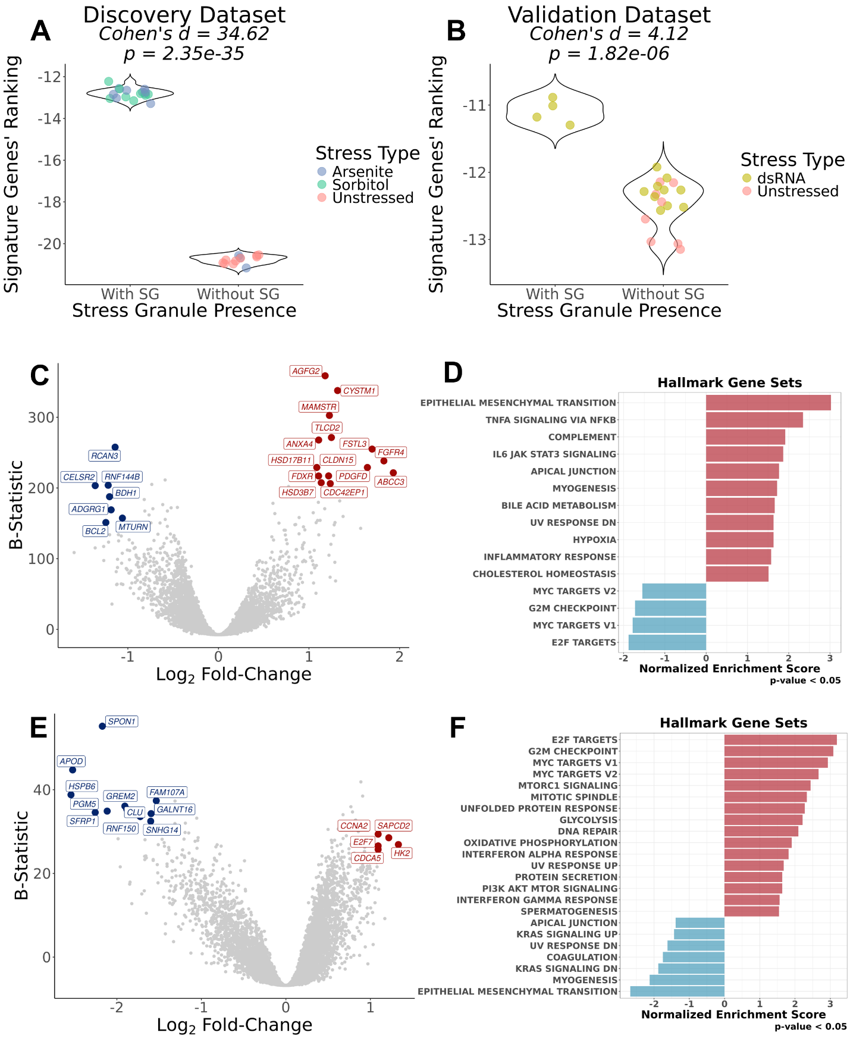
Figure 14. Development and validation of SG Score and its prognostic potential in GDC-TCGA datasets, (A/B) Violin plots of SG signature scores, calculated through a ranking metric (v. Methods), in cells without and with SGs. WC samples are colored in accordance to stress type stimuli. The discovery dataset (A) refers to T. Matheny 2019 and T. Matheny 2021^{34,50}, whereas as the validation dataset (B) refers to M. Paget 2024⁷. Effect Size (Cohen’s d) and corresponding statistical significance (p-value) are shown above plots. (C) Volcano plot of DGE (X-Axis - Log2 Fold-Change) and corresponding significance (Y-Axis – B-Statistic) in ACC, MESO, CHOL and STAD, versus other GDC-TCGA datasets^{99,100}, considering only tumour samples, corrected for dataset of origin; genes as circles; Most differentially expressed genes are coloured red (if upregulated, log2FC>1 with B-Statistic>200) or blue (if downregulated, log2FC< -1 with B-Statistic>150); (D) GSEA NES of Hallmark gene sets in DGE, ranked by t-statistic, in ACC, MESO, CHOL and STAD, versus other GDC-TCGA datasets^{99,100}, considering only tumour samples, corrected for dataset of origin; (E) Volcano plot of DGE (X-Axis - Log2 Fold-Change) and corresponding significance (Y-Axis – B-Statistic) in top 25% of SG-Score tumour samples in ACC, MESO, CHOL and STAD, versus bottom 25% of SG-Score samples, corrected for dataset of origin; genes as circles; Most differentially expressed genes are coloured red (if upregulated, log2FC>1 with B-Statistic>25) or blue (if downregulated, log2FC< -1.5 with B-Statistic>30); (F) GSEA NES of Hallmark gene sets in DGE, ranked by t-statistic, in top 25% of SG-Score tumour samples in ACC, MESO, CHOL and STAD, versus bottom 25% of SG-Score samples, corrected for dataset of origin;

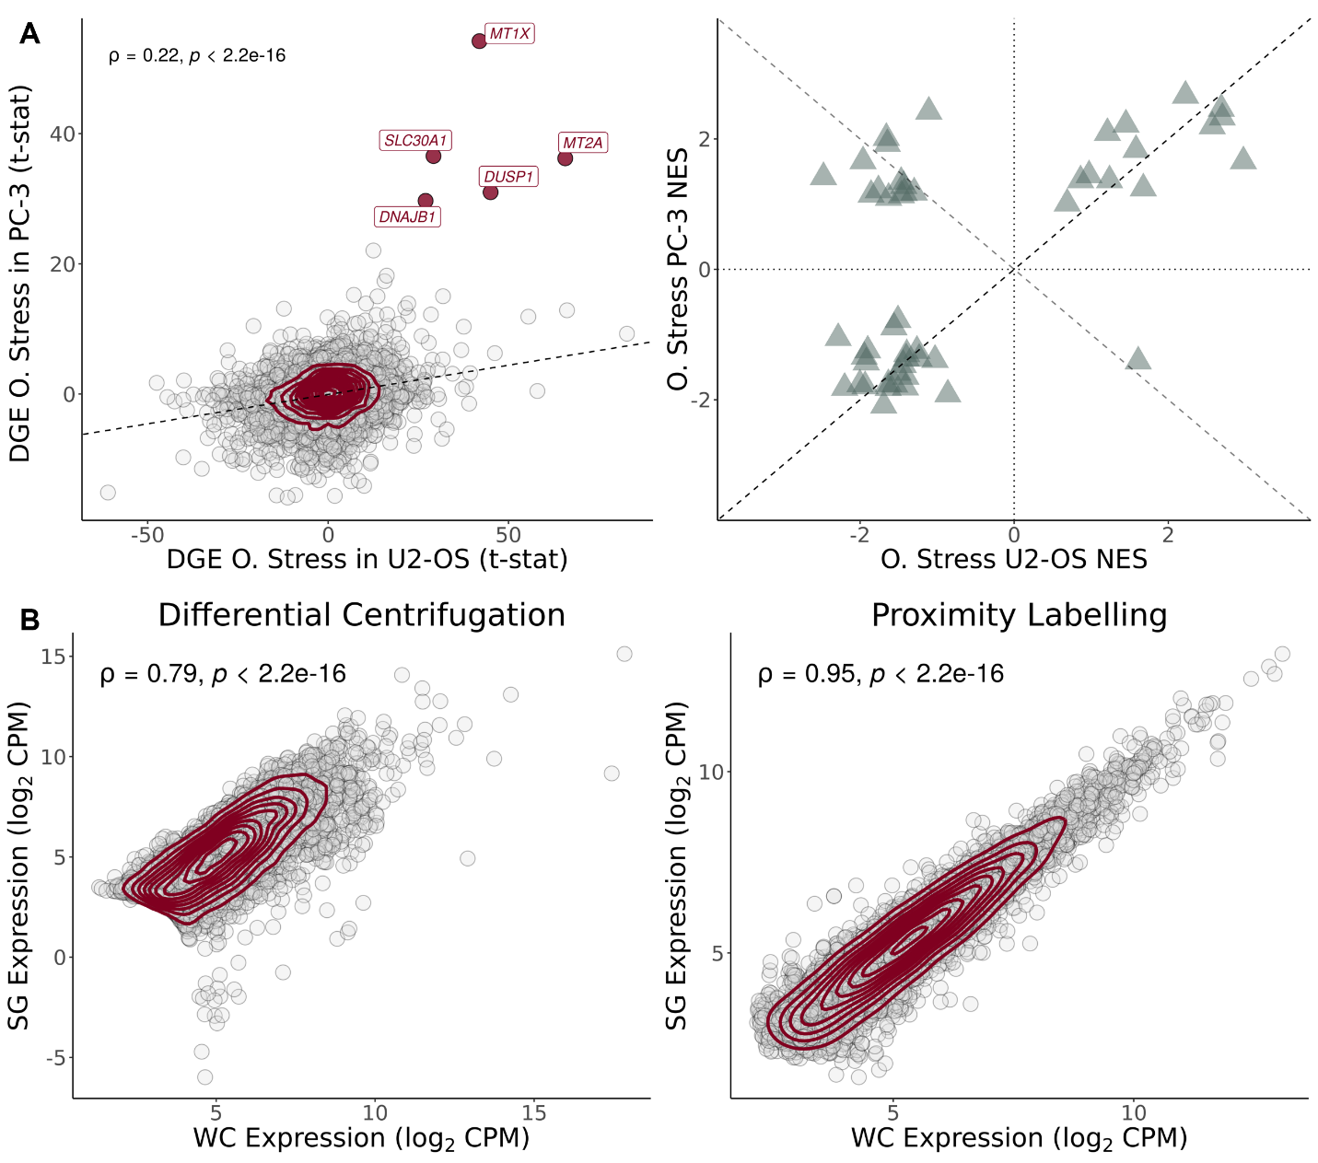
Supplementary Figure 1. (A) (left) Scatter plot of t-statistics of DGE between SGs and WCs in PC-3²⁷ (Y-Axis) and U2-OS³⁴ (X-Axis) cell lines exposed to oxidative stress through arsenite; genes as circles, density contour lines in dark red, Spearman’s correlation coefficient ρ and associated test’s p-value on top left corner; strongly upregulated genes in both cell lines (t-statistic > 25) are labelled and highlighted in dark red. (right) Scatter plot of GSEA NES of Hallmarks in DGE, ranked by t-statistic, in PC-3²⁷ (Y-axis) versus U2-OS³⁴ (X-axis) cell lines, exposed to oxidative stress through arsenite. (B) Scatter plots of gene expression (in log₂ counts-per-million (CPM)) in SGs (Y-Axis) versus WCs (X-Axis), for SG purification by DC²⁹ (left) and PL²⁷ (right); genes as circles, density contour lines in dark red, Spearman’s correlation coefficient ρ and associated test’s p-value on top left corner.

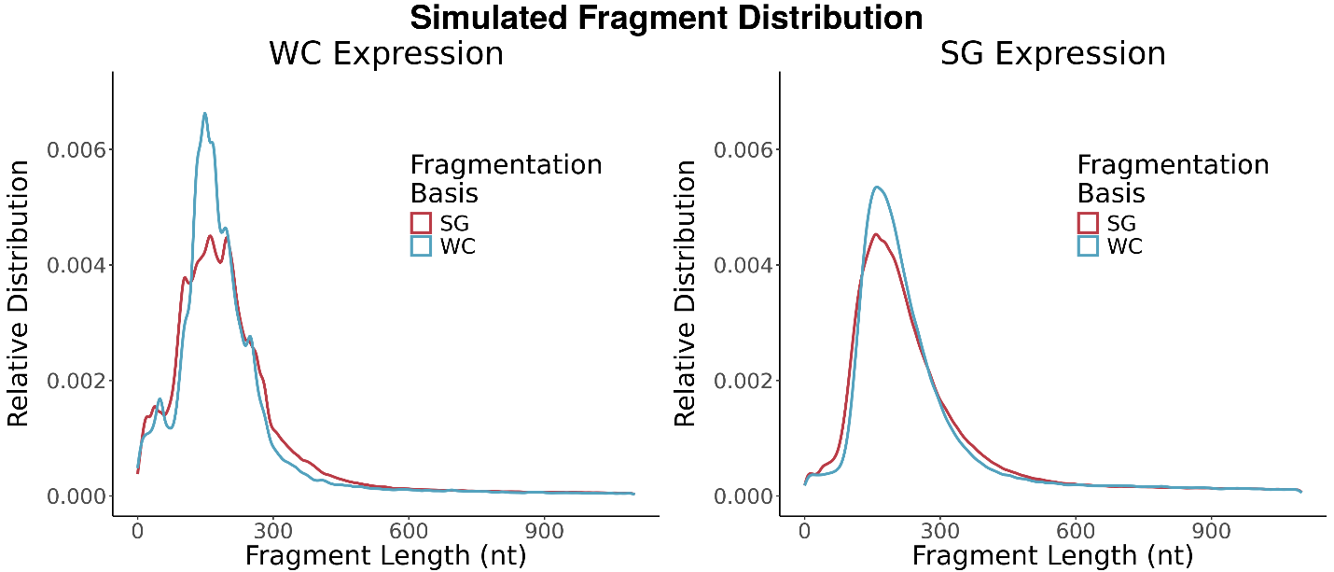
Supplementary Figure 2. Relative distribution of representative RNA fragment length in number of nucleotides in simulated samples, using WC (left) or SG (right) expression as basis, and WC (cyan) or SG (red) fragmentation distributions as basis.

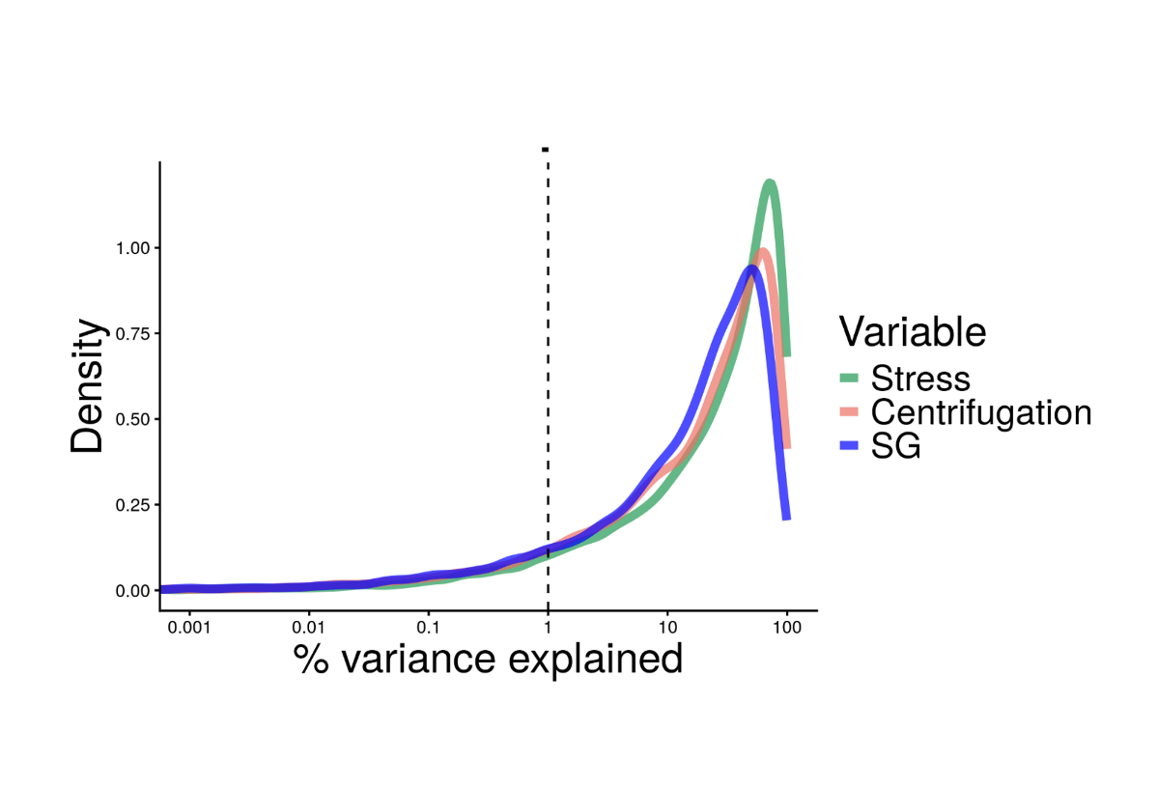
Supplementary Figure 3. Relative contributions of different sources to gene expression variance in the Matheny 2019³⁴ dataset. SG contributes less to gene expression variance than the stress itself or the centrifugation effect.

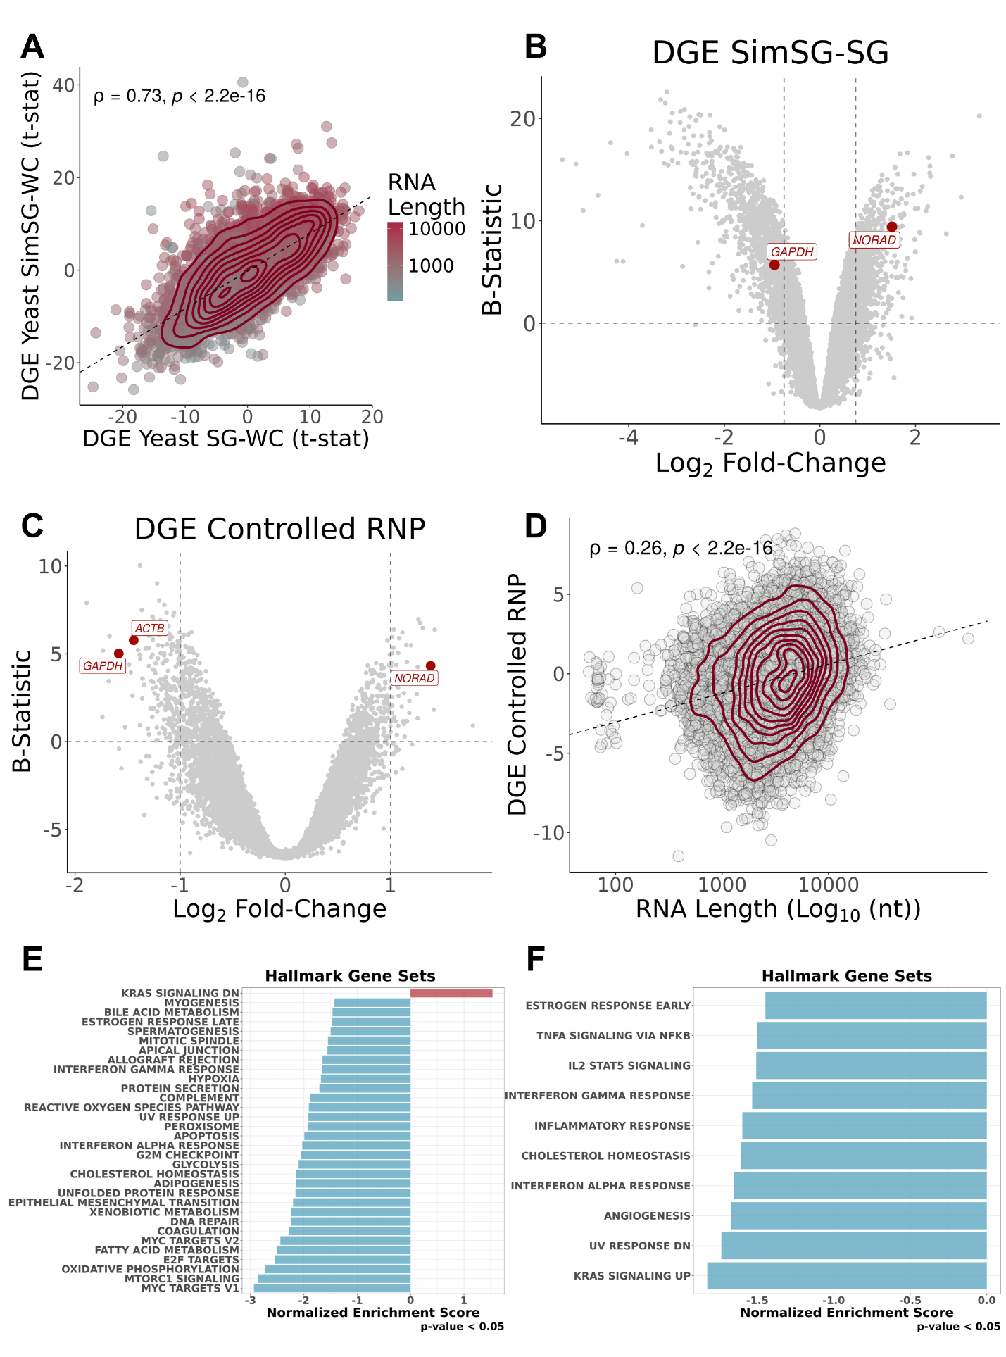

Supplementary Figure 4. (A) S modulation from Sed-seq yeast data is generalisable to other yeast datasets. Scatter plot of t-statistics of DGE of simulated yeast SG versus WC, with S estimations based on Sed-seq data³¹ (Y-Axis), and t-statistics of DGE in yeast SGs purified by DC²⁹ (X-Axis); transcripts as circles coloured by RNA length in log₁₀ of the number of nucleotides; density contour lines in dark red, Spearman’s correlation coefficient ρ and associated test’s p-value on top left corner. (B) Volcano plot of significance (Y-Axis – B-Statistic) and corresponding DGE (X-Axis - Log2 Fold-Change) between original SGs²⁹ and simulated SGs, based on Sed-Seq³¹ data; transcripts as circles, with commonly used RNA FISH controls²⁹ in red. Vertical dashed lines correspond to -0.75 and 0.75 log 2FC. Horizontal dashed line corresponds to B-statistic = 0. (C) Volcano plot of significance (Y-Axis – B-Statistic) and corresponding DGE (X-Axis - Log2 Fold-Change) between linear modelled DC-isolated RNP granule stress-specific sequestration³⁴; transcripts as circles, with commonly used RNA FISH controls²⁹ in red. Vertical dashed lines correspond to -1 and 1 log2FC. Horizontal dashed line corresponds to B-statistic = 0. (D) Scatter plot of t-statistics of DGE in linear modelled DC-isolated RNP granules stress-specific sequestration³⁴ (X-Axis) and RNA length in log₁₀ of the number of nucleotides (Y-Axis); transcripts as circles; density contour lines in dark red, Spearman’s correlation coefficient r and associated test’s p-value on top left corner. (E) GSEA NES of Hallmark gene sets in DGE, ranked by t-statistic, in linear modelled DC-isolated RNP granules stress-specific sequestration³⁴. (F) GSEA NES of Hallmark gene sets in DGE, ranked by t-statistic, in SG-bearing WC samples versus their Non-SG-bearing counterparts^{34,50}.
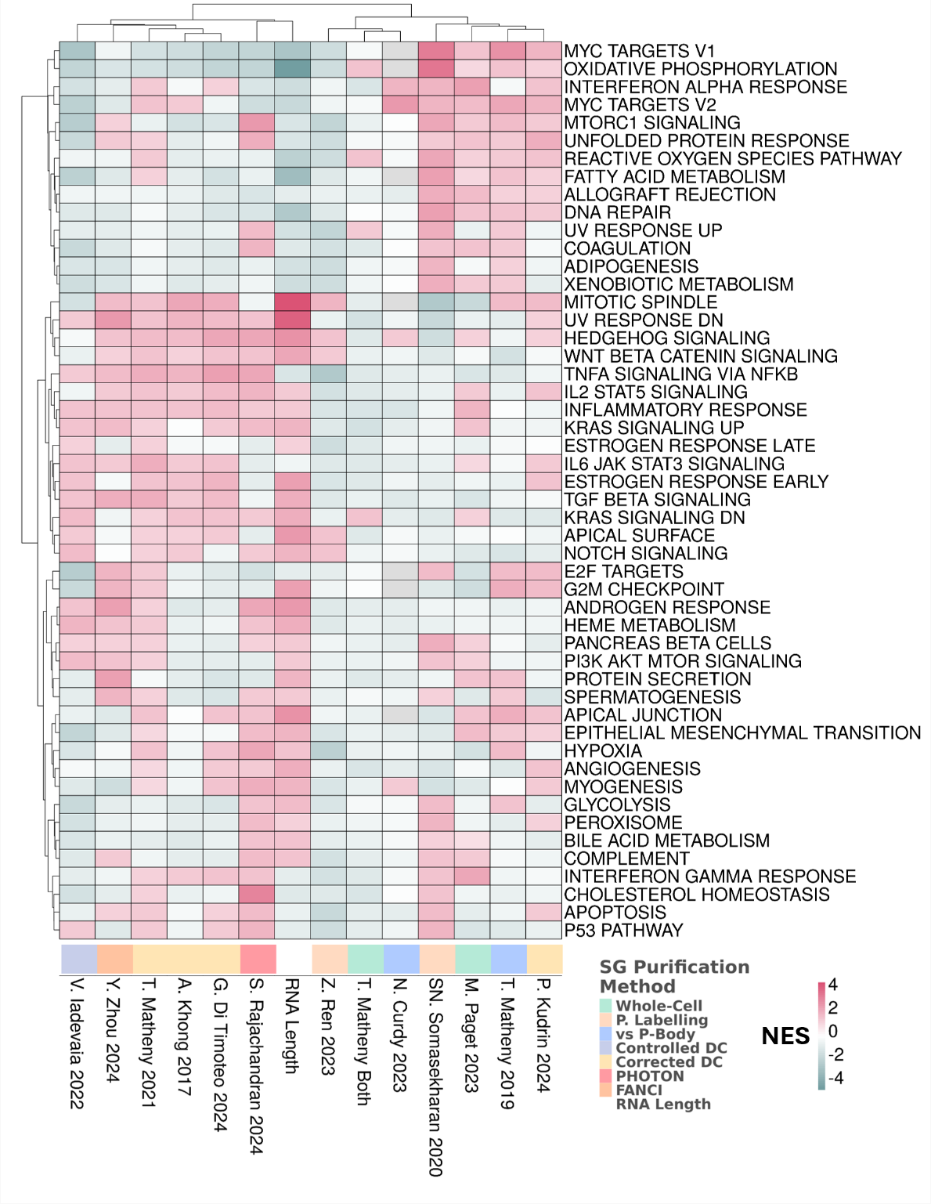
Supplementary Figure 5. NES from GSEA using Hallmark gene sets, based on genes ranked by t-statistic from DEG between corrected/controlled SGs and WCs across multiple studies. Both studies and gene sets were subjected to hierarchical clustering using Euclidean distance and the Ward.D2 method.

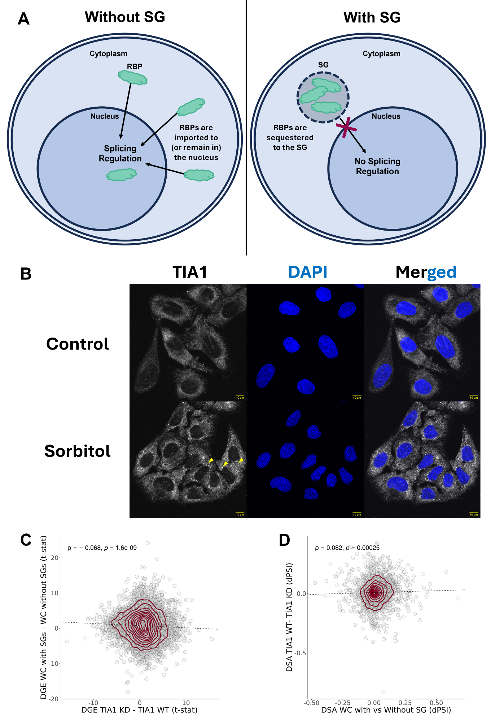

Supplementary Figure 6. (A) Schematic of the proposed effects of RBP sequestration by SGs. (left) In the absence of SGs, RBPs remain available in the nucleus (or are recruited to) to regulate splicing as needed. (right) When SGs form, RBPs are sequestered within them, reducing their nuclear availability and impairing splicing regulation. (B) Immunofluorescence images of U2-OS cells untreated or treated with sorbitol (0.4M). TIA1 is shown in white and nuclei (DAPI) in blue. Yellow arrows highlight representative SGs. Scale bar is shown on bottom right corner of each image, in yellow. (C) Scatter plot of t-statistics of DGE in HEPG2 and K562 cells treated with shRNA against TIA1 versus untargeted shRNA^{76,77} (X-Axis) and between U2-OS and A549 WT Cells (SG-Competent) exposed to dsRNA as a stressor⁷ (Y-Axis); genes as circles; density contour lines in dark red, Spearman’s correlation coefficient r and associated test’s p-value on top left corner. (D) Scatter plot of differential percent of splicing in (dPSI) of DSA in HEPG2 and K562 cells treated with shRNA against TIA1 versus untargeted shRNA^{76,77} (X-Axis) and between U2-OS and A549 WT Cells (SG-Competent) exposed to dsRNA as a stressor⁷ (Y-Axis); genes as circles; density contour lines in dark red, Spearman’s correlation coefficient r and associated test’s p-value on top left corner.

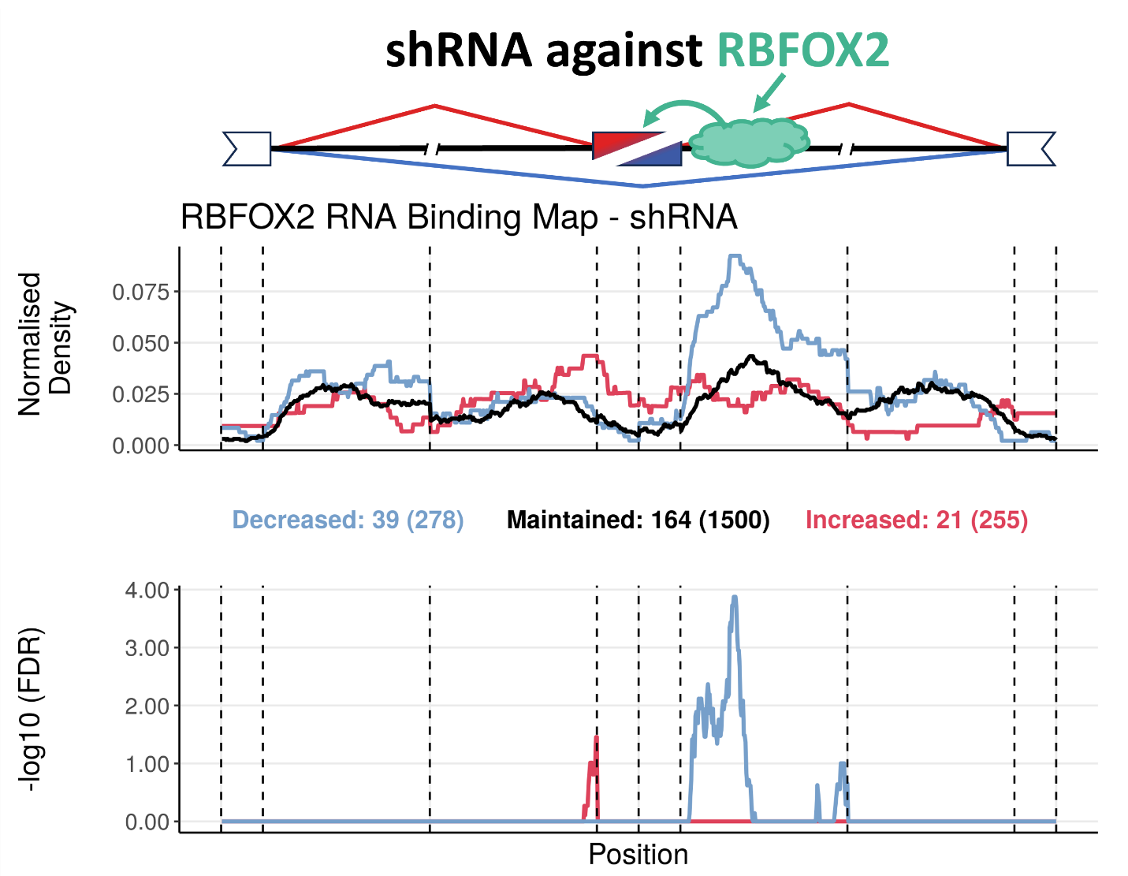
Supplementary Figure 7. RNA binding map of HepG2 and K562 cells exposed to shRNA against RBFOX2. (Top) Schematic of an alternative exon skipping event, regulated by an RBP, RBFOX2. (Middle) Normalized binding of RBFOX2 to metagenomic regulatory sequences of alternative exons. The plot discriminates excluded (blue), included (red) or maintained (black) alternative exons upon RBFOX2 knockdown, obtained from ENCODE^{76,77}. The total number of events in each category can be found beneath the plot in brackets, preceded by the number of events for which there is at least one binding site for that RBP. (Bottom) False discovery rate (FDR) of excluded (blue) or included (red) normalized binding, in relation to maintained events. Vertical lines delimitate the following metagenomic splicing regulatory sequences, in order: last 50 nt of upstream constitutive exon; first 200 nt of upstream intron; last 200 nt of upstream intron; first 50 nt of alternative exon; last 50 nt of alternative exon; first 200 nt of downstream intron; last 200 nt of downstream introm; first 50 nt of downstream constitutive exon. This example shows normalized RBFOX2 binding enriched downstream of alternative exond. Upon RBFOX2 knockdown, this binding is therefore lost, consistent with increased exon skipping. These results align with the known role of RBFOX2 in promoting exon inclusion¹³⁸, providing a proof of concept for our approach.

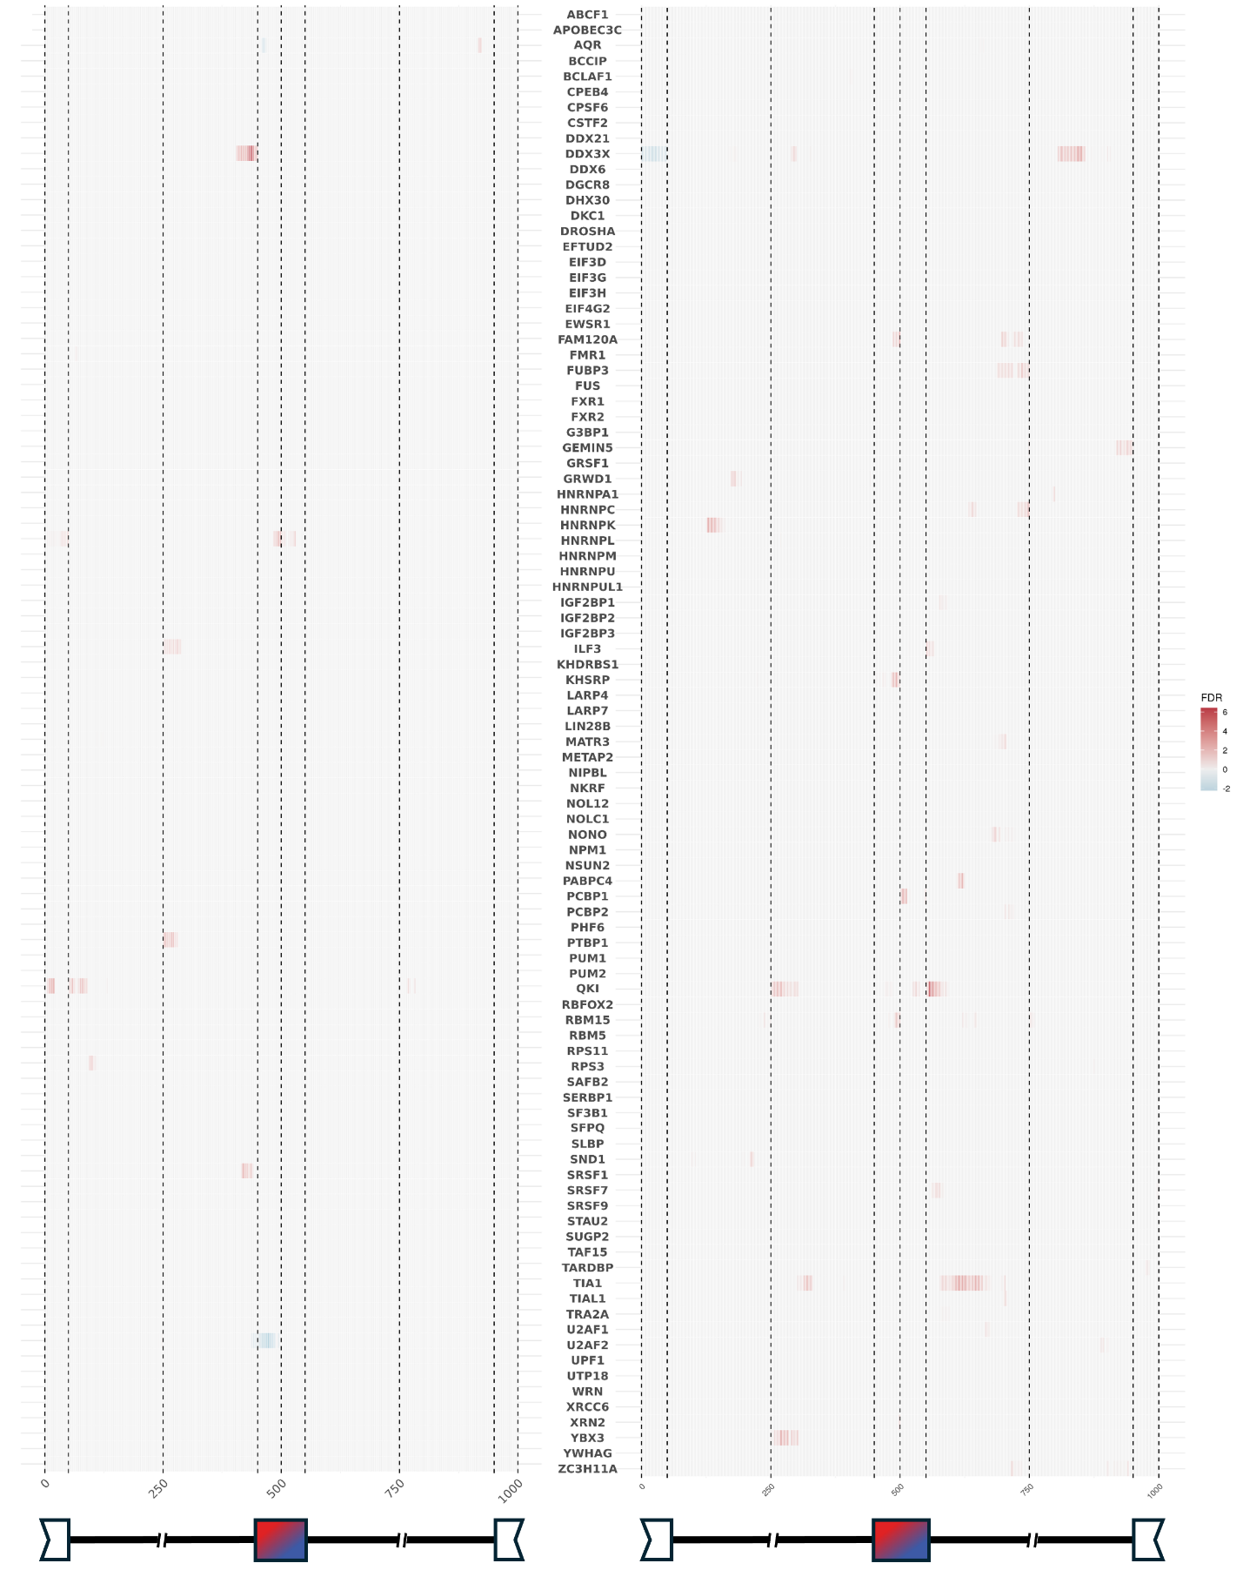
Supplementary Figure 8. Heatmap of significance of RBP binding to alternative splicing regulatory sequences in SG competent U2-OS and A549 cells treated with dsRNA as a stressor compared to their unstressed counterparts. The heatmaps show the significance of respective RBP binding enrichment in excluded (left) or included (right) alternative exons upon dsRNA treatment⁷ along metagenomic splicing regulatory sequences, in relation to maintained alternative exons. Positive and negative FDR values indicate that the frequency of putative binding of the RBP therein is respectively increased and decreased upon dsRNA treatment. Vertical lines delimitate the following metagenomic splicing regulatory sequences, in order: last 50 nt of upstream constitutive exon; first 200 nt of upstream intron; last 200 nt of upstream introm; first 50 nt of alternative exon; last 50 nt of alternative exon; first 200 nt of downstream intron; last 200 nt of downstream intron; first 50 nt of downstream constitutive exon. A schematic of the alternative exon skipping metagenome is presented below each heatmap.

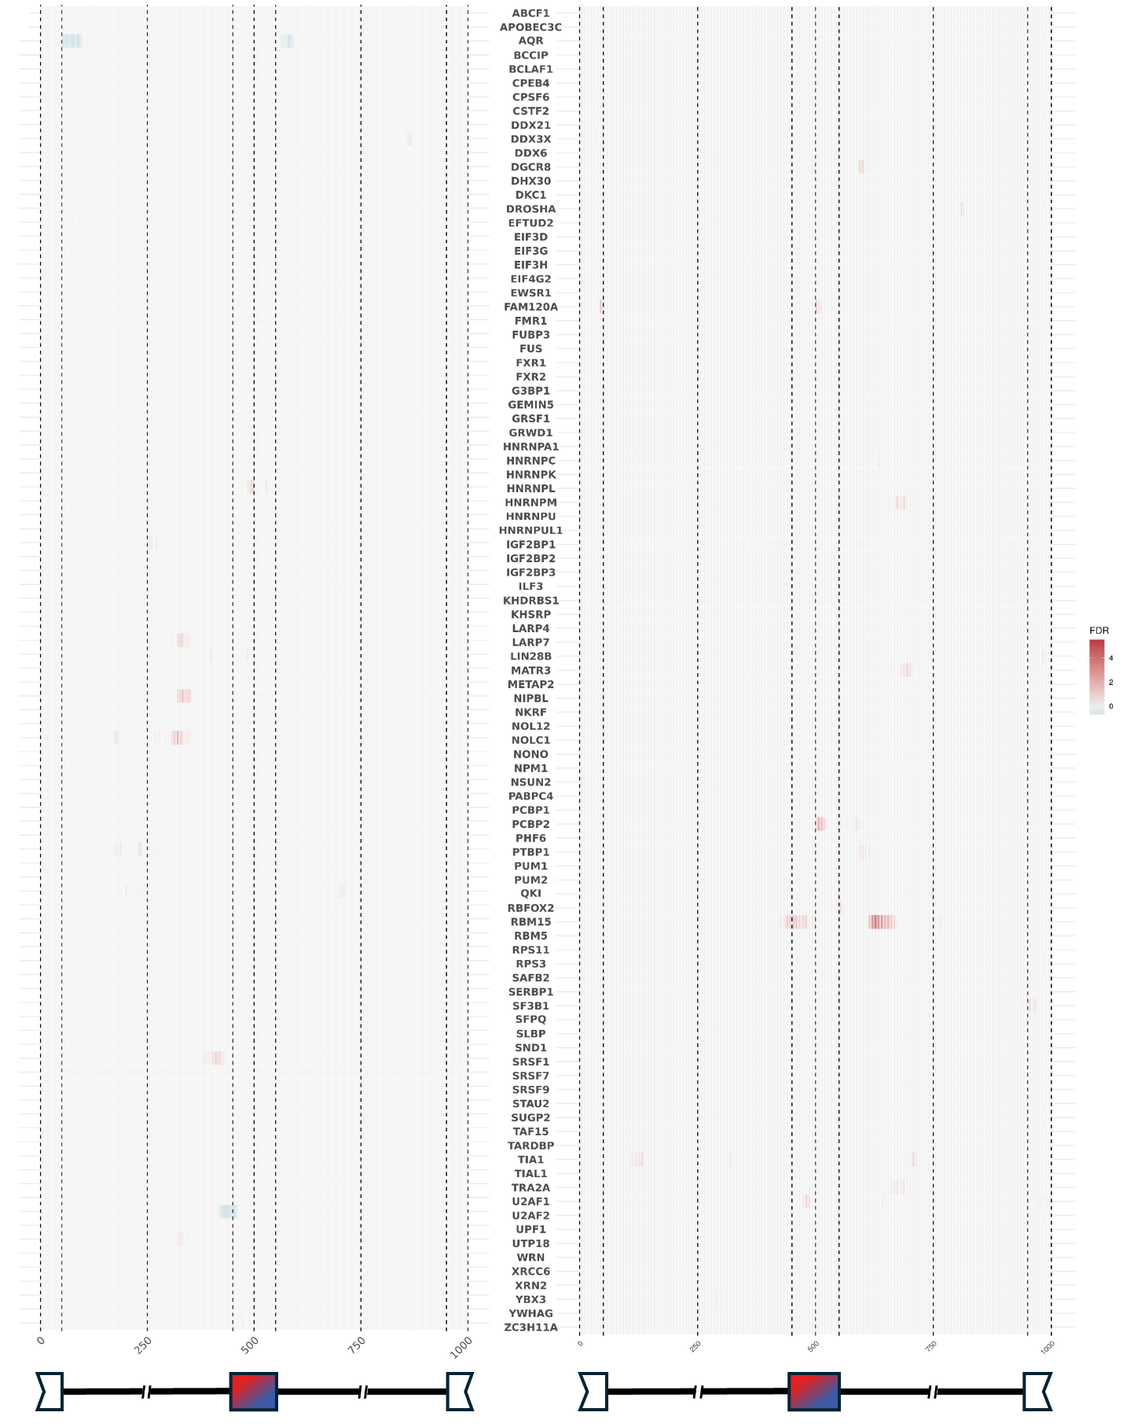
Supplementary Figure 9. Heatmap of significance of RBP binding to alternative splicing regulatory sequences in SG incompetent U2-OS and A549 cells treated with dsRNA as a stressor compared to their unstressed counterparts. The heatmaps show the significance of respective RBP binding enrichment in excluded (left) or included (right) alternative exons upon dsRNA treatment⁷ along metagenomic splicing regulatory sequences, in relation to maintained alternative exons. Positive and negative FDR values indicate that the frequency of putative binding of the RBP therein is respectively increased and decreased upon dsRNA treatment. Vertical lines delimitate the following metagenomic splicing regulatory sequences, in order: last 50 nt of upstream constitutive exon; first 200 nt of upstream intron; last 200 nt of upstream introm; first 50 nt of alternative exon; last 50 nt of alternative exon; first 200 nt of downstream intron; last 200 nt of downstream intron; first 50 nt of downstream constitutive exon. A schematic of the alternative exon skipping metagenome is presented below each heatmap.

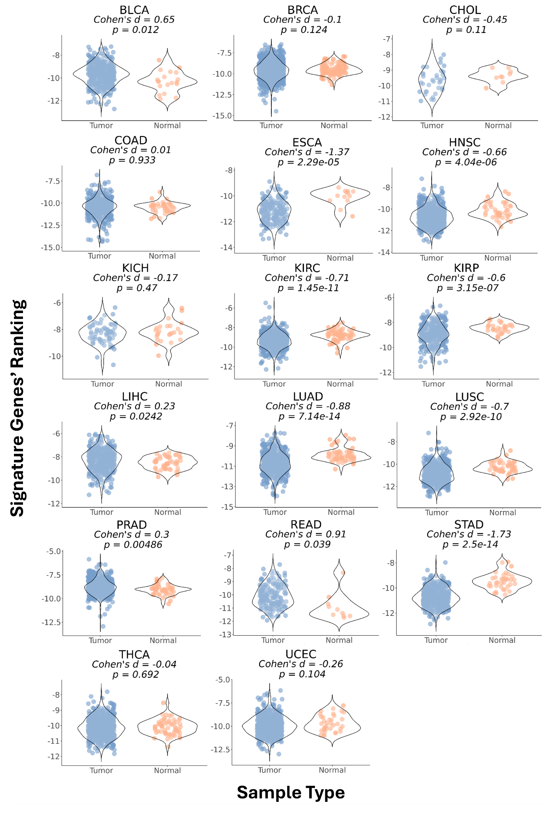
Supplementary Figure 10. Signature score in various GDC-TCGA datasets. Violin plots of SG signature scores, calculated through a ranking metric (v. Methods), in tumor (blue) and normal tissue (orange) samples from several GDC-TCGA datasets^{99,100}. Effect Size (Cohen’s d) and corresponding statistical significance (p-value) are shown above plots. Only GDC-TCGA^{99,100} datasets with at least 5 normal and tumor samples were considered for this analysis.

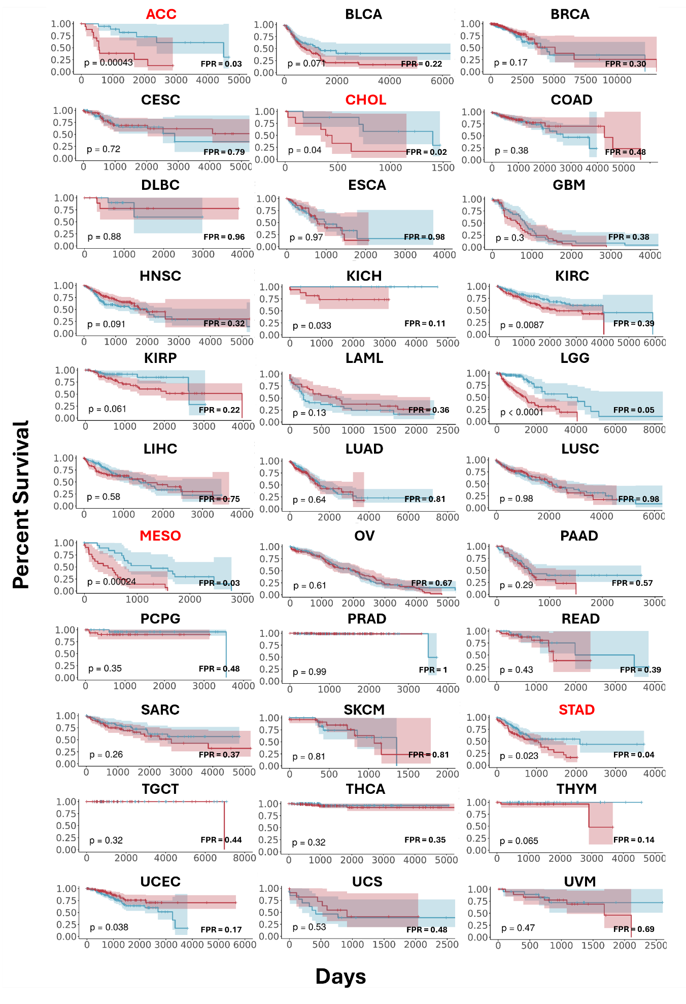
Supplementary Figure 11. Kaplan–Meier plots showing overall survival (Y-Axis) per days (X-Axis) of patients of GDC-TCGA datasets^{99,100}, stratified by SG score, with dataset identification as plot title. Patients were grouped into high and low expression cohorts based on bottom and upper quartile SG Score values. Log-rank p-value is shown on bottom left of each plot; FPR compared to 100 random signatures is shown on bottom right of each plot; Datasets with FPR > 0.05 are highlighted in red.

