markeR Shiny Web App: User Tutorial
markeR is a web app for scoring RNA-seq samples against gene sets to quantify a phenotype of interest, for example senescence. It helps answer two kinds of questions: how well one or more gene sets actually mark a phenotype, compared rigorously across methods (Benchmarking Mode), and which metadata variables are associated with a gene set (Discovery Mode). This tutorial walks through every tab in the order you'll typically use them: About, Data, Preprocessing, Gene Sets, Benchmarking Mode, and Discovery Mode.

Table of Contents
About Tab 3
Data Tab 4
Overview 4
Gene Expression Data 4
Importing from GEO (Beta) 5
Metadata 5
Gene Sets 6
Data Readiness Check 6
Summary Panel 7
Preprocessing Tab 7
Gene ID Conversion (banner) 8
Step 0: Verify Metadata Column Types 8
Step 1: Sample Complexity QC (optional) 9
Step 2: Filter Lowly Expressed Genes 9
Step 3: Normalisation & Quality Distribution 10
Step 4: PCA & Batch Correction (optional) 11
Removing Samples 12
Finalizing Preprocessing 13
Gene Sets Tab 14
Pairwise Overlap 14
Similarity vs MSigDB 14
Correlation 14
Effect Size (Cohen's d) 15
Gene PCA 15
Discriminatory Power (ROC / AUC) 15
Expression (Violins & Heatmap) 16
Benchmarking Mode Tab 16
Module A: Score Analysis 16
Score Distributions 17
Classification (ROC / AUC) 17
All Methods Summary 17
Score FPR Simulation 18
Score Results Table 18
Module B: Enrichment Analysis (GSEA) 18
DEG Volcanos 19
Combined Volcano 19
NES Lollipop 19
Enrichment Plots 20
Results Table 20
Discovery Mode Tab 20
Single Method Explorer 20
Method Summary 21

About Tab
Purpose: Confirm you're running the expected app/package versions, and find your way to the right tab.
Why use this: Knowing the exact package version matters if you're comparing your results to markeR’s paper, or comparing results across two analysis sessions run weeks apart.
What you'll see:
(A) Top-left corner shows the version of the web app.
(B) Warning message below the welcome message shows the version of the markeR R package the app was built on.
(C) Tab summaries: a brief explanation of what can be done in each tab. Methodologies are explained in greater detail in the markeR paper.
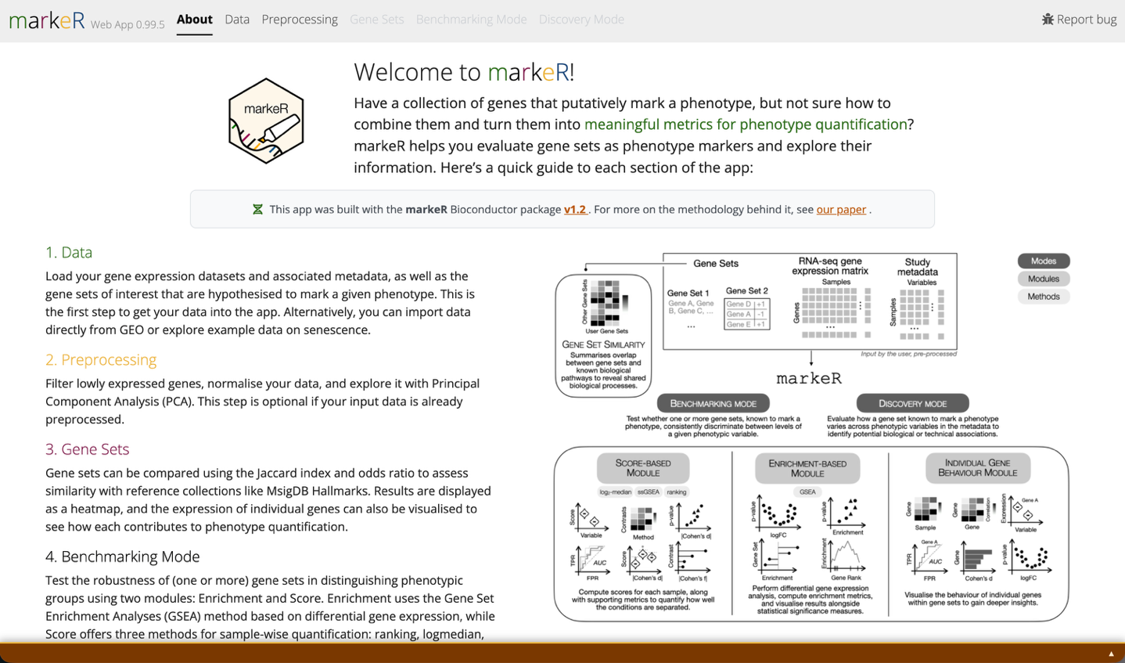
(D) Processing log: shows the R version, machine, and package versions running in the background, plus every decision made during data loading and pre-processing.
(A)
(B)
(C)
(D)

Data Tab
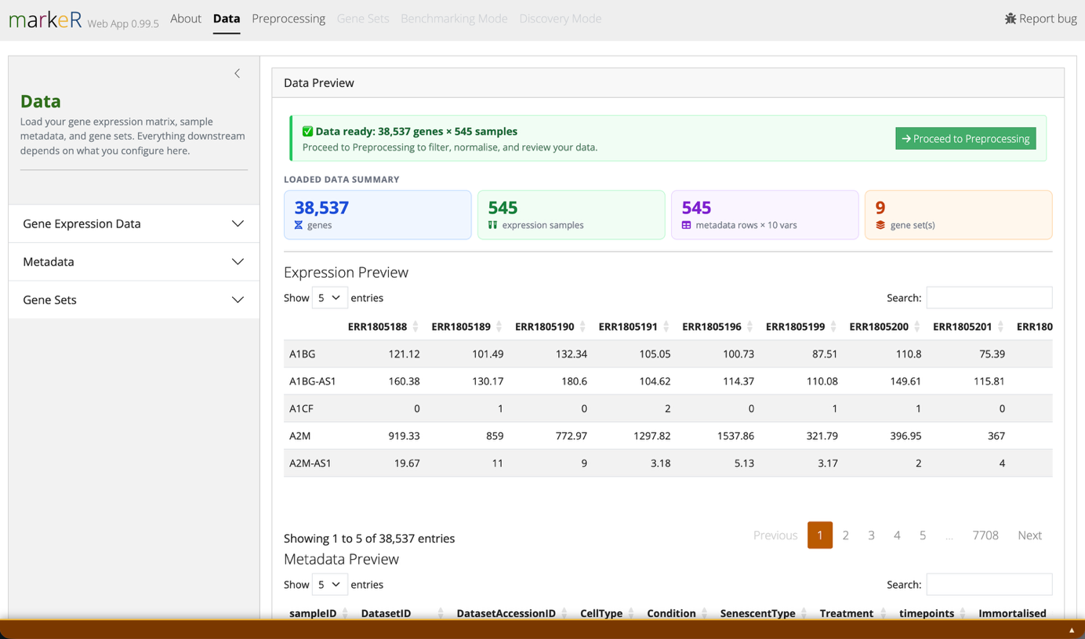
Load your three required inputs here: gene expression data, sample metadata, and gene sets. All three must be present and aligned before the remaining tabs unlock.
(A.1)
(A.2)
(A.3)
(B)
(C)

Overview
Purpose: Three dropdown menus load the data markeR needs: RNA-seq gene expression data, a metadata table linking each sample to clinical, phenotypic, or other variables, and the gene sets to calculate phenotype-quantification metrics for.
What you'll see:
(A.1) Gene Expression Data, including importing from GEO, see below.
(A.2) Metadata, see below.
(A.3) Gene Sets, see below.

Gene Expression Data
Purpose: Load the RNA-seq expression matrix that every downstream analysis scores.
Navigation:
- In the sidebar, pick a data source.
  - Example data: the unprocessed senescence cohort used in the markeR paper, loaded by default.
  - Processed example data: the same cohort, pre-processed per the paper's methodology.
  - Upload your own file:
      - Only RNA-seq data is supported. scRNA-seq is not yet compatible with the underlying methods; support is planned for a future release.
      - .csv / .txt: genes in rows, samples in columns; first column = gene names; first row = sample names; first cell can be empty or "Gene"; separator (comma, semicolon, tab) auto-detected; decimals may use "." or ","; trailing separators ignored; no quotation marks around values.
      - .rds: a matrix or data frame with gene names as row names and sample names as column names.
  - Import from GEO: fetch expression data directly from a public GEO accession. See Importing from GEO below.

Importing from GEO (Beta)
Purpose: Pull expression and metadata directly from a public GEO accession instead of uploading files.
Why use this: Saves you from manually downloading and reformatting supplementary files for public datasets you want to quickly explore or benchmark against.
What you'll see:
(A.1.1) Accession field: enter the GEO accession code and click Fetch from GEO.
(A.1.2) Ranked supplementary files: if expression data isn't detected automatically, files are listed ranked by an expression-likelihood score, a measure of how closely each file's structure matches expected RNA-seq expression data (genes as rows/columns, numeric counts). Higher-ranked files are more likely to be the correct one.
(A.1.3) Sample-matching tools: shown if sample names don't match between expression columns and metadata rows. Remove samples drops samples missing on either side; Match by keyword in a metadata column (recommended) links samples via partial text overlap, e.g. "Library: sampleA" vs "counts.sampleA"; or Manually rename expression columns to match metadata directly.
Good to know: GEO submissions aren't standardized, so some accessions may not parse or import correctly. If one doesn't work as expected, open an issue on markeR's GitHub page.

Metadata
Purpose: Load the sample-level table (clinical, phenotypic, or experimental variables) that analyses will test against.
Navigation:
- Pick a metadata source.
  - Example metadata: matches the default example expression data.
  - Upload your own:
- Text / CSV / TSV: one row per sample; first column must contain the Sample IDs, matched to expression matrix column names; remaining columns can be any sample-level variables (group, condition, batch, and so on); separator auto-detected; header row required; quoted values handled automatically.
- .rds / .xlsx: a data frame with samples as rows; column names used as variable labels.
  - From GEO: if the expression data source is set to Import from GEO, the metadata associated with that accession is fetched and loaded automatically; this option is unavailable for any other expression data source.

Gene Sets
Purpose: Load the gene set(s) used to score your phenotype of interest across every other tab.
Navigation:
- Pick a gene set source.
  - Example gene sets: nine senescence-associated sets used in markeR’s paper.
  - Upload your own: see format rules below. You can select multiple files at once; each becomes its own gene set, collected into the same list.
  - Paste gene set(s): enter gene sets directly, with no file required. See format rules below.
Format rules:
- Providing the expected direction of change (+1/-1 per gene) upon phenotype is preferred; it gives more interpretable biological results than an undirected gene list.
- .csv / .txt / .tsv: one column of gene names (undirected), or two columns, gene name then direction (directed). Do not include a header row: every line is read as data, starting from the first line. Separator (comma, semicolon, tab, or whitespace) is auto-detected. The file name (without extension) becomes the gene set name.
- .rds / .rda: a character vector of gene names, a two-column data frame (genes plus direction), or a named list combining either format.
- Paste gene set(s): provide a name for the set, then paste one gene per line into the text box. For a directional gene set, append the expected direction after a semicolon on every line, for example TP53;up and MKI67;down ("+1"/"-1" are also accepted). For an undirected gene set, list genes with no semicolon on any line, for example ACTB. A single gene set cannot mix the two conventions: either every line specifies a direction, or none do. Click Add another gene set to enter additional sets, then Use these gene sets to apply.

Data Readiness Check
Purpose: Confirm your three inputs are aligned before the rest of the app unlocks.
What you'll see:
(B) Green banner: sample names in the metadata correspond to the column names of the expression data, and the dimensions match. You're ready for the next steps.
(B.1) Yellow warning banner: shown at the top of the page if there's any mismatch between metadata and expression data (differing sample counts, or no name match).

If unresolved, access to the remaining tabs is blocked, since all three data types are essential to the analysis. The appropriate solution depends on the input source: for user-provided data, the files should be corrected and uploaded again; for GEO datasets, the controls described above can be used to resolve the mismatch.

Summary Panel
Purpose: Sanity-check everything you loaded before moving to analysis.
What you'll see:
(C) Browse sample names in the expression data and metadata, see which metadata column likely holds Sample IDs, and click any gene set name to expand its full gene list. Also reports the total number of samples, genes, metadata variables, and gene sets loaded; check these match your expectations before proceeding.

Preprocessing Tab
This tab operates on the gene expression data and metadata loaded in the Data tab; gene sets are not affected. It proceeds through five sequential steps, each unlocking once the previous one is completed or explicitly skipped; completed steps collapse into a green summary card you can reopen and redo at any time.
Why use this: Raw RNA-seq counts aren't directly comparable across samples. Differences in sequencing depth, low-complexity libraries, lowly-expressed noise genes, and technical batch effects can all masquerade as biological signal. This tab lets you inspect and correct for those before any phenotype score is calculated, so a gene set's discriminatory power reflects real biology rather than a technical artifact.
What you'll see:
- Progress bar. Sidebar progress tracker shows which step you're on, plus a Reset all button and a Skip (use data as-is) button that bypasses all five steps and sends your raw imported matrix straight through unmodified.
- Gene ID Conversion (banner).
- The pre-processing step boxes.
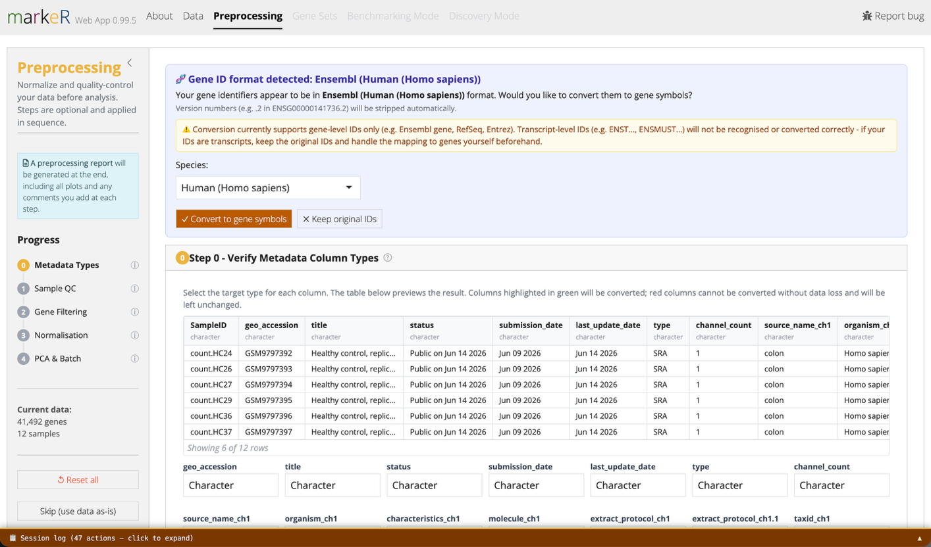
(A)
(B)
(C)

Gene ID Conversion (banner)
Purpose: Auto-detect whether your gene identifiers are Ensembl, RefSeq, or Entrez IDs and convert them to gene symbols.
Why use this: markeR's gene sets are defined by gene symbol. If your expression matrix is indexed by Ensembl or Entrez IDs instead, no gene in your data will ever match a gene set unless you convert first.
Navigation:
- A banner appears above Step 0 if ID types other than gene symbols are detected.
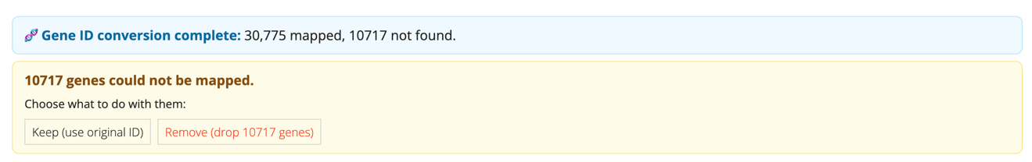
- If any gene IDs cannot be matched to gene names, the user is prompted to choose whether to discard the unmatched IDs or retain them in the analysis alongside the successfully matched gene names.
Good to know: Conversion supports gene-level identifiers only (for example, Ensembl gene, RefSeq, or Entrez IDs). Transcript-level identifiers (for example, ENST…, ENSMUST…) are not recognized or converted correctly. If your data is indexed by transcript IDs, map it to gene symbols before uploading.
Good to know: If multiple original identifiers map to the same gene symbol, their counts are summed into a single row for that symbol. The mapping table (below the banner, after conversion) flags which identifiers were merged this way.

Step 0: Verify Metadata Column Types
Purpose: Confirm each metadata column is read as the correct type (character, numeric, integer, factor, logical) before it's used in any statistical test.
Why use this: A numeric variable accidentally read as text (or vice versa) silently changes which statistical test markeR runs on it downstream, for example correlation versus group comparison. Catching this here avoids misleading results later.
Navigation:
- Change any column's type via its dropdown. A live preview table updates immediately.
- Check the preview table's highlighting.
  - Green means the conversion is safe.
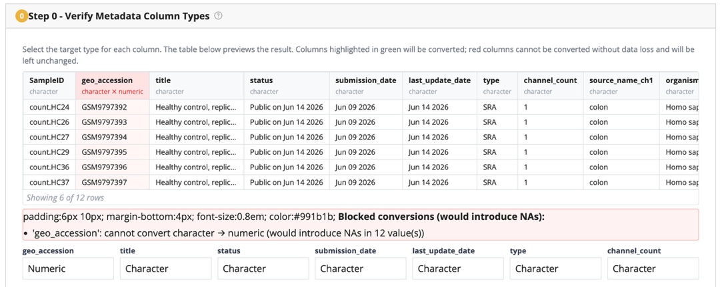
  - Red means it would introduce missing values, and is blocked.

- Click Apply changes or Confirm as-is to proceed.

Step 1: Sample Complexity QC (optional)
Purpose: Spot low-complexity or under-sequenced samples before normalization.
Why use this: A sample sequenced too shallowly, or with reads concentrated in very few genes, can distort the remaining analyses. Flagging and removing it here is cheaper than debugging a strange result three tabs later.
Navigation:
- Choose which samples to plot (all, specific, random N, or top/bottom N by library size).
What you'll see:
(C.1) Library Complexity Plot: Cumulative reads by gene index (order by descending order of total number of counts): a per-sample line plot of cumulative reads sorted by rank (log10 or percent of total).
(C.2) Read sampling plot: Unique genes vs. reads sampled: an iterative subsampling plot showing sequencing saturation and library complexity. Slower to compute; display-only, it does not filter your data.
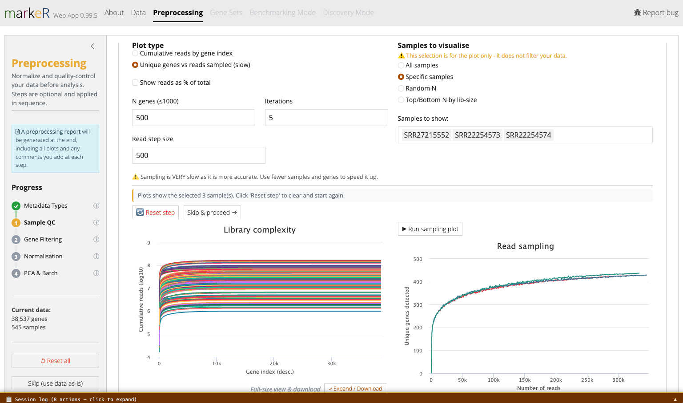
Good to know: Both plots are interactive: hover over any line to identify the sample it corresponds to. If a sample looks suspect here, note it and remove it after Step 4 (see Removing Samples, below).
(C.1)
(C.2)

Step 2: Filter Lowly Expressed Genes
Purpose: Remove genes whose expression is too low to be measured reliably.
Why use this: Genes near the detection floor are dominated by counting noise rather than biology. Including them adds noise to every downstream score without adding real signal, and can distort or inflate results.

Navigation:
- A density plot shows all genes by mean log2(count+1). Click on the plot, or type a value, to set the threshold.
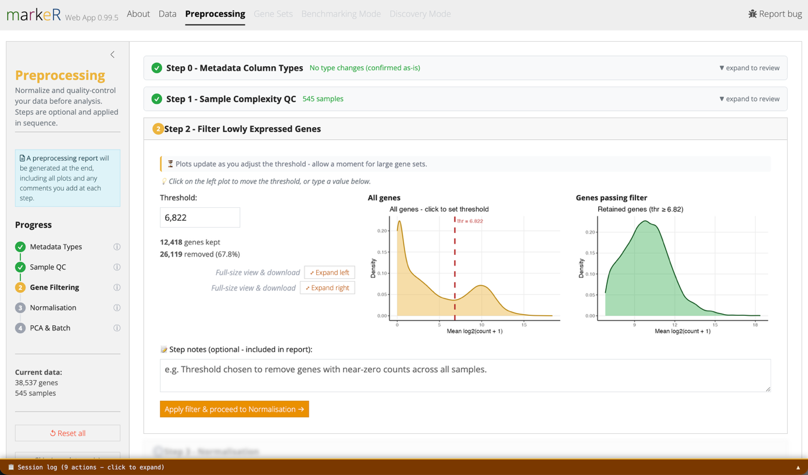
- A second density plot and a live gene counter show how many genes pass the current threshold.

Step 3: Normalisation & Quality Distribution
Purpose: Put samples on a comparable expression scale before scoring.
Why use this: Without normalization, a sample with more total reads will simply show systematically higher raw counts for every gene. A scoring method could mistake sequencing depth for biological signal.
Navigation:
- Choose a normalization method.
  - TMM (edgeR calcNormFactors + cpm): the standard choice for most RNA-seq count data.
  - VST (DESeq2): requires non-negative integer counts. The app warns or rounds if your data looks pre-normalized or fractional, and blocks negative values with a pointer to use TMM instead.
What you'll see:
(A) Before/after boxplots (log2 scale), fully reactive to display options (all, random-N, or extreme-N samples; color-by metadata; hide x labels) without re-running normalization.
Good to know: "Extreme N" shows the N/2 highest- and N/2 lowest-median samples together, which is useful for spotting outliers that a random sample might miss.

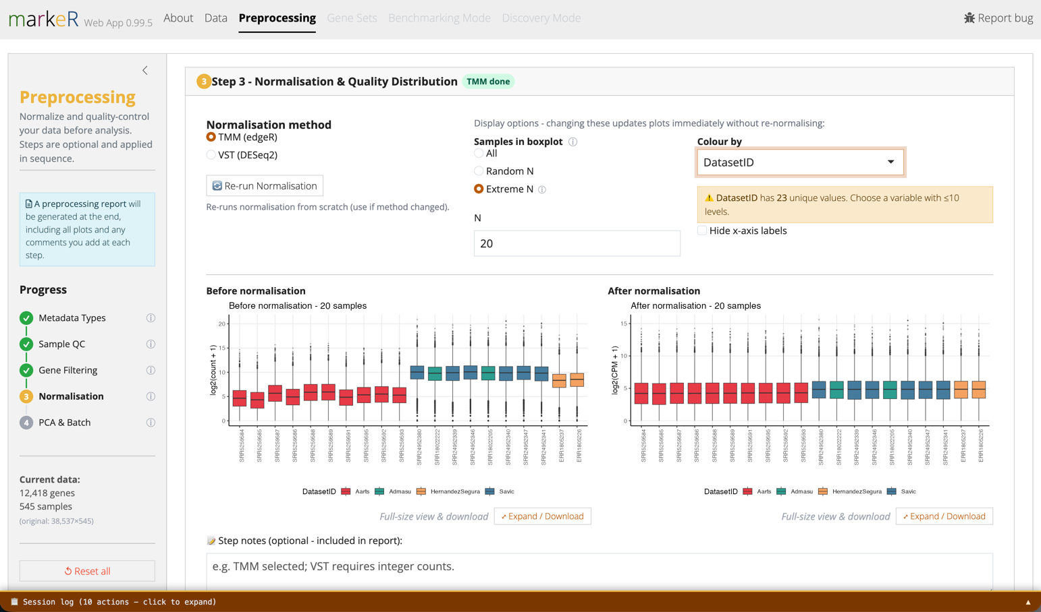
Step 4: PCA & Batch Correction (optional)
Purpose: Visualize sample structure and, if needed, remove known technical variation while protecting your biological variable of interest.
Why use this: If samples cluster by batch or processing date rather than by biology on the "before" PCA, any gene set score computed afterward risks reflecting the technical batch rather than the phenotype you're studying.
Navigation:
- Run PCA on the normalized matrix (center is recommended and on by default; scale is off by default, use with caution for RNA-seq).
- For batch correction (limma voom + lmFit):
  - Variable(s) to remove (batch): required, the technical variation to remove, for example DatasetID or processing batch.
  - Variable(s) to retain (signal): optional, the biological variable you don't want removed, which may be partially confounded with the variable(s) to remove, for example Condition or Age.
- A second "after" PCA and scree plot let you visually confirm the batch effect was removed without collapsing your biological grouping.
What you'll see:
(A) Both PCA plots are interactive: hover over a point to see its sample ID, group, and coordinates on the selected principal components.
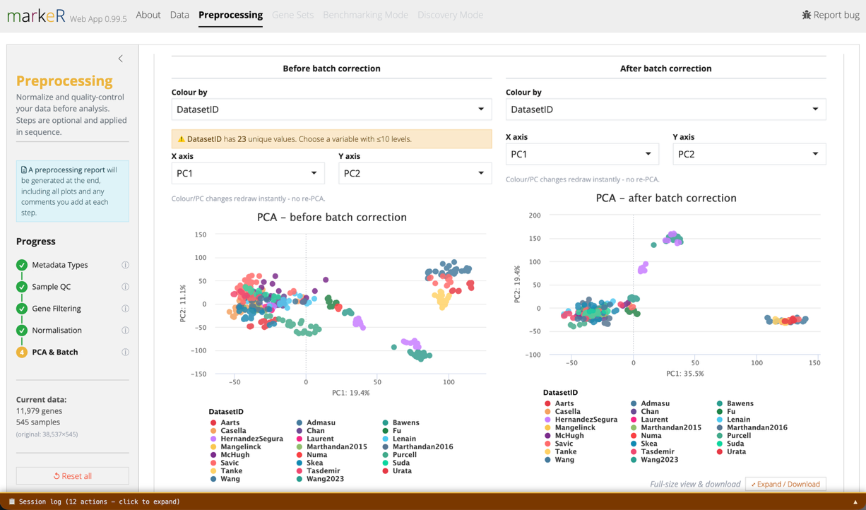
Good to know: The batch-correction method is credited to voyAGEr (eLife, 2024) and the markeR paper (NAR Genomics and Bioinformatics, 2026).

Removing Samples
Purpose: Remove a sample identified as an outlier during Steps 1 through 4.
Navigation:
- Located directly below the PCA plot at the end of Step 4.
- Select the sample(s) to remove.
- Optionally record a reason for removal, which is included in the preprocessing report.
- Optionally attach any of the diagnostic plots already produced during Steps 1 through 4 (sample complexity, gene filtering, normalisation, or PCA) as supporting evidence, also included in the report.
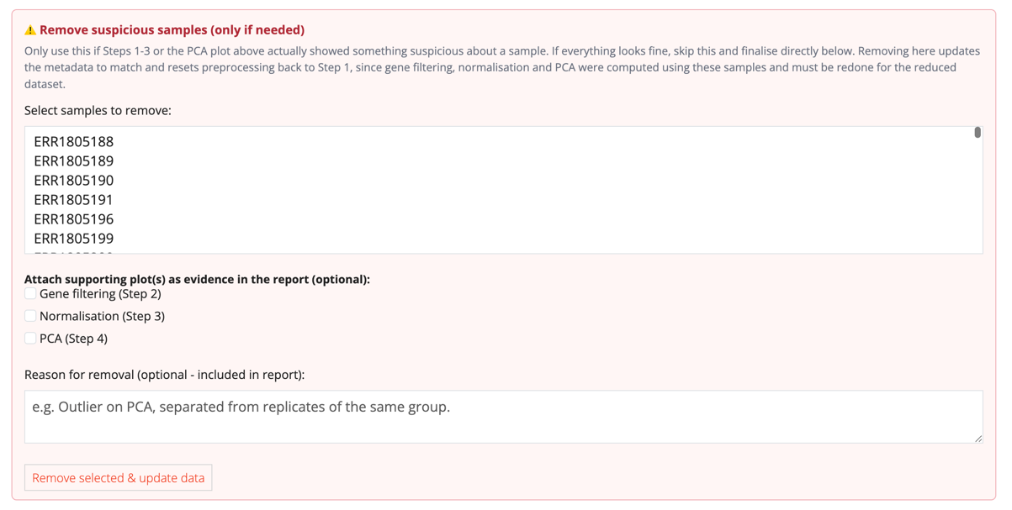
- Confirm the removal in the dialog that appears. Click Remove & reset to proceed.
Good to know: Removing a sample resets preprocessing back to Step 1: gene filtering, normalisation, and PCA were computed using that sample and must be recalculated on the reduced dataset. After the first removal, the control collapses behind a "Remove more samples…" toggle.

Finalizing Preprocessing
Purpose: Lock in your preprocessing choices and unlock the Gene Sets, Benchmarking Mode, and Discovery Mode tabs.
Navigation:
- Choose how to finish.
  - If batch correction was run: Use batch-corrected data or Use normalised only (no batch correction).
  - Otherwise: Finalise & apply preprocessing.
What you'll see:
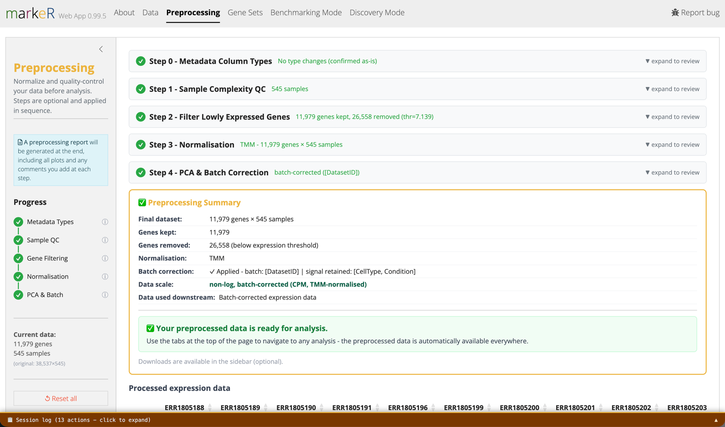
- Preprocessing Summary card: lists genes kept/removed, samples removed, normalization method, batch-correction status and variables, and the final data scale.
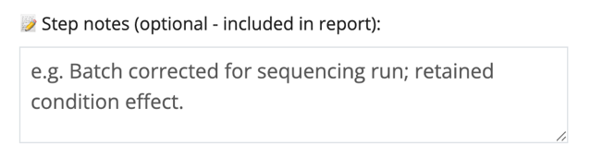
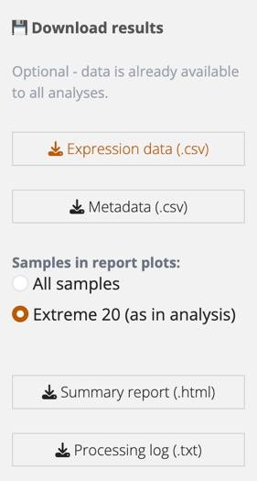
- Any "Step notes" you added along the way, plus every before/after plot, are compiled into an auto-generated HTML preprocessing report you can download for your records
- Options to download the preorpcessing report and data appear at the botton left of the sidebar.

Good to know: Until preprocessing is finalized (or explicitly skipped), the Gene Sets, Benchmarking Mode, and Discovery Mode tabs stay locked with the tooltip "Complete preprocessing first."

Gene Sets Tab
Use this tab to diagnose whether your gene set(s) behave as expected at the individual-gene level, before running full analyses in Benchmarking or Discovery Mode.
Good to know: Most sub-tabs analyse a single "Active gene set" chosen in the sidebar. Pairwise Overlap and Similarity vs MSigDB compare all loaded gene sets instead.

Pairwise Overlap
Purpose: Check how much your loaded gene sets overlap with each other.
Why use this: Before interpreting several signatures as independent findings, you might find it useful to know whether they're really measuring the same underlying biology (high overlap, likely redundant) or genuinely different processes.
Navigation:
- Choose a metric: Jaccard index or Odds ratio.
- Click Run Pairwise Overlap.
Analysis deep dive:
- Jaccard index = |A∩B| / |A∪B|, ranging from 0 (no overlap) to 1 (identical sets).
- Odds ratio = enrichment of overlap relative to chance. 1 is chance-level, above 1 is enriched overlap; self-comparisons show Inf.

Similarity vs MSigDB
Purpose: Check whether a gene set overlaps with known MSigDB pathways or your own reference sets.
Why use this: Even a strong discriminatory gene set may just be re-deriving a well-characterized pathway (for example, a Hallmark gene set) rather than reflecting a novel finding. This guards against over-claiming novelty.
Navigation:
- Choose a metric (Jaccard or Odds ratio), an organism (10 species supported), and an MSigDB collection, for example Hallmark, or a sub-collection such as CP:REACTOME.
- Optionally restrict to specific pathways, set a minimum Jaccard threshold (or odds-ratio and adjusted p-value cutoffs), or paste/upload custom reference gene sets.
- Click Run Similarity.

Correlation
Purpose: See which genes within the active gene set move together across samples.
Why use this: Reveals whether the gene set behaves as one coordinated module (co-regulated genes) or as several independent axes of variation.
Navigation:
- Select genes, choose a correlation method (Spearman, Pearson, or Kendall), and optionally split the heatmap by a metadata variable, producing one heatmap per level of that variable, for example when genes in a set are expected to be co-regulated under one condition but not under others.
- Toggle row/column clustering and labels, then click Plot Correlation Heatmap.
How to interpret this:
- Highly correlated genes may be co-regulated or redundant; uncorrelated genes contribute independent information to the signature score.

Effect Size (Cohen's d)
Purpose: Rank individual genes in the gene set by how well each one separates two groups.
Why use this: Decomposes the aggregate gene set into per-gene contributions, so you can identify which genes may be driving the signal and which contribute little.
Navigation:
- Choose specific genes, or Top/Random N (by |Cohen's d|, set order, or random).
- Pick a grouping variable and its "positive" class, then click Plot Effect Size.
Analysis deep dive:
- Cohen's d is the standardized difference in expression between the selected class and all other samples (one-vs-rest), using pooled standard deviation.
How to interpret this:
- d ≈ 0: no separation. d ≈ 0.5: moderate. d ≥ 0.8: large effect. The comparison is always binary, even for variables with more than two levels.

Gene PCA
Purpose: Test whether the genes in the active gene set, considered on their own, are sufficient to explain the separation of samples along a variable of interest.
Why use this: It shows how much variance the gene set's genes explain, and whether that variance happens to separate the grouping of interest.
Navigation:
- Pick a gene set, a variable to colour points by, and which principal components to plot (PC1 through PC10).
- Click Plot Gene PCA .
Analysis deep dive:
- PCA is computed on the expression matrix restricted to the genes in the active gene set; all other genes are excluded.
- PCA does not cluster samples and does not use the colour variable to compute the components. It identifies the directions of greatest variance among the data subset considering only the genes in the set; colouring points by a metadata variable afterward shows whether that variance aligns with the grouping of interest.

Discriminatory Power (ROC / AUC)
Purpose: Quantify, gene by gene, how well each gene discriminates between two groups.
Why use this: Turns "does this gene look different between groups" into a single comparable number (AUC), so you can screen and rank many genes for their standalone diagnostic value, independent of the full gene set score.
Navigation:
- Choose specific genes, or Top/Random N ranked by effective AUC = max(AUC, 1 − AUC). This captures strongly discriminatory genes in either direction.
- Pick a grouping variable and positive class, then click Plot Discriminatory Power.
How to interpret this:
- AUC = 0.5: no better than chance. AUC = 1.0: perfect separation.
Good to know: An AUC below 0.5 doesn't mean a gene is uninformative. It means high expression of that gene predicts the other class, for example the gene is down- rather than up-regulated in the condition of interest. The ROC curve itself never changes. Checking "Invert AUC < 0.5 genes" only flips how the AUC number and curve orientation are displayed: genes with raw AUC < 0.5 are shown as 1 − AUC instead, so you can visually rank many genes by discriminatory strength on one common 0.5-1 scale, without direction confounding the ranking.

Expression (Violins & Heatmap)
Purpose: Inspect expression patterns of individual genes to validate they behave as expected.
Why use this: A final visual gut-check before trusting a gene set's statistics: confirms that the genes actually show the expected pattern of change, rather than being an artifact of an aggregate score.
Navigation:
- Violin plots: select genes, a grouping variable (x-axis), and a colour variable, then click Plot Violins.
- Heatmap: toggle row/column clustering and labels, then click Plot Heatmap.
Analysis deep dive:
- The heatmap is row-scaled (Z-score per gene), so patterns are comparable across genes with very different absolute expression ranges.

Benchmarking Mode Tab
Purpose: Rigorously test and compare one or more gene sets' ability to mark a phenotype, using both score-based and enrichment-based methods.
Navigation:
- In the sidebar, choose gene set scope: All loaded or Select specific sets.

Module A: Score Analysis
Shared settings for this module: pick a variable (or "None" for a density plot), choose a contrast mode for categorical variables or a correlation method for numeric variables, and optionally filter which contrasts are displayed.

Score Distributions
Purpose: Visualize per-sample scores across groups.
Navigation:
- Choose a scoring method (Log-median, Ranking, or ssGSEA; see the markeR manuscript for further methodological detail) and a colour-by variable.
- Optionally connect paired samples across groups, set a "focus" comparison for Cohen's d, and show a t-test p-value in the subtitle.
Analysis deep dive:
- Log-median: log2-transforms expression and median-centres each gene across samples.
- Ranking: non-parametric. Scores are based on each sample's within-sample rank of the gene set's members.
- ssGSEA: single-sample running-sum enrichment score (Barbie et al. 2009). Sensitive to gene set size.
Good to know: Log-median expresses each score as the mean of centred, log-transformed expression, so it is sensitive to normalization and scale. Ranking expresses each score using each sample's within-sample rank of the gene set's members rather than expression magnitude, which makes it more robust to outliers but does not preserve the magnitude of expression differences between samples. ssGSEA computes a running-sum enrichment score. See the markeR manuscript for a detailed methodological comparison. Rather than relying on a single method, use the All Methods Summary sub-tab below to check whether results agree across methods.

Classification (ROC / AUC)
Purpose: Test how well a gene set's score classifies a categorical variable.
Navigation:
- Choose a scoring method and optionally check Ignore direction to fold AUC to 0.5 or above.
How to interpret this:
- AUC = 0.5 is chance-level; AUC = 1.0 is perfect classification.
Good to know: Off by default, direction is preserved: a curve can dip below the diagonal (AUC < 0.5), meaning the score runs opposite to how you defined the comparison, for example class order flipped, or it's really a "down" signature relative to this contrast. Checking "Ignore direction" folds any AUC below 0.5 to 1 − AUC, so you can compare separation strength across many contrasts or gene sets without direction sign flipping the ranking, at the cost of hiding which way the score actually points.

All Methods Summary
Purpose: Compare every gene set against every contrast, across all three scoring methods, in one view.
Why use this: Identifies which gene sets and contrasts are most consistently discriminatory regardless of scoring method.
Navigation:
- Set significance and effect-size thresholds, then click to run.
Analysis deep dive:
- A Cohen's d/f heatmap (gene sets by contrasts, cell text = effect size and adjusted p-value) plus an Effect Size Volcano (x = effect size, y = −log10 adjusted p-value, faceted by contrast).
How to interpret this:
- Dashed threshold lines mark your significance and effect-size cutoffs. Points beyond both lines, consistently across methods, are your best candidates.

Score FPR Simulation
Purpose: Test whether a gene set's discriminatory power is statistically distinguishable from what would be expected by chance, given random gene sets of the same size.
Why use this: A raw Cohen's d for a gene set score doesn't tell you if that specific gene combination matters, or if any random set of the same size would show a similarly large effect. This provides the empirical null, distinguishing true signature specificity from a size- or method-driven artifact.
Navigation:
- Choose a contrast mode and number of simulations (10 to 2000; default 100). More simulations means longer runtime, since it scales with gene sets times simulations times 3 methods.
- Click Run Score FPR Simulation.
Analysis deep dive:
- For each contrast, the app computes the observed Cohen's d/f for your gene set, then generates random gene sets of matching size from the full expression matrix to build a null distribution. A 95th-percentile threshold line marks where a random set would be considered "significant" purely by chance.
How to interpret this:
- If your observed effect size sits comfortably above the null distribution's 95th percentile, the result is unlikely to be a size artifact. This tests score-level specificity, not gene-level discriminability; pair it with the Gene Sets tab's per-gene diagnostics for the full picture.

Score Results Table
Purpose: Export raw per-sample scores for further analysis.
Navigation:
- Choose a method (or "All methods"), then download as CSV or Excel.

Module B: Enrichment Analysis (GSEA)
Purpose: Test gene set enrichment using differential expression plus GSEA, rather than per-sample scores.
Why use this: Score-based methods collapse each gene set into one number per sample and ask "does this score classify samples well?" GSEA instead runs differential expression across the whole cohort first, then asks "is this gene set as a whole coordinately shifted in this contrast?".
Navigation:
- Choose a design mode.
  - Automatic: pick a grouping variable; the app builds the design matrix and contrasts for you.
  - Manual: paste an R formula, for example ~ 0 + Condition + Batch, for covariates or paired designs.
- Set the ranking statistic (Auto, t-statistic, or B-statistic), number of permutations (default 1000), and p-adjustment settings, including whether to pool FDR correction across all contrasts.
- Click Run Enrichment Analysis (GSEA).
Good to know: Ranking statistic: Auto (recommended) uses the t-statistic for directional gene sets (a data frame with +1/-1 gene weights) and the B-statistic for gene sets without direction. Use t-statistic explicitly for a classic "up in disease, down in disease" signature, where preserving the sign of NES is biologically meaningful. Use B-statistic for an unsigned gene list with no inherent direction, where up- and down-regulated members should both be able to contribute to enrichment regardless of direction.

DEG Volcanos
Purpose: See differential expression results per contrast, with gene set membership highlighted.
Navigation:
- Set logFC and adjusted p-value thresholds, and how many top genes to label.
- Choose highlight mode: Gene set members or Significant genes by threshold.
How to interpret this:
- Grey = background gene. Green = annotated up in the gene set. Red = annotated down. Dark blue = in the gene set with no assigned direction. Blue = significant by your threshold.
Good to know: Colour encodes each gene's annotated direction from the gene set itself, not the side of the plot the point falls on for this particular contrast. For example, in a contrast A vs B where A is the positive class, a gene set annotated to mark class B will have its member genes colored red (annotated down), even for genes that fall on the right-hand, up-logFC side of the plot for this contrast.

Combined Volcano
Purpose: Compare NES and significance across all gene sets and contrasts at once.
Navigation:
- Runs automatically once GSEA completes.
Analysis deep dive:
- Each point represents one gene set by contrast pair; x-position reflects NES, y = −log10 adjusted p-value, color = gene set, shape = contrast.
How to interpret this:
- Altered panel (undirected gene sets, B-statistic): positive NES = enriched among the most-altered genes.
- Enriched/Depleted panel (directed gene sets, t-statistic): positive NES = enriched among up-regulated genes, negative NES = enriched among down-regulated genes.

NES Lollipop
Purpose: Rank gene sets by enrichment strength within each contrast.
Navigation:
- Runs automatically once GSEA completes.
Analysis deep dive:
- Lollipop length = |NES|; point color = adjusted p-value (red = significant). One panel per contrast, split into Altered and Enriched/Depleted as above.

Enrichment Plots
Purpose: See the classic GSEA running-enrichment-score curve for a specific gene set and contrast.
Navigation:
- Select a gene set and contrast to inspect.
Analysis deep dive:
- The curve tracks the running enrichment score along the ranked gene list; bars along the bottom mark where gene set members fall in that ranking. A peak concentrated on one side indicates strong, coordinated enrichment.

Results Table
Purpose: Export full GSEA statistics for every gene set and contrast.
Analysis deep dive:
- Columns include pathway, NES, adjusted p-value, ranking statistic used, contrast, and leading edge.
How to interpret this:
- NES > 0: enriched among up-regulated genes for that contrast. NES < 0: enriched among down-regulated genes. Leading edge: the gene set members that drove the enrichment.

Discovery Mode Tab
Purpose: Screen many metadata variables quickly against one gene set to generate hypotheses.
Why use this: Quickly tests which clinical or technical covariates (age, sex, batch, treatment, subtype, and so on) are associated with your gene set's signal, before you invest time in rigorously benchmarking one hand-picked variable. This mode assumes the gene set is already robust in marking a given phenotype.
Navigation:
- In the sidebar, pick one gene set.
- Select the metadata variables to test. Variables with only one observed level are excluded automatically; variables with more than six levels are flagged as potentially unwieldy.
- Choose a contrast mode: Simple pairwise, One vs rest, or All combinations. Hover over each option in the app for its exact definition and an example.
- Set the significance threshold (adjusted p-value, default 0.05) and p-adjustment method.
Good to know: Discovery Mode is for hypothesis generation, not confirmation. If a result looks promising, take it to Benchmarking Mode for a more rigorous look, and however it holds up there, confirm it in an independent dataset before relying on it.

Single Method Explorer
Purpose: Test one scoring or enrichment method against all selected variables.
Navigation:
- Choose a method: Log-median score, Ranking score, ssGSEA score, or GSEA enrichment, then click Run Selected Method.
Analysis deep dive:
- Score methods output an Effect Size Overview (Cohen's f per variable), Score Distributions per variable, and Pairwise Contrasts (Cohen's d per pairwise comparison with adjusted p-values).
- The GSEA method outputs a lollipop plot: one row per contrast across all variables. Point position = NES (normalized enrichment score); colour = adjusted p-value significance.
How to interpret this:
- Dashed, grey points flag B-statistic contrasts with negative NES: generally uninformative, meaning no strong coordinated expression change. Rows below your significance threshold are highlighted in the results table.

Method Summary
Purpose: Compare all four methods at once across every selected variable, in a single view.
Why use this: No single scoring or enrichment method is authoritative. A variable that shows up as significant across methods is far more trustworthy than one that only appears with a single method.
Navigation:
- Click to run. This is slower than Single Method Explorer, since GSEA runs once per variable.

Analysis deep dive:
- A combined heatmap: the left block shows Cohen's f per variable by scoring method (an asterisk marks p below your threshold); the right column shows the fraction of that variable's GSEA contrasts that were significant (for example, "2/3").

