markeR Shiny Web App: User Tutorial
markeR is a web app for scoring RNA-seq samples against gene sets to quantify a phenotype of interest, such as senescence. It helps answer two kinds of questions: how well one or more gene sets mark a phenotype, assessed rigorously across scoring and enrichment methods (Benchmarking Mode), and which metadata variables are associated with a gene set (Discovery Mode). This tutorial walks through all tabs in the order you will typically use them: About, Data, Preprocessing, Gene Sets, Benchmarking Mode, and Discovery Mode.

TABLE OF CONTENTS
About Tab 3
Data Tab 4
Overview 4
Gene Expression Data 4
Importing from GEO (Beta) 5
Metadata 5
Gene Sets 6
Data Readiness Check 6
Summary Panel 7
Preprocessing Tab 7
Gene ID Conversion (banner) 8
Step 0: Verify Metadata Column Types 8
Step 1: Sample Complexity QC (optional) 9
Step 2: Filter Lowly Expressed Genes 10
Step 3: Normalisation & Quality Distribution 11
Step 4: PCA & Batch Correction (optional) 12
Removing Samples 13
Finalising Preprocessing 14
Gene Sets Tab 15
Pairwise Overlap 15
Similarity vs MSigDB 15
Correlation 16
Effect Size (Cohen's d) 16
Gene PCA 16
Discriminatory Power (ROC / AUC) 17
Expression (Violins & Heatmap) 17
Benchmarking Mode Tab 18
Module A: Score Analysis 18
Score Distributions 18
Classification (ROC / AUC) 18
All Methods Summary 19
Score FPR Simulation 19
Score Results Table 19
Module B: Enrichment Analysis (GSEA) 20
DEG Volcanos 20
Combined Volcano 20
NES Lollipop 21
Enrichment Plots 21
Results Table 21
Discovery Mode Tab 21
Single Method Explorer 22
Method Summary 22

About Tab
Purpose: Confirm the app and package versions you are running, and find your way to the appropriate tab.
Why use this: Knowing the exact package version is important when comparing your results with those reported in the markeR paper or comparing analyses run at different times.
What you will see:
(A) The top-left corner shows the web app version.
(B) The warning message below the welcome message shows the version of the markeR R package on which the app was built.
(C) Tab summaries provide a brief explanation of what you can do in each tab. The underlying methodologies are described in greater detail in the markeR paper.
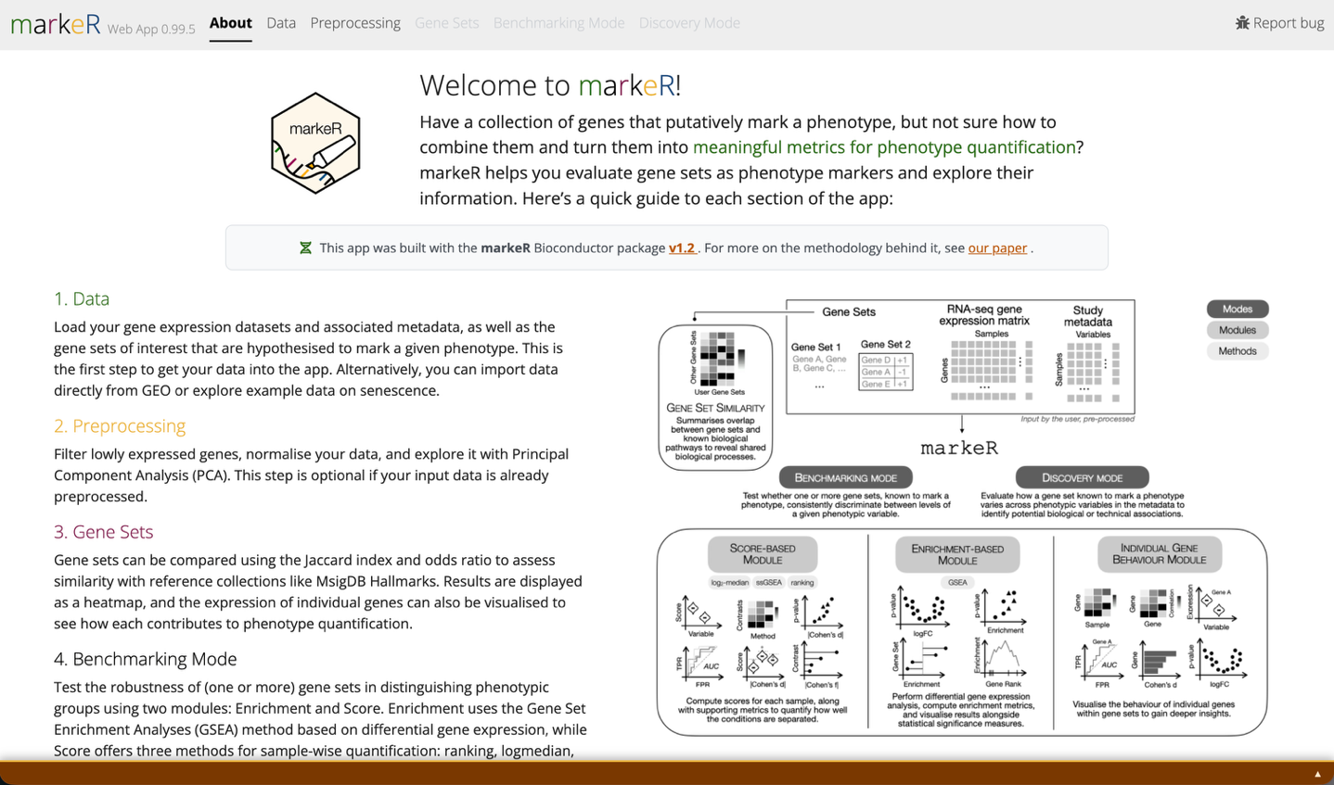
(D) The Processing log shows the R version, machine, and package versions running in the background, plus every decision made during data loading and preprocessing.
(A)
(B)
(C)
(D)

Data Tab
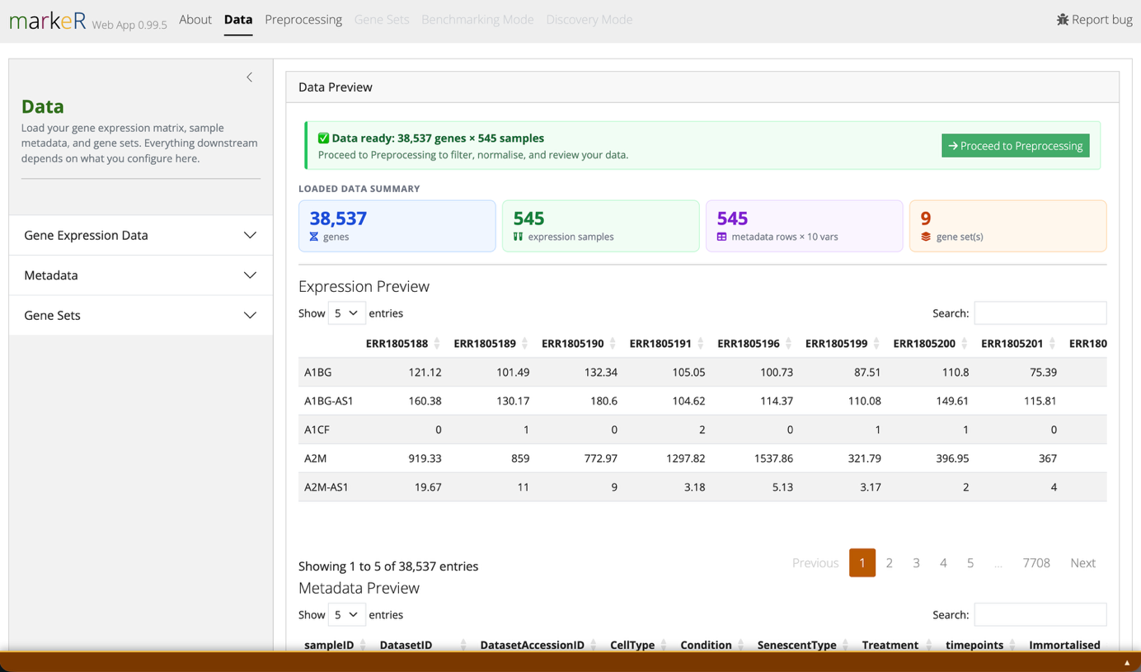
Load the three inputs required by markeR: gene expression data, sample metadata, and gene sets. All three must be present and correctly matched before the remaining tabs become available.
(A.1)
(A.2)
(A.3)
(B)
(C)

Overview
Purpose: The three dropdown menus load the data markeR needs: an RNA-seq gene expression matrix, a metadata table linking each sample to clinical, phenotypic, or experimental variables, and the gene sets used to quantify the phenotype of interest.
What you will see:
(A.1) Gene Expression Data, including the option to import data from GEO.
(A.2) Metadata, see below.
(A.3) Gene Sets, see below.

Gene Expression Data
Purpose: Load the RNA-seq expression matrix used in all downstream analyses.
Navigation:
- In the sidebar, pick a data source.
  - Example data: the unprocessed senescence cohort used in the markeR paper. This is loaded by default.
  - Processed example data: the same cohort, preprocessed according to the methodology described in the paper.
  - Upload your own file:
      - Only bulk RNA-seq data is currently supported. scRNA-seq is not yet compatible with the underlying methods; support is planned for a future release.
      - .csv / .txt: genes in rows and samples in columns; the first column contains gene names and the first row contains sample names. The first cell may be empty or "Gene". Comma, semicolon, and tab separators are detected automatically; decimals may use "." or ",". Trailing separators are ignored, and values should not be enclosed in quotation marks.
      - .rds: a matrix or data frame with gene names as row names and sample names as column names.
  - Import from GEO: fetch expression data directly from a public GEO accession. See Importing from GEO below.

Importing from GEO (Beta)
Purpose: Retrieve expression data and metadata directly from a public GEO accession instead of uploading files.
Why use this: This can save you from manually downloading and reformatting supplementary files when you want to quickly explore or benchmark a public dataset.
What you will see:
(A.1.1) Accession field: enter the GEO accession code and click Fetch from GEO.
(A.1.2) Ranked supplementary files: if expression data is not detected automatically, supplementary files are ranked by an expression-likelihood score. This score reflects how closely each file matches the expected structure of RNA-seq expression data (genes in rows or columns and numeric values). Higher-ranked files are more likely to be suitable.
(A.1.3) Sample-matching tools: these appear when sample names do not match between expression columns and metadata rows. Remove samples removes samples missing from either side; Match by keyword in a metadata column (recommended) links samples using partial text overlap, for example "Library: sampleA" vs "counts.sampleA"; Manually rename expression columns lets you rename expression columns to match the metadata directly.
Good to know: GEO submissions are not standardised, so some accessions may not parse or import correctly. If an accession does not work as expected, please open an issue on markeR's GitHub page.

Metadata
Purpose: Load the sample-level table containing the clinical, phenotypic, or experimental variables tested in downstream analyses.
Navigation:
- Pick a metadata source.
  - Example metadata: matches the default example expression data.
  - Upload your own:
- Text / CSV / TSV: one row per sample; the first column must contain Sample IDs matching the expression matrix column names. Remaining columns can contain any sample-level variables (group, condition, batch, etc.). The separator is detected automatically; a header row is required and quoted values are handled automatically.
- .rds / .xlsx: a data frame with samples as rows; column names used as variable labels.
  - From GEO: if the expression data source is set to Import from GEO, the metadata associated with that accession is fetched and loaded automatically; this option is unavailable for any other expression data source.

Gene Sets
Purpose: Load the gene set(s) used to score your phenotype of interest throughout the other tabs.
Navigation:
- Pick a gene set source.
  - Example gene sets: nine senescence-associated sets used in markeR’s paper.
  - Upload your own: see format rules below. You can select multiple files at once; each becomes its own gene set, collected into the same list.
  - Paste gene set(s): enter gene sets directly, with no file required. See format rules below.
Format rules:
- Providing the expected direction of change (+1/-1 per gene) for the phenotype is recommended because it allows more interpretable biological results than an undirected gene list.
- .csv / .txt / .tsv: one column of gene names (undirected), or two columns containing gene name and direction (directed). Do not include a header row; every line is read as data, starting from the first line. The separator (comma, semicolon, tab, or whitespace) is detected automatically. The file name (without extension) becomes the gene set name.
- .rds / .rda: a character vector of gene names, a two-column data frame (genes plus direction), or a named list combining either format.
- Paste gene set(s): provide a name for the gene set, then paste one gene per line into the text box. For a directional gene set, append the expected direction after a semicolon on every line, for example TP53;up and MKI67;down (+1/-1 are also accepted). For an undirected gene set, list genes with no semicolon on any line, for example ACTB. A single gene set cannot mix the two conventions: either every line specifies a direction, or none do. Click Add another gene set to enter additional sets, then click Use these gene sets to apply them.

Data Readiness Check
Purpose: Confirm that your three inputs are correctly matched before the remaining tabs become available.
What you will see:
(B) Green banner: sample names in the metadata correspond to the column names of the expression data, and the number of samples matches between the two. You are ready for the next steps.
(B.1) Yellow warning banner: shown at the top of the page if there is any mismatch between metadata and expression data (differing sample counts or non-matching sample names).

If unresolved, access to the remaining tabs is blocked, since all three data types are essential to the analysis. The appropriate solution depends on the input source: for user-provided data, correct the files and upload them again; for GEO datasets, use the controls described above to resolve the mismatch.

Summary Panel
Purpose: Perform a final sanity check on the loaded data before starting the analyses.
What you will see:
(C) Browse sample names in the expression data and metadata, identify which metadata column likely holds Sample IDs, and click any gene set name to expand its full gene list. Also reports the total number of samples, genes, metadata variables, and gene sets loaded; check that these match your expectations before proceeding.

Preprocessing Tab
This tab operates on the gene expression data and metadata loaded in the Data tab; gene sets are not affected. It proceeds through five sequential steps. Each step becomes available after the previous one is completed or explicitly skipped, and completed steps collapse into a green summary card that you can reopen and redo at any time.
Why use this: Raw RNA-seq counts are not directly comparable across samples. Differences in sequencing depth, library complexity, lowly expressed genes, and technical batch effects can all masquerade as biological signal. This tab lets you inspect and, where appropriate, correct these issues before calculating phenotype scores, reducing the risk that apparent discriminatory power reflects technical artefacts rather than biology.
What you will see:
- Progress bar. Sidebar progress tracker shows which step you are on, plus a Reset all button and a Skip (use data as-is) button that bypasses all five steps and sends your raw imported matrix straight through unmodified.
- Gene ID Conversion (banner).
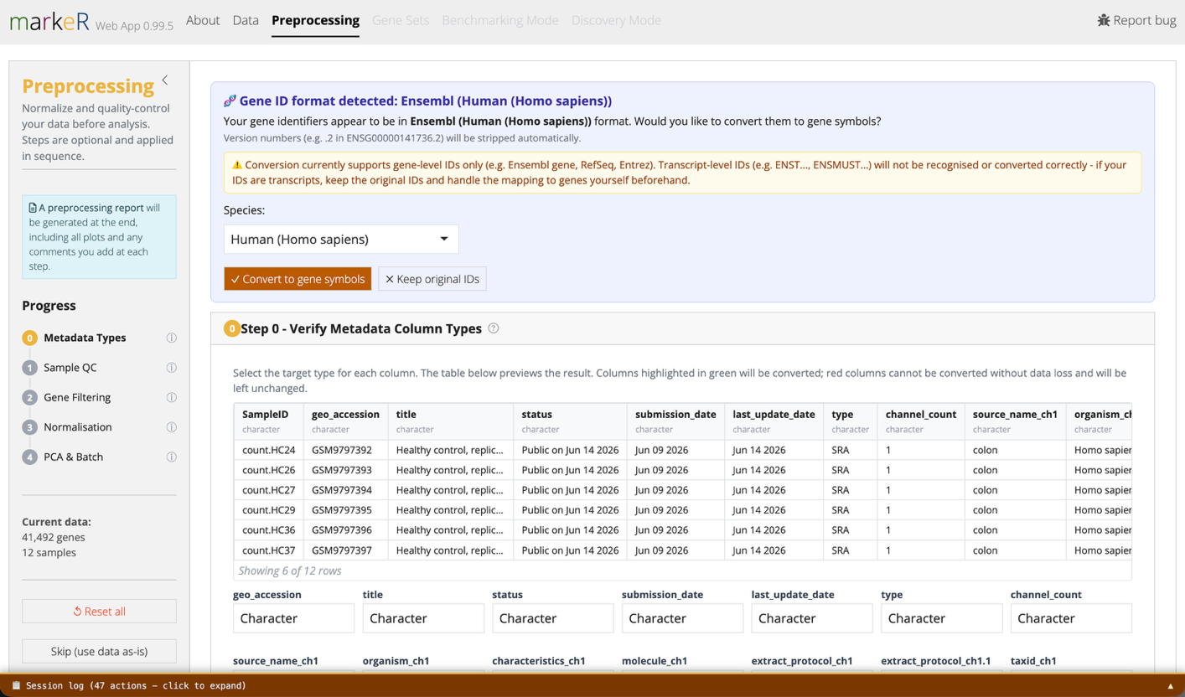
- The preprocessing step boxes.
(A)
(B)
(C)

Gene ID Conversion (banner)
Purpose: Automatically detect whether your gene identifiers are Ensembl, RefSeq, or Entrez IDs and convert them to gene symbols.
Why use this: markeR's gene sets are defined using gene symbols. If your expression matrix uses Ensembl, RefSeq, or Entrez identifiers instead, conversion is required for the genes in your data to match the gene sets.
Navigation:
- A banner appears above Step 0 if ID types other than gene symbols are detected.
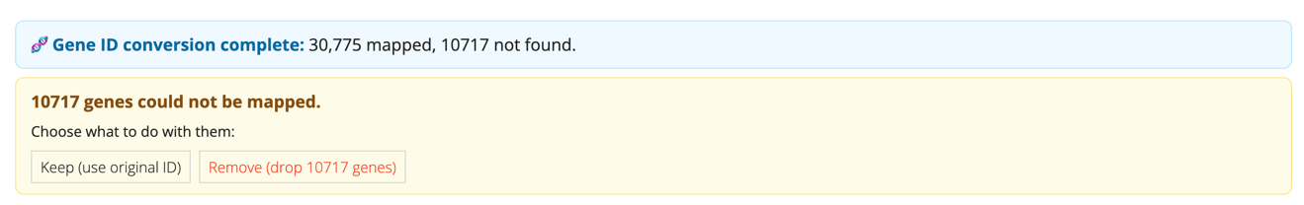
- If any gene IDs cannot be matched to gene names, the user is prompted to choose whether to discard the unmatched IDs or retain them in the analysis alongside the successfully matched gene names.
Good to know: Conversion supports gene-level identifiers only (for example, Ensembl gene, RefSeq, or Entrez IDs). Transcript-level identifiers (for example, ENST… or ENSMUST…) are not recognised or converted correctly. If your data uses transcript IDs, map them to gene symbols before uploading.
Good to know: If multiple original identifiers map to the same gene symbol, their counts are summed into a single row for that symbol. The mapping table (below the banner, after conversion) flags which identifiers were merged this way.

Step 0: Verify Metadata Column Types
Purpose: Confirm that each metadata column has the correct data type (character, numeric, integer, factor, or logical) before it is used in statistical tests.
Why use this: A numeric variable accidentally read as text (or vice versa) can change which statistical test markeR applies downstream – for example, correlation versus group comparison. Checking this here helps prevent misleading results.
Navigation:
- Change any column's type via its dropdown. A live preview table updates immediately.
- Check the preview table's highlighting.
  - Green means the conversion is safe.
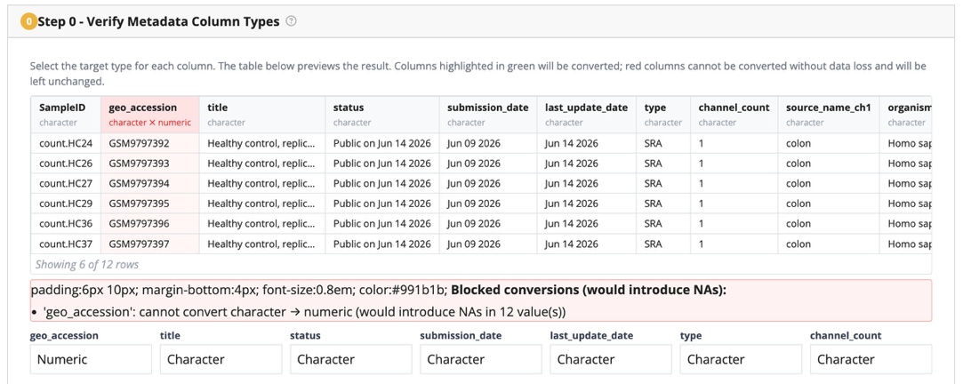
  - Red means it would introduce missing values and is blocked.

- Click Apply changes or Confirm as-is to proceed.

Step 1: Sample Complexity QC (optional)
Purpose: Identify low-complexity or under-sequenced samples before normalisation.
Why use this: A sample sequenced too shallowly, or with reads concentrated in very few genes, can distort downstream analyses. Identifying potential problems here makes them easier to investigate before interpreting later results.
Navigation:
- Choose which samples to plot (all, specific, random N, or top/bottom N by library size).
What you will see:
(C.1) Library Complexity Plot: Cumulative reads by gene index (order by descending order of total number of counts): a per-sample line plot of cumulative reads sorted by rank (log₁₀ or percent of total).
(C.2) Read sampling plot: Unique genes vs. reads sampled: an iterative subsampling plot showing sequencing saturation and library complexity. Slower to compute; display-only, it does not filter your data.
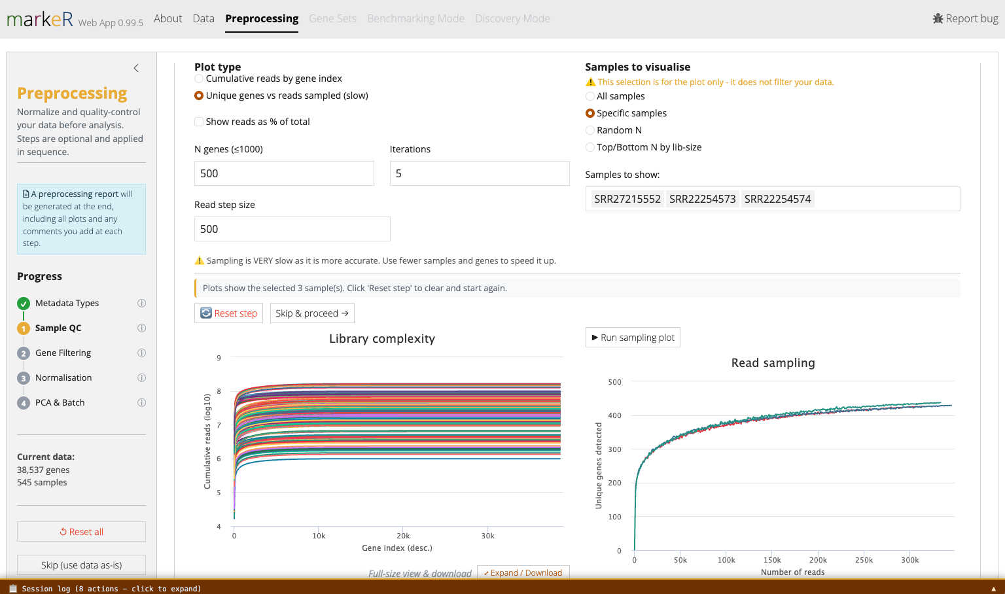
Good to know: Both plots are interactive: hover over any line to identify the sample it corresponds to. If a sample looks suspect here, note it and remove it after Step 4 (see Removing Samples, below).
(C.1)
(C.2)

Step 2: Filter Lowly Expressed Genes
Purpose: Remove genes with expression levels too low for reliable measurement.
Why use this: Genes near the detection limit are more strongly affected by counting noise. Including them can add noise to downstream scores without contributing reliable biological signal.

Navigation:
- A density plot shows all genes by mean log₂(count+1). Click on the plot, or type a value, to set the threshold.
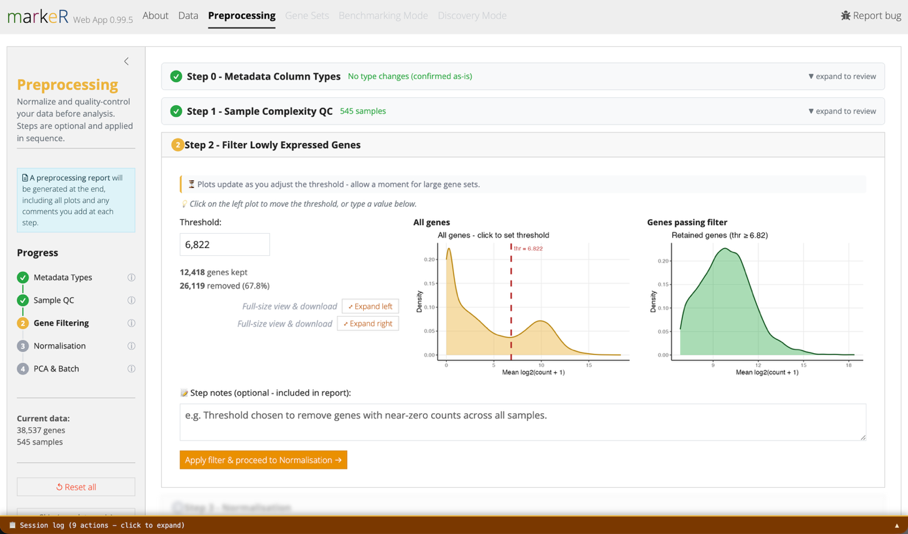
- A second density plot and a live gene counter show how many genes pass the current threshold.

Step 3: Normalisation & Quality Distribution
Purpose: Put samples on a comparable expression scale before scoring.
Why use this: Without normalisation, a sample with more reads will tend to have higher raw counts across genes. A scoring method could mistake differences in sequencing depth for biological signal.
Navigation:
- Choose a normalisation method.
  - TMM (edgeR calcNormFactors + cpm): the standard choice for most RNA-seq count data.
  - VST (DESeq2): requires non-negative integer counts. The app respectively warns or rounds if your data look pre-normalised or fractional, and blocks negative values with a pointer to use TMM instead.
What you will see:
(A) Before/after boxplots (log₂ scale), fully reactive to display options (all, random-N, or extreme-N samples; colour-by metadata; hide x labels) without re-running normalisation.
Good to know: "Extreme N" shows the N/2 highest- and N/2 lowest-median samples together, which is useful for spotting outliers that a random sample might miss.

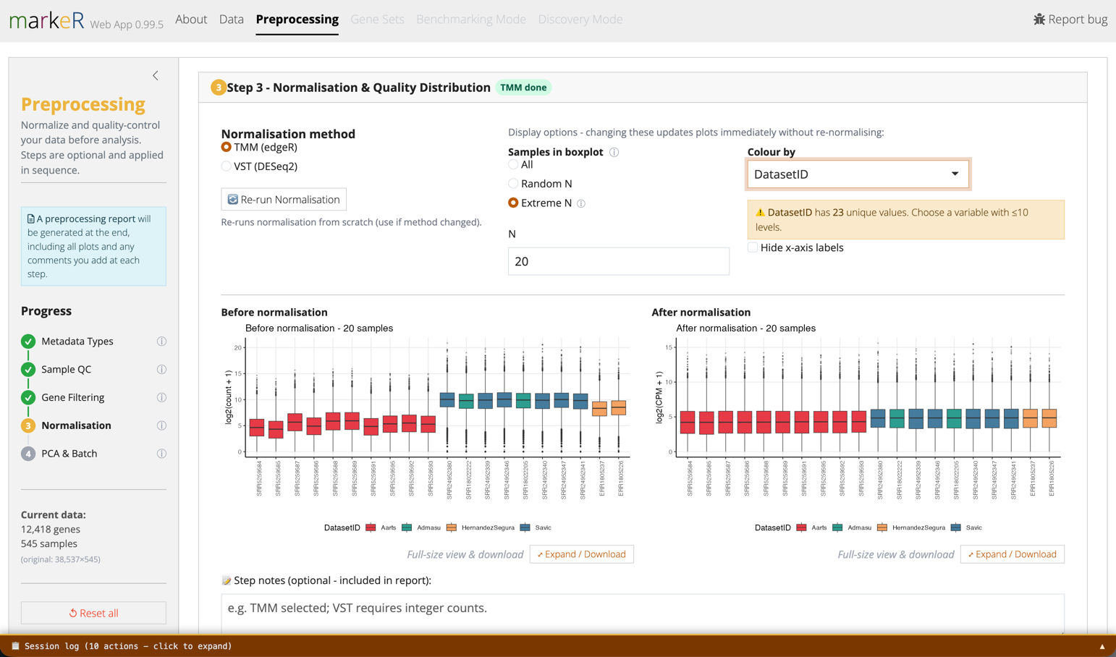
Step 4: PCA & Batch Correction (optional)
Purpose: Visualise sample structure and, if needed, remove known technical variation while preserving the biological variable of interest.
Why use this: If samples cluster by batch or processing date rather than by biology in the pre-correction PCA, gene set scores may reflect technical variation rather than the phenotype of interest.
Navigation:
- Run PCA on the normalised matrix (center is recommended and on by default; scale is off by default).
- For batch correction (limma voom + lmFit):
  - Variable(s) to remove (batch): required, the technical variation to remove, for example DatasetID or processing batch.
  - Variable(s) to retain (signal): optional, the biological variable you do not want removed, which may be partially confounded with the variable(s) to remove, for example Condition or Age.
- A second "after" PCA and scree plot let you visually assess whether the batch effect has been removed without collapsing your biological grouping.
What you will see:
(A) Both PCA plots are interactive: hover over a point to see its sample ID, group, and coordinates on the selected principal components.
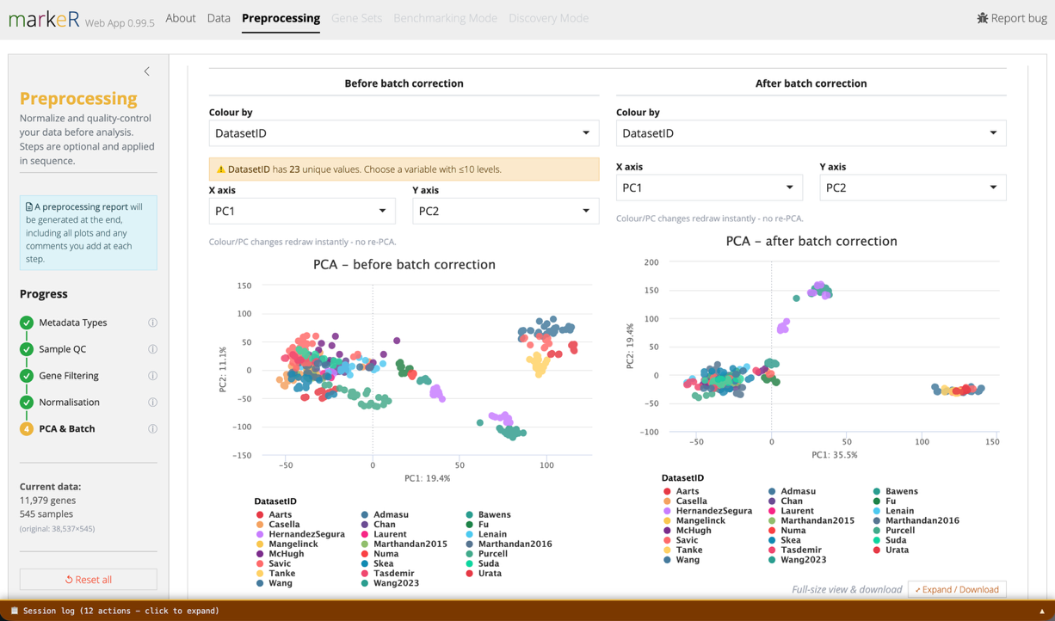
Good to know: The batch-correction method is credited to voyAGEr (eLife, 2024) and the markeR paper (NAR Genomics and Bioinformatics, 2026).

Removing Samples
Purpose: Remove a sample identified as an outlier during Steps 1 through 4.
Navigation:
- The sample-removal controls appear directly below the PCA plot at the end of Step 4.
- Select the sample(s) to remove.
- Optionally record a reason for removal, which is included in the preprocessing report.
- Optionally attach any of the diagnostic plots already produced during Steps 1 through 4 (sample complexity, gene filtering, normalisation, or PCA) as supporting evidence; these are also included in the report.
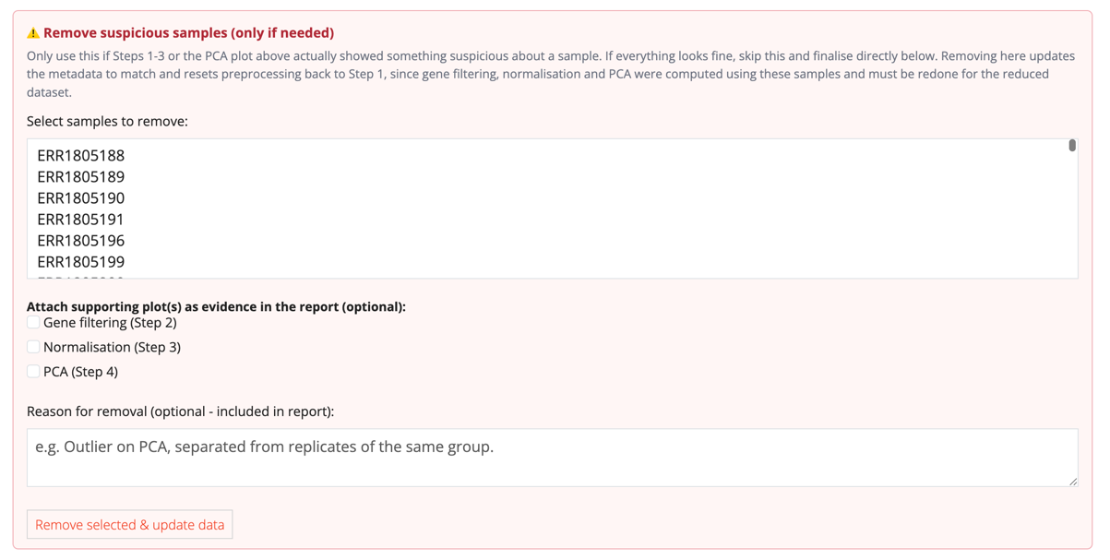
- Confirm the removal in the dialog that appears. Click Remove & reset to proceed.
Good to know: Removing a sample resets preprocessing to Step 1 because gene filtering, normalisation, and PCA must be recalculated for the reduced dataset. After the first removal, the control collapses behind a "Remove more samples…" toggle.

Finalising Preprocessing
Purpose: Finalise your preprocessing choices and unlock the Gene Sets, Benchmarking Mode, and Discovery Mode tabs.
Navigation:
- Choose how to finish.
  - If batch correction was run: Use batch-corrected data or Use normalised only (no batch correction).
  - Otherwise: Finalise & apply preprocessing.
What you will see:
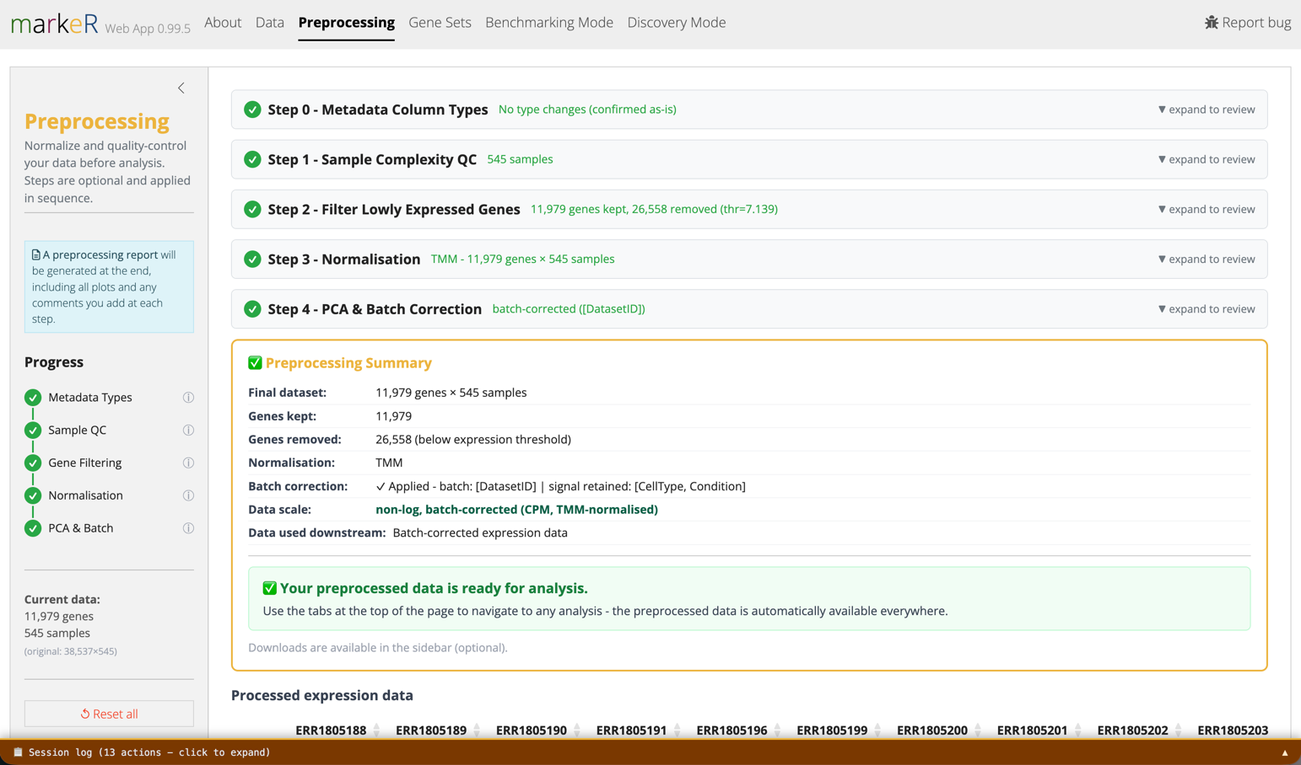
- Preprocessing Summary card: lists genes kept/removed, samples removed, normalisation method, batch-correction status and variables, and the final data scale.
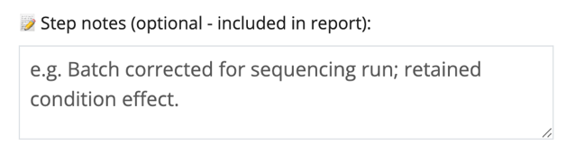
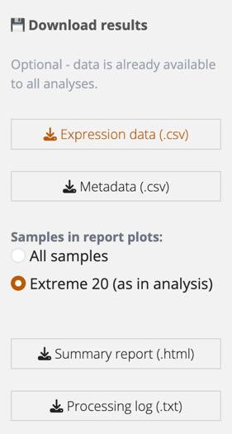
- Any "Step notes" you added along the way, plus every before/after plot, are compiled into an auto-generated HTML preprocessing report you can download for your records
- Options to download the preprocessing report and data appear at the bottom left of the sidebar.

Good to know: Until preprocessing is finalised (or explicitly skipped), the Gene Sets, Benchmarking Mode, and Discovery Mode tabs stay locked with the tooltip "Complete preprocessing first."

Gene Sets Tab
Use this tab to assess whether your gene set(s) behave as expected at the individual-gene level, before performing the full analyses available in Benchmarking or Discovery Mode.
Good to know: Most sub-tabs operate on a single Active gene set chosen in the sidebar. Pairwise Overlap and Similarity vs MSigDB instead compare all loaded gene sets.

Pairwise Overlap
Purpose: Quantify the overlap between your loaded gene sets.
Why use this: Before interpreting multiple signatures as independent findings, it is useful to determine whether they capture essentially the same biology (high overlap, likely redundant) or distinct biological processes.
Navigation:
- Choose a metric: Jaccard index or Odds ratio.
- Click Run Pairwise Overlap.
Analysis deep dive:
- Jaccard index = |A∩B| / |A∪B|, ranging from 0 (no overlap) to 1 (identical sets).
- Odds ratio measures whether the observed overlap exceeds that expected by chance. A value of 1 indicates chance-level overlap, values >1 indicate enrichment, and self-comparisons return Inf.

Similarity vs MSigDB
Purpose: Compare your gene sets against curated pathways from MSigDB or your own reference collections.
Why use this: A highly discriminatory gene set may simply recapitulate a well-characterised pathway (for example, a Hallmark signature) rather than represent a novel biological finding. This analysis helps place your results into biological context and avoids over-interpreting novelty.
Navigation:
- Choose a similarity metric (Jaccard index or Odds ratio), an organism (10 species supported), and an MSigDB collection (for example Hallmark) or subcollection (for example CP:REACTOME).
- Optionally restrict the analysis to selected pathways, define minimum similarity thresholds (or odds-ratio and adjusted P-value cut-offs), or upload/paste your own reference gene sets.
- Click Run Similarity.

Correlation
Purpose: Examine how genes within the active gene set co-vary across samples.
Why use this: This analysis reveals whether the gene set behaves as a coordinated transcriptional programme or comprises several relatively independent expression patterns.

Navigation:
- Select the genes to display, choose a correlation method (Spearman, Pearson, or Kendall), and optionally split the heatmap by a metadata variable, generating one heatmap per group. This is useful when genes are expected to be co-regulated only under specific conditions.
- Optionally cluster rows and columns and display labels, then click Plot Correlation Heatmap.
How to interpret this:
- Strongly correlated genes may be co-regulated or functionally redundant, whereas weakly correlated genes may contribute complementary information to the overall gene-set score.

Effect Size (Cohen's d)
Purpose: Rank genes according to how well each individually separates two groups.
Why use this: This analysis decomposes the overall gene-set signal into its individual gene contributions, helping identify genes that drive the phenotype and those contributing relatively little.
Navigation:
- Select specific genes or automatically choose the Top N or Random N genes (ranked by |Cohen's d|, gene-set order, or randomly).
- Select a grouping variable and its positive class, then click Plot Effect Size.
Analysis deep dive:
- Cohen's d measures the standardised difference in expression between the selected class and all remaining samples (one-vs-rest), using the pooled standard deviation.
How to interpret this:
- d ≈ 0 indicates little or no separation; d ≈ 0.5 a moderate effect; and d ≥ 0.8 a large effect. Even when the selected variable has more than two levels, the comparison is always performed as one-versus-rest.

Gene PCA
Purpose: Assess whether expression of the genes in the active gene set alone captures the sample variation associated with a variable of interest.
Why use this: This analysis shows how much of the variation explained by the selected genes corresponds to the biological grouping of interest.
Navigation:
- Choose a colouring variable and the principal components to display (PC1–PC10).
- Click Plot Gene PCA.
Analysis deep dive:
- PCA is computed using only the expression matrix of the active gene set; all other genes are excluded.
- PCA is entirely unsupervised: the metadata variable used to colour the samples plays no role in calculating the principal components. Colouring is applied afterwards to assess whether the major axes of variation correspond to the biological grouping of interest.

Discriminatory Power (ROC / AUC)
Purpose: Quantify the ability of each individual gene to discriminate between two groups.
Why use this: This analysis summarises each gene's discriminatory performance using a single metric (AUC), allowing genes to be ranked according to their standalone predictive value independently of the overall gene-set score.
Navigation:
- Select specific genes or automatically choose the Top N or Random N genes ranked by the effective AUC = max(AUC, 1 − AUC), which captures genes discriminating strongly in either direction.
- Select a grouping variable and its positive class, then click Plot Discriminatory Power.
How to interpret this:
- An AUC of 0.5 indicates no discriminatory ability, whereas an AUC of 0 or 1 indicates perfect discrimination.
Good to know: An AUC below 0.5 does not imply that a gene is uninformative. Instead, it indicates that higher expression predicts the opposite class (for example, the gene is downregulated rather than upregulated in the condition of interest). Selecting Invert AUC < 0.5 genes simply displays these genes as 1 − AUC, allowing all genes to be ranked on a common 0.5-1 scale irrespective of the direction of the association. The underlying ROC curve is also inverted.

Expression (Violins & Heatmap)
Purpose: Visually inspect expression patterns of individual genes.
Why use this: This provides a final qualitative check that genes exhibit the expected expression patterns before drawing conclusions from aggregate gene-set statistics.
Navigation:
- Violin plots: Select genes, a grouping variable (x-axis), and a colouring variable, then click Plot Violins.
- Heatmap: Optionally cluster rows and columns and display labels, then click Plot Heatmap.
Analysis deep dive:
- The heatmap displays row-scaled expression values (Z-scores computed independently for each gene), making expression patterns directly comparable across genes with widely different absolute expression levels.

Benchmarking Mode Tab
Purpose: Rigorously test and compare the ability of one or more gene sets to mark a phenotype using both score-based and enrichment-based methods.
Navigation:
- In the sidebar, choose gene set scope: All loaded or Select specific sets.

Module A: Score Analysis
Shared settings for this module: pick a variable (or "None" for a density plot), choose a contrast mode for categorical variables or a correlation method for numeric variables, and optionally filter which contrasts are displayed.

Score Distributions
Purpose: Visualise per-sample scores across groups.
Navigation:
- Choose a scoring method (Log-median, Ranking, or ssGSEA; see the markeR manuscript for further methodological detail) and a colour-by variable.
- Optionally connect paired samples across groups, set a "focus" comparison for Cohen's d, and show a t-test p-value in the subtitle.
Analysis deep dive:
- Log-median: log₂-transforms expression and median-centres each gene across samples.
- Ranking: non-parametric. Scores are based on each sample's within-sample rank of the gene set's members.
- ssGSEA: single-sample running-sum enrichment score (Barbie et al. 2009). Sensitive to gene set size.
Good to know: Log-median calculates each score from centred, log-transformed expression and is therefore sensitive to normalisation and scale. Ranking uses each sample's within-sample ranks for the genes in the set rather than their expression magnitudes, making it more robust to outliers but discarding information about the magnitude of expression differences. ssGSEA computes a running-sum enrichment score and is sensitive to gene-set size. See the markeR paper for a detailed methodological comparison. Rather than relying on a single method, use All Methods Summary to assess whether results agree across methods.

Classification (ROC / AUC)
Purpose: Test how well a gene set's score classifies a categorical variable.
Navigation:
- Choose a scoring method and optionally check Ignore direction to fold AUC to 0.5 or above.
How to interpret this:
- An AUC of 0.5 indicates chance-level performance, whereas an AUC of 1.0 indicates perfect classification.
Good to know: Off by default, direction is preserved: a curve can dip below the diagonal (AUC < 0.5), meaning the score runs opposite to how you defined the comparison, for example class order flipped, or it is really a "down" signature relative to this contrast. Checking "Ignore direction" folds any AUC below 0.5 to 1 − AUC, so you can compare separation strength across many contrasts or gene sets without direction sign flipping the ranking, at the cost of hiding which way the score actually points.

All Methods Summary
Purpose: Compare every gene set against every contrast, across all three scoring methods, in one view.
Why use this: Identifies which gene sets and contrasts are most consistently discriminatory regardless of scoring method.
Navigation:
- Set significance and effect-size thresholds, then click to run.
Analysis deep dive:
- A Cohen's d/f heatmap (gene sets by contrasts, with cell text showing the effect size and adjusted p-value) plus an Effect Size Volcano (x-axis: effect size; y-axis: −log₁₀ adjusted p-value; faceted by contrast).
How to interpret this:
- Dashed threshold lines mark your significance and effect-size cutoffs. Points beyond both lines, consistently across methods, are your best candidates.

Score FPR Simulation
Purpose: Test whether a gene set's discriminatory power is distinguishable from what would be expected by chance for random gene sets of the same size.
Why use this: A raw Cohen's d for a gene-set score does not tell you whether that particular gene combination is informative or whether a random set of the same size would produce a similarly large effect. The simulation provides an empirical null against which to assess score specificity.
Navigation:
- Choose a contrast mode and number of simulations (10 to 2000; default 100). More simulations means longer runtime, since it scales with gene sets times simulations times 3 methods.
- Click Run Score FPR Simulation.
Analysis deep dive:
- For each contrast, the app computes the observed Cohen's d/f for your gene set, then generates random gene sets of matching size from the full expression matrix to build a null distribution. A 95th-percentile threshold line marks where a random set would be considered "significant" purely by chance.
How to interpret this:
- If the observed effect size is above the null distribution's 95th percentile, the result is less likely to be explained by gene-set size alone. This tests score-level specificity, not gene-level discriminability; combine it with the per-gene diagnostics in the Gene Sets tab for a fuller assessment.

Score Results Table
Purpose: Export raw per-sample scores for further analysis.
Navigation:
- Choose a method (or "All methods"), then download as CSV or Excel.

Module B: Enrichment Analysis (GSEA)
Purpose: Test for gene-set enrichment by performing differential expression analysis followed by GSEA, rather than relying on per-sample scores.
Why use this: Score-based methods reduce each gene set to one value per sample and ask whether that score discriminates between groups. GSEA first performs differential expression across the cohort and then asks whether the gene set is coordinately shifted in the contrast.
Navigation:
- Choose a design mode.
  - Automatic: pick a grouping variable; the app builds the design matrix and contrasts for you.
  - Manual: paste an R formula, for example ~ 0 + Condition + Batch, for covariates or paired designs.
- Set the ranking statistic (Auto, t-statistic, or B-statistic), number of permutations (default 1000), and p-adjustment settings, including whether to pool FDR correction across all contrasts.
- Click Run Enrichment Analysis (GSEA).
Good to know: Ranking statistic: Auto (recommended) uses the t-statistic for directional gene sets (a data frame with +1/-1 gene weights) and the B-statistic for gene sets without direction. Use the t-statistic explicitly for a classic "up in disease, down in disease" signature, where preserving the sign of NES is biologically meaningful. Use the B-statistic for an unsigned gene list with no inherent direction, allowing both up- and down-regulated members to contribute to enrichment regardless of direction.

DEG Volcanos
Purpose: Examine differential expression results for each contrast, with gene set membership highlighted.
Navigation:
- Set logFC and adjusted p-value thresholds, and how many top genes to label.
- Choose highlight mode: Gene set members or Significant genes by threshold.
How to interpret this:
- Grey indicates a background gene. Green indicates a gene annotated as up in the gene set. Red indicates a gene annotated as down. Dark blue indicates a gene set member with no assigned direction. Blue indicates a gene that is significant by your threshold.
Good to know: Colour encodes each gene's annotated direction from the gene set itself, not the side of the plot on which the point falls for this particular contrast. For example, in a contrast A vs B where A is the positive class, a gene set annotated to mark class B will have its member genes coloured red (annotated down), even for genes that fall on the right-hand, up-logFC side of the plot for this contrast.

Combined Volcano
Purpose: Compare NES and significance across all gene sets and contrasts.
Navigation:
- This runs automatically once GSEA completes.
Analysis deep dive:
- Each point represents one gene set–contrast combination: the x-position reflects NES, the y-position reflects −log₁₀ adjusted p-value, colour represents the gene set, and shape represents the contrast.
How to interpret this:
- Altered panel (undirected gene sets, B-statistic): a positive NES indicates enrichment among the most-altered genes.
- Enriched/Depleted panel (directed gene sets, t-statistic): a positive NES indicates enrichment among up-regulated genes, and a negative NES indicates enrichment among down-regulated genes.

NES Lollipop
Purpose: Rank gene sets by enrichment strength within each contrast.
Navigation:
- This runs automatically once GSEA completes.
Analysis deep dive:
- Lollipop length reflects |NES|; point colour reflects adjusted p-value (red indicates significance). One panel is shown per contrast, split into Altered and Enriched/Depleted as described above.

Enrichment Plots
Purpose: Examine the classic GSEA running-enrichment-score curve for a specific gene set and contrast.
Navigation:
- Select a gene set and contrast to inspect.
Analysis deep dive:
- The curve tracks the running enrichment score along the ranked gene list; bars along the bottom mark where gene set members fall in that ranking. A peak concentrated on one side indicates strong, coordinated enrichment.

Results Table
Purpose: Export full GSEA statistics for every gene set and contrast.
Analysis deep dive:
- Columns include pathway, NES, adjusted p-value, ranking statistic used, contrast, and leading edge.

Discovery Mode Tab
Purpose: Screen many metadata variables quickly against one gene set to generate hypotheses for further investigation.
Why use this: Quickly tests which clinical or technical variables (age, sex, batch, treatment, subtype, etc.) are associated with the gene set's signal before you invest time in rigorously benchmarking a specific variable. This mode is exploratory and assumes that the gene set is already a plausible marker of the phenotype of interest.
Navigation:
- In the sidebar, pick one gene set.
- Select the metadata variables to test. Variables with only one observed level are excluded automatically; variables with more than six levels are flagged as potentially unwieldy.
- Choose a contrast mode: Simple pairwise, One vs rest, or All combinations. Hover over each option in the app for its exact definition and an example.
- Set the significance threshold (adjusted p-value, default 0.05) and p-adjustment method.
Good to know: Discovery Mode is for hypothesis generation, not confirmation. If a result looks promising, examine it more rigorously in Benchmarking Mode and, regardless of how it performs there, seek confirmation in an independent dataset before relying on it.

Single Method Explorer
Purpose: Test one scoring or enrichment method against all selected variables.
Navigation:
- Choose a method: Log-median score, Ranking score, ssGSEA score, or GSEA enrichment, then click Run Selected Method.
Analysis deep dive:
- Score methods output an Effect Size Overview (Cohen's f per variable), Score Distributions per variable, and Pairwise Contrasts (Cohen's d per pairwise comparison with adjusted p-values).
- The GSEA method outputs a lollipop plot: one row per contrast across all variables. Point position reflects NES (normalised enrichment score); colour reflects adjusted p-value significance.
How to interpret this:
- Dashed, grey points flag B-statistic contrasts with negative NES; these are generally uninformative, indicating no strong coordinated expression change. Rows below your significance threshold are highlighted in the results table.

Method Summary
Purpose: Compare all four methods across all selected variables in a single view.
Why use this: No single scoring or enrichment method is universally authoritative. A variable that shows a consistent signal across methods provides stronger evidence than one that is significant with only a single method.
Navigation:
- Click to run. This is slower than Single Method Explorer, since GSEA runs once per variable.

Analysis deep dive:
- A combined heatmap: the left block shows Cohen's f per variable by scoring method (an asterisk marks p below your threshold); the right column shows the fraction of that variable's GSEA contrasts that were significant (for example, "2/3").

