**快递物流系统**

**(Express Logistics System)**

**体系结构设计文档**



**学 院：南京大学软件学院**

**团 队：伪装者W小组**

**成 员：张词校 张家盛 王丽莉 魏彦淑**

**完成日期：2015年10月26日**

# 更新历史

# 1.引言

## 1.1编制目的

## 1.2词汇表

## 1.3参考资料

# 2.产品概述

# 3.逻辑视角

在快递物流系统中，选择了分层体系结构风格，将系统分为3层（展示层、业务逻辑层、数据层）能够很好地展示整个高层抽象。展示层包含GUI页面的实现，业务逻辑层包含业务逻辑处理的实现，数据层负责数据的持久化和访问。分层体系结构的逻辑视角和逻辑设计方案如图1和图2所示。

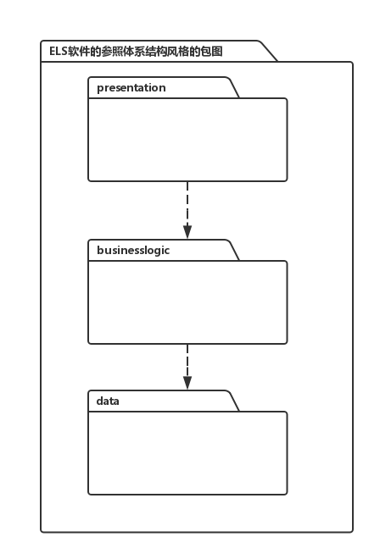

**图1 ELS参照体系结构风格的包图表达逻辑视角**

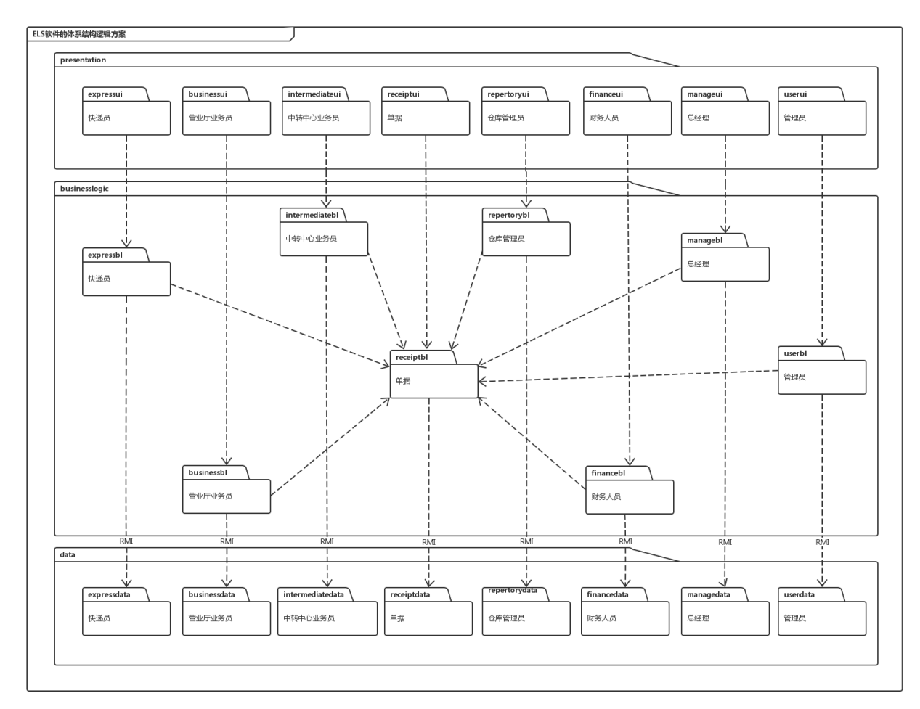

**图2 ELS体系结构初始逻辑设计包图表达逻辑视角**

# 4.组合视角

## 4.1开发包图

快递物流系统的最终开发包设计如表1所示

**表1 快递物流系统的最终开发包设计**

|  |  |
| --- | --- |
| 开发（物理）包 | 依赖的其他开发包 |
| mainui | loginui, inquireui, expressui, businessui, intermediateui, financeui, repertoryui, managerui, adminui, receiptui |
| loginui | expressui, businessui, intermediateui, financeui, repertoryui, managerui, adminui, receiptui |
| loginblservice |  |
| loginbl |  |
| logindataservice |  |
| logindata |  |
| expressui | expressblservice,vo,界面类库包 |
| expressblservice |  |
| expressbl | expressblservice，expressdataservice，po |
| expressdataservice | Java RMI,po |
| expressdata | Java RMI,databaseutility,po |
| businessui | businessblservice ,vo,界面类库包 |
| businessblservice |  |
| businessbl | businessblservice, businessdataservice,po |
| businessdataservice | Java RMI,po |
| businessdata | Java RMI,po,databaseutility |
| intermediateui | intermediateblservice,vo,界面类库包 |
| intermediateblservice |  |
| intermediatebl | intermediateblservice, intermediatedataservice,po |
| intermediatedataservice | Java RMI,po |
| intermediatedata | Java RMI,po,databaseutility |
| financeui | financeblservice,vo,界面类库包 |
| financeblservice |  |
| financebl | financeblservice,financedataservice,po |
| financedataservice | Java RMI,po |
| financedata | Java RMI,po,databaseutility |
| repertoryui | repertoryblservice,vo,界面类库包 |
| repertoryblservice |  |
| repertorybl | repertoryblservice,repertorydataservice,po |
| repertorydataservice | Java RMI,po |
| repertorydata | Java RMI,po,databaseutility |
| managerui | managerblservice,vo,界面类库包 |
| managerblservice |  |
| managerbl | managerblservice,managerdataservice,po |
| managerdataservice | Java RMI,po |
| managerdata | Java RMI,po,databaseutility |
| adminui | adminblservice,vo,界面类库包 |
| adminblservice |  |
| adminbl | adminblservice, admindataservice,po |
| admindataservice | Java RMI,po |
| admindata | Java RMI,po,databaseutility |
| receiptui | receiptblservice, vo,界面类库包 |
| receiptblservice |  |
| receiptbl | receiptblservice,receiptdataservice,po |
| receiptdataservice | Java RMI,po |
| receiptdata | Java RMI, po,databaseutility |
| vo |  |
| po |  |
| uitilitybl |  |
| 界面类库包 |  |
| Java RMI |  |
| databaseutility | JDBC,io类库包 |

## 4.2运行时进程

## 4.3物理部署

# 5．接口视角

## 5.1模块的职责

## 5.2用户界面层的分解

## 5.3业务逻辑层的分解

## 5.4数据层的分解

# 6.信息视角

## 6.1数据持久化对象

## 6.2TXT持久化格式

## 6.3数据库表