Technical Report on Training, Testing, and Validation of a Bidirectional LSTM Model for Life Expectancy Prediction

Abstract
This report details the development of a Bidirectional Long Short-Term Memory (LSTM) neural network model designed to predict life expectancy based on various socio-economic and health-related factors. The model was trained, tested, and validated using a dataset containing global health and environmental indicators. This report discusses the data preprocessing steps, the rationale behind model selection and architecture, training procedures, evaluation metrics, and the results obtained. Visualizations and additional analyses are included to provide a comprehensive understanding of the model's performance.

1. Introduction
Life expectancy is a critical indicator of a nation's overall health and well-being. Predicting life expectancy based on various factors can aid policymakers and health organizations in making informed decisions. Machine learning models, particularly neural networks, have shown promise in capturing complex patterns in data.
This project aims to develop a Bidirectional LSTM model to predict life expectancy using a dataset comprising health, environmental, and socio-economic features. The choice of a Bidirectional LSTM is motivated by its ability to capture temporal dependencies in both forward and backward directions, potentially enhancing predictive performance.

2. Data Preparation
Data preparation involved several critical steps:
- Loading the dataset (Data_GHGE.csv) containing features related to health and socio-economic indicators.
- Selecting 25 features based on domain relevance, including food supply metrics and energy use.
- Cleaning data by removing whitespace from column names.
- Splitting data into training and testing sets with stratification based on target variable quantiles.
- Scaling features using RobustScaler to handle outliers effectively.
- Creating sequences of length 3 for LSTM model input to capture temporal dependencies.

3. Model Development
The Bidirectional LSTM model architecture consisted of:
- Two Bidirectional LSTM layers with 64 and 32 units respectively.
- Dropout layers with a 30% rate to prevent overfitting.
- Dense layers with ReLU activation and an output layer for regression.
Rationale:
- Bidirectional processing enhances the model's ability to understand temporal patterns.
- Regularization techniques (dropout and L2) improve generalizability.

4. Model Compilation and Training
The model was compiled using:
- Mean Squared Error (MSE) as the loss function.
- Mean Absolute Error (MAE) and correlation coefficient as metrics.
Optimization was performed using the Adam optimizer with a learning rate of 0.001. EarlyStopping and ReduceLROnPlateau callbacks were employed to halt training when validation performance plateaued and adapt learning rates dynamically.

5. Model Evaluation and Results
The model achieved the following evaluation metrics:
- MAE: 0.8972
- RMSE: 1.0996
- R²: 0.8598
- Correlation Coefficient: 0.9301
Key Observations:
- Predictions closely matched actual values, as seen in line and scatter plots.
- Residuals were randomly distributed, indicating no systematic errors.

6. Visualizations
Key visualizations included:
- Actual vs. Predicted Life Expectancy (line and scatter plots).
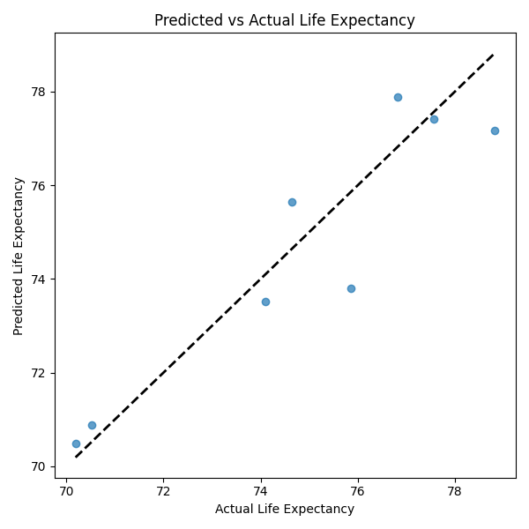
- Residual Analysis (residuals plot and histogram).
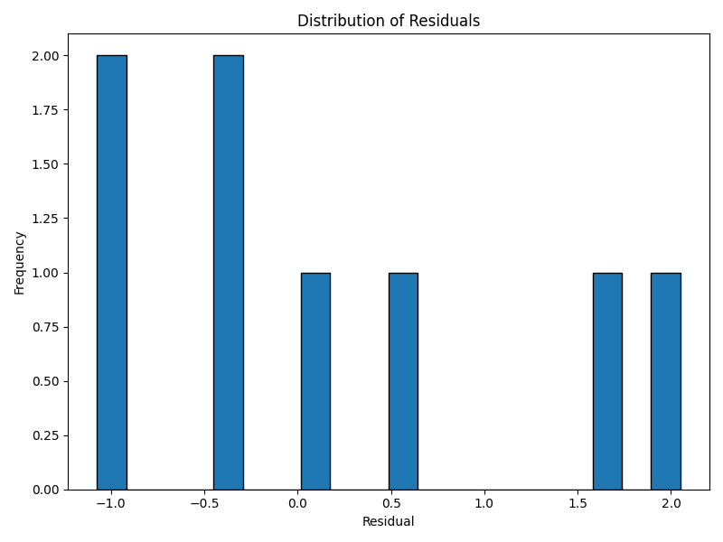
- Training history showing convergence of loss and MAE.
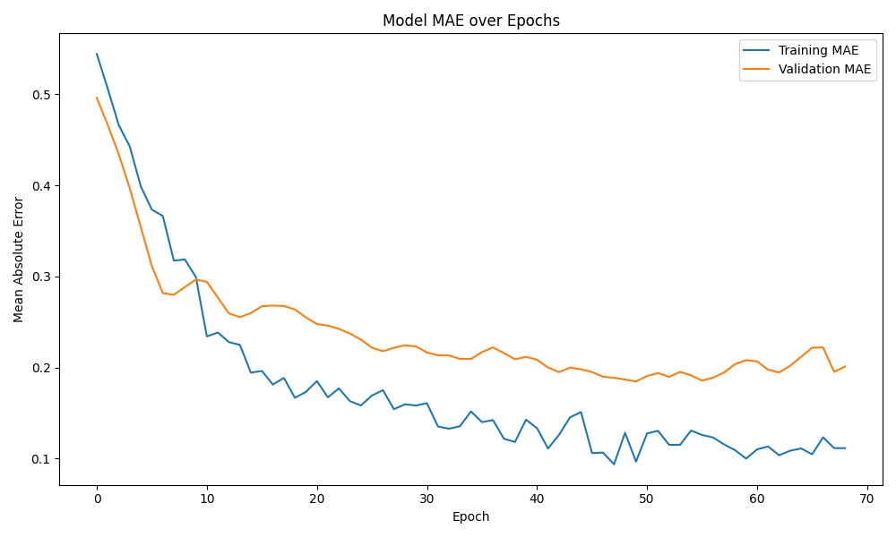

7. Discussion and Conclusion
The Bidirectional LSTM model effectively predicts life expectancy with high accuracy. However, limitations such as interpretability and computational complexity exist. Future work should explore hyperparameter tuning, feature engineering, and model interpretability techniques.

