Conditional Formatting
High CGPA

CGPA Category
=IF(B1:B50001>=8,"High CGPA","Average/Low CGPA")
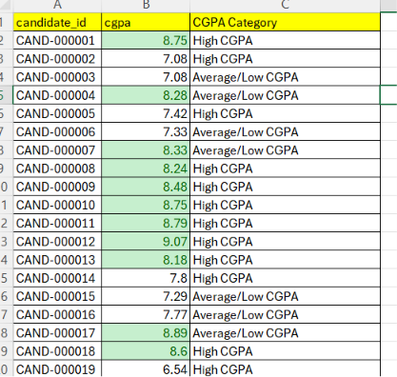

Low SQL Skill

SQL Category
=IF(D1:D50001<5,"Low SQL Skill",IF(J2<8,"Medium","High"))
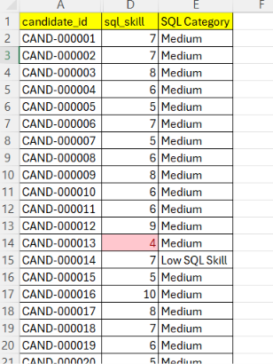

salary

Maximum salary
=MAX(F2:F50001)

Average salary
=AVERAGE(F2:F50001)

Expected Salary Category
=IF(F2:F50001>=25,"High Expected Salary","Normal")
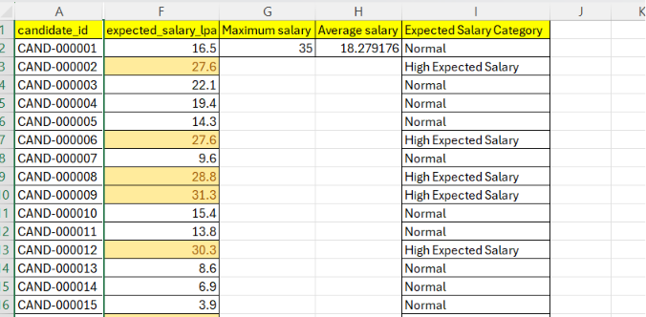

Selected candidates

Total Selected Candidates
=COUNTIF(J2:J50001,"Yes")
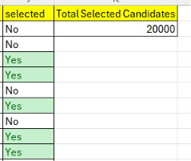

Employment gaps

Gap Status
=IF(L2:L50001=0,"No Gap","Has Employment Gap")
